Project Screen Shots

Welcome Message 1

Game Start Screen 1

Letter Being Dropped 2

Correct Key Pressed 3

Wrong Key Pressed 4

Top 5 Scores 5

## Welcome Message

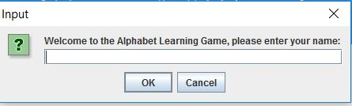

## Game Start Screen

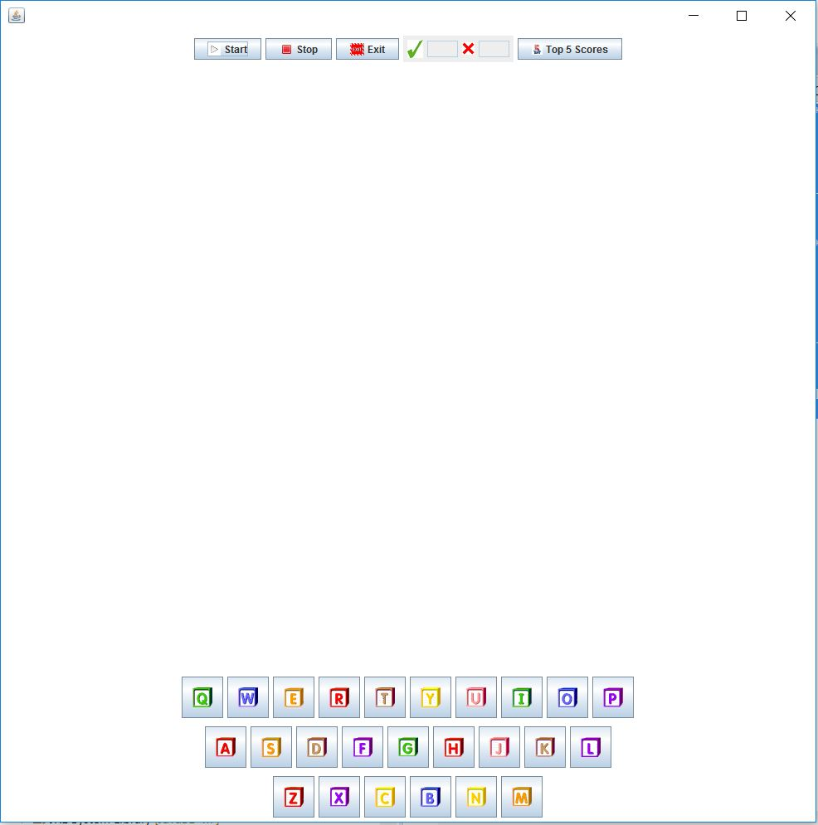

## Letter Being Dropped

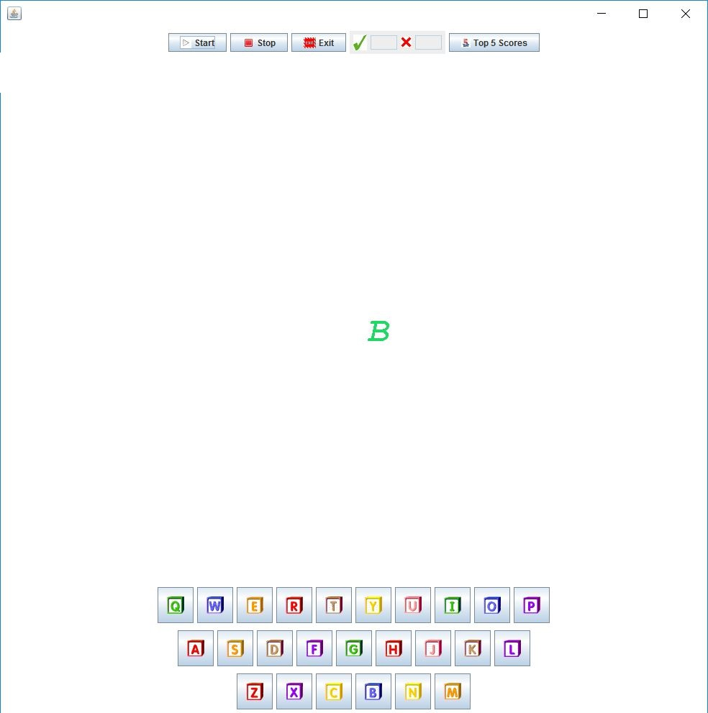

## Correct Key Pressed

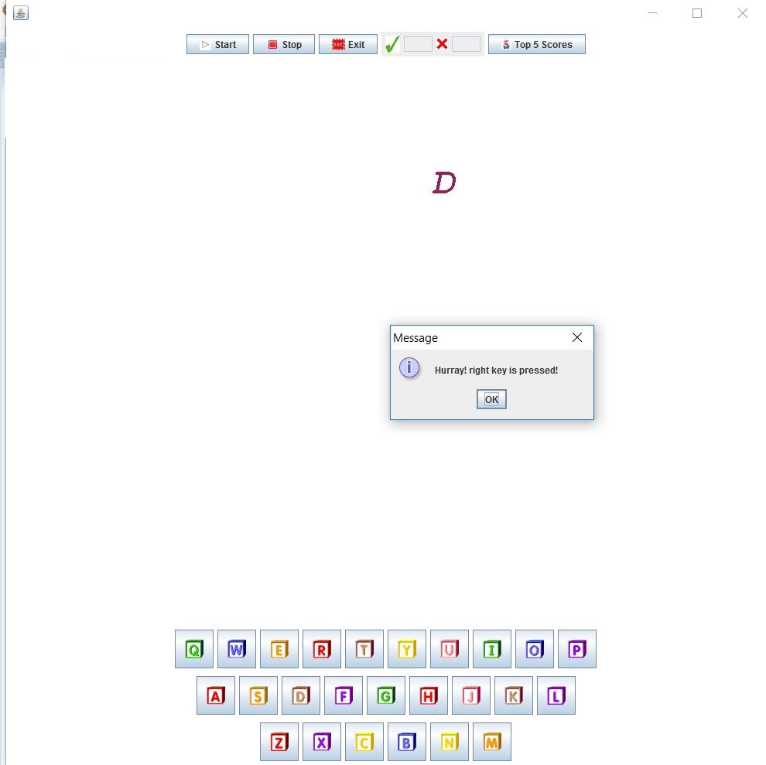

## Wrong Key Pressed

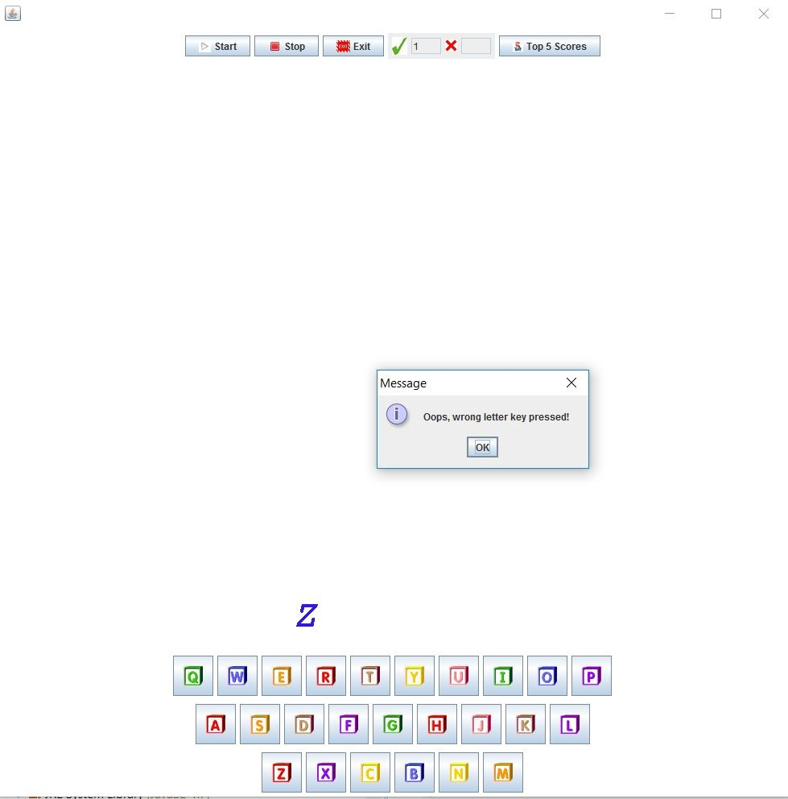

## Top 5 Scores

