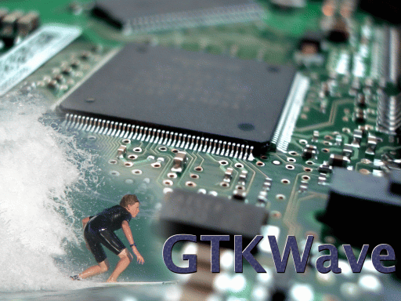

GTKWave 3.0 Wave Analyzer User's Guide

User's Guide
GTKWave

Created April 27, 2006
This manual supports GTKWave 3.0 and higher versions.

Copyright (c)1998-2007 BSI
GTKWave is free software. See http://www.gnu.org for more information on the GNU GPL General Public License. There is NO warranty; not even for MERCHANTABILITY or FITNESS FOR A PARTICULAR PURPOSE.

The information in this document is subject to change without notice.

Contents

Using This Manual 9
Printing Conventions 9

Compiling and Installing GTKWave 11
Unix and Linux Operating Systems 11
Microsoft Windows Operating Systems 12

Introduction 15
GTKWave Overview 15
Why Use GTKWave? 16
What Is GTKWave? 18

GTKWave User Interface 19
GTKWave 19
Main Window 19
Signal Subwindow 21
Wave Subwindow 23
Navigation and Status Panel 24
Menu Bar 25
TwinWave 26
RTLBrowse 27
Ergonomic Extras 30
Scroll Wheels 30
The Primary Marker 30
Interactive VCD 30

GTKWave Menu Functions 31
File 31
Edit 32
Search 36
Time 37
Markers 38
View 39
Help 40

Quick Start 41
Sample Design 41
Launching GTKWave 42
Displaying Waveforms 44
Signal Search 44
Hierarchy Search 45
Tree Search 45
Signal Save Files 46
Pattern Search 46
Alias Files and Attaching External Disassemblers 47
Debugging the Source Code 49

Appendix A: Command Line Options Reference 51
gtkwave 51
twinwave 54
lxt2miner 55
lxt2vcd 56
mvl2lxt 57
mvl2vcd 57
rtlbrowse 58
tex2vcd 59
tla2vcd 59
vcd2lxt 60
vcd2lxt2 61
vcd2vzt 63
vermin 64
vzt2vcd 65
vztminer 66
shmidcat 67

Appendix B: .gtkwaverc Variable Reference 69

Appendix C: VCD Recoding 79
VList Recoding Strategy 79
Time Encoding 80
Single-bit Encoding 80
Multi-bit Encoding 81
Reals and String Encoding 82
Final Notes on VCD Recoding 82

Appendix D: LXT File Format 83
LXT Framing 83
LXT Section Pointers 84
LXT Section Definitions 86
The lxt_write API 95

Index 99
Illustration Index 99
Alphabetical Index 99

Using This Manual

Printing Conventions
Text printed in the font courier reflects messages that will be seen on screen at a command prompt or as program output.

Text printed in courier bold is to be entered by the user.

Text printed in smaller monospace is help available either as a manual page or as a program help option.

Text printed in italics is a pathname in the file system or is the name of an application program.

Compiling and Installing GTKWave

Unix and Linux Operating Systems

Compiling GTKWave on Unix or Linux operating systems should be a relatively straightforward process as GTKWave was developed under both Linux and AIX. External software packages required are any version of GTK (http://www.gtk.org) greater than or equal to 1.2, and gperf (for RTLBrowse) which can be downloaded from the GNU website (http://www.gnu.org). The compression libraries libz (zlib) and libbz2 (bzip2) are not required to be installed on a target system as their source code is already included in the GTKWave tarball. Likewise goes for PCCTS-1.33 source code (required for compiling vermin) which is included in the contrib/ directory. Note that PCCTS-2.0 will not work as the grammar file format for v2.0 is incompatible with v1.33.

Compiling and Installing

Un-tar the source code into any temporary directory then change directory into it. After doing this, invoke the configure script. Note that if you wish to change the install point, use the doubledash –prefix option to point to the absolute pathname. For example, to install in /usr, type ./configure –prefix=/usr.

1 :/tmp/gtkwave-3.0.0> ./configure
Build GTKWave for GTK+-1.x or 2.x? Please enter '1' or '2'

Enter '1' or '2' depending on which version of GTKWave you would like to compile against. Typically, you will enter '2' (or just press enter).

2 :/tmp/gtkwave-3.0.0> make

Wait for the compile to finish. This will take some amount of time. Then log on as the superuser.

3 :/tmp/gtkwave-3.0.0> su
Password:
[root@localhost gtkwave-3.0.0]# make install

Wait for the install to finish. It should proceed relatively quickly. When finished, exit as superuser.

[root@localhost gtkwave-3.0.0]# exit
exit

GTKWave is now installed on your Unix or Linux system. To use it, make sure that the bin/ directory off the install point is in your path. For example, if the install point is /usr/local, ensure that /usr/local/bin is in your path. How to do this will vary from shell to shell.

Microsoft Windows Operating Systems

Cygwin

The best way to run GTKWave under Windows is to compile it as an application to run under Cygwin. This will provide the same functionality as compared to the Unix/Linux version and better graphical performance than the native binary version. Follow the directions for Unix compiles in the preceding section. Note that launching RTLBrowse requires Cygserver to be enabled. Please see the Cygwin documentation for information on how to enable Cygserver for your version of Cygwin.

MinGW versus VC++ for Native Binaries

It is recommended that Windows compiles and installs are done in the MinGW environment in order to mimic the Unix shell environment as well as produce binaries that are natively usable on Windows. Producing native binaries with VisualC++ has not been attempted for some time so it is currently untested and might not be supported. Proceed to use VisualC++ at your own risk.

MinGW with GTK-1.2

If you are missing a working version of gtk-config, you will need a fake gtk-config file in order to compile under GTK-1.2. It will look like this with the include and linker search directories modified accordingly:

#!/bin/sh

if [ "$1" == "--libs" ]
then
echo -L/home/bybell/libs -lgck -lgdk-1.3 -lgimp-1.2 -lgimpi -lgimpui-1.2 -lglib-1.3 -lgmodule-1.3 -lgnu-intl -lgobject-1.3 -lgthr
ead-1.3 -lgtk-1.3 -liconv-1.3 -ljpeg -llibgplugin_a -llibgplugin_b -lpng -lpthread32 -ltiff-lzw -ltiff-nolzw -ltiff
fi

if [ "$1" == "--cflags" ]
then
echo " -mms-bitfields -I/home/bybell/src/glib -I/home/bybell/src/gtk+/gtk -I/home/bybell/src/gtk+/gdk -I/home/bybell/src/gtk+ "
fi

Compiling as under Unix/Linux is the same however none of the helper applications will be compiled. The .exe file can be found in the bin/ directory. Copy it to wherever you store binaries on your system. (n.b., make install does not work for MinGW.)

MinGW with GTK-2.0

You do not need to do anything special except ensure that pkg-config is pointed to by your PATH environment variable. Proceed as with GTK-1.2.

Introduction

GTKWave Overview

GTKWave is an analysis tool used to perform debugging on Verilog or VHDL simulation models. With the exception of interactive VCD viewing, it is not intended to be run interactively with simulation, but instead relies on a post-mortem approach through the use of dumpfiles. Various dumpfile formats are supported:

- VCD: Value Change Dump. This is an industry standard file format generated by most Verilog simulators and is specified in IEEE-1364. This is the slowest of the formats for the viewer to process and requires the most memory, however the format is ubiquitous and almost all tools support it, which is why native support remains. Note that recent versions of the viewer default to dynamic VCD recoding in memory through some interesting tricks with zlib compressed VLists. (See Appendix C: VCD Recoding on page 79.) This greatly reduces the amount of memory required to store a large, full (non-interactive) VCD trace in memory such that in many cases, less memory is required than the actual size of the trace itself. Nevertheless, using one of the database formats will almost always be more efficient for larger traces, especially if they are to be viewed repeatedly. (i.e., the speed hit for converting a trace to a database format is offset by the repeated cost of recoding VCD every time the trace is viewed.) The more physical memory that is available on a machine being used to view VCD, the better.
- LXT: InterLaced eXtensible Trace. This is an optimized format utilizing interleaved back pointers and value changes. Processing LXT files is faster than VCD. It was created specifically for use with GTKWave, however some other simulators (notably, Icarus Verilog) support it natively.
- LXT2: InterLaced eXtensible Trace Version 2. This is a block-based variant of LXT that allows for greater compression and access speeds than can be achieved with LXT. It allows random-access at the block level and also optionally allows partial loading of blocks for even faster operation. Icarus Verilog also supports LXT2 natively.
- VZT: Verilog Zipped Trace. This is an outgrowth of LXT2 as it is also block based, however it employs a different heuristic for compression that allows for file sizes much smaller than most other dumpfile formats including commercial ones. VZT file write performance is the slowest of all the formats, however reading them can be extremely fast on multiprocessor machines as the file format has been designed such that the reader was able to be parallelized.
- GHW: GHDL Wavefile. This is a nine state (“01XZHUWL-”) file format written by the VHDL simulator GHDL.
- AET2: All Events Trace Version 2. This is format used by various IBM EDA tools. File size is very small and access is extremely fast. Support for it is determined at compile time. If the AET2 reader API libraries are not found, it is disabled. Users of IBM toolsets can modify the ./configure3 script to point to the libae2rw.a and/or libae2rw.so files in order to enable this feature.

Converter helper applications are packaged with the viewer in order to convert VCD files into LXT, LXT2, or VZT files. Conversion from LXT2 and VZT back into VCD is possible. Wholesale conversion from LXT is not currently possible, however it is possible to save the traces visible in the main GTKWave window as VCD so conversion to LXT is not strictly irreversible.

Why Use GTKWave?

GTKWave has been developed to perform debug tasks on large systems on a chip and has been used in this capacity as an offline replacement for third-party debug tools. It is 64-bit clean and is ready for the largest of designs given that it is run on a workstation with a sufficient amount of physical memory. The file formats LXT2 and VZT have been specifically designed to cope with large, real-world designs and AET2 (available to IBM EDA tool users only) has been designed to handle extremely large designs efficiently.

For Verilog, GTKWave allows users to debug simulation results at both the net level by providing a bird's eye view of multiple signal values over varying periods of time and also at the RTL level through annotation of signal values back into the RTL for a given timestep. The RTL browser frees up users from needing to be concerned with the actual location of where a given module resides in the RTL as the view provided by the RTL browser defaults to the module level. This provides quick access to modules in the RTL as navigation has been reduced simply to moving up and down in a tree structure that represents the actual design.

Source code annotation is currently not available for VHDL, however all of GTKWave's other debug features are readily accessible. VHDL support is planned for a future release.

What Is GTKWave?

GTKWave as a collection of binaries is comprised of two interlocking tools: the gtkwave viewer application and rtlbrowse. In addition, a collection of helper applications are used to facilitate such tasks as file conversions and simulation data mining. They are intended to function together in a cohesive system although their modular design allows each to function independently of the others if need be.

gtkwave is the waveform analyzer and is the primary tool used for visualization. It provides a method for viewing simulation results for both analog and digital data, allows for various search operations and temporal manipulations, can save partial results (i.e., “signals of interest”) extracted from a full simulation dump, and finally can generate PostScript and FrameMaker output for hard copy.

rtlbrowse is used to view and navigate through RTL source code that has been parsed and processed into a stems file by the helper application vermin. It allows for viewing of RTL at both the file and module level and when invoked by gtkwave, allows for source code annotation.

The helper applications perform various specialized tasks such as file conversion, RTL parsing, and other data manipulation operations considered outside of the scope of what a visualization tool needs to perform.

GTKWave User Interface

GTKWave

Main Window

The GTKWave visualization tool main window is comprised of a menu bar section, a status window, several groups of buttons, a time status section, and signal and wave value sections. New with GTKWave 3.0 is the inclusion of an embedded Signal Search Tree (SST) expander to the left of the signal section. The viewer typically appears as below when the embedded SST is disabled.

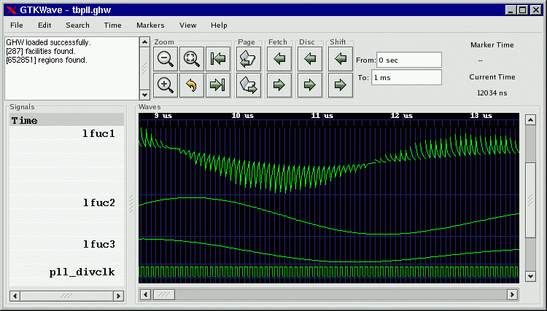Figure 1: The GTKWave main window
To the extreme left in a frame marked “Signals” is the signal section. Signal names can be left or right aligned (left aligned being useful for detection of hierarchy differences) and the number of levels of hierarchy (as counting from the rightmost side of a signal name) displayed can be set by the user.

To the right of the signal section is the wave section in a frame marked “Waves”. The top line is used as a timescale and all other lines are used to render trace value data with respect the the timescale. The vertical blue lines in the trace value data section are not normally present. In this case they are the result of keying on the rising edge of the digital signal “pll_divclk”. Analog traces of varying heights can be seen as well. Analog traces can dynamically be made as tall or short as desired in order to make the viewing of them easier, however the size is limited to integer multiples of the height of one digital trace.

With GTK versions greater than or equal to 2.4, an embedded SST is available. Drag and Drop of signals from the “Signals” pane inside the SST into the “Signals” pane outside of the SST is a convenient way to import signals into the viewer.
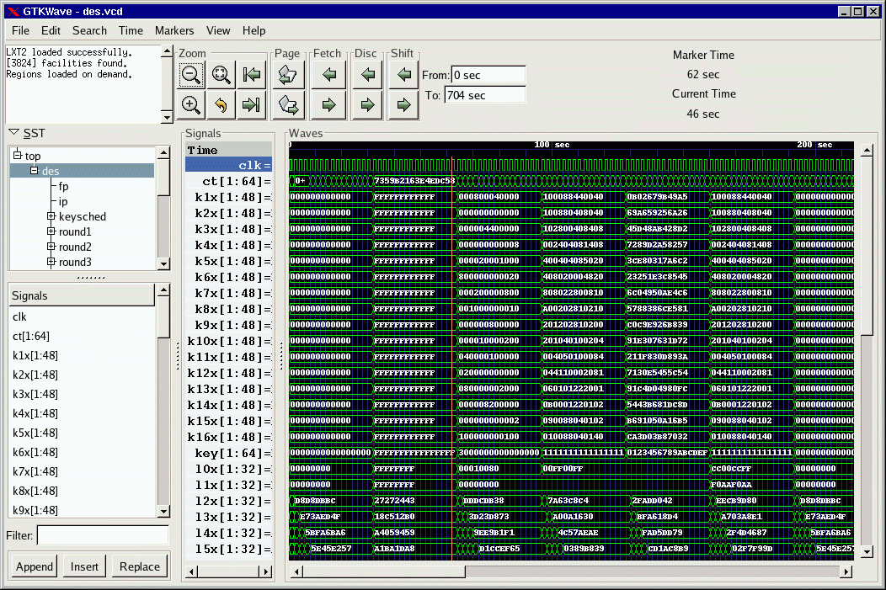Figure 2: The main window with an embedded SST
The main window size and position can be saved between sessions as well as the current viewer state. (i.e., which signals are visible, any attributes set for those signals such as alignment and inversion, where the markers are set, and what pattern marking is active.)

Signal Subwindow

The signal subwindow is nothing more than a list of signals, optional comments, and optional blank lines. The following is a sample view of the signal subwindow showing a highlighted trace (“clk”) and a comment trace (in blue with asterisks,
“*** Non-clock traces ***”. In between the two is a blank trace inserted by the user. Note that the highlighting of a trace can be toggled by clicking the left mouse button on an entry in the signal subwindow.

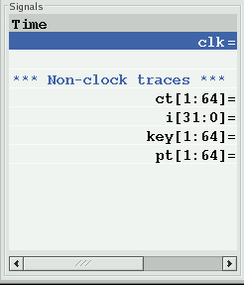Figure 3: Signal subwindow with scrollbar and an “open” collapsible trace

Groups of traces that start with a comment trace and end with a blank line are considered to be part of a collapsible group. Collapsible groups can be toggled open or closed by holding down the control key and then clicking on the comment trace. When a group is collapsed, the comment trace will be grayed out and the actual traces for that group will be hidden.

You will notice that the scrollbar along the bottom of the subwindow in Figure 3 indicates that there is a hidden section to the right. This hidden area contains the values of the signals shown. The scrollbar can be manually moved to show this area or the pane to the right of the signal subwindow can be enlarged in order to allow full viewing of the subwindow.

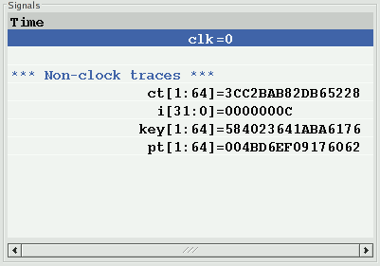Figure 4: Signal subwindow with no hidden area from left to right

Expanding the size of the subwindow by increasing the width of the pane is illustrated in Figure 4. No area is hidden as reflected by the scrollbar which is completely filled in from left to right along its length. In addition, the signal values which are present can be read. Any time the primary marker is nailed down, there will be an equals (“=”) sign indicating that signal values are present.

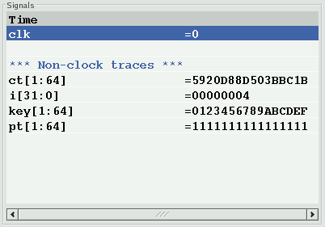Figure 5: Signal subwindow with left justified signal names
As seen in both Figure 3 and Figure 4, the signal names are right justified and are flush against the equals signs. This is only a matter of personal preference, and if desired, as shown in Figure 5, the signals can be left justified against the left margin of the signal subwindow by pressing the key combination of Shift-Home. This is useful when looking at signals if one is attempting to determine where hierarchies for different net names differ. Press Shift-End to right justify the signal names. (Right justification is the default behavior). Regardless of the state of signal name justification, the signal values are left justified against the equals sign and cannot be moved.

Note that the signal subwindow supports a form of self-contained Drag and Drop such that the right mouse button can be used to harvest all the highlighted traces in the window. By holding the right button and moving the mouse up and down, a destination for the traces can be selected. When the mouse button is released, the traces are dropped at the trace following the one the mouse pointer is pointing to.

Multiple traces can be selected by marking the first trace to highlight, move the cursor to the destination trace, and Shift click with the left mouse button. All the traces between the two will highlight or unhighlight accordingly. To highlight all the traces in the signal subwindow, Alt-H can be pressed. To unhighlight them, also press the Shift key in conjunction with Alt-H. (This can also be achieved by clocking on Highlight All or Unhighlight All in the Edit menu.)

Highlighting or unhighlighting traces by entering regular expressions will be covered in the menu section.

Wave Subwindow

The wave subwindow reformats simulation data into a visual format similar to that seen for digital storage scopes. As seen in Figure 6, the wave subwindow contains two scrollbars and a viewing area.

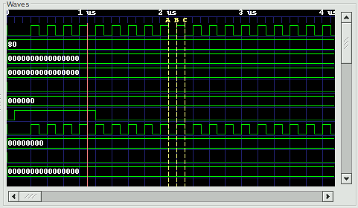Figure 6: A typical view of the wave subwindow

The scrollbar on the right scrolls not only the wave subwindow, but the signal subwindow in lockstep as well. The scrollbar on the bottom is used to scroll the simulation data with respect to the timescale that is shown on the top line of the wave subwindow.

The simulation data itself is shown as a horizontal series of traces. Values for multi-bit signals can be displayed in varying numeric bases such as binary, octal, hexadecimal, decimal, and ASCII. Values for single-bit traces are shown as “high” for zero and “low” for one, “z” (middle), and “x” (filled-in box). VHDL values are represented in a similar fashion but with different colors. The signal subwindow can always be used to verify the value of a value, so don't be too concerned right now if you are not sure of what the single-bit representation of a signal looks like or are not sure if you can remember.

Two functional markers are available: the primary marker (red, left mouse button) which the signal window uses as its pointer for value data, and the baseline marker (white, middle mouse button) which is used to perform time measurements with respect to the primary marker. Twenty-six lettered markers “A” through “Z” (dropped or collected through menu options) are provided to the user as convenience markers for indexing various points of interest in a simulation.

The primary marker can also be used to navigate with respect to time. It can be dropped with the right mouse button and dragged to “open” up a region for zooming in closer or out farther in time. It can also be used to scroll by holding down the left mouse button and dragging the mouse outside the signal subwindow. The simulation data outside of the window will then scroll into view with the scrolling being in the opposite direction that the primary marker is “pulling” outside of the subwindow.

Trace data in the signal subwindow can also be timeshifted as shown in Figure 7. In order to timeshift a trace, highlight the trace in the signal window the move over to the wave subwindow and then hold down the left mouse button in order to set the primary marker. Press the Ctrl key then move the primary marker left or right. When the timeshift is as desired, release the mouse button then release Ctrl. If you do not wish to go through with the timeshift, release the Ctrl key before releasing the left mouse button. The trace(s) will then spring back to their original pre-shifted position.
To achieve a finer level of granularity for timeshifting, menu options are available that allow the user to set specific values for a time shift. In this way, the pixel resolution of zoom is not the limiting factor in achieving an “exact” shift that suits a user's needs.

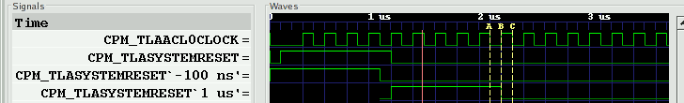Figure 7: An example of both positively and negatively timeshifted traces

Navigation and Status Panel

The navigation and status panel occupies the top part of the main window just below the menu bar.
The leftmost part contains a status window used for displaying various relevant messages to the user such as the dumpfile type, the number of facilities (nets) in a dumpfile, and any other information such as an operation that fails or completes successfully.

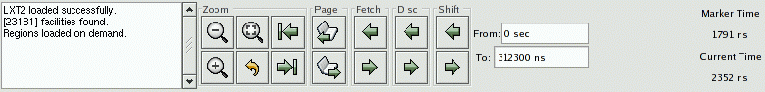Figure 8: The Navigation and Status Panel

The Zoom subframe contains six buttons. Three are magnifying glass icons. The one marked with a minus (“-”) zooms out which displays a larger amount of simulation time. The one marked with a plus (“+”) zooms in closer, displaying less simulation time. The one with a square in it is “Zoom Full” which is used either to zoom out to display the full range of simulation time or zooms between the primary and baseline marker when the baseline marker is set. The remaining non-magnifying glass buttons are a back arrow which is a zoom undo. The left arrow “zooms” to the start time of simulation and the right arrow zooms to the end time. The left and right arrows do not affect the zoom level in or out like the plus and minus buttons do; they simply are a shortcut to keep from having to move the scrollbar at the bottom of the wave subwindow.

The Page subframe contains left and right arrows. It scrolls the wave window left or right the granularity of one page. It is similar to clicking to the left or right of the “visible” gadget in a scrollbar, however, given the limited resolution of the GTK scrollbar (floating point), for simulations that have large time values, it might be necessary to use the page buttons rather than the scrollbar.

The Shift subframe contains similar arrows that scroll the display one pixel or timestep (depending on what the zoom level is).

The “From” and “To” boxes indicate the start and end times for what part of the simulation run shall be visible and can be navigated inside the wave subwindow. Values can directly be entered into these boxes and units (e.g., ns, ps, fs) can also be affixed to values.

The Fetch and Discard subframes modify the “From” and “To” box times. Clicking the left Fetch arrow decreases the “From” value. Clicking the right Fetch arrow increases the “To” value. Clicking the left Discard value increases the “From” value and clicking the right Discard button decreases the “To” value.

The Marker Time label indicates where the primary marker is located. If it is not present, a double-dash (“--”) is displayed. The Current Time label indicates where the mouse is pointing. Its function is to determine the time under the cursor without having to activate or move the primary marker. Note that when the primary marker is being click-dragged, the Marker Time label will indicate the delta time off the initial marker click.

When the baseline marker is set, the Marker Time and Current Time labels change. The Marker time label indicates the delta time between the baseline marker and the primary marker. The Current Time label is replaced with a Base Time label that indicates the value of the baseline marker.

Menu Bar

There are seven submenus in the menu bar: File, Edit, Search, Time, Markers, View, and Help. The functions of the individual items in each of those submenus will be covered in GTKWave Menu Functions on page 31.

TwinWave

TwinWave is a front end to GTKWave that allows two sessions to be open at one time in a single window. The horizontal scrolling, zoom factor, primary marker, and secondary marker are synchronized between the two sessions.

Starting a TwinWave session is easy: simply invoke twinwave with the arguments for each gtkwave session listed fully separating them with a plus sign.
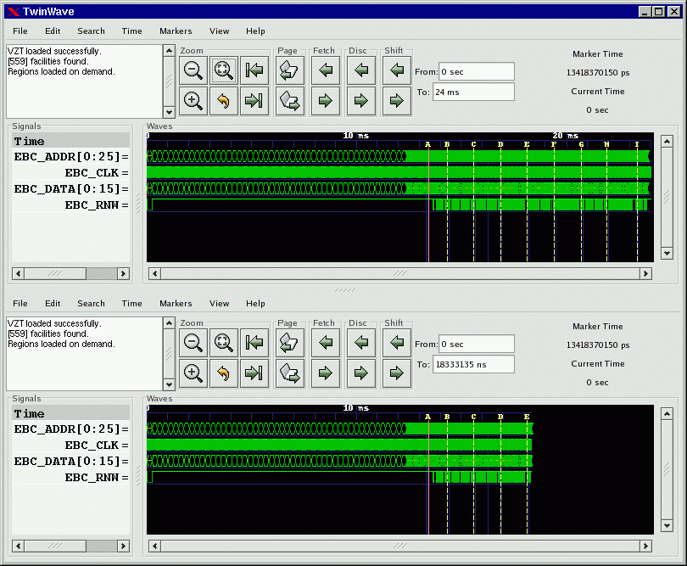Figure 9: TwinWave managing two GTKWave sessions in a single window

twinwave a.vcd a.sav + b.vcd b.sav

RTLBrowse

rtlbrowse is usually called as a helper application by gtkwave. In order to use RTLBrowse, Verilog source code must first be compiled with vermin in order to generate a stems file. A stems file contains hierarchy and component instantiation information used to navigate quickly through the source code. If GTKWave is started with the --stems option, the stems file is parsed and rtlbrowse is launched.

The main window for RTLBrowse depicts the design as a tree-like structure. (See Figure 10: The RTLBrowse RTL Design Hierarchy window on page 28.) Nodes in the tree may be clicked open or closed in order to navigate through the design hierarchy. Missing modules (unparsed, but instantiated as components) will be marked as “[MISSING]”.

When an item is selected, another window is opened showing only the source code the selected module. If the primary marker is set, then the source code will be annotated with values as shown in Figure 11: Source code annotated by RTLBrowse on page 29. The values shown are the full, wide value of the signal. RTLBrowse currently does not perform bit extractions on multi-bit vectors. If it is desired to see the full source code file for a module, click on the “View Full File” button at the bottom of the window.

Note that it is possible to descend deeper into the design hierarchy by selecting the component name in the annotated or unannotated source code.

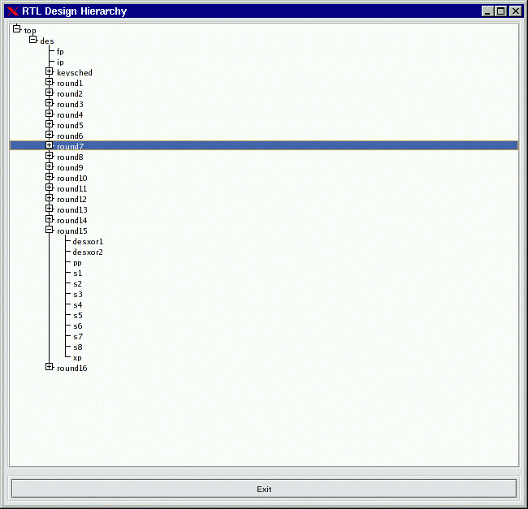Figure 10: The RTLBrowse RTL Design Hierarchy window

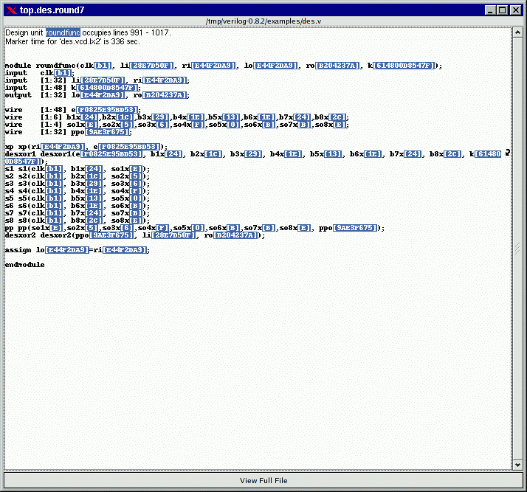Figure 11: Source code annotated by RTLBrowse

Ergonomic Extras

Scroll Wheels

Users with a scroll wheel mouse have some extra one-handed operations options available which correspond to some functions found in the Navigation and Status Panel description on page 24.

- Shift Right – Ctrl + scroll wheel down
- Shift Left – Ctrl + scroll wheel up
- Page Right – scroll wheel down
- Page Left – scroll wheel up
- Zoom In – Alt + scroll wheel down
- Zoom Out – Alt + scroll wheel up

Turning the scroll wheel “presses” the shift, page, and zoom options repeatedly far faster than is possible with the navigation buttons. Zoom functions are especially smooth this way.

The Primary Marker

The primary marker has also had function overloaded onto it for user convenience. Besides being used as a marker, it can also be used to navigate with respect to time. It can be dropped with the right mouse button and dragged to “open” up a region for zooming in closer or out farther in time. It can also be used to scroll by holding down the left mouse button and dragging the mouse outside the signal subwindow. The simulation data outside of the window will then scroll into view with the scrolling being in the opposite direction that the primary marker is “pulling” outside of the subwindow.

Interactive VCD

VCD files may be viewed as they are generated provided that they are written to a fifo (pipe) and are trampolined through shmidcat first (assume the simulator will normally generate outfile.vcd):

mkfifo outfile.vcd
cver myverilog.v &
shmidcat outfile.vcd | gtkwave -v -I myverilog.sav

You can then navigate the file as simulation is running and watch it update.

GTKWave Menu Functions

File

The File submenu contains various items related to the accessing of files, printing, and application respawning and exiting.

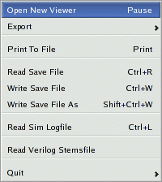Figure 12: The File submenu
Open New Viewer will open a file requester that will ask for the name of a VCD or AET file to view. This will fork off a new viewer process.

Export-Write VCD File As will open a file requester that will ask for the name of a VCD dumpfile. The contents of the dumpfile generated will be the vcd representation of the traces onscreen that can be seen by manipulating the signal and wavewindow scrollbars. The data saved corresponds to the trace information needed to allow viewing when used in tandem with the corresponding GTKWave save file.

Export-Write LXT File As will open a file requester that will ask for the name of an LXT dumpfile. The contents of the dumpfile generated will be the vcd representation of the traces onscreen that can be seen by manipulating the signal and wavewindow scrollbars. The data saved corresponds to the trace information needed to allow viewing when used in tandem with the corresponding GTKWave save file.

Print To File will open up a requester that will allow you to select print options (PS or MIF; Letter, A4, or Legal; Full or Minimal). After selecting the options you want, a file requester will ask for the name of the output file to generate that reflects the current main window display's contents.

Read Save File will open a file requester that will ask for the name of a GTKWave save file. The contents of the save file will determine which traces and vectors as well as their format (binary, decimal, hex, reverse, etc.) are to be appended to the display. Note that the marker positional data and zoom factor present in the save file will replace any current settings.

Write Save File will invoke Write Save File As if no save file name has been specified previously. Otherwise it will write the save file data without prompting.

Write Save File As will open a file requester that will ask for the name of a GTKWave save file. The contents of the save file generated will be the traces as well as their format (binary, decimal, hex, reverse, etc.) which are currently a part of the display. Marker positional data and the zoom factor are also a part of the save file.

Read Logfile will open a file requester that will ask for the name of a plaintext simulation log. By clicking on the numbers in the logfile, the marker will jump to the appropriate time value in the wave window.

Read Verilog Stemsfile will open a file requester that will ask for the name of a Verilog stemsfile. This will then launch an RTL browser and allow sourcecode annotation based on the primary marker position. Stems files are generated by Vermin. Please see its manpage for syntax and more information on stems file generation.

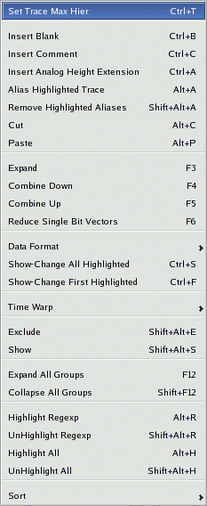Figure 13: The Edit submenu

Quit exits GTKWave after an additional confirmation requester is given the OK to quit.

Edit

The Edit submenu is used to perform sorts on net names, perform various utility functions such as attaching disassemblers and other external programs to GTKWave, and to change the data representation of values in the wave subwindow.

Set Max Hier sets the maximum hierarchy depth (counting from the right with bit numbers or ranges ignored) that is displayable for trace names. Zero indicates that no truncation will be performed (default). Note that any aliased signals (prefix of a "+") will not have truncated names.

Insert Blank inserts a blank trace after the last highlighted trace. If no traces are highlighted, the blank is inserted after the last trace.

Insert Comment inserts a comment trace after the last highlighted trace. If no traces are highlighted, the comment is inserted after the last trace.

Insert Analog Height Extension inserts a blank analog extension trace after the last highlighted trace. If no traces are highlighted, the blank is inserted after the last trace. This type of trace is used to increase the height of analog traces.

Alias Highlighted Trace only works when at least one trace has been highlighted. With this function, you will be prompted for an alias name for the first highlighted trace. After successfully aliasing a trace, the aliased trace will be unhighlighted. Single bits will be marked with a leading "+" and vectors will have no such designation. The purpose of this is to provide a fast method of determining which trace names are real and which ones are aliases.

Remove Highlighted Aliases only works when at least one trace has been highlighted. Any aliased traces will have their names restored to their original names. As vectors get their names from aliases, vector aliases will not be removed.

Cut removes highlighted signals from the display and places them in an offscreen cut buffer for later Paste operations. Cut implicitly destroys the previous contents of the cut buffer.

Paste pastes signals from an offscreen cut buffer and places them in a group after the last highlighted signal, or at the end of the display if no signal is highlighted. Paste implicitly destroys the previous contents of the cut buffer.

Expand decomposes the highlighted signals into their individual bits. The resulting bits are converted to traces and inserted after the last highlighted trace. The original unexpanded traces will be placed in the cut buffer. It will function seemingly randomly when used upon real valued single-bit traces. When used upon multi-bit vectors that contain real valued traces, those traces will expand to their normal "correct" values, not individual bits.

Combine Down coalesces the highlighted signals into a single vector named "<Vector>" in a top to bottom fashion placed after the last highlighted trace. The original traces will be placed in the cut buffer. It will function seemingly randomly when used upon real valued single-bit traces.

Combine Up coalesces the highlighted signals into a single vector named "<Vector>" in a bottom to top fashion placed after the last highlighted trace. The original traces will be placed in the cut buffer. It will function seemingly randomly when used upon real valued single-bit traces.

Reduce Single Bit Vectors decomposes the highlighted traces into their individual bits only if the highlighted traces are one bit wide vectors. In effect, this function allows single-bit vectors to be viewed as signals. The resulting bits are converted to traces and inserted after the last converted trace with the pre-conversion traces being placed in the cut buffer.

Data Format-Hex will step through all highlighted traces and ensure that vectors with this qualifier will be displayed with hexadecimal values.

Data Format-Decimal will step through all highlighted traces and ensure that vectors with this qualifier will be displayed with decimal values.

Data Format-Signed will step through all highlighted traces and ensure that vectors with this qualifier will be displayed as sign extended decimal values.

Data Format-Binary will step through all highlighted traces and ensure that vectors with this qualifier will be displayed with binary values.

Data Format-Octal will step through all highlighted traces and ensure that vectors with this qualifier will be displayed with octal values.

Data Format-ASCII will step through all highlighted traces and ensure that vectors with this qualifier will be displayed with ASCII values.

Data Format-BitsToReal will step through all highlighted traces and ensure that vectors with this qualifier will be displayed with Real values. Note that this only works for 64-bit values and that ones of other sizes will display as binary.

Data Format-Right Justify-On will step through all highlighted traces and ensure that vectors with this qualifier will be displayed right justified.

Data Format-Right Justify-Off will step through all highlighted traces and ensure that vectors with this qualifier will not be displayed right justified.

Data Format-Invert-On will step through all highlighted traces and ensure that bits and vectors with this qualifier will be displayed with 1's and 0's inverted.

Data Format-Invert-Off will step through all highlighted traces and ensure that bits and vectors with this qualifier will not be displayed with 1's and 0's inverted.

Data Format-Reverse Bits-On will step through all highlighted traces and ensure that vectors with this qualifier will be displayed in reversed bit order.

Data Format-Reverse Bits-Off will step through all highlighted traces and ensure that vectors with this qualifier will not be displayed in reversed bit order.

Translate Filter File Disable will remove translation filtering used to reconstruct enums for marked traces.

Translate Filter File will enable translation on marked traces using a filter file. A requester will appear to get the filter filename.

Translate Filter Process Disable will remove translation filtering used to reconstruct enums for marked traces.

Translate Filter Process will enable translation on marked traces using a filter process. A requester will appear to get the filter filename.

Analog Off causes the waveform data for all currently highlighted traces to be displayed as normal.

Analog Step causes the waveform data for all currently highlighted traces to be displayed as stepwise analog waveform.

Analog Interpolate causes the waveform data for all currently highlighted traces to be displayed as interpolated analog waveform.

Show-Change All Highlighted provides an easy means of changing trace attributes en masse. Various functions are provided in a Show-Change requester.

Show-Change First Highlighted provides a means of changing trace attributes for the first highlighted trace. Various functions are provided in a Show-Change requester. When a function is applied, the trace will be unhighlighted.

Warp Marked offsets all highlighted traces by the amount of time entered in the requester. (Positive values will shift traces to the right.) Attempting to shift greater than the absolute value of total simulation time will cap the shift magnitude at the length of simulation. Note that you can also warp traces dynamically by holding down CTRL and dragging a group of highlighted traces to the left or right with the left mouse button pressed. When you release the mouse button, if CTRL is pressed, the drag warp commits, else it reverts to its pre-drag condition.

Unwarp Marked removes all offsets on all highlighted traces.

Unwarp All unconditionally removes all offsets on all traces.

Exclude causes the waveform data for all currently highlighted traces to be blanked out.

Show causes the waveform data for all currently highlighted traces to be displayed as normal if the exclude attribute is currently set on the highlighted traces.

Expand All Groups causes all groups defined by comment traces to expand. Groups are manually toggled collapsed and uncollapsed individually by holding down CTRL and pressing the left mouse button on a comment trace.

Collapse All Groups causes all groups defined by comment traces to collapse. Groups are manually toggled collapsed and uncollapsed individually by holding down CTRL and pressing the left mouse button on a comment trace.

Highlight Regexp brings up a text requester that will ask for a regular expression that may contain text with POSIX regular expressions. All traces meeting this criteria will be highlighted.

UnHighlight Regexp brings up a text requester that will ask for a regular expression that may contain text with POSIX regular expressions. All traces meeting this criteria will be unhighlighted if they are currently highlighted.

Highlight All simply highlights all displayed traces.

UnHighlight All simply unhighlights all displayed traces.

Alphabetize All alphabetizes all displayed traces. Blank traces are sorted to the bottom.

Alphabetize All (CaseIns) alphabetizes all displayed traces without regard to case. Blank traces are sorted to the bottom.

Sigsort All sorts all displayed traces with the numeric parts being taken into account. Blank traces are sorted to the bottom.

Reverse All reverses all displayed traces unconditionally.
Search

The Search submenu is used to perform searches on net names and values.

Pattern Search only works when at least one trace is highlighted. A requester will appear that lists all the selected traces (maximum of 500) and allows various criteria to be specified for each trace. Searches can go forward or backward from the primary (unnamed) marker. If the primary marker has not been set, the search starts at the beginning of the displayed data ("From") for a forwards search and starts at the end of the displayed data ("To") for a backwards search. "Mark" and "Clear" are used to modify the normal time vertical markings such that they can be used to indicate all the times that a specific pattern search condition is true (e.g., every upclock of a specific signal). The "Mark Count" field indicates how many times the specific pattern search condition was encountered. The "Marking Begins at" and "Marking Stops at" fields are used to limit the time over which marking is applied (but they have no effect on searching).

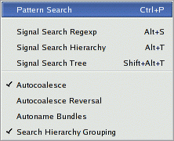Figure 14: The Search submenu

Signal Search Regexp provides an easy means of adding traces to the display. Various functions are provided in the Signal Search requester which allow searching using POSIX regular expressions and bundling (coalescing individual bits into a single vector).

Signal Search Hierarchy provides an easy means of adding traces to the display in a text based treelike fashion.

Signal Search Tree provides an easy means of adding traces to the display. Various functions are provided in the Signal Search Tree requester which allow searching a treelike hierarchy and bundling (coalescing individual bits into a single vector).

Autocoalesce when enabled allows the wave viewer to reconstruct split vectors. Split vectors will be indicated by a "[]" prefix in the search requesters.

Autocoalesce Reversal causes split vectors to be reconstructed in reverse order (only if autocoalesce is also active). This is necessary with some simulators. Split vectors will be indicated by a "[]" prefix in the search requesters.

Autoname Bundles when enabled modifies the bundle up/down operations in the hierarchy and tree searches such that a NULL bundle name is implicitly created which informs GTKWave to create bundle and signal names based on the position in the hierarchy. When disabled, it modifies the bundle up/down operations in the hierarchy and tree searches such that a NULL bundle name is not implicitly created. This informs GTKWave to create bundle and signal names based on the position in the hierarchy only if the user enters a zero-length bundle name. This behavior is the default.

Search Hierarchy Grouping when enabled ensures that new members added to the ``Tree Search'' and ``Hierarchy Search'' widgets are added alphanumerically: first hierarchy names as a group followed by signal names as a group. This is the default and is recommended. When disabled, hierarchy names and signal names are interleaved together in strict alphanumerical ordering. Note that due to the caching mechanism in ``Tree Search'', dynamically changing this flag when the widget is active may not produce immediately obvious results. Closing the widget then opening it up again will ensure that it follows the behavior of this flag.

Time

The Time submenu contains a superset of the functions performed by the Navigation and Status Panel button groups (see page 24).

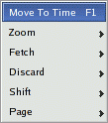Figure 15: The Time submenu

Move To Time scrolls the waveform display such that the left border is the time entered in the requester.

Zoom Amount allows entry of zero or a negative value for the display zoom. Zero is no magnification.

Zoom Base allows entry of a zoom base for the zoom (magnification per integer step) Allowable values are 1.5 to 10.0. Default is 2.0.

Zoom In is used to increase the zoom factor. Alt + Scrollwheel Down also performs this function.

Zoom Out is used to decrease the zoom factor. Alt + Scrollwheel Up also performs this function.

Zoom Full attempts a "best fit" to get the whole trace onscreen. Note that the trace may be more or less than a whole screen since this isn't a "perfect fit."

Zoom Best Fit attempts a "best fit" to get the whole trace onscreen. Note that the trace may be more or less than a whole screen since this isn't a "perfect fit." Also, if the middle button baseline marker is nailed down, the zoom instead of getting the whole trace onscreen will use the part of the trace between the primary marker and the baseline marker.

Zoom To Start is used to jump scroll to the trace's beginning.

Zoom To End is used to jump scroll to the trace's end.

Zoom Undo is used to revert to the previous zoom value used. Undo only works one level deep.

Fetch Size brings up a requester which allows input of the number of ticks used for fetch/discard operations. Default is 100.

Fetch Right increases the "To" time, which allows more of the trace to be displayed if the "From" and "To" times do not match the actual bounds of the trace.

Fetch Left decreases the "From" time, which allows more of the trace to be displayed if the "From" and "To" times do not match the actual bounds of the trace.

Discard Right decreases the "To" time, which allows less of the trace to be displayed.

Discard Left increases the "From" time, which allows less of the trace to be displayed.

Shift Right scrolls the display window right one tick worth of data. The net action is that the data scrolls left a tick. Ctrl + Scrollwheel Down also performs this function.

Shift Left scrolls the display window left one tick worth of data. The net action is that the data scrolls right a tick. Ctrl + Scrollwheel Up also performs this function.

Page Right scrolls the display window right one page worth of data. The net action is that the data scrolls left a page. Scrollwheel Down also performs this function.

Page Left scrolls the display window left one page worth of data. The net action is that the data scrolls right a page. Scrollwheel Up also performs this function.

Markers

The Markers submenu is used to perform various manipulations on the markers as well as control scrolling offscreen.

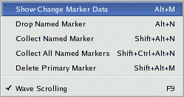Figure 16: The Markers submenu

Show-Change Marker Data displays and allows the modification of the times for all 26 named markers. The time for each marker must be unique.

Drop Named Marker drops a named marker where the current primary (unnamed) marker is placed. A maximum of 26 named markers are allowed and the times for all must be different.

Collect Named Marker collects a named marker where the current primary (unnamed) marker is placed if there is a named marker at its position.

Collect All Named Markers simply collects any and all named markers which have been dropped.

Delete Primary Marker removes the primary marker from the display if present.

Wave Scrolling allows movement of the primary marker beyond screen boundaries which causes the wave window to scroll when enabled. When disabled, it disallows movement of the primary marker beyond screen boundaries.

View

The View submenu is used to control various attributes dealing with the graphical rendering of status items as well as values in the signal subwindow.

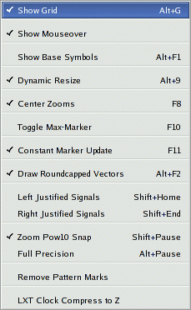Figure 17: The View submenu

Show Grid toggles the drawing of gridlines in the waveform display.

Show Mouseover toggles the dynamic tooltip for signal names and values which follow the marker on mouse button presses in the waveform display. This is useful for examining the values of closely packed value changes without having to zoom outward and without having to refer to the signal name pane to the left.

Show Base Symbols enables the display of leading base symbols ('$' for hex, '%' for binary, '#' for octal if they are turned off and disables the drawing of leading base symbols if they are turned on. Base symbols are displayed by default.

Dynamic Resize allows GTKWave to dynamically resize the signal window for you when toggled active. This can be helpful during numerous signal additions and/or deletions. This is the default behavior.

Center Zooms when enabled configures zoom in/out operations such that all zooms use the center of the display as the fixed zoom origin if the primary (unnamed) marker is not present, otherwise, the primary marker is used as the center origin. When disabled, it configures zoom in/out operations such that all zooms use the left margin of the display as the fixed zoom origin.

Toggle Delta-Frequency allows you to switch between the delta time and frequency display in the upper right corner of the main window when measuring distances between markers. Default behavior is that the delta time is displayed.

Toggle Max-Marker allows you to switch between the maximum time and marker time for display in the upper right corner of the main window. Default behavior is that the maximum time is displayed.

Constant Marker Update when enabled, allows GTKWave to dynamically show the changing values of the traces under the primary marker while it is being dragged across the screen. This works best with dynamic resizing disabled. When disabled, it restricts GTKWave to only update the trace values when the left mouse button is initially pressed then again when it is released. This is the default behavior.

Draw Roundcapped Vectors draws vector transitions that have sloping edges when enabled. Draws vector transitions that have sharp edges when disabled; this is the default.

Left Justify Signals draws signal names flushed to the left border of the signal window.

Right Justify Signals draws signal names flushed to the right ("equals") side of the signal window.

Zoom Pow10 Snap snaps time values to a power of ten boundary when active. Fractional zooms are internally stored, but what is actually displayed will be rounded up/down to the nearest power of 10. This only works when the ticks per frame is greater than 100 units.

Full Precision does not round time values when the number of ticks per pixel onscreen is greater than 10 when active. The default is that this feature is disabled.

Remove Pattern Marks removes any vertical traces on the display caused by the Mark feature in pattern search and reverts to the normal format.

LXT Clock Compress to Z reduces memory usage when active as clocks compressed in LXT format are kept at Z in order to save memory. Traces imported with this are permanently kept at Z.

Help

The Help submenu contains options for enabling on-line help as well as displaying program version information.

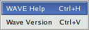Figure 18: The Help submenu

Wave Help brings up a help window that will show the function of any menu option when that option is selected. Closing the help window will turn off help and return back to normal menu function.

Wave Version merely brings up a requester which indicates the current version of this program.

Quick Start

Sample Design

In the examples/ directory of the source code distribition a sample Verilog design and testbench for a DES encryptor can be found as des.v.

10 :/home/bybell/gtkwave-3.0.0pre21/examples> ls -al
total 132
drwxrwxr-x 2 bybell bybell 4096 Apr 30 14:12 .
drwxr-xr-x 8 bybell bybell 4096 Apr 29 22:05 ..
-rw-rw-r-- 1 bybell bybell 187 Apr 29 22:09 des.sav
-rw-r--r-- 1 bybell bybell 47995 Apr 29 22:05 des.v
-rw-rw-r-- 1 bybell bybell 68801 Apr 29 22:06 des.vzt

If you have a Verilog simulator handy, you can simulate the design to create a VCD file. To try the example in Icarus Verilog (http://www.icarus.com), type the following:

/tmp/gtkwave-3.0.0/examples> iverilog des.v && a.out
VCD info: dumpfile des.vcd opened for output.
/tmp/gtkwave-3.0.0/examples> ls -la des.vcd
-rw-rw-r-- 1 bybell bybell 3465481 Apr 30 13:39 des.vcd

If you do not have a simulator readily available, you can expand the des.vzt file into des.vcd by typing the following:

/tmp/gtkwave-3.0.0/examples> vzt2vcd des.vzt >des.vcd
VZTLOAD | 1432 facilities
VZTLOAD | Total value bits: 22921
VZTLOAD | Read 1 block header OK
VZTLOAD | [0] start time
VZTLOAD | [704] end time
VZTLOAD |
VZTLOAD | block [0] processing 0 / 704
/tmp/gtkwave-3.0.0/examples> ls -la des.vcd
-rw-rw-r-- 1 bybell bybell 3456247 Apr 30 13:42 des.vcd

You will notice that the generated VCD file is about fifty times larger than the VZT file. This illustrates the compressibility of VCD files and the space saving advantages of using the database formats that GTKWave supports. Normally we would not want to work with VCD as GTKWave is forced to process the whole file rather than access only the data needed, but in the next section we will show how to invoke GTKWave such that VCD files are automatically converted into LXT2 ones.

Next, let's create a stems file that allows us to bring up RTLBrowse.

/tmp/gtkwave-3.0.0/examples> vermin des.v -emitstems >des.stems
Vermin: Verilog Parser v0.1.0 (w)1999-2006 BSI

Processing file 'des.v' ...
/tmp/gtkwave-3.0.0/examples> ls -la des.stems
-rw-rw-r-- 1 bybell bybell 4662 Apr 30 13:50 des.stems

Stems files only need to be generated when the source code undergoes file layout and/or hierarchy changes.
Now that we have a VCD file and a stems file, we can bring up the viewer.

Launching GTKWave

We already have a VZT file available, but to illustrate the automatic conversion of VCD files, let's use the -o option. The -t option is used to specify the stems file. The .sav file is a “save file” that contains GTKWave scope state.

/tmp/gtkwave-3.0.0/examples> gtkwave -o -t des.stems des.vcd des.sav

GTKWave Analyzer v3.0.0 (w)1999-2006 BSI

Converting VCD File 'des.vcd' to LXT2 file 'des.vcd.lx2'...

1432 symbols span ID range of 1395, using indexing...
[0] start time.
[704] end time.

LXTLOAD | 1432 facilities
LXTLOAD | Read 2 block headers OK
LXTLOAD | [0] start time
LXTLOAD | [704] end time
LXTLOAD |
LXTLOAD | Finished building 1432 facs.
LXTLOAD | Merging in 145 aliases.
LXTLOAD | Building facility hierarchy tree.
LXTLOAD | Sorting facility hierarchy tree.
LXTLOAD | 1432 facilities
LXTLOAD | Read 2 block headers OK
LXTLOAD | [0] start time
LXTLOAD | [704] end time
LXTLOAD |

You will see two sets of LXTLOAD messages. This is normal as RTLBrowse is launched as an external process in order to keep its operations from bogging down the viewer. After these messages scroll by, the GTKWave main window and an RTLBrowse hierarchy window will appear. We are now ready to start experimenting with various features of the wave viewer and RTLBrowse.

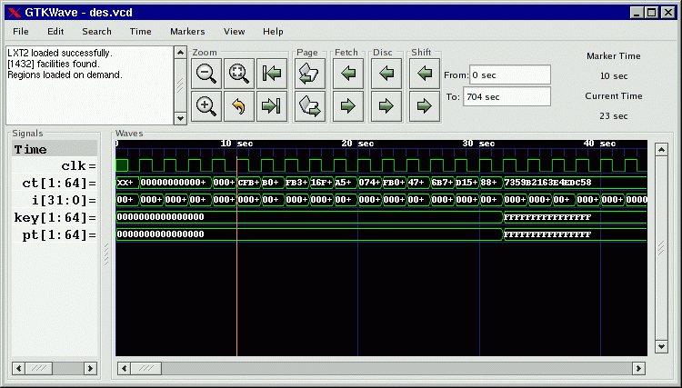Figure 19: The main window with viewer state loaded from a save file
The RTLBrowse window will come up as seen in Figure 10: The RTLBrowse RTL Design Hierarchy window on page 28, however none of the tree nodes will be opened yet.

Displaying Waveforms

In the preceding section, the viewer was brought up with a save file so when the viewer did appear, the main window already had signals present as seen in Figure 19 on page 43. All the signals in a model do not appear on their own as this would be unwieldy for large models. Instead, it is up to the user to import signals manually. An exception to this exists for VCD files, see the definition of the enable_vcd_autosave .gtkwaverc variable on page . That said, several requesters exist for importing signals into the main window.

Signal Search

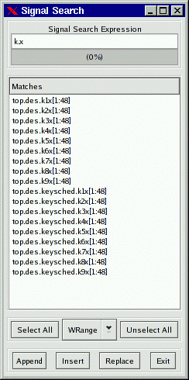Figure 20: The Signal Search (regular expression search) Requester

The signal search requester accepts a search string as a POSIX regular expression. Any signals found in the dumpfile that match that regular expression are listed in the Matches box and may be individually or multiply selected and imported into the viewer window. The regular expression can be modified in one of four ways: WRange, WStrand, Range, and Strand. No modification is possible with None. This optionally matches the string you enter in the search string above with a Verilog format range (signal[7:0]), a strand (signal.1, signal.0), or with no suffix. The “W” modifier for “Range” and “Strand” explicitly matches on word boundaries. (addr matches unit.freezeaddr[63:0] for “Range” but only unit.addr[63:0] for “WRange” since addr has to be on a word boundary.) Note that when “None” is selected, the search string may be located anywhere in the signal name.

Append will add the selected signals to end of the display on the main window.

Insert will add selected signals after last highlighted signal on the main window.

Replace will replace highlighted signals on the main window with signals selected.

Hierarchy Search

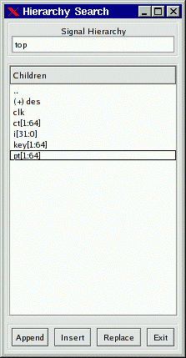Figure 21: The Hierarchy Search Requester

The hierarchy search requester provides a view of the hierarchy in a format similar to the current working directory of a file in a filesystem on a computer. The Signal Hierarchy box contains the current hierarchy and the Children box contain all of the signals in that immediate level of hierarchy and all of the component instantiation names for that level of hierarchy (denoted by a “(+)” prefix). To navigate down a level of hierarchy, click on an item with a “(+)” prefix. To move up a level of hierarchy, click on the “..” line.

Selecting individual items allow you to import traces singly when the Append, Insert, or Replace buttons are clicked. Not selecting anything will do a “deep import” such that all the child signals are imported. Use of that feature is not recommended for very large designs.

Note that is is possible to modify the display order such that components and signals are intermixed in this gadget rather than being separated such that all the components for a given level of hierarchy are listed alphabetically at the top and all signals are listed alphabetically at the bottom. In order to do this, toggle the Search submenu item Search Hierarchy Grouping as described on page 36.

Tree Search

The Tree Search Requester is the requester that most users will feel comfortable using and is also the requester that can optionally be embedded in the main window on versions of GTK greater than or equal to 2.4. See Figure 2: The main window with an embedded SST on page 20 for an example of this.

The Tree Search Requester is composed of a top tree selection box, a signals box, and a POSIX regular expression filter. The tree selection box is used to navigate at the hierarchy level. Click on an item in order to show the signals at that level of hierarchy. In the figure on page 46, the “top” level of hierarchy is selected and the signals box shows what signals are available at that level of hierarchy. Signals may be individually or multiply selected and can be dragged and dropped into the signal window. In addition, a POSIX filter can be specified that allows the selective filtering of signal names at a level of hierarchy which is handy for finding a specific signal at a level of hierarchy that is very large (e.g., in a synthesized netlist).

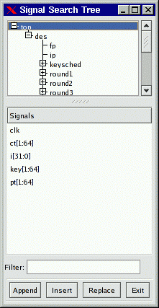Figure 22: The Signal Search Tree Requester

Signal Save Files

The signals show in the main window can be saved to a file so they can automatically be imported without reselection the next time the viewer is started. In order to save signals to a save file, select the File submenu option Write Save File (As). Save files can also be loaded at any time by selecting the Read Save File option.

Pattern Search

Values, not only nets may be searched on and marked in the wave window. In order to do this, select one or more nets in the signal window and then click on the Search submenu option Pattern Search. A Pattern Search Requester will then appear that will allow various types of search operations for the signals that have been selected.
The following is an example of a Pattern Search Requester being used to mark the rising edges for the clock signal in a simulation model.

The edges as they are marked by the configuration of the Requester in Figure 23 can be seen in Figure 2: The main window with an embedded SST on page 20.

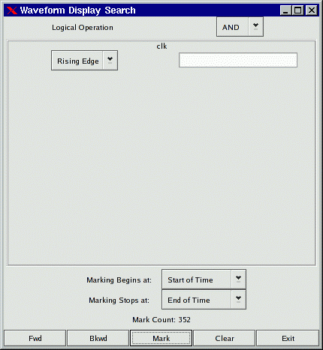Figure 23: The Pattern Search Requester

To remove pattern marks, either select another pattern or select the View submenu option Remove Pattern Marks. Note that pattern marks save to the save file and that the actual pattern search criteria is saved, not the absolute times of the individual marks themselves.

Search criteria for individual nets can be edge or value based. For “String” searches (the entry box to the right of the search type box which in the case above is marked “Rising Edge”), note that you must press Enter for the string in order to commit the value to the search.

Alias Files and Attaching External Disassemblers

The viewer supports signal aliasing through both plaintext filters and through external program filters. Note that signal aliasing is a strict one-to-one correspondence so the value represented in the viewer must exactly represent what format your filter expects. (e.g., binary, hexadecimal, with leading base markers, etc.) For your convenience, the comparisons are case insensitive.

For text filters, the viewer looks at an ASCII text file of the following format:

#
# this is a comment
#
00 Idle
01 Advance
10 Stop
11 Reset

The first non-whitespace item is treated as a literal value that would normally be printed by the viewer and the remaining items on the line are substitution text. Any time this text is encountered if the filter is active, it will replace the left-hand side text with the right-hand side. Leading and trailing whitespaces are removed from the right-hand side item.

To turn on the filter:

1) Highlight the signals you want filtered
2) Edit->Data Format->Translate Filter File->Enable and Select
3) Add Filter to List
4) Click on filter filename
5) Select filter filename from list
6) OK

To turn off the filter:

1) Highlight the signals you want unfiltered.
2) Edit->Data Format->Translate Filter File->Disable

NOTE: Filter configurations load and save properly to and from save files.

An external process that accepts one line in from stdin and returns with
data on stdout can be used as a process filter. An example of this are
disassemblers. The following sample code would show how to interface with
a disassembler function in C:

int main(int argc, char **argv)
{
while(1)
{
char buf[1025], buf2[1025];

buf[0] = 0;
fscanf(stdin, "%s", buf);
if(buf[0])
{
int hx;
sscanf(buf, "%x", &hx);
ppc_dasm_one(buf2, 0, hx);
printf("%s\n", buf2);
fflush(stdout);
}
}

return(0);
}

Note that the fflush(stdout) is necessary, otherwise gtkwave will hang. Also note that every line of input needs to generate a line of output or the viewer will hang too.

To turn on the filter:

1) Highlight the signals you want filtered
2) Edit->Data Format->Translate Filter Process->Enable and Select
3) Add Proc Filter to List
4) Click on filter filename
5) Select filter filename from list
6) OK

To turn off the filter:

1) Highlight the signals you want unfiltered.
2) Edit->Data Format->Translate Filter Process->Disable

Debugging the Source Code

See the description for RTLBrowse on page 27. More features are planned to be added in future releases.

Appendix A: Command Line Options Reference

gtkwave

GTKWAVE(1) Simulation Wave Viewer GTKWAVE(1)

NAME
gtkwave - Visualization tool for VCD, LXT, and VZT files

SYNTAX
gtkwave [option]... [DUMPFILE] [SAVEFILE] [RCFILE]

DESCRIPTION
Visualization tool for VCD, LXT, LXT2, VZT, and GHW. VCD is an indus-
try standard simulation dump format. LXT, LXT2, and VZT have been
designed specifically for use with gtkwave. GHW is the native VHDL
format generated by GHDL. Native dumpers exist in Icarus Verilog for
the LXT formats so conversion with vcd2lxt(1) or vcd2lxt2(1) is not
necessary to take direct advantage of LXT with that simulator. AET2
files can also be processed provided that libae2rw is available but
this is only of interest to people who use IBM EDA toolsets.

OPTIONS
-n,--nocli <directory name>
Use file requester for dumpfile name.

-f,--dump <filename>
Specify dumpfile name.

-o,--optimize
optimize VCD to LXT2. This will automatically call vcd2lxt2(1)
to perform the file conversion. This option is highly recom-
mended with large VCD files in order to cut down on the memory
usage required for file viewing. Can be used in conjunction
with -v,--vcd.

-r,--rcfile <filename>
Specify override .gtkwaverc filename.

-i,--indirect <filename>
Specify indirect facs file name. The file contains a series of
regular expressions used to limit what signals can be browsed.
Signal names which match any of the regular expressions will be
viewable. Typically, indirect files are used to reduce memory
requirements for extremely large models containing millions of
facilities or to strip out top-level hierarchy clutter from
BugSpray models. This feature is only available with the AET2
loader.

-l,--logfile <filename>
Specify simulation logfile name. Multiple logfiles may be spec-
ified by preceeding each with the command flag. By selecting
the numbers in the text widget, the marker will immediately zoom
to the specific time value.

-d,--defaultskip
If there is not a .gtkwaverc file in the home directory or cur-
rent directory and it is not explicitly specified on the command
line, when this option is enabled, do not use an implicit con-
figuration file and instead default to the old "whitescreen"
behavior.

-D,--dualid <which>
Specify multisession identifier information. The format of
"which" is m+nnnnnnnn where m is the session number 0 or 1 and
nnnnnnnn is a hexadecimal value indicating the shared memory ID
of an array of two gtkwave_dual_ipc_t data structures. The
intended use of this flag is for front ends such as twinwave(1).

-s,--start <time>
Specify start time for LXT2/VZT block skip.

-e,--end <time>
Specify end time for LXT2/VZT block skip.

-t,--stems <filename>
Specify stems file for source code annotation. This will auto-
matically launch the rtlbrowse(1) helper process. See vermin(1)
for information on stems file generation.

-c,--cpu <numcpus>
Specify number of CPUs available for parallelizable ops (e.g.,
block prefetching on VZT reads).

-N,--nowm
Disable window manager for most windows. The intended use of
this is to be used in conjunction with the --script option, how-
ever this also can be used to reparent into an alternate window
manager.

-M,--nomenus
Do not render menubar. This is mainly used for making a
restricted applet that cannot initiate file I/O on its own, how-
ever it also can be used as a workaround in earlier versions of
GTK+ that do not handle GTKSocket/GTKPlug focus interactions
properly.

-S,--script <filename>
Specify GUI command script file for execution. Comments are
indicated by the '#' character. Lines in the script are the
full menu pathname including the first forward slash. Arguments
for an option (such as a filename) will follow with one argument
each on its own separate line. Menu options that bring up com-
plex requesters (e.g., search) will hang in the GUI waiting for
user intervention. The intended use of this option is to allow
automated subset extraction to VCD as well as automated
Postscript file generation.

-X,--xid <XID>
Specify XID of window for a GtkPlug to connect to. GTKWave does
not directly render to a window but instead renders into a Gtk-
Plug expecting a GtkSocket at the other end. Note that there
are issues with accelerators working properly so menus are dis-
abled in the componentized version of GTKWave when it functions
as a plug-in.

-I,--interactive
Specifies that "interactive" VCD mode is to be used which allows
a viewer to navigate a VCD trace while GTKWave is processing the
VCD file. When this option is used, the filename is overloaded
such that it is the hexadecimal value for the shared memory ID
of a writer. Note that the shared memory ID can be passed
straight from stdin by using the --vcd option; see the manpage
for shmidcat(1) for more details.

-L,--legacy
Specifies that the viewer should use legacy VCD mode rather than
the VCD recoder. Note that using legacy mode will require con-
siderably more memory than the recoder and its use is discour-
aged for very large traces.

-v,--vcd
Use stdin as a VCD dumpfile.

-V,--version
Display version banner then exit.

-h,--help
Display help then exit.

-x,--exit
Exit after loading trace (for loader benchmarking).

FILES
~/.gtkwaverc

EXAMPLES
To run this program the standard way type:
gtkwave dumpfile.vcd

Alternatively you can run it with a save file as:
gtkwave dumpfile.vcd dumpfile.sav

To run interactively using shared memory handle 0x00050003:
gtkwave -I 00050003 dumpfile.sav

Command line options are not necessary for representing the dumpfile,
savefile, and rcfile names. They are merely provided to allow specify-
ing them out of order.

BUGS
AIX requires -bmaxdata:0x80000000 to be added to your list of compiler
flags for xlc if you want GTKWave to be able to access more than 256MB
of virtual memory. The value shown allows the VMM to use up to 2GB.
This may be necessary for very large traces.

Shift and Page operations using the wave window hscrollbar may be non-
functional as you move away from the dump start for very large traces.
A trace that goes out to 45 billion ticks has been known to exhibit
this problem. This stems from using the gfloat element of the horizon-
tal slider to encode the time value for the left margin. The result is
a loss of precision for very large values. Use the hotkeys or buttons
at the top of the screen if this is a problem.

When running under Cygwin, it is required to enable Cygserver if shared
memory IPC is being used. Specifically, this occurs when rtlbrowse(1)
is launched as a helper process. See the Cygwin documentation for more
information on how to enable Cygserver.

AUTHORS
Anthony Bybell <bybell@nc.rr.com>

SEE ALSO
gtkwaverc(5) lxt2vcd(1) vcd2lxt(1) vcd2lxt2(1) vzt2vcd(1) vcd2vzt(1)
vermin(1) rtlbrowse(1) twinwave(1) shmidcat(1)

Anthony Bybell 3.0.15 GTKWAVE(1)

twinwave

TWINWAVE(1) Simulation Wave Viewer Multiplexer TWINWAVE(1)

NAME
twinwave - Wraps multiple GTKWave sessions in one window

SYNTAX
twinwave <arglist1> + <arglist2>

DESCRIPTION
Wraps multiple GTKWave sessions in one window with synchronized mark-
ers, horizontal scrolling, and zooming.

EXAMPLES
To run this program the standard way type:

twinwave filename1.vcd filename1.sav + filename2.vcd filename2.sav
Two viewers are then opened in one window.

LIMITATIONS
twinwave uses the GtkSocket/GtkPlug mechanism to embed two gtkwave(1)
sessions into one window. The amount of coupling is currently limited
to communication of temporal information. Other than that, the two
gtkwave processes are isolated from each other as if the viewers were
spawned separately. Keep in mind that using the same save file for
each session may cause unintended behavior problems if the save file is
written back to disk: only the session written last will be saved.
(i.e., the save file isn't cloned and made unique to each session.)

AUTHORS
Anthony Bybell <bybell@nc.rr.com>

SEE ALSO
gtkwave(1)

Anthony Bybell 3.0.7 TWINWAVE(1)

lxt2miner

LXT2MINER(1) Dumpfile Data Mining LXT2MINER(1)

NAME
lxt2miner - Data mining of LXT2 files

SYNTAX
lxt2miner [option]... [LXT2FILE]

DESCRIPTION
Mines LXT2 files for specific data values and generates gtkwave save
files to stdout for future reload.

OPTIONS
-d,--dumpfile <filename>
Specify LXT2 input dumpfile.

-m,--match <value>
Specifies "bitwise" match data (binary, real, string)

-x,--hex <value>
Specifies hexadecimal match data that will automatically be con-
verted to binary for searches

-n,--namesonly
Indicates that only facnames should be printed in a gtkwave
savefile compatible format. By doing this, the file can be used
to specify which traces are to be imported into gtkwave.

-h,--help
Show help screen.

EXAMPLES
lxt2miner dumpfile.lxt2 --hex 20470000 -n

This attempts to match the hex value 20470000 across all facilities and
when the value is encountered, the facname only is printed to stdout in
order to generate a gtkwave compatible save file.

LIMITATIONS
lxt2miner only prints the first time a value is encountered for a spe-
cific net. This is done in order to cut down on the size of output
files and to aid in following data such as addresses through a simula-
tion model.

AUTHORS
Anthony Bybell <bybell@nc.rr.com>

SEE ALSO
vztminer(1) vzt2vcd(1) lxt2vcd(1) vcd2lxt2(1) gtkwave(1)

Anthony Bybell 1.3.64 LXT2MINER(1)

lxt2vcd

LXT2VCD(1) Filetype Conversion LXT2VCD(1)

NAME
lxt2vcd - Coverts LXT2 files to VCD

SYNTAX
lxt2vcd <filename>

DESCRIPTION
Converts LXT2 files to VCD files on stdout. Note that "regular" LXT2
files will convert to VCD files with monotonically increasing time val-
ues. LXT2 files which are dumped with the "partial" option (to speed
up access in wave viewers) will dump with monotonically increasing time
values per 2k block of nets. This may be fixed in later versions of
lxt2vcd.

EXAMPLES
To run this program the standard way type:

lxt2vcd filename.lxt
The VCD conversion is emitted to stdout.

LIMITATIONS
lxt2vcd does not re-create glitches as these are coalesced together
into one value change during the writing of the LXT2 file.

AUTHORS
Anthony Bybell <bybell@nc.rr.com>

SEE ALSO
vcd2lxt2(1) vcd2lxt(1) gtkwave(1)

Anthony Bybell 1.3.34 LXT2VCD(1)

mvl2lxt

MVL2LXT(1) Filetype Conversion MVL2LXT(1)

NAME
mvl2lxt - Coverts MVLSIM AET files to LXT

SYNTAX
mvl2lxt <filename.aet> <filename.lxt>

DESCRIPTION
Converts AET files to LXT. This is experimental as it is not a com-
plete implementation and is not intended for general use.

AUTHORS
Anthony Bybell <bybell@nc.rr.com>

SEE ALSO
tex2vcd(1) mvl2vcd(1) lxt2vcd(1) vcd2lxt2(1) vcd2lxt(1) gtkwave(1)

Anthony Bybell 1.3.34 MVL2LXT(1)

mvl2vcd

MVL2VCD(1) Filetype Conversion MVL2VCD(1)

NAME
mvl2vcd - Coverts MVLSIM AET files to VCD

SYNTAX
mvl2vcd <filename.aet>

DESCRIPTION
Converts AET files to VCD on stdout. This is experimental as it is not
a complete implementation and is not intended for general use.

AUTHORS
Anthony Bybell <bybell@nc.rr.com>

SEE ALSO
tex2vcd(1) mvl2lxt(1) lxt2vcd(1) vcd2lxt2(1) vcd2lxt(1) gtkwave(1)

Anthony Bybell 1.3.34 MVL2VCD(1)

rtlbrowse

RTLBROWSE(1) File Viewing RTLBROWSE(1)

NAME
rtlbrowse - Allows hierarchical browsing of Verilog HDL sourcecode and
library design files.

SYNTAX
rtlbrowse <stemsfilename>

DESCRIPTION
Allows hierarchical browsing of Verilog HDL sourcecode and library
design files. Navigation through the hierarchy may be done by clicking
open areas of the tree widget and clicking on the individual levels of
hierarchy. Inside the sourcecode, selecting the module instantiation
name by double clicking or selecting part of the name through drag-
clicking will descend deeper into the RTL hierarchy. Note that it per-
forms optional source code annotation when called as a helper applica-
tion by gtkwave(1) and when the primary marker is set. Source code
annotation is not available for all supported dumpfile types. It is
directly available for LXT2, VZT, and AET2. For VCD, use the
-o,--optimize option of gtkwave(1) in order to optimize the VCD file
into LXT2. All other dumpfile types (LXT, GHW) are unsupported at this
time.

EXAMPLES
To run this program the standard way type:

rtlbrowse stemsfile
The RTL is then brought up in a GTK tree viewer. Stems must
have been previously generated with vermin(1). Note that gtk-
wave(1) will bring up this program as a client application for
sourcecode annotation. It does that by bringing up the viewer
with the shared memory ID of a segment of memory in the viewer
rather than using a stems filename.

AUTHORS
Anthony Bybell <bybell@nc.rr.com>

SEE ALSO
vermin(1) gtkwave(1)

Anthony Bybell 0.1.0 RTLBROWSE(1)

tex2vcd

TEX2VCD(1) Filetype Conversion TEX2VCD(1)

NAME
tex2vcd - Coverts TEXSIM AET files to VCD

SYNTAX
tex2vcd <filename.aet>

DESCRIPTION
Converts AET files to VCD on stdout. This is experimental as it is not
a complete implementation and is not intended for general use.

AUTHORS
Anthony Bybell <bybell@nc.rr.com>

SEE ALSO
mvl2vcd(1) mvl2lxt(1) lxt2vcd(1) vcd2lxt2(1) vcd2lxt(1) gtkwave(1)

Anthony Bybell 1.3.34 TEX2VCD(1)

tla2vcd

TLA2VCD(1) Tektronix File Format Conversion TLA2VCD(1)

NAME
tla2vcd - Converts TLA to VCD or LST files

SYNTAX
tla2vcd [option]... TLAFILE [[TLAFILE]...]

DESCRIPTION
Converts TLA files from Tektronix logic analyzers to VCD or LST files.
Conversion to VCD allows viewing in tools such as gtkwave(1).

OPTIONS
-t Generate text LST file instead of VCD file

-l List the available channels/groups and exit

-s <signal_list>
Select signals from regular expression list

-a All channels

-m Append MagniVu info (only in listing mode)

-z Compress output

-v Verbose

AUTHORS
Emil

SEE ALSO
lxt2vcd(1) vzt2vcd(1) gtkwave(1)

Emil 1.0 TLA2VCD(1)

vcd2lxt

VCD2LXT(1) Filetype Conversion VCD2LXT(1)

NAME
vcd2lxt - Converts VCD files to interlaced or linear LXT files

SYNTAX
vcd2lxt [VCDFILE] [LXTFILE] [option]...

DESCRIPTION
Converts VCD files to interlaced or linear LXT files. Noncompressed
interlaced files will provide the fastest access, linear files will
provide the slowest yet have the greatest compression ratios.

OPTIONS
-stats Prints out statistics on all nets in VCD file in addition to
performing the conversion.

-clockpack
Apply two-way subtraction algorithm in order to identify nets
whose value changes by a constant XOR or whose value
increases/decreases by a constant amount per constant unit of
time. This option can reduce dumpfile size dramatically as
value changes can be represented by an equation rather than
explicitly as a triple of time, net, and value.

-chgpack
Emit data to file after being filtered through zlib (gzip).

-linear
Write out LXT in "linear" format with no backpointers. These
are re-generated during initialization in gtkwave. Addition-
ally, use libbz2 (bzip2) as the compression filter.

-dictpack <size>
Store value changes greater than or equal to size bits as an
index into a dictionary. Experimentation shows that a value of
18 is optimal for most cases.

EXAMPLES
Note that you should specify dumpfile.vcd directly or use "-" for
stdin.

vcd2lxt dumpfile.vcd dumpfile.lxt -clockpack -chgpack -dictpack 18
This turns on clock packing, zlib compression, and enables the
dictionary encoding. Note that using no options writes out a
normal LXT file.

vcd2lxt dumpfile.vcd dumpfile.lxt -clockpack -linear -dictpack 18
Uses linear mode for even smaller files.

AUTHORS
Anthony Bybell <bybell@nc.rr.com>

vcd2lxt2

VCD2LXT2(1) Filetype Conversion VCD2LXT2(1)

NAME
vcd2lxt2 - Converts VCD files to LXT2 files

SYNTAX
vcd2lxt2 [option]... [VCDFILE] [LXTFILE]

DESCRIPTION
Converts VCD files to LXT2 files.

OPTIONS
-v,--vcdname <filename>
Specify VCD input filename.

-l,--lxtname <filename>
Specify LXT2 output filename.

-d,--depth <value>
Specify 0..9 gzip compression depth, default is 4.

-m,--maxgranule <value>
Specify number of granules per section, default is 8. One gran-
ule is equal to 32 timsteps.

-b,--break <value>
Specify break size (default = 0 = off). When the break size is
exceeded, the LXT2 dumper will dump all state information at the
next convenient granule plus dictionary boundary.

-p,--partialmode <mode>
Specify partial zip mode 0 = monolithic, 1 = separation. Using
a value of 1 expands LXT2 filesize but provides fast access for
very large traces. Note that the default mode is neither mono-
lithic nor separation: partial zip is disabled.

-c,--checkpoint <mode>
Specify checkpoint mode. 0 is on which is default, and 1 is
off. This is disabled when the break size is active.

-h,--help
Show help screen.

EXAMPLES

Note that you should specify dumpfile.vcd directly or use "-" for
stdin.

vcd2lxt dumpfile.vcd dumpfile.lxt --depth 9 --break 1073741824
This sets the compression level to 9 and sets the break size to
1GB.

vcd2lxt dumpfile.vcd dumpfile.lxt --depth 9 --maxgranule 256
Allows more granules per section which allows for greater com-
pression.

LIMITATIONS
vcd2lxt2 does not store glitches as these are coalesced together into
one value change during the writing of the LXT2 file.

AUTHORS
Anthony Bybell <bybell@nc.rr.com>

SEE ALSO
lxt2vcd(1) vcd2lxt2(1) gtkwave(1)

Anthony Bybell 1.3.42 VCD2LXT2(1)

vcd2vzt

VCD2VZT(1) Filetype Conversion VCD2VZT(1)

NAME
vcd2vzt - Converts VCD files to VZT files

SYNTAX
vcd2vzt [option]... [VCDFILE] [VZTFILE]

DESCRIPTION
Converts VCD files to VZT files.

OPTIONS
-v,--vcdname <filename>
Specify VCD input filename.

-l,--vztname <filename>
Specify VZT output filename.

-d,--depth <value>
Specify 0..9 gzip compression depth, default is 4.

-m,--maxgranule <value>
Specify number of granules per section, default is 8. One gran-
ule is equal to 32 timesteps.

-b,--break <value>
Specify break size (default = 0 = off). When the break size is
exceeded, the VZT dumper will dump all state information at the
next convenient granule plus dictionary boundary.

-z,--ziptype <value>
Specify zip type (default = 0 gzip, 1 = bzip2). This allows you
to override the default compression algorithm to use a more
effective one at the expense of greater runtime. Note that
bzip2 does not decompress as fast as gzip so the viewer will be
about two times slower when decompressing blocks.

-t,--twostate
Forces MVL2 twostate mode (default is MVL4). When enabled, the
trace will only store 0/1 values for binary facilities. This is
useful for functional simulation and will speed up dumping as
well as make traces somewhat smaller.

-r, --rle
Uses an bitwise RLE compression on the value table. Default is
off. When enabled, this causes the trace data table to be
stored using an alternate representation which can improve com-
pression in many cases.

-h,--help
Show help screen.

EXAMPLES

Note that you should specify dumpfile.vcd directly or use "-" for
stdin.

vcd2vzt dumpfile.vcd dumpfile.lxt --depth 9 --break 1073741824
This sets the compression level to 9 and sets the break size to
1GB.

vcd2vzt dumpfile.vcd dumpfile.lxt --depth 9 --maxgranule 512
Allows more granules per section which allows for greater com-
pression at the expense of memory usage.

LIMITATIONS
vcd2vzt does not store glitches as these are coalesced together into
one value change during the writing of the VZT file.

AUTHORS
Anthony Bybell <bybell@nc.rr.com>

SEE ALSO
vzt2vcd(1) lxt2vcd(1) vcd2lxt2(1) gtkwave(1)

Anthony Bybell 1.3.48 VCD2VZT(1)

vermin

VERTEX(1) Verilog Compilation VERTEX(1)

NAME
vermin - Parses and processes Verilog HDL files

SYNTAX
vermin [VERILOGFILE]... [option]...

DESCRIPTION
Parses Verilog HDL files for use by other tools. The Verilog grammar
used is 1364-1995.

OPTIONS
-h[elp]
Prints out help screen.

-emitmono fname
Emit monolithic (parser view of) file to fname.

-emitstems
Emit source code stems to stdout.

-emitvars
Emit source code variables to stdout.

-Dx=y Equivalent to `define X Y in source.

+define+x=y
Equivalent to `define X Y in source.

+incdir+dirname
Add dirname to include search path.

+libext+ext
Add ext to filename when searching for files.

-pragma name
Add name (synopsys, verilint, vermin) to accepted pragmas.

-y dirname
Add directory dirname to source input path.

-yi dirname
Add directory dirname to source input path (case insensitive
search).

-f filename
Insert args from filename. Does not work recursively.

EXAMPLES
The following indicates that the library extension is .v and that the
include directory is the current working directory and that the library
directory is also the current working directory. Stems generation is
enabled to generate a stems file for use with other tools. Various
compile-time defines are also defined on the command line.

vermin XYZ450AC6V1.v -emitstems -y . +incdir+. +libext+.v -DUTLB_Out-
putData=0 -D__PORTALS_VERILOG__

AUTHORS
Anthony Bybell <bybell@nc.rr.com>

SEE ALSO
rtlbrowse(1) gtkwave(1)

Anthony Bybell 0.1.1 VERTEX(1)

vzt2vcd

VZT2VCD(1) Filetype Conversion VZT2VCD(1)

NAME
vzt2vcd - Coverts VZT files to VCD

SYNTAX
vzt2vcd <filename>

DESCRIPTION
Converts VZT files to VCD files on stdout.

EXAMPLES
To run this program the standard way type:

vzt2vcd filename.vzt
The VCD conversion is emitted to stdout.

LIMITATIONS
vzt2vcd does not re-create glitches as these are coalesced together
into one value change during the writing of the VZT file.

AUTHORS
Anthony Bybell <bybell@nc.rr.com>

SEE ALSO
vcd2lxt2(1) vcd2lxt(1) lxt2vcd(1) gtkwave(1)

Anthony Bybell 1.3.44 VZT2VCD(1)

vztminer

VZTMINER(1) Dumpfile Data Mining VZTMINER(1)

NAME
vztminer - Data mining of VZT files

SYNTAX
vztminer [option]... [VZTFILE]

DESCRIPTION
Mines VZT files for specific data values and generates gtkwave save
files to stdout for future reload.

OPTIONS
-d,--dumpfile <filename>
Specify VZT input dumpfile.

-m,--match <value>
Specifies "bitwise" match data (binary, real, string)

-x,--hex <value>
Specifies hexadecimal match data that will automatically be con-
verted to binary for searches

-n,--namesonly
Indicates that only facnames should be printed in a gtkwave
savefile compatible format. By doing this, the file can be used
to specify which traces are to be imported into gtkwave.

-h,--help
Show help screen.

EXAMPLES
vztminer dumpfile.vzt --hex 20470000 -n

This attempts to match the hex value 20470000 across all facilities and
when the value is encountered, the facname only is printed to stdout in
order to generate a gtkwave compatible save file.

LIMITATIONS
vztminer only prints the first time a value is encountered for a spe-
cific net. This is done in order to cut down on the size of output
files and to aid in following data such as addresses through a simula-
tion model.

AUTHORS
Anthony Bybell <bybell@nc.rr.com>

SEE ALSO
lxt2miner(1) vzt2vcd(1) lxt2vcd(1) vcd2lxt2(1) gtkwave(1)

Anthony Bybell 1.3.64 VZTMINER(1)

shmidcat

SHMIDCAT(1) Shared Memory Trampoline SHMIDCAT(1)

NAME
shmidcat - Copies stdin/file to a shared memory block for gtkwave(1)

SYNTAX
shmidcat [VCDFILE]

DESCRIPTION
Copies either the file specified at the command line or stdin (if no
file specified) line by line to a shared memory block. stdout will
contain a shared memory ID which should be passed on to gtkwave(1).

EXAMPLES
To run this program the standard way type:

cat whatever.vcd | shmidcat
The shared memory ID is emitted to stdout.

shmidcat whatever.vcd | gtkwave -v -I whatever.sav
GTKWave directly grabs the ID from stdin.

LIMITATIONS
This program is mainly for illustrative and testing purposes only. Its
primary use is for people who wish to write interactive VCD dumpers for
gtkwave(1) as its source code may be examined, particularly the
emit_string() function. It can also be used to test if an existing VCD
file will load properly in interactive mode. Note that it can also be
used to redirected VCD files which are written into a pipe to gtkwave(1)
in a non-blocking fashion.

AUTHORS
Anthony Bybell <bybell@nc.rr.com>

SEE ALSO
gtkwave(1)

Anthony Bybell 3.0.8 SHMIDCAT(1)

Appendix B: .gtkwaverc Variable Reference

A difference in Windows to be aware of is that the default (if unspecified) .gtkwaverc file is known as gtkwave.ini and resides in the current working directory.

GTKWAVERC(5) GTKWave Configuration File GTKWAVERC(5)

NAME
gtkwaverc - GTKWave Configuration File

SYNTAX
option <value>

The configuration file is a series of option and value pairs. Comment
lines marked with an initial '#' character are permissible. Blank
lines are ignored.

DESCRIPTION
Configuration file for gtkwave(1). The search path for the configura-
tion file (if unspecified) is the current working directory followed by
the user's home directory.

OPTIONS

accel <"pathvalue" accelerator>
This allows replacement of menu accelerator keys. See the .gtk-
waverc file in the source distribution for examples on pathvalue
and accelerator syntax. The special accelerator value of (null)
means that no accelerator is bound to the menu item.

alt_hier_delimeter <value>
This allows another character in addition to the hier_delimeter
to be used to delimit levels in the hierarchy for VCD. Only the
first character in the value is significant. Note that this is
normally off. The intended use is to resolve the hierarchies of
netlist based models that often contain slashes to delimit hier-
archy inside of $var statements.

append_vcd_hier <value>
Allows the specification of a prefix hierarchy for VCD files.
This can be done in "pieces," so that multiple layers of hierar-
chy are prepended to symbol names with the most significant
addition occurring first (see .gtkwaverc in the examples/vcd
directory). The intended use of this is to have the ability to
add "project" prefixes which allow easier selection of every-
thing from the tree hierarchy.

atomic_vectors <value>
Speeds up vcd loading and takes up less memory. This option is
deprecated; it is currently the default.

autocoalesce <value>
A nonzero value enables autocoalescing of VCD vectors when
applicable. This may be toggled dynamically during wave viewer
usage.

autocoalesce_reversal <value>
causes split vectors to be reconstructed in reverse order (only
if autocoalesce is also active).

autoname_bundles <value>
A nonzero value indicates that GTKWave will create its own bun-
dle names rather than prompting the user for them.

color_0 <value>
trace color when 0.

color_1 <value>
trace color when 1.

color_back <value>
background color.

color_baseline <value>
middle mouse button marker color.

color_black <value>
color value for "black" in signal window.

color_dash <value>
trace color when don't care ("-").

color_dashfill <value>
trace color (inside of box) when don't care ("-").

color_dkblue <value>
color value for "dark blue" in signal window.

color_dkgray <value>
color value for "dark gray" in signal window.

color_grid <value>
grid color (use Alt-G/Shift-Alt-G to show/hide grid).

color_high <value>
trace color when high ("H").

color_low <value>
trace color when low ("L").

color_ltgray <value>
color value for "light gray" in signal window.

color_mark <value>
color of the named markers.

color_mdgray <value>
color value for "medium gray" in signal window.

color_mid <value>
trace color when floating ("Z").

color_normal <value>
color value for "normal" GTK state in signal window.

color_time <value>
text color for timebar.

color_timeb <value>
text color for timebar's background.

color_trans <value>
trace color when transitioning.

color_u <value>
trace color when undefined ("U").

color_ufill <value>
trace color (inside of box) when undefined ("U").

color_umark <value>
color of the unnamed (primary) marker.

color_value <value>
text color for vector values.

color_vbox <value>
vector color (horizontal).

color_vtrans <value>
vector color (verticals/transitions).

color_w <value>
trace color when weak ("W").

color_wfill <value>
trace color (inside of box) when weak ("W").

color_white <value>
color value for "white" in signal window.

color_x <value>
trace color when undefined ("X") (collision for VHDL).

color_xfill <value>
trace color (inside of box) when undefined ("X") (collision for
VHDL).

constant_marker_update <value>
A nonzero value indicates that the values for traces listed in
the signal window are to be updated constantly when the left
mouse button is being held down rather than only when it is
first pressed then when released (which is the default).

convert_to_reals <value>
Converts all integer and parameter VCD declarations to real-val-
ued ones when set to a nonzero/yes value. The positive aspect of
this is that integers and parameters will take up less space in
memory and will automatically display in decimal format. The
negative aspect of this is that integers and parameters will
only be displayable as decimals and can't be bit reversed,
inverted, etc.

cursor_snap <value>
A nonzero value indicates the number of pixels the marker should
snap to for the nearest signal transition.

disable_mouseover <value>
A nonzero value indicates that signal/value tooltip pop up bub-
bles on mouse button presses should be disabled in the value
window. A zero value indicates that value tooltips should be
active. (default is disabled).

disable_tooltips <value>
A nonzero value indicates that tooltip pop up bubbles should be
disabled. A zero value indicates that tooltips should be active
(default).

do_initial_zoom_fit <value>
A nonzero value indicates that the trace should initially be
crunched to fit the screen. A zero value indicates that the ini-
tial zoom should be zero (default).

dynamic_resizing <value>
A nonzero value indicates that dynamic resizing should be ini-
tially enabled (default). A zero value indicates that dynamic
resizing should be initially disabled.

enable_fast_exit <value>
Allows exit without bringing up a confirmation requester.

enable_ghost_marker <value>
lets the user turn on/off the ghost marker during primary marker
dragging. Default is enabled.

enable_horiz_grid <value>
A nonzero value indicates that when grid drawing is enabled,
horizontal lines are to be drawn. This is the default.

enable_vcd_autosave <value>
causes the vcd loader to automatically generate a .sav file
(vcd_autosave.sav ) in the cwd if a save file is not specified
on the command line. Note that this mirrors the VCD $var defs
and no attempt is made to coalesce split bitvectors back
together.

enable_vert_grid <value>
A nonzero value indicates that when grid drawing is enabled,
vertical lines are to be drawn. This is the default. Note that
all possible combinations of enable_horiz_grid and
enable_vert_grid values are acceptable.

fontname_logfile <value>
When followed by an argument, this indicates the name of the X11
font that you wish to use for the logfile browser. You may gen-
erate appropriate fontnames using the xfontsel program.

fontname_signals <value>
When followed by an argument, this indicates the name of the X11
font that you wish to use for signals. You may generate appro-
priate fontnames using the xfontsel program.

fontname_waves <value>
When followed by an argument, this indicates the name of the X11
font that you wish to use for waves. You may generate appropri-
ate fontnames using the xfontsel program. Note that the signal
font must be taller than the wave font or the viewer will com-
plain then terminate.

force_toolbars <value>
When enabled, this forces everything above the signal and wave
windows to be rendered as toolbars. This allows for them to be
detached which allows for more usable wave viewer space. By
default this is off.

hide_sst <value>
Hides the Signal Search Tree widget for GTK2.4 and greater such
that it is not embedded into the main viewer window. It is
still reachable as an external widget through the menus.

hier_delimeter <value>
This allows characters other than '/' to be used to delimit lev-
els in the hierarchy. Only the first character in the value is
significant.

hier_grouping <value>
For the tree widgets, this allows the hierarchies to be grouped
in a single place rather than spread among the netnames.

hier_max_level <value>
Sets the maximum hierarchy depth (from the right side) to dis-
play for trace names. Note that a value of zero displays the
full hierarchy name.

hpane_pack <value>
A nonzero value indicates that the horizontal pane should be
constructed using the gtk_paned_pack functions (default and rec-
ommended). A zero value indicates that gtk_paned_add will be
used instead.

initial_window_x <value>
Sets the size of the initial width of the wave viewer window.
Values less than or equal to zero will set the initial width
equal to -1 which will let GTK determine the minimum size.

initial_window_xpos <value>
Sets the size of the initial x coordinate of the wave viewer
window. -1 which will let the window manager determine the posi-
tion.

initial_window_y <value>
Sets the size of the initial height of the wave viewer window.
Values less than or equal to zero will set the initial width
equal to -1 which will let GTK determine the minimum size.

initial_window_ypos <value>
Sets the size of the initial y coordinate of the wave viewer
window. -1 which will let the window manager determine the posi-
tion.

left_justify_sigs <value>
When nonzero, indicates that the signal window signal name jus-
tification should default to left, else the justification is to
the right (default).

lxt_clock_compress_to_z <value>
For LXT (not LXT2) allows clocks to compress to a 'z' value so
that regular/periodic value changes may be noted.

page_divisor <value>
Sets the scroll amount for page left and right operations. (The
buttons, not the hscrollbar.) Values over 1.0 are taken as 1/x
and values equal to and less than 1.0 are taken literally.
(i.e., 2 gives a half-page scroll and .67 gives 2/3). The
default is 1.0.

ps_maxveclen <value>
sets the maximum number of characters that can be printed for a
value in the signal window portion of a postscript file (not
including the net name itself). Legal values are 4 through 66
(default).

show_base_symbols <value>
A nonzero value (default) indicates that the numeric base sym-
bols for hexadecimal ('$'), binary ('%'), and octal ('#') should
be rendered. Otherwise they will be omitted.

show_grid <value>
A nonzero value (default) indicates that a grid should be drawn
behind the traces. A zero indicates that no grid should be
drawn.

splash_disable <value>
Turning this off enables the splash screen with the GTKWave mas-
cot when loading a trace. Default is on.

sst_expanded <value>
When true allows the SST dialog (when not hidden) to come up
already expanded.

use_big_fonts <value>
A nonzero value indicates that any text rendered into the wave
window will use fonts that are four points larger in size than
normal. This can enhance readability. A zero value indicates
that normal font sizes should be used.

use_frequency_delta <value>
allows you to switch between the delta time and frequency dis-
play in the upper right corner of the main window when measuring
distances between markers. Default behavior is that the delta
time is displayed (off).

use_full_precision <value>
does not round time values when the number of ticks per pixel
onscreen is greater than 10 when active. The default is that
this feature is disabled.

use_maxtime_display <value>
A nonzero value indicates that the maximum time will be dis-
played in the upper right corner of the screen. Otherwise, the
current primary (unnamed) marker time will be displayed. This
can be toggled at any time with the Toggle Max-Marker menu
option.

use_nonprop_fonts <value>
Allows accelerated redraws of the signalwindow that can be done
because the font width is constant. Default is off.

use_roundcaps <value>
A nonzero value indicates that vector traces should be drawn
with rounded caps rather than perpendicular ones. The default
for this is zero.

use_scrollbar_only <value>
A nonzero value indicates that the page, shift, fetch, and dis-
card buttons should not be drawn (i.e., time manipulations
should be through the scrollbar only rather than front panel
buttons). The default for this is zero.

vcd_explicit_zero_subscripts <value>
indicates that signal names should be stored internally as
name.bitnumber when enabled. When disabled, a more "normal"
ordering of name[bitnumber] is used. Note that when disabled,
the Bundle Up and Bundle Down options are disabled in the Signal
Search Regexp, Signal Search Hierarchy, and Signal Search Tree
options. This is necessary as the internal data structures for
signals are represented with one "less" level of hierarchy than
when enabled and those functions would not work properly. This
should not be an issue if atomic_vectors are enabled. Default
for vcd_explicit_zero_subscripts is disabled.

vcd_preserve_glitches <value>
indicates that any repeat equal values for a net spanning dif-
ferent time values in the vcd file are not to be compressed into
a single value change but should remain in order to allow
glitches to be present for this case. Default for vcd_pre-
serve_glitches is disabled.

vcd_warning_filesize <value>
produces a warning message if the VCD filesize is greater than
the argument's size in MB. Set to zero to disable this.

vector_padding <value>
indicates the number of pixels of extra whitespace that should
be added to any strings for the purpose of calculating text in
vectors. Permissible values are 0 to 16 with the default being
4.

vlist_compression <value>
indicates the value to pass to zlib during vlist processing
(which is used in the VCD recoder). -1 disables compression,
0-9 correspond to the value zlib expects. 4 is default.

wave_scrolling <value>
a nonzero value enables scrolling by dragging the marker off the
left or right sides of the wave window. A zero value disables
it.

zoom_base <value>
allows setting of the zoom base with a value between 1.5 and
10.0. Default is 2.0.

zoom_center <value>
a nonzero value enables center zooming, a zero value disables
it.

zoom_pow10_snap <value>
corresponds to the Zoom Pow10 Snap menu option. Default for this
is disabled (zero).

AUTHORS
Anthony Bybell <bybell@nc.rr.com>

SEE ALSO
gtkwave(1)

Anthony Bybell 3.0.0 GTKWAVERC(5)

Appendix C: VCD Recoding

VList Recoding Stategy

VCD files can now be recoded in gtkwave on a per-signal basis using a
modified form of VList. The VList structure used by gtkwave is as
follows:

struct vlist_t
{
struct vlist_t *next;
unsigned int siz;
int offs;
unsigned int elem_siz;
};

The elem_siz is always equal to 1 byte. For the first structure, the siz field is 1. For the next one, it will be 2, then 4, and so forth. Given this doubling property, this structure allows a dynamically growing indexable array. The offs field is a pointer to the next element to be written to the array. It starts at zero. When the offs value is equal to siz, another VList is prepended in front of the existing one. Note that the siz number of elements are allocated directly after the vlist_t structure, so the first element can be found by skipping sizeof(vlist_t) bytes from the start of the vlist_t structure.

When a new vlist_t is prepended in front of an old one, a compaction of the data elements following the old vlist_t is attempted with zlib when the number of bytes to compact is 64 or greater. If the compaction results in a savings of space, the uncompressed vlist_t is discarded and the compressed one is kept. To signify that a particular vlist_t is compressed, the offs field is negated. (Thus, when accessing the list later, a negative offset indicates that the vlist_t structure in question is compressed.) Note that for a given VList, it is possible that there will be both compressed and uncompressed vlist_t structures, and this will have to be taken into account when they are accessed later.

When a vlist_t is finalized (i.e., when no more elements are to be added to it), a compression is attempted. If that fails (i.e., not appreciable size savings), a naive truncation of the unused bytes (siz-offs)*elem_siz is done. Given the nature of the data in this list, compression usually succeeds.

These VList structures remain dormant in memory in their (possibly) compressed form until they are needed to be accessed. At that time they are decompressed (if required), traversed, and destroyed as they will no longer be needed. The actual data contained in the memory area following the vlist_t structures to represent VHDL/Verilog value changes will now be described.

Time Encoding

Along with the value changes, an uncompressed VList of 64-bit integers is also generated as time values are parsed from the VCD file. (i.e., lines of the form "#1000") As the time values are added to that VList, a numerical index (zeroth, first, second) is maintained separately that indicates what the current time index is.

The reason for maintaining a list of indices is so that value changes can be encoded as relative distances in this list rather than actual 64-bit integers.

Single-bit Encoding

Single bit value changes are encoded as a variable length integer of the format (delta<<2)|(zero_one_bit<<1) when the value is zero or one, or (delta<<4)|rcv_bit_value for all other bit values.

The "delta" value represents how many timesteps in the VCD file have taken place since the previous value change for a signal. Look at the following for an example:

#1000 clk = 0 index = n
#1001 n + 1
#1010 n + 2
#1013 n + 3
#1100 clk = 1 n + 4

...so for the value change on clk at time #1100, the delta is 4.

The rcv_bit_value when the bit value is not zero or one is encoded as the position numbered 0-7 in the string "XZHUWL-?" multiplied by 2 with one added to the result. (i.e., 1, 3, 5, 7, 9, 11, 13, 15)

The variable length integer is generated with the following algorithm. It shifts the value out seven bits at a time and sets the high bit on the last byte of the variable length integer:

unsigned int v; // value
char *pnt; // destination pointer

while((nxt = v>>7))
{
*(pnt++) = (v&0x7f);
v = nxt;
}

*pnt = (v&0x7f) | 0x80;

Using this scheme, most value changes can be encoded in one or two (uncompressed) bytes. For the example above, the tuple (4, '1') encodes into an integer as:

(4<<2) | (1<<1) = 0x12

As a variable length integer, it is stored as a single (uncompressed) byte 0x92.

Multi-bit Encoding

Multiple bits are encoded as a variable length integer representing the time delta (without any left shifting), and immediately after that a reformatted string is encoded as packed nybbles against the MVL9 string "0XZ1HUWL-". As multi-bit strings can be of any length, the value of 15 is used to signify the end of string marker. An example:

#1000 val = 1010 index = n
#1001 n + 1
#1010 n + 2
#1013 n + 3
#1100 val = 1zz0 n + 4

Thus, the tuple (4, "1ZZ0") at time #1100 is encoded bytewise as:

0x84 [variable length integer for delta of 4]
0x32 ["1Z": "0XZ1HUWL-"[3], "0XZ1HUWL-"[2]]
0x20 ["Z0": "0XZ1HUWL-"[2], "0XZ1HUWL-"[0]]
0xf0 [end of string marker + nybble pad to byte boundary]

For longer strings, this provides a 2:1 space compaction prior to calling
zlib.

Reals and String Encoding

They are stored simply as (delta, null terminated string) without any re-encoding of the real or string from its ASCII representation. So for the value (4, "3.14159"), it is encoded bytewise as

0x84 [variable length integer for delta of 4]
0x33 0x2e 0x31 0x34 0x31 0x35 0x39 0x00 ["3.14159" with null termination]

Final Notes on VCD Recoding

Even with zlib compression disabled (which gtkwave allows for performance), the memory usage savings are substantial. There are several reasons for this:

- Storing VCD identifiers is completely unnecessary as the value change data is routed to its appropriate VList. Hence, the identifier implicitly is represented by the VList itself.
- Single-bit changes can be represented in only one or two bytes in most cases.
- Multi-bit changes can be represented with slightly less than half the amount of memory required normally (as the VCD identifier is no longer required).
- The amount of "next" pointers required per-VList is lg(n bytes). This allows a low overhead even when having a large number of active growable VList “streams" in memory at once.
- VList truncation when the lists are finalized at the end of the VCD file read ensure that unused VList space is returned to the operating system.

Appendix D: LXT File Format

LXT Framing

The three most important values in an LXT(interLaced eXtensible Trace) file are the following:
#define LT_HDRID (0x0138)
#define LT_VERSION (0x0001)
#define LT_TRLID (0xB4)
An LXT file starts with a two byte LT_HDRID with the two byte version number LT_VERSION concatenated onto it. The last byte in the file is the LT_TRLID. These five bytes are the only "absolutes" in an LXT file.
01 38 00 01 ...file body... B4
As one may guess from the example above, all integer values represented in LXT files are stored in big endian order.

Note that all constant definitions found in this appendix may be found in the header file src/helpers/lxt_write.h. Note that LXT2 files use a completely different file format as well as different constant values.

LXT Section Pointers
Preceeding the trailing ID byte B4 is a series of tag bytes which themselves are preceeded by 32-bit offsets into the file which indicate where the sections pointed to by the tags are located. The exception is tag 00 (LT_SECTION_END) which indicates that no more tags/sections are specified:
00 ... offset_for_tag_2, tag_2, offset_for_tag_1, tag_1, B4
Currently defined tags are:
#define LT_SECTION_END (0)
#define LT_SECTION_CHG (1)
#define LT_SECTION_SYNC_TABLE (2)
#define LT_SECTION_FACNAME (3)
#define LT_SECTION_FACNAME_GEOMETRY (4)
#define LT_SECTION_TIMESCALE (5)
#define LT_SECTION_TIME_TABLE (6)
#define LT_SECTION_INITIAL_VALUE (7)
#define LT_SECTION_DOUBLE_TEST (8)
#define LT_SECTION_TIME_TABLE64 (9)
Let's put this all together with an example:
The first tag encountered is 08 (LT_SECTION_DOUBLE_TEST) at 339. Its offset value indicates the position of the double sized floating point comparison testword. Thus, the section location for the testword is at 0309 from the beginning of the file.
00000300: XX XX XX XX XX XX XX XX XX 6e 86 1b f0 f9 21 09 .........n....!.
00000310: 40 00 00 00 00 04 01 00 00 02 4b 02 00 00 00 be @.........K.....
00000320: 03 00 00 01 4b 04 00 00 03 08 05 00 00 02 8b 06 ....K...........
00000330: 00 00 03 07 07 00 00 03 09 08 b4 -- -- -- -- -- ...........
The next tag encountered is 07 (LT_SECTION_INITIAL_VALUE) at 334. Its offset value indicates the position of the simulation initial value. Even though this value is a single byte, its own section is defined. The reasoning behind this is that older versions of LXT readers would be able to skip unknown sections without needing to know the size of the section, how it functions, etc.
00000300: XX XX XX XX XX XX XX XX XX 6e 86 1b f0 f9 21 09 .........n....!.
00000310: 40 00 00 00 00 04 01 00 00 02 4b 02 00 00 00 be @.........K.....
00000320: 03 00 00 01 4b 04 00 00 03 08 05 00 00 02 8b 06 ....K...........
00000330: 00 00 03 07 07 00 00 03 09 08 b4 -- -- -- -- -- ...........
The next tag encountered is 06 (LT_SECTION_TIME_TABLE) at 32F. Its offset value (the underlined four byte number) indicates the position of the time table which stores the time value vs positional offset for the value change data.
00000300: XX XX XX XX XX XX XX XX XX 6e 86 1b f0 f9 21 09 .........n....!.
00000310: 40 00 00 00 00 04 01 00 00 02 4b 02 00 00 00 be @.........K.....
00000320: 03 00 00 01 4b 04 00 00 03 08 05 00 00 02 8b 06 ....K...........
00000330: 00 00 03 07 07 00 00 03 09 08 b4 -- -- -- -- -- ...........
The next tag encountered is 05 (LT_SECTION_TIMESCALE) at 32A. Its offset value indicates the position of the timescale byte.
00000300: XX XX XX XX XX XX XX XX XX 6e 86 1b f0 f9 21 09 .........n....!.
00000310: 40 00 00 00 00 04 01 00 00 02 4b 02 00 00 00 be @.........K.....
00000320: 03 00 00 01 4b 04 00 00 03 08 05 00 00 02 8b 06 ....K...........
00000330: 00 00 03 07 07 00 00 03 09 08 b4 -- -- -- -- -- ...........
The next tag encountered is 04 (LT_SECTION_FACNAME_GEOMETRY ) at 325. Its offset value indicates the geometry (array/msb/lsb/type/etc) of the dumped facilities (signals) in the file.
00000300: XX XX XX XX XX XX XX XX XX 6e 86 1b f0 f9 21 09 .........n....!.
00000310: 40 00 00 00 00 04 01 00 00 02 4b 02 00 00 00 be @.........K.....
00000320: 03 00 00 01 4b 04 00 00 03 08 05 00 00 02 8b 06 ....K...........
00000330: 00 00 03 07 07 00 00 03 09 08 b4 -- -- -- -- -- ...........
The next tag encountered is 03 (LT_SECTION_FACNAME) at 320. Its offset value indicates where the compressed facility names are stored.
00000300: XX XX XX XX XX XX XX XX XX 6e 86 1b f0 f9 21 09 .........n....!.
00000310: 40 00 00 00 00 04 01 00 00 02 4b 02 00 00 00 be @.........K.....
00000320: 03 00 00 01 4b 04 00 00 03 08 05 00 00 02 8b 06 ....K...........
00000330: 00 00 03 07 07 00 00 03 09 08 b4 -- -- -- -- -- ...........
The next tag encountered is 02 (LT_SECTION_SYNC_TABLE) at 31B. Its offset value points to a table where the final value changes for each facility may be found.
00000300: XX XX XX XX XX XX XX XX XX 6e 86 1b f0 f9 21 09 .........n....!.
00000310: 40 00 00 00 00 04 01 00 00 02 4b 02 00 00 00 be @.........K.....
00000320: 03 00 00 01 4b 04 00 00 03 08 05 00 00 02 8b 06 ....K...........
00000330: 00 00 03 07 07 00 00 03 09 08 b4 -- -- -- -- -- ...........
The next tag encountered is 01 (LT_SECTION_CHG) at 316. Its offset value points to the actual value changes in the file.
00000300: XX XX XX XX XX XX XX XX XX 6e 86 1b f0 f9 21 09 .........n....!.
00000310: 40 00 00 00 00 04 01 00 00 02 4b 02 00 00 00 be @.........K.....
00000320: 03 00 00 01 4b 04 00 00 03 08 05 00 00 02 8b 06 ....K...........
00000330: 00 00 03 07 07 00 00 03 09 08 b4 -- -- -- -- -- ...........
The final tag encountered is 00 at 311. It signifies that there are no more tags.
00000300: XX XX XX XX XX XX XX XX XX 6e 86 1b f0 f9 21 09 .........n....!.
00000310: 40 00 00 00 00 04 01 00 00 02 4b 02 00 00 00 be @.........K.....
00000320: 03 00 00 01 4b 04 00 00 03 08 05 00 00 02 8b 06 ....K...........
00000330: 00 00 03 07 07 00 00 03 09 08 b4 -- -- -- -- -- ...........
Note that with the exception of the termination tag 00, tags may be encountered in any order. The fact that they are encountered in monotonically decreasing order in the example above is an implementation detail of the lxt_write dumper. Code which processes LXT files should be able to handle tags which appear in any order. For tags which are defined multiple times, it is to be assumed that the tag instance closest to the termination tag is the one to be used unless each unique instantiation possesses a special meaning. Currently, repeated tags have no special semantics.

LXT Section Definitions
The body of each section (as currently defined) will now be explained in detail.
08: LT_SECTION_DOUBLE_TEST
This section is only present if double precision floating point data is to be found in the file. In order to resolve byte ordering issues across various platforms, a rounded version of pi (3.14159) is stored in eight consecutive bytes. This value was picked because each of its eight bytes are unique. It is the responsibility of an LXT reader to compare the byte ordering found in the LT_SECTION_DOUBLE_TEST section to that of the same rounded version of pi as represented by reader's processor. By comparing the position on the host and in the file, it may be determined how the values stored in the LXT file need to be rearranged. The following bit of code shows one possible implementation for this:
static char double_mask[8]={0,0,0,0,0,0,0,0};
static char double_is_native=0;
static void create_double_endian_mask(double *pnt)
{
static double p = 3.14159;
double d;
int i, j;
d= *pnt;
if(p==d)
{
double_is_native=1;
}
else
{
char *remote, *here;
remote = (char *)&d;
here = (char *)&p;
for(i=0;i<8;i++)
{
for(j=0;j<8;j++)
{
if(here[i]==remote[j])
{
double_mask[i]=j;
break;
}
}
}
}
}
If double_is_native is zero, the following function will then be needed to be called to rearrange the file byte ordering to match the host every time a double is encountered in the value change data:
static char *swab_double_via_mask(double *d)
{
char swapbuf[8];
char *pnt = malloc(8*sizeof(char));
int i;
memcpy(swapbuf, (char *)d, 8);
for(i=0;i<8;i++)
{
pnt[i]=swapbuf[double_mask[i]];
}
return(pnt);
}
07: LT_SECTION_INITIAL_VALUE
This section is used as a "shortcut" representation to flash all facilities in a dumpfile to a specific value at the initial time. Permissible values are '0', '1', 'Z', 'X', 'H', 'U', 'W', 'L', and '-' stored as the byte values 00 through 08 in the LXT file.
06: LT_SECTION_TIME_TABLE / 08: LT_SECTION_TIME_TABLE64
This section marks the time vs positional data for the LXT file. It is represented in the following format:
4 bytes: number of entries (n)
4 bytes: min time in dump (8 bytes for LT_SECTION_TIME_TABLE64)
4 bytes: max time in dump (8 bytes for LT_SECTION_TIME_TABLE64)
n 4-byte positional delta entries follow
n 4-byte time delta entries follow (8 byte entries for LT_SECTION_TIME_TABLE64)
It is assumed that the delta values are represented as current_value - previous_value, which means that deltas should always be positive. In addition, the previous_value for delta number zero for both position and time is zero. This will allow for sanity checking between the time table and the min/max time fields if it is so desired or if the min/max fields are needed before the delta entries are traversed.
Example:
00000005 5 entries are in the table
00000000 Min time of simulation is 0
00000004 Max time of simulation is 4.
00000000 time[0]=0
00000001 time[1]=1
00000001 time[2]=2
00000001 time[3]=3
00000001 time[4]=4
00000004 pos[0]=0x4
00000010 pos[1]=0x14
00000020 pos[2]=0x34
00000002 pos[3]=0x36
00000300 pos[4]=0x336
05: LT_SECTION_TIMESCALE
This section consists of a single signed byte. Its value (x) is the exponent of a base-10 timescale. Thus, each increment of '1' in the time value table represented in the previous section represents 10 x seconds. Use -9 for nanoseconds, -12 for picoseconds, etc. Any eight-bit signed value (-128 to +127) is permissible, but in actual practice only a handful are useful.
03: LT_SECTION_FACNAME
No, section 04: LT_SECTION_FACNAME_GEOMETRY hasn't been forgotten. It's more logical to cover the facilities themselves before their geometries.
4 bytes: number of facilities (n)
4 bytes: amount of memory required in bytes for the decompressed facilities
n compressed facilities follow, where a compressed facility consists of two values:
2 bytes: number of prefix bytes (min=0, max=65535)
zero terminated string: suffix bytes
An example should clarify things (prefix lengths are in bold):
00000020: 00 00 00 04 00 00 00 1d 00 00 61 6c 70 68 61 00 ..........alpha.
00000030: 00 01 70 70 6c 65 00 00 04 69 63 61 74 69 6f 6e ..pple...ication
00000040: 00 00 00 7a 65 72 6f 00 00 00 00 01 00 00 00 00 ...zero.........
Four facilities (underlined) are defined and they occupy 0x0000001d bytes (second underlined value).
This first prefix length is 0000 (offset 28).
The first suffix is "alpha", therefore the first facility is "alpha". This requires six bytes.
The second prefix length is 0001 (offset 30).
The second suffix is "pple", therefore the second facility is "apple". This requires six bytes.
The third prefix length is 0004 (offset 37).
The third suffix is "ication", therefore the third facility is "application". This requires twelve bytes.
The fourth prefix length is 0000 (offset 41).
The fourth suffix is "zero", therefore the fourth facility is "zero". This requires five bytes.
6 + 6 + 12 + 5 = 29 which indeed is 0x1d.
It is suggested that the facilities are dumped out in alphabetically sorted order in order to increase the compression ratio of this section.

04: LT_SECTION_FACNAME_GEOMETRY
This section consists of a repeating series of sixteen byte entries. Each entry corresponds in order with a facility as defined in 03: LT_SECTION_FACNAME. As such there is a 1:1 in-order correspondence between the two sections.
4 bytes: rows (typically zero, only used when defining arrays: this indicates the max row value+1)
4 bytes: msb
4 bytes: lsb
4 bytes: flags
flags are defined as follows:
#define LT_SYM_F_BITS (0)
#define LT_SYM_F_INTEGER (1<<0)
#define LT_SYM_F_DOUBLE (1<<1)
#define LT_SYM_F_STRING (1<<2)
#define LT_SYM_F_ALIAS (1<<3)
When an LT_SYM_F_ALIAS is encountered, it indicates that the rows field instead means "alias this to facility number rows", there the facility number corresponds to the definition order in 03: LT_SECTION_FACNAME and starts from zero.
02: LT_SECTION_SYNC_TABLE
This section indicates where the final value change (as a four-byte offset from the beginning of the file) for every facility is to be found. Facilities which do not change value contain a value of zero for their final value change. This section is necessary as value changes are stored as a linked list of backward directed pointers. There is a 1:1 in-order correspondence between this section and the definitions found in LT_SECTION_FACNAME.
4 bytes: final offset for facility (repeated for each facility in order as they were defined)
01: LT_SECTION_CHG
This section is usually the largest section in a file as is composed of value changes, however its structure is set up such that individual facilities can be quickly accessed without the necessity of reading in the entire file. In spite of this format, this does not prevent one from stepping through the entire section backwards in order to process it in one pass. The method to achieve this will be described later.
The final offset for a value change for a specific facility is found in 02: LT_SECTION_SYNC_TABLE. Since value changes for a facility are linked together, one may follow pointers backward from the sync value offset for a facility in order to read in an entire trace. This is used to accelerate sparse reads of an LXT file's change data such as those that a visualization tool such as a wave viewer would perform.
The format for a value change is as follows:
command_byte, delta_offset_of_previous_change[, [row_changed,] change_data ]

Command Bytes
The command_byte is broken into two (as currently defined) bitfields: bits [5:4] contain a byte count (minus one) required for the delta_offset_of_previous_change (thus a value from one to four bytes), and bits [3:0] contain the command used to determine the format of the change data (if any change data is necessary as dictated by the command byte).
Bits [3:0] of the command_byte are defined as follows. Note that this portion of the command_byte is ignored for strings and doubles and typically x0 is placed in the dumpfile in those cases:
0 MVL_2 [or default (for datatype) value change follows]
1 MVL_4
2 MVL_9
3 flash whole value to 0s
4 flash whole value to 1s
5 flash whole value to Zs
6 flash whole value to Xs
7 flash whole value to Hs
8 flash whole value to Us
9 flash whole value to Ws
A flash whole value to Ls
B flash whole value to -s
C clock compress use 1 byte repeat count
D clock compress use 2 byte repeat count
E clock compress use 3 byte repeat count
F clock compress use 4 byte repeat count
Commands x3-xB only make sense for MVL_2/4/9 (and integer in the case for x3 and x4 when an integer is 0 or ~0) facilities. They are provided as a space saving device which obviates the need for dumping value change data when all the bits in a facility are set to the same exact value. For single bit facilities, these commands suffice in all cases.
Command x0 is used when change_data can be stored as MVL_2. Bits defined in MVL_2 are '0' and '1' and as such, one bit of storage in an LXT file corresponds to one bit in the facility value.
Command x1 is used when change_data can't be stored as MVL_2 but can stored as MVL_4. Bits defined in MVL_4 are '0', '1', 'Z', and 'X' are stored in an LXT file as the two-bit values 00, 01, 10, and 11.
Command x2 is used when change_data can't be stored as either MVL_2 or MVL_4 but can be stored as MVL_9. Bits defined in MVL_9 are '0', '1', 'Z', 'X', 'H', 'U', 'W', 'L', and '-' corresponding to the four-bit values 0000 through 1000.
Commands xC-xF are used to repeat a clock. It is assumed that at least two clock phase changes are present before the current command. Their time values are subtracted in order to obtain a delta. The delta is used as the change time between future phase changes with respect to the time value of the previous command which is used as a "base time" and "base value" for repeat_count+1 phase changes.
Note that these repeat command nybbles also are applicable to multi-bit facilities which are 32-bits or less and MVL_2 in nature. In this case, the preceeding two deltas are subtracted such that a recurrence equation can reconstruct any specific item of the compressed data:
unsigned int j = item_in_series_to_create + 1;
unsigned int res = base + (j/2)*rle_delta[1] + ((j/2)+(j&1))*rle_delta[0];
For a sequence of: 7B 7C 7D 7E 7F 80 81 82 ...
base = 82
rle_delta[1] = 82 - 81 == 01
rle_delta[0] = 81 - 80 == 01
Two deltas are used in order to handle the case where a vector which changes value by a constant XOR. In that case, the rle_delta values will be different. In this way, one command encoding can handle both XOR and incrementer/decrementer type compression ops.

Delta Offsets
Delta offsets indicate where the preceeding change may be found with respect to the beginning of the LXT file. In order to calculate where the preceeding change for a facility is, take the offset of the command_byte, subtract the delta_offset_of_previous_change from it, then subtract 2 bytes more. As an example:
00001000: 13 02 10 ...
The command byte is 13. Since bits [5:4] are "01", this means that the delta_offset_of_previous_change is two bytes since 1 + 1 = 2.
The next two bytes are 0210, so 1000 - 0210 - 2 = 0DEE. Hence, the preceeding value change can be found at 0DEE. This process is to be continued until a value change offset of 0 is obtained. This is impossible because of the existance of the LXT header bytes.

Row Changed
This field is only present in value changes for arrays. The value is 2, 3, or 4 bytes depending on the magnitude of the array size: greater than 16777215 rows requires 4 bytes, greater than 65535 requires 3 bytes, and so on down to one byte. Note that any value type can be part of an array.

Change Data
This is only present for command_bytes x0-x2 for MVL_2, MVL_4, and MVL_9 data, and any command_byte for strings and doubles. Strings are stored in zero terminated format and doubles are stored as eight bytes in machine-native format with 08: LT_SECTION_DOUBLE_TEST being used to resolve possible differences in endianness on the machine reading the LXT file.
Values are stored left justified in big endian order and unused bits are zeroed out. Examples with "_" used to represent the boundary between consecutive bytes:
MVL_2: "0101010110101010" (16 bits) is stored as 01010101_10101010
MVL_2: "011" (3 bits) is stored as 01100000
MVL_2: "11111110011" (11 bits) is stored as 11111110_01100000
MVL_4: "01ZX01ZX" (8 bits) is stored as 00011011_00011011
MVL_4: "ZX1" (3 bits) is stored as 10110100
MVL_4: "XXXXZ" (5 bits) is stored as 11111111_10000000
MVL_9: "01XZHUWL-" (9 bits) is stored as 00000001_00100011_01000101_01100111_10000000

Correlating Time Values to Offsets
This is what the purpose of 06: LT_SECTION_TIME_TABLE is. Given the offset of a command_byte, bsearch(3) an array of ascending position values (not deltas) and pick out the maximum position value which is less than or equal to the offset of the command_byte. The following code sequence illustrates this given two arrays positional_information[] and time_information[]. Note that total_cycles corresponds to number_of_entries as defined in 06: LT_SECTION_TIME_TABLE.
static int max_compare_time_tc, max_compare_pos_tc;
static int compar_mvl_timechain(const void *s1, const void *s2)
{
int key, obj, delta;
int rv;
key=*((int *)s1);
obj=*((int *)s2);
if((obj<=key)&&(obj>max_compare_time_tc))
{
max_compare_time_tc=obj;
max_compare_pos_tc=(int *)s2 - positional_information;
}
delta=key-obj;
if(delta<0) rv=-1;
else if(delta>0) rv=1;
else rv=0;
return(rv);
}
static int bsearch_position_versus_time(int key)
{
max_compare_time_tc=-1; max_compare_pos_tc=-1;
bsearch((void *)&key, (void *)positional_information, total_cycles, sizeof(int), compar_mvl_timechain);
if((max_compare_pos_tc<=0)||(max_compare_time_tc<0))
{
max_compare_pos_tc=0; /* aix bsearch fix */
}
return(time_information[max_compare_pos_tc]);
}

Reading All Value Changes in One Pass
This requires a little bit more work but it can be done. Basically what you have to do is the following:
- Read in all the sync offsets from 02: LT_SECTION_SYNC_TABLE and put each in a structure which contains the sync offset and the facility index. All of these structures will compose an array that is as large as the number of facilities which exist.
- Heapify the array such that the topmost element of the heap has the largest positional offset.
- Change the topmost element's offset to its preceeding offset (as determined by examining the command_byte, bits [5:4] and calculating the preceeding offset by subtracting the delta_offset_of_previous_change then subtracting 2 bytes.
- Continue with step 2 until the topmost element's offset is zero after performing a heapify().
00: LT_SECTION_END
As a section pointer doesn't exist for this, there's no section body either.

The lxt_write API
In order to facilitate the writing of LXT files, an API has been provided which does most of the hard work.

struct lt_trace *lt_init(const char *name)
This opens an LXT file. The pointer returned by this function is NULL if unsuccessful. If successful, the pointer is to be used as a "context" for all the remaining functions in the API. In this way, multiple LXT files may be generated at once.

void lt_close(struct lt_trace *lt)
This fixates and closes an LXT file. This is extremely important because if the file is not fixated, it will be impossible to use the value change data in it! For this reason, it is recommended that the function be placed in an atexit(3) handler in environments where trace generation can be interrupted through program crashes or external signals such as control-C.

struct lt_symbol *lt_symbol_add(struct lt_trace *lt, const char *name, unsigned int rows, int msb, int lsb, int flags)
This creates a facility. Since the facility and related tables are written out during fixation, one may arbitrarily add facilities up until the very moment that lt_close() is called. For facilities which are not arrays, a value of 0 or 1 for rows. As such, only values 2 and greater are used to signify arrays. Flags are defined above as in 04: LT_SECTION_FACNAME_GEOMETRY.

struct lt_symbol *lt_symbol_find(struct lt_trace *lt, const char *name)
This finds if a symbol has been previously defined. If returns non-NULL on success. It actually returns a symbol pointer, but you shouldn't be deferencing the fields inside it unless you know what you are doing.

struct lt_symbol *lt_symbol_alias(struct lt_trace *lt, const char *existing_name,
const char *alias, int msb, int lsb)
This assigns an alias to an existing facility. This is to create signals which traverse multiple levels of hierarchy, but are the same net, possibly with different MSB and LSB values (though the distance between them will be the same).

void lt_symbol_bracket_stripping(struct lt_trace *lt, int doit)
This is to be used when facilities are defined in Verilog format such that exploded bitvectors are dumped as x[0], x[1], x[2], etc. If doit is set to a nonzero value, the bracketed values will be stripped off. In order to keep visualization and other tools from becoming confused, the MSB/LSB values must be unique for every bit. The tool vcd2lxt shows how this works and should be used. If vectors are dumped atomically, this function need not be called.

void lt_set_timescale(struct lt_trace *lt, int timescale)
This sets the simulation timescale to 10timescale seconds where timescale is an 8-bit signed value. As such, negative values are the only useful ones.

void lt_set_initial_value(struct lt_trace *lt, char value)
This sets the initial value of every MVL (bitwise) facility to whatever the value is. Permissible values are '0', '1', 'Z', 'X', 'H', 'U', 'W', 'L', and '-'.

int lt_set_time(struct lt_trace *lt, unsigned int timeval)
int lt_inc_time_by_delta(struct lt_trace *lt, unsigned int timeval)
int lt_set_time64(struct lt_trace *lt, lxttime_t timeval)
int lt_inc_time_by_delta64(struct lt_trace *lt, lxttime_t timeval)
This is how time is dynamically updated in the LXT file. Note that for the non-delta functions, timeval changes are expected to be monotonically increasing. In addition, time values dumped to the LXT file are coalesced if there are no value changes for a specific time value. (Note: lxttime_t is defined as an unsigned long long.)

void lt_set_clock_compress(struct lt_trace *lt)
Enables clock compression heuristics for the current trace. This cannot be turned off once it is on.

int lt_emit_value_int(struct lt_trace *lt, struct lt_symbol *s, unsigned int row, int value)
This dumps an MVL_2 value for a specific facility which is 32-bits or less. Note that this does not work for strings or doubles.

int lt_emit_value_double(struct lt_trace *lt, struct lt_symbol *s, unsigned int row, double value)

This dumps a double value for a specific facility. Note that this only works for doubles.

int lt_emit_value_string(struct lt_trace *lt, struct lt_symbol *s, unsigned int row, char *value)
This dumps a string value for a specific facility. Note that this only works for strings.

int lt_emit_value_bit_string(struct lt_trace *lt, struct lt_symbol *s, unsigned int row, char *value)
This dumps an MVL_2, MVL_4, or MVL_9 value out to the LXT file for a specific facility. Note that the value is parsed in order to determine how to optimally represent it in the file. In addition, note that if the value's string length is shorter than the facility length, it will be left justified with the rightmost character will be propagated to the right in order to pad the value string out to the correct length. Therefore, "10x" for 8-bits becomes "10xxxxxx" and "z" for 8-bits becomes "zzzzzzzz".

Index

Illustration Index
Figure 1: The GTKWave main window 19
Figure 2: The main window with an embedded SST 20
Figure 3: Signal subwindow with scrollbar and an “open” collapsible trace 21
Figure 4: Signal subwindow with no hidden area from left to right 21
Figure 5: Signal subwindow with left justified signal names 22
Figure 6: A typical view of the wave subwindow 23
Figure 7: An example of both positively and negatively timeshifted traces 24
Figure 8: The Navigation and Status Panel 24
Figure 9: TwinWave managing two GTKWave sessions in a single window 26
Figure 10: The RTLBrowse RTL Design Hierarchy window 28
Figure 11: Source code annotated by RTLBrowse 29
Figure 12: The File submenu 31
Figure 13: The Edit submenu 32
Figure 14: The Search submenu 36
Figure 15: The Time submenu 37
Figure 16: The Markers submenu 38
Figure 17: The View submenu 39
Figure 18: The Help submenu 40
Figure 19: The main window with viewer state loaded from a save file 43
Figure 20: The Signal Search (regular expression search) Requester 44
Figure 21: The Hierarchy Search Requester 45
Figure 22: The Signal Search Tree Requester 46
Figure 23: The Pattern Search Requester 47

Alphabetical Index
accel 69
accessing of files 31
AET2 16
AET2 reader API 16
Alias Files 47
Alias Highlighted Trace 33
All Events Trace 16
Alphabetize 35
alt_hier_delimeter 69
Analog 34
Analog traces 20
Append 44
append_vcd_hier 70
application respawning 31
ASCII 34
atomic_vectors 70
attaching disassemblers 32
autocoalesce 36, 70
autocoalesce_reversal 70
automatic conversion of VCD files 42
Autoname Bundles 36
autoname_bundles 70
Base Time label 25
baseline marker 23pp., 37
Binary 33
BitsToReal 34
bundling 36
bzip2 11
Center Zooms 39
Children box 45
click-dragged 25
Collapse All Groups 35
Collapsible groups 21
Collect All Named Markers 38
Collect Named Marker 38
Combine Down 33
Combine Up 33
comment trace 21
Compiling 11
compressibility of VCD files 42
Constant Marker Update 39
constant_marker_update 72
convert_to_reals 72
Current Time label 25
current version 40
cursor_snap 72
Cut 33
Cygserver 12
Cygwin 12
data representation of values 32
Decimal 33
deep import 45
Delete Primary Marker 38
delta time 25
disable_mouseover 72
disable_tooltips 72
Discard 37
do_initial_zoom_fit 72
Drag and Drop 20, 22
drag warp 35
Draw Roundcapped Vectors 39
Drop Named Marker 38
dumpfiles 15
Dynamic Resize 39
dynamic tooltip 39
dynamic_resizing 72
enable_fast_exit 72
enable_ghost_marker 72
enable_horiz_grid 73
enable_vcd_autosave 73
enable_vert_grid 73
enums 34
Exclude 35
Expand 33
Expand All Groups 35
facilities 24
Fetch 37
file conversion 18, 51
Filetype Conversion 56p., 59pp., 63, 66
fontname_logfile 73
fontname_signals 73
fontname_waves 73
force_toolbars 73
FrameMaker 18
Full Precision 40
GHDL 16
GHDL Wavefile 16
GHW 16
glitch 57, 62, 64, 66, 76
GNU GPL General Public License 4
gperf 11
GTK 11
GtkPlug 53
GtkSocket 53
GTKWave scope state 42
gtkwave.ini 69
helper applications 16
Hex 33
hide_sst 73
hier_delimeter 73
hier_grouping 73
hier_max_level 74
Hierarchy Search 45
Highlight All 35
Highlight Regexp 35
highlighted trace 21
hpane_pack 74
Icarus Verilog 15, 41
importing signals 44
indirect facs file 52
initial_window_x 74
initial_window_xpos 74
initial_window_y 74
initial_window_ypos 74
Insert 44
Insert Analog Height Extension 32
Insert Blank 32
Insert Comment 32
Installing 11
interactive 53
interactive VCD 30, 68
InterLaced eXtensible Trace 15
Introduction 15
Invert 34
Left Justify Signals 39
left mouse button 21pp., 30, 35, 39
left_justify_sigs 74
legacy VCD mode 53
lettered markers 23
LXT 15
LXT Clock Compress to Z 40
LXT File Format 83
LXT Framing 83
LXT Section Definitions 86
LXT Section Pointers 84
lxt_clock_compress_to_z 74
LXT2 15
LXT2/VZT block skip 52
lxt2miner 55
lxt2vcd 56
magnifying glass icons 24
MagniVu 60
Main Window 19
Mark Count 36
Marker time label 25
Matches box 44
maximum hierarchy depth 32
menu accelerator keys, replacement of 69
Microsoft Windows Operating Systems 12
middle mouse button 23, 70
MinGW environment 12
Missing modules 27
Move To Time 37
multiprocessor machines 16
mvl2lxt 57
mvl2vcd 57
MVL9 81
Navigation and Status Panel 24
nomenus 52
nowm 52
Octal 34
Open New Viewer 31
override .gtkwaverc filename 51
Overview 15
Page 38
page_divisor 74
partial zip mode 62
Paste 33
pattern marks 47
Pattern Search 36, 46
PCCTS 11
pipe 30
plug-in 53
POSIX filter 45
POSIX regular expression 35p., 44p.
PostScript 18
primary marker 21, 23pp., 27, 30, 32, 36pp., 58, 73
Print To File 31
printing 31
ps_maxveclen 74
Quit 32
Range 44
Read Logfile 32
Read Save File 31
Read Verilog Stemsfile 32
redirected VCD 68
Reduce Single Bit Vectors 33
Remove Highlighted Aliases 33
Remove Pattern Marks 40
Replace 44
Reverse 35
Reverse Bits 34
Right Justify 34
Right Justify Signals 40
right mouse button 22p., 30
RTLBrowse 27
sample Verilog design 41
script file 53
Scroll Wheels 30
Search Hierarchy Grouping 36
Set Max Hier 32
shared memory ID 59
sharp edges 39
Shift 38
Shift-End 22
Shift-Home 22
shmidcat 30, 53, 67
Show 35
Show Base Symbols 39
Show Grid 39
Show Mouseover 39
show_base_symbols 75
show_grid 75
Show-Change All Highlighted 34
Show-Change First Highlighted 34
Show-Change Marker Data 38
Signal Hierarchy box 45
Signal Save Files 46
Signal Search 44
Signal Search Hierarchy 36
Signal Search Regexp 36
Signal Search Tree 36
Signed 33
Sigsort 35
sloping edges 39
splash_disable 75
spring back 24
sst_expanded 75
status window 19, 24
stems file 18, 27, 32, 42, 52, 59, 65
Strand 44
superuser 11
Tektronix logic analyzers 60
tex2vcd 59
The lxt_write API 95
time measurements 23
timeshift 24
tla2vcd 59
Toggle Delta-Frequency 39
Toggle Max-Marker 39
top-level hierarchy clutter 52
trace color 70
Translate Filter File 34
Translate Filter Process 34
Tree Search 45
TWINWAVE 26, 52, 54p.
UnHighlight All 35
UnHighlight Regexp 35
Unix and Linux Operating Systems 11
Unwarp 35
use_big_fonts 75
use_frequency_delta 75
use_full_precision 75
use_maxtime_display 75
use_nonprop_fonts 75
use_roundcaps 75
use_scrollbar_only 75
utility functions 32
Value Change Dump 15
value tooltip 72
variable length integer 81
VCD 15
VCD recoder 53
VCD Recoding 79
vcd_explicit_zero_subscripts 76
vcd_preserve_glitches 76
vcd_warning_filesize 76
vcd2lxt 60
vcd2lxt2 61
vcd2vzt 63
vector_padding 76
Verilog Zipped Trace 16
vermin 64
vertical blue lines 20
VisualC++ 12
VList 76, 79
vlist_compression 76
VZT 16
vzt2vcd 65
vztminer 66
Warp 35
Wave Help 40
Wave Scrolling 38
Wave Subwindow 23
Wave Version 40
wave_scrolling 76
window manager 74
WRange 44
Write LXT File As 31
Write Save File 32
Write Save File As 32
Write VCD File As 31
WStrand 44
XID 53
zlib 11, 79
Zoom 37
Zoom Amount 37
Zoom Base 37
Zoom Pow10 Snap 40
zoom_base 76
zoom_center 76
zoom_pow10_snap 76
.gtkwaverc 69
'#' 39
'%' 39
'$' 39
"[]" 36
“--” 25
“..” 45
“(+)” prefix 45
“[MISSING]” 27
“String” searches 47

