**DA621**

**Deep Learning for Computer Vision**

**Assignment-1**

**Amey Rambatla**

**190106011**

* K-Nearest Neighbour Classifier:
  + **Validation**:

|  |  |
| --- | --- |
| **Neigbours (k)** | **Validation Accuracy** |
| 1 | 30% |
| 2 | 30% |
| 3 | 30% |
| 4 | 40% |
| 5 | 20% |
| 6 | 30% |
| 7 | 20% |
| 8 | 20% |
| 9 | 20% |

* + **Testing**: For k = 4, test accuracy is 20.0 %
  + **Results**: k = 4 results in maximum validation accuracy of 40% and testing accuracy of 20%
  + **NOTE**: Only 10 images were selected during validation and testing to minimize time taken to run.
* Linear classifier with SVM (or, hinge) loss:
  + Loss value graph over 500 epochs of training

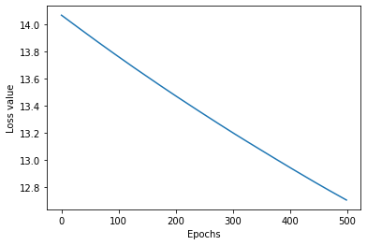

* + For initial training over 1000 samples with a learning rate of 1e-10 and regularization of 0 over 500 epochs, results achieved are:
    - Training accuracy: 9%
    - Validation accuracy: 10%
    - Testing accuracy: 9%
  + During grid search, with 100 training and validation samples over 10 epochs, best results were achieved using:
    - Learning Rate: 1e-08
    - Regularization: 10000
    - Results achieved:
* Linear classifier with the SoftMax loss:
  + Loss value graph over 500 epochs of training

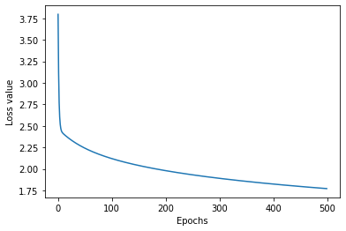

* + For initial training over 1000 samples with a learning rate of 1e-10 and regularization of 0 over 500 epochs, results achieved are:
    - Training accuracy: 36%
    - Validation accuracy: 31%
    - Testing accuracy: 27%
  + During grid search, with 100 training and validation samples over 10 epochs, best results were achieved using:
    - Learning Rate: 1e-05
    - Regularization: 10000