**DA621**

**Deep Learning for Computer Vision**

**Assignment-2**

**Amey Rambatla**

**190106011**

**Part 1:**

* Pre-trained model used: MobileNet-v3:
* Reason**:** 
  + MobileNetV3 is a convolutional neural network that is tuned to mobile phone CPUs through a combination of hardware-aware network architecture search (NAS) complemented by the NetAdapt algorithm, and then subsequently improved through novel architecture advances. Advances include (1) complementary search techniques, (2) new efficient versions of nonlinearities practical for the mobile setting, (3) new efficient network design.
  + The network design includes the use of a hard swish activation and squeeze-and-excitation modules in the MBConv blocks.
  + [[1905.02244v5] Searching for MobileNetV3 (arxiv.org)](https://arxiv.org/abs/1905.02244v5)
* Transfer Learning achieves a testing accuracy of **83%** over 10 epochs.

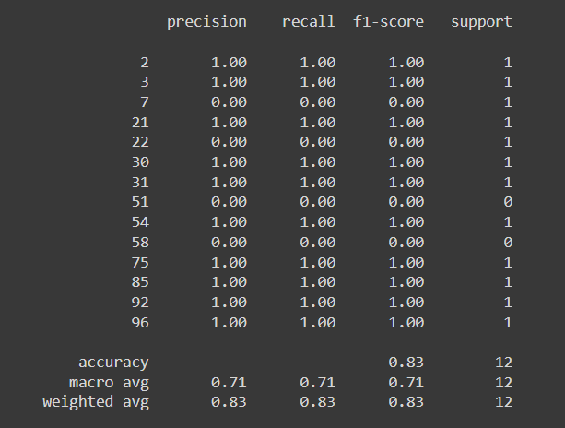

* While training after random initialization achieves a testing accuracy of 12.58 % over 10 epochs.

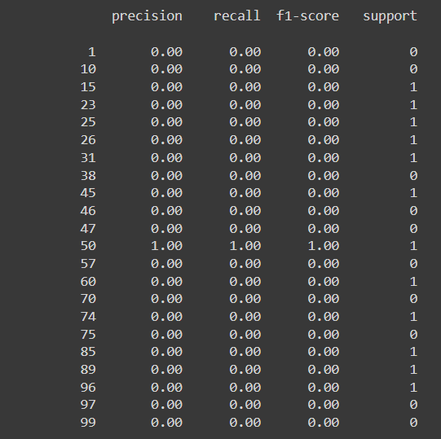

**Part 2:**

* Benchmark Loss: 0.160
* RNN Loss: 0.160 (5 Epochs)
* LSTM Loss: 0.163 (5 Epochs)
* GRU Loss: 0.170 (2 Epochs)