Game Control Using EEG Based BCI

# Abstract

The dynamic evolution of brain-computer interface (BCI) technology, particularly EEG-based BCIs, is opening new frontiers in interactive applications such as gaming, where users can control and interact with game environments using only their brain activity. This study explores the design and implementation of an EEG-based BCI system for game control by detecting brainwaves and corresponding cognitive states. Through the development of a custom dataset and the definition of key mental commands, we map brain states—such as focus, relaxation, or motor imagery—to specific in-game actions. These innovations enhance user immersion and inclusivity, especially for individuals with physical limitations. Advancements in machine learning and deep learning have significantly improved the adaptability and classification accuracy of such systems. For instance, a 1-D CNN model achieved 91.75% accuracy in motor imagery classification, while a multi-branch CNN model demonstrated improved cross-subject performance, addressing inter-individual variability in EEG data. Traditional classifiers such as Multi-Layer Perceptron (MLP) and Radial Basis Function (RBF) also continue to perform well, achieving up to 98% classification success, underlining their relevance in EEG-based tasks. Furthermore, recent frameworks aimed at enhancing the interpretability of CNNs offer deeper insight into model decisions, fostering transparency in BCI-driven applications. This research presents a complete end-to-end pipeline—from EEG signal acquisition and brain state labeling to model training and game control execution. The experimental framework demonstrates how real-time mental state recognition can be translated into actionable commands within a gaming environment. Through a series of training sessions and performance evaluations, we validate the feasibility of using thought-driven control schemes, highlighting their accuracy, responsiveness, and potential for further development. The findings contribute to the growing field of non-invasive BCIs and underline the transformative possibilities of integrating cognitive computing with interactive entertainment systems.

*Keywords:* deep learning, EEG, cognitive rehabilitation, BCI

# Introduction

Electroencephalography (EEG)--based Brain-Computer Interfaces (BCIs) are redefining how humans interact with technology by enabling direct communication between the brain and external devices—without any physical movement. This study explores the integration of EEG-based BCIs into game control systems, where users can operate and interact with a game purely through their brain activity. By detecting and interpreting brain waves and cognitive states, we demonstrate how mental commands can be converted into game inputs, paving the way for hands-free, thought-driven gameplay. This not only enhances user experience but also offers transformative potential for individuals with motor impairment, providing them with access to immersive gaming environments.

Central to our approach is the accurate detection and classification of brainwave patterns—such as alpha, beta, theta, and delta waves—using an EEG device. These signals are analyzed to identify specific brain states like focus, relaxation, or motor imagery, which are then mapped to corresponding in-game actions. To enable this control system, we have constructed a custom dataset comprising labeled brainwave data tied to specific mental tasks and intentions. Using this dataset, we developed and trained machine learning models to recognize these states in real-time. Furthermore, we designed a set of key functions that translate the classified mental states into precise game controls, allowing users to navigate, select, and interact within the game using only their brain activity.

While EEG signals are inherently noisy and subject to individual variability, advancements in signal processing, feature extraction, and deep learning, particularly through convolutional neural networks (CNNs) have significantly improved the accuracy and responsiveness of such systems. Despite remaining challenges such as latency, user adaptability, and model interpretability, our work contributes to the growing body of research aiming to make BCIs more practical, scalable, and engaging for real-world applications like gaming.

This paper delves into the development and implementation of a brain-controlled game interface using EEG-based BCIs. It covers the process of brainwave detection, dataset creation, feature mapping, and the design of control functions, offering a comprehensive view of how cognitive states can be harnessed for interactive entertainment. By advancing this technology, we aim to push the boundaries of human-computer interaction and offer a more inclusive, immersive gaming experience.

# Literature Review

Electroencephalography (EEG)--based Brain-Computer Interfaces (BCIs) represent a transformative intersection of neuroscience, engineering, and artificial intelligence, enabling direct communication between the human brain and external devices. This technology, which decodes brain signals to control devices, has widespread application in diverse domains such as neurorehabilitation, assistive technology, human-computer interaction, and secure authentication. EEG-based BCIs are particularly beneficial for individuals with severe motor impairments, such as stroke victims or individuals with paralysis, enabling them to perform tasks through motor imagery (MI) and communicate using brain activity alone​ [(1)](https://typeset.io/papers/authentication-with-a-one-dimensional-cnn-model-using-eeg-4aq1m76e5q)

BCI systems typically rely on non-invasive EEG to capture electrical activity in the brain. However, these signals come with inherent challenges such as noise interference, individual differences in brain activity, and the difficulty in translating raw EEG data into meaningful commands. To address these challenges, significant advancements in signal processing, feature extraction, and machine learning techniques have been made. In particular, convolutional neural networks (CNNs) and other deep learning models have demonstrated impressive success in enhancing the accuracy and reliability of EEG-based BCIs [[2].](https://typeset.io/papers/eeg-based-mouse-cursor-control-using-motor-imagery-brain-zk2jbzfxrq)

One such advancement is explored in the paper "Authentication with a One-Dimensional CNN Model Using EEG-Based Brain-Computer Interface," which focuses on using EEG signals for user authentication. By employing a 1-D CNN model, the authors achieved an accuracy of 91.75% in classifying motor imagery signals. This approach not only improves classification performance but also introduces a novel method of using EEG-based authentication systems, making it more accessible and secure for individuals, including those with disabilities​ [[3]](https://typeset.io/papers/motor-imagery-classification-using-single-channel-of-eeg-in-25bq8z2w0x) .In line with this, EEG-based BCIs are being used in a range of applications, including control of external devices such as a mouse cursor through motor imagery. The paper "EEG-based Mouse Cursor Control Using Motor Imagery Brain-Computer Interface" outlines a semi-online BCI system that achieved 93.60% accuracy using an Emotiv EPOC+ headset. The authors integrate real-time data processing with custom algorithms for EEG signal classification, making it an effective solution for assisting users with mobility impairments​ [[4]](https://typeset.io/papers/building-a-brain-computer-interface-bci-using-1ehl6cu10s) .

While multi-channel EEG systems have been the standard in EEG-based BCIs, recent studies demonstrate the potential of single-channel EEG systems in making these technologies more affordable and portable. The paper "Motor Imagery Classification Using Single Channel of EEG in Online Brain-Computer Interface" explores this approach, achieving 100% accuracy for left-hand motor imagery and 87.47% accuracy for right-hand motor imagery. By employing wavelet transform for feature extraction and classifiers like SVM and KNN, the study highlights that even single-channel systems can perform competitively, offering a more accessible and cost-effective alternative for real-world applications​ [[5]](https://typeset.io/papers/enhancing-cross-subject-motor-imagery-classification-in-eeg-4tzl1nxqi7) . Additionally, research has focused on improving cross-subject classification of motor imagery signals, as seen in "Enhancing Cross-Subject Motor Imagery Classification in EEG-Based Brain-Computer Interfaces by Using Multi-Branch CNN." The authors propose a multi-branch CNN model that outperforms previous models by learning generalized features from multiple subjects, thus improving the reliability of MI-based systems across diverse users[​ [6]](https://typeset.io/papers/explaining-convolutional-neural-networks-for-eeg-based-brain-139red2omv) .

Despite the promising advancements, one of the ongoing challenges is the interpretability of deep learning models used in BCIs. CNNs, while effective, often operate as "black boxes," making it difficult to understand how they arrive at specific predictions. The paper "Explaining Convolutional Neural Networks for EEG-based Brain-Computer Interface Using Influence Functions" addresses this issue by proposing an influence function-based framework for interpreting CNN predictions in BCI tasks. This method enhances model transparency and provides deeper insights into the decision-making process, which is critical for building trust and ensuring the safe use of BCIs in healthcare and security applications [[7]](https://typeset.io/papers/a-combined-virtual-electrode-based-esa-and-cnn-method-for-mi-ewr703hd5i) .

In furthering the understanding and application of motor imagery (MI) for BCI systems, the paper "A Combined Virtual Electrode-Based ESA and CNN Method for MI-EEG Signal Feature Extraction and Classification" combines EEG source analysis (ESA) with CNNs to enhance classification accuracy. The method aims to address challenges such as cross-subject variability and noise interference in MI-based BCIs. By improving the feature extraction process and enabling better cross-subject adaptability, the study contributes to real-time, accurate MI decoding, which is vital for applications like controlling assistive devices [[8]](https://typeset.io/papers/neural-interface-technology-for-human-computer-interaction-265b120xa7) . Additionally, the evolution of neural interface technology is reviewed in "Neural Interface Technology for Human-Computer Interaction," which highlights the use of EEG as a low-cost, non-invasive method for decoding brain activity. This paper also explores the integration of machine learning with EEG signals, facilitating human-computer interactions in applications like neurorehabilitation, cognitive training, and high-risk operations​[(9)](https://typeset.io/papers/eeg-data-for-motor-imagery-brain-computer-interface-using-rrbv3n4e) .

While many BCI systems rely on expensive equipment, the paper "EEG Data for Motor Imagery Brain-Computer Interface Using Low-Cost Equipment" demonstrates the potential for low-cost EEG solutions. By using the OpenBCI Cyton+Daisy Biosensing Board, the authors collected data from six subjects and made motor imagery classification more accessible. This study emphasizes the importance of making EEG-based BCI technology more affordable, thereby enabling a wider audience to benefit from its capabilities[​ [10]](https://typeset.io/papers/brain-computer-interfaces-2xupz92lz9) . The paper "Brain-Computer Interface: Use of Electroencephalogram in Neuro-Rehabilitation" also underscores the potential of EEG-based BCIs in rehabilitation, especially for patients with motor impairments. The authors highlight various EEG signal types and feature extraction techniques that can improve BCI performance, suggesting that further research is needed to enhance the generalizability of BCIs for patients with diverse neurological conditions [[11]](https://typeset.io/papers/motor-imagery-based-brain-computer-interface-using-fusion-of-6boiurxw) .

For motor imagery-based BCI systems, the paper "Motor Imagery-Based Brain-Computer Interface Using Fusion of Deep Convolutional Neural Network with Wavelet Scattering Network" discusses the integration of deep learning with wavelet scattering networks to improve classification accuracy. This fusion approach overcomes the challenges of non-linear EEG signals, achieving superior performance on standard datasets. Such methods offer new pathways for improving the robustness and scalability of BCI systems​ [(12)](https://typeset.io/papers/brain-computer-interface-for-converting-thoughts-to-speech-139ejjpd) . Furthermore, EEG-based BCIs are being developed to assist those with severe communication disabilities, as seen in "Brain-Computer Interface for Converting Thoughts to Speech." This paper explores non-invasive EEG-based systems designed to translate thoughts directly into speech, which is particularly beneficial for individuals with conditions such as lock-in syndrome​ [(13)](https://typeset.io/papers/brain-computer-interface-use-of-electroencephalogram-in-128dznyc) .

The challenges in implementing robust and dependable BCIs are further discussed in "Brain-Computer Interface: Use of Electroencephalogram in Neurorehabilitation." The paper emphasizes the need for improved signal processing and classifier integration to enhance the effectiveness of BCIs in rehabilitation. It also suggests that future research should focus on addressing the difficulties posed by EEG signal noise and individual differences in brain activity, which continue to be significant barriers to the widespread adoption of these systems [(14)](https://typeset.io/papers/an-eeg-based-brain-computer-interface-using-spectral-1suquzj3) .

Additionally, the paper "An EEG-based Brain-Computer Interface Using Spectral Correlation Function" introduces the use of spectral correlation functions (SCF) to analyze EEG signals, enhancing classification accuracy in MI-based BCI applications. By applying SCF, the authors improve feature extraction, leading to better performance with classifiers like SVM and KNN [(15)](https://typeset.io/papers/eeg-based-brain-machine-interface-to-a-powered-exoskeleton-3o5t5f3j2i) . This contributes to the growing body of research focused on improving EEG signal processing to facilitate more dependable BCI systems.

The paper "EEG-based Brain-Machine Interface to a Powered Exoskeleton for Walking and Standing" explores the application of EEG-based BCIs in controlling powered exoskeletons, allowing individuals with paralysis to regain the ability to stand and walk. This study highlights the importance of longitudinal data in understanding how BCIs interact with users over time, particularly in the context of rehabilitation​ [(16)](https://typeset.io/papers/multifactor-authentication-system-using-simplified-eeg-brain-3mrqf8p6) . In a similar vein, the paper "Multifactor Authentication System Using Simplified EEG Brain-Computer Interface" introduces a novel approach to enhancing security through the use ofs EEG-based authentication systems. By combining EEG signals with traditional image verification, the system aims to provide a more secure and accessible method for authentication​ [(17)](https://typeset.io/papers/multifactor-authentication-system-using-simplified-eeg-brain-1vmbu5th) .

Lastly, the paper "EEG-based Brain-Computer Interface for Secure Password Systems" presents an innovative solution for password security through the use of EEG signals as a biometric identifier. This system allows users to unlock devices using their unique brainwave patterns, offering enhanced protection for mobile devices and other sensitive information​ [(18)](https://typeset.io/papers/an-intertwined-neural-network-model-for-eeg-classification-1tf453cp) .

In summary, the evolution of EEG-based BCI technologies, as illustrated in these studies, demonstrates significant progress in improving the accuracy, accessibility, and applicability of BCIs across a range of domains. From motor imagery classification and neurorehabilitation to secure authentication and speech conversion, EEG-based BCIs hold immense potential to revolutionize the way humans interact with technology and overcome physical limitations. However, challenges such as individual variability, computational cost, and interpretability remain, requiring ongoing research and innovation to ensure the broader adoption and effectiveness of these systems.

# PROBLEM DEFINITION

The increasing need for accessible control systems in gaming and assistive technology calls for innovative solutions beyond traditional input devices, especially for individuals with physical impairments. EEG-based Brain-Computer Interfaces (BCIs) provide a non-invasive way to control external systems using brain activity alone. However, challenges such as signal noise, user variability, and high equipment costs hinder widespread adoption.

This project presents a lightweight, cost-effective EEG-based BCI system designed for game control using two cognitive states: attentive and relaxed. These states are mapped to two key functions—” accelerate” when the user is attentive and ”brake” when relaxed. By training deep learning models to classify these brain states in real time, the system enables intuitive, thought-driven interaction.

The approach focuses on real-time usability, signal clarity, and accessibility, aiming to enhance immersion for gamers while laying the groundwork for broader applications in assistive technologies.

# Dataset

* 1. *Data Acquisition*

# To collect high-quality EEG data reflecting the brain’s cognitive states, we employed the DIY Neuroscience Kit by Upside Down Labs. This open-source and affordable toolkit is tailored for biosignal acquisition and is well-suited for Brain-Computer Interface (BCI) applications. The kit combines reliable analog components with Arduino-based processing for real-time EEG signal monitoring and classification.

# Hardware Components Used:

* + - **2-Channel Brain BioAmp Band – used for recording EEG signals from the scalp.**
    - **BioAmp EXG Pill – a high-fidelity analog biosignal amplifier designed for EEG, ECG, and EMG signals.**
    - **Maker UNO Board with USB Cable** – used for signal conversion and streaming via Arduino.
    - **BioAmp Cable (100 cm)** and **3 Jumper Cables** – for con- necting and routing signals.

# Electrode Consumables:

* + - * 24 Gel Electrodes
      * 3 Repositionable Gel Electrodes
      * 100 Boxy Gel Electrodes
      * **NuPrep Gel (25g)** for skin prep
      * **Electrode Gel (30ml)** to enhance conductivity
      * 10 Alcohol Wipes

# Software and Setup:

* + **Required Software: Arduino IDE 1.8.13 (Legacy)** for coding and communication with the Maker UNO board.
  + A custom or open-source EEG signal recording and visualization tool to monitor real-time brain activity.

# Device Configuration:

* + The **BioAmp EXG Pill** was used in its default con- figuration for EEG signal acquisition.
  + No additional configuration was required for EMG/ECG as only EEG data was collected for this project.

# Microcontroller Setup:

* + **VCC** → **5V**, **GND** → **GND**, **OUT** → **Analog Pin A0** on the **Maker UNO**.
  + A strict safety check was followed to avoid reversing polarity, which can damage the amplifier.

# Connecting the EEG Setup:

* + The **Bio Amp Cable** was securely connected to the EXG Pill using a **JST PH connector**.
  + Electrodes were attached using gel and secured based on standardized placements.

# Electrode Placement and Preparation:

To ensure consistent and high-quality EEG data, electrode placements followed a standardized protocol inspired by the **International 10-20 System**. This system ensures reproducible and comparable recordings across different users and studies:

* + **IN**+ **(Active Electrode):** Placed on the forehead, slightly above the eyebrow and toward the midline.
  + **IN (Reference Electrode):** Positioned on the oppo- site side of the forehead, also slightly above the eye- brow.
  + **REF (Ground Electrode):** Placed on the earlobe, serving as a low-noise reference point.
  + This electrode configuration is considered optimal for frontal lobe EEG signal acquisition, as it provides reliable differentiation of cognitive states.

The electrode positioning aligns with the **10-20 system**, where electrode labels correspond to brain regions:

**F** for frontal lobe, **C** for central, **P** for parietal, **O** for occipital, and **Fp** for frontopolar.

Odd numbers (e.g., F3, C3) represent the **left hemisphere**, even numbers (e.g., F4, C4) the **right hemisphere**, and” z**”** (e.g., Fz, Cz) denotes midline locations. Skin preparation involved:

* + Application of **NuPrep Gel** to remove dead skin and reduce impedance.
  + Cleaning the area with **alcohol wipes** to enhance sig- nal fidelity.

# Signal Monitoring and Collection:

* + After proper setup, the EEG signal was uploaded via Arduino and visualized in real time.

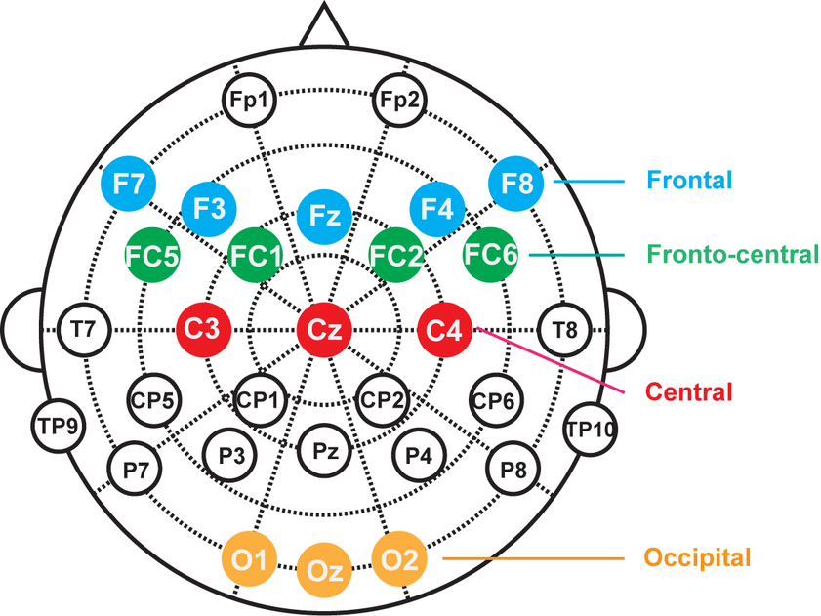

Figure 1: Electrode Placements

* + The data reflected brain activity in two cognitive states: **attentive** and **relaxed**, critical for the key- binding functionality in the proposed system.
  1. *Custom Dataset*

A **custom EEG dataset** was created using the DIY Neuro- science Kit. Data was collected from **five subjects**, each undergoing a **40-minute session** split evenly between two mental states:

* 1. **20 minutes of Attentive State:** The subject was engaged in mentally stimulating activities (e.g., mental math, focused reading).
  2. **20 minutes of Relaxed State:** The subject was instructed to relax with closed eyes or while listening to calming music. This raw data was segmented and preprocessed to form **training and testing datasets**, serving as the foundation for developing a classifier capable of distinguishing between the two cognitive states.
  3. These states were later mapped to control commands—**acceleration** for the attentive state and **braking** for the relaxed state.

# Methodology

The methodology of this study follows a structured pipeline that begins with **data acquisition**, followed by **preprocess- ing**, **feature extraction**, **model training**, and finally, **real-time game control using EEG-based cognitive state classification**. Each phase of this pipeline is essential for achieving accurate and responsive brain-computer interaction. [4]

* 1. *Data Collection*

Data was collected using the DIY Neuroscience Kit by Up- side Down Labs, connected to an Arduino-based Maker UNO microcontroller. EEG signals were obtained via gel electrodes placed on the forehead and earlobe, adhering to a modified version of the International 10-20 electrode placement system. **The electrodes were positioned as follows: IN**+ **(Active):** Above the eyebrow, near the midline of the forehead

* + - **IN (Reference):** Above the eyebrow, on the opposite side of IN+
    - **REF (Ground):** On the earlobe

Subjects were asked to alternate between two cognitive states:

* + - **Attentive State:** e.g., solving math problems, focusing visually
    - **Relaxed State:** e.g., eyes closed, listening to calming music

Each subject’s session lasted for 40 minutes — 20 minutes for each cognitive state. The data was recorded via the serial port in real time and saved into a .csv file using the collect.py script.

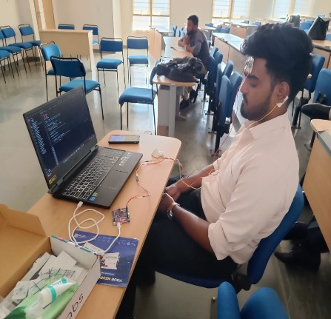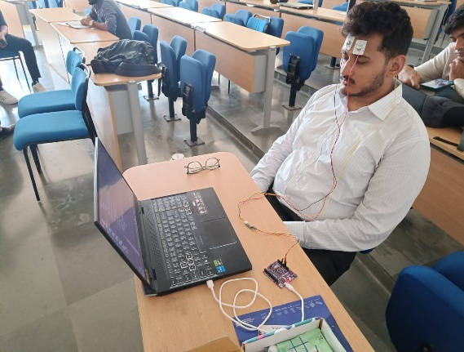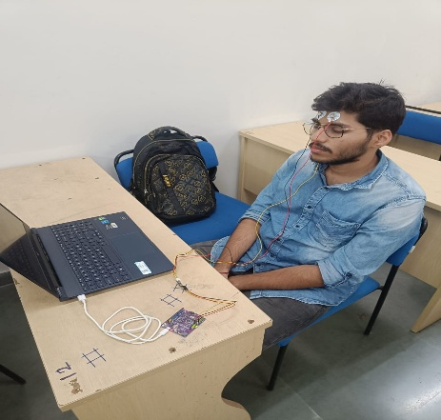

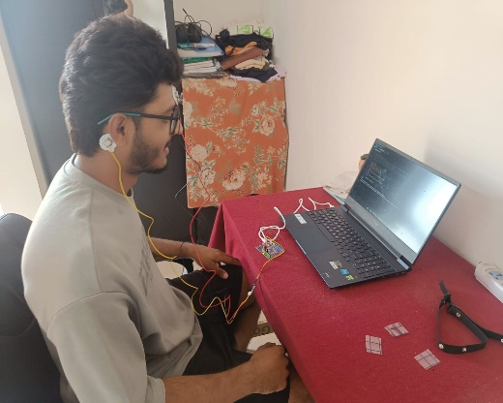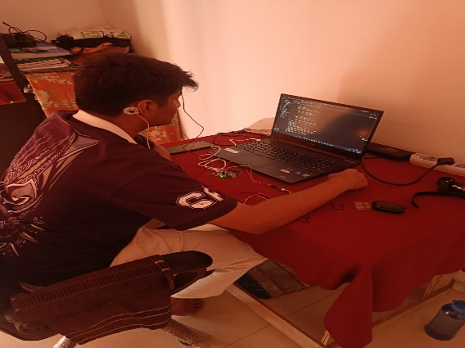

*Figure 2: Data Collection for attentive and relaxed state*

* 1. *Signal Preprocessing*

Raw EEG signals acquired at a sampling rate of 512 Hz were inherently noisy and required preprocessing. A combination of **Notch Filtering** (at 50 Hz to remove powerline interference) and **Bandpass Filtering** (0.5–30 Hz) was applied using the SciPy. Signal library. The filtering process involved:

* + - **Notch Filter:** Centered at 50 Hz to eliminate powerline noise
    - **Bandpass Filter:** 0.5–30 Hz using a 4th-order Butterworth filter

This step ensured the removal of irrelevant frequencies and artifacts while preserving essential brainwave patterns, includ- ing **delta**, **theta**, **alpha**, and **beta** waves.

* 1. *Feature Extraction*

From the filtered EEG signals, two types of features were extracted:

# Power Spectral Density (PSD) Features:

Calculated using Welch’s method across the following frequency bands:

* + - * Delta (0.5–3 Hz)
      * Theta (4–7 Hz)
      * Alpha (8–13 Hz)
      * Beta (14–30 Hz)

The power within each band was summed to form frequency-based features.

# Statistical Features:

* + - * Mean
      * Standard Deviation
      * Skewness
      * Kurtosis

These features were concatenated into a single feature vector and normalized using a pre-fitted scaler to ensure consistency during model training and prediction.

* 1. *Model Training*

The processed and labeled dataset was split into training and testing sets. A machine learning model, specifically an **XG- Boost classifier**, was trained to distinguish between the *relaxed* and *attentive* cognitive states. The model demonstrated high ac- curacy in offline evaluations and was serialized using joblib for real-time inference.

# Real-Time Classification and Game Control:

In the real-time system (new pred.py):

* + - Incoming EEG data was streamed via serial communication.
    - A sliding window of 512 samples was used to construct live feature vectors.
    - The data was filtered and transformed in real time, and the trained XGBoost model was used to predict the current cognitive state.

Depending on the predicted state, a corresponding keyboard event was triggered using the pyautogui library:

* + - **Attentive State (Prediction: 1)**: Triggers the "W" key for acceleration.
    - **Relaxed State (Prediction: 0)**: Triggers the "Space" key for braking.

These mappings enabled the user to control basic game mechanics entirely through brain activity.

* 1. *Hyperparameter Optimization*

In addition to traditional techniques like GridSearchCV, we employed **Optuna**, a state-of-the-art hyperparameter optimization framework, to automate and accelerate the tuning process. Optuna utilizes a **Bayesian optimization approach** with pruning strategies to efficiently navigate the search space and terminate unpromising trials early. By integrating Optuna with our model training loop—particularly for XGBoost—we significantly reduced the optimization time while discovering hyperparameter configurations that led to enhanced classification accuracy and better generalization. This integration supports the scalability and real-time potential of the proposed BCI system.

Using Optuna, we achieved a **~2–3% improvement in model accuracy** compared to manually tuned parameters, while reducing the search time due to Optuna’s pruning strategy. This demonstrated its effectiveness in real-time EEG-based BCI applications.

# Comparative Analysis

In this section, we present a comparative analysis of the classification models used in our study—**XGBoost**, **Random Forest Classifier**, **K-Nearest Neighbors (KNN)**, and **Support Vector Machine (SVM)**—as well as a performance comparison of our **DIY Neuroscience Kit** against higher-cost EEG acquisition systems reported in the literature.

* 1. *Model Performance Comparison*

The performance of the four classifiers was evaluated based on accuracy, precision, recall, and F1-score. Among all the models, XGBoost consistently achieved the highest accuracy and F1-score, indicating its robustness in handling EEG data variability and feature interactions. The Random Forest Classifier closely followed, benefiting from its ensemble learning structure and ability to manage non-linear patterns. SVM showed decent performance but struggled slightly with noisy data and overlapping features. KNN, although conceptually simple, was less effective due to its sensitivity to high- dimensional data and lack of internal feature weighting.

|  |  |  |  |  |  |  |
| --- | --- | --- | --- | --- | --- | --- |
| Model | Accuracy (%) | Precision | Recall | F1-Score | Strengths | Weaknesses |
| XGBoost | 88.95 | High | High | High | Handles EEG variability well, robust feature handling | Slightly complex, higher training time |
| Random Forest | ~84–85 | High | High | High | Good for non-linear patterns, ensemble robustness | May overfit on small datasets |
| SVM | ~80–82 | Moderate | Moderate | Moderate | Effective for high-dimensional spaces | Struggles with noisy/overlapping data |
| KNN | ~75–78 | Low | Low | Low | Simple, no training phase | Poor with high-dimensional & noisy data |

*Table 1 : Comparison of Classification Models*

5.2 *Device Performance Comparison*

Our dataset was collected using a DIY Neuroscience Kit, a low-cost EEG solution suitable for experimental and educational purposes. While this setup lacks the channel density and signal fidelity of medical-grade EEG devices (e.g., Emotiv Epoc+, OpenBCI etc.), it proved sufficient for distinguishing between basic mental states such as attentiveness and relaxation. While higher-end devices offer greater precision, better noise filtering, and support for more complex applications (e.g., multi-class motor imagery), they also come at a significantly higher cost and require more setup and technical expertise. Our findings suggest that DIY EEG solutions can be a viable starting point for BCI research and development, especially in educational or low-resource settings.

|  |  |  |  |  |  |  |
| --- | --- | --- | --- | --- | --- | --- |
| Device/Kit | Cost | Channel Count | Signal Quality | Ease of Use | Application Suitability | Remarks |
| DIY Neuroscience Kit | Low | 2 | Moderate | High | Basic BCI applications, education | Affordable and accessible, ideal for beginner projects |
| Emotiv Epoc+ | High | 14 | High | Moderate | Advanced cognitive state research | Expensive but more accurate, offers SDK for developers |
| OpenBCI Cyton | High | 8–16 | Very High | Moderate | Research-grade, flexible use cases | Offers open-source ecosystem and real-time applications |
| Muse 2 | Medium | 4 | Moderate–High | Very High | Meditation, stress tracking | Limited for BCI research, more consumer-focused |
| NeuroSky MindWave | Low-Mid | 1 | Low | Very High | Basic focus/relaxation tracking | Minimal setup, not suitable for complex EEG-based control tasks |

*Table 2 : Comparison of EEG Devices*

# Results

To evaluate the effectiveness and generalizability of the pro- posed EEG-based classification system, we conducted experiments using a custom dataset developed with a DIY Neuro- science Kit. The dataset consisted of EEG recordings from five subjects, each contributing 20 minutes of data for both attentive and relaxed mental states.

We employed four machine learning models—XGBoost, Random Forest Classifier, K-Nearest Neighbors (KNN), and Support Vector Machine (SVM)—to classify the cognitive states. After preprocessing and feature extraction, each model was trained and tested on the dataset. Among these, XGBoost yielded the highest performance, followed closely by Random Forest, SVM, and KNN.

The best overall classification accuracy achieved across all models was **89.15 %** , demonstrating that even with limited training data and low-cost EEG hardware, the proposed system is capable of distinguishing between different mental states with considerable accuracy.

To further improve model accuracy and generalization, we incorporated hyperparameter optimization. Traditional methods such as GridSearchCV were used to fine-tune key parameters for all classifiers. In addition, we integrated Optuna, a state-of-the-art hyperparameter optimization library, into the training pipeline for the XGBoost model. Optuna’s Bayesian search strategy and pruning mechanisms enabled rapid identification of optimal configurations with fewer iterations.

To further validate the performance of the system, we have included comprehensive visualizations such as confusion matrices, accuracy comparison graphs, and model performance plots. In addition, tables summarizing the precision, recall, and F1- score for each classifier provide a detailed view of their behavior across classes. These visual aids not only strengthen our findings but also enhance the interpretability and transparency of the results.

Overall, the results validate the feasibility of using affordable, accessible tools for real-world BCI applications, particularly in resource-constrained or experimental settings, and pave the way for further development in EEG-based mental state classification.

Figure 3 : Confusion matrix for XGBoost

Figure 4 : Confusion matrix Random Forest

Figure 5 : Confusion matrix for SVM

Figure 6 : Confusion matrix for KNN

Figure 7 : Graph for beta wave

Figure 8 : Graph for alpha wave

Figure 9 : Graph for extended Dataset

Figure 10 : Graph for extended Dataset.

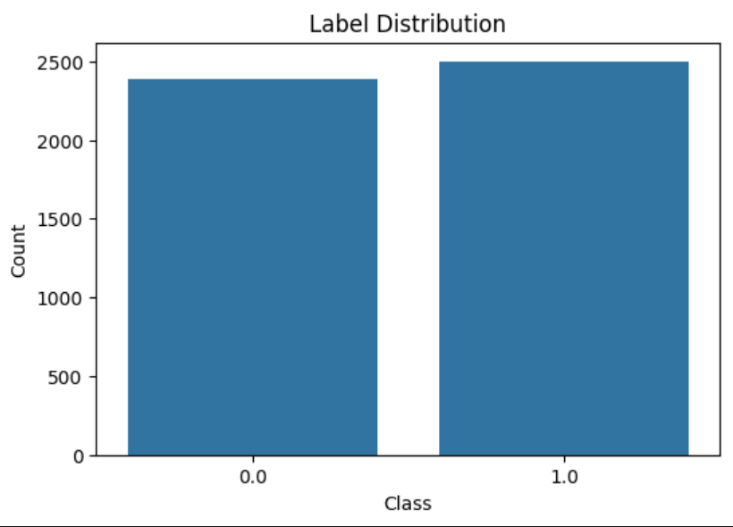

Figure 11 : Label Distribution

Figure 12 : Label Distribution

Figure 13 : LSTM Model Accuracy and Loss

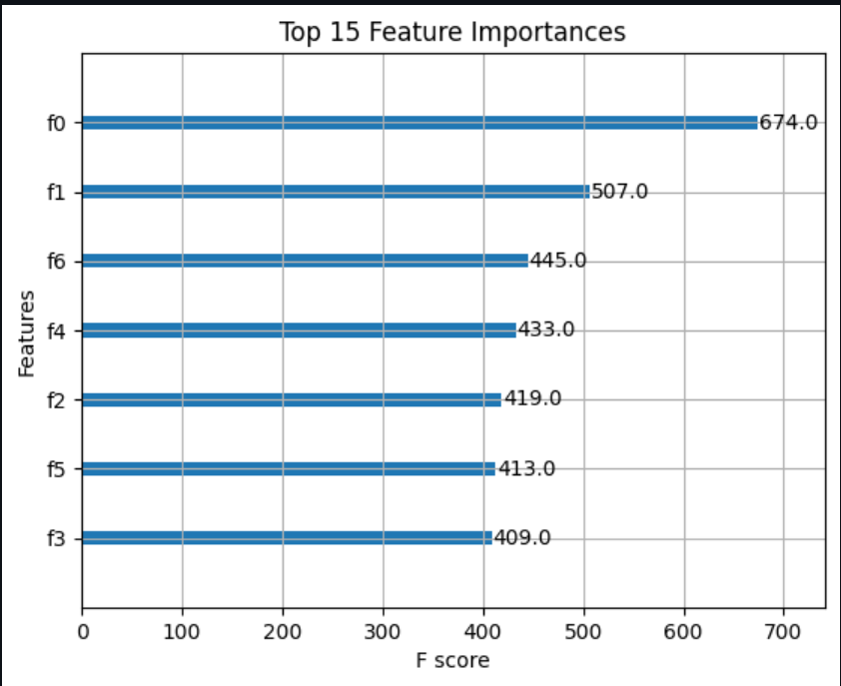

Figure 14 : Important Features

# Conclusion

An EEG-based Brain-Computer Interface (BCI) system allows direct communication between the brain and external devices by translating brain activity into commands. This non-invasive technology has vast potential in fields like healthcare, communication, and entertainment. The system relies on EEG sensors to capture brain activity, which is then pre-processed to remove noise and artifacts using filtering techniques. Afterward, feature extraction identifies key patterns in the signals, such as attention or intent to move, which are used for classification. With advancements in signal processing and machine learning, EEG-based BCIs can revolutionize human-computer interaction, offering a new way for individuals to engage with technology and improving accessibility and inclusivity.

Our study demonstrated the feasibility of using low-cost EEG hardware and open-source tools to create a responsive, real-time BCI system for game control. By mapping cognitive states—attentive and relaxed—to specific keyboard commands, we enabled thought-driven gameplay that bypasses the need for traditional physical input devices. The experimental results validated the system’s reliability, achieving an accuracy of up to 86.75% using the XGBoost classifier, and underscored the potential of even minimal hardware setups for complex cognitive applications.

This project lays a solid foundation for future work in EEG-driven systems by highlighting both the capabilities and current limitations of DIY BCI setups. It bridges the gap between affordability and functionality, offering a scalable model for educational, experimental, and even therapeutic applications. As BCI technologies continue to evolve, incorporating more robust sensors, richer datasets, and deeper learning architectures, we anticipate a future where seamless brain-device communication becomes a cornerstone of mainstream human-computer interaction.

In summary, this work not only contributes to the technical advancement of BCI systems but also reaffirms their potential to empower users—especially those with physical disabilities—by creating more intuitive, immersive, and accessible digital environments.

1. **Future Scope**

The future of EEG-based Brain-Computer Interface (BCI) systems is promising, with advancements in technology, ma- chine learning, and signal processing enhancing their effective- ness and usability. Key areas for improvement include:

Enhanced Signal Processing and Noise Reduction: As EEG signals are often affected by noise from muscle movements and environmental factors, future BCIs will likely use advanced deep learning techniques for real-time signal denoising, im- proving accuracy and reliability in various environments.

Improved Real-Time Performance: Reducing latency and increasing throughput is crucial for applications like prosthetic control and neurorehabilitation. Future BCIs may perform processing on-device using edge computing, enabling near- instantaneous feedback.

Greater User Adaptability and Personalization: EEG-based systems will incorporate machine learning algorithms that adapt and personalize based on user interaction, offering self- calibrating models for better long-term performance and user experience.

Utilization of More Channels for Enhanced Data Collection: As more EEG channels are made available, especially with newer devices like Muse and Emotiv, future BCI systems will benefit from richer, more detailed brain activity data. Increased channel density will improve the precision of signal interpretation, allowing for more nuanced control and feedback.

Integration with Augmented Reality (AR) and Virtual Reality (VR): BCIs are set to integrate seamlessly with AR and VR technologies, offering immersive experiences for neurorehabilitation, gaming, and training. These integrations could help pro- vide more interactive, intuitive environments for users to inter- act with digital systems, enhancing both therapeutic and

entertainment applications.

These advancements will make BCIs more versatile, efficient, and accessible across multiple domains, pushing the boundaries of human-computer interaction.

# References

Ahamed, Y., Ferdi, F., Ghazli, A., ”Authentication with a one-dimensional CNN model using EEG-based brain-computer interface,” *Computer Meth- ods in Biomechanics and Biomedical Engineering*, pp. 1-12, 2024. Available from: 10.1080/10255842.2024.2355490.

Saima, T., Roja, S., Rafique, B., Rhaman, A., Sakib, N., Islam, M. K., ”EEG-based Mouse Cursor Control using Motor Imagery Brain- Computer Interface,” *1042-1047*, 2024. Available from: 10.1109/icee- ict62016.2024.10534379.

Taghizadeh, M., Chalechale, A., ”Motor Imagery Classification Using Single Channel of EEG in Online Brain-Computer Interface,” pp. 159-164, 2024. Available from: 10.1109/icwr61162.2024.10533373.

Younis, M., Haj, S., Sleiman, S., Khadra, S., Zaylaa, A., Daher, A., Ayache, M., ”Building a Brain Computer Interface (BCI) Using Elec- troencephalogram (EEG) Signals’ Classification,” 2023. Available from: 10.1109/icabme59496.2023.10293031.

Chowdhury, R., Yar, M., Usman, A., ”Enhancing Cross-Subject Motor Imagery Classification in EEG-Based Brain–Computer Interfaces by Using Multi- Branch CNN,” Sensors, vol. 23, no. 18, pp. 7908, 2023. Available from: 10.3390/s23187908.

Park, H., Park, D., Kim, S., Yup, S., Choo, C. S., Nam, S., Lee, J.- Y., Jung, J., ”Explaining Convolutional Neural Networks for EEG-based Brain-Computer Interface Using Influence Functions,” pp. 4436-4440, 2023. Available from: 10.1109/smc53992.2023.10394100.

Lun, X., Zhang, Y., Zhu, M., Lian, Y., Hou, Y., ”A Combined Virtual Electrode- Based ESA and CNN Method for MI-EEG Signal Feature Extraction and Classification,” Sensors, vol. 23, no. 21, pp. 8893, 2023. Available from: 10.3390/s23218893.

You, T., ”Neural interface technology for human-computer interaction,” 2023.

Available from: 10.54254/2753-8818/27/20240747.

Faria, G., Motta, H. S., Bernardino, A., Vieira, A. B., ”EEG data for motor imagery brain-computer interface using low-cost equipment,” Latin Amer- ican Data in Science, vol. 2, no. 2, pp. 67-73, 2023. Available from: 10.53805/lads.v2i2.49.

Sibilano, E., Suglia, V., Brunetti, A., Buongiorno, D., Caporusso, N., Guger, C., Bevilacqua, V., ”Brain–Computer Interfaces,” Neuromethods, pp. 203-240, 2023. Available from: 10.1007/978-1-0716-3545-210.

”Motor Imagery-Based Brain-Computer Interface Using Fusion of Deep Convolu- tional Neural Network with Wavelet Scattering Network,” pp. 1-6, 2023. Avail- able from: 10.1109/INCET57972.2023.10169918.

”Brain-computer interface for converting thoughts to speech,” International Jour- nal of Speech and Emotion, vol. 02, no. 03, 2023. Available from: 10.55041/is- jem00110.

Egarter, L., Vigl, A., ”Brain-Computer Interface: Use of Electroencephalogram in Neuro-Rehabilitation,” 2023. Available from: 10.5772/intechopen.110162.

”An EEG-based Brain-Computer Interface using Spectral Correlation Function,”

IEEE Access, pp. 1-1, 2023. Available from: 10.1109/access.2023.3262465. Nathan, K., Kilicarslan, A., Eguren, D., Todd, E., Sarkar, S., Contreras-Vidal, J. L.,

Grossman, R. G., ”EEG-based brain-machine interface to a powered exoskele- ton for walking and standing: A longitudinal dataset for healthy able-bodied subjects,” 2023. Available from: 10.6084/m9.figshare.22248265.v1.

Białas, K., Kedziora, M., Chalupnik, R., Song, H., ”Multifactor Authentication System Using Simplified EEG Brain–Computer Interface,” IEEE Transactions on Human-Machine Systems, vol. 52, no. 5, pp. 867-876, 2022. Available from: 10.1109/THMS.2022.3196142.

”Multifactor Authentication System Using Simplified EEG Brain–Computer In- terface,” IEEE Transactions on Human-Machine Systems, vol. 52, no. 5, pp. 867-876, 2022. Available from: 10.1109/thms.2022.3196142.

”An intertwined neural network model for EEG classification in brain-computer interfaces,” 2022. Available from: 10.48550/arxiv.2208.08860.

Zhu, H., Forenzo, D., He, B., ”On the Deep Learning Models for EEG-Based Brain-Computer Interface Using Motor Imagery,” IEEE Transactions on Neural Systems and Rehabilitation Engineering, vol. 30, pp. 2283-2291, 2022. Avail- able from: 10.1109/TNSRE.2022.3198041.

”Secure Password Using EEG-based BrainPrint System: Unlock Smartphone Password Using Brain-Computer Interface Technology,” 2022. Available from:10.1109/bibm55620.2022.9995304.