

Technical description

*Supervisor:Dr. Knolmár Marcell*

*Amgalantuul Purevsuren GJOPB2*

*2020/2021 1 semester*

1. ***Exposition of the task***

The task which is given to me was to plan water supply, sewage in a smaller area of a settlement. The number of inhabitants, water demand, seasonal variation coefficient, loss efficient… are stated in the data.

Low repair cost, efficient system in the long run is expected from result.

1. ***Exposition of the planning area***

In this part of the area, there are houses, university, fire station and industrial plants. I designed main loop simple. The ground is increasing from southwest towards northeast. The lowest point in this area is around point 0. Connection points can be reached by all different network.

1. ***Exposition of the basic data***

The basic data are based on average consumptions, maximum consumptions, and minimum consumptions given by the supplier.

1. ***Technical regulations***

In the water supply system there is only one requirement that the pressure must be at least 25m above the ground. The loss-coefficient must be less than 10%0 in each branch.

In case of the sewage and storm water systems the velocity must be at least 0,4 m/s to let the pipe clean itself. The water depth in the pipe must be between 20% and 80% of the diameter and the pipe should be between 2-6 meters below the ground.

1. ***Determining the loads***

In the water supply system, firstly I calculated the amount of water flowing in each branch for min, max, average. Then iteration was used to determinate the exact flows in the branches.

In the case of sewage system I got the consumption data from the previous data, so using these I could compute the amount of the used water. Then I used prandtl-kármán-colebrook formula to find out the diameters.

1. ***Exposition of alternatives of the lay of pipelines***

The pipes in the water supply system should reach most of the houses the industrial plant and the school. These were the rules I was following.

The pipes in the sewage and the storm water system should follow the slope of the ground.

***7. Exposure of the pipes designing***

In the water supply system, according to max loads the used diameters will be:

|  |  |
| --- | --- |
| 1-2 | 200mm |
| 2-3 | 175mm |
| 3-4 | 175mm |
| 4-5 | 175mm |
| 5-6 | 175mm |
| 6-7 | 175mm |
| 7-8 | 175mm |
| 8-9 | 175mm |
| 9-2 | 175mm |

In the sewage system the used diameters will be the following:

The main branch diameters:

From the outlet point until point number 2: 500 mm

From point number 2 until the end of the branch: 500mm

All the sub-branches: 500 mm

Attachments:

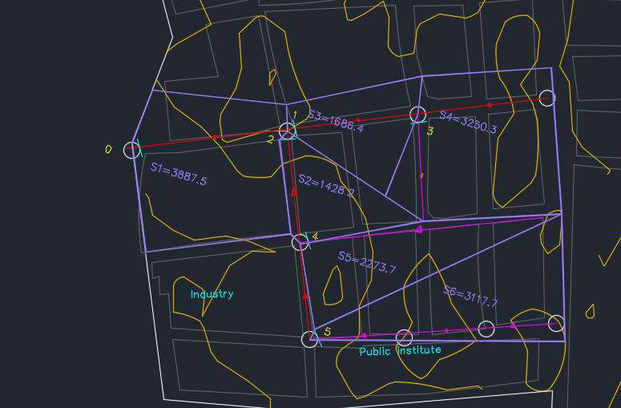

*Figure 1. Sewage pipe system design with its area.*

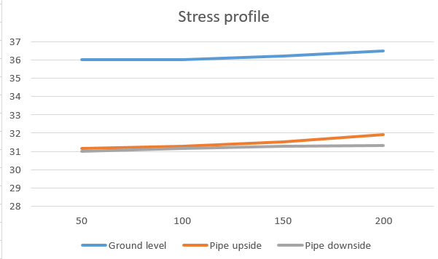

*Figure2. Stress profile of the sewage pipe.*

About the stress profile, I took a small area to design system, so elevation doesn’t significantly change in between.

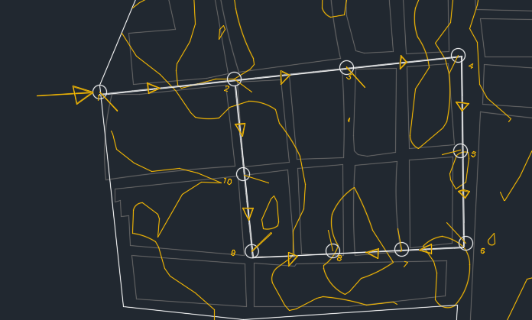

*Figure 3. The path of drinking water system*

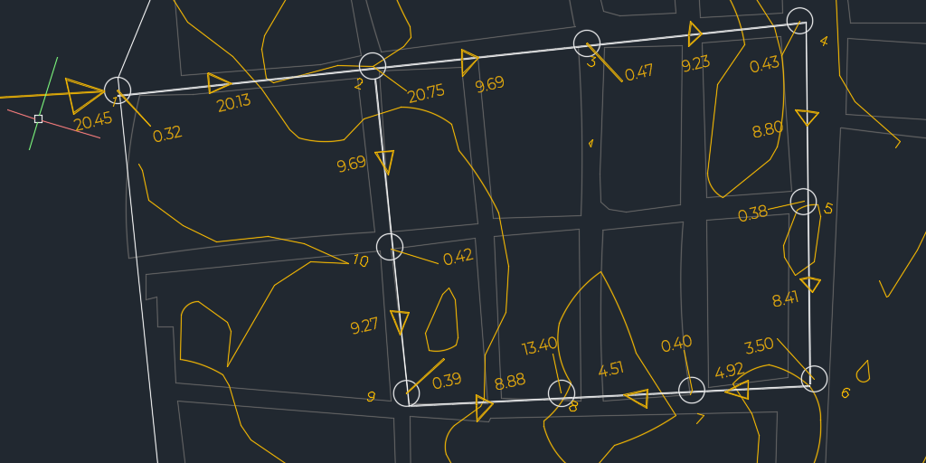

*Figure 4. Maximum initial water flow*

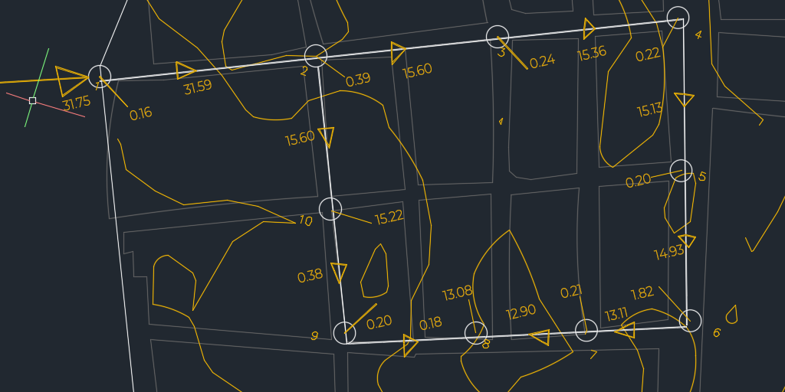

*Figure 5. Average initial flow*

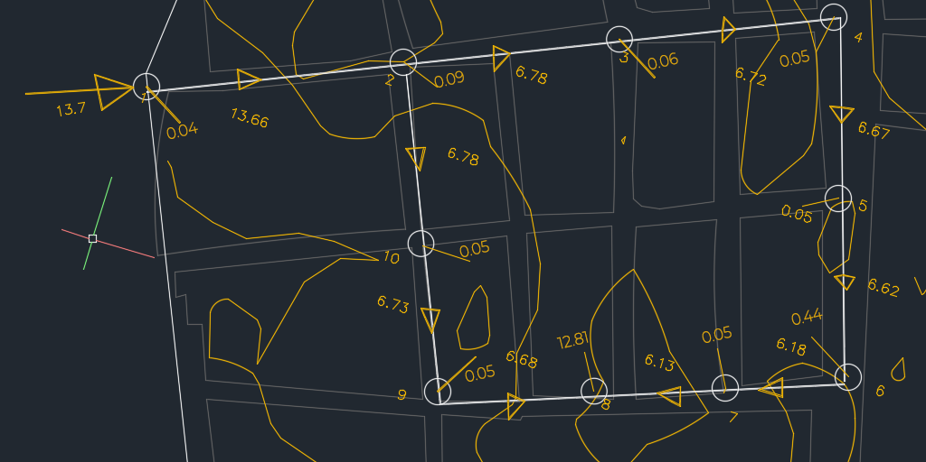

*Figure 5. Minimum initial flow*