ScriptScriptScriptIn [1]:

# import libraries

import numpy as np

import pandas as pd

from pprint import pprint as pp

import string

import seaborn as sns;sns.set(style="ticks", color_codes=True)

from sklearn.linear_model import LogisticRegression

import warnings

warnings.filterwarnings('ignore')

import matplotlib.pyplot as plt

from matplotlib.colors import ListedColormap

%matplotlib inline

Project Task 1

In [2]:

# 1. import the dataframe

df = pd.read_csv(r"D:\DataScience_Masters program doc\Course 6_Data Science Capstone\Project 2\Healthcare - Diabetes\health care diabetes.csv")

df.head()

Out[2]:

|  | Pregnancies | Glucose | BloodPressure | SkinThickness | Insulin | BMI | DiabetesPedigreeFunction | Age | Outcome |
| --- | --- | --- | --- | --- | --- | --- | --- | --- | --- |
| 0 | 6 | 148 | 72 | 35 | 0 | 33.6 | 0.627 | 50 | 1 |
| 1 | 1 | 85 | 66 | 29 | 0 | 26.6 | 0.351 | 31 | 0 |
| 2 | 8 | 183 | 64 | 0 | 0 | 23.3 | 0.672 | 32 | 1 |
| 3 | 1 | 89 | 66 | 23 | 94 | 28.1 | 0.167 | 21 | 0 |
| 4 | 0 | 137 | 40 | 35 | 168 | 43.1 | 2.288 | 33 | 1 |

In [3]:

# checking the data type of the varialbles

df.info()

<class 'pandas.core.frame.DataFrame'>

RangeIndex: 768 entries, 0 to 767

Data columns (total 9 columns):

# Column Non-Null Count Dtype

--- ------ -------------- -----

0 Pregnancies 768 non-null int64

1 Glucose 768 non-null int64

2 BloodPressure 768 non-null int64

3 SkinThickness 768 non-null int64

4 Insulin 768 non-null int64

5 BMI 768 non-null float64

6 DiabetesPedigreeFunction 768 non-null float64

7 Age 768 non-null int64

8 Outcome 768 non-null int64

dtypes: float64(2), int64(7)

memory usage: 54.1 KB

In [4]:

# 1. Perform descriptive analysis.

df.describe().transpose()

Out[4]:

|  | count | mean | std | min | 25% | 50% | 75% | max |
| --- | --- | --- | --- | --- | --- | --- | --- | --- |
| Pregnancies | 768.0 | 3.845052 | 3.369578 | 0.000 | 1.00000 | 3.0000 | 6.00000 | 17.00 |
| Glucose | 768.0 | 120.894531 | 31.972618 | 0.000 | 99.00000 | 117.0000 | 140.25000 | 199.00 |
| BloodPressure | 768.0 | 69.105469 | 19.355807 | 0.000 | 62.00000 | 72.0000 | 80.00000 | 122.00 |
| SkinThickness | 768.0 | 20.536458 | 15.952218 | 0.000 | 0.00000 | 23.0000 | 32.00000 | 99.00 |
| Insulin | 768.0 | 79.799479 | 115.244002 | 0.000 | 0.00000 | 30.5000 | 127.25000 | 846.00 |
| BMI | 768.0 | 31.992578 | 7.884160 | 0.000 | 27.30000 | 32.0000 | 36.60000 | 67.10 |
| DiabetesPedigreeFunction | 768.0 | 0.471876 | 0.331329 | 0.078 | 0.24375 | 0.3725 | 0.62625 | 2.42 |
| Age | 768.0 | 33.240885 | 11.760232 | 21.000 | 24.00000 | 29.0000 | 41.00000 | 81.00 |
| Outcome | 768.0 | 0.348958 | 0.476951 | 0.000 | 0.00000 | 0.0000 | 1.00000 | 1.00 |

In [5]:

# Detecting missing values

# We can see from the above result there are columns that have a minimum value of zero (0).

# For columns: Glucose,BloodPressure,SkinThickness,Insulin and BMI a value of zero does not make sense and indicates an invalid or missing value.

# count the number of missing values for each column

from numpy import nan

df['Glucose'] = df['Glucose'].replace(0, nan)

df['BloodPressure'] = df['BloodPressure'].replace(0, nan)

df['SkinThickness'] = df['SkinThickness'].replace(0, nan)

df['Insulin'] = df['Insulin'].replace(0, nan)

df['BMI'] = df['BMI'].replace(0, nan)

In [6]:

# number of missing values

df.isnull().sum()

Out[6]:

Pregnancies 0

Glucose 5

BloodPressure 35

SkinThickness 227

Insulin 374

BMI 11

DiabetesPedigreeFunction 0

Age 0

Outcome 0

dtype: int64

In [7]:

# Lets check the dataset is filled with the na values

df.head(10)

Out[7]:

|  | Pregnancies | Glucose | BloodPressure | SkinThickness | Insulin | BMI | DiabetesPedigreeFunction | Age | Outcome |
| --- | --- | --- | --- | --- | --- | --- | --- | --- | --- |
| 0 | 6 | 148.0 | 72.0 | 35.0 | NaN | 33.6 | 0.627 | 50 | 1 |
| 1 | 1 | 85.0 | 66.0 | 29.0 | NaN | 26.6 | 0.351 | 31 | 0 |
| 2 | 8 | 183.0 | 64.0 | NaN | NaN | 23.3 | 0.672 | 32 | 1 |
| 3 | 1 | 89.0 | 66.0 | 23.0 | 94.0 | 28.1 | 0.167 | 21 | 0 |
| 4 | 0 | 137.0 | 40.0 | 35.0 | 168.0 | 43.1 | 2.288 | 33 | 1 |
| 5 | 5 | 116.0 | 74.0 | NaN | NaN | 25.6 | 0.201 | 30 | 0 |
| 6 | 3 | 78.0 | 50.0 | 32.0 | 88.0 | 31.0 | 0.248 | 26 | 1 |
| 7 | 10 | 115.0 | NaN | NaN | NaN | 35.3 | 0.134 | 29 | 0 |
| 8 | 2 | 197.0 | 70.0 | 45.0 | 543.0 | 30.5 | 0.158 | 53 | 1 |
| 9 | 8 | 125.0 | 96.0 | NaN | NaN | NaN | 0.232 | 54 | 1 |

As you can see in the above distribution greter number of “missing value” is found in the dataset. Hence, different strategies may be needed for different columns to ensure that there are still a sufficient number of records left to train a predictive model.

Therefore, Before handling missing values, let’s first demonstrate that “missing value” in a dataset can cause problems by seeing the distribution of the missied value columns using the historgram function.

1. Visually explore these variables using histograms. Treat the missing values accordingly.

In [8]:

df.Glucose.hist()

Out[8]:

<AxesSubplot:>

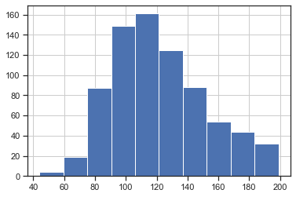

In [9]:

df.BloodPressure.hist()

Out[9]:

<AxesSubplot:>

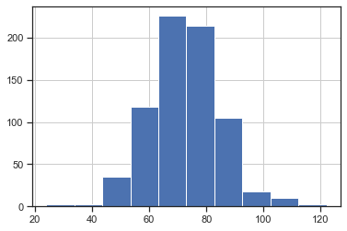

In [10]:

df.SkinThickness.hist()

Out[10]:

<AxesSubplot:>

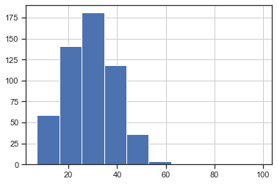

In [11]:

df.Insulin.hist()

Out[11]:

<AxesSubplot:>

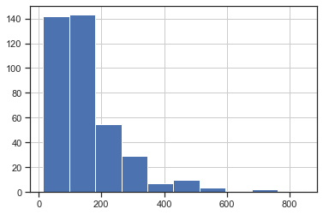

In [12]:

df.BMI.hist()

Out[12]:

<AxesSubplot:>

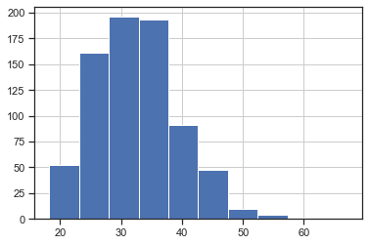

As we can see in the above dataset distirbution of the "missing value" columns having not much skewed or normal distirbution or less number of missing value like Glucose,BloodPressure and BMI will be handled by mean of the variable and for the other variables having a skewed distribution the missing values will be handeled by median.

In [13]:

df['Glucose'].fillna(df['Glucose'].mean(), inplace=True)

df['BloodPressure'].fillna(df['BloodPressure'].mean(), inplace=True)

df['BMI'].fillna(df['BMI'].mean(), inplace=True)

df['SkinThickness'].fillna(df['SkinThickness'].median(), inplace=True)

df['Insulin'].fillna(df['Insulin'].median(), inplace=True)

In [14]:

# checking the missied columns are replaced by mean and median

df['BloodPressure'].mean()

Out[14]:

72.40518417462486

In [15]:

df['SkinThickness'].median()

Out[15]:

29.0

In [16]:

df.head(10)

Out[16]:

|  | Pregnancies | Glucose | BloodPressure | SkinThickness | Insulin | BMI | DiabetesPedigreeFunction | Age | Outcome |
| --- | --- | --- | --- | --- | --- | --- | --- | --- | --- |
| 0 | 6 | 148.0 | 72.000000 | 35.0 | 125.0 | 33.600000 | 0.627 | 50 | 1 |
| 1 | 1 | 85.0 | 66.000000 | 29.0 | 125.0 | 26.600000 | 0.351 | 31 | 0 |
| 2 | 8 | 183.0 | 64.000000 | 29.0 | 125.0 | 23.300000 | 0.672 | 32 | 1 |
| 3 | 1 | 89.0 | 66.000000 | 23.0 | 94.0 | 28.100000 | 0.167 | 21 | 0 |
| 4 | 0 | 137.0 | 40.000000 | 35.0 | 168.0 | 43.100000 | 2.288 | 33 | 1 |
| 5 | 5 | 116.0 | 74.000000 | 29.0 | 125.0 | 25.600000 | 0.201 | 30 | 0 |
| 6 | 3 | 78.0 | 50.000000 | 32.0 | 88.0 | 31.000000 | 0.248 | 26 | 1 |
| 7 | 10 | 115.0 | 72.405184 | 29.0 | 125.0 | 35.300000 | 0.134 | 29 | 0 |
| 8 | 2 | 197.0 | 70.000000 | 45.0 | 543.0 | 30.500000 | 0.158 | 53 | 1 |
| 9 | 8 | 125.0 | 96.000000 | 29.0 | 125.0 | 32.457464 | 0.232 | 54 | 1 |

In [17]:

# checking missing values are handled

df.isnull().sum()

Out[17]:

Pregnancies 0

Glucose 0

BloodPressure 0

SkinThickness 0

Insulin 0

BMI 0

DiabetesPedigreeFunction 0

Age 0

Outcome 0

dtype: int64

1. There are integer and float data type variables in this dataset. Create a count (frequency) plot describing the data types and the count of variables.

In [18]:

sns.countplot(df.dtypes.map(str))

plt.show()

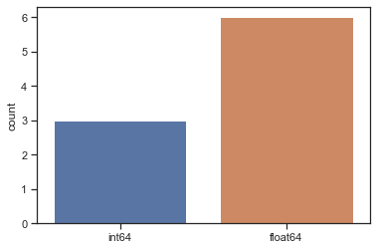

Project Task:2

1. Check the balance of the data by plotting the count of outcomes by their value. Describe your findings and plan future course of action.

In [19]:

Counts=df['Outcome'].value_counts()

Counts

Out[19]:

0 500

1 268

Name: Outcome, dtype: int64

In [20]:

Percent=df['Outcome'].value_counts(normalize = True)

Percent

Out[20]:

0 0.651042

1 0.348958

Name: Outcome, dtype: float64

In [21]:

Percent100=df['Outcome'].value_counts(normalize = True).mul(100).round(1).astype(str) + '%'

Percent100

Out[21]:

0 65.1%

1 34.9%

Name: Outcome, dtype: object

In [22]:

pd.DataFrame({'Counts':Counts , 'per':Percent , 'per100':Percent100})

Out[22]:

|  | Counts | per | per100 |
| --- | --- | --- | --- |
| 0 | 500 | 0.651042 | 65.1% |
| 1 | 268 | 0.348958 | 34.9% |

In [23]:

diabetes = sns.countplot(df['Outcome'])

diabetes.set_xticklabels(['Not diabetes','diabetes'])

plt.show()

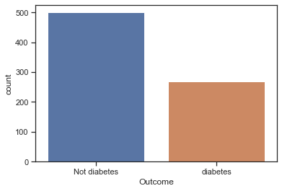

You can clearly see that there is a huge difference between the outcome variable. 500 Not diabetes and 268 with diabetes. Therefore, Imbalance data can hamper our model accuracy and high error. In a dataset with highly unbalanced classes, the classifier will always “predicts” the most common class without performing any analysis of the features and it will have a high accuracy rate, obviously not the correct one.

There is no short answer to the question if an undersampling or oversampling method is better for imbalanced data, even more so on.However, most researches have pointed out that undersampling in most cases does produce better results than oversampling.

The common argument is that undersampling is generally “cheaper” than oversampling and since the class of interest (Diabetes) is the minority positive class, reducing some information of the majority negative class is acceptable.

1. Create scatter charts between the pair of variables to understand the relationships. Describe your findings

In [24]:

sns.pairplot(df, hue = 'Outcome')

Out[24]:

<seaborn.axisgrid.PairGrid at 0x2093ced9280>

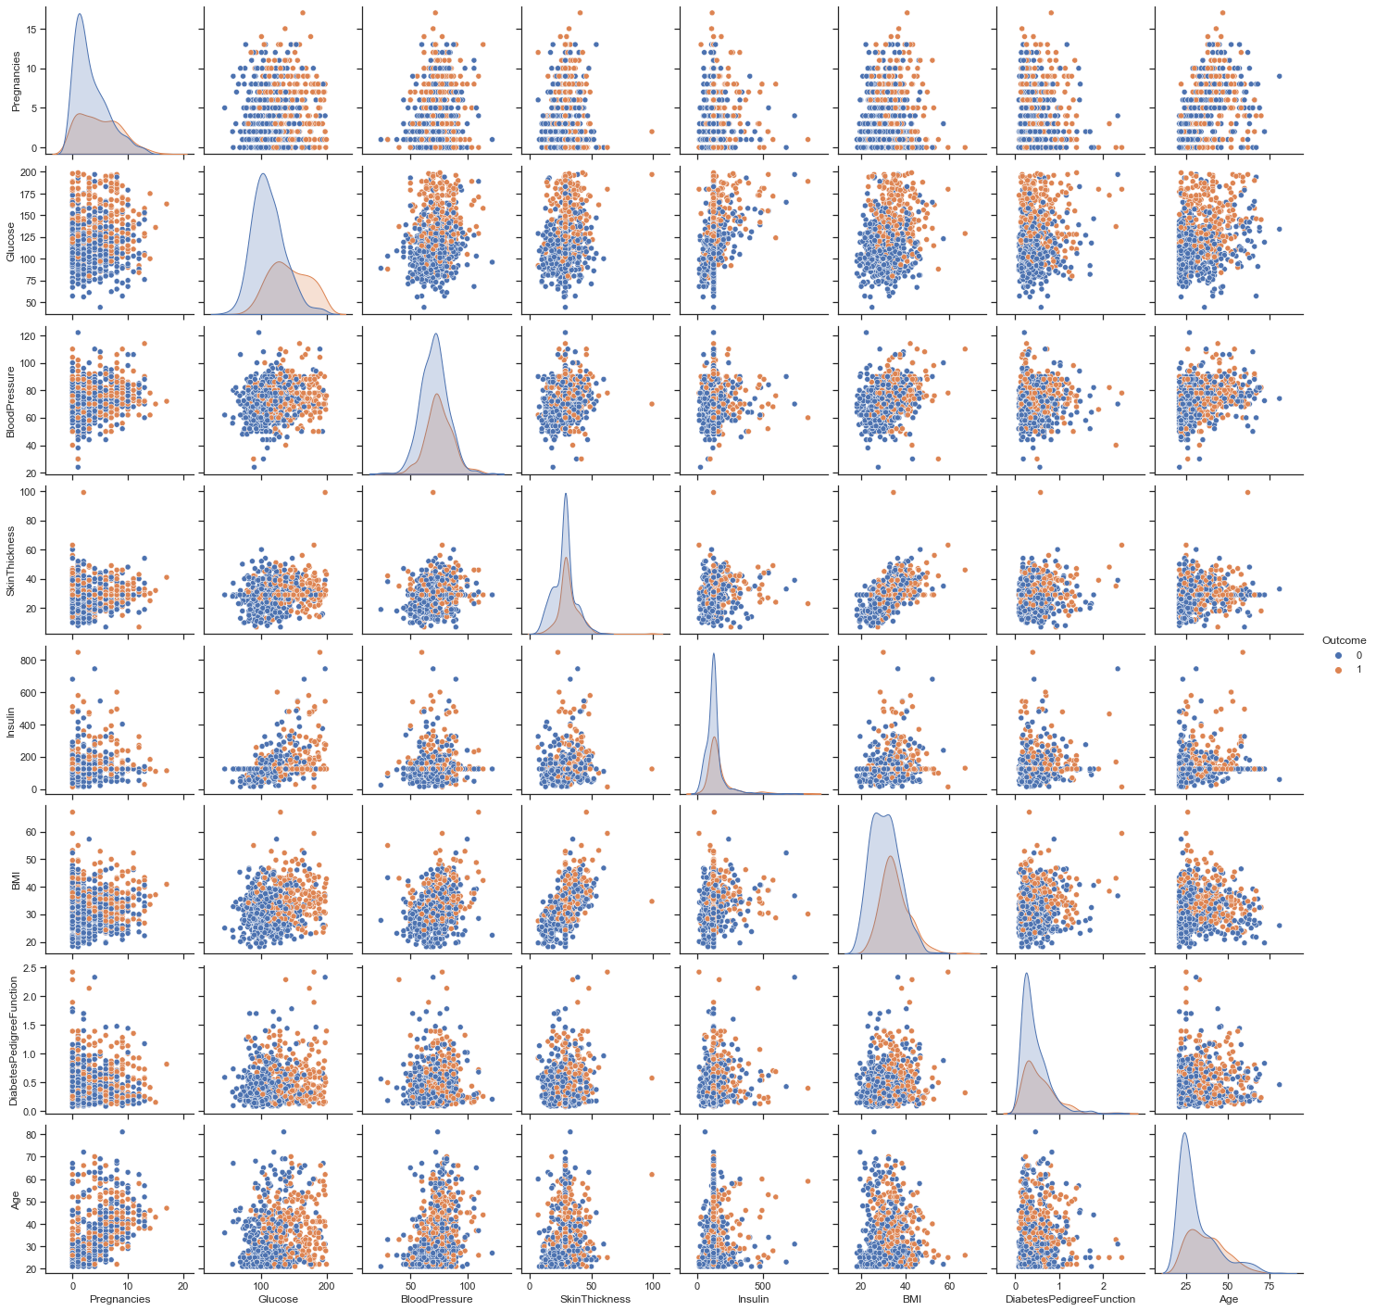

As we can see in the above scatter charts; We see that BMI is positively correlated with inceresing Skin thinkness,BloodPressure, Insulin level and Diabetes Pedigree Function and also tends to increase the occurance of diabetics. This means having a greater numeber of BMI tends to have high level of Skin thinkness,BloodPressure, Insulin level and Diabetes Pedigree Function and ofcourse may have a contirbution for beeing diabetic (although this of course does not prove that one causes the other).

The other finding is that as the age increases a positive coorrelation with the the occurance of diabets.

1. Perform correlation analysis. Visually explore it using a heat map.

In [25]:

corr = df.corr()

print(corr)

sns.heatmap(corr,

xticklabels=corr.columns,

yticklabels=corr.columns)

Pregnancies Glucose BloodPressure SkinThickness \

Pregnancies 1.000000 0.127911 0.208522 0.081770

Glucose 0.127911 1.000000 0.218367 0.192686

BloodPressure 0.208522 0.218367 1.000000 0.191853

SkinThickness 0.081770 0.192686 0.191853 1.000000

Insulin 0.025047 0.419064 0.045087 0.155610

BMI 0.021565 0.230941 0.281268 0.543162

DiabetesPedigreeFunction -0.033523 0.137060 -0.002763 0.102188

Age 0.544341 0.266534 0.324595 0.126107

Outcome 0.221898 0.492928 0.166074 0.214873

Insulin BMI DiabetesPedigreeFunction \

Pregnancies 0.025047 0.021565 -0.033523

Glucose 0.419064 0.230941 0.137060

BloodPressure 0.045087 0.281268 -0.002763

SkinThickness 0.155610 0.543162 0.102188

Insulin 1.000000 0.180170 0.126503

BMI 0.180170 1.000000 0.153400

DiabetesPedigreeFunction 0.126503 0.153400 1.000000

Age 0.097101 0.025519 0.033561

Outcome 0.203790 0.311924 0.173844

Age Outcome

Pregnancies 0.544341 0.221898

Glucose 0.266534 0.492928

BloodPressure 0.324595 0.166074

SkinThickness 0.126107 0.214873

Insulin 0.097101 0.203790

BMI 0.025519 0.311924

DiabetesPedigreeFunction 0.033561 0.173844

Age 1.000000 0.238356

Outcome 0.238356 1.000000

Out[25]:

<AxesSubplot:>

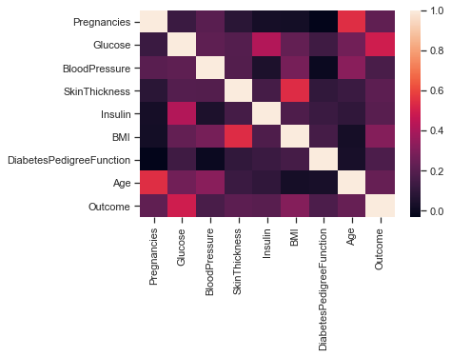

In this heatmap above, the values that are closest to the light orange color represent stronger positive correlations. Those closer to the deep purple represent stronger negative correlations.

Project Task:3

1. Devise strategies for model building. It is important to decide the right validation framework. Express your thought process.

Before using validation techniques we deal with Imbalanced Classes using Undersampling by removing some observations of the majority class. This is done until the majority and minority class is balanced out.

In [26]:

#Separating the Outcome that will be 0 and 1.

# Outcome count

Outcome_count_0, Outcome_count_1 = df['Outcome'].value_counts()

# Separate Outcome

Outcome_0 = df[df['Outcome'] == 0]

Outcome_1 = df[df['Outcome'] == 1]

# print the shape of the Outcome

print('Outcome 0:', Outcome_0.shape)

print('Outcome 1:', Outcome_1.shape)

Outcome 0: (500, 9)

Outcome 1: (268, 9)

In [27]:

Outcome_0_under = Outcome_0.sample(Outcome_count_1)

df_test_under = pd.concat([Outcome_0_under, Outcome_1], axis=0)

print("total class of 1 and 0:",df_test_under['Outcome'].value_counts())

# plot the count after under-sampeling

df_test_under['Outcome'].value_counts().plot(kind='bar', title='count (target)')

total class of 1 and 0: 0 268

1 268

Name: Outcome, dtype: int64

Out[27]:

<AxesSubplot:title={'center':'count (target)'}>

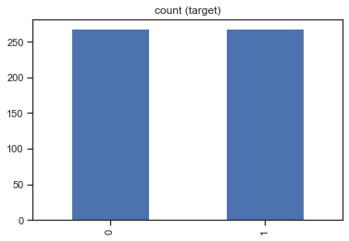

In [28]:

# Check the shape of the dataset

print('Shape of the Dataframe after using under sampling to deal with Imbalanced Classes:', df_test_under.shape)

Shape of the Dataframe after using under sampling to deal with Imbalanced Classes: (536, 9)

Inorder to have the confidence that the trained model will generalize well on the unseen data we will check implementation of several validation techniques, mentioned below:

1. Hold Out Validation-Train and Test Set Split
2. K-fold Cross-Validation.
3. Stratified K-fold Cross-Validation
4. Leave One Out Cross-Validation.
5. Repeated Random Test-Train Splits

Since the outcome variable is catagorical we use the Logistic Regression Model for the perdicition and comapring the accuracy of validation techniques.

In [29]:

# Creating Arrays for the Features and the Outcome Variable

x1 = df_test_under.drop('Outcome', axis=1).values

y1 = df_test_under['Outcome'].values

1. Holdout Validation Approach - Train and Test Set Split The training data is used to train the model while the unseen data is used to validate the model performance. The common split ratio used is 70:30.

In [30]:

# import the necessary modules

from sklearn import model_selection

from sklearn.model_selection import train_test_split

In [31]:

# splits the data into the training and the test data

X_train, X_test, Y_train, Y_test = model_selection.train_test_split(x1, y1, test_size=0.30, random_state=100)

# instantiate the LogisticRegression() model

model = LogisticRegression()

# fit the model on the training data

model.fit(X_train, Y_train)

# use the trained model to generate Accuracy scores on the test data

result = model.score(X_test, Y_test)

# print the accuracy result.

print("Holdout Validation Approach Accuracy Score: %.2f%%" % (result*100.0))

Holdout Validation Approach Accuracy Score: 76.40%

1. K-fold Cross-Validation. In k-fold cross-validation, the data is divided into k folds. The model is trained on k-1 folds with one fold held back for testing. This process gets repeated to ensure each fold of the dataset gets the chance to be the held back set. Once the process is completed, we can summarize the evaluation metric using the mean or/and the standard deviation. We will use 10-fold cross-validation for our problem statement.

In [32]:

# import the necessary modules

from sklearn.model_selection import KFold

# creates 10 folds.

kfold = model_selection.KFold(n_splits=10, random_state=None)

# instantiate the LogisticRegression() model

model_kfold = LogisticRegression()

# fits the model and generates cross-validation scores

results_kfold = model_selection.cross_val_score(model_kfold, x1, y1, cv=kfold)

# prints the mean accuracy result.

print("K-fold Cross-Validation Accuracy Score: %.2f%%" % (results_kfold.mean()*100.0))

K-fold Cross-Validation Accuracy Score: 65.86%

1. Stratified K-fold Cross-Validation - is a variation of k-fold cross-validation that returns stratified folds.

In [33]:

# import the necessary modules

from sklearn.model_selection import StratifiedKFold

# creates the Stratified KFolds

skfold = StratifiedKFold(n_splits=3, random_state=None)

# instantiate the LogisticRegression() model

model_skfold = LogisticRegression()

# fits the model and generates cross-validation scores

results_skfold = model_selection.cross_val_score(model_skfold, x1, y1, cv=skfold)

# prints the mean accuracy result.

print("Stratified K-fold Cross-Validation Accuracy Score: %.2f%%" % (results_skfold.mean()*100.0))

Stratified K-fold Cross-Validation Accuracy Score: 72.21%

1. Leave One Out Cross-Validation(LOOCV) - This variation is useful since the training data is of limited size and the number of parameters to be tested is not high.

In [34]:

# import the necessary modules

from sklearn.model_selection import LeaveOneOut

from sklearn.model_selection import LeavePOut

# creates the leave-one-out cross-validation

loocv = model_selection.LeaveOneOut()

# instantiate the LogisticRegression() model

model_loocv = LogisticRegression()

# fits the model and generates cross-validation scores

results_loocv = model_selection.cross_val_score(model_loocv, x1, y1, cv=loocv)

# prints the mean accuracy result.

print("Leave One Out Cross-Validation Accuracy Score: %.2f%%" % (results_loocv.mean()*100.0))

Leave One Out Cross-Validation Accuracy Score: 73.13%

In [35]:

# The mean accuracy result for the various techniques is summarised below:

print("Holdout Validation Approach Accuracy Score: %.2f%%" % (result*100.0))

print("K-fold Cross-Validation Accuracy Score: %.2f%%" % (results_kfold.mean()*100.0))

print("Stratified K-fold Cross-Validation Accuracy Score: %.2f%%" % (results_skfold.mean()*100.0))

print("Leave One Out Cross-Validation Accuracy Score: %.2f%%" % (results_loocv.mean()*100.0))

Holdout Validation Approach Accuracy Score: 76.40%

K-fold Cross-Validation Accuracy Score: 65.86%

Stratified K-fold Cross-Validation Accuracy Score: 72.21%

Leave One Out Cross-Validation Accuracy Score: 73.13%

We can conclude that the Holdout Validation Approach improves the performance of the model and is a better model validation strategy.

1. Apply an appropriate classification algorithm to build a model. Compare various models with the results from KNN algorithm.

Since the Holdout Validation Approach has greater accuracy score we used to evaluate each algorithm, to ensure that the same splits to the training data are performed and that each algorithms is evaluated in precisely the same way.

In [36]:

from sklearn.linear_model import LogisticRegression

from sklearn.tree import DecisionTreeClassifier

from sklearn.neighbors import KNeighborsClassifier

from sklearn.discriminant_analysis import LinearDiscriminantAnalysis

from sklearn.naive_bayes import GaussianNB

from sklearn.svm import SVC

%matplotlib inline

In [37]:

# prepare models

models = []

models.append(('LR', LogisticRegression()))

models.append(('LDA', LinearDiscriminantAnalysis()))

models.append(('KNN', KNeighborsClassifier()))

models.append(('CART', DecisionTreeClassifier()))

models.append(('NB', GaussianNB()))

models.append(('SVM', SVC()))

In [38]:

# evaluate each model for algorithm comparison

results = []

names = []

for name, model in models:

X_train, X_test, Y_train, Y_test = model_selection.train_test_split(x1, y1, test_size=0.30, random_state=100)

model.fit(X_train, Y_train)

result = model.score(X_test, Y_test)

results.append(result)

names.append(name)

msg = "%s: %f " % (name, result)

print(msg)

LR: 0.763975

LDA: 0.751553

KNN: 0.701863

CART: 0.695652

NB: 0.732919

SVM: 0.732919

As you can see in the above results, Logistic regaration has a great accuracy score of 77% and its a best peridictive model

Project Task: 4

1. Create a classification report by analyzing sensitivity, specificity, AUC (ROC curve), etc. Please be descriptive to explain what values of these parameter you have used.

In [39]:

# splits the data into the training and the test data

X_train, X_test, Y_train, Y_test = model_selection.train_test_split(x1, y1, test_size=0.30, random_state=100)

# instantiate the necessary libraries

from sklearn import metrics

from sklearn.metrics import classification_report

from sklearn import model_selection

from sklearn.metrics import plot_confusion_matrix

from sklearn.metrics import accuracy_score

from sklearn.metrics import roc_curve

from sklearn.metrics import roc_auc_score

from sklearn.metrics import confusion_matrix

from sklearn import metrics

from sklearn.model_selection import cross_val_score

# instantiate the LogisticRegression() model

model = LogisticRegression()

# fit the model on the training data

model.fit(X_train, Y_train)

# predict the attrition on the test data

y_pred_full = model.predict(X_test)

In [40]:

# print the classification report

print(classification_report(Y_test, y_pred_full))

precision recall f1-score support

0 0.79 0.76 0.77 86

1 0.73 0.77 0.75 75

accuracy 0.76 161

macro avg 0.76 0.76 0.76 161

weighted avg 0.77 0.76 0.76 161

In the above classification report,

1. Sensitivity or recall is the ratio of correct positive predictions (diabetes) to the total no. of positive predictions. Or more simply, how sensitive the classifier is for detecting positive instances.Therefore, the model have 76% sensitive to detect the diabetics
2. Specificity is the ratio of correct negative predictions (not diabetic) to the total no. of negative predictions. This determines how specific the classifier is in predicting positive instances.Therefore, the model have 78% Specificity to detect the none diabetics
3. Precision is the ratio of correct predictions to the total no. of predicted correct predictions(diabates). Therefore, the Precision of model to detect diabates is 75%

In [41]:

plot_confusion_matrix(model, X_test, Y_test)

Out[41]:

<sklearn.metrics._plot.confusion_matrix.ConfusionMatrixDisplay at 0x2093fdc8370>

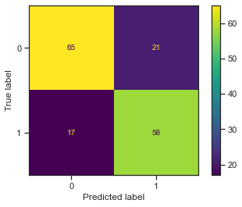

In [42]:

# the roc_curve() returns the values for false positive rate, true positive rate and threshold

# pass the actual target values and predicted probabilities to the function

fpr, tpr, thresholds = roc_curve(Y_test, y_pred_full)

In [43]:

# plot the straight line showing worst prediction for the model

plt.plot([0, 1], [0, 1],'r--')

# plot the ROC curve

plt.plot(fpr, tpr)

# add the AUC score to the plot

# 'x' and 'y' gives position of the text

# 's' is the text

# use round() to round-off the AUC score upto 4 digits

plt.text(x = 0.02, y = 0.8, s = ('AUC Score:',round(metrics.roc_auc_score(Y_test, y_pred_full),4)))

# plot the grid

plt.grid(True)

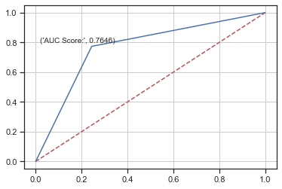

In [44]:

roc_auc_score(Y_test, y_pred_full)

Out[44]:

0.7645736434108528

AUC Score of 0.7695 showed in the above graph tells that , there is a high chance that the classifier will be able to distinguish the positive class values from the negative class values.

End of analysis part of the project

In [61]:

# Exporting the cleaned dataset for the data visualization on tabealu

df.to_excel(r'D:\DataScience_Masters program doc\Course 6_Data Science Capstone\Project 2\Healthcare - Diabetes\health care diabetes_cleaned.xlsx', index = False)

Please check the tabealu public for the visulaization section