PRODUCT DESIGN & TECHNOLOGY RESEARCH
TapLog as a Living Field Journal
How to replace perfectionist minimalism with a human, artsy, tree-and-flower interface—without slowing five-second expense capture
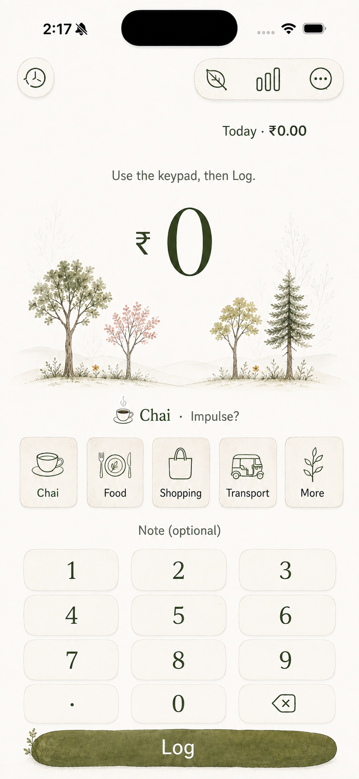
Prepared for product and implementation review
September 3, 2026 · TapLog iOS 17+ · SwiftUI

Executive recommendation
Decision Keep SwiftUI. Build the botanical identity primarily with native Canvas, Path, Shape, asset-catalog vectors, keyframe animation and a tiny paper texture. Prototype Rive only for one complex hero or onboarding animation; do not make it the rendering foundation.
TapLog already has the correct interaction model: amount, category, keypad and Log are immediately available. The redesign should preserve that skeleton and make the empty visual field carry a living representation of the user’s budgets. The forest becomes useful product state—not decorative wallpaper.
The proposed design language is “a pocket field journal where spending grows a small personal grove.” It combines editorial typography, restrained hand-inked illustration, translucent botanical color and short state-driven motion. The result should feel authored and warm while remaining unmistakably a utility.

Recommended stack at a glance
Layer | Recommended technology | Why
App structure | SwiftUI | Preserves the existing app, accessibility model and fast native controls.
Dynamic grove | Canvas + Path + GraphicsContext | Best fit for variable, state-driven trees and flowers.
Illustrated stamps | SVG/vector PDF in Assets.xcassets | Sharp, themeable artwork without runtime parsing.
Motion | withAnimation, keyframeAnimator, phaseAnimator | Enough for brief growth and settling reactions on iOS 17.
Texture | Small seamless PNG + ImagePaint | Predictable paper grain at negligible conceptual complexity.
Complex authored animation | Rive, selectively | Useful when a designer needs state machines and artboard-level control.
Fixed cinematic animation | Lottie, selectively | Suitable for onboarding or paywall sequences, not a procedural grove.

Non-goals
- Do not turn TapLog into a gardening game or add collection mechanics merely to justify the visual theme.
- Do not decorate every control with leaves, flowers, paper edges or animations.
- Do not replace accessible native controls with a static illustration or screenshot.
- Do not install multiple animation frameworks before a native prototype proves insufficient.
- Do not regress the core promise: a purchase should still be captured in roughly five seconds.

1. Current-state assessment and design thesis
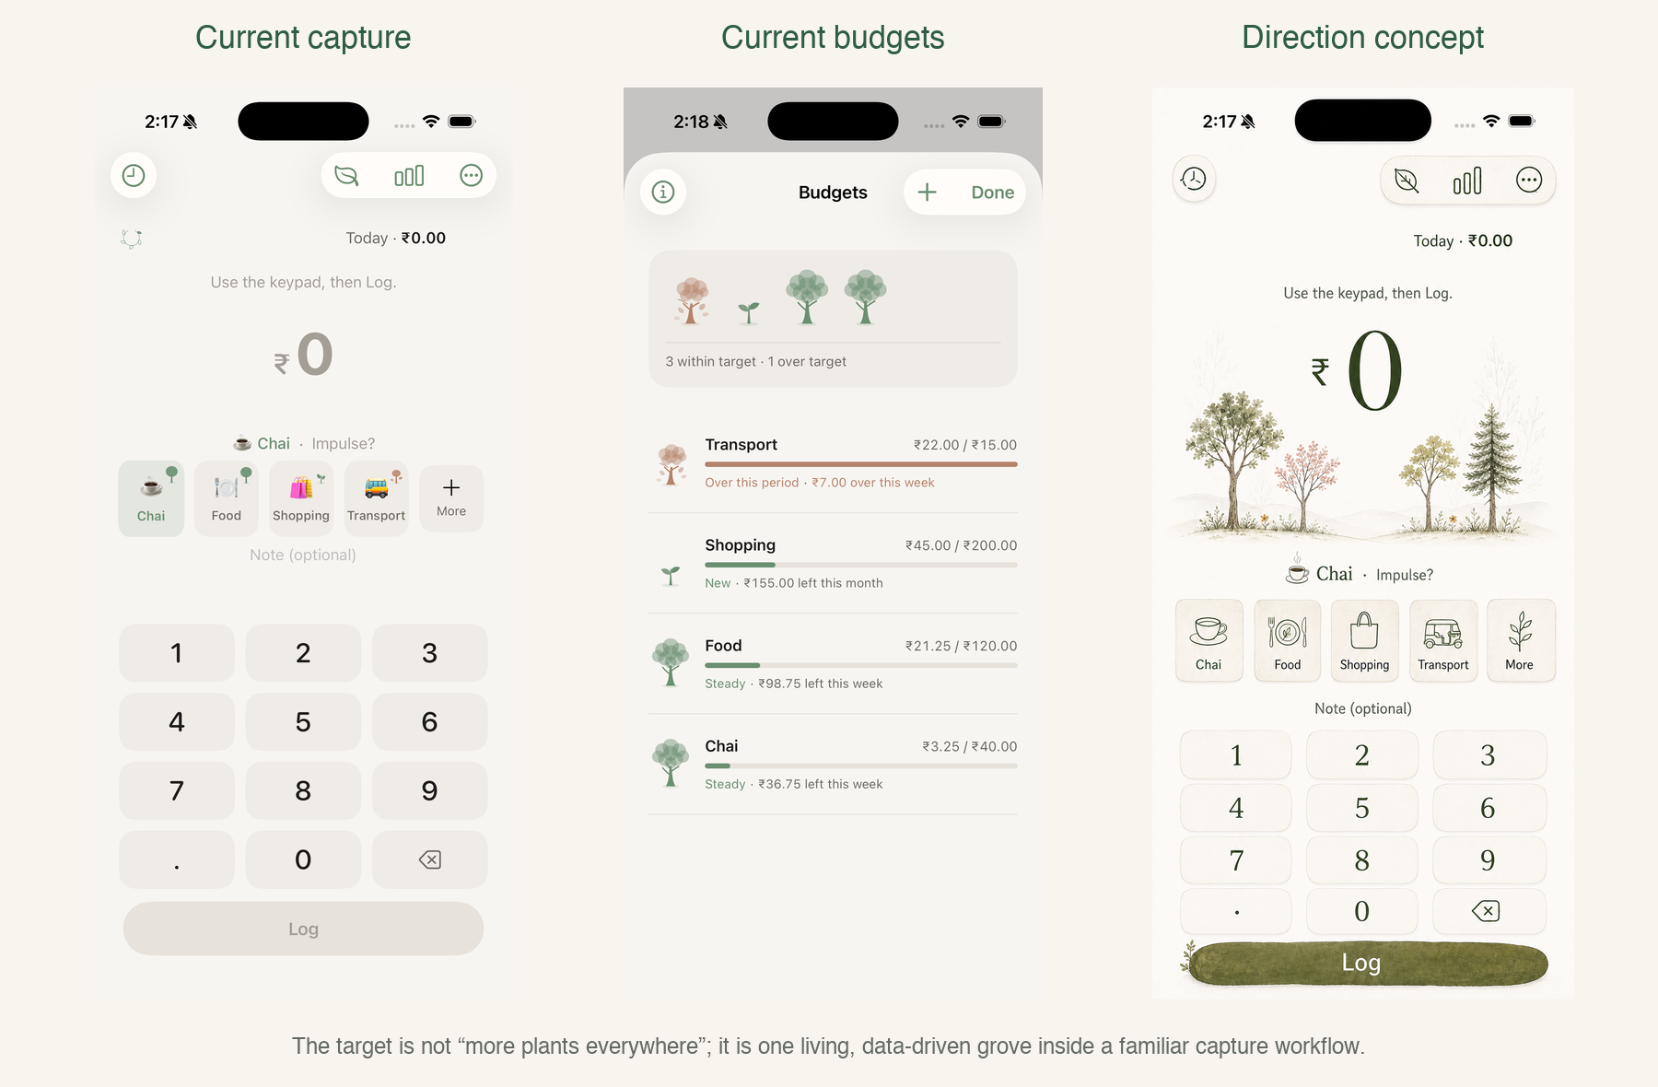
Figure 1. Current capture and budget screens compared with the restrained field-journal direction.

What is working today
- The capture path is direct, thumb-friendly and visually centered on the amount.
- The custom keypad avoids system-keyboard delay and preserves a predictable five-second flow.
- Budget health already has a kind, nonpunitive tree metaphor with seedling, growing, wilting and resting states.
- Theme, motion and scalable tree geometry are already centralized enough to evolve surgically.

Why the current design feels perfectionist
The interface is composed primarily from flawless capsules, rounded rectangles, centered type and a narrow warm-neutral palette. Large areas of empty background communicate calm, but they do not communicate identity. Small tree badges read as status icons rather than a world. Emoji, SF Symbols and custom tree drawings also create three competing illustration dialects.
The redesign should not remove whitespace. It should give the whitespace one narrative job: hold the grove. Everything else remains edited and quiet.

Design thesis
North star A familiar finance utility resting on a lightly illustrated field-journal page, with one living grove that changes because of real spending behavior.

2. Proposed visual system

2.1 Visual grammar
Dimension | Current tendency | Proposed treatment
Background | Flat warm paper color | Off-white paper plus nearly invisible fibrous grain.
Shapes | Repeated perfect capsules | A small authored family of deterministic organic silhouettes.
Color | One sage accent | Semantic moss, fern, lichen, bloom, bark and autumn accents.
Type | System rounded throughout | Editorial serif for focal amounts; humanist sans for controls and data.
Icons | Emoji + SF Symbols + tree art | Custom botanical stamps for categories; native symbols only for chrome.
Illustration | Tiny standalone tree marks | One integrated grove scene with varied height and species.
Motion | General fades and scaling | Short growth reactions tied to successful user actions.

2.2 Proposed color roles
Token | Example | Role
paper | #F8F5EE | Primary light background; warm but not yellow.
ink | #20231F | Primary text and critical numeric information.
moss | #2F5D43 | Primary action, healthy foliage, selected state.
fern | #5F7D62 | Secondary botanical linework and navigation tint.
lichen | #DDE7D7 | Soft selection and quiet grouped surfaces.
clay | #AD6F50 | Over-target, autumn and warm warning states.
bloom | Muted marigold / dusty rose | Sparse progress flowers; never essential state alone.

2.3 Typography
Use one expressive typographic voice and one utility voice. The large amount, budget-cover totals and selected recap headlines can use the system serif design or New York. Buttons, labels, keypad digits, histories and settings should remain SF Pro/SF Rounded with Dynamic Type. Apple recommends minimizing the number of typefaces and retaining readable text styles; this two-voice split preserves hierarchy without becoming editorial theater. [7]

2.4 Controlled imperfection
- Author three or four organic corner profiles and assign them consistently by component role.
- Use tapered strokes, slight asymmetry and translucent overlaps inside artwork—not in text baselines.
- Seed scene variation from stable category identifiers so a user’s grove does not rearrange on every render.
- Never use live random values inside SwiftUI body or Canvas drawing; visual instability reads as a bug.
- Keep the amount, keypad digits, totals and progress bars geometrically precise because they carry financial meaning.

3. Turning the forest into product behavior
The strongest natural interfaces map user behavior to visible consequences. Forest’s focus product succeeds because a focus session grows a tree; the metaphor is the feedback loop rather than the wallpaper. TapLog should use the same principle without copying its mechanics. This is a product-design inference from Forest’s published model. [16]

3.1 Suggested data-to-art mapping
Product signal | Visual expression | User meaning
Budgeted category | One named tree in the grove | This spending area is being tended.
Category identity | Stable tree species and small accent color | The tree remains recognizable over time.
Budget age | Height and branch maturity | Long-lived budgets acquire presence.
Low utilization | Open young foliage | Plenty of room remains.
Healthy utilization | Balanced crown and a few buds | Spending is progressing steadily.
Near target | Denser warm foliage | Attention is appropriate, without alarm.
Over target | Autumnal thinning or resting posture | The period exceeded its target; the tree is not punished.
Successful log | One leaf or bloom appears briefly | The recorded action affected this category.
Weekly consistency | Wreath fills leaf by leaf | Habit formation is visible at a glance.

3.2 Emotional rules
- No tree dies. Resting, thinning and seasonal change communicate status without shame.
- Growth is acknowledgment, not a reward currency. Avoid coins, unlock shops and collectible species in the first version.
- Flowers remain sparse. Their appearance should mean something—consistency, recovery or a completed period.
- Use copy that sounds observant rather than congratulatory: “Steady this week” is better than “Amazing job!”

3.3 Surface-specific expression
Surface | Botanical role | Restraint
Capture | Quiet grove horizon around the amount | One focal illustration; controls remain visually plain.
Budgets | Expanded grove plus detailed rows | Rows use small species marks, not full scenes.
History | Field-note dividers and category stamps | No continuous forest background behind transaction text.
Recap | Seasonal journal spread | Illustration frames the data; it does not replace charts or values.
Onboarding | Seed → sprout → tree explanation | One authored sequence, skippable and brief.
Widget | Single strong tree/wreath glyph | Widget legibility and system tinting take priority.

4. Recommended SwiftUI architecture
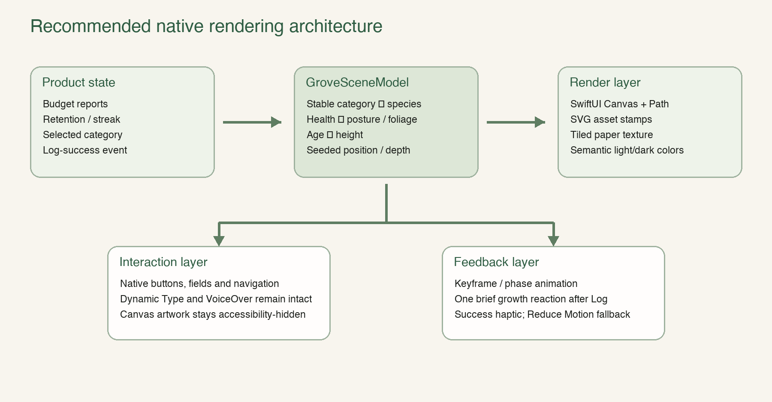
Figure 2. Product state remains separate from rendering and accessible controls.

4.1 Model layer
Introduce a view-model representation rather than teaching the rendering code about SwiftData entities directly. The model should contain only stable, resolved drawing inputs: species, health, height, x-position, depth, tint, optional bloom state and accessibility summary.
A deterministic scene builder can hash the category key into species and position. Health remains derived from BudgetCalculator. This allows Canvas previews, snapshot tests and future widget reuse without duplicating business logic.

4.2 Render layer
- Continue authoring reusable paths on a normalized design canvas, as TreeArt already does.
- Compose several species from shared trunks, branches, leaf masses, flower heads and ground strokes.
- Use GraphicsContext opacity and blend behavior to create gouache-like depth from overlaps.
- Draw the static scene in one Canvas; keep interactive category controls outside it.
- Mark decorative Canvas content accessibility-hidden and expose one concise grove summary separately.

4.3 Interaction and feedback
The Log button should update application state immediately. The growth reaction is downstream feedback and must never delay persistence, dismissal, another entry or VoiceOver announcement. Under Reduce Motion, replace growth with a short opacity change or omit it while preserving the haptic and confirmation copy. Apple recommends brief, purposeful motion and specifically warns against making users wait for frequent animations. [3]

5. Technology and library evaluation

5.1 Native SwiftUI Canvas and GraphicsContext — recommended foundation
Canvas supports immediate-mode drawing with paths, images, text, transformations, masks, filters and resolved SwiftUI symbols. Apple notes that it can be more performant than a complex view hierarchy when artwork does not require per-element interaction or accessibility. [1]
Fit for TapLog Excellent. The app already uses Canvas successfully, the grove is data-driven, and the visual states can be represented as normalized geometry plus semantic colors.
- Advantages: zero dependency, small conceptual surface, dynamic dark-mode colors, direct Swift model inputs and scalable geometry.
- Tradeoff: designers cannot independently author every motion in a visual state-machine editor; complex path morphs require engineering.
- Use for: grove scene, tree marks, wreath, growth interpolation, flower placement and decorative ground lines.

5.2 Rive — best optional interactive-art runtime
Rive provides a visual editor and an MIT-licensed Apple runtime supporting SwiftUI, state machines, events, data binding and local .riv files. Its Apple runtime supports iOS 14 and later. The current documentation describes a newer Swift-first, concurrency-aware API while noting that feature support can vary by renderer and that the newer runtime path has been evolving. [8][9]
Fit for TapLog Good for one hero tree, onboarding sequence or paywall illustration. Poor as the source of truth for a grove whose tree count and layout are generated from SwiftData.
- Use Rive when an illustrator must tune interactive states without rebuilding path logic in Swift.
- Prototype cold launch, memory, renderer behavior, transparency, VoiceOver semantics and Reduce Motion before adopting it.
- Keep critical numbers and controls outside the Rive artboard.

5.3 Lottie — fixed authored motion
Lottie renders bodymovin JSON exported from After Effects and provides a declarative SwiftUI LottieView. The project is Apache-2.0 licensed. Its recommended compact Swift package points to a precompiled XCFramework that the documentation describes as typically around 8 MB. [10]
Fit for TapLog Suitable for a fixed seed-to-tree onboarding sequence. Less suitable than Rive or native Canvas for interactive health states and a variable grove.

5.4 Asset-catalog SVG/vector art — recommended for stamps
Known illustrations should be compiled into the asset catalog rather than parsed at runtime. This keeps category stamps sharp, allows appearance variants, reduces runtime failure modes and preserves native Image behavior. Runtime SVG parsing is valuable only when the app must manipulate arbitrary SVG nodes or load artwork not known at build time.

5.5 SVGView — specialized, not required
SVGView is an MIT-licensed SwiftUI SVG parser supporting node lookup, gestures and SwiftUI animation. Its own documentation says broad SVG-standard coverage remains a work in progress. [11]
Fit for TapLog Low. TapLog owns its illustrations at build time and does not need arbitrary SVG documents or node-level runtime editing.

5.6 Pow — optional micro-effect library
Pow provides SwiftUI transitions, particles and change effects and currently supports iOS 15 and later under the MIT license. [12] It can rapidly prototype a small leaf burst, but it does not create a coherent botanical visual language.
Fit for TapLog Low to moderate. Consider only after the native animation prototype, and only if one effect would otherwise be disproportionately costly.

5.7 SpriteKit — powerful but excessive here
SpriteKit is Apple’s Metal-backed 2D scene framework with sprites, particles, physics and a continuous update cycle. [13] It is appropriate for an explorable miniature world, not for a restrained illustration behind a financial capture form.
Fit for TapLog Low. It adds a separate scene graph and lifecycle. Reconsider only if the grove becomes a genuinely interactive simulation with many continuously animated elements.

5.8 SwiftUI shaders — phase-three polish
SwiftUI can apply color, distortion and layer shaders without changing layout. [6] A shader could provide subtle pigment separation or watercolor-edge bleed, but a static texture and translucent paths are easier to tune, test and disable. Shaders should be additive polish after accessibility and performance targets are met.

5.9 Comparative decision matrix
Option | Dynamic data | Designer control | Runtime cost | TapLog decision
Canvas/Path | Excellent | Engineer-led | Low | Adopt
Asset SVG/PDF | Limited tint/state | Excellent | Very low | Adopt
Rive | Good via inputs/binding | Excellent | Medium | Prototype selectively
Lottie | Limited playback inputs | Excellent for timelines | Medium | Use only for fixed sequence
SVGView | Good node access | Good | Low–medium | Do not adopt now
Pow | Event-triggered effects | Preset-oriented | Low | Optional, likely unnecessary
SpriteKit | Excellent | Engineer-led | High for this scope | Avoid
Shaders | Excellent | Specialist-led | Variable | Defer

6. Implementation plan

Phase 0 — visual proof and guardrails
- Produce one production-resolution home concept and one budget-screen concept using the same visual system.
- Lock the allowed palette, typography roles, tree species, component silhouettes and motion vocabulary.
- Define baseline metrics: cold launch, capture completion time, accessibility behavior and screenshot references.

Phase 1 — native foundation
- Rename the conceptual “Zen” design layer to a neutral design-system name and add semantic botanical tokens.
- Extract GrovePlant and GroveSceneModel from the existing report calculations.
- Build GroveScene with the existing TreeArt geometry before adding new species.
- Add a static paper-grain asset and verify light/dark appearances.
- Keep all existing controls and persistence behavior unchanged.

Phase 2 — illustration language
- Author three tree species plus seedling, healthy, near-target and resting variants.
- Create one consistent category-stamp family for built-in categories.
- Add deterministic organic shapes for selected categories, keypad keys and the Log action.
- Replace badge-style trees on the home tiles with the integrated grove; retain compact marks where rows need status.

Phase 3 — feedback and motion
- Trigger one growth event only after persistence succeeds.
- Implement the event with native keyframe/phase animation and a success haptic.
- Add a Reduce Motion substitute and prevent animation from blocking repeated capture.
- Measure frame pacing and energy use on an older supported device.

Phase 4 — secondary surfaces
- Extend the grove to Budgets, then adapt History and Recap using lighter field-note motifs.
- Update onboarding and the paywall only after the product surface feels coherent.
- Update widgets with simplified, system-compatible botanical glyphs.

Phase 5 — optional Rive decision
Build one isolated Rive spike for the hero tree. Compare it with the native version using visual fidelity, implementation complexity, binary impact, memory, cold launch, VoiceOver semantics, Reduce Motion and designer handoff. Adopt it only if it materially improves the result.

7. Proposed component inventory
Component | Responsibility | Likely location
BotanicalTheme | Semantic palette, typography, strokes, surfaces and motion tokens | Theme/
OrganicSurface | Deterministic authored control outlines | Theme/
PaperGround | Adaptive background color and tiled texture | Theme/
GrovePlant | Resolved drawing data independent of persistence | Budget or Theme/
GroveSceneModel | Budget reports → stable scene composition | Budget/
GroveScene | Canvas rendering of ground, trees and blooms | Capture/ or Theme/
BotanicalStamp | Built-in category illustration and custom fallback | Category/
GrowthEvent | One-shot post-save animation payload | Capture/
MotionPolicy | Reduce Motion-aware durations and replacements | Theme/

Illustrative model shape
struct GrovePlant: Identifiable, Equatable {
let categoryKey: String
let species: TreeSpecies
let health: TreeHealthMark
let normalizedX: CGFloat
let depth: CGFloat
let height: CGFloat
let tint: BotanicalTint
let bloom: BloomState?
}

XcodeGen dependency shape if Rive is approved
packages:
Rive:
url: https://github.com/rive-app/rive-ios
from: 6.24.0
targets:
TapLog:
dependencies:
- package: Rive
product: RiveRuntime
The exact version should be pinned only after the prototype is validated. The project specification, not the generated .xcodeproj, remains the source of truth. XcodeGen documents top-level packages and target product dependencies directly. [15]

8. Quality, accessibility and performance gates

8.1 Measurable success criteria
Area | Acceptance criterion | Evidence
Core workflow | No added tap and no material regression from the five-second capture promise | Timed simulator and real-device runs
Hierarchy | Amount, selected category and Log remain the first three task-relevant targets | Five-person observation plus screenshot review
Identity | Reviewers describe the app as warm, human, botanical or field-journal-like—not childish or busy | Short adjective test
Accessibility | VoiceOver, Dynamic Type, Increase Contrast, Differentiate Without Color and Reduce Motion remain usable | Accessibility test matrix
Contrast | Financial values and controls meet contrast expectations in light and dark modes | Automated and manual contrast checks
Motion | No looping decorative animation; feedback is brief and cancellable | Reduce Motion and repeated-entry tests
Performance | Smooth interaction and no persistent high-frequency redraw | Instruments and older-device profiling
Stability | Grove layout is deterministic for unchanged data | Snapshot/unit tests

8.2 Accessibility requirements
- Never use foliage color alone to communicate budget state; pair it with posture, leaf density, text and accessibility labels. Apple explicitly recommends alternative cues when color conveys information. [5]
- Keep Canvas artwork hidden from VoiceOver and expose a concise semantic summary such as “Four budget trees: three within target, one over.”
- Keep actual buttons, navigation, values and fields code-native. Do not place essential UI text inside SVG, Lottie or Rive assets.
- At accessibility text sizes, allow the grove to yield space before shrinking the amount or obscuring the keypad.
- When Reduce Motion is enabled, use opacity or immediate state replacement; never rely on animation as the only confirmation.

8.3 Performance approach
- Redraw the grove when its resolved model changes, not on an always-running TimelineView.
- Precompute stable plant placement and reusable path parts outside the Canvas renderer.
- Keep the paper texture small, seamless and static.
- Profile release builds on the oldest supported physical device before adopting shaders or third-party renderers.
- Measure dependency impact using the archived App Store binary rather than repository or XCFramework download size alone.

9. Risks and mitigations
Risk | Failure mode | Mitigation
Over-decoration | Capture becomes slower to scan | One grove focal point; plain utility controls; screenshot hierarchy tests.
Theme becomes childish | Finance credibility declines | Editorial serif, muted pigment palette, sparse flowers, restrained copy.
Shame mechanics | Over-budget trees feel punished | Seasonal/resting states; no death, damage or accusatory language.
Random instability | Trees jump between renders | Stable seeded layout from category keys; snapshot tests.
Framework lock-in | Core interface depends on proprietary authoring workflow | Keep data model and critical UI native; isolate optional Rive view.
Accessibility loss | Artwork replaces semantic information | Separate render and interaction layers; text/state alternatives.
Binary/performance growth | App becomes heavier for a small flourish | Native-first prototype; measure archive and runtime before dependency approval.
Dark-mode mismatch | Paper textures and pigments muddy contrast | Semantic colors and dedicated appearance assets; do not invert raster art.

10. Final technology decision
Recommended Proceed with a native botanical rendering layer. Approve Rive only as an isolated optional experiment. Do not adopt Lottie, SVGView, Pow, SpriteKit or shaders in the first implementation milestone.

Decision rationale
- The existing code already proves Canvas can render the tree vocabulary.
- The grove must be generated from dynamic budget data, which maps naturally to Swift models and immediate-mode drawing.
- Native controls preserve the strongest part of the current product: speed and familiarity.
- A small asset and animation stack reduces maintenance risk while leaving room for high craft.
- An isolated Rive experiment preserves access to designer-authored state-machine animation without committing the whole app.

Review questions
- Does “pocket field journal” describe the desired emotional tone, or should it be more playful or more premium?
- Should the home grove show every budget tree or only the most relevant three to five?
- Should category species be automatic, user-selectable or fixed by category?
- Is the system serif expressive enough, or should a licensed custom typeface be evaluated later?
- Does the product want one Rive-quality hero animation, or should the identity remain entirely code-native?

Appendix A — Research sources
[1] Apple: Canvas. Immediate-mode SwiftUI drawing, capabilities and accessibility limitations.
[2] Apple: GraphicsContext. Drawing context and environment-aware resolution.
[3] Apple Human Interface Guidelines: Motion. Purposeful, brief motion; accessibility and interruption guidance.
[4] Apple: SwiftUI Animations. State, phase and keyframe animation APIs.
[5] Apple Human Interface Guidelines: Color. Semantic, adaptive and inclusive color use.
[6] Apple: VisualEffect. Color, distortion and layer shader surfaces.
[7] Apple Human Interface Guidelines: Typography. Readable hierarchy, Dynamic Type and limited typeface use.
[8] Rive: Apple runtime documentation. SwiftUI integration, platforms, concurrency and renderer considerations.
[9] Rive iOS runtime repository. MIT-licensed runtime, examples and package distribution.
[10] Airbnb: Lottie iOS documentation. SwiftUI view, bodymovin workflow and Swift Package distribution.
[11] Exyte: SVGView. Runtime SVG parsing, node access, animation and documented coverage status.
[12] Emerge Tools: Pow. SwiftUI transitions and change effects.
[13] Apple: SpriteKit. Metal-backed 2D scene, sprite, particle and physics framework.
[14] Apple: ImagePaint. Repeating an image region as a shape style.
[15] XcodeGen: Project specification. Swift Package declarations and target dependency syntax.
[16] Forest product site. Reference for mapping a natural growth metaphor to user behavior.
[17] Google Design: Material 3 Expressive research. Research on emotion-driven interfaces using color, shape, scale, motion and containment.
[18] Figma: Evolving the visual language. Visual identity as a flexible language built from reusable primitives.

Appendix B — Research limitations
Framework APIs, releases and package sizes change. Version numbers should be rechecked when implementation begins, and binary impact should be measured from TapLog’s own release archive. This report evaluates technical fit from current official documentation and the app’s inspected SwiftUI architecture; it is not a substitute for a one-screen runtime prototype on physical devices.
The visual concept included here is a direction-setting mockup generated with the built-in image-generation tool. It is not a production asset and should not be embedded as interface UI. Production controls must remain code-native; final botanical components should be authored as SwiftUI paths or separable vector/raster assets.

