1. **Compile T3000**

1. Download the repo from github to your local working folder.

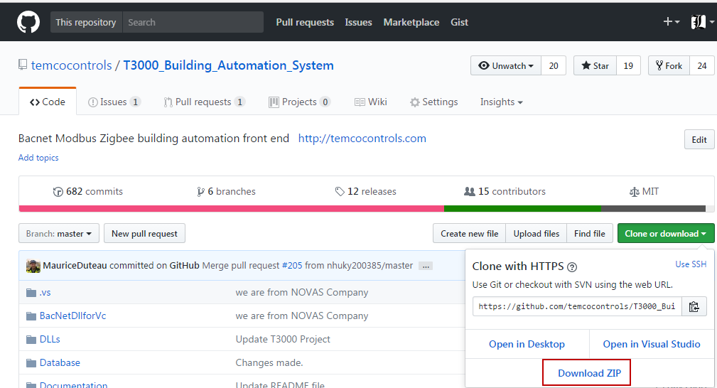

1. OpenT3000Project , using VS2015

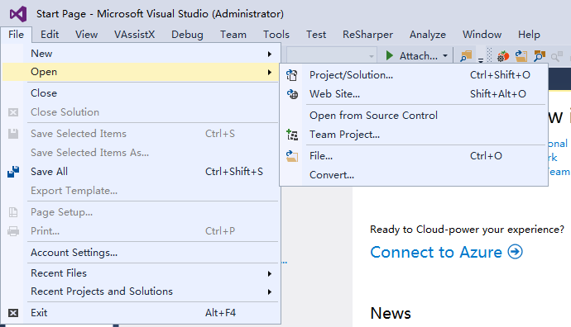

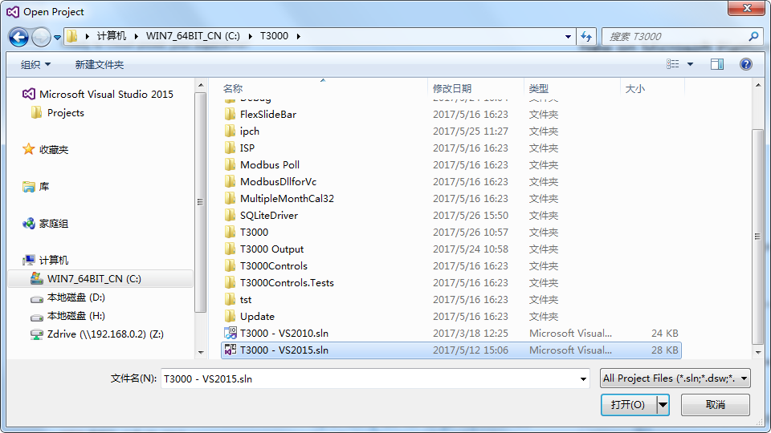

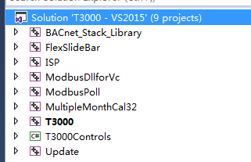

We specify that we will create a Win32 application which can run on both 32 and 64bit Windows installations.

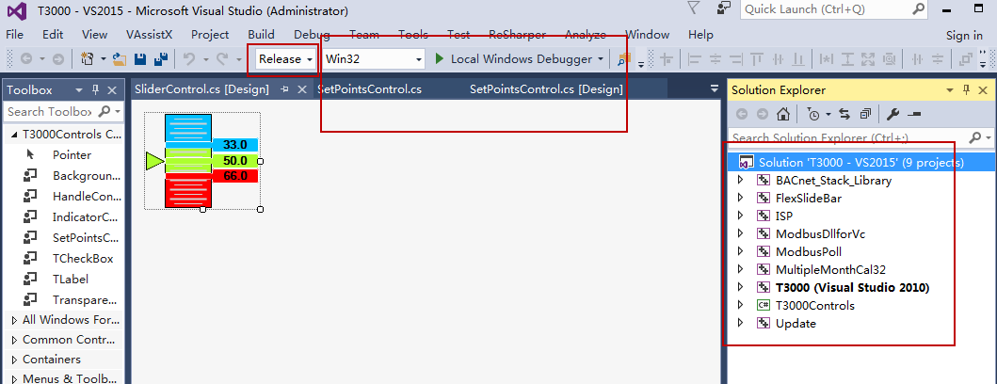

2. Compile T3000 OneByOne

Two Modes ,one is debug ,one is Release .

The platform ,please select Win32 OR x86

The build will rebuild the following items in this order:

1. BACnet_Stack_Library
2. FlexSlideBar
3. ModbusDllforVc
4. MultipleMonthCal32
5. T3000Controls
6. ISP
7. ModbusPoll
8. Update

You can select all project to compile .

Notes:

You can rebuild all the project or just parts which you know have changed. The compiler is not smart enough to know which parts have changed, so if you are unsure just build the whole project.

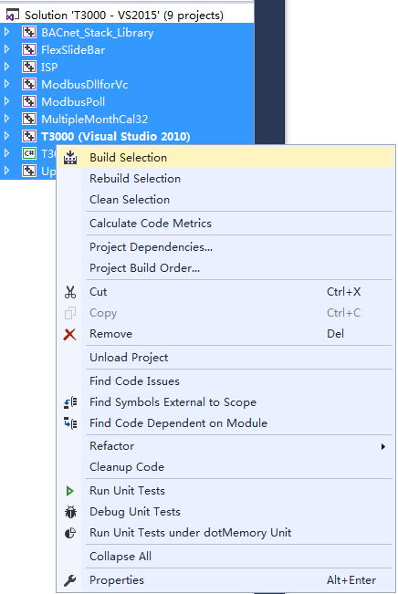

To find your latest release .

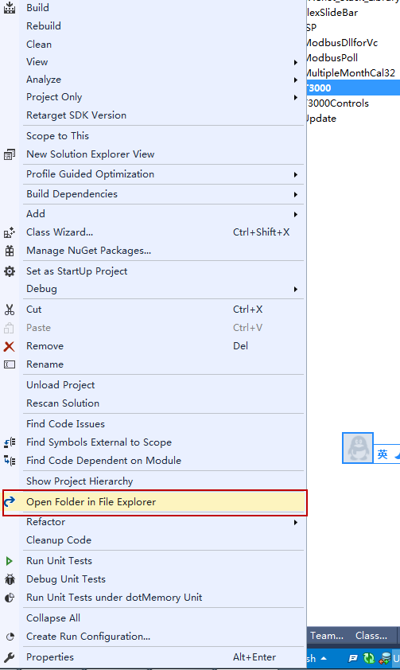

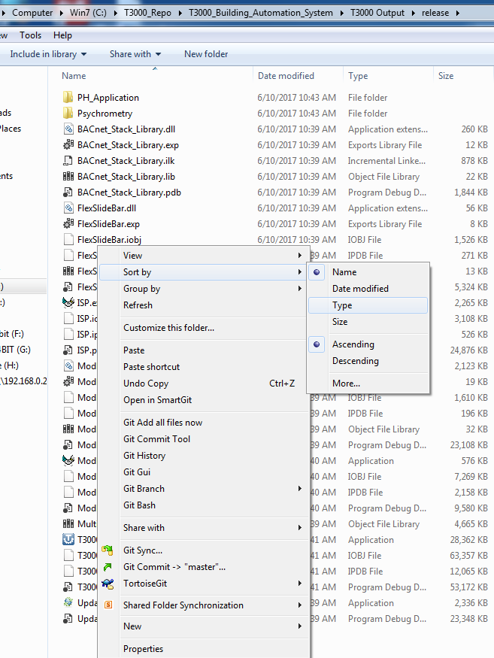

These files should be copied to the Installshield folder on your local machine. Installshield will only look to its local folder for files to be combined into the MSI install file, so this step is necessary.

These are the files which the build will produce, EXE and some DLL’s.

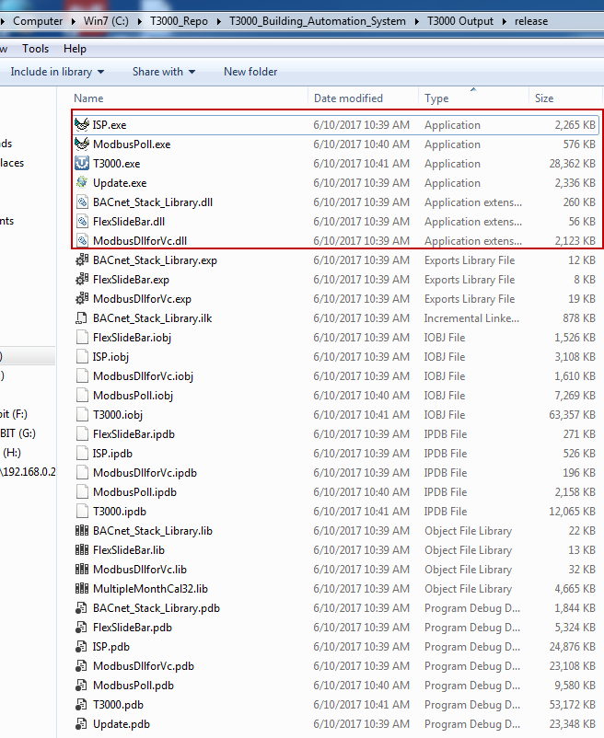

Copy these file to T3000InstallShield , and then replace the old files.

Using the same way to compile Psychrometric Tool && PH_Application

Add these two separate applications as part of the solution, not separate applications like it is now.

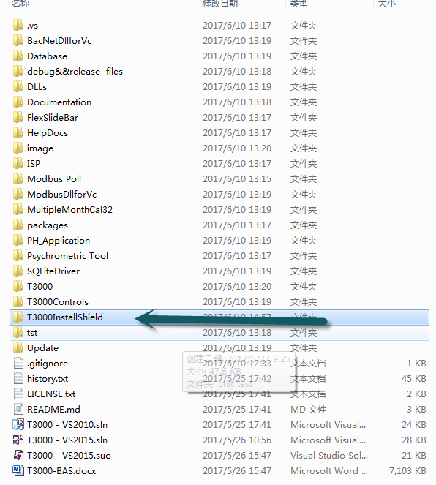

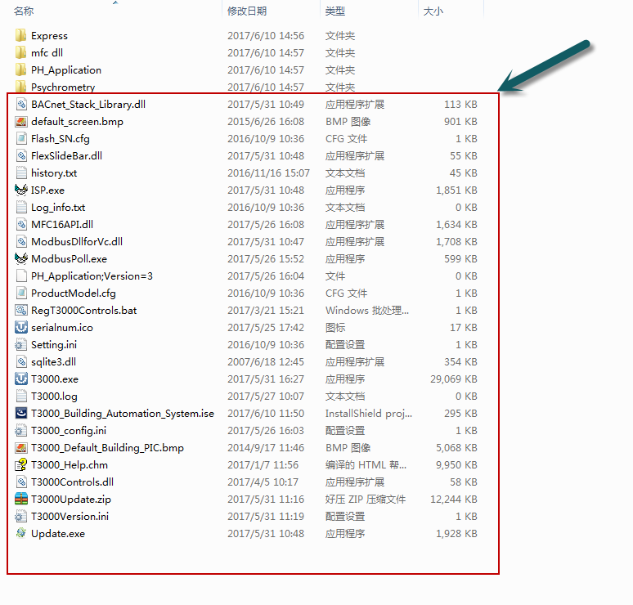

**2.How to make an MSI for T3000**

This MSI will include all the proejcts, T3000 as well as the separate Psychrometric and PH applications.

1. double click installshield project file

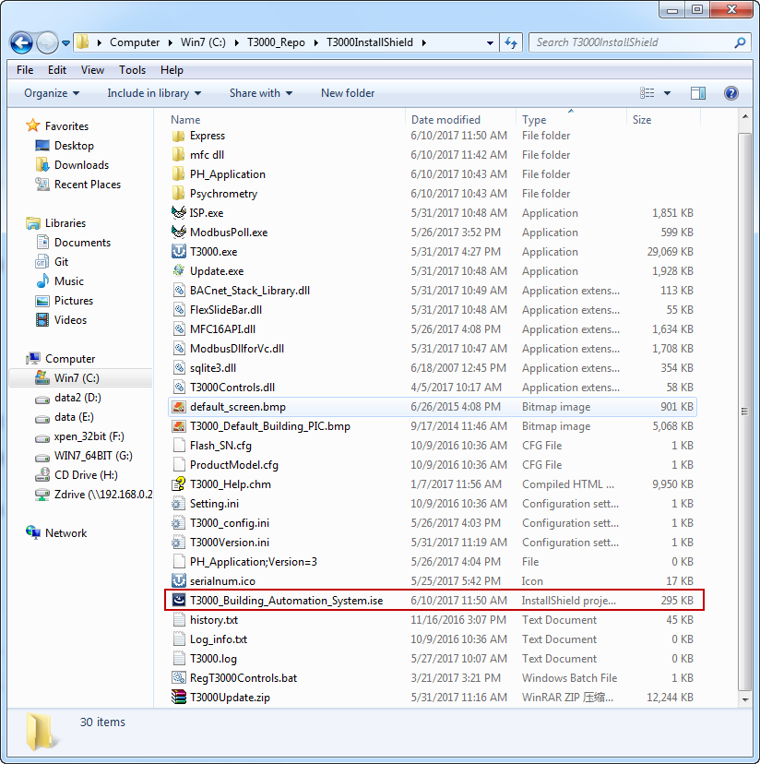

2. InstallSheild showing

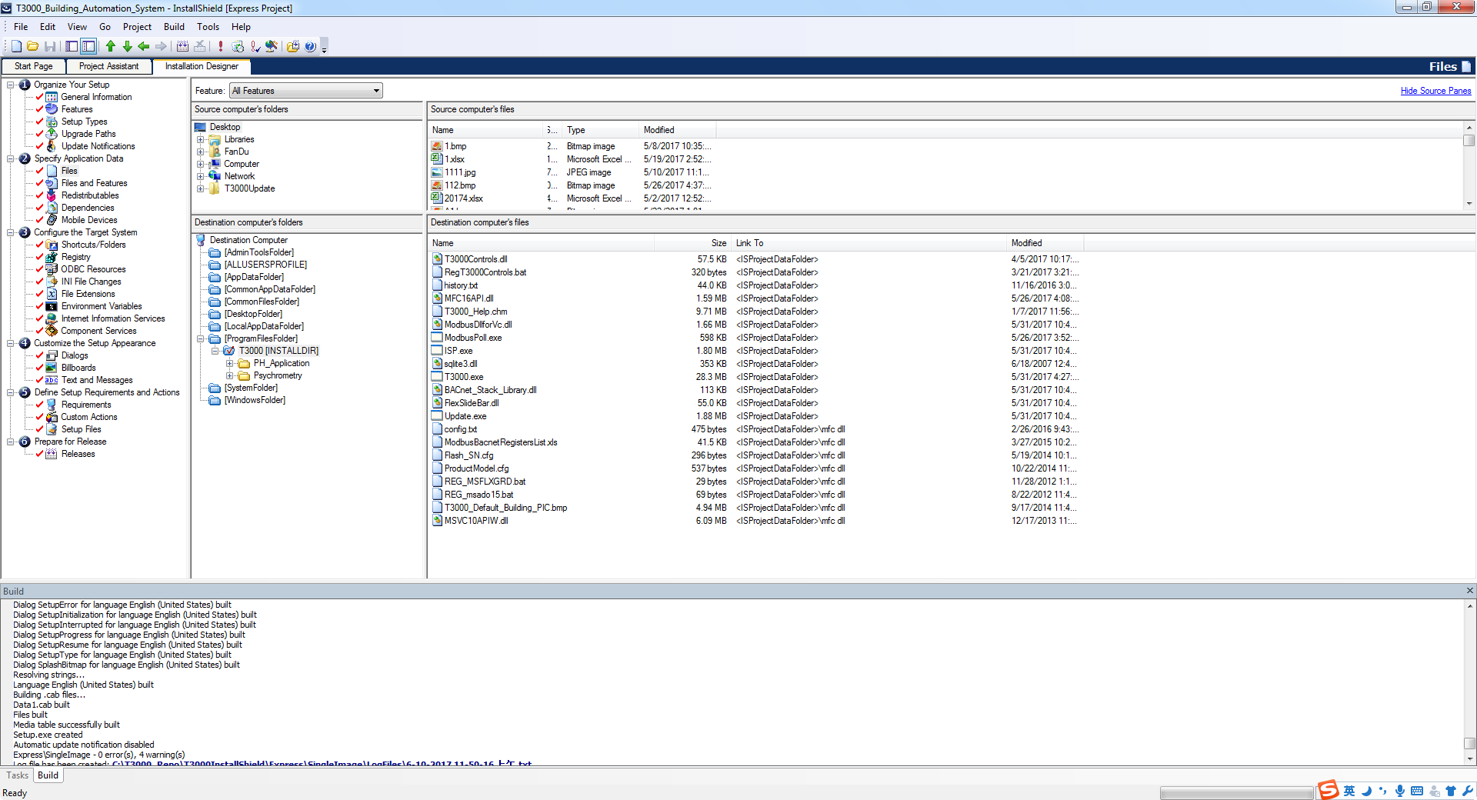

2.Click on the “General Information’ tab, then on the ‘Prooduct Code” cell to generate a GUID which is a code for the application.



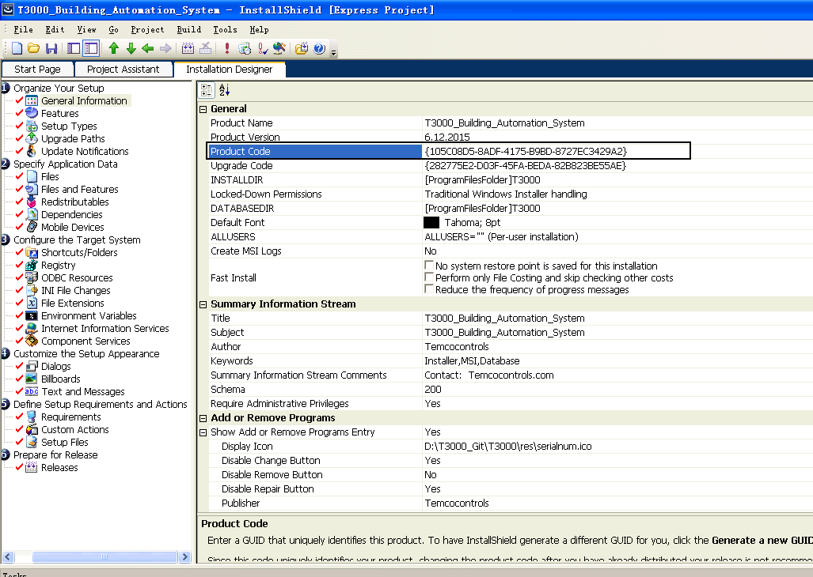

3. Click on the Prepare for release tab, ‘Releases’ itms which generates another GUID, these are just codes which are automatically generated.



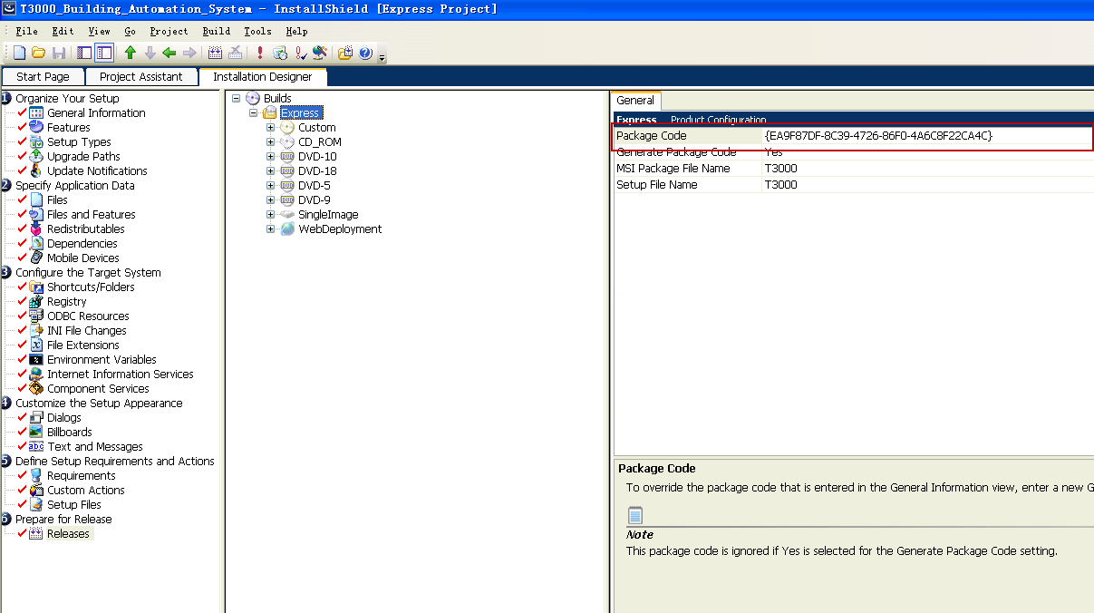

4.Sleect what type of image to generate, in our case SingleImage

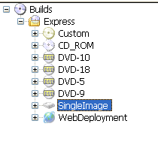

5. Build



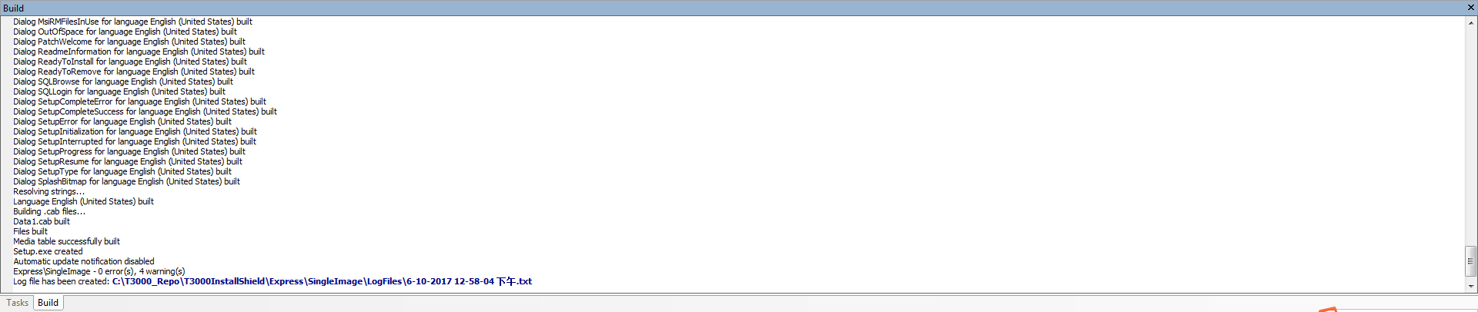

6.Open the setup exe file



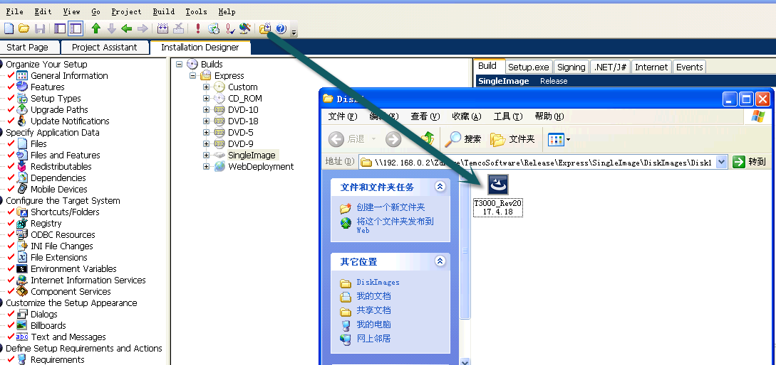

For generating the smaller EXE for updates from within T3000, just copy these files to the a zip file and load the following files to the temco FTP folder.

The files can be found in the T3000 output folder, only the DLL and exe files need to be sent there.

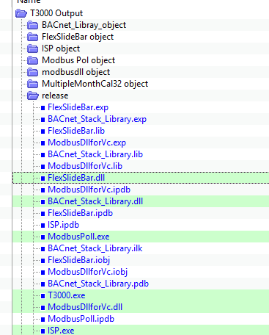

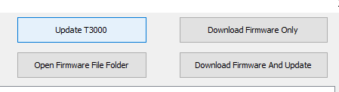

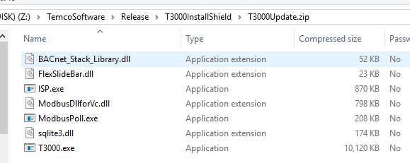

Load the files to this FTP site with this exact name.

Note: this doesn’t update the database and the files. If you want to update those you need to completely re-install from T3000.zip.

