# T3000 Items

Added a new item about the grapics displays, difficult to edit the value

**Item1: T3000 Startup**

When T3000 starts up there is a lot of unnecessary, and annoying, flashing of the screen while it starts up, see the attached movie. We need to get rid of this flashing and do a nicer startup. With the flash screen going up first.

After the startup splash screen is done, T3000 will switch over to the last screen the user was visiting before shutting T3000 down.

If they were online

If they were programming in a certain basic program, that program will be again loaded up. Exactl to a building, T3000 will re-establish communications to that same building.y where they were when T3000 was shut down

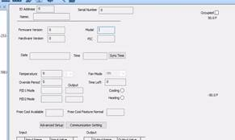

**Item 2. Advanced settings - > add a Done button.**

It would be better to have a DONE button here so the user can make changes and see the results. Leaving this screen also has the same effect, any changes are written to the controller without hitting the DONE button. If the user hits escape here, it also activates the DONE button and changes are written to the device.

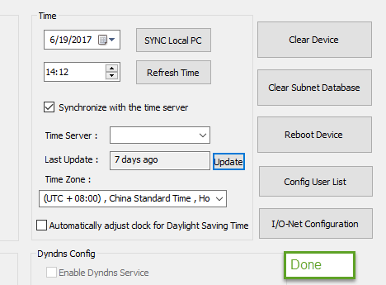

**Alex>>>>Done**

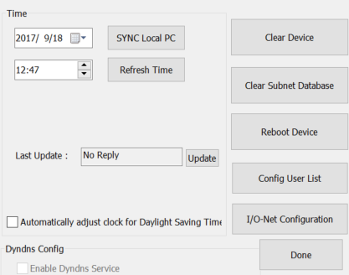

**Item3: Custom time server.**

The Vietnam guys did this I think, I hope you can merge their work.

When the user edits the time server they can select from three built in time servers. They can also type in this edit box and enter their own custom time server name. The custom name is supposed to be written to the T3 controller which will save it and use that custom time server. However we see now that the custom name is lost.

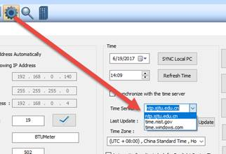

Entering my own custom name and then click update, the name is lost. It should be saved by the controller. The feature was working before but somehow its not now. Please check .

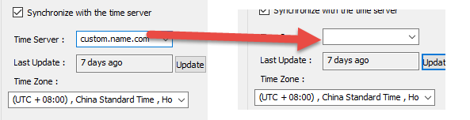

**Alex>>>>chelsea say ,the item is because of minipenel .she will fix it .**

**Item4: Editor losing expansion I/O points.**

This is a little difficult to demonstrate because you don’t have an expansion board there.

When we send the program like this, which makes use of expansion I/O, the T3000 front end tries to locate the label of the output25 and ends up deleteing it if it cannot find a label properly.

First

Start a virtual controller by clicking down here, then right click add a virtual device

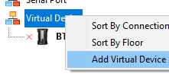

Then go to offline mode

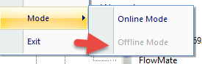

Select the virtual controller at tab1, select the programming icon to bring up all the programs, hit insert on a blank program at tab3, then then enter a program in the editor at tab4 as chelsea has done below.

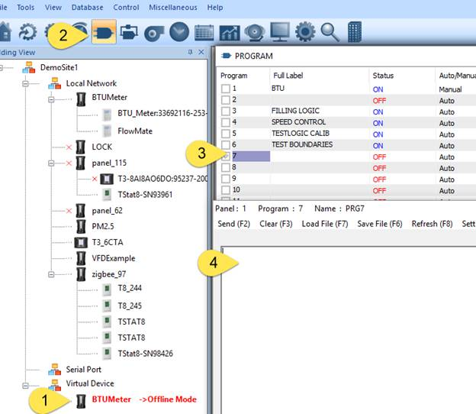

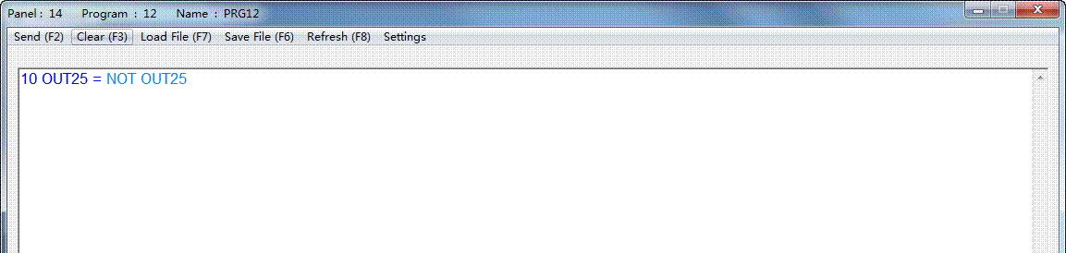

SEND, CLOSE it , then open it again, OUT25 is replaced with its label, it is ok.

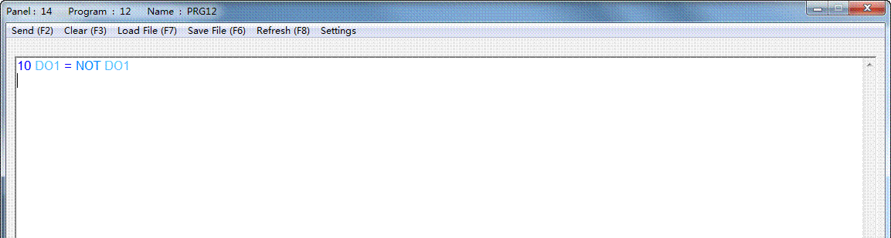

SEND IT AGAIN, CLOSE IT THEN OPEN IT AGAIN. LABEL IS GONE.

>>>>DO is a key word ,you can’t use it as a name .



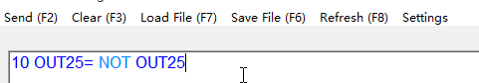

Close and reopen it

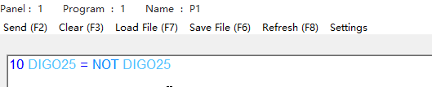

Press F2

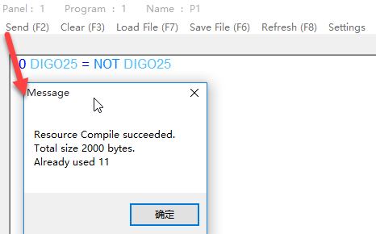

Close ,and reopen it . still here . don’t disappear.

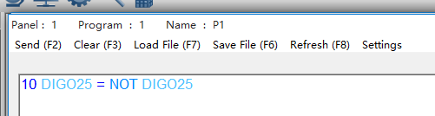

**Item5: The file extension  PRG Done**

Change the default file name extension for T3000 prg files from ‘prg’  to ‘prog’. This will let us easily email program files to Microsoft outlook users. The prg extension is blocked by outlook.  The program will show all prg and prog files by default. And offer to save as .prog, not *.prg .

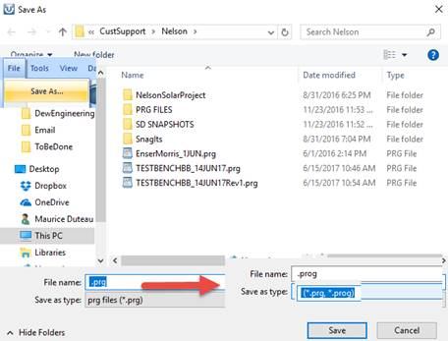

**Item6: Sliders**

The sliders are not scaling properly when the temperature is over the cooling setpoint

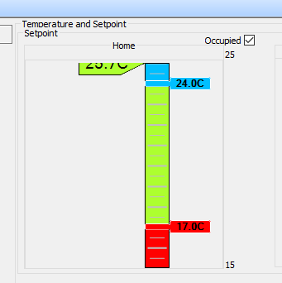

**Item7: Communications is not reliable to Tstat8, work with Chelsea to make this FAST and RELIABLE**

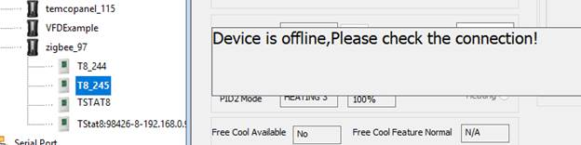

**Item8: Port forwarding**

Currently, the user must port forward three ports.

UDP port 1234, for the scan command.  <Would like to move this scan to port 47808

UDP port 47808 , for bacnet comms

TCP 502  , for Modbus

We would like to reduce this to two ports, do the scan on port 47808. In order to maintain compatibility, T3000 will do a scan on port 1234 and also on 47808 for now.

If a controller replies on port **1234** a message will pop up: Detected old firmware on your devices, please update the device at IP XXXXXXXXX by clicking here BUTTON which opens the update firmware dialog for the device.

Fandu says this may be a little complex, see what you can do to combine 1234 with 47808, only spend maximum one or two days on this because we have a new method planned for remote connections anyway.

Alex>> I talk with chelsea about port forwarding . not only T3000 need to change ,

**Item9: Port number in building database.**

Change text to show ‘Modbus TCP Port’ instead of just ‘IP Port’.

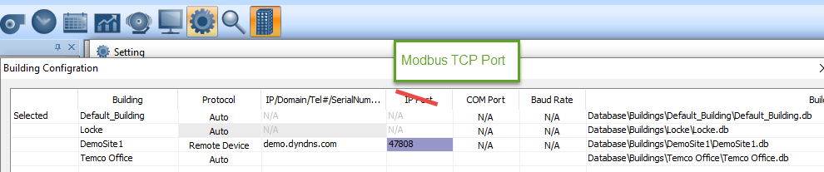

Change this text also:

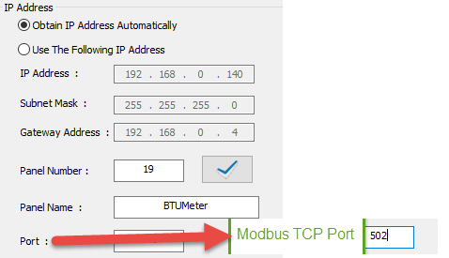

Alex>>>>>>>>>>>>>>>>>>>



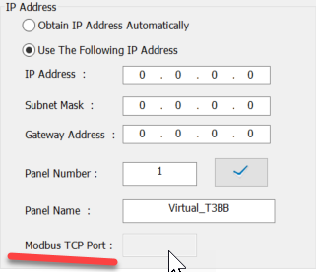

********************************************************************

**Item 10: Seem to often lose the panel name. A short time ago I renamed this SELFTEST. I loaded the program and worked for some time and now its back to the default.**

               Please change the default name to T3Controller:192.168.0.xx

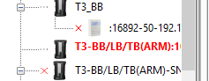

And after a few minutes is back to normal. Very strange, I was not even working on it and now it is correct again. Please check the logic of what is going on wih this. If it’s a cache issue then it needs to be cleaned up.

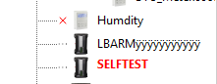

**Item11**

In the graphics user screens, I type a new value here and it will not stay. Keeps jumping back to the old value.

