# How to use the slider

1. Run Visual Studio in administator mode(Right click -> Run as administator)
2. Build SliderControlLibrary(ir is registered dll with regasm)
3. Open MFC Conrol Designer

[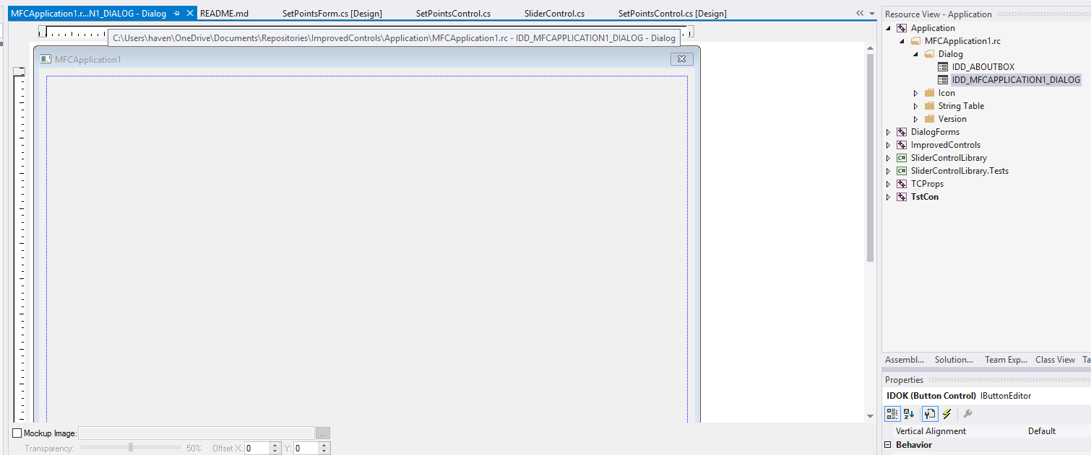](https://github.com/temcocontrols/T3000_Building_Automation_System/blob/master/T3000Controls/Quick%20Install/3.png)

1. Right click on dialog and select Insert ActiveX Control

[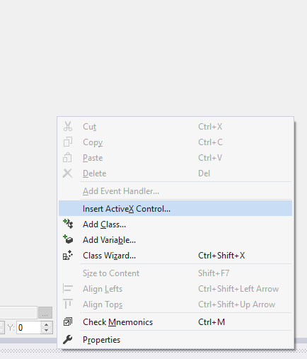](https://github.com/temcocontrols/T3000_Building_Automation_System/blob/master/T3000Controls/Quick%20Install/4.png)

1. Select need control

[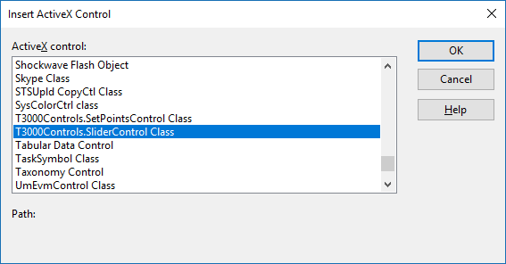](https://github.com/temcocontrols/T3000_Building_Automation_System/blob/master/T3000Controls/Quick%20Install/5.png)

1. Control added

[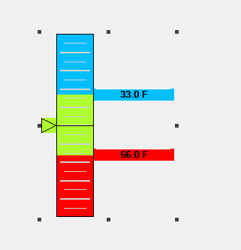](https://github.com/temcocontrols/T3000_Building_Automation_System/blob/master/T3000Controls/Quick%20Install/6-1.png)

1. . Properties and events are available:
2. [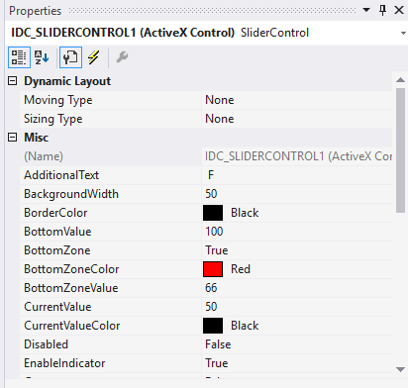](https://github.com/temcocontrols/T3000_Building_Automation_System/blob/master/T3000Controls/Quick%20Install/6-2.png)

[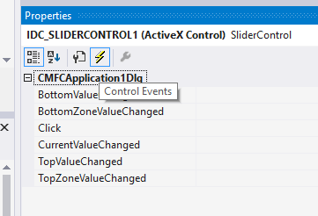](https://github.com/temcocontrols/T3000_Building_Automation_System/blob/master/T3000Controls/Quick%20Install/6-3.png)

1. For set property from code need right click and select Add Variable

[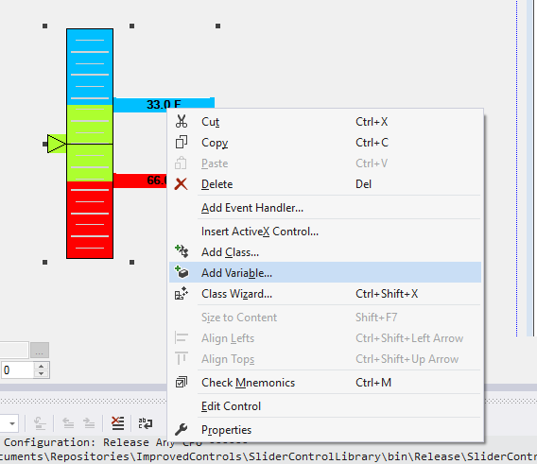](https://github.com/temcocontrols/T3000_Building_Automation_System/blob/master/T3000Controls/Quick%20Install/7.png)

1. Input variable name and click Finish

[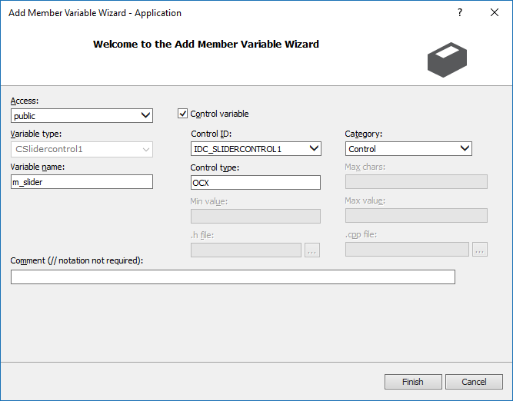](https://github.com/temcocontrols/T3000_Building_Automation_System/blob/master/T3000Controls/Quick%20Install/8.png)

1. If class not created, need next actions

[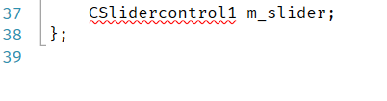](https://github.com/temcocontrols/T3000_Building_Automation_System/blob/master/T3000Controls/Quick%20Install/9.png):

1. Right click to project, Add -> Class..

[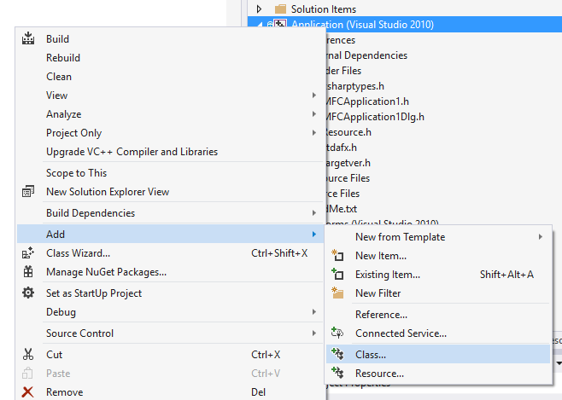](https://github.com/temcocontrols/T3000_Building_Automation_System/blob/master/T3000Controls/Quick%20Install/10.png)

1. Select MFC -> MFC Class From TypeLib

[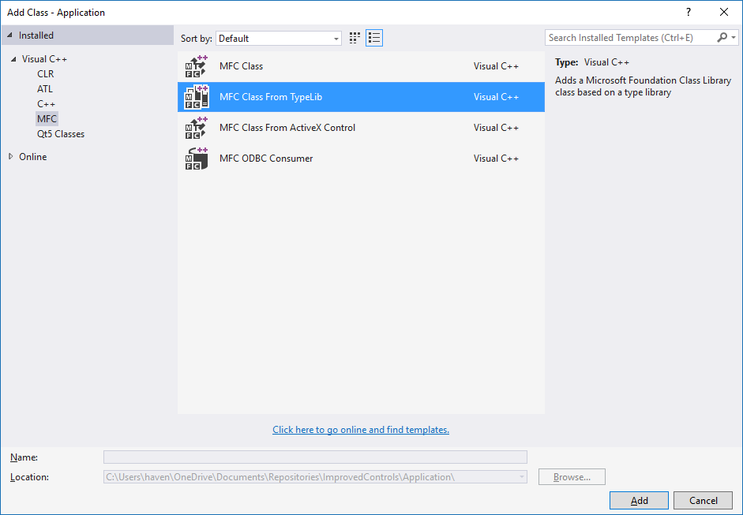](https://github.com/temcocontrols/T3000_Building_Automation_System/blob/master/T3000Controls/Quick%20Install/11.png)

1. Select SliderControlLibrary from dropdown menu, select need interface and click to button ">". Click finish

[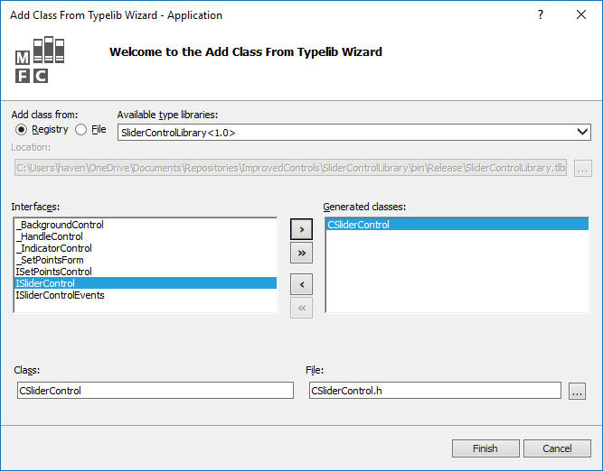](https://github.com/temcocontrols/T3000_Building_Automation_System/blob/master/T3000Controls/Quick%20Install/12.png)

1. Include header

[https://github.com/temcocontrols/T3000_Building_Automation_System/raw/master/T3000Controls/Quick%20Install/13-1.png](https://github.com/temcocontrols/T3000_Building_Automation_System/blob/master/T3000Controls/Quick%20Install/13-1.png),

rename class

[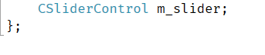](https://github.com/temcocontrols/T3000_Building_Automation_System/blob/master/T3000Controls/Quick%20Install/13-2.png),

replace this

[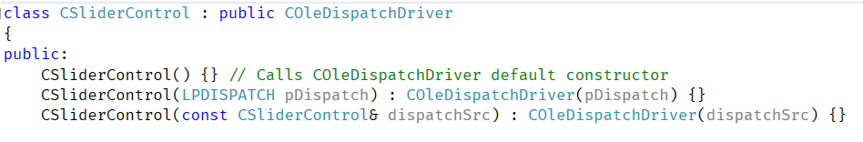](https://github.com/temcocontrols/T3000_Building_Automation_System/blob/master/T3000Controls/Quick%20Install/13-3.png)

as this

[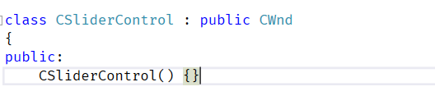](https://github.com/temcocontrols/T3000_Building_Automation_System/blob/master/T3000Controls/Quick%20Install/13-4.png).

Add include in stdafx

[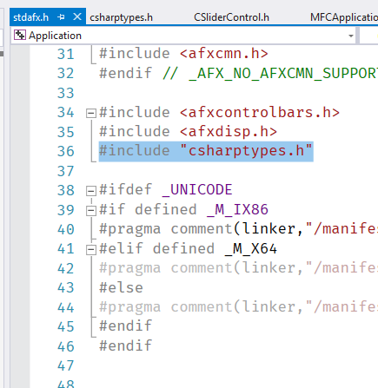](https://github.com/temcocontrols/T3000_Building_Automation_System/blob/master/T3000Controls/Quick%20Install/13-5.png).

Create file csharptypes.h with next data

[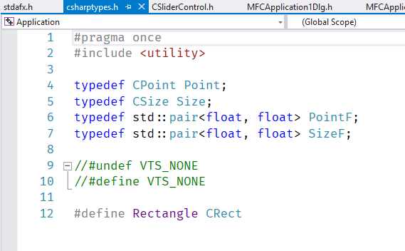](https://github.com/temcocontrols/T3000_Building_Automation_System/blob/master/T3000Controls/Quick%20Install/13-6.png)

#pragma once

#include <utility>

typedef CPoint Point;

typedef CSize Size;

typedef std::pair<float, float> PointF;

typedef std::pair<float, float> SizeF;

//#undef VTS_NONE

//#define VTS_NONE

#define Rectangle CRect

1. Enter need properties

[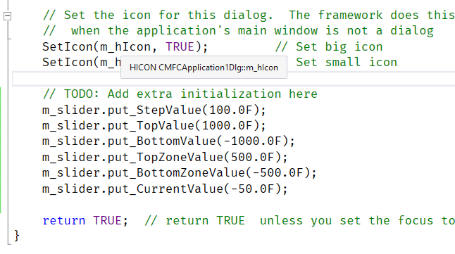](https://github.com/temcocontrols/T3000_Building_Automation_System/blob/master/T3000Controls/Quick%20Install/14-1.png)

and get results

[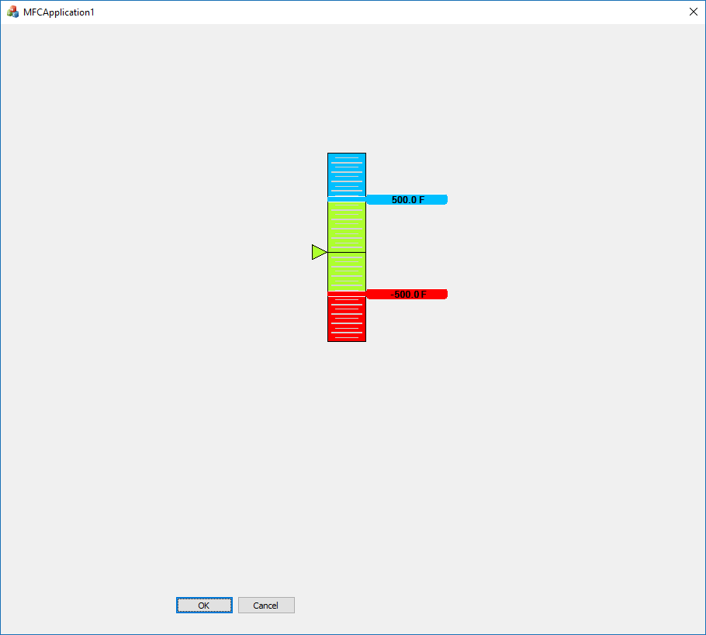](https://github.com/temcocontrols/T3000_Building_Automation_System/blob/master/T3000Controls/Quick%20Install/14-2.png).

1. Thanks!

#Alternative:

1. Run Visual Studio Native Tools Command Promt in administator mode
2. Go to SliderControlLibrary dll path
3. regasm SliderControlLibrary.dll /codebase /tlb SliderControlLibrary.tlb
4. Go to 3-15 first method.

#For internal usage in the resource file:

SliderControl guid: "ABA068FC-6B49-3031-B74A-1C51A3C8833A"

SetPointsControl guid: "A7CFC298-FE4E-4819-B868-2C014BA244DE"