Bellabeat

Defination:-
Bellabeat, a high-tech manufacturer of health-focused products for women sice 2013. Bellabeat is a successful small company, but they have the potential to become a larger player in the global smart device market. Urška Sršen, cofounder and Chief Creative Officer of Bellabeat, believes that analyzing smart device fitness data could help unlock new growth opportunities for the company .

Business Task:-
Analyze FitBit Fitnes Tracker App data to gain insights into how consumers are using the FitBit app and discover trends and insights for Bellabeat.

Business Objectivies:-

- What are the trends identified?
- How could these trends apply to Bellabeat customers?
- How could these trends help influence Bellabeat marketing strategy?

Data Set:-

Data will be available on Kaggle. Click the link below for the datset.

https://www.kaggle.com/datasets/arashnic/fitbit

Tools:-

- Python and R Programming for data cleaning
- matplotlib for data visualization and analysis in Python
- ggplot2 for data visualization and analysis in R Programing

Deliverables:-
- A clear summary of the business task.
- A description of all data sources used.
- Documentation of any cleaning or manipulation of data.
- A summary of analysis
- Supporting visualizations and key findings.
- High-level content recommendations based on the analysis.

Key Stakeholders:-
- Urška Sršen: Bellabeat’s cofounder and Chief Creative Officer.
- Sando Mur: Mathematician, Bellabeat’s cofounder and key member of the Bellabeat executive team.
- Bellabeat marketing analytics team: A team of data analysts guiding Bellabeat's marketing strategy.

Information on Data Source:-
1. This data is Generated by respondents from a distributed survey via Amazon Mechanical Turk between 12th march,2016 to 12th may, 2016.
2. 30 FitBit users who consented to the submission of personal tracker data.
3. Data collected includes...
  - Physical activity recorded in minutes
  - heart rate
  - sleep monitoring
  - daily activity
  - steps

Limitations of Data Set:-
- Data collected from year 2016. Users' daily activity, fitness and sleeping habits, diet and food consumption may have changed since then, hence data may not be timely or relevant.
- Sample size of 30 female FitBit users is not representative of the entire female population.
- As data is collected in a survey, hence unable to ascetain the integrity or accuracy of data.

Is Data ROCCC?:-
A good data source is ROCCC which stands for...
- R: Reliable
- O: Original
- C: Comprehensive
- C: Current
- C: Cited.
- Reliable: LOW: Not reliable as it only has 30 respondents.
- Original: LOW: Third party provider (Amazon Mechanical Turk)
- Comprehensive - MED: Parameters match most of Bellabeat's products' parameters.
- Current: LOW: Data is 5 years old and is not relevant
- Cited: LOW: Data collected from third party, hence unknown.
Overall, the dataset is considered bad quality data and it is not recommended to produce business recommendations based on this data.

Exploratory Data Analysis (EDA):-

- How many rows and columns are in the datset?
- How many users are using this app or How many unique Ids are there?
- How many times users logged in app during the week?
- What is the average total steps or distance taken by users in daily activity?
- What is the maximumn total steps taken by users?
- What is the average sedentary timing users are taking?
- What is the average calories burnt by users in daily basis?
- What is the correlation between Calories burned and stpes taken?
- How much calories burned for every hour logged?
- What is the percentage of every active minutes like lightly active minutes, Fairly active minutes, Very active minutes, Sedentary active minutes?

Answers of EDA:-

In python I used “DailyActivity_merged.csv” file form the whole dataset.

QUS- 1. How many rows and columns are in the datset?
- There are 940 rows and 15 columns in the dataset

QUS-2. How many users are using this app or How many unique Ids are there?
- 33 unique ids are there. So, we can say that 33 users are using this app.

QUS-3. How many times users logged in app during the week?

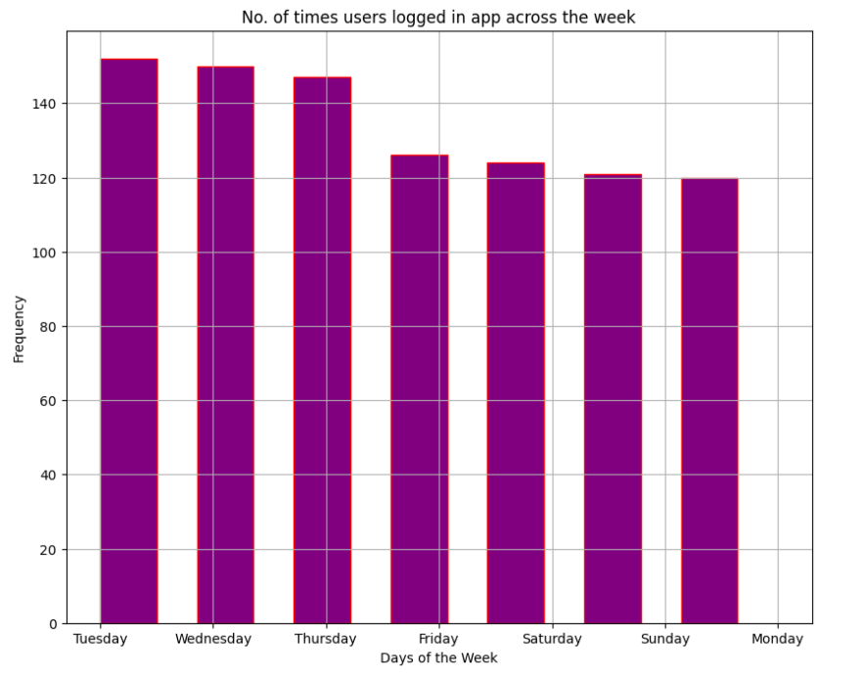
- Users are using the app mostly during Tuesday to Sunday.
- as I can see in the plot I discovered users prefer to track their activity on the app during midweek from Tuesday to Friday which menas only 4 days in a week.
- Users' frequency dropped down from Friday to Monday. So, we can say that most users are not preferring to use the app on weekends.

QUS-4. What is the average total steps or distance taken by users in daily activity?
- Users' average total steps are 7637 and total distance is 5.4 km which is not adequate. As recomendation by the CDC, an adult female has to aim for at least 10,000 steps or 8 km per day to benefit from general health, weight loss, and fitness improvement.

QUS-5. What is the maximum total steps taken by users?
- 36019 are the Maximum count of total steps taken byu users.

QUS-6. What is the average sedentary timing users are taking?
- Sedentary users are the majority logging on average 991 minutes or 20 hours making up 81% of total average minutes.

QUS-7. What is the average calories burnt by users in daily basis?
- average calories burned is 2303 calories. but it could not be interpreted in detail as calories burned depending on several factors such as the age, weight, daily tasks, exercise , hormones, daily calorie intake, etc.

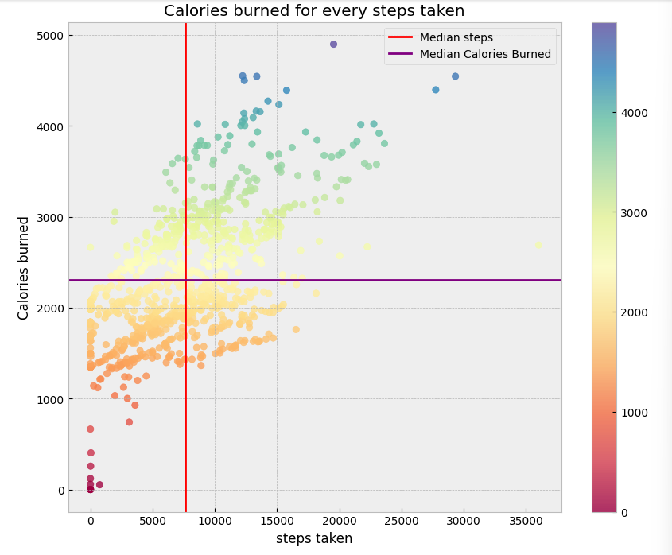
QUS-8. What is the correlation between Calories burned and stpes taken?
- This is a positive correlation between calories burned and how many steps taken by users.
- That means if more steps are taken by users more calories are burned.
- As we can see in the plot points are lying in between 5000 to 10000 steps and for that, 2000 to 3000 calories can be buned.
- As go beyond 15000 steps calories will burned more than 3000.
- here, there are some outliers like 15000 steps was there but calories burned only 1500. which is not appropriate. So there are some exceptions.

QUS-9. How much calories burned for every hour logged?
- This straight line shows poor positive correlation where increase of houors looged does not increase the burn calories.
- That is just because of sedentary hours wehich is in between 15 to 20 houors range. red line shows the average hours of sedentary hours.
- again here, outliers are also there..
  - The same zero value outliers.
  - An unusual red dot at the 24 hours with zero calories burned which may be due to the same reason as above.

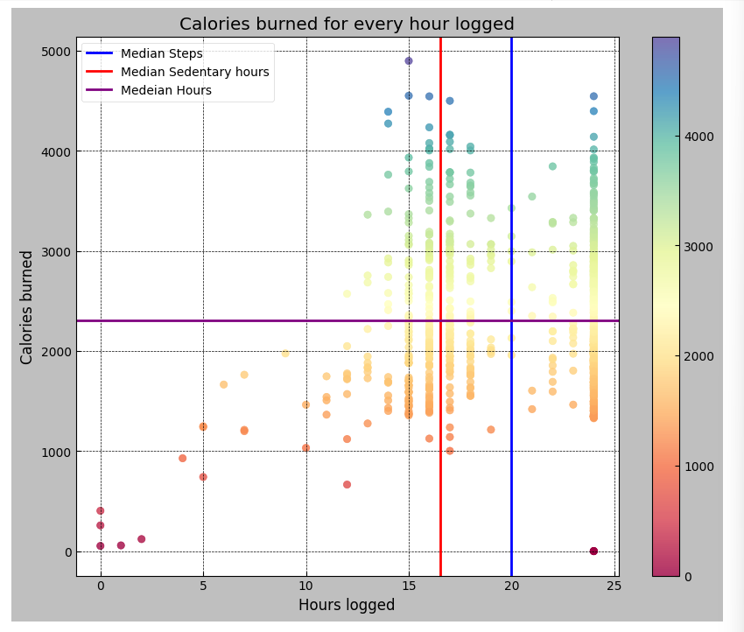
QUS-10. What is the percentage of every active minutes like lightly active minutes, Fairly active minutes, Very active minutes, Sedentary active minutes?
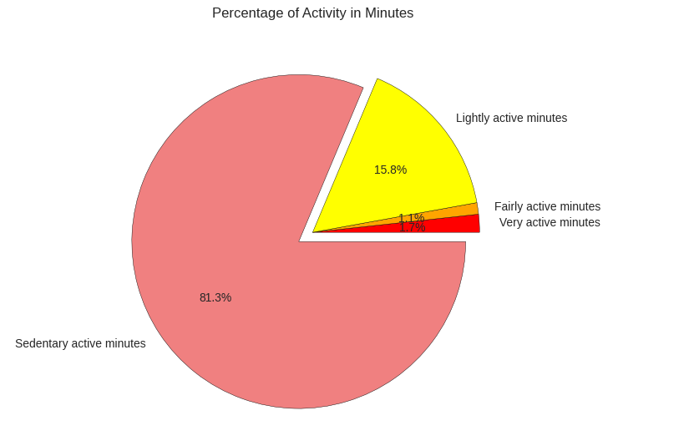
- Here, Sedentary minutes are taking the biggest slice which is 81.3%.
- This idicates that users are using the FitBit app to log daily activities such as daily commutes, inactive movements(moving from one spot to another) or running errands.
- App is rarely being used to track fitness as per the minor percentage of fairly active activity(1.1%) and very active activity(1.7%). This is highly discourageing a FitBit app was developed to encourage fitness.

After EDA step, we will be delivering our insights and providing recommendations based on our analysis... Here, we revisit our business questions and share with you our high-level business recommendations.
1. What are the trends identified?
Majority of users are spending more time on Sedentary hours(81.3%) which is more than another active hour.
Users prefer to track their activities during weekdays rather than weekends as many users are staying in or want to chill out with family or friends on weekends,we can assume.
2. How could these trends apply to Bellabeat Customers?
Companies develop products focused on providing women with their health, habit and fitness data and encouraging them to understand their current habits and make healthy decisions. These common trends surrounding health and fitness can very well apply to Bellbeat customers.
- How could these trend help influence Bellabeat marketing strategy?
Bellabeat marketing team can encourage users by educating adn equipping them with knowledge about fitness benefits, suggest different types of exercise (ie. 5 min cardio, 10 min simple exercise, 20 walking exercise on weekdays and more intense exercise on weekends) and calories intake and burnt rate information on the Bellabeat app.
On weekends, the Bellabeat app can also prompt notifications to encourage users to exercise like dance fitness, yoga, etc.

