Movie Recommendations System
Introduction:
“Everybody has something that chews them up and, for me, that thing was always loneliness. The cinema has the power to make you not feel lonely, even when you are.” -Tom Hanks
All, regardless of age, gender, ethnicity, colour, or geographic place, enjoys movies. Through this incredible medium, we are all linked in some way. What’s most intriguing, though, is how special our movie tastes and variations are. Some people like genre films, such as thrillers, romances, or science fiction, while others are more interested in the lead actors and directors. Taking all of this into account, it’s incredibly difficult to generalize a film and conclude that everybody will enjoy it. Despite this, similar films are enjoyed by a particular segment of the population.
Data Source:
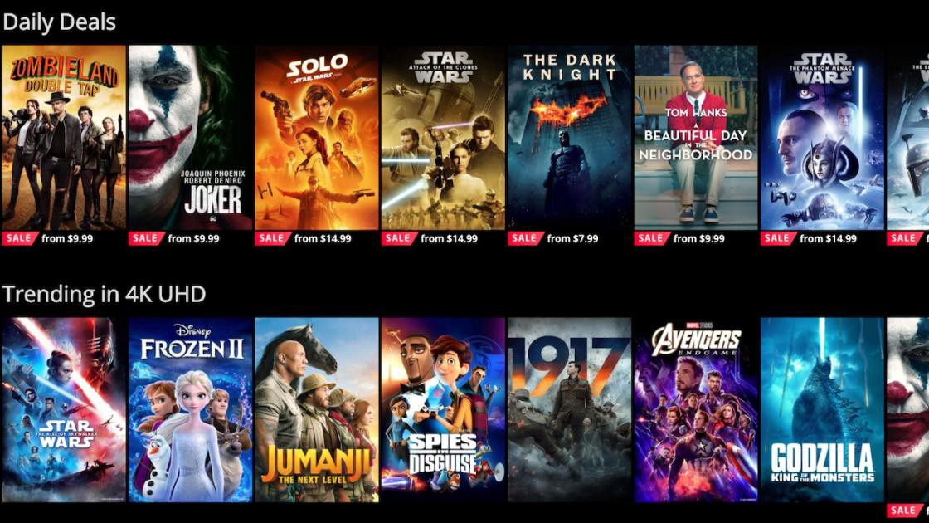
https://grouplens.org/datasets/movielens/100k/
Tech Stack (Technical Tools):
Language: R Programming, ML
Tools: RStudio, Tableau
Libraries: recommenderlab, ggplot2, data.table, reshape2, dplyr, magrittr
Overview:
The MovieLens datasets, first released in 1998, describe people’s expressed preferences for movies. These preferences take the form of tuples, each the result of a person expressing a preference (a 0-5 star rating) for a movie at a particular time.
What is a Recommendation System?
A Recommendation System is a filtration program with the primary purpose of predicting a user’s “rating” or “preference” for a domain-specific object or item. Since the domain-specific object in our case is a movie, the main goal of our recommendation system is to filter and predict only those movies that a user would choose based on certain information about the user.
Collaborative Filtering:
Here, I used Collaborative filtering using the Movielens dataset to recommend movies to users. Our goal is to be able to predict ratings for movies a user has not yet watched. The movies with the highest predicted ratings can then be recommended to the user.
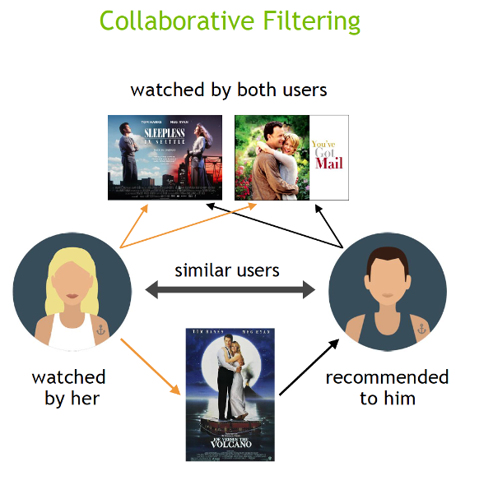
This filtration technique is focused on a comparison and contrast of the user’s actions with the behaviour of other users in the database. This algorithm heavily relies on the past of all users. The key difference between content-based filtering and collaborative filtering is that collaborative filtering considers the interactions of all users with the objects, while content-based filtering only considers the data of the concerned user. Collaborative filtering can be implemented in a variety of ways, but the key principle to understand is that in collaborative filtering, the data of multiple users affect the recommendation’s outcome. and does not depend on the data of a single consumer for modeling.

Dataset:

Ratings dataset:
- userId — unique for each user.
- movieId — using this feature, we take the title of the movie from the movie’s dataset.
- rating — Ratings given by each user to all the movies.
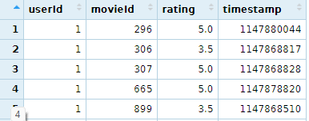

Movies dataset:
- movieId — once the recommendation is done, we get a list of all similar movieId and get the title for each movie from this dataset.
- genres — we used one hot encoding to split the genres as different genres mentioned for one movie.

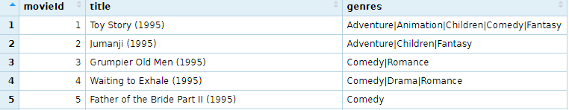
Here, we’ll import the dataset by adding the path of the CSV files.
Approach:
Business Questions / Exploratory Data Analysis (EDA):
In the real world, ratings are scarce, and data points are often gathered from widely successful films and active users. We wouldn’t like movies with a small number of user ratings because they aren’t trustworthy. Similarly, users who have just rated a few movies should not be taken into consideration.
So, with all that considered and some trial-and-error experimentations, we will reduce the noise by adding some filters for the final dataset.
Questions:
- How many unique movieId are available in the movie’s dataset?
- How many userId are available in ratings dataset?
- How many and what kind of the unique genres are available in the dataset?
- In collaboration filtering how are you going to split the genres of the movies?
- Which genres are most preferable by the users from the whole dataset?
- Who are the top10 users with ratings between 1 to 5
- Which top10 movies are most likely viewed by the users?
- what is the average of the most likely top10 views of the movies by the recommendation system?
- Which top movies are recommended by the recommendation system?
- Mention the top movies which are predicted with the recommendation system using recommenderlab?
- How can we use the box plot for the outliers of the recommendation system?
- Which final top movies are recommended by the recommendation_matrix?

Data pre-processing:

- Splitting the data from the movies dataset where genres are merged in the genres column by using Matrix.
- One hot encoding for the genre matrix is where we can find different genres which are related to movies.
  - For example:
    - Movie: toy story,
    - Genres: Adventure, Animation, Children, Comedy, Fantasy where one hot encoding will put 1 for the right genres & 0 for the false genre.
- Recommenderlab where we will convert the rating matrix into a recommenderlab.

Model Building:

- We will use Recommendation model by using the recommenderRegistry library.

Collaborative Filtering:

- From recommendation_model will use IBCF_realRatingMatrix parameters.

Users Similarity

- Search similarities between users (0-1) with the matrix.

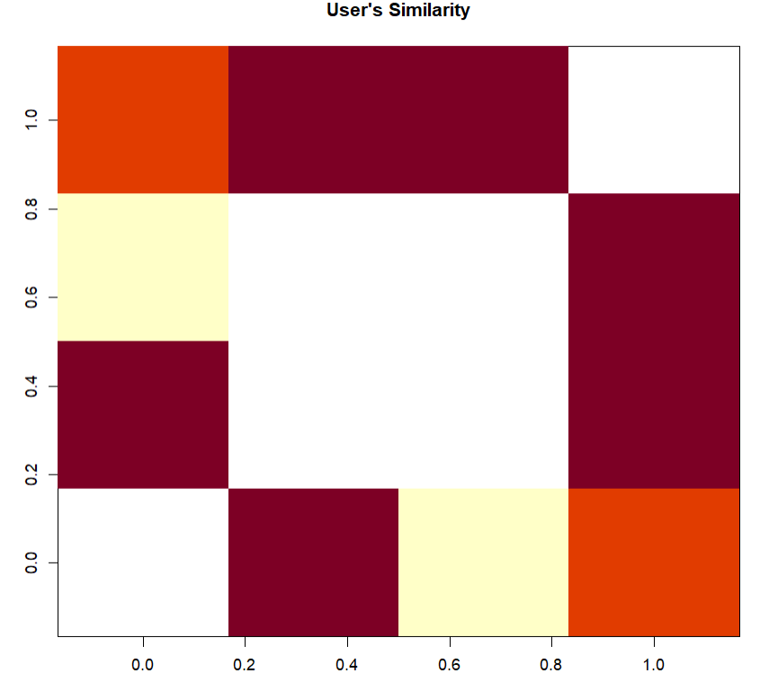

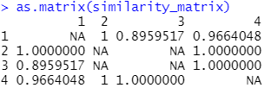

Movie Similarity

- Search similarity between movies (0-1) with the help of Matrix.

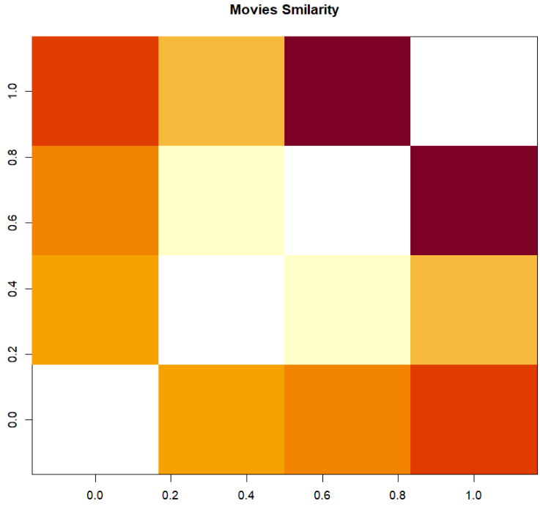

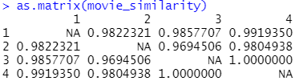

- Relation between top users and movies using heatmap

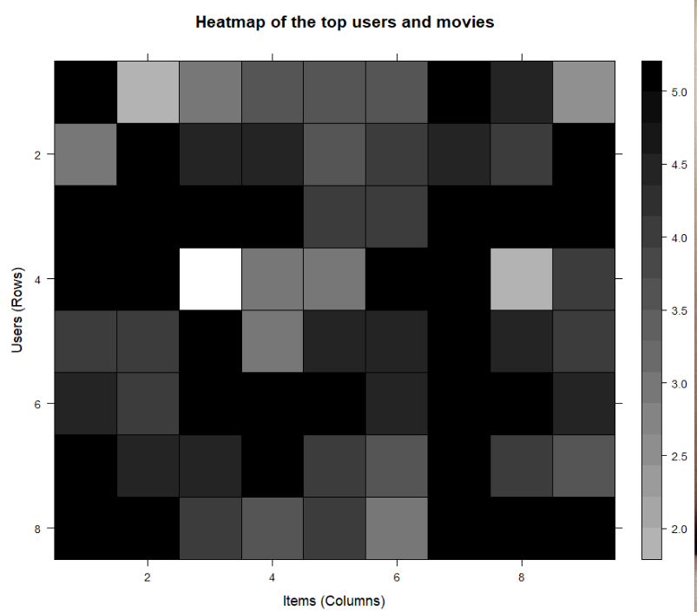

- Distribution of the Average rating per Users.

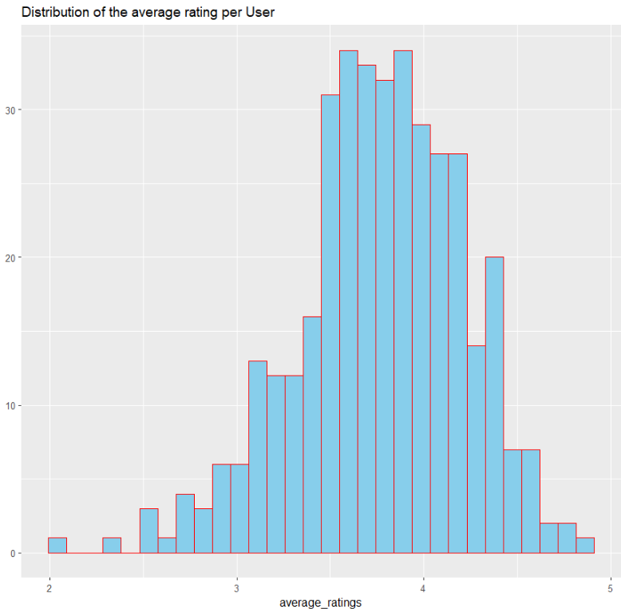

Data Normalization:

- Normalizing ratings of the top users.

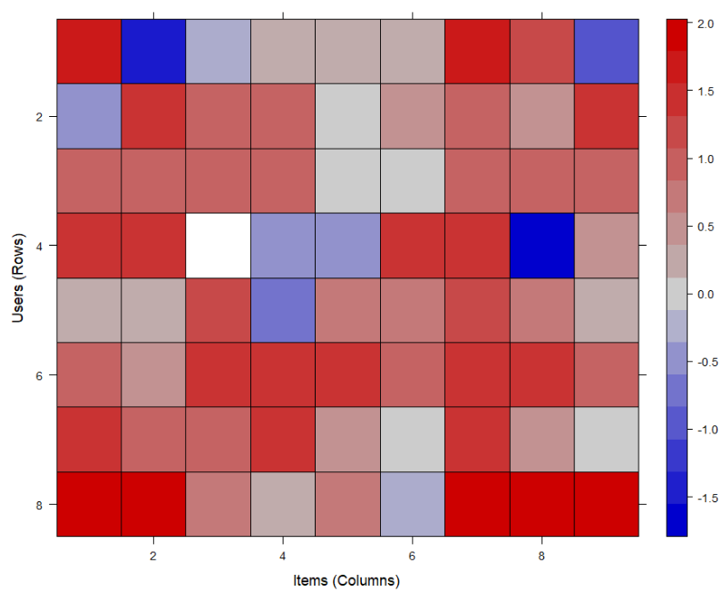

Data Binarization:
- Here, we get binary relation between minimum movies and minimum users from the top users and top movies.

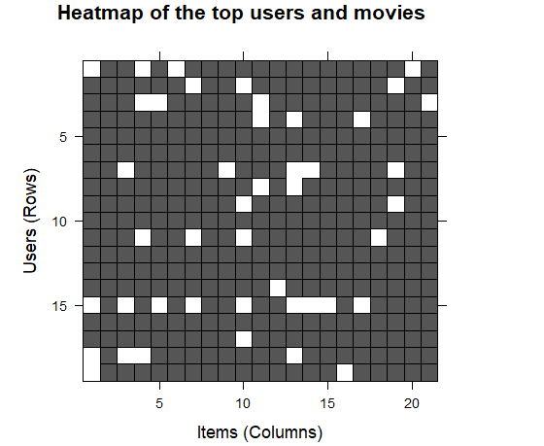

Collaborative Filtering System:
- For the best testing purpose will split the dataset into test and train dataset.
- The ratio will be…
  - Train dataset: 80%
  - Test dataset: 20%
Build the Recommendation System:
- From the recommendation model will use recommenderlab.
- Parameter will be IBCF_realRatingMatrix
- Here, in the recommen_model, we can predict top recommended users from test & train data, who are comes in top10 recommendation predictive model.
- we already predicted our top 10 users in predicted_recommendation
- from there we get movie_user1 and movie_users2.
- and from movies_data we get movieId which gives us top users with its movieId.
- from the movieId we can recommended top movies to them.

Matrix with the recommendation System:

- from the predicted recommendation we will use a recommendation matrix.
- Where we get the top 4 recommendations matrix of the top 10 users.
- Distribution plot for the numbers of the Items for IBFC.
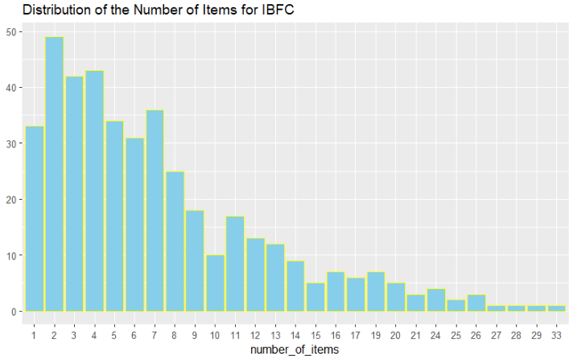
- Distribution of Data, where we will get the final top5 movies from the recommendation system.

Solution Of Business Questions:
- How many unique movieId are available in the movie’s dataset?
Ans: There are 9742 unique movieId with 3 columns in the movie’ dataset.
- How many and what kind of the unique genres are available in the dataset?
Ans: There are 18 unique genres available in the dataset.
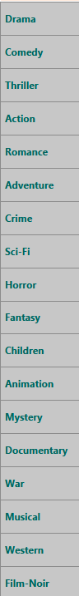

- How many userId are available in ratings dataset?
Ans: There are 9742 unique movieId with 3 columns in the movie’ dataset.

- In collaboration filtering how are you going to split the genres of the movies?
Ans: We are using One-hot-encoding to split the genres of the movies.
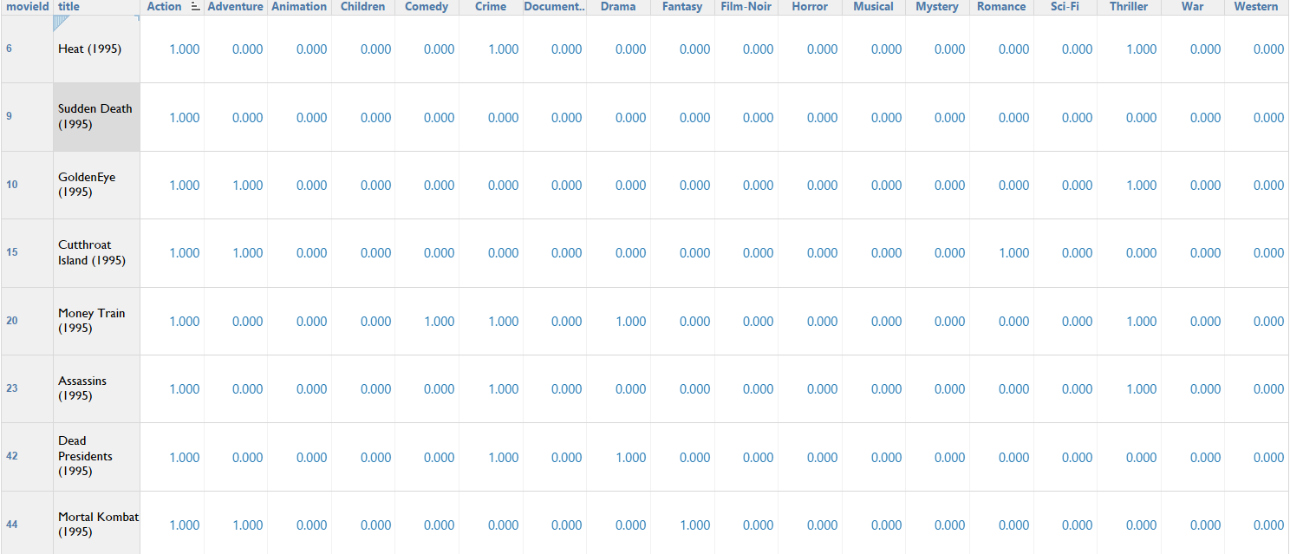
- Which genres are the most preferable genre by the users from the whole dataset?
Ans:
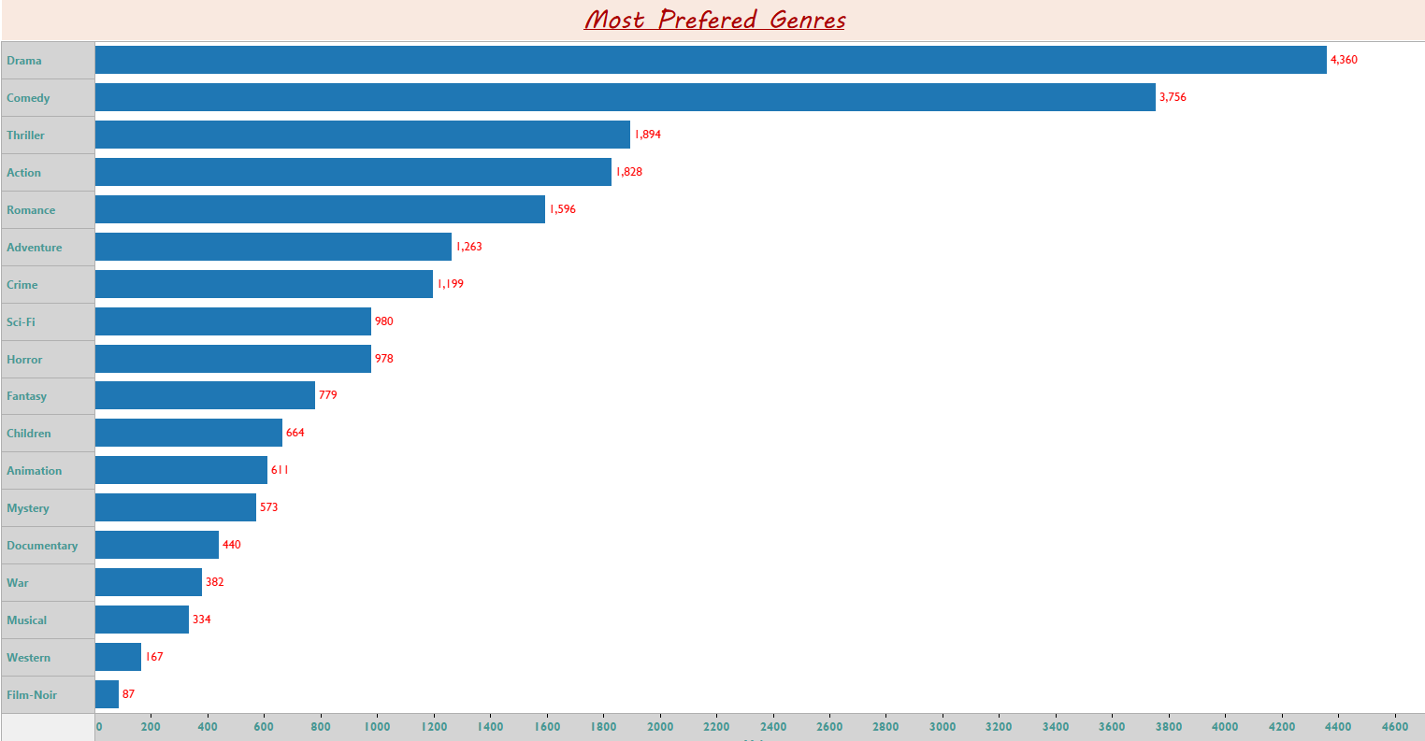
So, we can say that Drama is the most preferable genre.

- Who are the top10 users with ratings between 1 to 5
Ans:
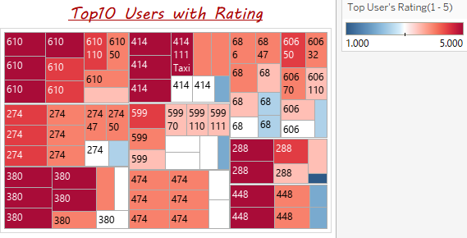

- Which top10 movies are most likely viewed by the users?
Ans:
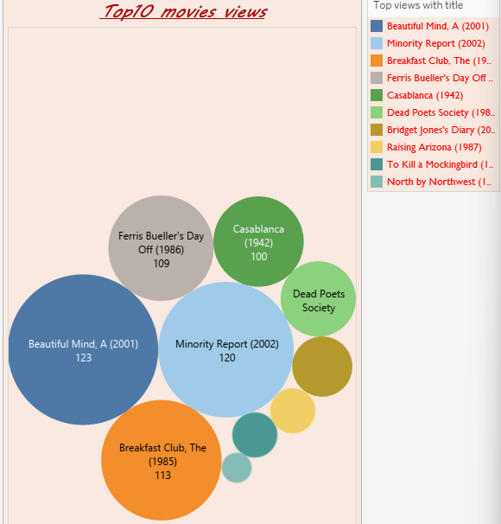

- what is the average of the most likely top10 views of the movies by the recommendation system?
Ans:

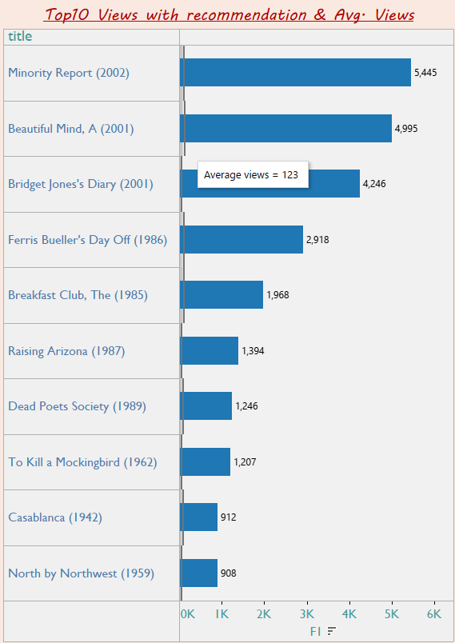

- Mention the top movies which are predicted with the recommendation system using recommenderlab?
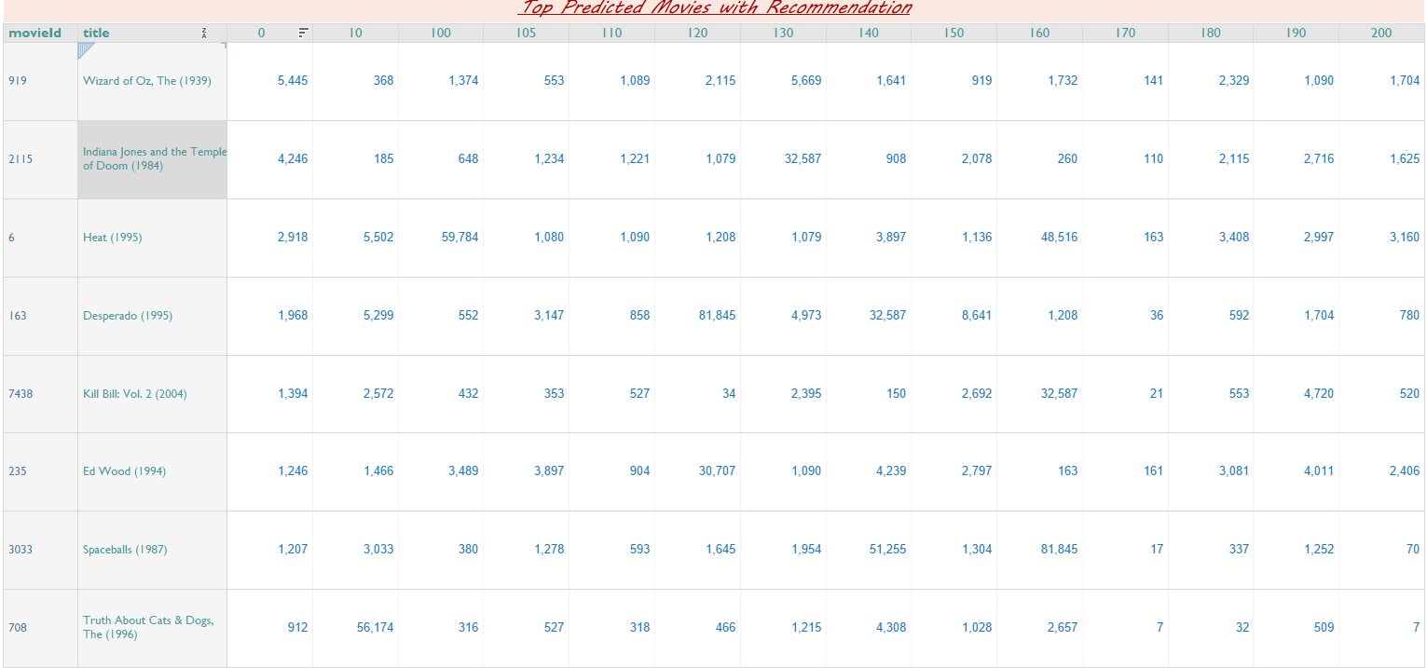
Ans:

- Which similar top movies are watched by users_2 from the recommendation of user_1?
Ans:
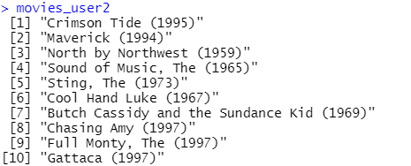

- How can we use the box plot for the outliers of the recommendation system?
Ans:
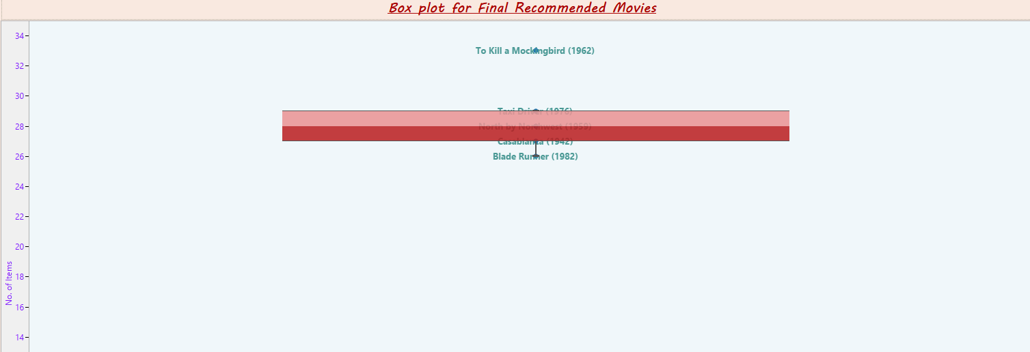
- Which final top movies are recommended by the recommendation_matrix?
Ans:
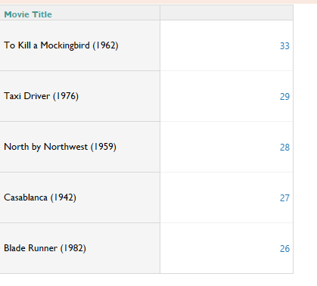

Conclusion:
The Recommendation system is a very powerful technology that helps people to find what they like. These systems have certain limitations not recommending efficiently to the users. If we take Collaborative Filtering as an example, then we find it is the most successful and powerful algorithm, even though it is the best, this algorithm has some high runtime and faces some issues like data Sparsity which can be removed by using a Hybrid movie recommendation system. But each algorithm has its strength and weakness. Our proposed approach can handle quite a big amount of data effectively. Collaborative filtering has its own pros and cons, which I mention here…
- Pros:
  - Uses both product features and user preferences.
  - Higher accuracy since product features are also optimized.
- Cons:
  - Required lots of data to train → ‘Cold Start’ problem.
  - Large numbers of parameters → computationally demanding.

