**How to install OpenCV in windows-64 bit using MinGW and Codeblocks**

***Note***

*This tutorial is provided to help people struggling with the installation of opencv. If you have another system configuration or you don’t want to use codeblocks, you will have to do your own research.*

**Step 1: Install minGW**

Download [minGW 64bit installe](https://sourceforge.net/projects/mingw-w64/files/Toolchains%20targetting%20Win32/Personal%20Builds/mingw-builds/installer/)r and follow the default configuration for the installation.

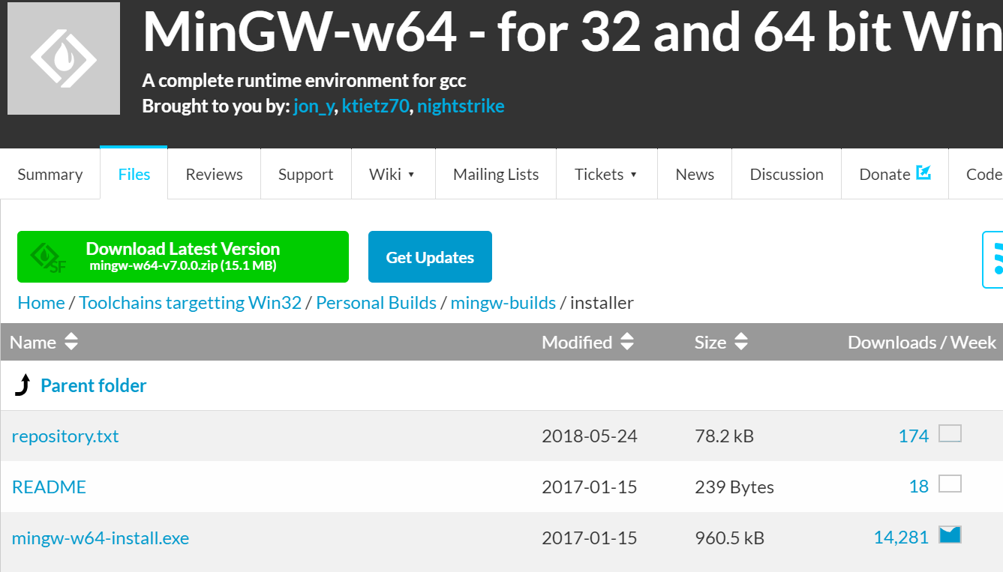

**Step 2: Add minGW to system path**

Go to Environment variables, select ***path->edit->new*** then add the path to ***bin*** folder:

C:\Program Files\mingw-w64\x86_64-8.1.0-posix-seh-rt_v6-rev0\mingw64\bin

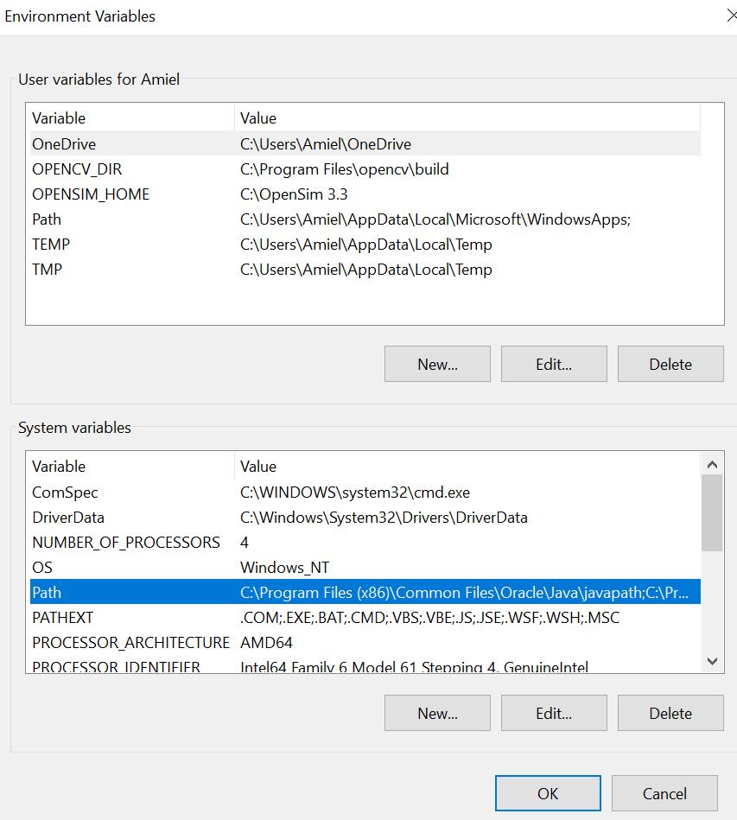 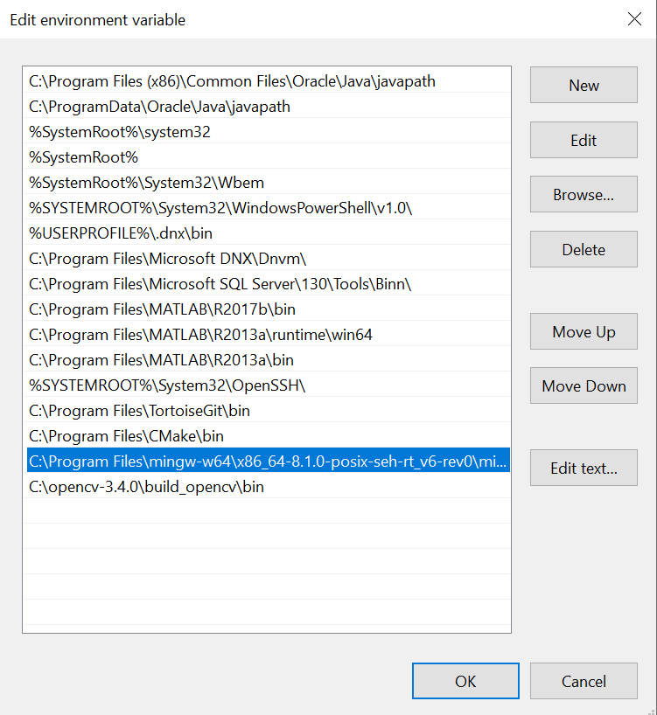

**Step 3: install codeblocks**

Download [codeblocks installer](https://sourceforge.net/projects/codeblocks/files/Binaries/17.12/Windows/codeblocks-17.12mingw_fortran-setup.exe/download) and follow the default configuration for the installation. When the installer is finished click yes to run codeblocks, then go to Settings -> Compiler -> Toolchain Executables, and select the right directory for mingw and .exe files.

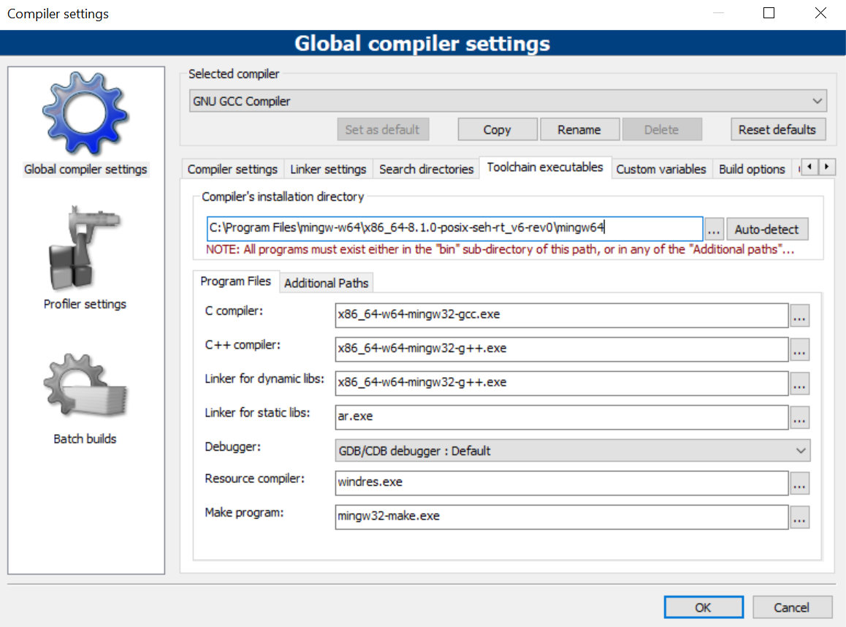

Opencv 3.4.0 is the one we use in CSGame competition for stability reasons. We had some trouble at the compilation of opencv latest version.

**Step 4: Install opencv**

Click on the OpenCV-3.4.0.exe and choose C:\ as the extract directory. OpenCV is now installed – but not configured with Codeblocks.

**Step 5: Compiling OpenCV**

First you’ll need to download and install [cmake](https://cmake.org/download/). Open cmake and select C:\opencv as the source directory and C:\opencv\build as the directory to build the binaries. In cmake, set ENABLE_PRECOMPILED_HEADERS=OFF. Press configure then generate.

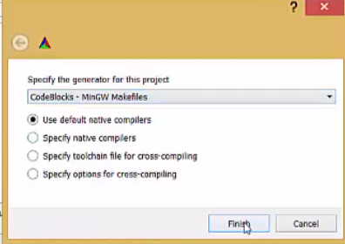 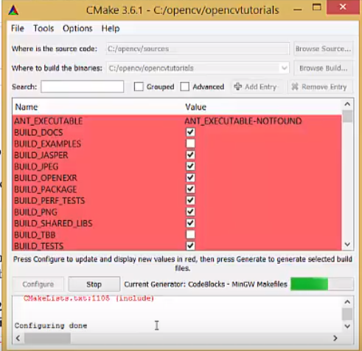

You will find a codeblocks project file (opencv.cbp) in C:\opencv\build folder. Just double click it and codeblocks will load it.

Finally, from codeblocks, you just need to build it. Build target should be set to ‘install’ so that you can find all the binaries inside the ‘install’ folder of C:\opencv\build\install. Just go to ‘build ->select target -> install’ in the codeblocks menu and then hit ‘build->build’ button (Its going to take some time 2-3 hour depending on the configuration of your pc).

**Step 6: Add OpenCV to the system path**

C:\opencv\build\bin (use the same process as above).

**Step 7: Run a C++ test program**

Create a test project in codeblocks.

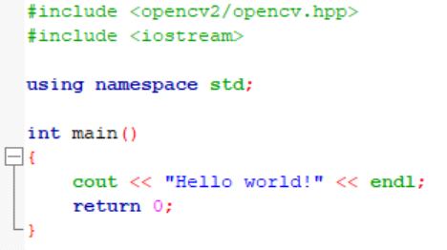

Go to settings -> compiler -> Lincker setting. Add all the libraries from C:\opencv\build\lib.

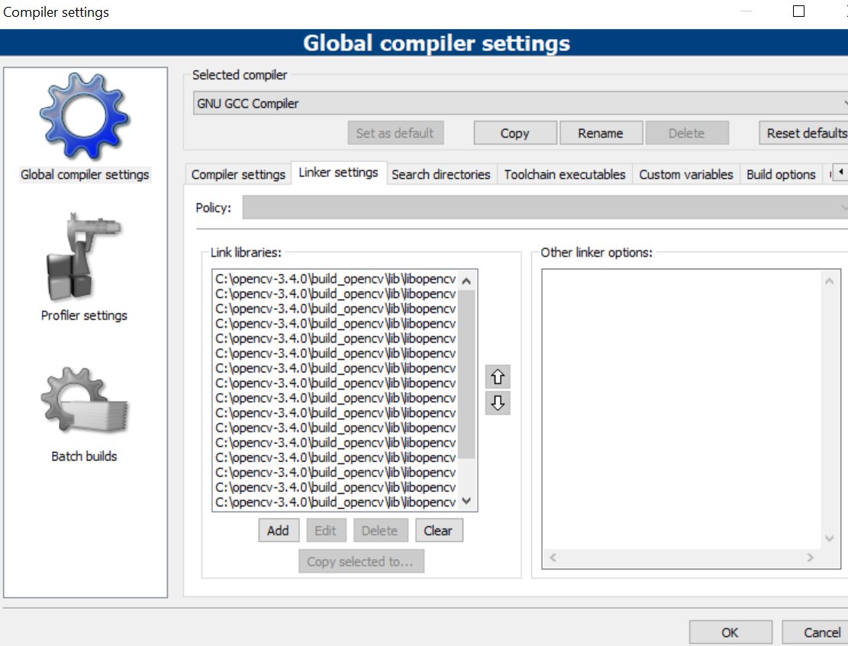

Go to settings -> compiler -> Search directories.

Add mingw64 include, search the corresponding directory in your computer.

Then add opencv include:

C:\opencv\build\install\include

C:\opencv\build\install\opencv2

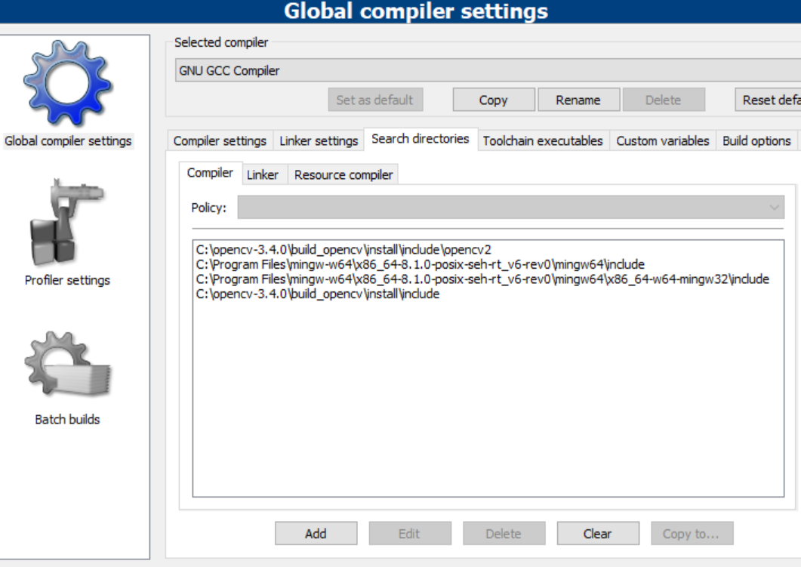

Go to settings -> compiler -> Compiler settings. Select the following option:



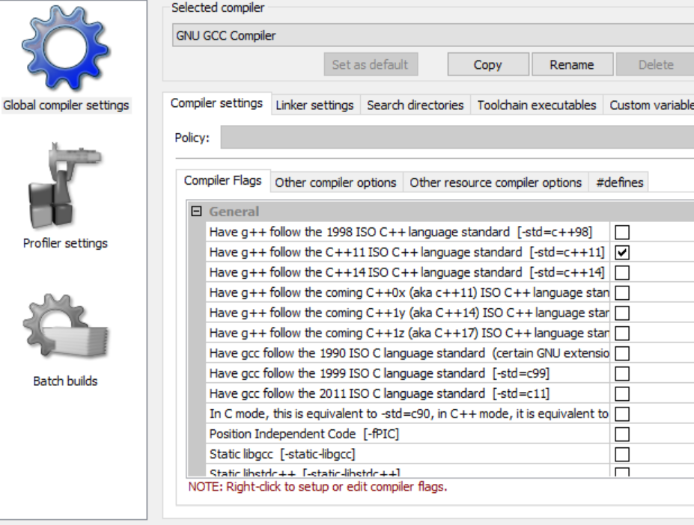

Close codeblock, and restart (important), then build and run your code.

**Reference for opencv installation**

<https://medium.com/@sourabhjigjinni/install-opencv-4-0-0-for-c-windows-7-10-code-blocks-tdm-gcc-64-dff65addf162>

<https://www.kevinhughes.ca/tutorials/opencv-install-on-windows-with-codeblocks-and-mingw>

<https://www.youtube.com/watch?v=7jVmkH89DKg>