Time series model

A broad method of trend estimation, non-linear modelling, is a more realistic approach to trend estimation, and often relies on complex statistical practices like higher-degree polynomials or non-parametric smoothing splines (Wood, 2006; Scinocca et al., 2010). The output of non linear models is often difficult to interpret and extremely challenging to quantify. A non-linear model of decadal trend at a particular upwelling system, or as relevant to this thesis, is ideal; however, comparing results between upwelling systems a linear model would be required. Because this study is to observe difference in upwelling metrics within the various EBUS, it is necessary to use GAMs for the modelling of long term trends.

The section of the appropriate model can largely influence the ability to detect trends. Two approaches are widely used in climate change research. The first estimates linear tends and may not reflect reality. The second accommodates nonlinear trajectories of temperature throuh time by the use of higher-degree polynomial terms or nonparametric smoothing splines. The complication exists when not being able to easily compared models among different upwelling system.

Table 1:

Model statistics for generalised additive models (GAMs) fitted to the decadal metrics associated with the individual EBUS. Edf – estimated degrees of freedom; Ref.df. - residual degrees of freedom; R²-adj. -Adjusted R²; Dev. Expl. - deviance explained.

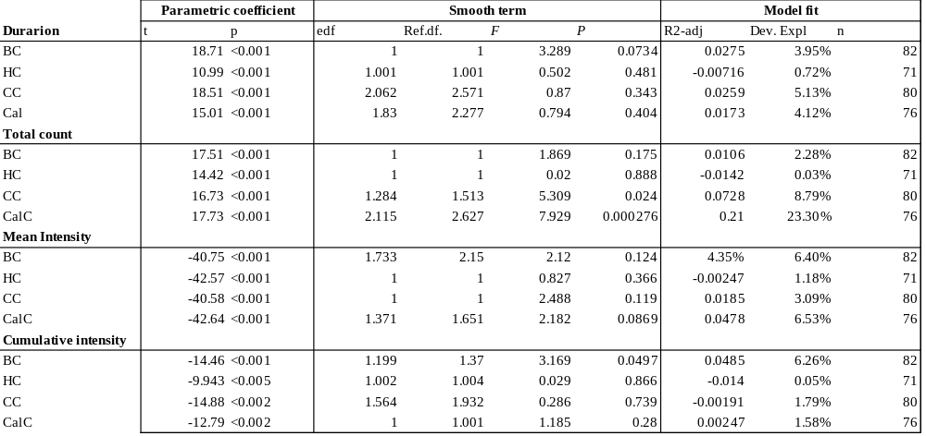

The mean duration (days) of signals detected from 1982 – 2012 was significantly different in each of the upwelling system. The Bengula system (t = 18.71, p < 0.001), the Humboldt current (t = 10.99, p = <0.001), Canary current (t = 18.71, p = <0.001) and the California current (t = 15.0, p = <0.001)

