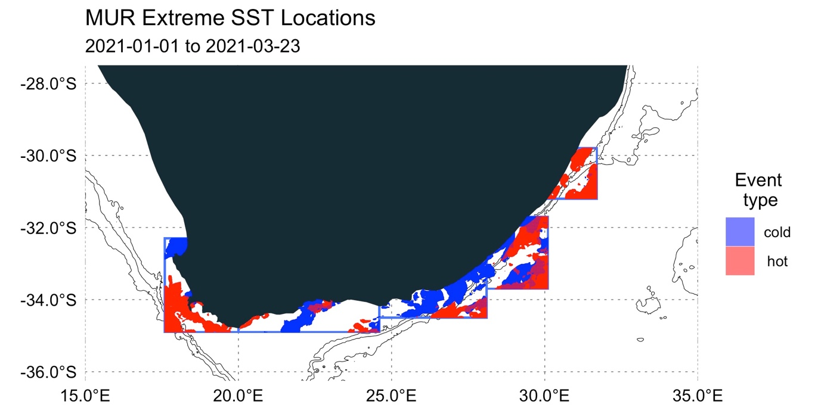

**Figure 1:** Locations of occurrences of extreme hot or cold water during the period 2021-01-01 to 2021-03-23. Extreme events defined as per the definitions of Hobday et al (2016) and Schlegel et al. (2017).

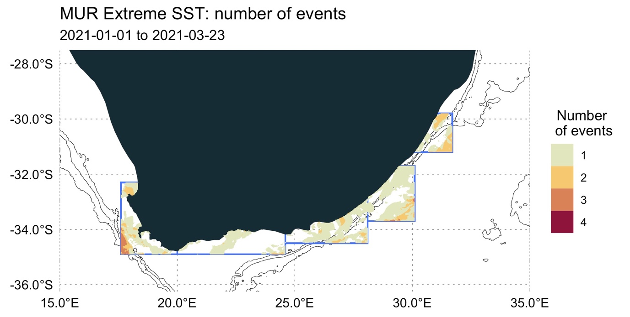

**Figure 2:** Spatial location of counts of repeat occurrences of marine heatwaves and cold spells during the period 2021-01-01 to 2021-03-23.

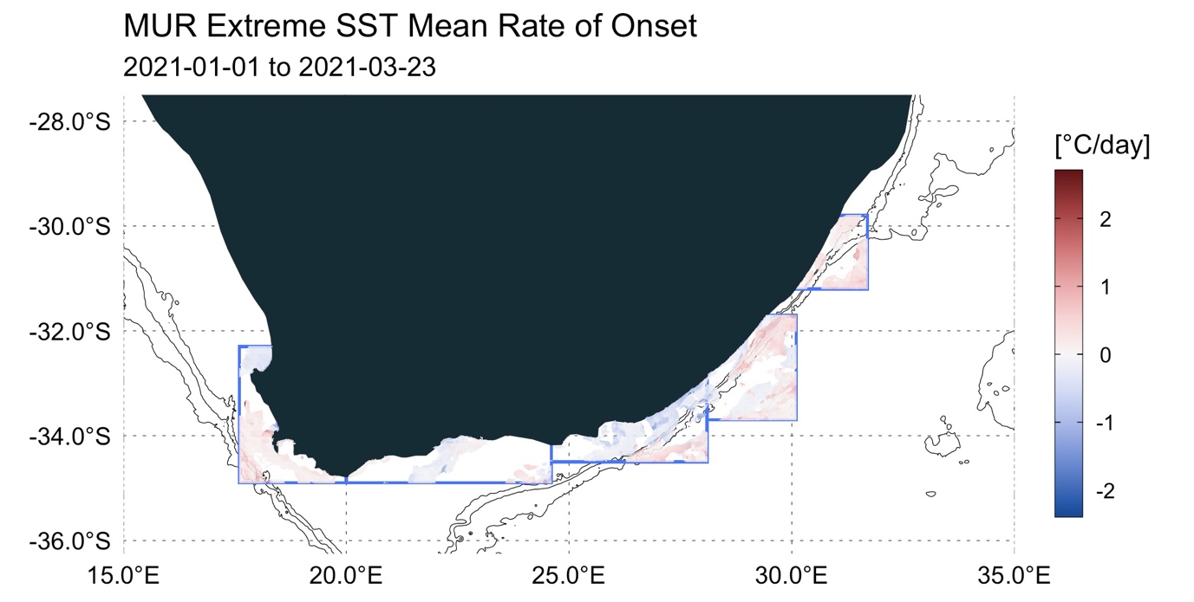

**Figure 3:** Rate of onset of marine heatwaves and cold spells during the period 2021-01-01 to 2021-03-23.