# Quantifying the impact of wind and wave action on seawater temperature along the South African coastline

**Amieroh Abrahams**

*A mini-thesis submitted in partial fulfilment of the requirement for the degree Bachelor of Science (Honours) in the Department of Biodiversity and Conservation Biology, Faculty of Science, University of the Western Cape*

**Supervisor:** Prof. A.J Smit

**Co-supervisors:** Dr. Robert Williamson

19 November 2018

# Plagiarism declaration

|  |  |
| --- | --- |
| http://www.logowise.com/images/stock/rad32D51.gif | University of the Western Cape  *Private Bag X17 Bellville 7535 South Africa*  *Telephone: [021] 959-2255/959 2762*  *Fax: 021]959 1268/2266* |

##### FACULTY OF NATURAL SCIENCE

**PLAGIARISM DECLARATION TO BE INCLUDED IN ALL ASSIGNMENTS, THESIS PROPOSALS ETC, BE IT FOR MARKS OR NOT:**

I, **Amieroh Abrahams**, having the student number **3559244**, do hereby declare that the following assignment entitled **“Quantifying the impact of wind and wave action on seawater temperatures along the South African coastline”** is my own work and that all the sources I have quoted have been indicated and acknowledged by means of complete references.

Signed this day 19 November 2018 at the University of the Western Cape.

Signature: ………………………………………

# Turnitin report

Quantifying the impact of wind and wave action on seawater temperature along the South African coastline

Amieroh Abrahams

Department of Biodiversity and Conservation Biology, University of the Western Cape,

Private Bag X17, Bellville 7535, South Africa

## Abstract

The South African coastline is comprised of three distinct coastal regions, each varying in average temperature due to the presence of two distinct ocean currents; namely the Agulhas and Benguela currents. Seawater temperature is an important driver in maintaining and regulating marine biodiversity, therefore a thorough understanding of the factors affecting variations and fluctuations of ocean temperatures is critically important. Coastal temperature variation exists between sites along the same region, yet reasons for this variation remains unclear. Analysis of temperature time series data from 18 different sites distributed along the South African coastline was conducted in order to examine intensity of variation occurring between the sites located along the same coastal region. This study further assessed the effects of wind and wave exposure on the variations of temperatures, using coefficient of determination analyses; as this determines how much of the variance in a dependent variable is explained by an independent variable. Results showed that wind and wave action did not significantly affect temperature, achieving low *R*2 values. Other localised effects, such as solar radiation, vertical mixing, internal waves or atmospheric temperature as well as tides are suggested to be the main drivers affecting temperature. These factors may be directly influencing marine biodiversity by altering ocean temperatures, ultimately this insight could prove useful in aiding in conservation efforts.

Keywords: Seawater temperature, climate change, coastal regions, code: R, variability

# Introduction

Seawater temperature is a key indicator of environmental change in marine ecosystems (Pearce, Faskel, and Hyndes 2006), and yet little is known regarding the controlling influences of temperatures within coastal zones (with the coastal zone here defined as the region ≤400m from the shore). Coastal temperature observations are generally limited in their spatial and temporal coverage. Oceanic regions however are studied to great extent due to availability of long-term datasets from moorings and satellites of monitoring ocean surface temperatures (Rouault et al. 2010; Beal et al. 2011; Tapia et al. 2014; Lee et al. 2018). Nearshore processes, such as wave action, coastal winds, and surface radiant heating, and the thermal properties of the substratum, are a few of the factors that have been implicated in affecting thermal variability across small spatial scales (Woodson et al. 2007; Davis et al. 2011; Fewings and Lentz 2011; Sinnett and Feddersen 2014). Given the significance of the temperature variation for the biogeographical limits of organisms, due to its effects on the reproductive, growth and survival limits of species (Hoek 1982; Breeman 1988; Pearce, Faskel, and Hyndes 2006; Broitman et al. 2008; Byrne et al. 2009; Smale and Wernberg 2009; Smit et al. 2013), it is imperative to understand how marine organisms may respond to climatic variation in coastal regions on both a global and local scale. Developing an understanding of the physical variables present within the coastal zone that are able to mediate thermal patterns and processes across small spatial scales and short temporal scales that are typically associated with nearshore processes will be instrumental in this understanding.

Temperature variability of the coastal region of South Africa, spanning approximately 3,100 km in distance (Smit et al. 2013), has not yet been studied in great detail at highly localised scales. At the broad scale, this region exhibits a large variation in seawater temperatures along its coastline (Mead et al. 2013; Smit et al. 2013) and is divided into four bioregions, each with contrasting temperatures. These bioregions are the Benguela Marine Province (BMP), Benguela-Agulhas Transition Zone (B-ATZ), the Agulhas Marine Province (AMP) and the East Coast Transition Zone (ECTZ) (Smit, Bolton, and Anderson 2017). These regions display noticeable differences in seawater temperatures in comparison to each other, primarily due to the influences of the neighbouring ocean currents (Bolton et al. 2004; Mead et al. 2013; Schlegel and Smit 2016). These temperature gradients are associated with differences in ecosystem physiology, species distribution, and habitat structure (Smale and Wernberg 2009; Wernberg et al. 2010, 2011; Smit, Bolton, and Anderson 2017). As a result of the diverse habitats defined by thermal differences and exposure gradients along the coastline, species diversity is not uniformly distributed; consequently, the east and south coast has much higher species diversity and beta-diversity compared to the west coast (Mead et al. 2013; Smit, Bolton, and Anderson 2017).

On broad scales, the influences due to the Benguela and Agulhas Currents greatly affect the thermal climatologies of the nearshore in the west and the east of the subcontinent, respectively. At an even broader scale, the Agulhas Current is driven by a wind stress curl between the southeast trade winds and the Southern Hemisphere westerlies (Beal et al. 2011), while the Benguela Current is driven by the anticyclone high pressures systems and eastward moving cyclones which determine the boundaries of the Benguela upwelling region (Shannon 2006; Hutchings et al. 2009). Regionally, the Benguela Current assists in transporting cold water northwards from the Southern Ocean to the coast (Lüning 1990; Lutjeharms, Cooper, and Roberts 2000; Hutchings et al. 2009; Schlegel et al. 2017), whereas the Agulhas Current transports sub-tropical, warm water towards the tip of Africa (Schlegel et al. 2017). Together these two currents are responsible for the presence of a strong west-east thermal gradient occurring along the coastline of South Africa, with the west coast having significantly colder waters than the east coast (Smit et al. 2013; Smit, Bolton, and Anderson 2017). The south coast is unique as it is affected by both the Benguela and Agulhas Currents, with a strong overlap region from Cape Agulhas to Cape Point (Smit, Bolton, and Anderson 2017), and it experiences a greater spatial and temporal variation in temperature compared to elsewhere along the coast (Lutjeharms and Van Ballegooyen 1988). At the localised scale, the statistical properties of temperature climatologies, such as the mean, minimum, and maximum of *in situ* coastal seawater temperature time series for the South African coastline, show distinct coastal variations (Schlegel and Smit 2016). The local influences acting on the water masses originating from the Benguela and Agulhas Currents can introduce thermal variation of up to 10°C within a 24-hour period (Schlegel et al. 2017), thus creating a highly dynamic nearshore environment.

Climate change is often understood as a long-term rise in the global mean temperatures and has resulted in increased mean ocean temperatures over the past few decades (Stocker 2014). The seawater temperature of the Benguela Current has been decreasing at a rate of approximately 0.5°C per decade whilst the Agulhas Current has been increasing by between 0.55°C-0.7°C per decade (Rouault, Penven, and Pohl 2009; Rouault et al. 2010). Overall, sea surface temperatures (SST) around South Africa have increased by approximately 0.25°C between 1903 and 2013 (DEA, 2013) and are still increasing at a rate of 0.12 °C per decade (Schlegel et al. 2017). Climate change is also leading to an increase in extreme atmospheric heating (Easterling et al. 2000; Perkins and Alexander 2013) and a decrease in extreme cold events (Meehl and Tebaldi 2004). Human activities are largely responsible for these decadal trends (Rouault, Penven, and Pohl 2009; Rouault et al. 2010; Mead 2011; Mead et al. 2013).

Over the last few decades, improvements in remote sensing technology have enabled researchers to map global sea surface temperature with a high level of accuracy (Zainuddin et al. 2006; Smale and Wernberg 2009). The National Oceanic and Atmospheric Administration’s (NOAA) series of satellites have provided global SST datasets from the 1980s on both global and local scales (Pearce, Faskel, and Hyndes 2006). The NOAA dataset is critically important as it is often used to monitor changes in oceanic temperatures, and provide valuable information on both biological and physical parameters in the ocean (Demarcq et al. 2010). Furthermore, satellite-derived SST data play an important role in creating projections of the potential effects of climate change on coastal and oceanic marine biota (Müller et al. 2009; Wethey et al. 2011; Bartsch, Wiencke, and Laepple 2012). Satellite-derived data are not as reliable as *in situ* temperature measurements when used near the shoreline (Smit et al. 2013), but are often used as a proxy when these measurements are scarce or unavailable (Smale and Wernberg 2009). However, in South Africa, the local availability of an *in situ* collected coastal temperature data product provides a reliable source of accurate coastal seawater temperature data (Smit et al. 2013). The South African Coastal Temperature Network (SACTN) has collected SST data form the South African coastline from as early as 1972, with contributions from various organisations and governmental departments. This dataset, used in combination with satellite-derived data that give a broader view, provides an opportunity to launch an investigation into the mechanistic underpinning for why the thermal milieu of the nearshore environment is so dynamic across short time scales and over short distances along the shore.

The intention of this study is to examine variations in temperature between selected sites along the South African coastline using seawater temperature data to better understand patterns of coastal temperature at a localised scale. The SACTN dataset used in this study consisted of *in situ* coastal seawater temperature measurements, allowing for comparisons between sites at a high temporal frequency. We also use co-located and overlapping satellite datasets, including that of SST, winds, and waves, to provide measurements of influential variables (*i.e.* as hypothesised drivers of the nearshore temperature field) representative of the wider regional scale. The aims of this study are to: i) examine whether there is homogeneity between the various sites sampled; ii) examine whether or not wind and wave action may contribute towards a variation in seawater temperatures along the South African coastline; and iii) to examine whether or not SST data collected via satellite may be affected by wind and wave action.

# Methods

In order to compare abiotic variables such as wind and wave action along the South African coastline, large historical datasets for temperature, wave and wind were analysed and accessed.

## Wave and wind data

Wind and wave action were important variables in this study as they were hypothesised to exhibit a direct influence on coastal water temperatures (Sinnett and Feddersen 2014); consequently, they were investigated for their impact on seawater temperature at specific sites along the South African coastline. Wind and wave data were obtained from the South African Weather Service (SAWS), and were provided at three-hour resolutions. Specific wind and wave characteristics were measured, namely, wave height (*hs*), wave period (*tp*), wave direction (*dir*), wind direction (*dirw*) and wind speed (*spw*). The data were then used to model short–crested waves, generated by the wind into the coastal environment, using the wave model Simulating Waves in the Nearshore (SWAN). SWAN enables the extraction of wave parameters from specific gridded locations in the nearshore (Appendix C). A resolution of 200m was modelled at both 7 and 15m isobaths.

## *In situ* temperature data

The SACTN dataset was the primary source of temperature data used in this study. This dataset consisted of coastal seawater temperatures for 129 sites along the coast of South Africa, measured daily from 1972 until 2017 (Appendix A). Of these, 80 were measured using hand-held thermometers and the remaining 45 were measured using UTRs. The duration and extent of the recordings per site were uneven, with the longest time series in the dataset being that of Gordons Bay, recorded by SAWS. Data collected for this region started on 13 September 1972 and concluded on 26 January 2017, with recordings still continuing daily. During the 1970s, a total of 11 time series began recording. A further 53 entries were added during the 1980s, 34 entries were added during the 1990s, and 18 entries were added during the 2000s. Recordings are still ongoing at many of these sites.

For this analysis, the data were combined and formatted into standardized comma delineated values (CSV) files which allowed for a fixed methodology to be used across the entire dataset. Prior to data analysis, all data points exceeding 35°C and/or below 0°C were removed as these were considered as outliers. These data points were then changed to NA (not available) so as to not interfere with analysis. All analyses were conducted in R software version 3.4.2 (http://www.r-project.org/). The data used within this study and comprehensive script used for data analyses, and production of figures can be found at <https://github.com/AmierohAbrahams/HONOURSPROJECT>.

## Satellite SST data

This study made use of four satellite-derived SST datasets to compare with the SACTN *in situ* coastal seawater temperature and wave datasets. The AVHRR-only Optimally-Interpolated Sea Surface Temperature (OISST) was used to determine SST within the study region. The AVHRR datasets have been provided global SSTs for more than four decades (Reynolds and Smith, 1994; Pearce et al 2006). OISST is a global 1/4° gridded daily SST product that assimilates both remotely sensed and *in situ* sources of data to create a level-4 gap free product (Banzon et al., 2016). The Multi-scale Ultra-high Resolution (MUR) Sea Surface Temperature Analysis, the second dataset, is produced using satellite instruments with datasets spanning 1 June 2002 to present times (PO.DAAC, <https://podaac.jpl.nasa.gov/>). MUR provides SST data at a spatial resolution of 0.01° in longitude-latitude coordinates and is currently among the highest resolution SST datasets available. The third dataset, K10, is produced at the Naval Oceanographic Office (NAVOCEANO) on a 10km resolution, globally (DATA.GOV, <https://catalog.data.gov/>). The K10 analysis makes use of SST observations from the AVHRR, the Geostationary Operational Environmental Satellite (GOES) Imager and the Advanced Microwave Scanning Radiometer for EOS (AMSR-E). The CMC dataset constitutes the forth dataset and is a version 3.0 Group for High Resolution Sea Surface Temperature (GHRSST) Level 4 dataset with a 10km resolution constructed by the Canadian Meteorological Center (CMC). The CMC dataset combines infrared satellite SST at numerous points in the time series from the AVHRR, the European Meteorological Operational-A (METOP-A) and Operational-B (METOP-B) platforms, and microwave SST data from the Advanced Microwave Scanning Radiometer 2 in conjunction with *in situ* observations of SST from ships and buoys from the ICOADS program.

## Site selection

In order to compare temperatures along the South African coastline at a localised scale, we selected appropriate sites from each of the major coastal regions. Since temperature data were not evenly recorded for each of the 129 sites representing South Africa’s coastline, we firstly narrowed down the full dataset to only those sites that could be adequately compared. To do this a clustering analysis was performed using the kmeans() function in R, with multiple random seeds to identify a number of clustering solutions that grouped sites together based on their available temperature data. The mean, minimum, and maximum temperature values were used within the clustering algorithm to group sites with similar temperatures along each coastal region. The clustering analysis represented the most accurate and distinct site groupings based on temperature distributions and yielded distinct east, south, and west coast groupings. Eight clustering solutions along the South African coastline are shown (Figure 1). With the data now divided into eight distinct coastal regions, portions of overlapping time series (*i.e.* across the multiple sites per region) were selected of at least one decade in duration, but excluding those sites with temperature data collected deeper than 5m.

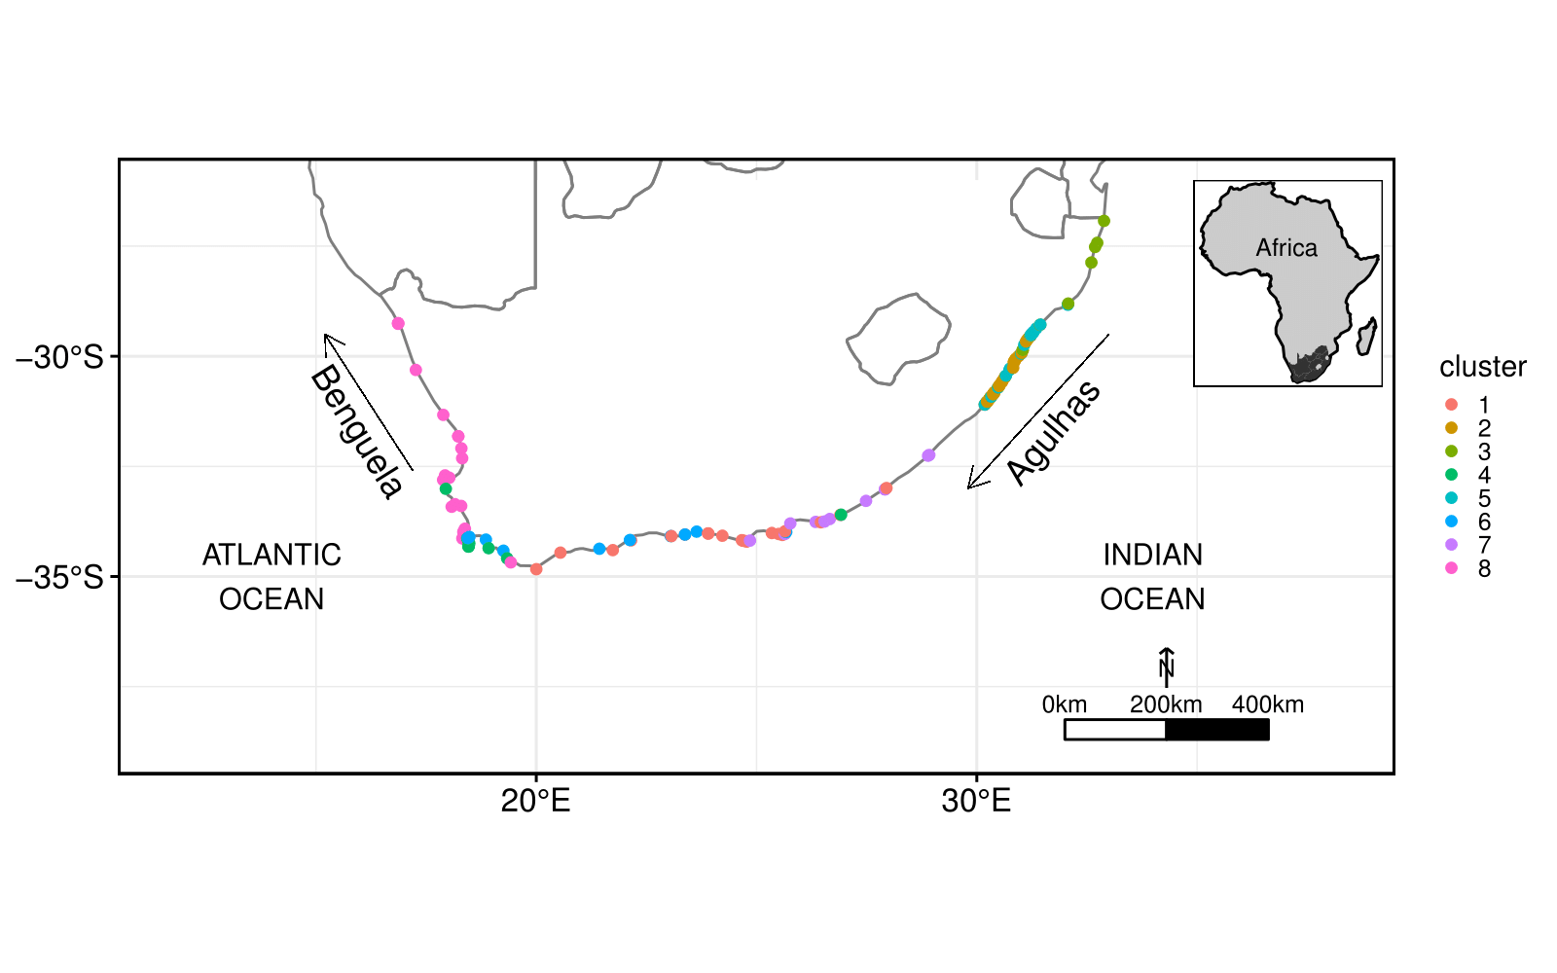

**Figure 1:** Map of the study area representing the 129 sites where in situ coastal seawater temperature was collected. These sites were grouped based on similar mean, minimum and maximum temperatures and as such each group represents a unique colour variation.

Once sites were clustered, we reduced the number of sites to a manageable but still representative sub-sample of the whole. This was done for two reasons. The first was to allow for the comparisons to be more readily interpretable by humans. Secondly, it was to allow for equal amount of sampling per coast. The east coast has previously been more heavily sampled than the rest, and such an imbalance needed to be addressed (Appendix B). The criteria considered for the sub-samples included selecting the longest time series within the region and including data from as many different sources (*i.e.* contributors to the SACTN) as possible. This process yielded three sites for each of the clusters along the South African coastline (Figure 2). The statistical characteristics of the temperature were used to guide analysis of the time series to produce an accurate assessment of temperature variation between sites that were grouped together.

With three sites per cluster, the haversine formula was used to calculate the geodesic distance between points specified by radians. Using this formula, the distances (km) between each of the sites along the coastline were determined. Thereafter, sites within the same cluster were matched based on the date that temperature was collected. This allowed for a comparison to test whether or not temperature variation exists between sites within the same cluster. Once the sites were matched, the means and standard deviations of temperatures between sites and clusters were determined. This highlighted the temperature variation between matched sites and allowed for seasonal comparisons within the same cluster.

Once the temperature variation between sites were carefully analysed, the seawater temperature data along with the wave and wind data were compared. The data were modelled for water depths of 7m and 15m. Since the wave and wind data were modelled at three-hour resolutions, they were converted into daily data points in order to compare them with the temperature data. The circular() function in R software was then used to create circular objects around the wave data in order to calculate the daily wave and wind parameters.

With temperature and wave values now corresponding to their respective sites, depths and dates, the hypothesis regarding whether or not a relationship existed between wind/wave action and temperature was tested. To do this, linear models for each site were produced, reflecting temperature and wave variations at each depth. Linear models typically produce coefficients of determination R2 as an output. The purrr() function within the **tidyverse** R package was used to simultaneously compare temperature and wave data across sites and depths. An ANOVA analyses was done compare one variable in two or more groups, considering the variability of other variables. Hereafter, a wind rose diagram was constructed to determine the most predominant direction for a particular site. This was done to ascertain what the potential relationship between wind/waves and temperature was at each site during only the prevailing wind directions.

## Satellite data analysis

SST measurements used in this study were obtained from four different sources: MUR, CMC, K10 and AVHRR. A time series of SST was determined by creating a bounding box which represented the region of extent at the latitudes (39.5°S, 25.5°S), and the longitudes (10.5°E, 39.5°E). The size of the pixel search area was set to a 5km resolution from each of the stations. The satellite datasets and the corresponding SACTN *in situ* collected dataset were matched based on the coordinates and the date at which temperature was collected. Some sites, however, shared the same satellite data due to their close proximities. Once the satellite data corresponded to the *in situ* collected data, linear models for each site were produced, reflecting temperature and wave variations at each depth. Linear models typically produce coefficients of determination (*R*2 values) as an output, which is the statistic showing how much of the variance in a dependent variable is explained by the independent variable. This allows for us to test whether or not wave and wind direction may influence temperature at the various sites and whether or not satellite temperature have influential effects on nearshore temperatures.

## Statistical analyses

A series of ANOVA tests were used to compare the main effects of the chosen variables on a continuous variable. In this analysis the relationship between matched sites based on the mean temperature as a function of year and season were analysed; these analyses tested if significant differences occurred between each pair of sites within each of the clusters. To determine the strength of correlation of temperature between sites found within the same clusters along the coast, boxplots were constructed. These plots enabled the visual identification of variations in temperature by summarising the descriptive statistics. To further analyse the temperature variation between sites line graphs were constructed. This plot allowed for visual identification of the variation in average temperature for each of the month and year for paired sites.

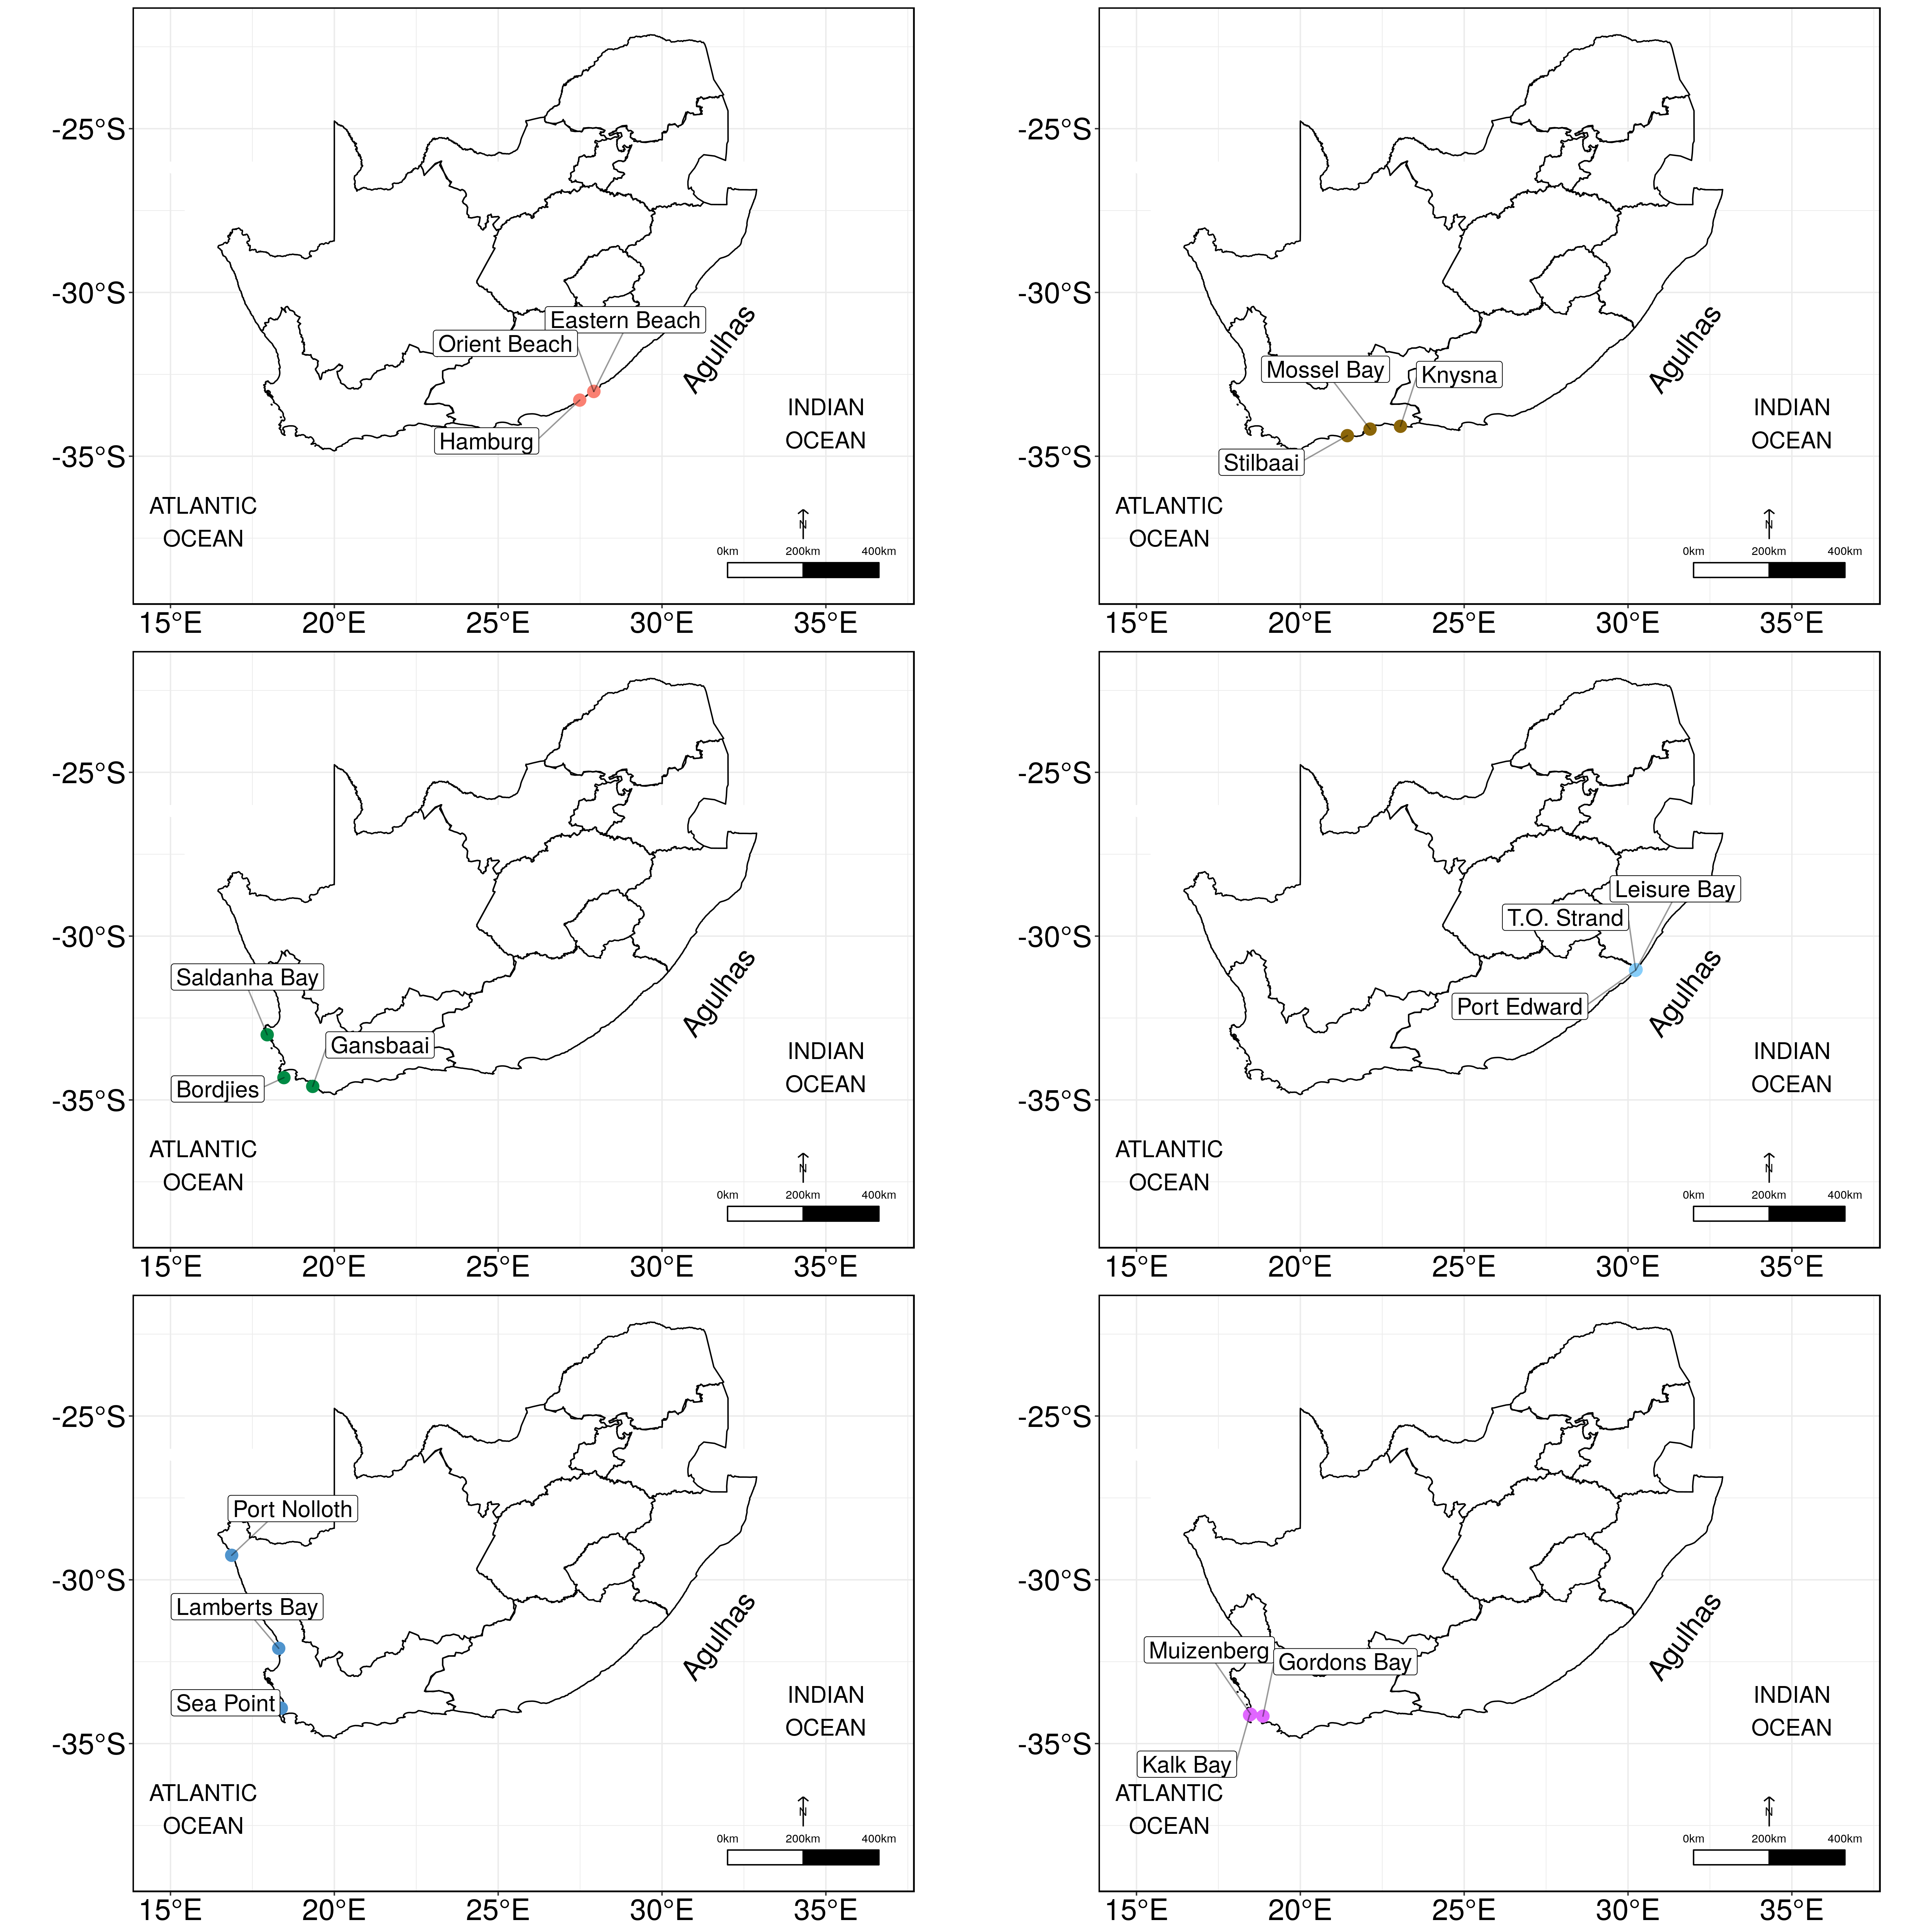

**Figure 2:** Map representing the three sites chosen within each of the six cluster along the South African coastline.

# Results

## Temperature variation

Seawater temperature was not uniformly distributed across the six clusters produced (Figure 3), with each set of sites having unique patterns of temperature variation. Within Cluster 1, along the south and east coast, comprising of Hamburg, Eastern Beach and Orient Beach, temperature varied from approximately 13 to 22ºC. Within this cluster of sites, Hamburg had the highest maximum temperatures and the lowest minimum temperatures of the three sites. Conversely, Orient Beach had the lowest range of temperature. Orient Beach and Eastern Beach had relatively similar ranges and distributions of temperatures.

Along the south coast, within Cluster 2 comprised of Mossel Bay, Stilbaai and Knysna, temperatures ranged from approximately 12 to 27ºC. Stilbaai had the widest range of temperature variation among the three sites, but despite the apparent differences in temperature ranges between these sites, the average temperatures were relatively similar. Average temperatures were nearly identical within this cluster, with very few outliers present within the temperatures ranges of these sites.

Sites located within Cluster 3 had slightly lower temperatures than the previous two clusters. This cluster comprised of Bordjies, Saldanha, and Gansbaai and temperatures within here ranged from approximately 11 to 21ºC, with a median temperature being close to 15ºC across all three sites. Gansbaai had relatively low variation in temperature. Conversely, Saldanha had a high variation and relatively evenly distributed temperatures by showing little skewness. These sites were similar in terms of their temperature. There were however, several outliers present within the temperatures of these sites.

Cluster 4 which was located along the east coast, comprised of Port Edward, Leisure Bay, and T.O. Strand. Overall, the temperatures of these sites were higher than those of the sites within the other clusters, with a range of 15 to 25ºC. These sites displayed a low variation in temperature, with little skewness across sites. Temperatures were identical between these three sites. The median temperature for each of the sites within this cluster is 20.5ºC.

Sites within Cluster 5 had overall lower temperatures than those within the other clusters. This cluster comprised Port Nolloth, Lamberts Bay, and Sea Point; here sharp declines in average temperatures were observed throughout. Temperatures within this cluster ranged between 8 and 18ºC, with an average temperature being close to 13ºC. Port Nolloth had low variation in temperature. Lamberts Bay and Sea Point were similar in terms of temperature variances. Several outliers were present within the temperatures of these sites.

Cluster 6 comprising of Kalk Bay, Muizenberg, and Gordons Bay temperatures ranged from 8 to 24ºC. Muizenberg had the widest range of temperature variation of the three sites. Gordons Bay and Kalk Bay had identical temperature ranges. Similarly, to the second cluster, despite the apparent differences in temperature ranges between these sites, the median temperatures across them were relatively similar and nearly identical.

On a monthly basis, large differences of average temperatures were seen between sites within Cluster 1. These differences largely occurred during the summer and spring months of 1995 to 1997 (Figure 4). For the remaining sites, however, differences in average temperatures were lower during autumn. It was also evident that the average temperature between Hamburg and Orient Beach and between Orient Beach and Eastern Beach varied largely on an apparent seasonal basis. The comparison between Hamburg and Eastern Beach however are not reliable due to the short overlap and hence does not stabilise the long-term trends. Small monthly average temperature differences existed between Eastern Beach and Orient Beach throughout the different seasons.

Converse to Cluster 1, the sites within Cluster 2 displayed the largest differences in average temperatures during spring. In this cluster, large differences in average temperatures were present between Mossel Bay and Knysna, with the differences increasing annually from 1985 to 2017. Similarly, differences in average temperature also increased slightly between Stilbaai and Knysna during winter and spring. During summer months little differences in average temperature were seen between all three sites within this cluster.

Differences of average temperatures between sites within Cluster 3 varied on a seasonal basis. During the summer months, large differences in average temperatures existed between Bordjies and the remaining two sites, with an increase in differences of average temperature between Saldanha Bay and Gansbaai throughout autumn, winter and spring. In Cluster 4, small changes in the pairwise differences of monthly average temperatures were noticed between sites between 1980 to 2017. Here, large differences in temperatures were observed towards the end of spring and during summer months. Temperatures were relatively stable throughout winter and the beginning of spring across all three sites within this cluster.

In Cluster 5, large differences in average temperatures existed between sites at selected months between 1972 and 2017. During summer and autumn months, differences in average temperature were observed between Lamberts Bay and the remaining sites increased. During the months of autumn Lamberts Bay and Sea Point showed large differences in average temperature variation. For the remaining sites, differences in average temperatures were relatively low throughout each month for the same time period.

In Cluster 6, the largest differences in average temperatures were observed during mid-autumn and winter months. In this cluster, large differences in average temperatures were seen between Muizenberg and the remaining sites, with the differences increasing annually throughout 1972 and 2016 during winter. Similarly, differences of average temperatures also increased between Kalk Bay and Muizenberg during these same months. In the summer and spring months little differences in average temperatures between sites, with minimal differences in the rates of these changes. These rates increased during spring.

## Average temperature of clustered sites

Sites located along the east coast shows no difference in temperature. Conversely to the east coast, sites located along the south coast however exhibits a large difference in temperature both seasonally and yearly. Similarly, sites located along the west coast shows large variation between individual sites and paired sites on a seasonal and yearly basis. In Cluster 1, the results of a three-way ANOVA showed that there was a significant (*p*<0.05) difference in average temperatures between paired sites (*F*=12.07, *SS*=15.28, *p*<0.001). These differences were present across season (*F*=3.44, *SS*=13.07, *p*<0.002) but were not present yearly between individual sites and paired sites (*F*=1.38, *SS*=1.75, *p*=0.25). Similarly, paired sites within Cluster 2 also displayed a significantly difference in average temperature (*F*=166.84, *SS*=418.6, *p*<0.001). Conversely to Cluster 1, however, these differences were present yearly (*F*=33.21, *SS*=41.7, *p*<0.001) and seasonally (*F*=16.72, *SS*=125.9, *p*<0.02) between individual and paired sites. In Cluster 3, a three-way ANOVA revealed no significant differences in average temperatures between paired sites (*F*=1.17, *SS*=2.9, *p*=0.31), but temperatures varied seasonally and yearly between individual sites. In Cluster 4 there were again no significant difference in average temperatures between paired sites (*F*= 0.73, *SS*=2.9, *p*=0.48). Significant differences were also absent across seasons (*F*=0.75, *SS*=0.0042, *p*=0.52) and years (*F*=0.495, *SS*=0.0009, *p*=0.48) between both individual and paired sites. Sites within Cluster 5 were significantly different in average temperatures between paired sites (*F*=77.10, *SS*=196.7, *p*<0.002), with these differences being present yearly (*F*=172.80, *SS*=220.4, *p*<0.001) and seasonally (*F*=77.10, *SS*=29.92, *p*<0.002) for both paired and individual sites. Finally, Cluster 6 sites also had significant difference in average temperatures between paired sites, both yearly and seasonally (*F*=132.044, *SS*=419.7, *p*<0.01).

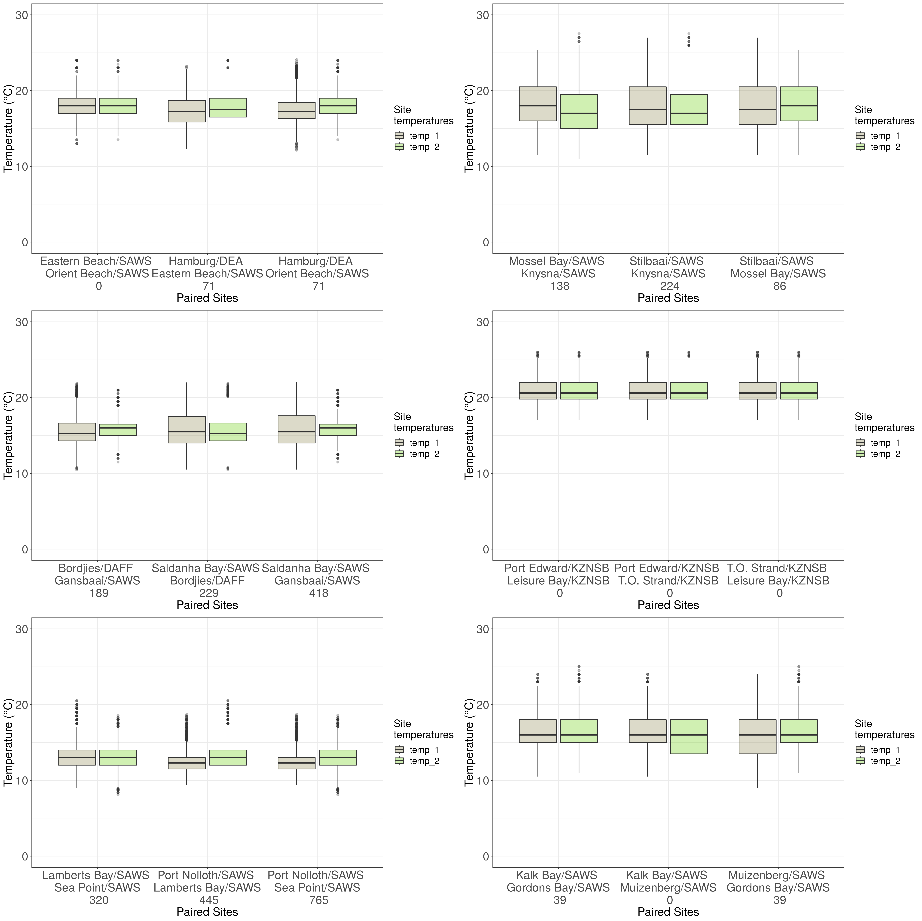

**Figure 3:** Boxplots representing the seawater temperature of paired sites within each cluster along the South African coast with the values representing the distance (km) between paired sites.

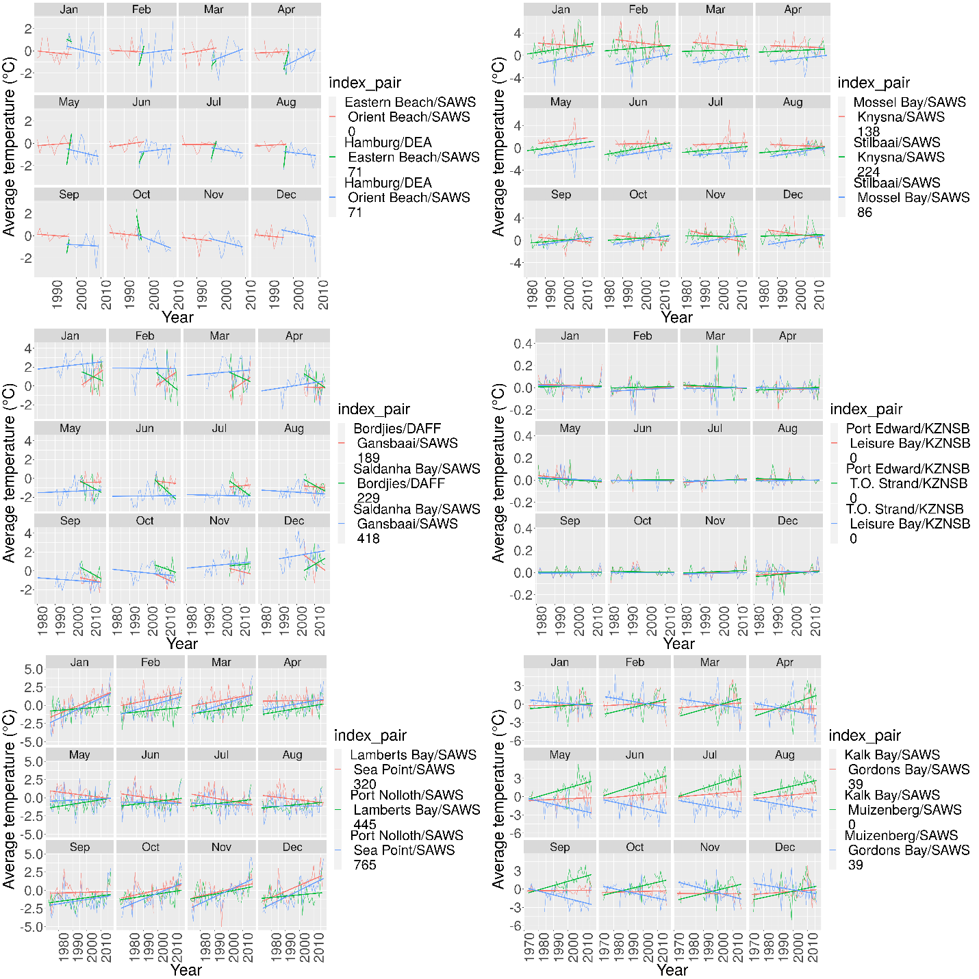

**Figure 4:** Line graphs representing the pairwise differences in median seawater temperature, shown individually for each month across years. The values appended to the end of the legend keys represent the distances (km) between the paired sites.

## The impact of wind and wave action on temperature

The coefficient of determination (*R*2) was calculated to determine how differences in one variable can be explained by a difference in the second variable. Here, the relationship between temperature and several variables, including wind direction and speed as well as wave height, period, direction and speed, was determined for all 18 sites. The findings revealed little influence of the hypothesised predictor variables on *in situ* SACTN temperatures for each of the sites. Wind and wave direction influenced temperature at 0–3%. Although not statistically significant (*p*>0.05), the most influential relationships were found in Muizenberg, Kalk Bay and Mossel Bay where the *R*2 values indicated that wave period had a 6-7% influence on temperature. Overall wind and wave action had no significant impact on temperature differences along the coast.

Upon examining the impact of wind and wave action on seawater temperature of the AVHRR temperature dataset, it emerged that wave and wind direction had a minimal effect on temperature variation in this SST dataset, with its *R*2 values ranging between 0-3%. The results did however suggest that wave height might have minimally influenced temperature at some of the sites, namely at Gansbaai and Lamberts Bay where wave height had a 9% (*p*<0.05) impact on temperature variation. The results obtained from the MUR dataset continued to show little variation in regards to the influence of wind and wave action on temperature. At many of the sites, both wind and wave direction had a 0% impact on the temperature; however, it was seen that wave height and wave period had the greatest impact on temperature at some of the sites, with Gordons Bay and Gansbaai indicating an 8% and 10% (*p*<0.05) impact of wave height on temperature variation, respectively. The results obtained from the CMC temperature dataset indicated that wave and wind direction as well as wind speed showed the least significant impact on temperature variation with *R*2 values ranging between 0-3%. Wave height continued to show the largest impact on temperature variation at some of the sites. Gansbaai and Gordons Bay indicated the highest *R*2 values of 12% and 9% (*p*<0.05) respectively. Upon comparing the impact of various environmental factors on temperature variation for the K10 data, the results indicated that the each of the above-mentioned variables had no impact on the temperature variation at Hamburg. The impact of wind direction on temperature is highest at Gansbaai, representing an *R*2 value of 4% while wave height still represented the greatest influence on temperature occurring at these sites.

## The relationship between satellite SST and costal *in situ* temperatures

The relationship between satellite SST and costal *in situ* temperatures is significant, with the AVHRR and K10 SST dataset represented an *R*2 value of 58% (*F*=2.27, *p*<0.05). Similarly, the MUR and CMC SST dataset also represented a significant influence with an *R*2 value of 55% (*F*=8.41, *p*<0.05) and 65% (*F*=213, *p*<0.05) respectively.

## Wind and wave rose diagrams

Wind and wave diagrams (Figure 5 and Figure 6) help visualise the patterns present at a particular site. Moving outward on the radial scale, the frequency associated with wind and waves coming from a particular direction increases. The predominant wind direction along the south coast of South Africa is 105º. The predominant wind direction of sites located along the east coast such as T.O. Strand, Port Edward and Eastern Beach occurred at 15º. Orient Beach and Leisure Bay, also located along the east coast however indicates a predominant wind direction of 225º. Sites located along the west coast, indicates a highly variable predominant wind directions ranging between 105º and 165º respectively.

The predominant wave direction for sites along the east coast such as T.O strand, Port Edward, Eastern Beach and Leisure Bay occurred at 135º. Orient Beach, also located along the south coast however indicates a predominant wave direction of 165º. Stilbaai and Hamburg, located along the south coast, displays a predominant wave direction of 135º. Muizenberg and Kalk Bay, also located along the south coast however indicates a predominant wave direction of 135º with Knysna and Mossel Bay indicating a predominant direction of 75º. Sites located along the west coast such as Sea Point and Lamberts Bay indicate a predominant wave direction of 225º. Saldanha Bay, also located along the west coast indicate a predominant wave direction of 75º.

## Impact of predominant wind and wave action on seawater temperature

The results (Figure 7) indicated that wind speed, wind height, wind and wave direction, as well as wave period had no significant (*p*>0.05) impact on *in situ* temperature variation at the various sites along the coastline (Figure 7). Muizenberg, however, showed that wave height appears to have the largest effect on temperature variation (*R*2=4%; *p*<0.05). At Hamburg and Gordons Bay, wave direction had a significant impact and explained 4% of the temperature variation (*p*<0.05). At Muizenberg the largest influence of 5% was due to wave height on temperature variation. At Cluster 2, wind and wave action also had very little impact on temperature variation. The results obtained from both Cluster 3 and Cluster 4 indicated that wind speed, wind height, wind and wave direction, as well as wave period had no significant impact on temperature variation (*p*>0.05). In Cluster 6, wave height was seen to have had a minor impact on temperature variation with an *R*2 value varying between 1-5%. Overall, it is seen that predominant wind and wave direction have no impact on the seawater temperature variation along the coast.

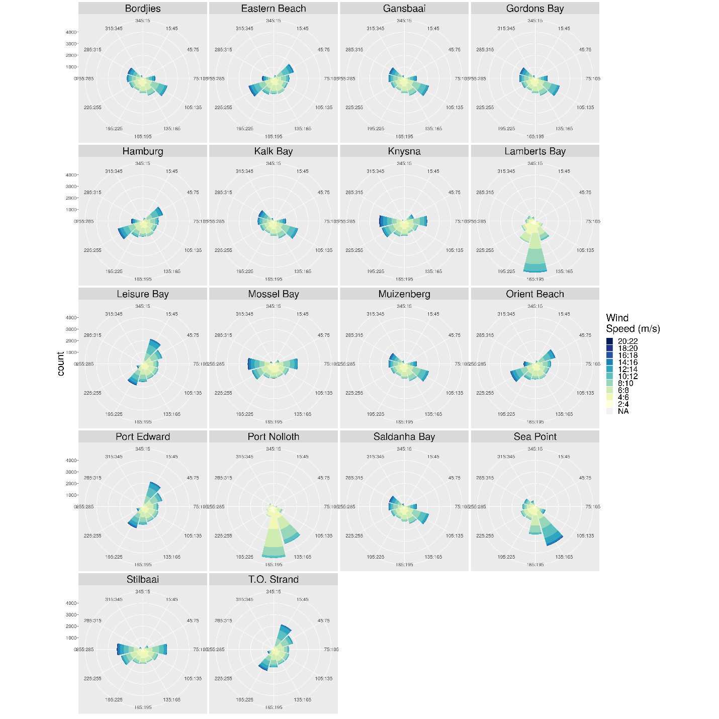

**Figure 5:** Wind rose diagrams representing the most predominant wind direction for each of the sites. Each spoke is divided by colour into wind speed ranges. The radial length of each spoke around the circle is the time that the wind and waves come from that direction.

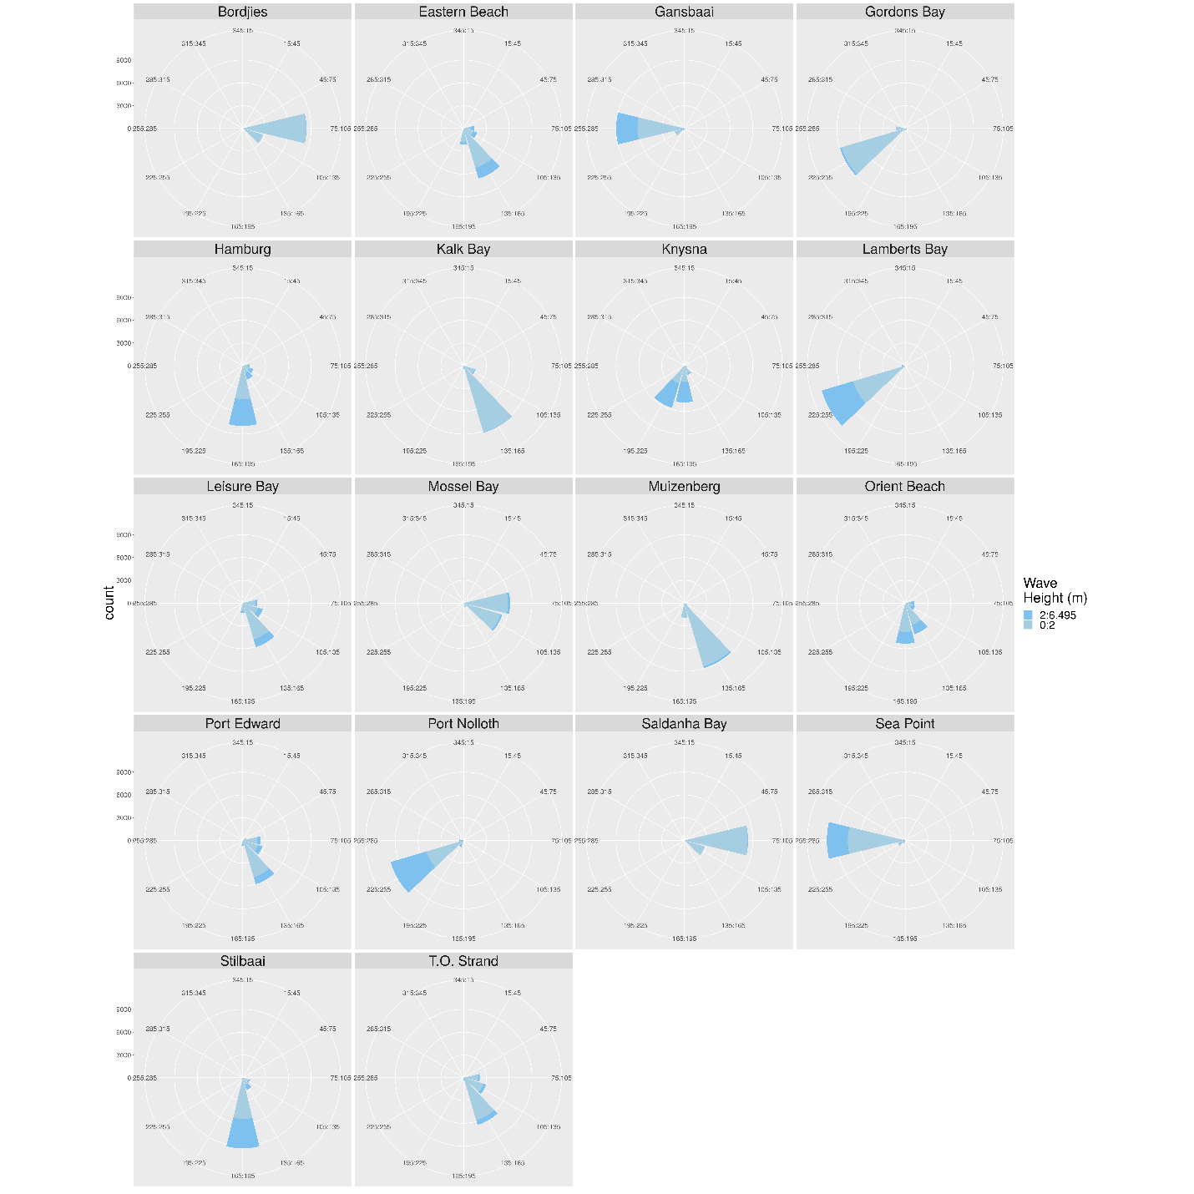

**Figure 6:** Wave rose diagrams representing the most predominant wave direction for each of the sites. Each spoke is divided by colour into wave height ranges. The radial length of each spoke around the circle is the time that the waves comes from that direction.

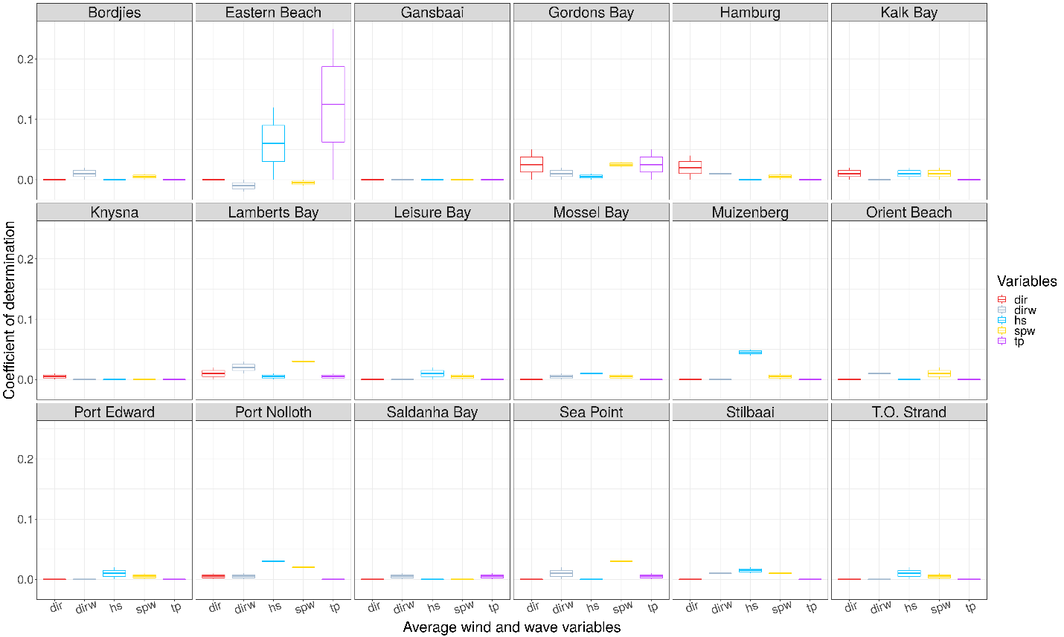

**Figure 7:** Boxplot representing the R2 value each of the environmental variables at the most predominant wave and wind direction for each of the sites.

# Discussion

This study aimed to investigate how wind and wave action influenced variation in coastal seawater temperature along the South African coastline. As seawater temperature is known to have large influences on species distributions (Bolton 2010; Smit et al. 2013), it is important to understand not only how temperatures vary along the coastline, but also the factors driving these variations as well. In this way, the proximal causes of environmental change might be understood in terms of their relevance in affecting ecological patterns and processes along the coastline. Sinnett and Feddesen (2014) showed that various environmental factors such as solar radiation, air temperature, humidity and wave energy are responsible for temperature variation within the coastal region. Here, however, additional influences were examined (*i.e.* broader-scale SST fields, and prevailing winds and waves impacting the coast), but none of these variables were found to offer any mechanistic influence on the alongshore thermal variability along the South African shore.

Wave energy along the South African coastline is consistently high (Wright and Mason 1993). Specifically, across each of the 18 sites that were assessed, we found wind and wave action to not significantly influence both satellite and *in situ* SSTs. Our results indicated that both wave height and wave period diminish northward along the east and west coast. Differences in temperature between sites at different locations along the coastline were therefore not caused by variations in wind or wave action, suggesting that other factors were responsible for the observed patterns of temperature variation. These findings were consistent across six different datasets from various sources, with each of these providing minimal evidence of a relationship between wind or wave action and the SST of a site. It must be noted that these analyses consisted of a combination of satellite and thermometer data, which varied in their measurements and time series–this consistency of findings across independent datasets is a strength of this analysis.

Theron et al. (2014) discussed how the wave dataset, from which the current study data were extracted, was created and validated. However, despite the validation, discrepancies may arise as a result of the assumptions made in the SWAN model. Quasi-stationary SWAN computations were performed under the assumption that the boundary conditions were fluctuating at a much slower tempo compared to the time it took for those conditions to propagate towards the coastline. This may ultimately result in the wind driven wave components to be overestimated as the duration limited effect of the wind was thus neglected and computed towards a converging wave condition during each quasi-stationary time step. The SWAN model usually overestimates the energy of developing waves with low frequencies (long periods) for very short distances from the shore. This is because wave conditions are simplified by using an a priori wave spectrum (Booij, Ris, and Holthuijsen 1999; Thomas and Dwarakish 2015). For most modelled areas, these assumptions were reasonable to make because most of the South African coastline is exposed and agree to the requirements of these assumptions (Joubert et al. 2013).

Previous studies suggest that a longer time series containing more data would have greater accuracy in detecting subtle changes in temperature differences obtained from variable coastal regions such as the South African coastline. Schlegel and Smit (2016) suggested that having a time series of greater than 30 years for sites with a low variance results in increased ability to detect changes. They showed that high quality time series datasets have frequent measurements with minimal missing (NA) values present. Furthermore, low quality datasets (*i.e.* those with more than 5% of NA values) have a higher chance of detecting variation where none exists.

We would be amiss to point out some weaknesses inherent in the SACTN dataset. Temperature measurement along the South African coastline started in the 1970s, and has been inconsistent in terms of instruments used, modifications to styles and methods, calibration, and site locations (Smit et al. 2013; Schlegel and Smit 2016). Additionally, older records within some datasets, such as the SACTN dataset, may have been lost or are unreliable since the metadata for these are unavailable. These metadata are essential as their absence prevents the understanding of the influence that the instruments had on temperature recordings. Some measurements may therefore not represent accurate or well-validated temperatures due to the instrumentation used; however, we mitigated these effects by selecting only the most reliable and longest duration data, which other studies (Williamson et al., in progress) have suggested are most suitable for the problem at hand.

Data in the SACTN are comprised of multiple sources, acquired by various means, and efforts are currently underway to homogenise these datasets (Williamson et al., in progress). The underwater temperature recorders (UTRs) used to collect data in the SACTN dataset expressed a lower number of NA values compared to the data collected with hand thermometers. As such, this may have influenced the overall time series dataset (Schlegel and Smit 2016). The level of precision at which data were collected also influenced the length of the time series needed. Time series in which temperature was collected at a precision of 0.5ºC may require another 24 months of recordings to precisely detect long term variation (Schlegel and Smit 2016). The average length of the thermometer time series component of the SACTN dataset was 346 months whereas the average length of UTR time series was less than half of that. With the extent of these differences in length being so severe, even once correcting for potential negative effects on the measurement precision of the thermometer collected time series, it was clear that thermometer data were more useful than that of UTRs. These influences may be expected to affect trend estimates of change derived from the data, but we do not anticipate that they have affected estimates of the variability in time and between sites in the way that they were used in this current study.

Satellite-acquired SST records are useful to modern marine scientists. These data are often used to model and predict a wide range of oceanic and biological processes in the open ocean, but have only recently been used to study temperature variations influencing benthic organisms (Pearce, Faskel, and Hyndes 2006). Here, both satellite SST data and *in situ* thermometer data were correlated with wind and wave data along the coastal environment above a depth of 7 and 15m (representing variable distances from the shore, depending on the local bathymetry). SST data acquired by satellites deviate from coastal *in situ* collected seawater temperatures for a variety of reasons (Smit et al. 2013). The SST data presented the broader-scale situation along the coast, and we use it here as a forcing boundary that we hypothesise influence the coastal temperatures. Our analysis shows that neither the offshore SSTs (various sources) nor the SACTN *in situ* records are affected by wind and wave action anywhere along the South African coastline.

Our findings were surprising but not entirely unexpected. Along the coastline of South Africa, there is a known east-west thermal temperature gradient that may have caused some interesting influences on the nature of our findings (Smit et al. 2013). This is caused by major oceanic processes such as coastal upwelling, thermohaline circulation, solar radiation, atmospheric temperature (Sinnett and Feddersen 2014) and the presence of major ocean currents, which cumulatively, influence the temperatures along this coastline (Walker 1990; Schlegel and Smit 2016). While it was reasonable to assume that surface level environmental factors like wind and wave action would affect sea surface temperatures at both local and regional scales, it is not completely unexpected that they would have little effect given the prevalence of the major processes mentioned above. In other words, the overriding thermal climatology of the boundary currents imprint their signals on the coast over the long-term. This study showed that over shorter daily time scales, SST does have influences in finer spatial scale nearshore temperatures, thus demonstrating that offshore processes may influence inshore temperature variation. The degree at which offshore processes influence inshore processes may vary between sites. However, this is unlikely as the ‘West Coast’ system is considered wind driven in the regional scale and there is multiple wind driven upwelling cells, each of differing strength, along the south coast. Those processes are of the largest drivers behind coastal temperature variation and may simply be overpowering the effects of other environmental factors. Yet, recent data (unpublished) show that within the consistent regional patterns that are generally in sync from site to site, smaller localised effects remain that begs an explanation. Other factors such as latent heat flux and wave energy flux were also proven to heat and cool coastal seawater temperatures (Sinnett and Feddersen 2014).

Given the almost complete lack of support of waves, winds or offshore temperatures on the nearshore thermal variability, it is likely that other as yet unknown factors influence temperatures along the South African coastline. For example, whilst rainfall can have large influences on coastal SST (Reason and Mulenga 1999) other, non-climatic, factors could be playing a greater role. Coastal regions are highly impacted by human mediated pressures (Mead et al. 2013). These pressures are predicted to drive change over a spatial and temporal scale and is often a cause of temperature variation (Griffiths, Mead, and Zietsman 2011). Other factors such as local bathymetry, vertical mixing, internal waves, tides and local geomorphology may additionally influence coastal seawater temperature. The geomorphological variability of the southern African subcontinent spans a range of climatic and morphological zones (Cooper 2001), and as such, the South African coastline is highly variable in such associated aspects. The tidal range shows minimal variation along the shore, and most areas experience a spring tidal range of 1.8 and 2m (Cooper 2001). Diurnal solar heating is another major factor contributing toward seawater temperature variation (Kaimal et al. 1972; Kudryavtsev and Soloviev 1990; Gentemann, Minnett, and Ward 2009). Solar radiation produces a positive buoyance flux contributing to the stability of the upper ocean. The heating of the surface layer is most effective in areas with low wind speed (Wunsch and Ferrari 2004). At low wind speed downward penetration of turbulent mixing is minimal allowing for an increase in surface seawater temperatures. Studies have also shown that on average day-time SSTs are 0.22°C warmer and have a standard deviation of 0.8°C when compared to night temperatures (Gentemann, Minnett, and Ward 2009). Internal waves may also impact seawater variation and are caused by a range of mechanisms that occurs when density increases continuously with depth (Pineda 1991). These internal waves tend to move inshore along the thermocline causing vertical mixing and so may influence seawater temperature variation (Baines 1986; Leichter et al. 1996). None of these factors have as yet been studied close to the shore as potential mechanisms that might influence the thermal structure and variability there.

The importance of understanding the contributions of the components of variation in nearshore temperature that are due to external forcing mechanisms relate to how these might affect biological systems along coastlines. Within marine environments, coastal temperature variation allows for a variation in the spatial arrangements of marine biodiversity. Whilst wind and wave action may not be directly affecting ocean temperatures, Blamey and Branch (2009) have found that wave action has a profound influence on species distributions along the coastline. The presence or absence of marine species are determined by a variety of factors and whilst those factors may not be influencing each other as was the case here, they collectively play important roles in affecting the marine life of the South African coastline, and identifying those roles can aid in improving our understanding of nearshore dynamics, thereby providing greater knowledge to be used for conservation.

This study has shown that wind and wave action are not directly affecting seawater temperature variation along the South African coastline, However, other factors may be. Future research could aim to examine the effects of air temperature and rainfall on the coastal seawater temperature for the 18 sites being assessed. Additionally, other factors such as the amount of sunlight penetrating the ocean or site exposure could also be tested, as well as assessing the optimal locations for data collection. Further studies should also consider examining how chlorophyll-a concentrations and salinity varies with temperature in order to assess the effects of seawater temperature on marine plant and animal life. Coastlines with distinct temperature gradients, each with their own localised nuances in the variability structure, such as is found in South Africa, provide a model environment for temperature analyses at fine-resolutions. These data could provide critically important information that can be used to assist in conserving marine biodiversity within these waters and should be given greater priority within marine research in the near future.

# Acknowledgments

Special thanks go to my supervisor, Prof. AJ Smit, for the continuous motivation and guidance throughout my Honours year. All of your contributions and efforts towards my academic career and experiences have been appreciated beyond measure. I would also like to thank Dr. Robert Schlegel and my co-supervisor, Dr. Robert Williamson for the help with my R analyses. I would like to thank KZNSB, DEA, DAFF, SAEON, SAWS, UWC and EKZNW for contributing the raw data allowing me to do this study. Without the data this thesis would not be possible. I would also like to thank my colleagues within Team Kelp and Jody Barends for assisting me throughout this project. Their discussions and friendship have largely aided in the completion of this thesis. To my friends and family, thank you for providing me with the necessary support and encouragement. I would like to thank the entire Biodiversity and Conservation biology department at the University of the Western Cape. Lastly, I would like to thank the NRF for providing the necessary funding towards the completion of this project.

# References

Baines PG. 1986. Internal Tides, Internal Waves and Near-Inertial Motions. *Baroclinic Processes on Continental Shelves* 3: 19–31.

Bartsch I, Wiencke C, Laepple T. 2012. Global Seaweed Biogeography Under a Changing Climate: The Prospected Effects of Temperature. In *Seaweed Biology*, 383–406. Springer.

Beal LM, De Ruijter-Wilhelmus PM, Biastoch A, Zahn R, Cronin M, Hermes J, Lutjeharms J. 2011. On the Role of the Agulhas System in Ocean Circulation and Climate. *Nature* 472 (7344): 429.

Bolton JJ, Leliaert F, De Clerck O, Anderson RJ, Stegenga H, Engledow HE, Coppejans E. 2004. Where Is the Western Limit of the Tropical Indian Ocean Seaweed Flora? An Analysis of Intertidal Seaweed Biogeography on the East Coast of South Africa. *Marine Biology* 144 (1): 51–59.

Bolton JJ. 2010. The Biogeography of Kelps (Laminariales, Phaeophyceae): A Global Analysis with New Insights from Recent Advances in Molecular Phylogenetics. *Helgoland Marine Research* 64 (4): 263.

Booij NRRC, Ris RC, Holthuijsen LH. 1999. A Third-Generation Wave Model for Coastal Regions: 1. Model Description and Validation. *Journal of Geophysical Research: Oceans* 104 (C4): 7649–66.

Breeman AM. 1988. Relative Importance of Temperature and Other Factors in Determining Geographic Boundaries of Seaweeds: Experimental and Phenological Evidence. *Helgoländer Meeresuntersuchungen* 42 (2): 199.

Broitman BR, Blanchette CA, Menge BA, Lubchenco J, Krenz MF, Raimondi PT, Lohse D, Gaines SD. 2008. Spatial and Temporal Patterns of Invertebrate Recruitment Along the West Coast of the United States. *Ecological Monographs* 78 (3): 403–21.

Byrne M, Ho M, Selvakumaraswamy P, Hong DN, Dworjanyn SA, Davis AR. 2009. Temperature, but Not pH, Compromises Sea Urchin Fertilization and Early Development Under Near-Future Climate Change Scenarios. *Proceedings of the Royal Society of London B: Biological Sciences* 276 (1663): 1883–8.

Cooper JAG. 2001. Geomorphological Variability Among Microtidal Estuaries from the Wave-Dominated South African Coast. *Geomorphology* 40 (1-2): 99–122.

Davis KA, Lentz SJ, Pineda J, Farrar JT, Starczak VT, Churchill JH. 2011. Observations of the Thermal Environment on Red Sea Platform Reefs: A Heat Budget Analysis. *Coral Reefs* 30 (1): 25–36.

Easterling DR, Meehl GA, Parmesan C, Changnon SA, Karl ST, Mearns LO. 2000. Climate Extremes: Observations, Modeling, and Impacts. *Science* 289 (5487): 2068–74.

Fewings MR, Lentz SJ. 2011. Summertime Cooling of the Shallow Continental Shelf. *Journal of Geophysical Research: Oceans* 116 (C7).

Gentemann CL, Minnett PJ, Ward B. 2009. Profiles of Ocean Surface Heating (Posh): A New Model of Upper Ocean Diurnal Warming. *Journal of Geophysical Research: Oceans* 114 (C7).

Griffiths CL, Mead A, Zietsman L. 2011. Human Activities as Drivers of Change on South African Rocky Shores. *Observations on Environmental Change in South Africa, Sun Media, Stellenbosch, South Africa*, 242–6.

Hoek C . 1982. The Distribution of Benthic Marine Algae in Relation to the Temperature Regulation of Their Life Histories. *Biological Journal of the Linnean Society* 18 (2): 81–144.

Hutchings L, Van der Lingen CD, Shannon LJ, Crawford RJM, Verheye HMS, Bartholomae CH, Van der Plas AK. 2009. The Benguela Current: An Ecosystem of Four Components. *Progress in Oceanography* 83 (1-4): 15–32.

Joubert JR, van Niekerk JL, Reinecke J, Meyer I. 2013. Wave Energy Converters (Wecs). *Centre for Renewable and Sustainable Energy Studies, Centre for Renewable and Sustainable Energy Studies, Faculty of Engineering*.

Kaimal JC, Wyngaard JCJ, Izumi Y, Coté OR. 1972. Spectral Characteristics of Surface-Layer Turbulence. *Quarterly Journal of the Royal Meteorological Society* 98 (417): 563–89.

Kudryavtsev VN, Alexander VS. 1990. Slippery Near-Surface Layer of the Ocean Arising Due to Daytime Solar Heating. *Journal of Physical Oceanography* 20 (5): 617–28.

Lee KA, Moninya R, Malcolm H, Otway H. 2018. Assessing the Use of Area-and Time-Averaging Based on Known de-Correlation Scales to Provide Satellite Derived Sea Surface Temperatures in Coastal Areas. *Frontiers in Marine Science* 5: 261.

Leichter JJ, Stephen RW, Steven LM, Denny MW. 1996. Pulsed Delivery of Subthermocline Water to Conch Reef (Florida Keys) by Internal Tidal Bores. *Limnology and Oceanography* 41 (7): 1490–1501.

Lutjeharms JRE, Cooper J, Roberts M. 2000. Upwelling at the Inshore Edge of the Agulhas Current. *Continental Shelf Research* 20 (7): 737–61.

Lutjeharms JRE, Van Ballegooyen RC. 1988. Anomalous Upstream Retroflection in the Agulhas Current. *Science* 240 (4860): 1770.

Lüning K. 1990. *Seaweeds: Their Environment, Biogeography, and Ecophysiology*. John Wiley & Sons.

Mead A, Griffiths CL, Branch GM, McQuaid CD, Blamey LK, Bolton JJ, Anderson RJ. 2013. Human-Mediated Drivers of Change—Impacts on Coastal Ecosystems and Marine Biota of South Africa. *African Journal of Marine Science* 35 (3): 403–25.

Mead A, Angela S. 2011. Climate and Bioinvasives Drivers of Change on South African Rocky Shores? PhD thesis, University of Cape Town.

Meehl GA, Tebaldi C. 2004. More Intense, More Frequent, and Longer Lasting Heat Waves in the 21st Century. *Science* 305 (5686): 994–97.

Müller R, Laepple T, Bartsch I, Wiencke C. 2009. Impact of Oceanic Warming on the Distribution of Seaweeds in Polar and Cold-Temperate Waters. *Botanica Marina* 52 (6): 617–38.

Pearce A, Fabienne F, Hyndes G. 2006. Nearshore Sea Temperature Variability Off Rottnest Island (Western Australia) Derived from Satellite Data. *International Journal of Remote Sensing* 27 (12): 2503–18.

Perkins SE, Alexander LV. 2013. On the Measurement of Heat Waves. *Journal of Climate* 26 (13): 4500–4517.

Jesus P. 1991. Predictable Upwelling and the Shoreward Transport of Planktonic Larvae by Internal Tidal Bores. *Science* 253 (5019): 548–49.

Reason CJC, Mulenga R. 1999. Relationships Between South African Rainfall and Sst Anomalies in the Southwest Indian Ocean. *International Journal of Climatology: A Journal of the Royal Meteorological Society* 19 (15): 1651–73.

Rouault MJ, Mouche A, Collard F, Johannessen JA, Chapron B. 2010. Mapping the Agulhas Current from Space: An Assessment of Asar Surface Current Velocities. *Journal of Geophysical Research: Oceans* 115 (C10).

Rouault MJ, Mathieu A, Penven P, Pohl B. 2009. Warming in the Agulhas Current System Since the 1980’s. *Geophysical Research Letters* 36 (12).

Schlegel RW, Oliver ECJ, Kirkpatrick SP, Kruger A, Smit AJ. 2017. Predominant Atmospheric and Oceanic Patterns During Coastal Marine Heatwaves. *Frontiers in Marine Science* 4: 323.

Schlegel RW, Smit AJ. 2016. Climate Change in Coastal Waters: Time Series Properties Affecting Trend Estimation. *Journal of Climate* 29 (24): 9113–24.

Shannon V. 2006. 1 a Plan Comes Together. In *Large Marine Ecosystems*, 14:3–10. Elsevier.

Sinnett G, Feddersen F. 2014. The Surf Zone Heat Budget: The Effect of Wave Heating. *Geophysical Research Letters* 41 (20): 7217–26.

Smale DA, Wernberg T. 2009. Satellite-Derived Sst Data as a Proxy for Water Temperature in Nearshore Benthic Ecology. *Marine Ecology Progress Series* 387: 27–37.

Smit AJ, Bolton JJ, Anderson RJ. 2017. Seaweeds in Two Oceans: Beta-Diversity. *Frontiers in Marine Science* 4: 404.

Smit AJ, Roberts M, Anderson RJ, Dufois F, Dudley S, Bornman TG, Olbers J, Bolton JJ. 2013. A Coastal Seawater Temperature Dataset for Biogeographical Studies: Large Biases Between in Situ and Remotely-Sensed Data Sets Around the Coast of South Africa. *PLoS One* 8 (12): e81944.

Stocker T. 2014. *Climate Change 2013: The Physical Science Basis: Working Group I Contribution to the Fifth Assessment Report of the Intergovernmental Panel on Climate Change*. Cambridge University Press.

Tapia FJ, Largier JL, Castillo M, Wieters EW, Navarrete SA. 2014. Latitudinal Discontinuity in Thermal Conditions Along the Nearshore of Central-Northern Chile. *PLoS One* 9 (10): e110841.

Thomas TJ, Dwarakish GS. 2015. Numerical Wave Modelling–a Review. *Aquatic Procedia* 4: 443–48.

Walker ND. 1990. Links Between South African Summer Rainfall and Temperature Variability of the Agulhas and Benguela Current Systems. *Journal of Geophysical Research: Oceans* 95 (C3): 3297–3319.

Wernberg T, Russell BD, Moore PJ, Ling SD, Smale DA, Campbell A, Coleman AM, Steinberg PD, Kendrick G, Connell SD. 2011. Impacts of Climate Change in a Global Hotspot for Temperate Marine Biodiversity and Ocean Warming. *Journal of Experimental Marine Biology and Ecology* 400 (1-2): 7–16.

Wernberg T, Thomsen M, Tuya F, Kendrick G, Staehr P, Toohey B. 2010. Decreasing Resilience of Kelp Beds Along a Latitudinal Temperature Gradient: Potential Implications for a Warmer Future. *Ecology Letters* 13 (6): 685–94.

Wethey DS, Sarah AW, Thomas J, Jones S, Lima F, Brannock P. 2011. Response of Intertidal Populations to Climate: Effects of Extreme Events Versus Long Term Change. *Journal of Experimental Marine Biology and Ecology* 400 (1-2): 132–44.

Woodson CB, Eerkes-Medrano DI, A Flores-Morales MM, Henkel SK, Hessing-Lewis M, Jacinto D. 2007. Local Diurnal Upwelling Driven by Sea Breezes in Northern Monterey Bay. *Continental Shelf Research* 27 (18): 2289–2302.

Wright CI, Mason TR. 1993. Management and Sediment Dynamics of the St. Lucia Estuary Mouth, Zululand, South Africa. *Environmental Geology* 22 (3): 227–41.

Wunsch C, Ferrari C. 2004. Vertical Mixing, Energy, and the General Circulation of the Oceans. *Annu. Rev. Fluid Mech.* 36: 281–314.

Mukti Z, Kiyofuji H, Saitoh K, Sei-Ichi S. 2006. Using Multi-Sensor Satellite Remote Sensing and Catch Data to Detect Ocean Hot Spots for Albacore (*Thunnus alalunga*) in the Northwestern North Pacific. *Deep Sea Research Part II: Topical Studies in Oceanography* 53 (3-4): 419–31.