Results

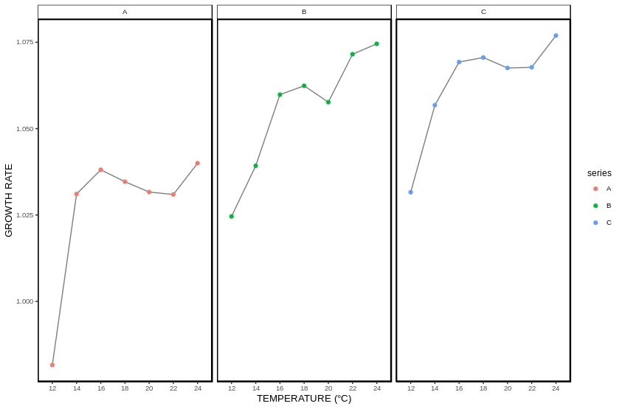
Figure 1: A line graph showing the relationship between the growth rate of each polyp at various temperatures

The growth rate of each polyp in graph A appears to grow at a much slower rate than the polyps present in graph B and C. Polyps present in Graph A experiences optimal growth rate at a temperature of 16°C and the growth rate of these polyps slowly decreases from 16°C to 22°C. Hereafter the polyps growth slowly increase. In graph B shows a constant increase in the growth rate of each polyp. However, at a temperature of 18°C we see a decrease in polyp growth followed by a rapid increase in growth occuring from a temperature of 20°C to 24°C. Graph C expresses the highest growth rate when compared to Graph A and B. Here polyp growth rate constantly increases until a temperature of 18°C. Thereafter the polyp growth rate decreases uptil 22°C and increase from 22°C-24°C.
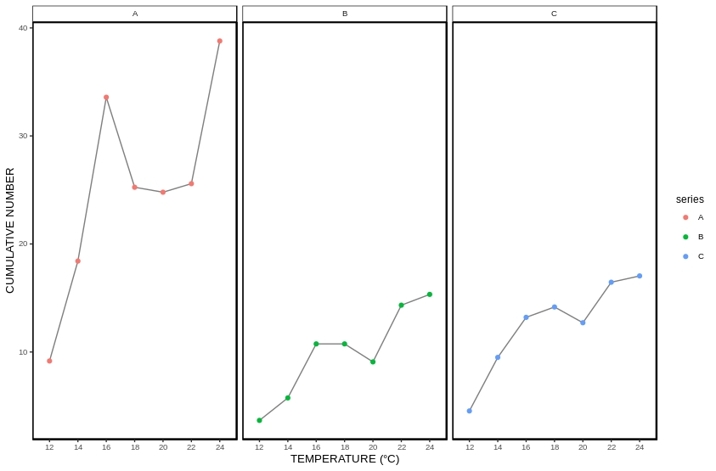
Figure 2: A line graph showing the relationship between the amount of polyps at various temperatures with the temperatures varying betwween 12 – 14°C.

Graph A expressess the highest amount of polyps present throughout the experiment. The amount of polyps present in graph A, B and C decreases at a temperature of 20°C. In graph A the cummalative number of polyps present rapidly decreases between 16-22°C which is then followed by a rapid increase after 22°C. Graph A expressess a much higher cummalative number of polyps when compared to each of the other graphs.
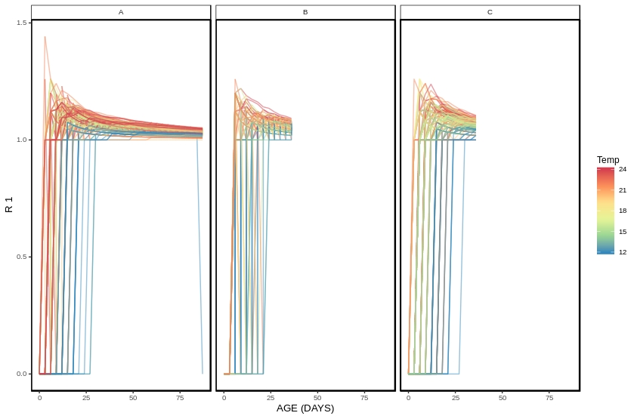
Figure 3: A line graph showing the rate of growth at various days with each line colour representing a different temperature.

From this graph it is observed that polyps need optimal conditions to grow and reproduce. Previous graphs clearly show that warmer temperatures result in an optimal growth rate. From this graph it can be seen that polyps in colder temperatures take much longer to bud when compared to polyp growing in warmer temperatures.
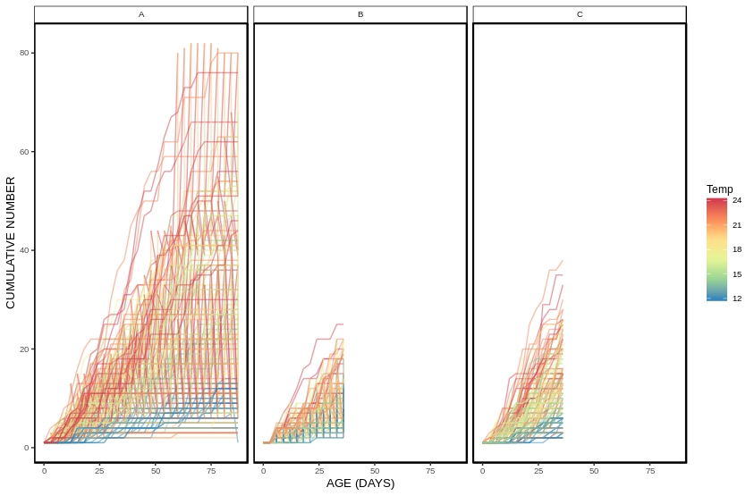
Figure 4: A line graph showing the relationship between the amount of polyps present at various days.

The graph above shows that at low temperature the amount of polyps present were relativley low. As the temperature increase however the number of polyps increased. There are some outliers present which shows a constant increase in the cummalative number. In graph A the cummalative number of polyps increased at a much greater rate when compared to graph B and C. Over a period of 36 days the polyp number slightly increases. Graph A shows a much steeper increase in the amount of polyps present as this experiment took place over a period of 87days where as graph B and C occurred over a period of 36 days.

Table 1: A two-way ANOVA tests comparing the amount of polyps present in each series for each of the age groups. P < 0.05.

There is a significant difference between the amount of polyps present for each of the three series at each of the age and temperature groups within this experiment (P < 0.05).

Table 2: A one-way ANOVA tests comparing the growth rate of each polyp present in each series. P < 0.05.

A significant difference exist between the growth rate for each of the three series within this experiment (P < 0.05).

