So the dataset that we chose was the AVHRR- Advanced very high resolution radiometer. This is basically the sea surface temperature set of the entire globe.

Now what is sea surface temperature?
Sea Surface Temperature (sst) is a measure of the energy due to the motion of molecules at the top layer of the ocean.
How is the SST measured?
Prior to the 1980s measurements of sea surface temperature were derived from instruments on shorelines, ships and buoys. The first automated method of gathering sst was by measuring water flowing through the input ports of ocean faring ships. Whilst this was a useful method it still expressed several limitations.
Since the 1980's most of the information about global SST has come from satellite observations. Instruments like the Moderate Resolution Imaging Spectroradiometer on board (MODIS) orbit the Earth approximately 14 times per day, enabling it to gathering more SST data in 3 months than all other combined SST measurements taken before the advent of satellites.
Now all of this is obtained by physics. Where the ocean emit radiation in the infrared and the microwave wavelengths. The amplitude of these wavelengths vary with the temperature of the ocean and therefore can be used to measure surface temperatures. Satellite sensors can measure these bands from space.
Now a commonly raised question asked is that how do we know if this satelite data is accurate?
Today in addition to satellite and shipboard measurements there are thousands of floats in the oceans measuring temperature and salinity. These are used to validate satellite instruments in addition to sampling throughout the water column.
One important thing to remember though is that satellites can only measure temperature at the surface or close to the surface. So other instruments or models must be used to determine temperature at a depth.
So SST measured below a 5meter depth are ususally done using moorings and drifters. Moorings good for measuring temperature at one location and drifters are usually placed at one location and desended to a specific depth.

Okay so looking at the AVHRR dataset specifically
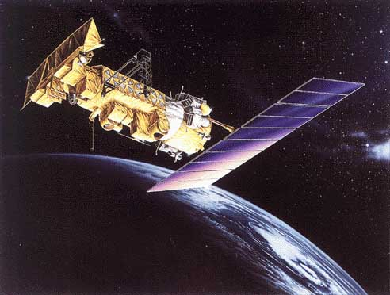
This Pathfinder SST time series represents the longest continual global ocean physical measurement from space. The Pathfinder program was originally initiated in the 1990s.
This research quality data consists of daily, 5 day, 8 day, monthly and yearly level 3 products on a 4km global grid.
Now this dataset is open to anyboy to download and the file that is downloaded is in the netCDF format and within this downloaded file we get the metadata along with it as well. Netcdf is a class model, with internal compression and chunking.
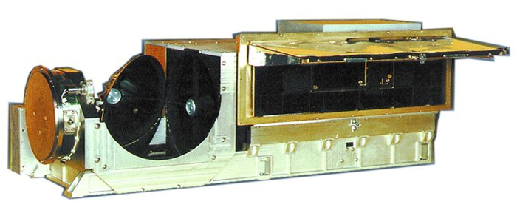

This is the AVHRR instrument
The AVHRR/3 is a 6 channel imaging system in which a small field of view is scanned across the earth from one horizon to the other by continuous 360 degree rotation. A total of 2048 samples will be obtained per channel per Earth scan. The AVHRR/3 instrument weighs approximately 72 pounds, measures 11.5 inches X 14.4 inches X 31.4 inches, and consumes 28.5 watts power".

Some info:
Sea surface temperature (SST) is an important indicator of the state of the earth’s climate system Thus, accurate knowledge of SST is essential for climate monitoring, research, and prediction. SSTs are also used asa surface boundary condition for weather prediction.
With this dataset what we could look at is to see or test how sea surface temperatures change over time.
Another thing we could test using this dataset is which regions of the world sea surface temperatures increase most rapidly and if this directly affect the climate. Using this dataset we can also look and test for anomolies or look for arine heatwaves present within this dataset. This is important is may influence mass bleaching in coral reefs and influence the habitats and diversity within this regions.

