Ecologists study the relationships between living things and their environment. ... Ecologists can be teachers or research scientists. They can work for environmental organizations like The Nature Conservancy or for the government. They may work at museums, zoos and aquariums.

Ecological methods address a wide range of scales and are concerned with the acquisition of data on individual organisms, single populations and entire ecosystems. Ecological studies have three key components: programme planning, field data acquisition and data analysis.

Different types of sampling:

Quadrat sampling a series of squares (quadrats) of a set size are placed in a habitat of interest and the species within those quadrats are identified and recorded.

A line transect is carried out by unrolling the transect line along the gradient identified. The species touching the line may be recorded along the whole length of the line (continuous sampling).

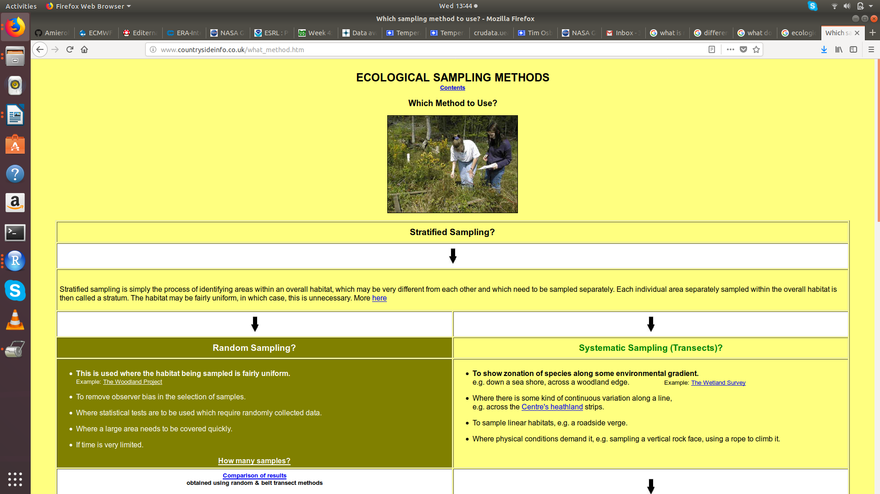

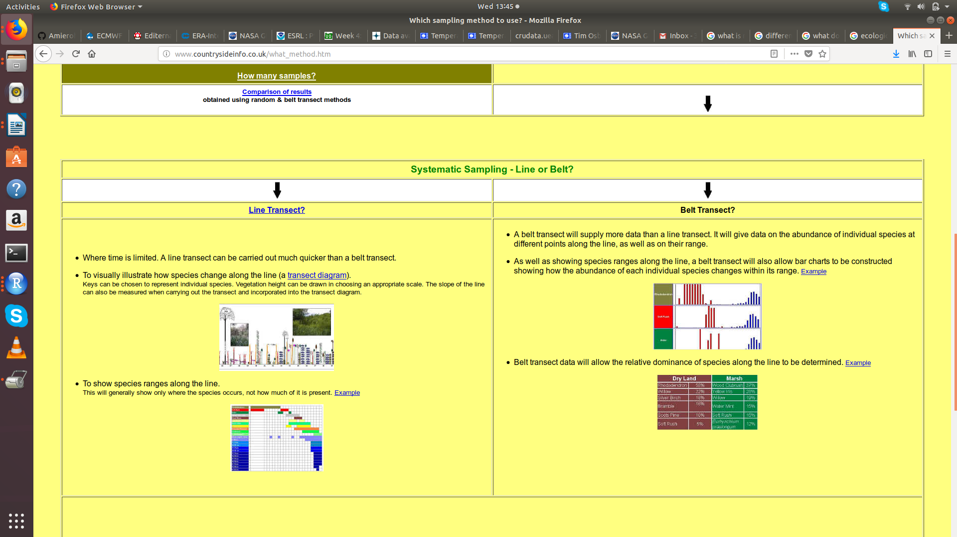
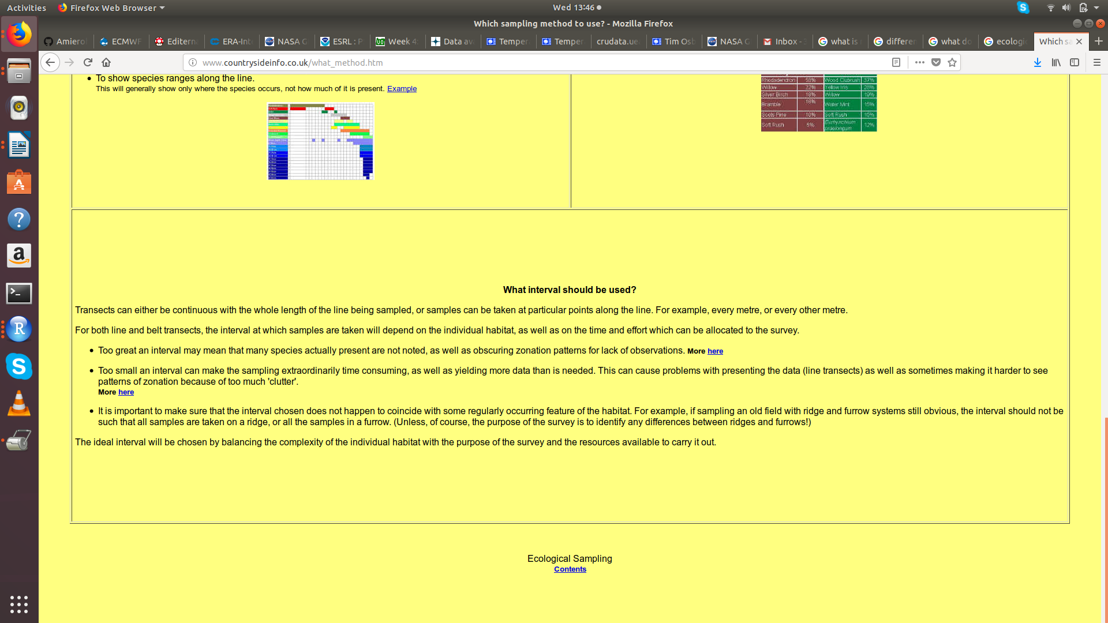

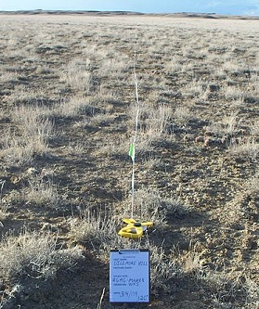
A transect line is laid along an environmental gradient and samples are taken at predetermined intervals
Belt transects are similar to line transects but they allow for a greater area of sampling. With this method, instead of counting along the line, you count the abundance or percent cover within the area of a quadrat.
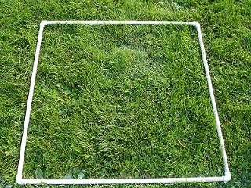
A quadrat allows scientists to measure abundance or percent cover within a known area

trapping
audio
video recordings
survey techniques

The main aim of spatial sampling is to collect samples in 1-, 2- or 3-dimensional space. It is typically used to estimate the total or mean for a parameter in an area, to optimize parameter estimations for unsampled locations, or to predict the location of a movable object.



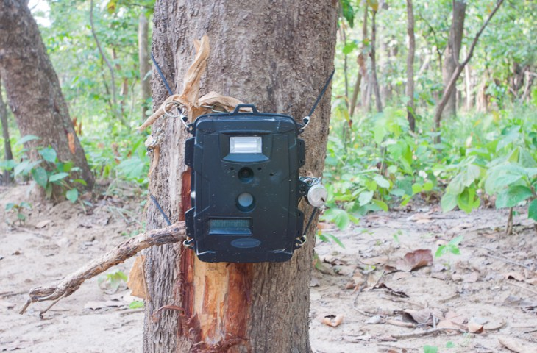

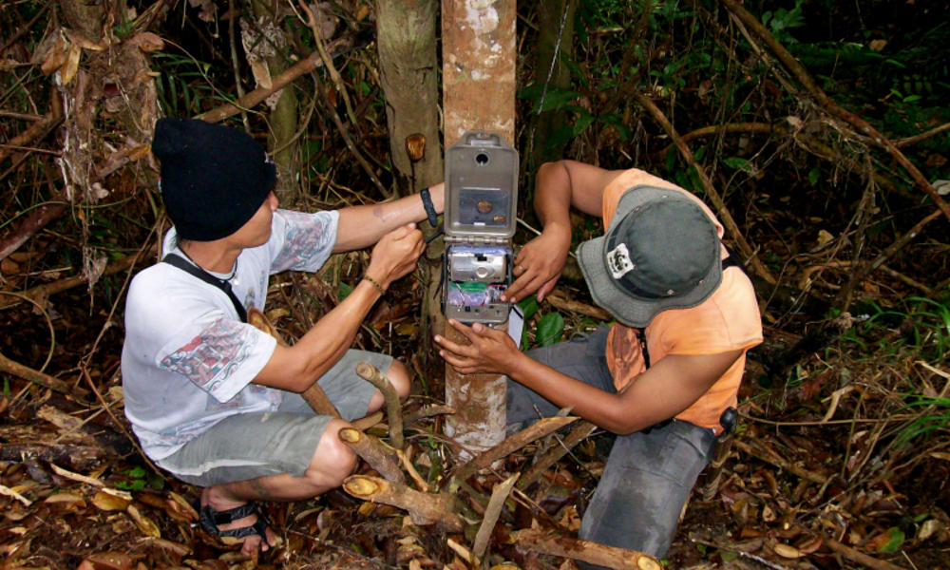

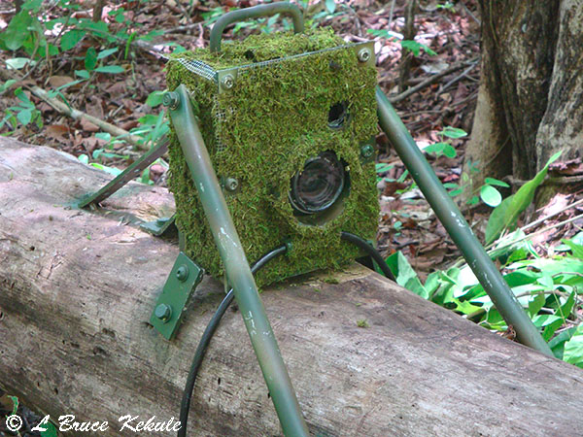
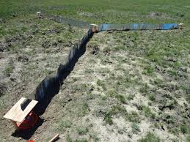

Pitfall trap arrays

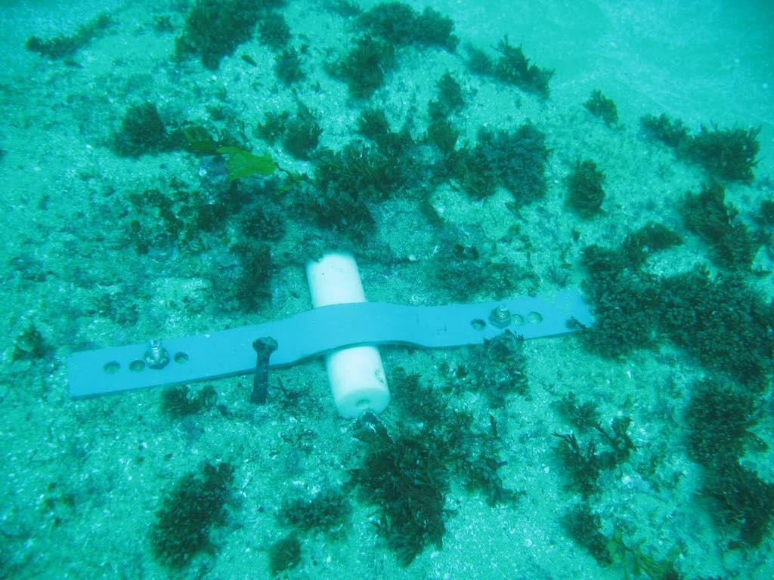

9999999999

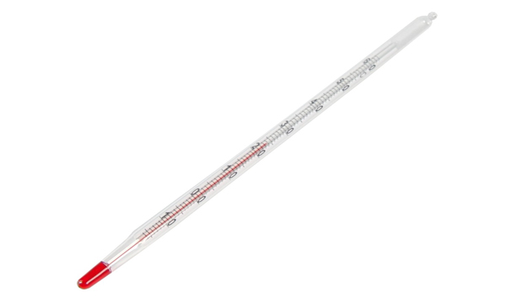
Camera trap surveys can be used to gather baseline data.

Camera traps are a useful means for researchers to observe the behaviour of animal populations. Remote motion-sensitive photography, or camera trapping, is revolutionising surveys of wild animal populations.

Funnel traps consist of a tapering funnelshaped entrance that guides animals into a larger holding chamber. Once within the chamber, animals are unable to fi nd their way back out the small entrance hole, becoming trapped.

Pitfall traps consist of some type of container that is sunk into the ground, with the rim level with the surface. Animals that fall into pitfalls are unable to climb out, becoming trapped.
Common reasons to capture mammals include livetrapping to tag (with radiotransmitters, necklaces, ear tags, or passive integrated transponder [PIT] tags), mark (number, band, hair color, freeze brand, ear tag, or toe clip), or tissue collection.
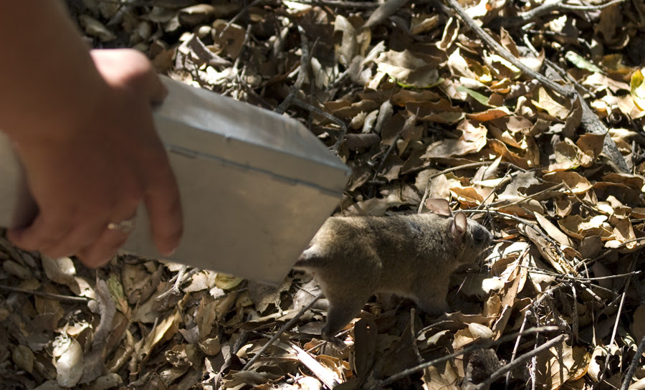
(Woodrat being released from a Sherman Live Trap. Photo by Adam Green)

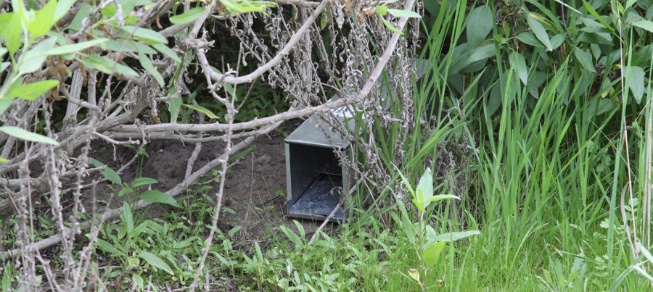
(Trap set in shade of shrub. This protects the trap from direct sunlight and overheating. Photo by Adam Green)

MARKING FOR IDENTIFICATION
External Marks and Tags
Where naturally occurring identifying marks are not available, external dye, freeze-branding, or paint marks might provide the degree of longevity required. Dye marks on juveniles or subadults are of more limited duration because of rapid molting. Identiﬁcation marks might be made with nontoxic hair dyes or paint. Care should be taken to ensure that substances used for external marks are nontoxic and do not otherwise alter the behavior of animals or subject them to increased predation. Freeze branding is an effective means of marking bats and other species and marks might last several years (Sherwin et al. 2002).
Metallic or plastic tags and bands or collars are cost-effective and might be suitable for identiﬁcation at appreciable distance on large terrestrial species. Tags typically are applied to the ears of terrestrial mammals and to ﬂippers of seals and sea lions. Use of individually numbered tags on small mammals necessitates handling the animal each time an individual is to be identiﬁed.Wing bands for bats should be applied so that they slide freely along the forearm, which may necessitate cutting a slit in the wing membrane in some cases. Another external marking option for bats is a bead-chain necklace (Barclay and Bell 1988), although these necklaces must be sized carefully.

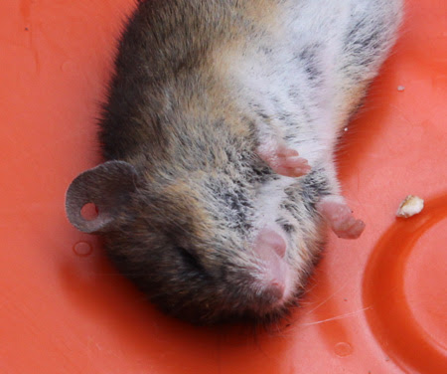
(Ear punch to collect tissue for DNA analysis. Photo by Adam Green)

Tattooing and ear punches provide a permanent means of identiﬁcation but require handling of individuals for individual recognition.
Inide (NRC 1996), toe clipping requires considerable justiﬁcation to the IACUC. Justiﬁcation for ms) via licking likely cause more stress and harm than conducting the procedure without their use.
Radiotransmitters provide a mechanism to monitor movements and survival of individuals and, therefore, also serve to identify an individual. Transmitters can be attached externally with surgical or skin glue or a collar, or implanted into the animal’s body cavity.
Internal Tags
Passive integrated transponder (PIT) tags are electronic devices encased in glass or resin capsules. They do not emit constant signals but can be interpreted with a remote reader in much the same way that bar codes are scanned. Tags are injected subcutaneously by using a modiﬁed large-bore hypodermic syringe and are suitable for many ﬁeld and laboratory identiﬁcation needs.

Techniques and Practice of Ecological Sampling

One of the first things a field ecologist will want to know about an animal or plant species is: How dense is the population [units of density are number of individuals {or colonies etc.} per unit area {or volume}]. Another important question is: How are the organisms dispersed [The pattern of distribution in space] within the habitat? In most cases it is impossible to count every individual or plot their location on a map [This would be a census] because of the time, effort or money involved. So it would be useful if there were some way that we could get an accurate representation of some spatial characteristics of the population without having to map every organism.

By sampling the population we can do this, BUT the sampling must be done properly if we want our representation to be valid. To insure an adequate representation, some guidelines must be followed. This laboratory exercise is designed to introduce you to the methods, and rules of ecological sampling in the spatial domain, and to allow you to use some common tools to practice these techniques. You will use these methods in most of the rest of your labs this semester.

Choosing sample sites: Random vs. Haphazard:
Experimenter bias in sampling is a common hazard and must be continuously guarded against (for example: “It’s late and this rock is too hard to look under so it wouldn’t hurt to sample under this smaller rock” right?) To obtain an unbiased estimate of the population, sampling should be done at random –or more specifically the sampling should be conducted in such a way that the probability of each individual being selected in the sample is the same. There are several ways of insuring this criterion is met – or at least approximated. Random numbers are series of numbers such that the chance of selecting, for example, any digit (0 – 9) is equal at any point in the sampling procedure. If the random numbers can be assigned to organisms or to locations in the habitat, they can be used to select the sample from the population. One way to generate a series of random numbers is to write the numerals 0 through 9 on slips of paper, mix them in a hat, draw the slips out, write the number down, then replace the slip in the hat, remix, and draw again, etc. etc. etc. A faster and less cumbersome method is to use a random number table. You worked with ways of getting random numbers in the previous lab. You can use the numbers in the table to select sampling positions (e.g. paces along a trail, GIS coordinates, termite holes in a wall that you have numbered etc.). Most calculators and spreadsheet applications also have random number generating functions,

Often a person will think that they can make up random numbers and/or sample “randomly” without recourse to the use of some randomizing method. This rarely works [you will get a chance to test this statement in this lab] and such samples are termed haphazard.

Commonly Used methods for Sampling in the Spatial Domain:

There are three general types of sampling methods used to select individuals from a population situated in space: quadrats, transect lines and plotless techniques.

1) A quadrat is a frame (usually a square or a circle) of known area used to isolate a subset of the population.

2) The transect method is most useful when the area to be sampled is zoned in some way, or has some sort of gradients running through it. Think of the intertidal habitat on a small scale or the vegetation running up the side of a mountain on a larger scale.

3) The plotless technique we will use is the nearest-neighbor method. It is particularly useful in areas where carrying large quadrats would be difficult to manage such as a dense forest. It is also most suited to habitats that are relatively uniform. Plotless methods do not use a defined area (like a quadrat), nor are they arranged linearly as in transect methods, rather, they use distances between a point and an individual, or between two individuals.

d₂
d₁

Randomly selected point

d₁ = the distance from the randomly selected point to the closest individual of interest.
d₂ = the distance to the nearest neighbor

In this technique each sample consists of a pair of measurements, d₁ and d₂. To obtain the next sample, a new random point is chosen and another pair of measurements is made. While nearest neighbor methods are especially useful in certain field situations like dense forests etc. you will see that unlike quadrat methods, they are not that useful for determining density. They are however quite useful for determining the dispersion pattern of the organisms.

Clark, P. J. and F. C Evans,. 1954. Distance to nearest neighbor as a measure of spatial relationships in populations. Ecol 35: 445-453.

Greig-Smith, P. 1964. Quantitative Plant Ecology. Plenum Press NY

Greig Smith 1979. Pattern in Vegetation J. Ecol. 67:755-779.

Kinzie III, R. and R. H. Snider 1978. A simulation study of coral reef survey methods. IN Coral Reef Research Methods. D. R. Stoddart & R. E Johannes eds. UNESCO Paris

Pielou, E. C. 1969 An Introduction to Mathematical Ecology. Wiley Inter Science NY

Poole, R. W. 1974 An Introduction to Quantitative Ecology McGraw-Hill NY

Simberloff, D. 1979. Nearest neighbor assessments of spatial configuration of circles rather than points Ecology 60:679-685

Southwood, T. E. E. 1966 Ecological Methods. Methuen London

