What is Sea Surface Temperature?
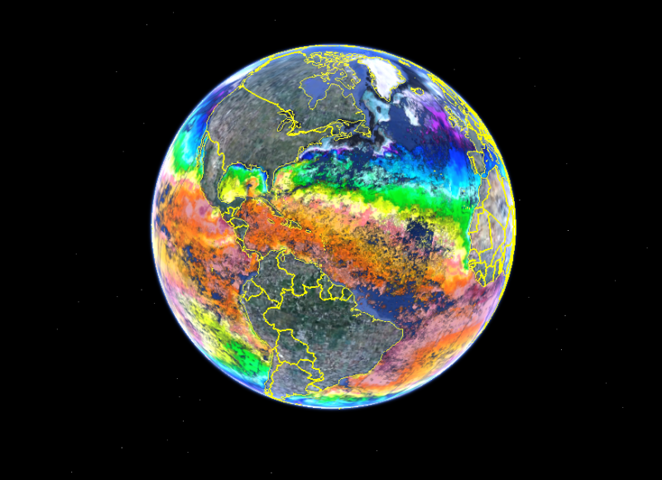
Sea Surface Temperature (sst) is a measure of the energy due to the motion of molecules at the top layer of the ocean. Depending on the sensor, spaceborne measurements give us an unprecedented global measurement of sea surface temperatures every few days to a week. Temperatures are measured from approximately 10 µm below the surface (infrared bands) to 1mm (microwave bands) depths using radiometers.

How is Sea Surface Temperature Measured?
Prior to the 1980s measurements of sea surface temperature were derived from instruments on shorelines, ships and buoys. The first automated method of gathering sst was by measuring water flowing through the input ports of ocean faring ships. While this method obtained a significant quantity of useful SST data there were some shortcomings. The depth of the input ports of different ships can vary greatly from ship to ship. In a stratified ocean these different depths can have different temperatures. This method also resulted in rigorous sampling along major shipping routes but a dearth of information about the vast majority of the world's oceans.
Since the 1980's most of the information about global SST has come from satellite observations. Instruments like the Moderate Resolution Imaging Spectroradiometer on board (MODIS) onboard NASA’s Terra and Aqua satellites orbit the Earth approximately 14 times per day, enabling it to gathering more SST data in 3 months than all other combined SST measurements taken before the advent of satellites.
The motion of electrically charged particles produces electromagnetic radiation of various wavelengths. The electromagnetic spectrum comprises the range of these wavelengths. From longest to shortest the general wavelength categories are radio, microwave, infrared, visible, ultraviolet, x-ray, and gamma ray.
The ocean and most other objects emit radiation in the infrared and the microwave wavelengths. The amplitude of these wavelengths vary with the temperature of the ocean and therefore can be used to measure it. Satellite sensors can measure these bands from space. Infrared radiation of the ocean comes from the top 10 microns of the surface. Microwave radiation results from the topmost 1-millimeter layer. Infrared satellite sensors have better spatial resolution but are more susceptible to cloud contamination than microwave. This is due to the absorption of the ocean emitted infrared energy by clouds.
Today in addition to satellite and shipboard measurements there are thousands of floats in the oceans measuring temperature and salinity. These are used to validate satellite instruments in addition to sampling throughout the water column. The surface drifters from the Global Drifter Program (GDP) provide regularly about 60,000 night time SST measurements per month at a shallower depth of 0.2 m. becoming the biggest contribution to the in-situ global SST, Ocean Currents, and Salinity measurements.
A major accomplishment in the distribution of satellite derived SSTs occurred with the Group for High Resolution Sea Surface Temperature (GHRSST) project. The project provides all SST data sets in a common format that allows for easy accessibility across different computer platforms and operating systems. To provide data sets that are suitable for climate modeling a necessary requirement is that climate data records come with a description of the errors associated with each SST value. The GHRSST project, to accommodate using these data sets in climate and ocean modeling, provides a full characterization of the errors associated with each pixel. It is important to remember that satellites can only measure temperature at or close to the surface. Other instruments, or models, must be used to determine temperature at depth.
How is Sea Surface Temperature measured below 5 meters?
Global ocean temperature data below the surface are primarily measured using moorings and drifters. Moorings are good for measuring time series through the depths of the water column and one particular longitudinal/latitudinal location. Most deeper ocean temperature data are measured from drifters. There are over 3000 drifters in the ocean today. Ocean drifters are usually placed at a particular place in the ocean and then descend to a predefined depth where they record a time series of water temperature while moving with the currents at that depth. One disadvantage of drifters is that most shut off their sensors between 5m deep and the surface to avoid fouling.
If a particular area or line of interest is to be measured underwater, autonomous gliders and/or forward propelled vehicles may be used. These carry temperature-recording devices along with depth and salinity sensors, clocks and GPS. These vehicles enable scientists to plan specific routes in which to make measurements.
Sea Surface Temperature (SST)
SST is a measure of the kinetic energy of the atoms and molecules of the very top layer of the ocean. The overwhelming majority of SST data are sensed via spaceborne radiometers and are measured from approximately 10 µm below the surface (infrared bands) to 1mm (microwave bands) depths using radiometers.

AVHRR-Pathfinder
Mission Specification
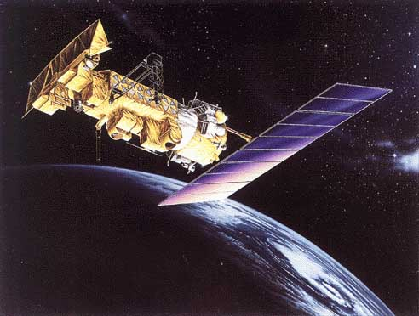
Multichannel sea surface temperature (SST) products have been constructed operationally from the five and six channel Advanced Very High Resolution Radiometer (AVHRR) by NOAA's National Environmental Satellite, Data, and Information Service (NESDIS) since late 1981.
This Pathfinder SST time series represents the longest continual global ocean physical measurement from space. Development of the Pathfinder dataset (including all Version 5.0 and above data sets) is sponsored by the NOAA National Oceanographic Data Center (NODC) in collaboration with the University of Miami Rosensteil School of Marine and Atmospheric Science (RSMAS) while distribution is a collaborative effort between the NASA Physical Oceanography Distributed Active Archive Center (PO.DAAC) and the NODC. From a historical perspective, the Pathfinder program was originally initiated in the 1990s as a joint NOAA/NASA research activity for reprocessing of satellite based data sets including SST.
This research quality data consists of daily, 5 day, 8 day, monthly and yearly level 3 products on a 4km global grid. As of January 2011 it includes data from August 24, 1985 through December 31, 2009. Pathfinder AVHRR data comes from NOAA -9 (1/4/1985 – 11/07/88 & 9/14/94 – 01/21/95), NOAA – 11 (11/8/88 – 9/13/94), NOAA-14 (1/22/95 – 10/11/2000), NOAA-16 (10/12/00 -12/31/02), NOAA-17 (01/01/03 – 06/04/05), and NOAA-18 (06/05/05 – 12/31/09) satellites.
In 2009 NODC released Pathfinder version 5.1 from October of 1981 through January of 1985. This previously un-released data was from the NOAA -7 satellite. Version 5.1 uses higher resolution reference data than 5.0 for the purpose of achieving better resolution in the coastal and high gradient SST regions.
In September of 2011 the Pathfinder Version 5.2 (PFV5.2) was released. Several significant changes and improvements occurred with the release of PFV52. The following description may be found at the NOAA/NODC web site (http://www.nodc.noaa.gov/SatelliteData/pathfinder4km/).
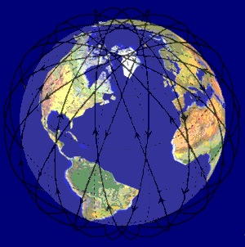
"PFV52" was computed using an entirely modernized system, based on SeaDAS and incorporating several key changes over the older Pathfinder V5.0 and V5.1 datasets. PFV52 is viewed as a significant step forward in preparation for the future Version 6 (PFV6) data set (no release has yet been established for PFV6). Changes in PFV52 include the use of an entirely new land mask, a modified grid, and the inclusion of sea ice and wind speed ancillary data to support the use of the SST data. Importantly, the new PFV52 data are provided in netCDF-4 (classic model, with internal compression and chunking) and are nearly 100% compliant with the GHRSST Data Specification Version 2.0 (GDS2.0,http://data.nodc.noaa.gov/pathfinder/Version5.2/GDS_TechSpecs_v2.0.pdf) for L3C products. These data deviate from that standard only in that the Single Sensor Error Statistics (SSES) which include the sses_bias, sses_standard_deviation are empty. Additionally the sst_dtime variable is empty. Data for 1981-2010 are available. All of the PFV52 data are available through NODC's ftp, http, OPeNDAP, and THREDDS access systems.” More information on data gaps, processing may be found at: http://www.nodc.noaa.gov/SatelliteData/pathfinder4km/ .
All the orbits are sun synchronous and have an ascending node of between 13:30 and 14:20 local time with the exception of NOAA-17 that has a daytime descending node of approximately 10:00.
AVHRR Instrument
The AVHRR/3 is a 6 channel imaging system in which a small field of view (1.3 milliradians by 1.3 milliradians) is scanned across the earth from one horizon to the other by continuous 360 degree rotation of a flat scanning mirror.
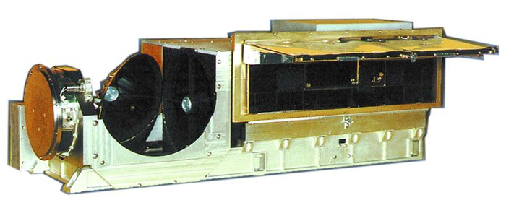The orientation of the scan lines are perpendicular to the spacecraft orbit track and the speed of rotation of the scan mirror is selected so that adjacent scan lines are contiguous at the subsatellite (nadir) position. A total of 2048 samples will be obtained per channel per Earth scan, which will span an angle of 55.4 degrees from the nadir (subpoint view). All 6 spectral channels of the AVHRR/3 are registered so that they all measure energy from the same spot on the earth at the same time. All 6 channels are also calibrated so that the signal amplitude in each channel is a measure of the scene radiance. The radiometers are designed to operate for a period of 3 years.
The Polar Operational Environmental Satellites (POES) system offers the advantage of daily global coverage, with morning and afternoon orbits that deliver global data. Data includes surface temperature, cloud cover, storm location and heat balance in the earth's atmosphere. The NOAA-x series have been performing earth observations since 1970.
The AVHRR/2 is a 5 channel imaging system in which a small field of view (1.3 milliradians by 1.3 milliradians) is scanned across the earth from one horizon to the other by continuous 360 degree rotation of a flat scanning mirror. The orientation of the scan lines are perpendicular to the spacecraft orbit track and the speed of rotation of the scan mirror is selected so that adjacent scan lines are contiguous at the subsatellite (nadir) position. A total of 2048 samples will be obtained per channel per Earth scan, which will span an angle of 55.4 degrees from the nadir (subpoint view). All 5 spectral channels of the AVHRR/3 are registered so that they all measure energy from the same spot on the earth at the same time. All 5 channels are also calibrated so that the signal amplitude in each channel is a measure of the scene radiance. The radiometers are designed to operate for a period of 3 years.
The satellites used for PO.DAAC's AVHRR data are the NOAA-7, 9, 11, 13, 14, 16, 17, 18 ,19 and the European Space Administration's Metop-A (launched between NOAA-18 and 19). The AVHRR/2 on NOAA satellites 7 (launched 1981) through 14 (launched 1994) measure 5 wavelengths. AVHRR/3 on NOAA-15 through 19 measure 6 wavelengths.
The AVHRR/3 instrument weighs approximately 72 pounds, measures 11.5 inches X 14.4 inches X 31.4 inches, and consumes 28.5 watts power".

