PCA Analysis
Basic PCA
PCA – method for compressing a lot of data into something that captures the essence of the orginal data.

1 Dimensional graphs: numberline: plot some values on a numberline
2 Dimensional graphs: and x and a y axis: can plot two variables at the same time
3 dimensional graphs: Used in calculus. Fancy graph that has depth.
4 dimensional graph cant be drawn or if you have data from 200 cells cant draw.

PCA takes a dataset with many dimensions and flatterns it to 2 or 3 dimensions so we can look at it.
It finds a meaningful way to flattern the data by focusing on the things that are different between cells.

PC1- Principal component 1: is the axis that spans the most variation
PC2: Principal component 2: is the axis that spans the second most variation
PC3: principal component 3: Spans the direction of the 3rd most variation

and so on and so on....

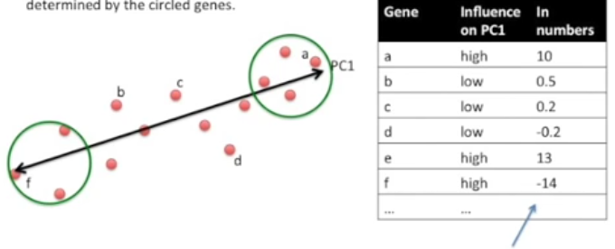
A and f closer to the end appear to have highly influenced by pC1 when compared to c and d
A will have a high positive value because its closer to PC1 where as F will have a high negative value because its all the way at the other end of the line.

Eigenvectors
An eigenvector is a vector whose direction remains unchanged when a linear transformation is applied to it

PCA: It is used to express data in such a way that it highlights their similarities and differences. Often used to find data of high dimensions.
For PCA to work properly, you have to subtract the mean from each of the data dimen-
sions. The mean subtracted is the average across each dimension.
PCA: useful to describe a dataset since it summarises the information

In PCA graphs the origin represents the geometrical centre. The origin represent the mean value of each orginal variable. Each variable that passess through the origin by acquiring positive or negative values.

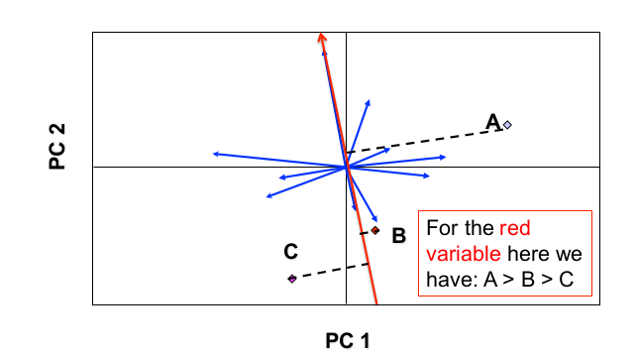

Angles between the vectors represent the correlation between variables on the PCA graph.
The size of the eignvalue can be used to determine the number of principal comonenets. Use only the principal component with the eigenvalues greater than 1.
Eignvalues of the corr matrix -----easily done in R
For example, a principal component with a proportion of 0.621 explains 62.1% of the variability in the data

