Variability in upwelling patterns across the Benguela

Amieroh Abrahams ^{a,*}, Albertus J. Smit ª, Robert W. Schlegel ^{b}
ªDepartment of Biodiversity and Conservation Biology, University of the Western Cape, Private Bag X17, Bellville 7535, South Africa
^{b}Department of Oceanography, Dalhousie University, South St 6299, Halifax, Canada

Abstract
Time series of accurate Sea Surface Temperatures (SSTs) are needed to resolve subtle signals that may be indicative of a changing climate. SST data are often provided as gridded products, typically at resolutions of order 0.05° from satellite observations. This study was designed to examine whether the same upwelling patterns were discemble at varying distances from the coastline and if this was apparent from SST datasets, collected at different resolutions. The study made use of wind data to determine the upwelling index (UI) for each of the sites. The UI value was used to identify when upwelling occurred. Analyses of temperature time series data from four sites within the west coast of South Africa were conducted.

Keywords: Seawater temperature, climate change, coastal regions, code: R, variability, upwelling

1. Introduction

Sea surface temperature (SST) are regarded as one of the most important parameters within the global ocean-atmosphere system, and is particularly useful research tool in the scientific fields of meteorology and oceanography (Mesias, Bisagni and Brunner, 2007). For over 150 years, SST data has been collected using in situ measurement techniques (Rayner et al., 2003); with satellite measurements of SST being available since the 1970s; furthermore, over the past decade techniques have been developed to allow the combination of the different SST information available from the various in situ and satellite platforms into higher resolution global gap-free analyses. Previous studies demonstrated that satellite-based SST data are less accurate than in-situ data due to the complexity of the oceanic and atmospheric conditions (Robinson, Wells and Charnock, 1984; Brown, Brown and Evans, 1985; Minnett, 1991), although the errors in satellite-based SSTs were found to vary both regionally and temporally (Wick, Emery and Schluessel, 1992). In comparison to in situ SST measurements established from ships, or buoys, a major advantage of SST is the reliable global coverage, and near real time availability. SST datasets with a high level of accuracy, spatial completeness and fine resolutions are necessary for weather forecasting and is of great importance for reliable climate change monitoring (Chao et al., 2009; Reynolds & Smith, 1995; Reynolds et al., 2002; Smith & Reynolds, 1998)

Long-term SST data has been obtained from two kinds of satellite remote sensors; specifically thermal infrared (TIR) and microwave (MW) remote sensors, both of which show different weather sensitivity characteristics and accuracies. Infrared remote sensor SST products have high spatial resolution ranging at approximately 4km grid as well as having a long history; however, they are unfortunately affected by the presence clouds and significantly large amounts of aerosols in the atmosphere. This is known to result in spatial discontinuity. MW SST products have a lower resolution than infrared SSTs at approximately 25km grid, with a much lower accuracy near coastlines. However, by combining these SST products, it is possible to take advantage of the strengths within both of these data types, and each sensor type could produce an SST dataset with more spatial coverage and higher resolution.

For many applications, SST data are not used or provided at the full resolution of the sensors but are averaged over defined areas in order to produce a gridded product. For datasets with long time series observations, this approach is often necessary to reduce the volume of the data produced; however, gridding in this way destroys more detailed information and as a result a gridded SST measurement is taken as an estimate of the average SST across a specific grid cell over a certain time period. Spatial sampling uncertainty is present in gridded products as the full gridded cell is often not being observed as a result of interference due to the presence of clouds or aerosols, as previously mentioned.

Until recently, high-resolution information from these sensors were rarely used in gridded multi-sensors SST analysis. In existing daily global SST analysis products, typical grid resolution ranges from 0.05°×0.05° to 0.25° ×0.25°, or from approximately 5 to 25 km (e.g., Reynolds and Smith, 1994; Brasnett, 2008; Donlon et al., 2012). However, due to spatial and temporal averaging applied for interpolation, the actual resolution of the physical features can be substantially coarser than grid resolutions (Reynolds and Chelton, 2010; Reynolds et al., 2013), often just enough to resolve ocean mesoscale features. In some cases, the SST analysis fields may be smoothed to satisfy the operational requirements. It should be noted that space time sampling rate sets a fundamental limit on the physical resolution of the analysed SST field. Small scale features can evolve during the course of the day, but the sensor sampling during this time is not dense enough for the sub-daily global analyses at a high spatial resolution. To capture these small-scale features in a gridded analysis, it is suggested that the development of an improved analysis would have high resolution at small-scale features in regions of good coverage and lower resolution in areas of poor coverage (Reynolds et al, 2013).

This study aimed to observe recent trends of upwelling patterns across a range of SST products. Upwelling is defined as a physical oceanographic process in which cold, nutrient rich waters are pushed to the surface as a result of the motion caused by alongshore equatorial winds. The reason for selecting an upwelling system was simply a matter of convenience , as there are strong spatial and temporal patterns that provide a confident result when similar patterns are detected amongst vastly different kinds of data. Upwelling as a process is also shown to inject a certain known or expected signal into each of the data sources, which should then be detectable in all the data types. It was hypothesized that the higher resolution data should have a better fidelity at detecting upwelling that might be confined to smaller spatial areas, or closer to the shore. With SST fields from AVHRR-only Optimally-Interpolated Sea Surface (OISST), Multi-scale Ultra-high Resolution (MUR), the Canadian Meteorological Center (CMC) and Global 1-km Sea Surface Temperature (G1SST), would be utalised during this research. For the purpose of this study, various SST products of increasingly higher resolutions and at increasing distances from the shore were used in order to examine consistencies of upwelling patterns detected in satellite products against the more reliable in situ collected SSTs. This assisted in detecting whether the same patterns that are identified the in situ data are present in the satellite data; as well as how far a distance from the coastline the same patterns propagate. Due to the temperature gradients that exist inshore and offshore, this study aimed to observe whether the same upwelling patterns existed from the coastal region up to a distance of 50km offshore (Andrews and Hutchings, 1980; Shannon et al, 1984).

These upwelling events are known to have a large influence on the abundance, diversity, and distribution of marine organisms, and moreover, critically affect marine ecosystem processes. Changes in the coupled atmosphere-marine climate within the Benguela upwelling system (BUS) affect both ecological and socio-economic important sub-systems, which, in turn affects many residents inhabiting the coastline as well as those who derive their livelihoods and resources from the BUS. Occurring globally throughout the world's oceans, four major eastern boundary upwelling systems (EBUS) can be recognised. These respective systems are characterized as vast regions of coastal ocean occurring along the western shores of continents bordering the Pacific and Atlantic Oceans (Bakun, 1990; Pauly and Christensen, 1995; Bakun et al., 2015, Bakun et al., 2010).

In order to resolve signals that may be indicative of climate change, a long time series of accurate, spatially as well as temporally averaged SSTs are important. Anthropogenic climate change has become an issue of global concern as it has been shown to have negatively affected marine and terrestrial ecosystems (Hoegh-Guldberg and Bruno, 2010; IPCC, 2015) by largely influencing coastal species such as corals, muscles and oysters (Hoegh-Guldberg and Bruno, 2010). The consequences of these changes are shown to have had direct effects on the functioning of marine ecosystems, with consequences across all trophic positions (Doney et al., 2011). According to the ‘Bakun hypothesis,’ an increase in greenhouse gases will result in an increase in day-time warming and night-time cooling and ultimately cause an increase in temperature gradients which will form stronger atmospheric pressure gradients (Bakun, 1990). It should be noted pressure gradients module the winds which affect the intensity and duration of upwelling events (Bakun et al., 2010; Hsieh and Boer, 1992; Lima and Wethey, 2012; Mote and Mantua, 2002). Furthermore, it should also be understood that changes in sea surface temperatures indirectly affects, and bears considerable economic impacts as well (Murawski, 1993; Murawski et al., 2000, Bakun et al., 2010).

The central assumption of this project was that remotely-sensed SST data and in situ seawater temperature data may be compared. It is hypothesised that the higher resolution data should be able to detect gradients better than the coarser resolution data.

2. Methods
2.1. Datasets

The South African Coastal Temperature Network (SACTN) data served as the in situ temperature dataset used in this study. This dataset consists of coastal seawater temperatures obtained from 129 sites along the South African coastline. This dataset consisted of coastal seawater temperatures for 129 sites along the coast of South Africa, measured daily from 1972 until 2017, with contributions made from several organisations and governmental departments. Of these, 80 were measured using hand-held thermometers and the remaining 45 were measured using UTRs. The duration and extent of the recordings per site were uneven, with the longest time series in the dataset being that of Gordons Bay. Data collected for this region started on 13 September 1972 and concluded on 26 January 2017, with recordings still continuing daily. During the 1970s, a total of 11-time series began recording. A further 53 entries were added during the 1980s, 34 entries were added during the 1990s, and 18 entries were added during the 2000s. Recordings are still ongoing at many of these sites. For this analysis, the data were combined and formatted into standardized comma delineated values (CSV) files which allowed for a fixed methodology to be used across the entire dataset. Prior to data analysis, all data points exceeding 35°C and/or below 0°C were removed as these were considered as outliers. These data points were then changed to NA (not available) so as to not interfere with analysis. Recordings are still ongoing at many of these sites.

Additionally, this study has sought to incorporate remotely sensed temperature datasets; complied by a number of organisations across the globe, each specialising in remotely sensed SST data and information products; utilising satellites to provide a system of large spatial and temporal data retrieval. The AVHRR-only Optimally-Interpolated Sea Surface Temperature (OISST) was used to determine SST within the study region. The AVHRR datasets have been providing global SSTs for more than four decades (Reynolds et al., 1994). OISST is a global 1/4° gridded daily SST product that assimilates both remotely sensed and in situ sources of data to create a level-4 gap free product (Banzon et al., 2016). The CMC dataset constitutes the second dataset and is a version 3.0 Group for High Resolution Sea Surface Temperature (GHRSST) Level 4 dataset with a 10km resolution constructed by the Canadian Meteorological Center (CMC). The CMC dataset combines infrared satellite SST at numerous points in the time series from the AVHRR, the European Meteorological Operational-A (METOP-A) and Operational-B (METOP-B) platforms, and microwave SST data from the Advanced Microwave Scanning Radiometer 2 in conjunction with in situ observations of SST from ships and buoys from the ICOADS program (PO.DAAC, https://podaac.jpl.nasa.gov/). The Multi-scale Ultra-high
Resolution (MUR) Sea Surface Temperature Analysis, the third dataset, is produced using satellite instruments with datasets spanning 1 June 2002 to present times (PO.DAAC,https://podaac.jpl.nasa.gov/). MUR provides SST data at a spatial resolution of 0.01° in longitude-latitude coordinates and is currently among the highest resolution SST datasets available.A final dataset used, A Group for High Resolution Sea Surface Temperature (GHRSST) Level 4 sea surface temperature analysis produced daily using a multi-scale two-dimensional variational (MS-2DVAR) blending algorithm on a global 0.009 degree grid. This Global 1 km SST (G1SST) analysis uses satellite data from sensors, with some of the popular sensors being the Advanced Very High Resolution Radiometer (AVHRR), the Advanced Along Track Scanning Radiometer (AATSR), the Spinning Enhanced Visible and Infrared Imager (SEVIRI), the Moderate Resolution Imaging Spectroradiometer (MODIS), etc and in situ data from drifting and moored buoys.

An advantage of using of in situ data over satellite data is that they provide a more accurate representation of the thermal properties closer to the coast where satellite temperatures do not capture temperature properties well and can therefore more accurately explain upwelling within the coastal inshore environment. Smit et al (2013) have shown that satellite data collected along the South African coastline represent a warm bias reaching as high as 6°C over in situ temperatures within the nearshore environment.

In order to create a time series of each of the remotely sensed SST data and also to compare whether the same upwelling patterns exist on the broad-scale against the in situ time series, shore-normal transects were extended from the in situ sites along the west coast of South Africa. Temperature values from the various satellite datasets were extracted at 15, 25, and 50 km along the shore-normal transect from the coast shown as black boxes in Fig. 1. The daily SST values obtained from the various remotely sensed datasets along each of the transects were used to produce an offshore time series that could accurately be used as a dataset to be compared against the in situ time series. Offshore transects were used in order to generate a time series in this manner as they accurately represent the mesoscale temperatures we were interested in comparing against coastal upwelling. Had we only made use of the nearest remotely sensed pixels to compare against the SACTN time series this would simply only draw a comparison between datasets, and not the mesoscale activity within the ocean.

2.2 Wind data

The wind was an important variable in this study as it was hypothesised that wind direction and wind speed may have a direct influence on upwelling, consequently, the wind was investigated for its impact on upwelling at specific sites along the west coast of South Africa. Wind data were obtained from the South African Weather Service (SAWS), and were provided at a three-hour temporal resolution. The wind variables used here were wind direction (dirw) and wind speed (spw). Since the wind data were modelled at three-hour resolutions, they were converted into daily data points in order to compare them with the temperature data. The `circular()` function in R software (R Core Team, 2019) was used to create circular objects around the wave data in order to calculate the daily wind parameters.

2.3 Site Selection

The South African coastline exhibits a large variation in seawater temperature and is divided into four bioregions (Smit et al., 2013; Mead et al., 2013). The western region of the coastline is dominated by the Benguela Current forming an Eastern Boundry Upwelling System (EBUS) (Hutchings et al, 2009), which provides a natural laboratory for this study. Annual mean coastal seawater temperatures within this region have a range of 12.3 ± 1.2°C at the Western limit near the Namibian border. Seasonal upwelling is controlled by south-easterly trade winds and as a result reflects distinct temperature variations representing much lower temperatures within the upwelling cells over a fairly narrow continental shelf found from the Cape Peninsula to Cape Columbine. In order to accurately examine upwelling patterns at various distances from the coast, several sites from the SACTN dataset along the west coast of South Africa (i.e. sites influenced by the Benguela current) were selected. Since temperature data were not evenly recorded for each of the sites, the entire dataset was narrowed to only those sites with a time series of longer than 30 years. This yielded a total of four sites within the Benguela region (Fig 1).

2.4 Defining and determining upwelling

In order to determine the change in upwelling signals at various different distances from the coastline, and to test which dataset showed a clear, and visible representation of these events, it was first necessary to define when upwelling was occurring; however, to accomplish this it was first required to establish a threshold value for identifying when the phenomenon was in taking place. Given that upwelling is primarily caused by alongshore, equatorward winds, it was necessary to consider both temperature and wind values. These data values are instrumental in determining the specific environmental conditions and parameters required for upwelling to occur; to accomplish this an upwelling index was calculated using the formula presented in the work by Fielding and Davis (1989).

Upwelling Index = μ(Cosθ − coastal angle)

In this equation, μ represents the wind speed (m/s) and θ represents the wind direction, which is measured in degrees, and the coastal angle as the angle of each of the sites perpendicular to the coastline. The index relies heavily on wind speed and direction data in order to determine the intensity of upwelling and the likelihood of the phenomenon occurring. The above equation produces a value called the upwelling index; for this study specifically, upwelling was classified to occur when the index value is greater than 1. However to further ascertain a threshold for upwelling, the exceedance() function within the heatwaveR package (Schlegel et al., 2017) was utilised, specifically to determine the consecutive number of days that the event must exceed for it to be regarded and classified as an upwelling event. However, it should be noted that upwelling is known to vary on a seasonal basis and also may occur hourly. Therefore, this study sought to establish the minimum duration for the analyses of upwelling as 1 day; the rationale behind this being that data from the SACTN dataset as well as the satellite remotely sensed SST data is collected daily. Furthermore, it was also decided to make use of a percentile value rather than a static upwelling index value of greater than 1 as percentile values are often more approved. It was then determined that a 25th percentile threshold for the upwelling index result lasting for more than and equal to 1 day matched with the upwelling index value of >1. As a result, the 25th percentile threshold was used as a more acceptable value to predict upwelling events. In order to determine the upwelling metrics, the detect_event() function within the heatwaveR package was used.An R script (https://github.com/AmierohAbrahams/Upwelling_MCS) was used to calculate the individual upwelling events for both the in situ and remotely sensed SST data. Because upwelling events were calculated relative to percentile exceedances, rather than an absolute definition such as periods with temperatures above a fixed temperature threshold, upwelling events occurred any time of the year with upwelling shown to be more dominant during spring and summer months. It must also be stated that due to irregular sampling efforts in the SACTN dataset the spatial and temporal distributions of upwelling is not necessarily even.

3. Results
Many of the events occurring within Lamberts Bay (Fig. 2, A) exceeded a duration of 5 days, with few events lasting for less than 5 days. Three major events were detected. One event was detected during 2011 and two during 2012 at a distance of 10 km and 20 km away from the coastline. The duration of the events varied, with the longest events occuring during 2011 and lasting for approximately 20 days. Events occuring during 2012 lasted for approximately 16-19 days. At 30 km fewer upwelling was detected. The longest event detected occurred during 2012 and lasted for 20 days. At a distance of 40 km no event exceeded 15 days, with more events being detected here compared to at a distance of 30 km. However, at a distance of 50 km a major upwelling event is detected lasting for longer than 20 days. Fewer events were however detected at a distance of 50 km from the coastline.

Throughout Port Nolloth (Fig. 2, B), most of the events detected lasted less than five days. At a distance of 10 km three events were detected during 2012. This event persisted at 20 km, 30 km and 40 km from the coastline, however the duration of these events varied. Here, most upwelling events were detected at 10 km and 20 km respectively. The least number of events were detected at 40 km. At a distance of 50 km from the coastline, three upwelling signals lasted for longer than 10 days but less than 15 days.

Events within Saldanha Bay (Fig 3, C) typically lasted for approximately three days but this varied across the different distances from the coastline. At a distance of 10km, three upwelling signals exceeding a duration of 10 days were detected. During 2011 and 2012 the longest event was detected lasting for approximately 11 days. This event was also present at a distance of 20 km and 30 km from the coastline but with a change in the duration of the detected signal. Events occurring within 30 km and 40 km from the coastline showed fewer signals. The duration of these signals often exceeded 5 days. However, the majority of events were observed at a distance of 10 km and 20 km from the coastline. Fewer events occurred at a distance of 50km, with most of the events occurring at this distance having lasted for less than five days.

Sea Point showcased the longst upwelling period found to occur at 10km and 20 km from the coastline during the year 2013, this process lasted for approximately 18 days (Fig. 3, D). The majority of upwelling events in Sea Point occurred around 10, 20 and 30 km away from the coastline. Conversely, at a further distances like 40 and 50 km from the coastline, fewer upwelling events were detected, with most of the upwelling signals lasted for less than 5 days. At a distance of 40 km from the coastline the same signal occruring at 10, 20 and 30km during 2013 was present however the duration of this event varied. At a distance of 50km this signal was still detected during 2013 lasting for approimately 14 days.

***CMC observations of upwelling (Fig. 4) at Lamberts Bay (Fig.4, A) most upwelling events lasted for less than 5 days. A total of three upwelling events lasted for a duration of longer than 5 days but less than 10 days, during 2010. This pattern persisted throughout the different distances from the coastline, however, the duration of this event appears to have shorten throughout the distances. At a distance of 50 km from the coastline, the longest upwelling event lasted for 5 days. At Port Nolloth (Fig. 4, B), most of the events are found to occur for duration of three days. Two major upwelling events were present at different distances within 2010. Those events both lasted for approximately seven days. Here, more events were detected at a distance of 50 km compared to a distance of 10 km from the coastline.

At Saldanha Bay, the duration of upwelling events mostly ranged between three to four days. Events of the same duration are detected at a distance of 10 and 20 km from the coastline. At a distance of 20km from the coastline to a distance of 50 km, more events were detected. At 40 km an event was detected for 20 days within 2010, this was the longest event detected within Saldanha Bay. Sea Point detected durations of less than four days for most upwelling events (Fig.5, D). The most intense event occurred in 2010. The fewest number of events occurred 50 km away from the coastline. *****

Within the SACTN dataset (Fig. 6), the majority of upwelling signals detected in Lamberts Bay lasted for less than five days. The longest upwelling signals were detected in 2012 and 2013 lasting for approximately 12 days. Several upwelling events were detected at this site. However, only six upwelling signals were recorded and detected at Port Nolloth during the years 2011 to 2014. Here most of the lasted between three to five days with the most intense event occuring during the year 2012 and lasting for 11 days. Most of the upwelling signals detected in Saldanha Bay upwelling lasted between three to five days. Three obvious events, with the longest duration were detected in 2012 and 2013 respectively. The longest event detected in 2013 lasting for approximately 16 days. Several upwelling signals were present in Saldanha Bay compared to that of Port Nolloth and Lamberts Bay. Upwelling signals detected in Sea Point often lasted for less than 5 days, with some signals lasting up to 10 days. The longest event was detected during 2012 and lasted for approximately 21 days. Two obvious signals were present in 2013, both signals exceeded a duration of 10 days.

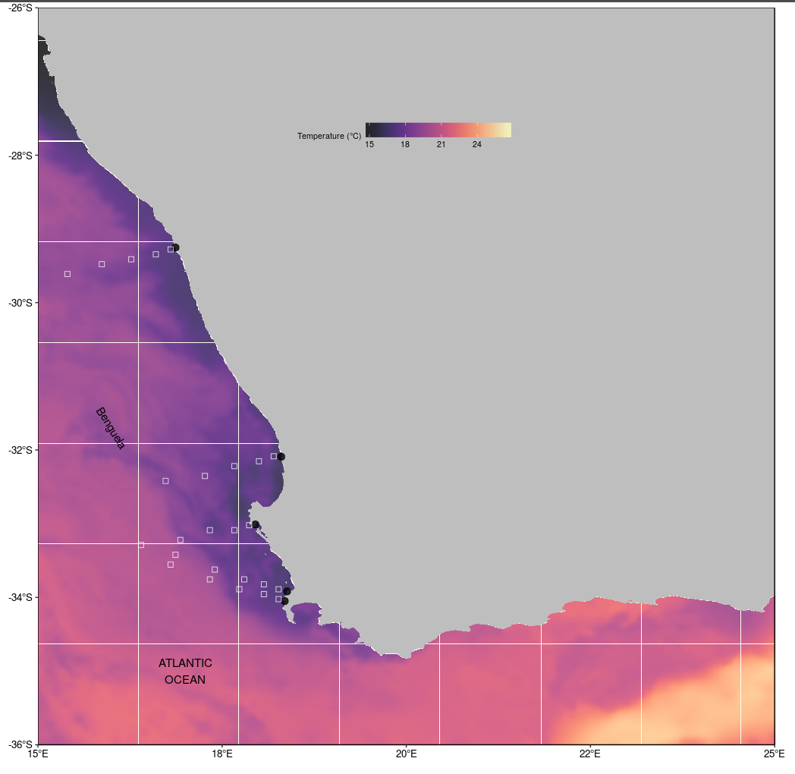
Fig.1. Map representing the study region along the west coast of South Africa. The black points represent the location of the in situ temperatures and approximations of the pixels used along the shore normal transect from the satellite sea surface temperatures, shown with black boxes.

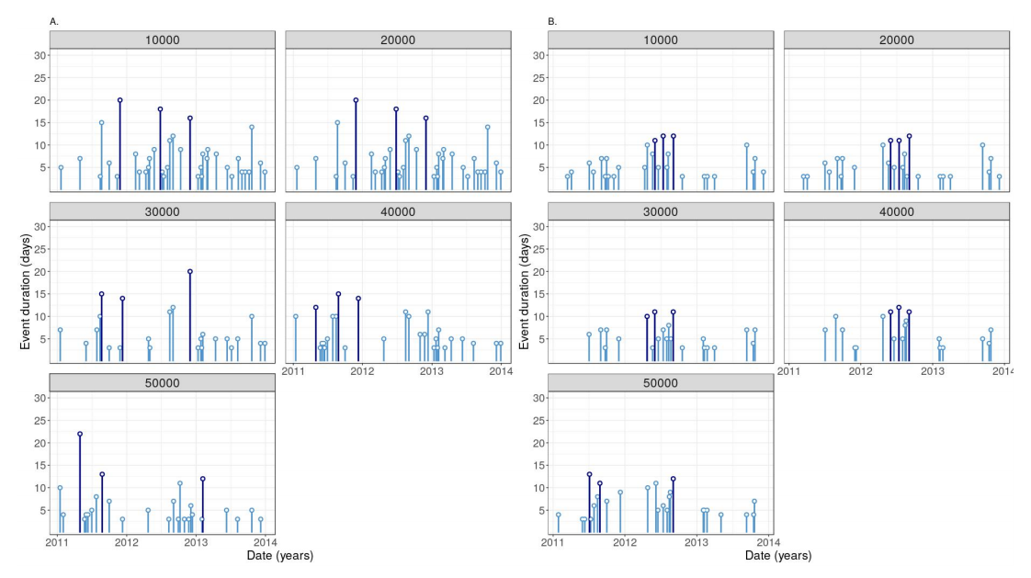
Fig. 2. Timeline of several event metrics. This graph shows the duration of events on the y-axis and the time variable on the x-axis for A (Lamberts Bay) and B (Port Nolloth) using the OISST dataset at variable distances from the coastline. These distances range from 10000m (10km) to 50000m (50km). The number of top events from the chosen metric may be highlighted in a brighter colour.

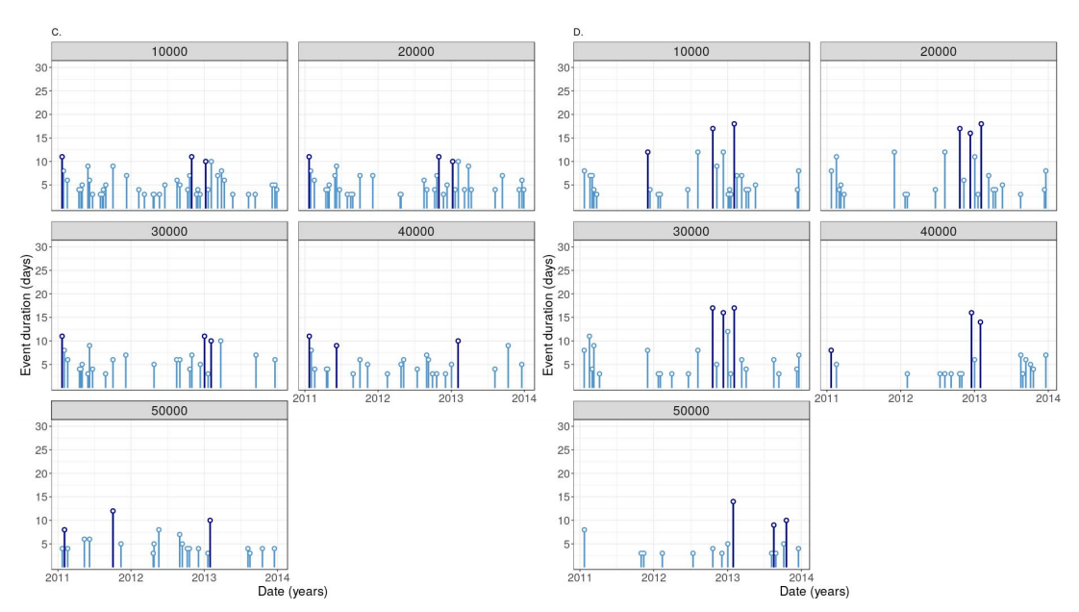
Fig. 3. Timeline of several event metrics. This graph shows the duration of events on the y-axis and the time variable on the x-axis for C (Saldanha Bay) and D (Sea Point) using the OISST dataset at variable distances from the coastline. These distances range from 10000m (10km) to 50000m (50km). The number of top events from the chosen metric may be highlighted in a brighter colour.
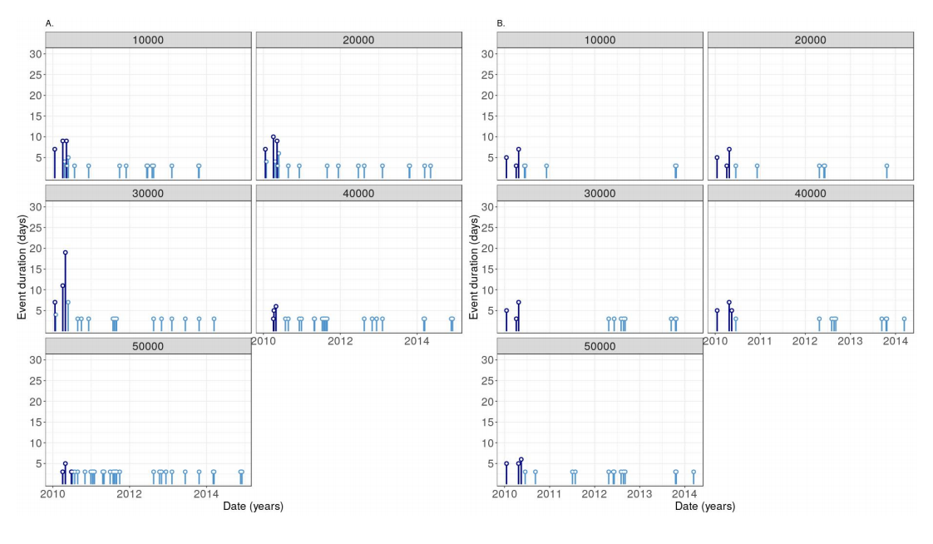
Fig. 4. Timeline of several event metrics. This graph shows the duration of events on the y-axis and the time variable on the x-axis for A (Lamberts Bay) and B (Port Nolloth) using the CMC dataset at variable distances from the coastline. These distances range from 10000m (10km) to 50000m (50km). The number of top events from the chosen metric may be highlighted in a brighter colour.

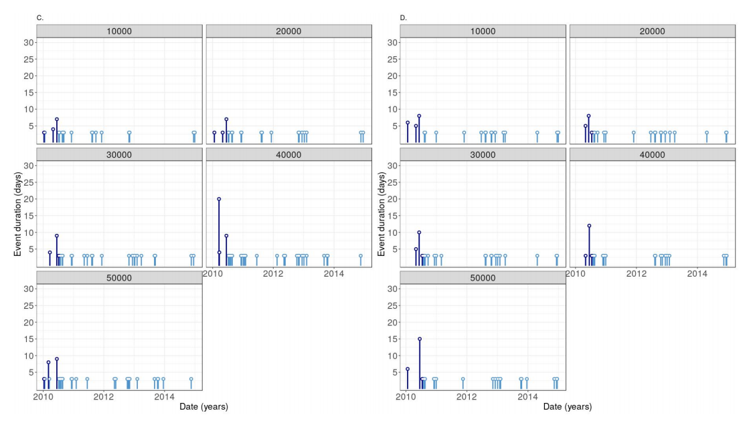
Fig. 5. Timeline of several event metrics. This graph shows the duration of events on the y-axis and the time variable on the x-axis for C (Saldanha Bay) and D (Sea Point) using the CMC dataset at variable distances from the coastline. These distances range from 10000m (10km) to 50000m (50km). The number of top events from the chosen metric may be highlighted in a brighter colour.

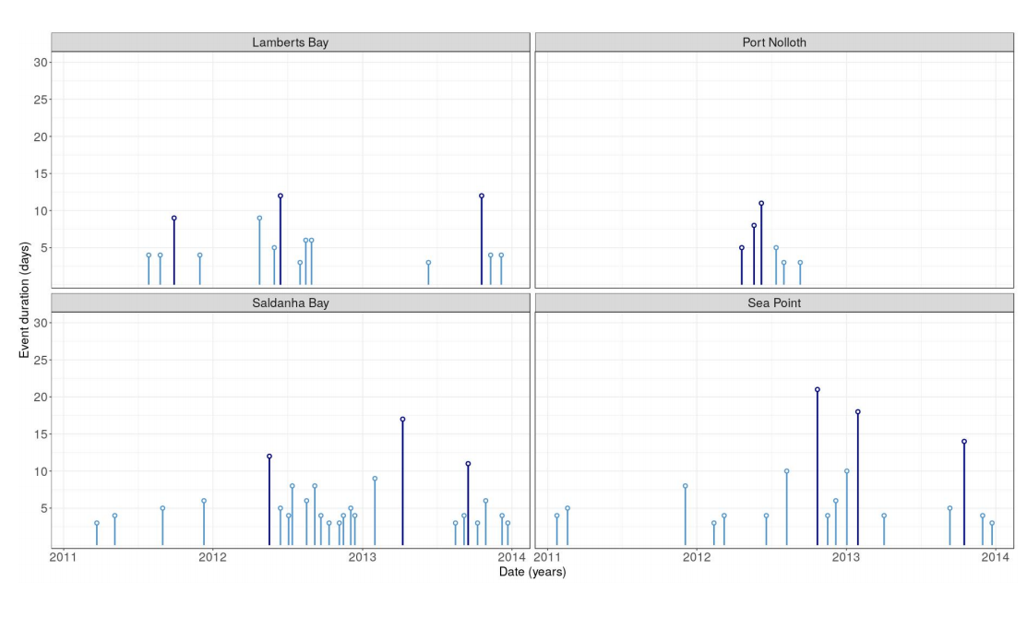
Fig. 6. Timeline of several event metrics. This graph shows the duration of events on the y-axis and the time variable on the x-axis for the SACTN dataset. The number of top events from the chosen metric may be highlighted in a brighter colour.

