Upwelling signals: a comparison of sea surface temperature products in the Benguela

Amieroh Abrahams ^{a,*}, Robert W. Schlegel ^{b,} Albertus J. Smit ª,
ªDepartment of Biodiversity and Conservation Biology, University of the Western Cape, Private Bag X17, Bellville 7535, South Africa
^{b}Department of Oceanography, Dalhousie University, South St 6299, Halifax, Canada

Abstract
Time series of accurate sea surface temperatures (SSTs) are needed to detect subtle signals. SST data are often provided as gridded products from satellite observations, typically at resolutions of 0.05°. This study was designed to examine whether the same upwelling patterns were detectable at varying distances from the coastline from satellite and in situ SST datasets, collected at different resolutions. The study uses wind and SST data to create an upwelling index (UI) for each of the sites that was used to identify upwelling signals. The results showed that a diffrence exist between SST products and between signals detected at different distances from the coastline.

Keywords: Seawater temperature, coastal regions, code: R, upwelling

1. Introduction

Sea surface temperature (SST) is regarded as one of the most important ocean-atmosphere system and is particularly useful research tool in the scientific fields of meteorology and oceanography (Mesias et al., 2007; Harlaß et al., 2015). For over 150 years, SST data has been collected using in situ measurement techniques (Rayner et al., 2003); with satellite measurements of SST being available since the 1970s (Reynolds et al. 2013). Furthermore, over the past decade, techniques have been developed to allow the assimulation of different SST datasets from various in situ and satellite platforms. These are referred to as the Level-3 and Level-4 high resolution gap-free products. Previous studies demonstrated that satellite-based SST data are less accurate than in situ data due to the complexity of the oceanic and atmospheric conditions that need to be accounted for in deriving satellite SST products(Robinson et al., 1984; Brown et al., 1985; Minnett, 1991). These errors vary both regionally and temporally (Wick et al., 1992). In comparison to in situ SST measurements collected from ships, or buoys, a major advantage of satellite SST is their global coverage and near real time availability. SST datasets with a high level of accuracy, spatial completeness and fine-scale resolution are necessary for weather and climate forecasting and are of great importance for reliable climate change monitoring (Reynolds and Smith, 1995; Smith and Reynolds, 1998; Reynolds et al., 2002; Chao et al., 2009)

Long-term SST data have been obtained from two kinds of satellite remote sensors; thermal infrared (TIR) and microwave (MW), which show different weather sensitivity characteristics and accuracies (Li et al., 2013). Infrared remote sensor SST products are available from the 1970’s and may have a spatial resolution as fine as approximately a 4 km grid; however, they are unfortunately affected by the presence of clouds and other aerosols in the atmosphere. This is known to result in spatial discontinuity. MW SST products have a lower resolution than infrared SSTs at approximately a 25 km grid, with a much lower accuracy near coastlines(Li et al., 2013; Hain et al., 2011, Parinussa et al., 2008). By combining these different types of SST products, it is possible to take advantage of the strengths within both, and each sensor type can help produce an SST dataset with more spatial and temporal coverage and higher resolution.

For many applications, SST data are not used or provided at the full resolution of the sensors but are averaged over defined areas in order to produce a gridded product (Bulgin et al., 2016; Reynolds et al., 2002). Gridding in this way destroys more detailed information and as a result a gridded SST measurement is taken as an estimate of the average SST across a specific grid cell over a certain time period. Spatial sampling uncertainty and temporal averaging is present in gridded products as the full gridded cell is often not being observed as a result of interference due to the presence of clouds or aerosols, as previously mentioned. In existing daily global SST analysis products, typical grid resolution ranges from 0.05°×0.05° to 0.25° ×0.25°, or from approximately 5 to 25 km (e.g., Reynolds and Smith, 1994; Brasnett, 2008; Donlon et al., 2012). Small scale features can evolve during the course of the day, but the sensor sampling during this time is not dense enough for the sub-daily global analyses at a high spatial resolution (Reynolds and Chelton, 2010; Reynolds et al., 2013). Furthermore, considering that the satellites are passing over head only once every ~24 hours; therefore images are only captured at very specific times during the day. It bares mention that sensors can’t resolve small-scale features as they continue to evolve over the course of day; the reason being that the sensors are only looking at a restricted portion of the ocean for several minutes at a time; the exception being of-course, geo-stationary satellites like the POES (polar orbiting environmental satellite). To capture these small-scale features in a gridded analysis, it is suggested that the development of an improved analysis would have high resolution at small-scale features in regions of good coverage and lower resolution in areas of poor coverage (Reynolds et al., 2013).

In order to assess the suitability of a range of SST products for coastal application, this study aimed to observe patterns and trends in upwelling signals in the Benguela Upwelling System (BUS) across a range of localities and spatial scales off the South African West Coast. We selected an upwelling system because this physical process provides a strong signal of increasing and decreasing SST that is strongly localised to known centres of upwelling, and which relates to the coastal wind field that drives the offshore advection of water mass. Because upwelling is a well characterised oceanographic process, the resultant fluctuating SST signal should be observed across independent SST products – here we assess blended SST products covering a range of spatial grid resolutions from 0.05°×0.05° to 0.25° ×0.25°. We hypothesized that the higher resolution data should have a better fidelity at detecting these upwelling signals, some of which might only be confined to smaller spatial scales or localised closer to the shore.

The BUS is one of the four major Eastern Boundry Upwelling Systems (EBUS) (Bakun et al., 2015). EBUS are characterised as vast regions of coastal ocean occuring along the western shores of continents bordering the Pacific and Atlantic Oceans (Bakun, 1990; Pauly and Christensen, 1995; Bakun et al., 2015; Bakun et al., 2010). Coastal upwelling associated with EBUS is known to have a large influence on the associated ecosystem’s primary priductivity, and hence the abundance, diversity, distribution and production of marine organisms at all trophic levels (Bakun et al., 2010; 2015). According to the ‘Bakun hypothesis,’ an increase in greenhouse gases will result in an increase in day-time warming and night-time cooling and ultimately cause an increase in temperature gradients which will form stronger atmospheric pressure gradients (Bakun, 1990). It should be noted pressure gradients modulate the winds which ultimately affect the intensity and duration of upwelling (Bakun et al., 2010; Hsieh and Boer, 1992; Lima and Wethey, 2012; Mote and Mantua, 2002). Furthermore, it should also be understood that changes in sea surface temperatures indirectly affects coastal communities, and bears considerable, often far-reaching economic impacts as well (Murawski, 1993; Bakun et al., 2010). It is hypothesised that the higher resolution data should be able to detect gradients better than the coarser resolution data and that signals are more visible closer to the coastline at a distance of 0 km rather than at a distance of 50 km.

2. Methods

2.1 Site Selection

The South African coastline exhibits a large variation in seawater temperature and is divided into four bioregions (Smit et al., 2013; Mead et al., 2013). The western region of the coastline is dominated by the Benguela Current forming an Eastern Boundary Upwelling System (EBUS) (Hutchings et al, 2009), which provides a natural laboratory for this study. Annual mean coastal seawater temperatures within this region have a range of 12.3 ± 1.2°C at the Western limit near the Namibian border. Seasonal upwelling is controlled, with intense upwelling occuring throughout the summer months, by south-easterly trade winds and as a result reflects distinct temperature variations representing much lower temperatures within the upwelling cells over a fairly narrow continental shelf found from the Cape Peninsula to Cape Columbine. In order to examine upwelling patterns along the coastline, several sites from the SACTN dataset (Schlegel et al.,, 2016; 2017) along the west coast of South Africa (i.e. sites influenced by the Benguela current) were selected. As the main objective of this study was to simply ascertain whether or not the same upwelling signals were detected congruently throughout the various SST products; a study period of four years of data was sufficient in order to compare congruency among the detections between products. Four sites were selected, occuring at different regions in the benguela system, these include Port Nolloth, Lamberts Bay, Sea Point and Saldanha Bay (Fig.1.).

2.2 Datasets

This study uses four Level-4 remotely sensed temperature datasets; complied by a number of organisations. The AVHRR-only (Advanced Very High Resolution Radiometer) Optimally-Interpolated Sea Surface Temperature (OISST) dataset has been providing global SSTs for nearly four decades (Reynolds et al., 1994). OISST is a global 0.25° × 0.25° gridded daily SST product that assimilates both remotely sensed and in situ sources of data to create a gap free product (Banzon et al., 2016). The second is a version 3.0 Group for High Resolution Sea Surface Temperature (GHRSST) product with a 0.2° × 0.2° global grid resolution constructed by the Canadian Meteorological Center (CMC). It combines infrared satellite SST at numerous points in the time series from the AVHRR, the European Meteorological Operational-A (METOP-A) and Operational-B (METOP-B) platforms, as well as the microwave SST data from the Advanced Microwave Scanning Radiometer 2 in conjunction with in situ observations of SST from ships and buoys from the ICOADS program. The Multi-scale Ultra-high Resolution (MUR) Sea Surface Temperature Analysis is produced using satellite instruments with datasets spanning 1 June 2002 to present times. MUR provides SST data at a spatial resolution of 0.01° × 0.01° and is currently among the highest resolution SST datasets available. The final dataset used is the GHRSST analysis produced daily using a multi-scale two-dimensional variational (MS-2DVAR) blending algorithm on a global 0.01° grid known as G1SST. This product uses satellite data from a variety of sensors, such as AVHRR, the Advanced Along Track Scanning Radiometer (AATSR), the Spinning Enhanced Visible and Infrared Imager (SEVIRI), the Moderate Resolution Imaging Spectroradiometer (MODIS), and in situ data from drifting and moored buoys. We see that not all products are completely independent as they share the use of AVHRR SST data, but the amount of subsequent blending, the incorporation of other SST data sources, the different blending and interpolation approaches used, and the differing final grid resolutions make them comparable in this study.

Additionally, this study uses the South African Coastal Temperature Network (SACTN) dataset for its source of in situ temperature. This dataset consists of coastal seawater temperatures obtained from 129 sites along the South African coastline, measured daily from 1972 until 2017 (Schlegel et al., 2016, Schlegel and Smit, 2017). Of these, 80 were measured using hand-held thermometers and the remaining 45 were measured using underwater temperature recorders (UTRs). For this analysis, the data were combined and formatted into standardized comma seperated values (CSV) files which allowed for a fixed methodology to be used across the entire dataset. Prior to data analysis, all data points exceeding 35°C and/or below 0°C were removed as these were considered irregularities. These data points were then changed to NA (not available) so as to not interfere with analysis.

An advantage to using in situ data over satellite data is that they may provide a more accurate representation of the thermal properties closer to the coast, whereas satellite data often fails to accurately capture and represent temperature properties within the same spatial context; the result being in situ data can therefore more accurately explain upwelling signals within the coastal inshore environment. Further evidence by Smit et al. (2013) has shown that satellite data collected along the South African coastline may have a warm bias as high as 6°C over in situ temperatures within the nearshore environment.

In order to create a time series of each of the remotely sensed SST data products and to determine whether the same upwelling patterns exist on the broad-scale against the in situ time series., shore-normal transects of all Level-4 products were extended at West Coast stations where the in situ data in the SACTN database were available. Time series of SSTs were extracted at 0, 25 and 50 km along these shore-normal transect from the coast shown as black boxes in Fig. 1.

2.3 Wind data

Wind data were obtained using a wind instrument called the RM YOUNG Weather Transmitter. This compact instrument provides reliable and accurate measurements of four key meteorological variables. Ultrasonic wind speed and direction, atmospheric pressure, humidity and temperature sensors are carefully integrated into an enclosure optimized for durability, airflow and mitigation of solar radiation effects. Wind was an important variable for this study as wind direction and wind speed may have a direct influence on the intensity and duration of upwelling, consequently, wind data collected from 1989-01-01 to present were investigated for their relationship with upwelling at the sites for which SST time series were created. When the instrument collects wind data, the raw files are converted by the logger into a format readable by the metcap program, which draws the graphs and writes the data into excel spread-sheets in which they are stored for later use.

2.4 Defining and determining upwelling

In order to determine the change in upwelling signals at various distances from the coast and to test which dataset showed a clear, and visible representation of these signals, it was first necessary to define when upwelling was occurring; however, to accomplish this a set of threshold values for identifying when the phenomenon was taking place was required. Given that upwelling is primarily caused by alongshore, equatorward winds, both SST and wind data were used. The wind data were used to inform an upwelling index calculated using the formula presented in the work by Fielding and Davis (1989).

Upwelling Index = μ(cosθ − 160)

where μ represents the wind speed (m/s), θ represents the wind direction in degrees, and 160 is the orientation of the west coast (Jury 1980). The index relies heavily on wind speed and direction data in order to determine the presence of upwelling and its intensity. The above equation produces a value called the upwelling index. An upwelling index < 0 represents downwelling whilst an upwelling index > 0 represents upwelling (Fielding and Davis, 1989). When the upwelling index is greater than 0, SSTs usually drop, as expected, suggesting that upwelling is occuring. It was found that the drop in SST that coincided with a positive upwelling index was close to the seasonally varying 25th percentile threshold for SST., so this threshold temperature was used in combination with the upwelling index to determin when upwelling may be occuring. With the bottom threshold set for which temperatures may qualify as an upwelling signal it was then necessary to determine the number of consecutive days that must be exceeded for an upwelling signal to qualify as a discrete event. Here it must be noted that upwelling is known to vary on a seasonal basis and may also occur hourly (sub-daily). Therefore, the minimum duration for the classification of an upwelling signal was set as one day. The rationale being that data from the SACTN dataset as well as the satellite remotely sensed SST data are collected only at a daily resolution, preventing a temporally finer definition. With the upwelling index, temperature threshold, and duration for an upwelling signal established, the detect_event function from the heatwaveR package (Schlegel et al., 2018) was used to calculate metrics for the upwelling signals. Because upwelling signals were calculated relative to percentile exceedances, rather than an absolute definition such as temperatures below a fixed temperature threshold, upwelling signals could occur any time of the year, however, upwelling was shown to be more dominant during spring and summer months, as expected.

2.5 Statistical analyses

A series of ANOVA tests were used to compare the main effects of the chosen variables on the continuous variable. In this analysis the relationship between the SST products across the various selected study sites was established; factors used to correlate these relationships included duration, mean intensity and cumulative intensity. These analyses sought to test if significant differences occurred between sites and data products. A correlation analysis was constructed to determine if a signal detected at a distance of 0 km from the coastline would be visible at a distance of 25 km from the coastline and, similarly if the same trend could be observed when comparing the 0 to the 50 km offshore regions.

3. Results

The durations of upwelling signals detected at each site were not uniformly detected across the five data products (Fig 2). At both Lamberts Bay and Port Nolloth, the durations of upwelling signals were noticeably lower to those of Saldanha Bay and Sea Point respectively, and appeared to last for a shorter number of days overall. Additionally, signal duration in Lamberts Bay and Port Nolloth both had narrower ranges to those of Saldanha Bay and Sea Point respectively across each of the data products.

Variation of the number of upwelling signals detected across all data products at each site also showed noticeable differences. The median upwelling duration at Lamberts Bay did not exceed 10 days. However, the ranges varied per product with the MUR dataset exhibiting the widest range as well as the maximum duration in comparison to other products. The CMC and SACTN products had relatively similar ranges, but the SACTN dataset had more outliers present. Conversely, Port Nolloth showed no major differences in detected durations between data products. The median duration of signals exceeded 10 days in the G1SST and MUR data products. A slight overlap was present in the overall ranges in the G1SST, MUR and OISST products. Here the OISST and MUR dataset also showed a large variance in maximum duration range.

Saldanha Bay showed differences in durations of signals detected between data products. Here, the OISST and MUR datasets both had comparatively larger medians, maximums, and overall ranges to the CMC and SACTN datasets respectively. In Sea Point the MUR data product represented the widest range, highest maximum and highest median, indicating that it has the greatest fluctuations in duration length. SACTN had a comparatively narrow overall range suggesting a high level of agreement in duration length between events and therefore greater consistency. CMC and OISST datasets were relatively similar but CMC has a lower median.

The OISST data for Lamberts Bay found to have a positive correlation between the number of upwelling signals at 0 km and 25 km away from the coastline (r = 0.59; Table 1). However, this relationship was not present further from the coastline as there was no apparent correlation in upwelling signals between 0 km and 50 km from the coastline (r = 0.14). At Port Nolloth and Sea Point a very high positive correlation was found to exist between the number of signals at 0 km and 25 km from the coastline (r = 0.76; r = 0.76) and again a poor correlation at 0 km and 50 km respectively (r = 0.38; r = 0.18). Saldanha Bay showed a similarly high correlation between upwelling signals at 0 km and 25 km (r = 0.65), but also had the highest rate of correlation for upwelling signals at 0 km and 50 km (r = 0.42).

The CMC data showed similar patterns to the OISST data with positive correlations between the number of upwelling signals at a distance of 0 km and 25 km from the coastline. Lamberts Bay had a low correlation (r = 0.12) at 0 km and 25 km from the coastline but when comparing the amount of signals detected at 0 km and 50 km the correlation was lower still (r = 0.05). Similar patterns are presented for Port Nolloth and Saldanha Bay with each having a stronger correlation at 0 km and 25 km, as well as 0 km and 50 km (Table 1), with the strongest correlation of r = 66 at 0 km and 25 km. At Sea Point however, a strong correlation was found between the number of upwelling signals at 0 km and 25 km (r = 0.69) but at a distance of 0 km and 50 km from the shore we see a negative correlation value (r = - 0.01).
The MUR data for Lamberts Bay (r = 0.60), Port Nolloth (r = 0.74) , Saldanha Bay (r = 0.52) and Sea Point (r = 0.63) all displayed relatively strong positive correlation between upwelling signals at 0 km and 25 km from the coastline. At Lamberts Bay and Saldanha Bay a poor correlation exists between 0 km and 50 km, r = 0.29 and r = 0.23 respectively. For the G1SST products we see similar patterns with Lamberts Bay having the strongest correlation (r = 0.73) in upwelling signals between 0 km compared to 25 km (r = 0.65). Port Nolloth shows a values of r = 0.66 at 0 km and 25 km and r = 0.65 between 0 km and 50 km. Saldanha Bay had a weaker correlation in upwelling signals at 0 km and 25 km (r = 0.28) and a stronger correlation at 0 km and 50 km (r = 0.33) within the G1SST dataset.

When comparing the number of upwelling signals at the various distances from the coastline (Table 2) it was observed that the number of signals detected in the OISST data decreased with an increase in distance from the coast. In the OISST product, 225 upweling signals were detected at a distance of 0 km from the coast, 221 signals were detected at a distance of 25 km and 179 signals were observed at the final distance of 50 km. However, the remaining products shows an increase in signals detected with an increase in distance from the coastline. At a distance of 0 km 222 signals were detected, the highest number of signals detected (240 signals) occurred at a distance of 25 km from the coastline, at distance of 50 km however, we see a decrease in signals detected, with 225 signals. Far fewer signals were detected in the CMC dataset and these signals showed an increase in the number of signals as distance from the coastline increased. At a distance of 0 km, 141 signals were detected, at a distance of 50 km, 169 signals were detected. The G1SST dataset represented the highest number of signals detected and showed similar to the OISST dataset, the number of signals detected decreased as the distance from the coastline increased. A total of 353 signals detected at a distance of 0 km from the coastline, at a distance of 25 km 355 signals were detected with a final 335 upwelling signals observed at a distance of 50 km from the coastline.

The comparison of the upwelling metrics revealed that there was an overall significant difference between the durations of upwelling signals collected from the different products (Three-Way ANOVA: F = 7.31, SS = 1111, p <0.001), at the different distances (F = 4.40, SS = 223, p <0.03) and across the different sites (F = 6.34, SS = 963, p <0.001). The mean intensity of upwelling events also differed between data products (F = 52.16, SS = 40.5, p <0.05) and across sites (F = 41.58, SS = 32.30, p <0.05), as well as at different distances from the coastline (F = 265.35, SS = 68.70, p <0.002). Similarly, there were also a significant differences between the average cumulative intensity of signals detected across data products (F = 22.30, SS = 10604, p <0.001). This same pattern was present between sites (F = 2.722, SS = 1294, p = 0.001) and also between distances from the coastline (F = 44.66, SS = 7078, p <0.001).

4. Discussion
We report here that upwelling signals detected by the highest resolution data, specifically those collected on a 0.01° grid (G1SST and MUR) displayed signals lasting for a longer duration when compared directly to the CMC, OISST and SACTN data products.Analysis of the OISST, CMC and SACTN datasets revealed that recorded signals often did not exceed a duration of 10 days. Additionally, the G1SST and MUR data products also showed a high abundance of signals detected at a duration of less than, or equal to 10 days. Furthermore, highest number of signals detected, were register by the MUR and G1SST data products. This may be due to the errors in any satellite Level 4 product, that are a result of accumulation of errors from different sources, as well as the quantification of one component sampling error and thus requires us to focus on this error source alone (Liu et al., 2013).

MUR and G1SST products were the data sources that yield upwelling signals with the longest duration, often exceeding 10 days; the MUR and G1SST data products both rely heavily on satellite data sources whereas the CMC and OISST products are generated from a broader spectrum of data collection methods using multiple sources of satellite and in situ collected dataset. As a result, the MUR and G1SST products are more likely to be affected by contamination from clouds and aerosols (Ricciardulli et al., 2004). Consequently, the durations of upwelling signals derived from these products may be falsely detected at exaggerated lengths. On the other hand, datasets constructed from multiple data sources, particularly from ships and buoys, are inherently more reliable in terms of reducing the frequency of falsely detecting signals. The extended duration of upwelling signals detected by MUR and G1SST may be as a result of the microwave frequencies where land surfaces have a higher emissivity (0.9) compared to the ocean (0.4). Microwave observations in the proximity of land are affected by the warm emission of land entering the antenna near-in side-lobes. This warming of the microwave brightness temperatures is a source of errors in the TMI retrievals of coastal waters. Since infrared retrievals are not affected by land emission (if retrieved at least a few kilometres from the coast) (Ricciardulli et al., 2004). However, microwave instruments are able to retrieve SSTs in non-precipitating cloud-covered regions where IR instruments cannot (Wentz et al., 2001).

It is also evident that signals detected at a distance of 0 km from the coastline are often the same signal detected at the 25 km region. However, if a signal is detected at a distance of 0 km of the coast, it is rare that the corresponding signal will be identified at a distance 50 km. Thus it is preferable to obtain satellite SST as close as possible to the shoreline in order to identify when coastal upwelling is occuring. However, it should also be noted, that the use of SST pixels that transgress the land/sea boundary is always bad practice, and often this approach is not encouraged (Tang et al., 2003). Additionally, our findings reveal that signal count within the OISST and MUR datasets, decreases with an increase in distance from the coastline. Conversely, the G1SST and CMC datasets displayed an increase in upwelling signals with an increase in distance from the shoreline. Furthermore, it was also evident that dissimilarities existed between products and sites when comparing the upwelling metrics. This may be due to the occasional satellite instrument outages such as result from satellite manoeuvres, or specifically with the MUR dataset, MUR pixel are identified as cloudy or fall in the inter-swath gap. The presence of clouds causes gaps in the data. Gaps between successive swaths of some sensors also lead to sampling errors. Sensors with narrower swaths are subject to a larger gap than others. MUR has unresolved SST variability on scales of 25 km in regions where extensive clouds are present, due to only microwave SSTs being used. Using microwave SSTs can reduce the sampling error caused by clouds, but there are sampling errors caused by precipitation. It is also possible that less upwelling signals are being detected close to the coastline in the CMC and G1SST dataset because of land heating thus increasing the SST and making upwelling not detectable (Ricciardulli et al., 2004).
.
It is important to note that the data sources are intrinsically different in the ways in which they were obtained or recorded. Consequently, one should not be too surprised to find large discrepancies; for example the SACTN in situ collected SST product will reflect actual temperature of the water being measured, however instrumental differences exist; for example, whether the data were collected using a thermometer or an electric sensor. Satellite temperatures however, are collected remotely and sensors never have contact with the water. Here, bio-physical properties of IR and MW are related through complex algorithms to temperature (Minnett et al., 2002). Smit et al (2013) showed that warm and cold biases exist along the southern and western coastal region of South Africa, and the juncture between upwelling and non-upwelling regions have a tendency to influence on the variability and magnitude of the SST bias.

When comparing SST products, a small bias does indeed exist, and is a result of solar flux, cloud cover as well as wind strength (Dufois et al. 2012). In conclusion the different data products, as used within this study, over the same geographical region, specifically the Benguela upwelling system have yielded different results. While flagging techniques are supposed to occasionally flag good values (Kilpatrick et al., 2001), it was found that flagging may occasionally be too vigorous for EBUS (Dufois et al., 2012). For example, the flagging method used on an OISST reference test induces warm coastal bias in data from both the MUR and G1SST data during summer. It should, however be noted that this phenomenon can be explained by strong coastal SST gradients in these upwelling regions.

In the Benguela Upwelling system, as in many global regions, systematic, high resolution and wide coverage data sets of meteorological and oceanographic measurements are lacking. Global model outputs, reconstruction and reanalysis of datasets are potential solutions to this problem and thus provide data when none or only sparse information is available. Remotely sensed infrared SSTs have become a major data source and are instrumental in both oceanographic and atmospheric research (Dong et al., 2006). Despite the many factors that can influence how well the SST products reflect the climatological reality, these SSTs do show high degrees of correspondence with measurements obtained by buoys and other sources of in situ seawater temperatures measurements (Smit et al., 2013; Donlon et al., 2002). However, although SST products developed offshore and within the oceanic regions are being applied to the coastal regions, reports exist to inform users to exercise caution when using SST datasets in these coastal regions (Tittensor et al., 2010; Tyberghein et al., 2011). Warm and cold biases have already been reported in several regions such as Australia (Blanchette et al., 2008), South Africa (Dufois et al., 2012) and China (Tang et al., 2003).

It must, be kept in mind that variability does indeed exist, as described here in; the use of these products are dependent on their quality as well as homogeneity of the data. The spatial incompleteness and low accuracy problems associated with satellite SSTs limit product applications in oceanographic analyses, as well as air-sea temperature interaction studies. It is also evident that several physical processes such as inshore hydrodynamics operate in the mixed layer situated at the coastal region, and this may not be clearly detected by satellite temperature sensors. These processes include convection mixing due to cooling through evaporation, as well as tidal mixing and the injection of turbulence through breaking waves. Although progress in the analysis of sea surface temperature has been substantial in recent years, challenges do however remain. Improvements to the analyses are needed in areas where variability is substantial and sudden, namely near ocean fronts. Increased resolution and incorporation of in situ data would be among the avenues likely to yield a gain in accuracy within these areas (Brasnett Bruce, 2008). Studies often make use of broad scale phenomenon to define processes in the nearshore regions and vice versa; however, as illustrated within this study, events in the coastal region do not always coincide with or reflect those events of the offshore regions and vice versa.

Ample evidence suggests that satellite SST alone are not idea for coastal applications due to the presence of large biases. Contributing towards the magnitude of the biases are factors such as coastal proximity, presence of upwelling and coastal embayments. The coarser resolution of many existing SST products clearly has limitations in dynamic coastal regions, and the sampling capabilities in combination with the higher fidelity of moored buoys offer the potential for improving SST parameterizations in these regions. By excluding moored coastal buoys when merging multi-sensor SSTs, high- resolution analyses risk erroneously estimating the magnitude of the coastal SSTs; ultimately suppressing the high variability associated with small-scale processes in the coastal oceans. Data products representing upwelling signals with a duration exceeding 10 days may likely be related to an incorrect flagging of pixels affected by diurnal warming.

Finally, concerns about satellite temperature accuracy changes in the ocean should make the accurate monitoring of seawater temperature a priority. Our results demonstrate that upwelling signals are more accurately detected at a distance of 10 and 30 km from the coastline and that MUR and G1SST data products have detected (albeit potentially erroneously) more upwelling signals lasting for longer durations.

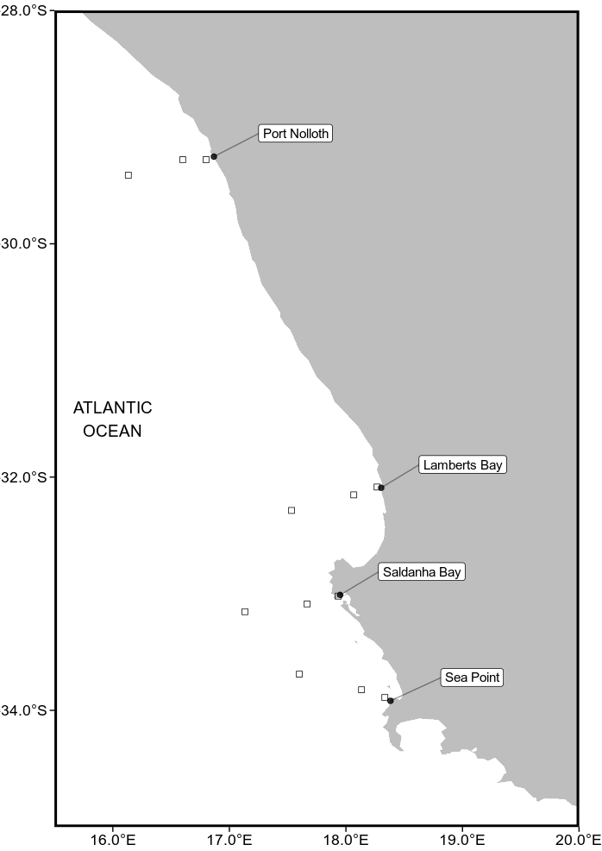

Fig.1. A map of the study region along the west coast of South Africa. The black points represent the location of the in situ temperatures and the empty boxes show the pixels used along the shore normal transect from the satellite sea surface temperatures (SST) time series. The black boxes are at 0 km, 25 km and 50 km from the coastline.

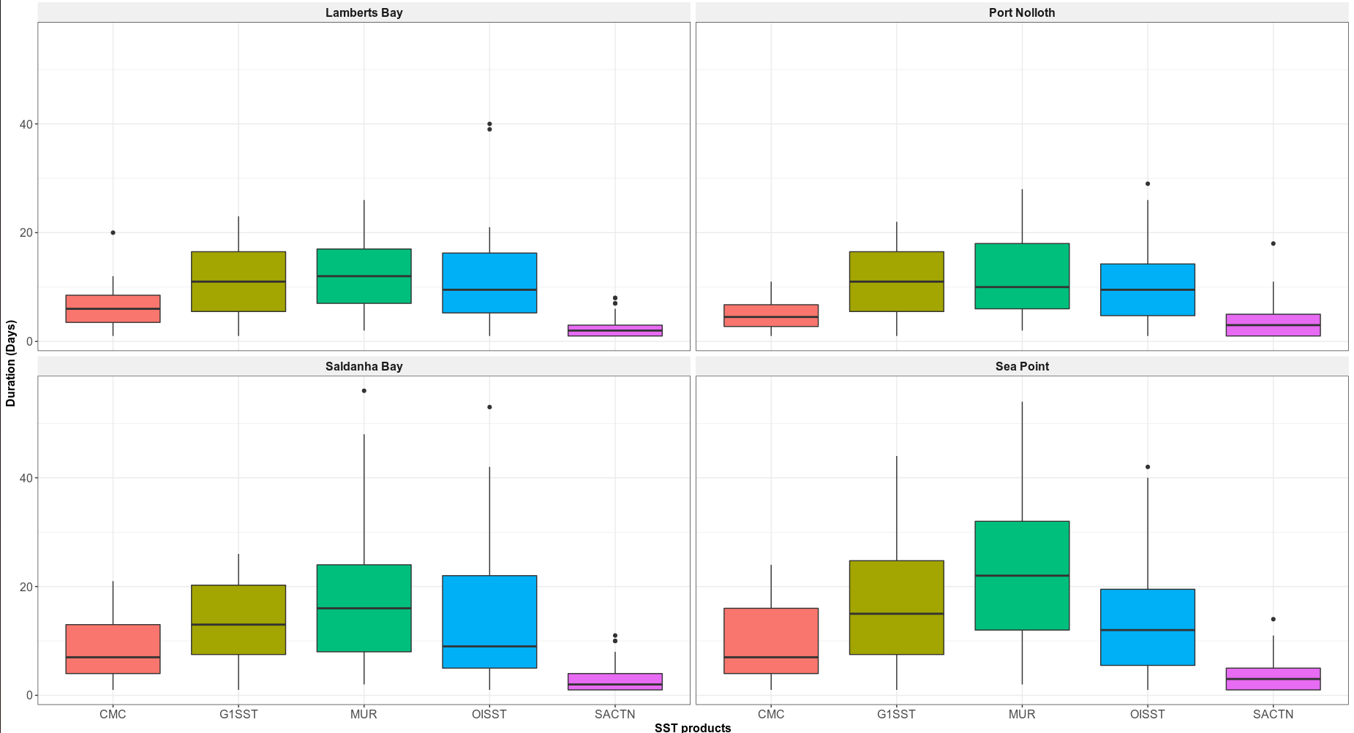
Fig.2. Graph showing the duration for each of the signals detected for the four satellite products and the SACTN in situ collected data for the summer months (December, January and February) over a four year period.

Table 1
A pairwise correlation coefficient of the relationship between the number of signals collected at a distance of 0 km versus a distance of 25 km from the coastline and a correlation between the number of signals at 0 km and 50 km from the coastline.

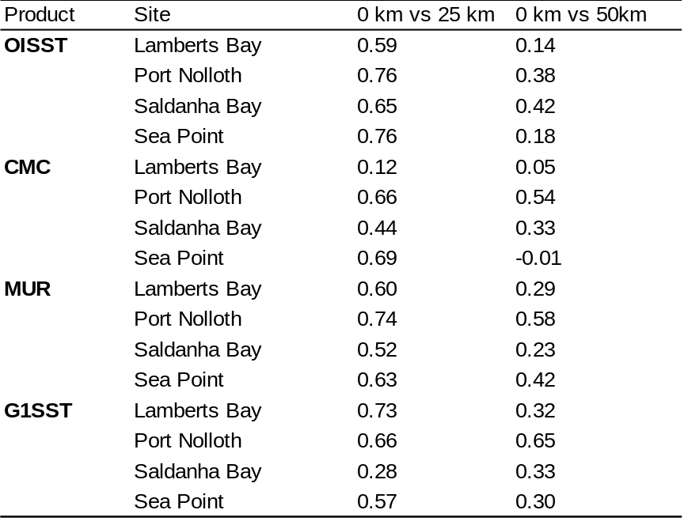

Table 2
The number of upwelling signals detected in each of the SST products. The distance column indicates the various distances from the coastline (0, 25 and 50 km) as seen in Fig.1. The signal column indicates the number of signals detected at each of these distances.

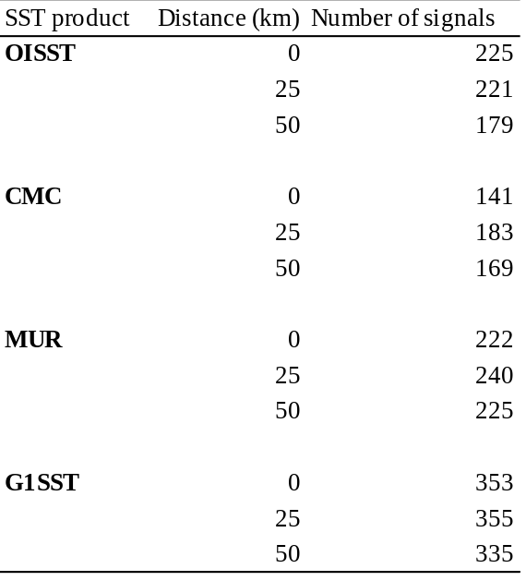

References

Bakun, A. (1990). Global climate change and intensification of coastal ocean upwelling. Science, 247(4939), pp.198-201.

Bakun, A., Field, D. B., Redondo‐Rodriguez, A.N.A. and Weeks, S .J. (2010). Greenhouse gas, upwelling‐favorable winds, and the future of coastal ocean upwelling ecosystems. Global Change Biology, 16(4), pp.1213-1228.

Bakun, A., Black, B. A., Bograd, S. J., Garcia-Reyes, M., Miller, A. J., Rykaczewski, R. R. and Sydeman, W. J. (2015). Anticipated effects of climate change on coastal upwelling ecosystems. Current Climate Change Reports, 1(2), pp.85-93.

Brasnett, B. (200)8. The impact of satellite retrievals in a global sea‐surface‐temperature analysis. Quarterly Journal of the Royal Meteorological Society, 134(636), pp.1745-1760.

Brown, O. B., Brown, J. W. and Evans, R. H. (1985). Calibration of advanced very high resolution radiometer infrared observations. Journal of Geophysical Research: Oceans, 90(C6), pp.11667-11677.

Bulgin, C.E., Embury, O. and Merchant, C. J. (2016). Sampling uncertainty in gridded sea surface temperature products and Advanced Very High Resolution Radiometer (AVHRR) Global Area Coverage (GAC) data. Remote Sensing of Environment, 177, pp.287-294.

Chao, Y., Li, Z., Farrara, J. D. and Hung, P. (2009). Blending sea surface temperatures from multiple satellites and in situ observations for coastal oceans. Journal of atmospheric and oceanic technology, 26(7), pp.1415-1426.

Donlon, C. J., Martin, M., Stark, J., Roberts-Jones, J., Fiedler, E. and Wimmer, W. (2012). The operational sea surface temperature and sea ice analysis (OSTIA) system. Remote Sensing of Environment, 116, pp.140-158.

Fielding, P. J. and Davis, C. L. (1989). Carbon and nitrogen resources available to kelp bed filter feeders in an upwelling environment. Marine Ecology Progress Series, pp.181-189.

Harlass, J., Latif, M. and Park, W. (2015). Improving climate model simulation of tropical Atlantic sea surface temperature: The importance of enhanced vertical atmosphere model resolution. Geophysical Research Letters, 42(7), pp.2401-2408.

HSIEH, W. W. and BOER, G. J. (1992). Global climate change and ocean upwelling. Fisheries Oceanography, 1(4), pp.333-338.

Hutchings, L., Van der Lingen, C. D., Shannon, L. J., Crawford, R. J. M., Verheye, H. M. S., Bartholomae, C. H., Van der Plas, A. K., Louw, D., Kreiner, A., Ostrowski, M. and Fidel, Q. (2009). The Benguela Current: An ecosystem of four components. Progress in Oceanography, 83(1-4), pp.15-32.

Jury, M. R. (1980). Characteristics of summer wind field and air sea interaction over the Cape Peninsula upwelling regions. M.Sc. Thesis. University of Cape Town, South Africa.

Li, A., Bo, Y., Zhu, Y., Guo, P., Bi, J. and He, Y. (2013). Blending multi-resolution satellite sea surface temperature (SST) products using Bayesian maximum entropy method. Remote sensing of environment, 135, pp.52-63.

Lima, F. P. and Wethey, D. S. (2012). Three decades of high-resolution coastal sea surface temperatures reveal more than warming. Nature communications, 3(1), pp.1-13.

Mead, A., Griffiths, C. L., Branch, G. M., McQuaid, C. D., Blamey, L. K., Bolton, J. J., Anderson, R. J., Dufois, F., Rouault, M., Froneman, P. W. and Whitfield, A. K. (2013). Human-mediated drivers of change—impacts on coastal ecosystems and marine biota of South Africa. African Journal of Marine Science, 35(3), pp.403-425.

Mesias, J. M., Bisagni, J. J. and Brunner, A. M. (2007). A high-resolution satellite-derived sea surface temperature climatology for the western North Atlantic Ocean. Continental Shelf Research, 27(2), pp.191-207.

Minnett, P. J. (1991). Consequences of sea surface temperature variability on the validation and applications of satellite measurements. Journal of Geophysical Research: Oceans, 96(C10), pp.18475-18489.

Mote, P. W. and Mantua, N. J. (2002). Coastal upwelling in a warmer future. Geophysical research letters, 29(23), pp.53-1.

Murawski, S. A. (1993). Climate change and marine fish distributions: forecasting from historical analogy. Transactions of the American Fisheries Society, 122(5), pp.647-658.

Parinussa, R. M., de Jeu, R. A., Holmes, T. R. and Walker, J. P. (2008). Comparison of microwave and infrared land surface temperature products over the NAFE'06 research sites. IEEE Geoscience and Remote Sensing Letters, 5(4), pp.783-787.

Pauly, D. and Christensen, V. (1995). Primary production required to sustain global fisheries. Nature, 374(6519), pp.255-257.

Rayner, N. A., Brohan, P., Parker, D. E., Folland, C. K., Kennedy, J. J., Vanicek, M., Ansell, T. J. and Tett, S. F. B. (2006). Improved analyses of changes and uncertainties in sea surface temperature measured in situ since the mid-nineteenth century: The HadSST2 dataset. Journal of Climate, 19(3), pp.446-469.

Reynolds, R. W. and Smith, T. M. (1994). Improved global sea surface temperature analyses using optimum interpolation. Journal of climate, 7(6), pp.929-948.

Reynolds, R. W. and Smith, T. M. (1995). A high-resolution global sea surface temperature climatology. Journal of Climate, 8(6), pp.1571-1583.

Reynolds, R. W., Rayner, N. A., Smith, T. M., Stokes, D. C. and Wang, W. (2002). An improved in situ and satellite SST analysis for climate. Journal of climate, 15(13), pp.1609-1625.

Reynolds, R. W. and Chelton, D. B. (2010). Comparisons of daily sea surface temperature analyses for 2007–08. Journal of climate, 23(13), pp.3545-3562.

Reynolds, R. W., Chelton, D. B., Roberts-Jones, J., Martin, M. J., Menemenlis, D. and Merchant, C. J. (2013). Objective determination of feature resolution in two sea surface temperature analyses. Journal of climate, 26(8), pp.2514-2533.

Ricciardulli, L. and Wentz, F. J. (2004). Uncertainties in sea surface temperature retrievals from space: Comparison of microwave and infrared observations from TRMM. Journal of Geophysical Research: Oceans, 109(C12).

Robinson, I. S., Wells, N. C. and Charnock, H. (1984). The sea surface thermal boundary layer and its relevance to the measurement of sea surface temperature by airborne and spaceborne radiometers. International Journal of Remote Sensing, 5(1), pp.19-45.

Schlegel, R. W. and Smit, A. J. (2016). Climate change in coastal waters: time series properties affecting trend estimation. Journal of Climate, 29(24), pp.9113-9124.
Schlegel, R. W., Oliver, E. C., Perkins-Kirkpatrick, S., Kruger, A. and Smit, A. J. (2017). Predominant atmospheric and oceanic patterns during coastal marine heatwaves. Frontiers in Marine Science, 4, p.323.

Smith, T. M. and Reynolds, R. W. (1998). A high-resolution global sea surface temperature climatology for the 1961–90 base period. Journal of Climate, 11(12), pp.3320-3323.

Smit, A. J., Roberts, M., Anderson, R. J., Dufois, F., Dudley, S. F., Bornman, T. G., Olbers, J. and Bolton, J. J. (2013). A coastal seawater temperature dataset for biogeographical studies: large biases between in situ and remotely-sensed data sets around the coast of South Africa. PLoS One, 8(12).

Wick, G. A., Emery, W. J. and Schluessel, P. (1992). A comprehensive comparison between satellite‐measured skin and multichannel sea surface temperature. Journal of Geophysical Research: Oceans, 97(C4), pp.5569-5595.

