Results

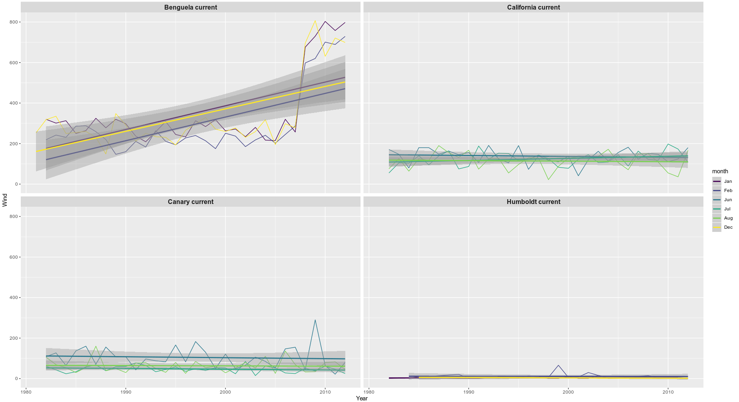

Figure 1: The summer monthly south eastern wind patterns over a 30 year period

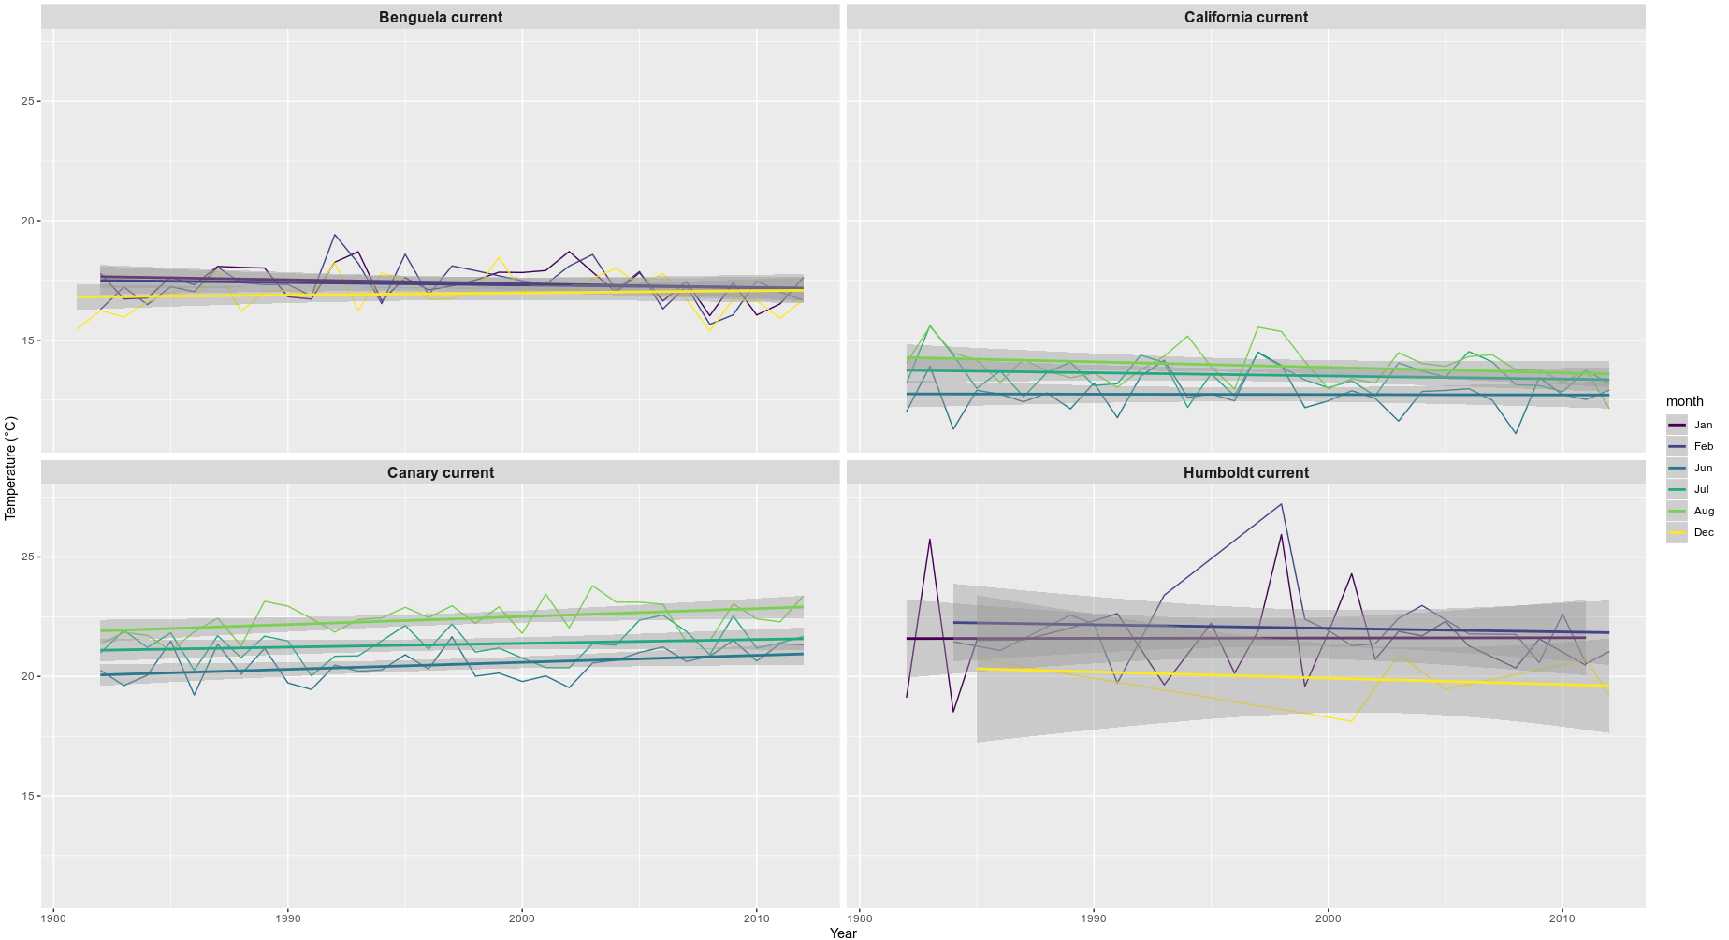
Figure 2: The summer monthly mean temperature patterns over a 30 year period

