Upwelling signals: a comparison of sea surface temperature products in the Benguela
Amieroh Abrahams ^{a,*}, Robert W. Schlegel ^{b} , Albertus J. Smit ª
ªDepartment of Biodiversity and Conservation Biology, University of the Western Cape, Private Bag X17, Bellville 7535, South Africa
^{b}Department of Oceanography, Dalhousie University, Halifax, Canada

Abstract
The importance of coastal upwelling systems is widely recognised. However, several aspects of the current and future behaviours of these systems remain uncertain. Fluctuations in temperature as a consequence of anthropogenic climate change are hypothesised to affect upwelling-favourable winds and coastal upwelling is expected to intensify across all Eastern Boundary Upwelling Systems. In this paper we used sea surface temperature data from five different products of varying resolutions, in conjunction with wind data, to detect and analyse upwelling signals at four sites within the Benguela Upwelling System at varying distances from the coastline. We found that upwelling signals were not uniformly detected across the five products for each of the four sites and that the durations of those signals were longer when using SST data products with higher spatial resolutions. Moreover, the high-resolution data products were significantly more likely to display upwelling signals at a distance of 25 km away from the coastline when signals were also detected at shoreline. Our findings promote the viability of SST and wind time series data towards detecting upwelling signals within coastal upwelling systems. However, our results also highlight the importance of high-resolution data products to improve the accuracy of such estimates. This study represents an important step towards the development of a novel method for predicting the behaviours of coastal upwelling systems.
Keywords: Seawater temperature, coastal regions, code: R, upwelling

2.1. Introduction
Sea surface temperature (SST) is regarded as one of the most important variables in the coupled ocean-atmosphere systems, and is a particularly useful research tool in the scientific fields of meteorology and oceanography (Mesias et al., 2007; Harlass et al., 2015). For over 150 years, SST data have been collected using in situ measurement techniques (Rayner et al., 2003) with satellite measurements of SST being available since the 1970s (Reynolds et al., 2013). Over the past decade, techniques have been developed to allow the assimilation and blending of different SST datasets from various in situ and satellite platforms. These are referred to as the Level-3 and Level-4 high resolution gap-free products. Previous studies demonstrated that satellite-based SST data are less accurate than in situ data due to the complexity of the oceanic and atmospheric conditions that need to be accounted for in deriving satellite SST products (Robinson et al., 1984; Brown et al., 1985; Minnett, 1991; Smit et al., 2013). The reason for this is that the sensors only ‘look’ at a restricted portion of the ocean for several minutes at a time; the exception being of-course, geo-stationary satellites like the POES (polar orbiting environmental satellite). These errors vary both regionally and temporally (Wick et al., 1992). In comparison to in situ SST measurements collected from ships or buoys, a major advantage of satellite SST is their global coverage and near real time availability. SST datasets with a high level of accuracy, spatial completeness, and fine-scale resolution are necessary for weather and climate forecasting and are of great importance for reliable climate change monitoring (Reynolds and Smith, 1995; Smith et al., 1998; Reynolds and Smith, 2002; Chao et al., 2009).
Long-term SST data have been obtained from two kinds of satellite remote sensors. Thermal infrared (TIR) and microwave (MW) sensors have different weather sensitivity characteristics and accuracies (Li et al., 2013). TIR SST products are available from the 1970s and may have a spatial resolution as fine as approximately a 4 km grid; however, they are affected by the presence of clouds and other aerosols in the atmosphere, which is known to result in spatial discontinuity. MW SST products have a lower resolution than TIR SSTs at approximately a 25 km grid, leading to a much lower accuracy near coastlines (Parinussa et al., 2008; Li et al., 2013). By combining these different types of SST products, it is possible to take advantage of the strengths within both, and each sensor type can help produce an SST dataset with more spatial and temporal coverage and higher resolution.
For many applications, SST data are not used or provided at the full resolution of the sensors, but are averaged over defined areas in order to produce a gridded product (Reynolds et al., 2002; Bulgin et al., 2016). Gridding in this way destroys more detailed information and as a result a gridded SST measurement is taken as an estimate of the average SST across a specific grid cell over a certain time period. Spatial sampling uncertainty and temporal averaging is present in gridded products as the full gridded cell is often not being observed as a result of interference due to the presence of clouds or aerosols, as previously mentioned. In existing daily global SST analysis products, typical grid resolution ranges from 0.05° × 0.05° to 0.25° × 0.25°, or from approximately 5 to 25 km (e.g., Reynolds and Smith, 1994; Brasnett, 2008; Donlon et al., 2012). Small-scale features can evolve during the course of the day, but the sensor sampling during this time is not dense enough for the sub-daily global analyses at a high spatial resolution (Reynolds and Chelton, 2010; Reynolds et al., 2013). Furthermore, considering that the satellites are passing overhead only once every ~24 hours, images are only captured at very specific times during the day. To capture these small-scale features in a gridded analysis, it is suggested that the development of an improved analysis would have high resolution at small-scale features in regions of good coverage and lower resolution in areas of poor coverage (Reynolds et al., 2013).
Eastern Boundary Upwelling Systems (EBUS) are characterised as vast regions of coastal ocean occurring along the western shores of continents bordering the Pacific and Atlantic Oceans (Bakun, 1990; Pauly and Christensen, 1995; Bakun et al., 2010; Bakun et al., 2015). Coastal upwelling associated with EBUS is known to have a large influence on the associated ecosystem’s primary productivity, and hence the abundance, diversity, distribution and production of marine organisms at all trophic levels (Bakun et al., 2010; 2015). The upwelling process is also hypothesised to be strongly affected by anthropogenic climate change. According to the ‘Bakun hypothesis,’ an increase in greenhouse gases will result in an increase in day-time warming and night-time cooling and ultimately cause an increase in temperature gradients which will form stronger atmospheric pressure gradients (Bakun, 1990). These pressure gradients modulate the winds which ultimately affect the intensity and duraThe BUS is one of the four major Eastern Boundary Upwelling Systems (EBUS) (Bakun et al., 2015). EBUS are characterised as vast regions of coastal ocean occurring along the western shores of continents bordering the Pacific and Atlantic Oceans (Bakun, 1990; Pauly and Christensen, 1995; Bakun et al., 2010; Bakun et al., 2015). Coastal upwelling associated with EBUS is known to have a large influence on the associated ecosystem’s primary productivity, and hence the abundance, diversity, distribution and production of marine organisms at all trophic levels (Bakun et al., 2010; 2015). The upwelling process is also hypothesised to be strongly affected by anthropogenic climate change. According to the ‘Bakun hypothesis,’ an increase in greenhouse gases will result in an increase in day-time warming and night-time cooling and ultimately cause an increase in temperature gradients which will form stronger atmospheric pressure gradients (Bakun, 1990). These pressure gradients modulate the winds which ultimately affect the intensity and duration of upwelling (Hsieh and Boer, 1992; Bakun et al., 2010; Lima and Wethey, 2012; Mote and Mantua, 2002). Since changes in SST indirectly affect coastal communities, and have considerable, often far-reaching economic impacts (Murawski, 1993; Bakun et al., 2010), this work could be of great importance to our understanding of how climatic change might affect EBUS in decades to come.tion of upwelling (Hsieh and Boer, 1992; Bakun et al., 2010; Lima and Wethey, 2012; Mote and Mantua, 2002). Because changes in SST indirectly affect coastal communities, and have considerable, often far-reaching economic impacts (Murawski, 1993; Bakun et al., 2010), a better understanding of which SST products can most accurately detect upwelling will be important for any studies looking to identify and understand long-term changes to upwelling signals in EBUS. .
In order to assess the suitability of a range of SST products for the detection of upwelling signals, this study aimed to observe patterns and trends in upwelling signals in the Benguela upwelling system (BUS) across a range of localities and spatial scales off the South African West Coast. We selected an upwelling system for this study because this physical process provides a strong signal of increasing and decreasing SST that is strongly localised to known centres of upwelling, and which relates to the coastal wind field that drives the offshore advection of water mass. Here, a unique method for identifying upwelling signals was used. This method made use of wind variables as seen in Fielding and Davis (1989), but also applied a novel upwelling signal detection method to SST, which allowed for a more accurate identification of upwelling. Because upwelling is such a well characterised oceanographic process, the resultant fluctuating SST signal should be observed across independent SST products. Here we assess blended SST products covering a range of spatial grid resolutions from 0.05° × 0.05° to 0.25° × 0.25°. We hypothesised that the higher resolution data should have a better fidelity at detecting these upwelling signals, some of which might only be confined to smaller spatial scales or localised closer to the shore.

2.2. Methods

2.2.1. Site Selection
The western region of the South African coastline is dominated by the Benguela Current, which forms the foundation of an Eastern Boundary Upwelling System (EBUS) (Hutchings et al., 2009), and it provides a natural laboratory for this study. Annual mean coastal seawater temperatures within this region have a range of 12.3 ± 1.2°C at the western limit near the Namibian border. Seasonal upwelling is controlled by south-easterly trade winds, with intense upwelling occurring throughout the summer months. This creates distinct temperature variations with much lower temperatures within the upwelling cells over a fairly narrow continental shelf found from the Cape Peninsula to Cape Columbine. In order to examine upwelling patterns at different distances from the coastline within the southern Benguela region, several sites from the SACTN dataset (Schlegel and Smit, 2016; Schlegel et al., 2017) along the west coast of South Africa were selected. The main objective of this study was to identify upwelling signals with a variety of data products. This involved four separate SST products that covered a time period of four years. To assess upwelling metrics within the BUS four sites were selected as points of comparison. Each site was situated along the West Coast of South Africa at various distances from the upwelling centre of the BUS (Figure 1).
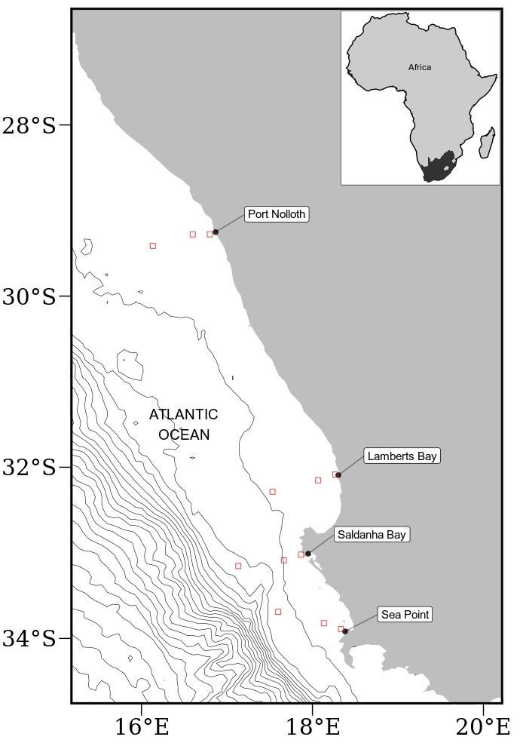

Figure 1: Map of southern Africa showing and coastal bathymetry. The black points represent the location of the in situ temperature sites and the empty red boxes show the pixels used along the shore normal transect from the satellite sea surface temperatures (SST) time series. The red boxes are at 0 km, 25 km and 50 km from the coastline.

2.2.2 Datasets
This study uses four Level-4 remotely sensed temperature datasets compiled by a number of organisations. The AVHRR-only (Advanced Very High-Resolution Radiometer) Optimally-Interpolated Sea Surface Temperature (OISST) dataset has been providing global SSTs for nearly four decades (Reynolds and Smith, 1994). OISST is a global 0.25° × 0.25° gridded daily SST product that assimilates both remotely sensed and in situ sources of data to create a gap free product (Banzon et al., 2016). The version 3.0 Group for High Resolution Sea Surface Temperature (GHRSST) product has a 0.2° × 0.2° global grid resolution and is constructed by the Canadian Meteorological Center (CMC). It combines infrared satellite SST at numerous points in the time series from the AVHRR, the European Meteorological Operational-A (METOP-A) and Operational-B (METOP-B) platforms, as well as the microwave SST data from the Advanced Microwave Scanning Radiometer 2 in conjunction with in situ observations of SST from ships and buoys from the ICOADS program. The Multi-scale Ultra-high Resolution (MUR) SST Analysis is produced using satellite instruments with datasets spanning 1 June 2002 to present times. MUR provides SST data at a spatial resolution of 0.01° × 0.01° and is currently among the highest resolution SST datasets available. The final dataset used is the GHRSST analysis produced daily using a multi-scale two-dimensional variational (MS-2DVAR) blending algorithm on a global 0.01° grid known as G1SST. This product uses satellite data from a variety of sensors, such as AVHRR, the Advanced Along Track Scanning Radiometer (AATSR), the Spinning Enhanced Visible and Infrared Imager (SEVIRI), the Moderate Resolution Imaging Spectroradiometer (MODIS), and in situ data from drifting and moored buoys. We see that not all products are completely independent as they share the use of AVHRR SST data, but the amount of subsequent blending, the incorporation of other SST data sources, the different blending and interpolation approaches used, and the differing final grid resolutions make them acceptably different for this study.
Additionally, this study uses the South African Coastal Temperature Network (SACTN) dataset for its in situ temperature records. This dataset consists of coastal seawater temperatures obtained from 129 sites along the South African coastline, measured daily from 1972 until 2017 (Schlegel and Smit, 2016; Schlegel et al., 2017). Of these, 80 were measured using hand-held thermometers and the remaining 45 were measured using underwater temperature recorders (UTRs). For this analysis, the data were combined and formatted into standardized comma separated values (CSV) files which allowed for a fixed methodology to be used across the entire dataset.
An advantage to using in situ data over satellite data is that they may provide a more accurate representation of the thermal properties closer to the coast, whereas satellite data often fail to accurately capture and represent temperature properties within the same spatial context. The result is that in situ data can more accurately explain upwelling signals within the coastal inshore environment. Further, evidence by Smit et al. (2013) has shown that satellite data along the South African coastline may have a warm bias as high as 6 °C greater than in situ temperatures within the nearshore environment. In order to create a time series of each of the remotely sensed SST data products, shore-normal transects of all Level-4 products were extended at west coast stations where the in-situ data in the SACTN database were available. Time series of SSTs were extracted at 0, 25 and 50 km along these shore-normal transects from the coast Figure 1.

2.2.3 Wind data
Wind data were obtained from the South African Weather Service (SAWS), and were provided at three-hour resolutions. Specific wind characteristics were measured, namely, wind direction (dirw) and wind speed (spw). Wind was an important variable for this study as wind direction and wind speed have a direct influence on the intensity and duration of upwelling, consequently, wind data collected from 1989-01-01 to present were investigated for their relationship with upwelling at the sites for which SST time series were extracted.

2.2.4 Defining and determining upwelling
In order to detect and analyse upwelling signals at four sites within the BUS, it was first necessary to define when upwelling was occurring; however, to accomplish this a set of threshold values for identifying when the phenomenon was taking place was required. Given that upwelling is primarily caused by alongshore, equatorward winds, both SST and wind data were used. The wind data were used to inform an upwelling index calculated using the formula presented in the work by Fielding and Davis (1989):
upwelling index = μ(cosθ − 160)
where μ represents the wind speed (m/s), θ represents the wind direction in degrees, and 160 is the orientation of the west coast (Jury 1980). The index relies heavily on wind speed and direction data in order to identify the presence and intensity of upwelling. The above equation produces a value called the upwelling index. An upwelling index < 0 represents downwelling whilst an upwelling index > 0 represents upwelling (Fielding and Davis, 1989). When the upwelling index is greater than 0, SSTs usually drop, as expected, suggesting that upwelling is occurring. It was found that the drop in SST that coincided with a positive upwelling index was close to the seasonally varying 25th percentile threshold for SST, so this threshold temperature was used in combination with the upwelling index to identify when upwelling may be occurring. With the threshold set for which temperatures may qualify as an upwelling signal it was then necessary to identify the number of consecutive days that must be exceeded for an upwelling signal to qualify as a discrete event. Here it must be noted that upwelling is known to vary on a seasonal basis and may also occur hourly (sub-daily). Therefore, the minimum duration for the classification of an upwelling signal was set as one day, the rationale being that data from the SACTN dataset as well as the satellite remotely sensed SST data are collected only at a daily resolution, preventing a temporally finer definition. With the upwelling index, temperature threshold, and duration for an upwelling signal established, the detect_event() function from the heatwaveR package (Schlegel and Smit, 2018) was used to calculate metrics for the upwelling signals. Because upwelling signals were calculated relative to percentile exceedances, rather than an absolute definition such as temperatures below a fixed temperature threshold, upwelling signals could occur any time of the year; however, upwelling was shown to be more dominant during summer months (December, January and February), as expected. This method of determining upwelling signals is unique as it considers both SST and wind pattern, and provides us with a descriptive statistical output of each of the signals detected (Table 1).
Table 1: Metrics of upwelling signals and their descriptions.

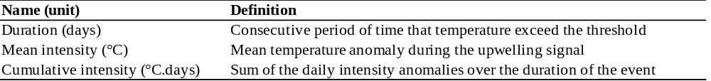
ANOVAs were used to compare the upwelling metrics such as duration, intensity, and cumulative intensity against the main effects: site, product and distance. Upwelling metrics as a function of satellite product type was assessed using product as main effect, and nesting distance within site. To establish whether differences existed between sites or distances from the shore, the upwelling metrics were assessed as a function of site or distance, independently for each satellite. Restrictions to experimental design prevented testing interaction effects within product types. In the analysis the relationship between the SST products across the various selected study sites were established; factors used to correlate these relationships included duration and the number of signals detected. These analyses sought to test if significant differences occurred between sites and data products. A Pearson Product Moment correlation was used to identify if the same upwelling signal detected at a distance of 0 km from the coastline would be visible at a distance of 25 km from the coastline and similarly if the same upwelling signal could be observed when comparing at a distance of 0 and 50 km from the shore. The signals were classified by start and end date and within the same data product. Thereafter, the average numbers of upwelling signals detected by each individual data product across all sites were compared using an ANOVA test.

2.3. Results
A one-way ANOVA indicated no significant difference in upwelling duration between sites within the South African portion of the BUS as detected in the CMC (d.f. = 3, F = 0.88, p > 0.05) and OISST (d.f. = 3, F = 0.76, p > 0.05) (Figure 2) products. However, a significant difference was found between the G1SST (d.f. = 3, F = 3.46, p < 0.05), MUR (d.f. = 3, F = 4.45, p < 0.005) and SACTN (d.f. = 3, F = 3.61, p < 0.01) data products. The Sea Point site had the longest mean duration of upwelling signals detected. Lamberts Bay and Port Nolloth had the shortest duration of upwelling signals detected. Particularly, Lamberts Bay in the SACTN data product yield the shortest duration of upwelling signals.
A significant difference was found in upwelling mean intensity between sites in the CMC (d.f. = 3, F = 5.29, p < 0.001), OISST (d.f. = 3, F = 7.56, p < 0.001) and SACTN (d.f. = 3, F = 17.82, p < 0.001) products. However, no significant difference was found in the G1SST (d.f. = 3, F = 2.01, p > 0.05) and MUR (d.f. = 3, F = 1.38, p < 0.05) products (Figure 2). Sea Point represents the highest mean intensity of upwelling signals collected among all of the remotely sensed SST. Differences in means were present across data products at each site individually but were consistent across sites (i.e. each data product detected a similar means at each of the respective sites.
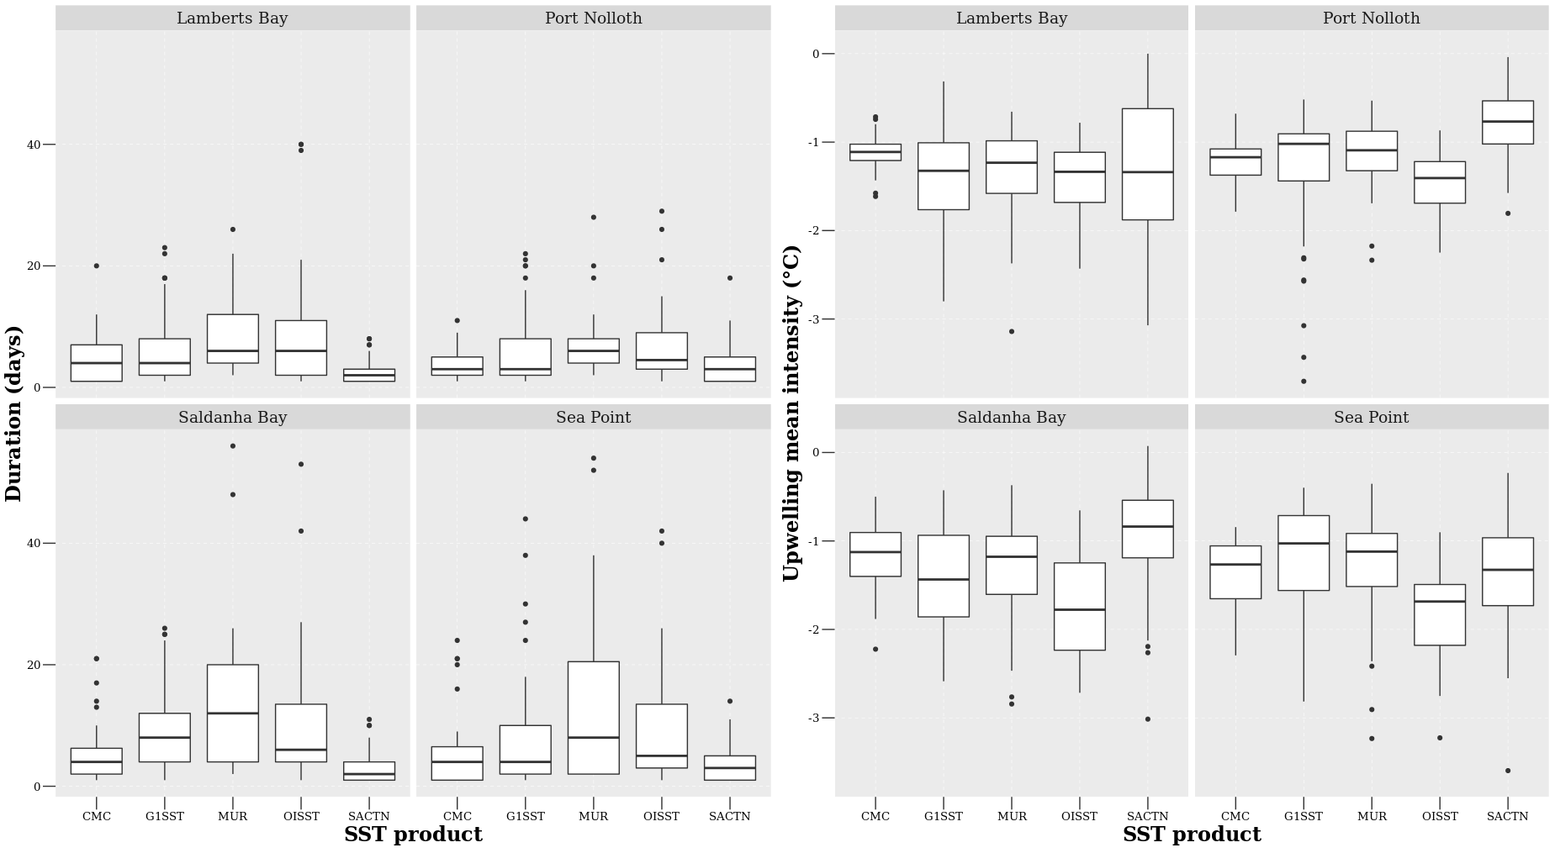
Figure 2: The upwelling duration and mean intensity for each of the signals detected for the four satellite products and the SACTN in situ collected data during summer months (December, January and February), over a four-year period.
There was no significant difference in upwelling cumulative intensity between sites within the South African portion of the BUS as detected in the CMC (d.f. = 3, F = 1.23, p = 0.3) and OISST (d.f. = 3, F = 1.54, p > 0.05) data product (Figure 3). A significant difference in cumulative intensity of upwelling signals was found in the G1SST (d.f. = 3, F = 2.96, p < 0.05), MUR (d.f. = 3, F = 3.81, p < 0.01) and SACTN (d.f. = 3, F = 9.44, p < 0.001) data products during the summer season. The cumulative intensity of upwelling signals is most intense in Saldanha Bay and Sea Point for the MUR, G1SST and OISST products. The cumulative intensity from sites within the SACTN data product were the lowest.
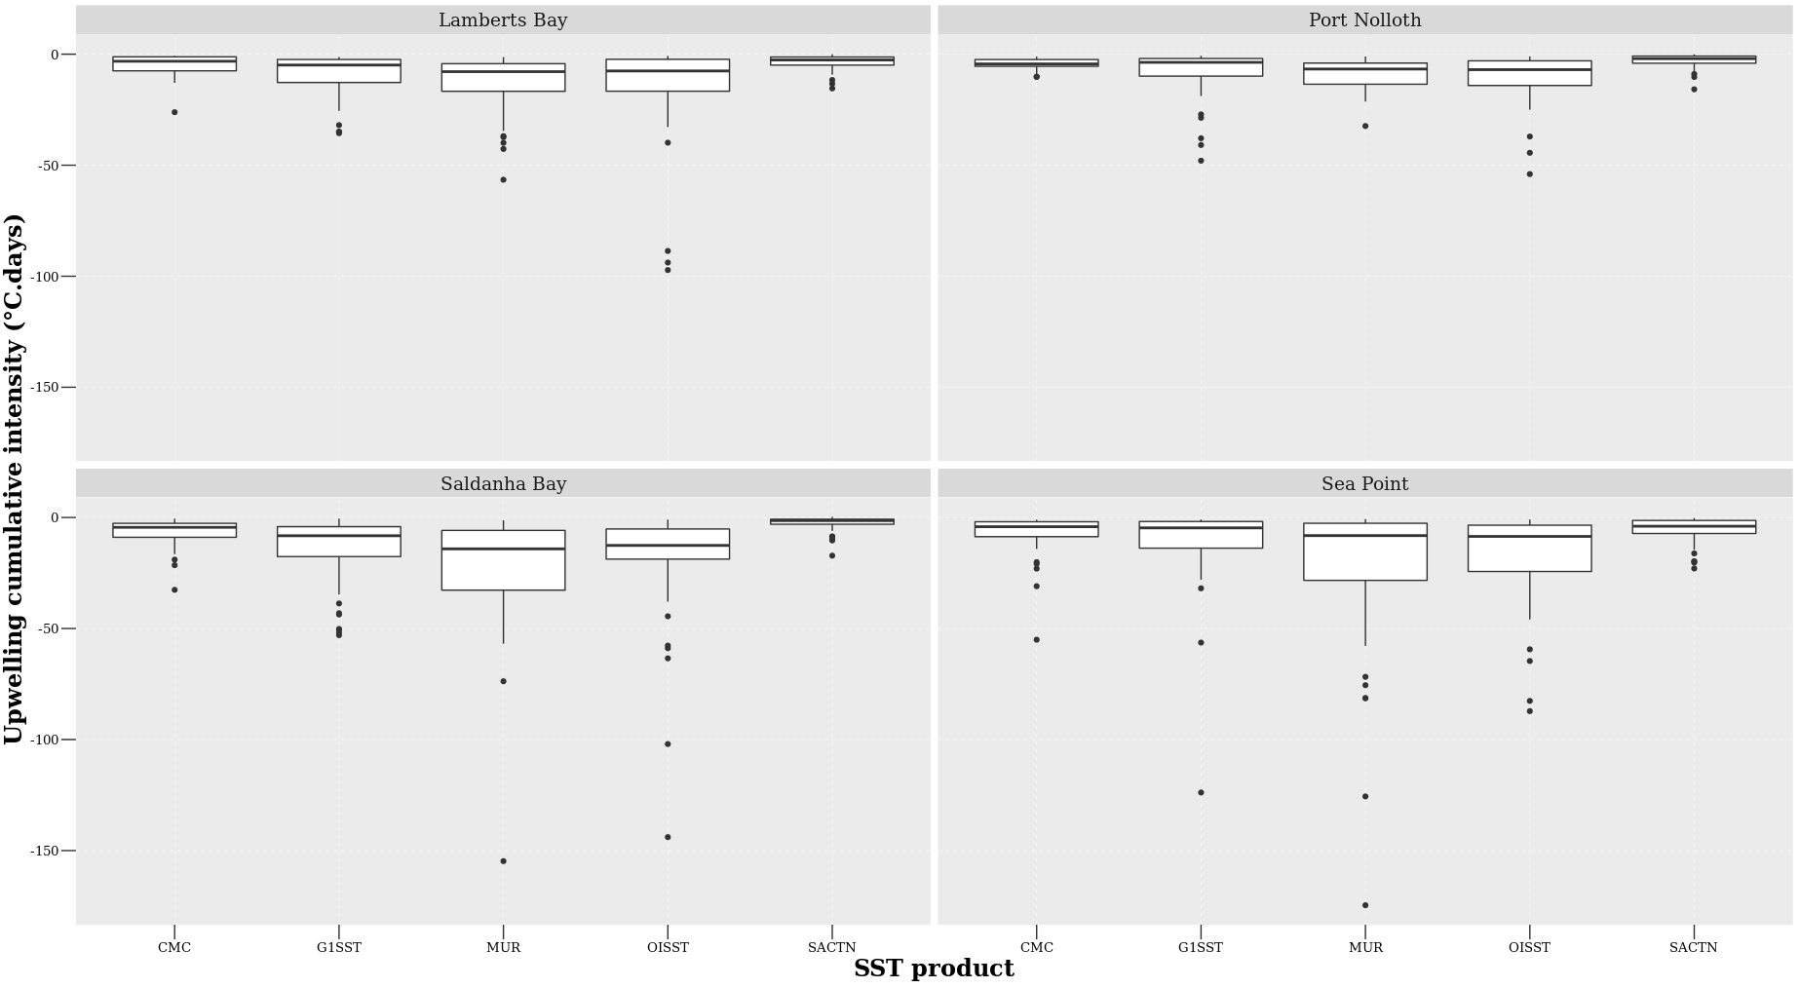
Figure 3: The upwelling cumulative intensity for each of the signals detected for the four satellite products and the SACTN in situ collected data during summer months (December, January and February), over a four-year period.
An ANOVA showed that no significant difference exist in the duration of upwelling signals detected at different distances from the shore during the summer season in the CMC (d.f. = 2, F = 0.86, p > 0.04), G1SST (d.f. = 2, F = 0.59, p > 0.05), MUR (d.f. = 2, F = 2.29, p > 0.05) and OISST data (d.f. = 2, F = 1.61, p > 0.05) products. The MUR and G1SST often detected the longest duration of upwelling signals at a distance of 0 and 25 km from the shore (Figure 4).
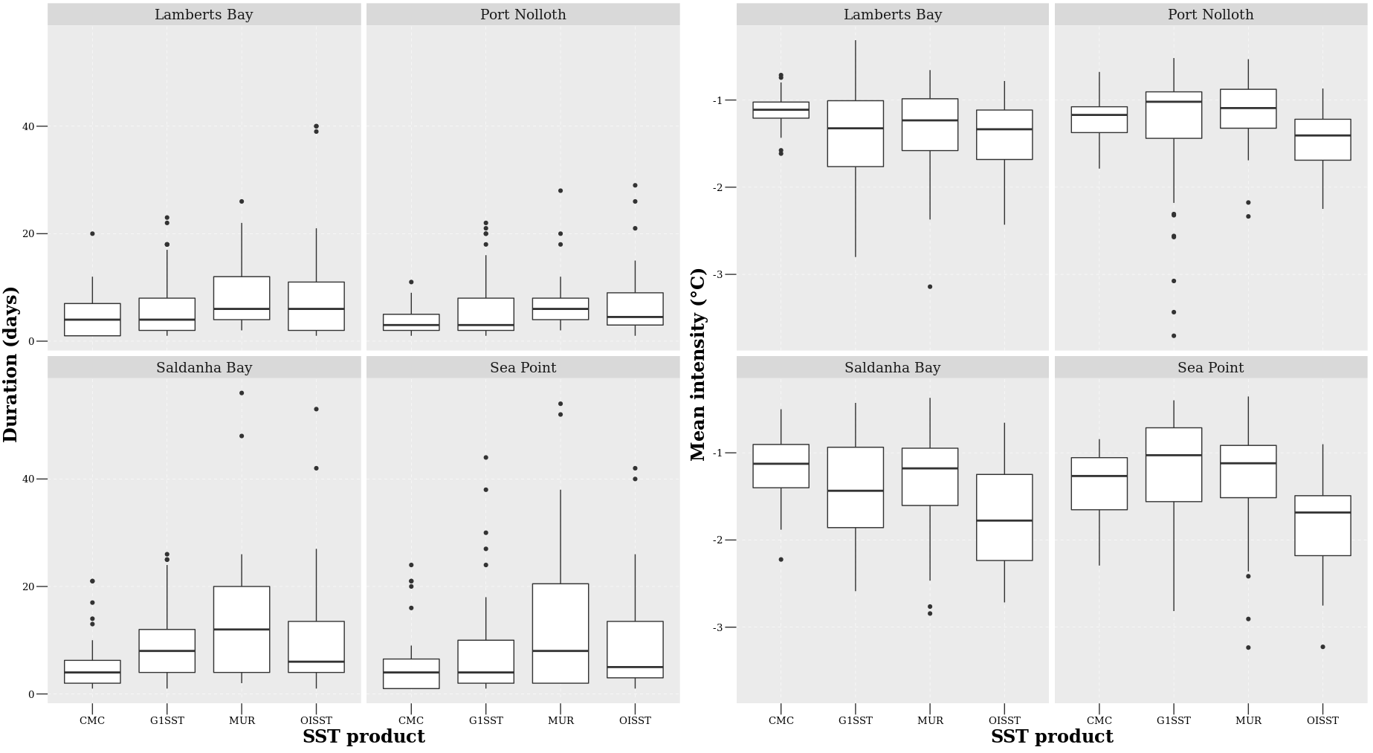
Figure 4: The duration and mean intensity for each of the signals detected at the various distances from the shore for the four satellite products during summer months (December, January and February), over a four-year period.
Significant difference in the mean intensity of upwelling signals were detected at different distances in all of the remotely sensed SST products. CMC (d.f. = 2, F = 2.89, p < 0.05), G1SST (d.f. = 2, F = 25.71, p < 0.001), MUR (d.f = 2, F = 21.74, p < 0.001) and OISST (d.f. = 2, F = 6.68, p < 0.001). MUR and G1SST products recorded the highest mean intensity of upwelling signals at a distance of 0 km from the shore (Figure 5). The mean intensity of upwelling decreased further away from the shore in all of the SST products.

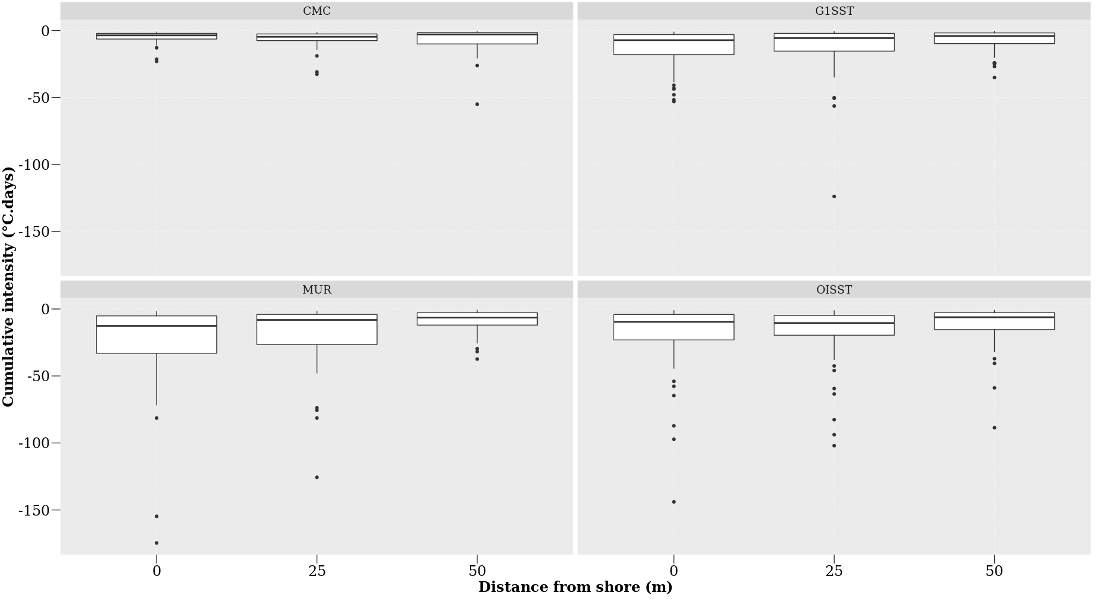
Figure 5: The cumulative intensity for each of the signals detected for the four satellite products during summer months (December, January and February), over a four-year period.
A one-way ANOVA showed a significant difference in the cumulative intensity of upwelling signals detected at different distances from the shore in the G1SST (d.f. = 2, F = 5.46, p < 0.005) and MUR (d.f. = 2, F = 6.42, p < 0.005) data products. (Figure 6). However, the CMC (d.f. = 2, F = 0.93, p > 0.05) and OISST (d.f. = 2, F = 2.19, p > 0.05) products showed no significant difference in cumulative intensity of upwelling signals detected. The MUR and OISST product observed the highest cumulative intensity at a distance of 0 km from the coastline, this intensity decreases further away from the coastline. The cumulative intensity of upwelling signals for all product decreased further from the shore. A nested ANOVA (Figure 6) showed that there is a significant difference in the duration of upwelling signals detected amongst the data products (nested ANOVA, d.f. = 3, F = 13.43, p < 0.001). The MUR product had the longest duration of upwelling signals while the CMC products had the shortest.

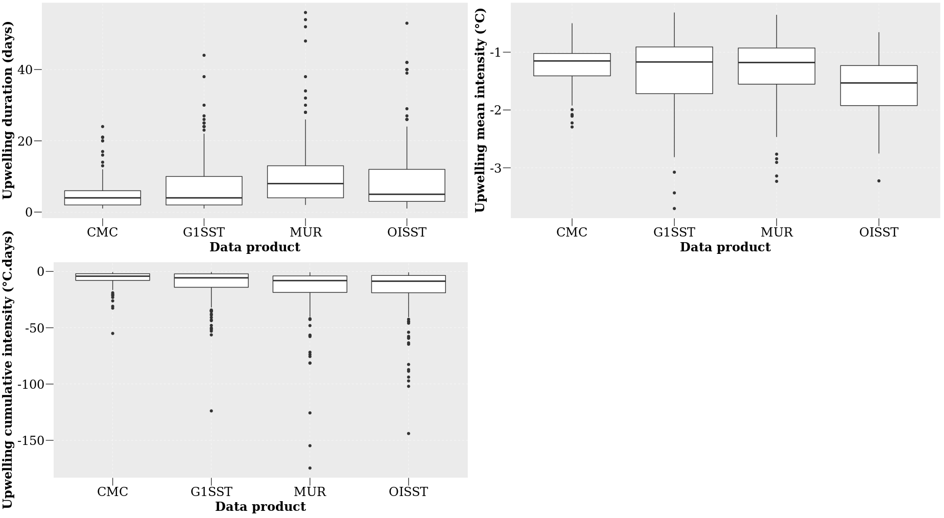
Figure 6: The duration, mean intensity and cumulative intensity of upwelling signals detected for the four satellite products at the different distances from the shore during summer months (December, January and February), over a four-year period.
The ANOVA analysis suggests (Figure 6) that there is a significant difference in the mean intensity of upwelling signals detected between the data products of variable resolution (nested ANOVA, d.f. = 3, F = 19.84, p < 0.001). The G1SST and MUR data products represented the highest mean intensity while CMC represented the lowest mean intensity of upwelling signals. I found (Figure 6) that there is a significant difference in the cumulative intensity of upwelling signals detected between the data products of variable resolution (nested ANOVA, d.f. = 3, F = 14.12, p < 0.001). The MUR SST product presented the highest cumulative intensity of upwelling signals and the CMC data represents the lowest cumulative intensity of upwelling signals detected.
Pearson correlation analyses revealed that the possibility of observing the same upwelling signal detected at 0 km from the coast, at 25 km and at 50 km from the coast respectively varied across the individual data products at each of the four sites (Table 2). Overall, it was found that upwelling signals occurred simultaneously at 0 ﻿km and at 25 km considerably more frequently than between 0 km and 50 km from the coastline. In addition, the likelihood of detecting upwelling signals at 50 km from the coastline were notably lower throughout all pairwise comparisons, apart from signals detected at Port Nolloth, using the CMC, MUR, and G1SST products.
Table 2: A Pearson correlation of the relationship between the number of signals detected at a distance of 0 km versus a distance of 25 km and between the number of signals at 0 km and 50 km.
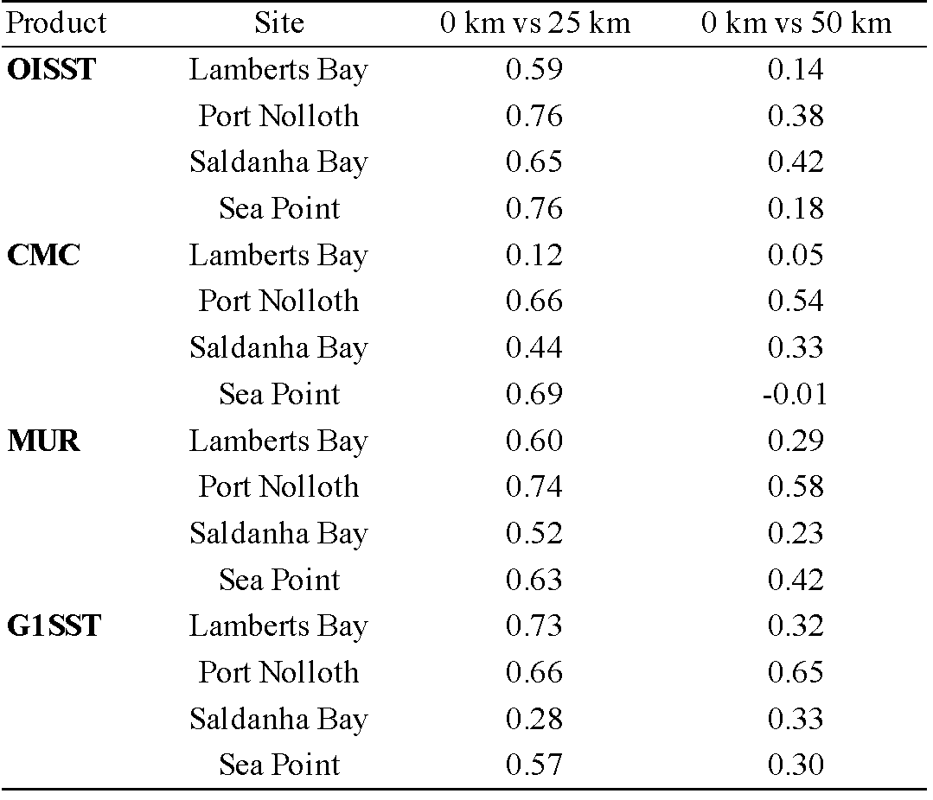

The individual data products displayed different numbers of upwelling signals at distances of 0 km, 25 km, and 50 km from the coastline (Figure 7). There was no significant difference between the number of upwelling signals collected at the different sites (one-way ANOVA: F = 2.27, d.f = 3, SS = 2664, p > 0.05). However, there was a significant difference in the number of signals detected between products (F = 53.53, d.f = 3, SS = 13740, p < 0.001) and at different distances from the coastline (F = 0.75, d.f = 2, SS = 129, p > 0.05).
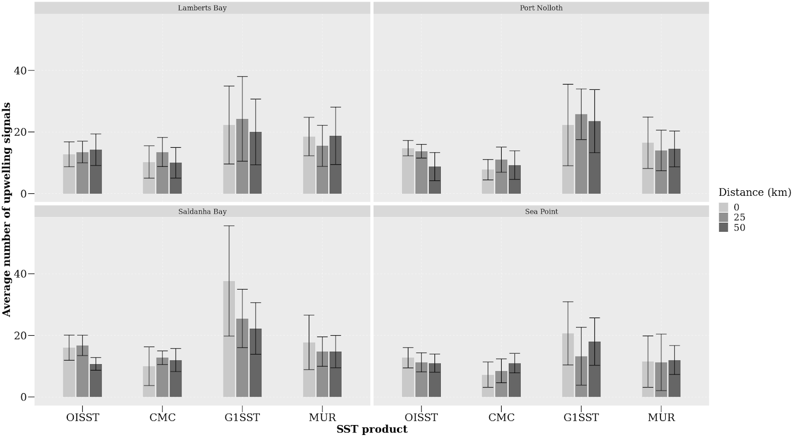
Figure 7: The average number of the signals detected at each site for the various satellite products from 2011 to 2014.

2.4. Discussion

2.4.1 Data products
The analyses in this paper showed that dissimilarities exist between products and sites when comparing the upwelling metrics. It was reported here that the highest resolution data, MUR and G1SST, which are available on a 0.01° grid, yielded the longest duration and cumulative intensity of upwelling signals compared to the coarser resolution data products. The MUR product, in particular, consistently yielded upwelling signals of the greatest intensity. Upwelling signals were most intense at the shore in all of the SST products. Analyses of the CMC, OISST and SACTN datasets revealed that recorded signals did not often exceed a duration of 10 days, whereas in MUR and G1SST the signals were detected for up to 14 days and even longer in some rare cases. Moreover, most of the signals detected in CMC, OISST and SACTN products only lasted for three days. This was similar for the higher resolution data products (G1SST and MUR) which also showed a high prevalence of signals lasting for just four days. In most cases, the number of signals detected at 0 km was higher than the number of signals detected at 50 km for the data products with the highest resolution. There was also a difference in mean intensity between products and distances from the site. The highest number of signals detected was recorded in the MUR and G1SST products.
Gridded datasets obtained from satellite imagery have provided an important understanding of offshore oceanographic processes and are reliable as they are usually spatially complete. However, coastal features such as upwelling cells are often smaller than the highest resolution of most SST products. In this study, estimates of upwelling duration, mean intensity and cumulative intensity (Table 1) may have been overestimated from data collected by the MUR and G1SST data products. These products are more likely to be susceptible to errors relating to limitations and data collection biases associated with satellite-derived sampling (Ricciardulli and Wentz, 2004; Liu et al, 2016), such as cases where there are large gaps within datasets that may have been caused by cloud cover or precipitation. These gaps are typically inferred from algorithms using past and forecasted data entries as well as data from nearby pixels which do not always reflect on real world patterns. For example, if upwelling signals were detected in an area that experienced extensive cloud cover over several weeks, the algorithm may suggest that upwelling continued throughout that period which may not have been the case. However, datasets constructed from multiple data sources, particularly from ships and buoys, are inherently more reliable in terms of reducing the frequency of falsely detecting signals as in situ help to prevent the SST algorithm from making interpolations away from reality (Smith and Reynolds, 2005; Kennedy et al., 2011). The overestimated data may be due to errors from different sources which are produced at each of the successive data processing level (Liu et al, 2016). For example, the Level 0 products (digitised detector output) to Level 4 products (bias corrected, geo-located, gridded, and gap-free SSTs). The SST accuracy refers to the retrieval error produced at Level 2 (derived SSTs at pixel bases), but Level 3 (binned, gridded and averaged Level 2 values) and Level 4 fields are extensively used in climate and modeling studies, mainly because of the desirable features of being “gridded and gap-free” (Liu et al, 2016). Another reason for this could be as a result of sampling error caused by incomplete coverage of satellite measurements. This incomplete coverage may be due to the presence of clouds causing gaps in the sampling of SST. Cloudy pixels rejected by SST cloud masks constitute up to 90% of the total sampled pixels (Liu et al, 2016) and because of gaps between successive swaths of some sensors which may cause sampling errors.
It is important to note that the data sources are intrinsically different in the ways in which they were obtained or recorded. Consequently, discrepancies between datasets are to be expected. For example, the SACTN in situ collected SST product will reflect the actual temperature of the water being measured but instrumental differences when using a thermometer or an electronic sensor will result in inconsistencies. This is particularly prevalent because satellite temperatures are collected remotely and sensors do not make contact with the water. Here, properties of infrared (IR) and microwave (MW) are related through complex algorithms to temperature (Minnett et al., 2002). Smit et al. (2013) showed that warm and cold biases exist along the southern and western coastal region of South Africa, and the juncture between upwelling and non-upwelling regions have a tendency to influence the variability and magnitude of the SST bias. When comparing SST products, a small bias is always likely to be present because of cloud cover and wind strength (Dufois et al., 2012). Overall, the different data products compared within this study yielded different results. While flagging techniques are supposed to occasionally flag good values (Kilpatrick et al., 2001), it was found that flagging may occasionally be too vigorous for EBUS (Dufois et al., 2012). For example, the flagging method used on an OISST reference test induces warm coastal bias in data from both the MUR and G1SST data during summer. It should be noted that this phenomenon can be explained by strong coastal SST gradients in these upwelling regions. Differences in observations of upwelling events between data products at different sites, and at various distances from the coastlines can be attributed to several facets relating to the measurement protocols of each product. For example, differences in algorithms, components, and resolutions are contributed to the variable observation. Pixel-based atmospheric corrections developed for oceanic applications often fail or are in appropriate at the coast, and flagging techniques used to de-cloud data are also know to reduce strong biases at a monthly scale with strong horizontal SST gradients especially in upwelling systems. Missing pixels at the land/sea edge or ‘land bleed’—i.e. pixels not flagged as missing but which are influenced by land temperatures ‘mixing’ with the actual sea temperatures may also influence temperature data obtained. Contributing towards the magnitude of differences in upwelling signals detected between the different SST products are factors such as data resolution, proximity from the coastline, the presence or absence of upwelling cells or embayments.

2.4.2. Oceanography
Upwelling processes in the southern Benguela are highly influenced by bottom topography (Nelson and Hutchings, 1983). The continental shelf that forms the eastern boundary of the Cape Basin, defined roughly by the 200 m isobath, varies in width from 10 km at prominent capes to 150 km near Port Nolloth. In the vicinity of the Cape Peninsula and Cape Columbine, the coastline is irregular and two canyons associated with these features cut into the shelf, parallel to the coast (Nelson and Hutchings, 1983). However, along the remaining portion of the west coast, canyons are rare. The Cape Basin is bounded in the north by the Walvis Ridge which runs from the coast at 18° S to the Atlantic Central Ridge in a south westerly direction (Nelson and Hutchings, 1983). In the south, it is bounded by the Agulhas Ridge, a less pronounced topographic feature running parallel to the Walvsis Ridge from the Agulhas Plateau (Nelson and Hutchings, 1983). The dynamic topography of the area is such that the Agulhas Current water is fed into the Benguela systems from south of the Agulhas Bank.
Upwellling in the BUS occurs in a number of distinct upwelling cells, that form at location of maximum wind stress curl, and where there is a change in the orientation of the coastline. Lutjeharms and Meeuwis (1987) distinguished eight different cells: Cunene, Namibia, Walvis Bay, Lüderitz, Namaqua, Columbine, Cape Peninsula and the Agulhas cell. Shannon and Nelson (1996) further included three more upwelling cells along the south coast. The Lüderitz cell was identified as the most intense cell. Given that this research study is restricted to the southern Benguela, discrete upwelling cells at Cape Columbine and the Cape Peninsula will be discussed (Nelson and Hutchings, 1983). The Cape Columbine and Cape Peninsula upwelling cells are identified as two distinct bands of cold water on the inner and mid-continental shelves at a depth of 0-100 m, where upwelling is generally more intense during summer (Nelson and Hutching, 1983). This cold water is apparent along the length of the on the inner (0-100 m) and mid-continental shelves (100-200 m) (Weeks et al., 2006). In the Cape Peninsula region, a change in SST is present at Port Nolloth notable owing to the combined effects of being at the point of the southern limit of the Cape Peninsula upwelling cell and the sudden broadening of the inner shelf immediately to the south of the Peninsula. At the Cape Peninsula latitude, cooler upwelled water (<14°C) is confined primarily to the narrow inner shelf and this is evident in our data as we observe the most intense upwelling signals closer to the shore. It is also evident that the high resolution G1SST and MUR data sampled in Lamberts Bay, Saldanha Bay and Sea Point show the highest number of upwelling signals detected at the narrow inner shelf with fewer signals collected at the mid latitude shelf. The findings made here further show that the coarser resolution (OISST) product fails pick up signals further offshore, as seen in Sea Point. Currie (1953) and Hart and Currie (1960) further explain that the BUS consists of a series of anticyclonic eddies of interlocking cool and warm water, which is in constant state of change. This allows for upwelling to not be uniform along the coast and found upwelling water to originate between 200 and 300 m deep. By understanding the topography, it is evident that, although upwelling is not visible at the surface, subsurface upwelling is possible (Nelson and Hutching, 1983). This further suggests that in cases when the same signal was detected at the shoreline and 25 km from the coast, a corresponding signal would not be identified at a distance of 50 km and this may be explained by sub-surface upwelling.
While the SST data may be satisfactory for interpretation of regional phenomena; SST suffers from several drawbacks when applied within the coastal region. Here the interaction of hydrodynamic and atmospheric forces creates a complex system which is influenced by larger variability at smaller spatial scales than further offshore (Dufois et al., 2012). Hydrodynamic regimes such as stratified water columns may break down at the coast in very shallow waters, and seawater temperatures measured there may not directly relate to SSTs measured further from the coast at the ocean’s surface (Broitman et al., 2008). These inshore hydrodynamics may be described by a) the injection of turbulence through breaking waves, thus increasing the breakdown of the mixed layer; b) convective mixing due to the cooling through the process of evaporation, which occurs during winter months under cool dry air; c) tidal mixing which minimises the vertical thermal gradient; and d) mixing through velocity often caused by wind driven currents. Together, these processes homogenise the first few meters of the water column and therefore minimise the difference between the surface temperature and deeper bulk temperature (Minnett et al., 2004). In hydrodynamically active zones, such as the BUS, the absence of shallow stratification would cause a portion of cooler water than the bulk surface waters of the ocean to which satellite SSTs have been referenced. Thermal heating of coastal waters may also be exaggerated due to the proximity to the coast (Dufois et al., 2012). This type of heating is commonly seen in embayments, which reduce water exchange and limit wave activity and ultimately affect the deepening of the thermocline. These processes are highly variable on a spatial and temporal scale depending on the coastal bathymetry and wind regime.

2.4.3 Conclusion
Despite the influence of many oceanographic factors affecting the detection of upwelling signals, SST generally shows a high degree of correspondence with measurements obtained by buoys and other sources of in situ seawater temperature measurements (Donlon et al., 2002; Smit et al., 2013). However, although SST products developed offshore and within the oceanic regions are being applied to the coastal regions, reports exist to inform users to exercise caution when using SST datasets in these coastal regions (Tittensor et al., 2010). It should also be noted that the patterns visible within this study region may result because of different scales in signals causing only higher resolutions to be able to detect them. Upwelling signals are small signals (cold pulses of water that may last for a few hours or days), which may have contributed to the higher resolution (MUR and G1SST) products detecting more signals lasting for a longer period when compared to the coarser resolution products (e.g. OISST). Finally, the MUR SST showed the most promise in terms of a reliable source for detecting and quantifying upwelling metrics as it was able to accurately detect the same signals visible at 0 km and 50 km from the coastline. However, in a case where long term (> 30 years) trends of upwelling signals are being studied, the OISST dataset would be more suitable as this time series extends for more than three decades.
Data products of the highest resolution yield upwelling signals more abundantly and intensely closer to the shore in the inner continental shelf region as expected given the topographical differences along the coastline. Hence, we conclude that the higher resolution data are more accurate at detecting these fine scale cold pulses. This research not only provides us with a better method of detecting upwelling signals, which is useful to observe trends in upwelling signals overtime, but also emphasizes the importance of selecting the correct data product in concert with knowledge about the nature of the physical phenomena being studied. Detecting and monitoring upwelling is a useful tool for ecosystem management and better characterisation of oceanographic processes. While this SST approach to upwelling shows promise, the limitations and biases within SST data collection methods as well as other factors of near shore versus offshore, oceanographic phenomena, and spatial resolution are all important considerations that must be taken into account.

Acknowledgments
The authors thank DAFF, DEA, KZNSB, EKZNW, SAWS, and SAEON for contributing all of the raw data used within the SACTN dataset. This research was supported by a South African National Research Foundation Grant (SFH180604339745). The analyses used in this paper maybe found at https://github.com/AmierohAbrahams/Upwelling_MCS

References
Bakun, A. 1990. Global climate change and intensification of coastal ocean upwelling. Science, 247(4939), pp.198-201.

Bakun, A., Field, D. B., Redondo‐Rodriguez, A.N.A. and Weeks, S .J. (2010). Greenhouse gas, upwelling‐favorable winds, and the future of coastal ocean upwelling ecosystems. Global Change Biology, 16(4), pp.1213-1228.

Bakun, A., Black, B. A., Bograd, S. J., Garcia-Reyes, M., Miller, A. J., Rykaczewski, R. R. and Sydeman, W. J. (2015). Anticipated effects of climate change on coastal upwelling ecosystems. Current Climate Change Reports, 1(2), pp.85-93.

Brasnett, B. (200)8. The impact of satellite retrievals in a global sea‐surface‐temperature analysis. Quarterly Journal of the Royal Meteorological Society, 134(636), pp.1745-1760.

Brown, O. B., Brown, J. W. and Evans, R. H. (1985). Calibration of advanced very high resolution radiometer infrared observations. Journal of Geophysical Research: Oceans, 90(C6), pp.11667-11677.

Bulgin, C.E., Embury, O. and Merchant, C. J. (2016). Sampling uncertainty in gridded sea surface temperature products and Advanced Very High Resolution Radiometer (AVHRR) Global Area Coverage (GAC) data. Remote Sensing of Environment, 177, pp.287-294.

Chao, Y., Li, Z., Farrara, J. D. and Hung, P. (2009). Blending sea surface temperatures from multiple satellites and in situ observations for coastal oceans. Journal of atmospheric and oceanic technology, 26(7), pp.1415-1426.

Donlon, C. J., Martin, M., Stark, J., Roberts-Jones, J., Fiedler, E. and Wimmer, W. (2012). The operational sea surface temperature and sea ice analysis (OSTIA) system. Remote Sensing of Environment, 116, pp.140-158.

Fielding, P. J. and Davis, C. L. (1989). Carbon and nitrogen resources available to kelp bed filter feeders in an upwelling environment. Marine Ecology Progress Series, pp.181-189.

Harlass, J., Latif, M. and Park, W. (2015). Improving climate model simulation of tropical Atlantic sea surface temperature: The importance of enhanced vertical atmosphere model resolution. Geophysical Research Letters, 42(7), pp.2401-2408.

HSIEH, W. W. and BOER, G. J. (1992). Global climate change and ocean upwelling. Fisheries Oceanography, 1(4), pp.333-338.

Hutchings, L., Van der Lingen, C. D., Shannon, L. J., Crawford, R. J. M., Verheye, H. M. S., Bartholomae, C. H., Van der Plas, A. K., Louw, D., Kreiner, A., Ostrowski, M. and Fidel, Q. (2009). The Benguela Current: An ecosystem of four components. Progress in Oceanography, 83(1-4), pp.15-32.

Jury, M. R. (1980). Characteristics of summer wind field and air sea interaction over the Cape Peninsula upwelling regions. M.Sc. Thesis. University of Cape Town, South Africa.

Li, A., Bo, Y., Zhu, Y., Guo, P., Bi, J. and He, Y. (2013). Blending multi-resolution satellite sea surface temperature (SST) products using Bayesian maximum entropy method. Remote sensing of environment, 135, pp.52-63.

Lima, F. P. and Wethey, D. S. (2012). Three decades of high-resolution coastal sea surface temperatures reveal more than warming. Nature communications, 3(1), pp.1-13.

Mead, A., Griffiths, C. L., Branch, G. M., McQuaid, C. D., Blamey, L. K., Bolton, J. J., Anderson, R. J., Dufois, F., Rouault, M., Froneman, P. W. and Whitfield, A. K. (2013). Human-mediated drivers of change—impacts on coastal ecosystems and marine biota of South Africa. African Journal of Marine Science, 35(3), pp.403-425.

Mesias, J. M., Bisagni, J. J. and Brunner, A. M. (2007). A high-resolution satellite-derived sea surface temperature climatology for the western North Atlantic Ocean. Continental Shelf Research, 27(2), pp.191-207.

Minnett, P. J. (1991). Consequences of sea surface temperature variability on the validation and applications of satellite measurements. Journal of Geophysical Research: Oceans, 96(C10), pp.18475-18489.

Mote, P. W. and Mantua, N. J. (2002). Coastal upwelling in a warmer future. Geophysical research letters, 29(23), pp.53-1.

Murawski, S. A. (1993). Climate change and marine fish distributions: forecasting from historical analogy. Transactions of the American Fisheries Society, 122(5), pp.647-658.

Parinussa, R. M., de Jeu, R. A., Holmes, T. R. and Walker, J. P. (2008). Comparison of microwave and infrared land surface temperature products over the NAFE'06 research sites. IEEE Geoscience and Remote Sensing Letters, 5(4), pp.783-787.

Pauly, D. and Christensen, V. (1995). Primary production required to sustain global fisheries. Nature, 374(6519), pp.255-257.

Rayner, N. A., Brohan, P., Parker, D. E., Folland, C. K., Kennedy, J. J., Vanicek, M., Ansell, T. J. and Tett, S. F. B. (2006). Improved analyses of changes and uncertainties in sea surface temperature measured in situ since the mid-nineteenth century: The HadSST2 dataset. Journal of Climate, 19(3), pp.446-469.

Reynolds, R. W. and Smith, T. M. (1994). Improved global sea surface temperature analyses using optimum interpolation. Journal of climate, 7(6), pp.929-948.

Reynolds, R. W. and Smith, T. M. (1995). A high-resolution global sea surface temperature climatology. Journal of Climate, 8(6), pp.1571-1583.

Reynolds, R. W., Rayner, N. A., Smith, T. M., Stokes, D. C. and Wang, W. (2002). An improved in situ and satellite SST analysis for climate. Journal of climate, 15(13), pp.1609-1625.

Reynolds, R. W. and Chelton, D. B. (2010). Comparisons of daily sea surface temperature analyses for 2007–08. Journal of climate, 23(13), pp.3545-3562.

Reynolds, R. W., Chelton, D. B., Roberts-Jones, J., Martin, M. J., Menemenlis, D. and Merchant, C. J. (2013). Objective determination of feature resolution in two sea surface temperature analyses. Journal of climate, 26(8), pp.2514-2533.

Ricciardulli, L. and Wentz, F. J. (2004). Uncertainties in sea surface temperature retrievals from space: Comparison of microwave and infrared observations from TRMM. Journal of Geophysical Research: Oceans, 109(C12).

Robinson, I. S., Wells, N. C. and Charnock, H. (1984). The sea surface thermal boundary layer and its relevance to the measurement of sea surface temperature by airborne and spaceborne radiometers. International Journal of Remote Sensing, 5(1), pp.19-45.

Schlegel, R. W. and Smit, A. J. (2016). Climate change in coastal waters: time series properties affecting trend estimation. Journal of Climate, 29(24), pp.9113-9124.

Schlegel, R. W., Oliver, E. C., Perkins-Kirkpatrick, S., Kruger, A. and Smit, A. J. (2017). Predominant atmospheric and oceanic patterns during coastal marine heatwaves. Frontiers in Marine Science, 4, p.323.

Smith, T. M. and Reynolds, R. W. (1998). A high-resolution global sea surface temperature climatology for the 1961–90 base period. Journal of Climate, 11(12), pp.3320-3323.

Smit, A. J., Roberts, M., Anderson, R. J., Dufois, F., Dudley, S. F., Bornman, T. G., Olbers, J. and Bolton, J. J. (2013). A coastal seawater temperature dataset for biogeographical studies: large biases between in situ and remotely-sensed data sets around the coast of South Africa. PLoS One, 8(12).

Wick, G. A., Emery, W. J. and Schluessel, P. (1992). A comprehensive comparison between satellite‐measured skin and multichannel sea surface temperature. Journal of Geophysical Research: Oceans, 97(C4), pp.5569-5595.

