Upwelling signals: a comparison of sea surface temperature products in the Benguela

Amieroh Abrahams ^{a,*}, Albertus J. Smit ª, Robert W. Schlegel ^{b}
ªDepartment of Biodiversity and Conservation Biology, University of the Western Cape, Private Bag X17, Bellville 7535, South Africa
^{b}Department of Oceanography, Dalhousie University, South St 6299, Halifax, Canada

Abstract
Time series of accurate Sea Surface Temperatures (SSTs) are needed to detect subtle signals. SST data are often provided as gridded products, typically at resolutions of order 0.05° from satellite observations. This study was designed to examine whether the same upwelling patterns were discemble at varying distances from the coastline and if this was apparent from satellite and in situ SST datasets, collected at different resolutions. The study made use of wind data to determine the upwelling index (UI) for each of the sites. The UI value was used to identify upwelling signals. Analyses of temperature time series data from four sites along the west coast of South Africa were conducted.

Keywords: Seawater temperature, climate change, coastal regions, code: R, variability, upwelling

1. Introduction

Sea surface temperature (SST) are regarded as one of the most important parameters within the global ocean-atmosphere system, and is particularly useful research tool in the scientific fields of meteorology and oceanography (Mesias et al., 2007). For over 150 years, SST data has been collected using in situ measurement techniques (Rayner et al., 2003); with satellite measurements of SST being available since the 1970s; furthermore, over the past decade techniques have been developed to allow the combination of the different SST information available from the various in situ and satellite platforms into higher resolution global gap-free analyses. Previous studies demonstrated that satellite-based SST data are less accurate than in situ data due to the complexity of the oceanic and atmospheric conditions (Robinson et al., 1984; Brown et al., 1985; Minnett, 1991), although the errors in satellite-based SSTs were found to vary both regionally and temporally (Wick, 1992). In comparison to in situ SST measurements established from ships, or buoys, a major advantage of SST is the reliable global coverage, and near real time availability. SST datasets with a high level of accuracy, spatial completeness and fine resolutions are necessary for weather forecasting and is of great importance for reliable climate change monitoring (Reynolds and Smith, 1995; Smith and Reynolds, 1998; Reynolds et al., 2002; Chao et al., 2009)

Long-term SST data has been obtained from two kinds of satellite remote sensors; specifically, thermal infrared (TIR) and microwave (MW) remote sensors, both of which show different weather sensitivity characteristics and accuracies (Li et al., 2013). Infrared remote sensor SST products have high spatial resolution ranging at approximately a 4km grid as well as having a long history; however, they are unfortunately affected by the presence clouds and significantly large amounts of aerosols in the atmosphere. This is known to result in spatial discontinuity. MW SST products have a lower resolution than infrared SSTs at approximately a 25km grid, with a much lower accuracy near coastlines(Li et al., 2013; Hain et al., 2011, Parinussa et al., 2008). However, by combining these SST products, it is possible to take advantage of the strengths within both of these data types, and each sensor type could help produce an SST dataset with more spatial coverage and higher resolution.

For many applications, SST data are not used or provided at the full resolution of the sensors but are averaged over defined areas in order to produce a gridded product. For datasets with long time series observations, this approach is often necessary to reduce the volume of the data produced; however, gridding in this way destroys more detailed information and as a result a gridded SST measurement is taken as an estimate of the average SST across a specific grid cell over a certain time period. Spatial sampling uncertainty is present in gridded products as the full gridded cell is often not being observed as a result of interference due to the presence of clouds or aerosols, as previously mentioned.

Until recently, high-resolution information from these sensors were rarely used in gridded, multi-sensors SST analysis. In existing daily global SST analysis products, typical grid resolution ranges from 0.05°×0.05° to 0.25° ×0.25°, or from approximately 5 to 25 km (e.g., Reynolds and Smith, 1994; Brasnett, 2008; Donlon et al., 2012). However, due to spatial and temporal averaging applied for interpolation, the actual resolution of the physical features can be substantially coarser than grid resolutions (Reynolds and Chelton, 2010; Reynolds et al., 2013), often just enough to resolve ocean mesoscale features. In some cases, the SST analysis fields may be smoothed to satisfy the operational requirements. It should be noted that space time sampling rate sets a fundamental limit on the physical resolution of the analysed SST field. Small scale features can evolve during the course of the day, but the sensor sampling during this time is not dense enough for the sub-daily global analyses at a high spatial resolution (Reynolds and Chelton, 2010; Reynolds et al., 2013). To capture these small-scale features in a gridded analysis, it is suggested that the development of an improved analysis would have high resolution at small-scale features in regions of good coverage and lower resolution in areas of poor coverage (Reynolds et al., 2013).

This study aimed to observe recent trends of upwelling signals at different distances from the coastline, across a range of SST products. Upwelling is defined as a physical oceanographic process in which cold, nutrient rich waters are pushed to the surface as a result of the motion caused by alongshore equatorial winds. The reason for selecting an upwelling system was simply a matter of convenience, as these are strong spatial and temporal patterns that provide a confident result when similar patterns are detected amongst vastly different kinds of data. Upwelling as a process is also shown to inject a certain known or expected signal into each of the data sources, which should then be detectable in all the data types. It was hypothesized that the higher resolution data should have a better fidelity at detecting these upwelling signals which might be confined to smaller spatial areas, or closer to the shore. With SST fields from AVHRR-only Optimally-Interpolated Sea Surface (OISST), Multi-scale Ultra-high Resolution (MUR), the Canadian Meteorological Center (CMC) and Global 1-km Sea Surface Temperature (G1SST), would be utilised during this research. For the purpose of this study, various SST products of increasingly higher resolutions and at increasing distances from the shore were used in order to examine consistencies of upwelling signals detected in satellite products against the more reliable in situ collected SSTs. This assisted in detecting whether the same patterns that are identified the in situ data are present in the satellite data; as well as how far a distance from the coastline the same patterns propagate. Due to the temperature gradients that exist inshore and offshore, this study aimed to observe whether the same upwelling signals existed from the coastal region up to a distance of 50km offshore (Andrews and Hutchings, 1980; Shannon et al., 1984).

These upwelling signals are known to have a large influence on the abundance, diversity, and distribution of marine organisms, and moreover, critically affect marine ecosystem processes. Changes in the coupled atmosphere-marine climate within the Benguela upwelling system (BUS) affect both ecological and socio-economic important sub-systems, which, in turn affects many residents inhabiting the coastline as well as those who derive their livelihoods and resources from the BUS. Occurring globally throughout the world's oceans, four major eastern boundary upwelling systems (EBUS) can be recognised. These respective systems are characterized as vast regions of coastal ocean occurring along the western shores of continents bordering the Pacific and Atlantic Oceans (Bakun, 1990; Pauly and Christensen, 1995; Bakun et al., 2015, Bakun et al., 2010).

In order to resolve signals that may be indicative of climate change, a long time series of spatially accurate, as well as temporally averaged SSTs are important. Anthropogenic climate change has become an issue of global concern as it has been shown to have negatively affected marine and terrestrial ecosystems (Hoegh-Guldberg and Bruno, 2010; IPCC, 2015) by largely influencing coastal species such as corals, muscles and oysters (Hoegh-Guldberg and Bruno, 2010). The consequences of these changes are shown to have had direct effects on the functioning of marine ecosystems, with consequences across all trophic positions (Doney et al., 2011). According to the ‘Bakun hypothesis,’ an increase in greenhouse gases will result in an increase in day-time warming and night-time cooling and ultimately cause an increase in temperature gradients which will form stronger atmospheric pressure gradients (Bakun, 1990). It should be noted pressure gradients modulate the winds which ultimately affect the intensity and duration of upwelling (Bakun et al., 2010; Hsieh and Boer, 1992; Lima and Wethey, 2012; Mote and Mantua, 2002). Furthermore, it should also be understood that changes in sea surface temperatures indirectly affects coastal communities, and bears considerable, often far-reaching economic impacts as well (Murawski, 1993; Murawski et al., 2000, Bakun et al., 2010).

The central assumption of this project was that remotely-sensed SST data and in situ seawater temperature data may be compared. It is hypothesised that the higher resolution data should be able to detect gradients better than the coarser resolution data.

2. Methods
2.1. Datasets

The South African Coastal Temperature Network (SACTN) data served as the in situ temperature dataset used in this study. This dataset consists of coastal seawater temperatures obtained from 129 sites along the South African coastline. This dataset consisted of coastal seawater temperatures for 129 sites along the coast of South Africa, measured daily from 1972 until 2017, with contributions made from several organisations and governmental departments. Of these, 80 were measured using hand-held thermometers and the remaining 45 were measured using underwater temperature recorders (UTRs). The duration and extent of the recordings per site were uneven, with the longest time series in the dataset being that of Gordons Bay. Data collected for this region started on 13 September 1972 and concluded on 26 January 2017, with recordings still continuing daily. During the 1970s, a total of 11-time series began recording. A further 53 entries were added during the 1980s, 34 entries were added during the 1990s, and 18 entries were added during the 2000s. Recordings are still ongoing at many of these sites. For this analysis, the data were combined and formatted into standardized comma delineated values (CSV) files which allowed for a fixed methodology to be used across the entire dataset. Prior to data analysis, all data points exceeding 35°C and/or below 0°C were removed as these were considered as outliers. These data points were then changed to NA (not available) so as to not interfere with analysis.

Additionally, this study has sought to incorporate remotely sensed temperature datasets; complied by a number of organisations across the globe, each specialising in remotely sensed SST data and information products; utilising satellites to provide a system of large spatial and temporal data retrieval. The AVHRR-only Optimally-Interpolated Sea Surface Temperature (OISST) was used to determine SST within the study region. The AVHRR datasets have been providing global SSTs for more than four decades (Reynolds et al., 1994). OISST is a global 0.25° (Latitude) x 0.25° (Latitude) gridded daily SST product that assimilates both remotely sensed and in situ sources of data to create a level-4 gap free product (Banzon et al., 2016). The CMC dataset constitutes the second dataset and is a version 3.0 Group for High Resolution Sea Surface Temperature (GHRSST) Level 4 dataset with a 0.2° (Latitude) x 0.2° (Latitude) global grid resolution constructed by the Canadian Meteorological Center (CMC). The CMC dataset combines infrared satellite SST at numerous points in the time series from the AVHRR, the European Meteorological Operational-A (METOP-A) and Operational-B (METOP-B) platforms, as well as the microwave SST data from the Advanced Microwave Scanning Radiometer 2 in conjunction with in situ observations of SST from ships and buoys from the ICOADS program (PO.DAAC, https://podaac.jpl.nasa.gov/). The Multi-scale Ultra-high Resolution (MUR) Sea Surface Temperature Analysis, the third dataset, is produced using satellite instruments with datasets spanning 1 June 2002 to present times (PO.DAAC,https://podaac.jpl.nasa.gov/). MUR provides SST data at a spatial resolution of 0.01° in longitude-latitude coordinates and is currently among the highest resolution SST datasets available. The final dataset used; a Group for High Resolution Sea Surface Temperature (GHRSST) Level 4 sea surface temperature analysis produced daily using a multi-scale two-dimensional variational (MS-2DVAR) blending algorithm on a global 0,01° grid. This Global 1 km SST (G1SST) analysis uses satellite data from sensors, with some of the popular sensors being the Advanced Very High Resolution Radiometer (AVHRR), the Advanced Along Track Scanning Radiometer (AATSR), the Spinning Enhanced Visible and Infrared Imager (SEVIRI), the Moderate Resolution Imaging Spectroradiometer (MODIS) to mention a few, and in addition in situ data from drifting and moored buoys.

An advantage to using in situ data over satellite data is that they provide a more accurate representation of the thermal properties closer to the coast, whereas satellite data often fails to accurately capture and represent temperature properties within the same spatial context; the result being in situ data can therefore more accurately explain upwelling signals within the coastal inshore environment. Further evidence by Smit et al. (2013) has shown that satellite data collected along the South African coastline represents a warm bias reaching as high as 6°C over in situ temperatures within the nearshore environment.

In order to create a time series of each of the remotely sensed SST data and also to compare whether the same upwelling patterns exist on the broad-scale against the in situ time series; shore-normal transects were extended from the in situ sites along the west coast of South Africa. Temperature values from the various satellite datasets were extracted at 10, 30, 50km along the shore-normal transect from the coast shown as black boxes in Fig. 1. The daily SST values obtained from the various remotely sensed datasets along each of the transects were used to produce an offshore time series that could accurately be used as a dataset to be compared against the in situ time series. Offshore transects were used in order to generate a time series in this manner as they accurately represent the mesoscale temperatures we were interested in comparing against coastal upwelling. Had we only made use of the nearest remotely sensed pixels to compare against the SACTN time series this would simply only draw a comparison between datasets, and not the mesoscale activity within the ocean.

2.2 Wind data

Wind was an important variable in this study as it was hypothesised that wind direction and wind speed may have a direct influence on the intensity and duration of upwelling, consequently, wind data was investigated for its impact on upwelling at specific sites along the west coast of South Africa. Wind data was obtained from the South African Weather Service (SAWS), and was provided at a three-hour temporal resolution. The wind data variables used here were wind direction (dirw) and wind speed (spw). Since the wind data was modelled at three-hour resolutions, they were converted into daily data points in order to compare them with the temperature data. The circular() function in R software (R Core Team, 2019) was used to create circular objects around the wave data in order to calculate the daily wind parameters.

2.3 Site Selection

The South African coastline exhibits a large variation in seawater temperature and is divided into four bioregions (Smit et al., 2013; Mead et al., 2013). The western region of the coastline is dominated by the Benguela Current forming an Eastern Boundary Upwelling System (EBUS) (Hutchings et al, 2009), which provides a natural laboratory for this study. Annual mean coastal seawater temperatures within this region have a range of 12.3 ± 1.2°C at the Western limit near the Namibian border. Seasonal upwelling is controlled by south-easterly trade winds and as a result reflects distinct temperature variations representing much lower temperatures within the upwelling cells over a fairly narrow continental shelf found from the Cape Peninsula to Cape Columbine. In order to accurately examine upwelling patterns at various distances from the coast, several sites from the SACTN dataset along the west coast of South Africa (i.e. sites influenced by the Benguela current) were selected. Since temperature data were not evenly recorded for each of the sites, the entire dataset was narrowed to only those sites with a time series of longer than 30 years. This yielded a total of four sites within the Benguela region (Fig 1).

2.4 Defining and determining upwelling

In order to determine the change in upwelling signals at various different distances from the coastline, and to test which dataset showed a clear, and visible representation of these signals, it was first necessary to define when upwelling was occurring; however, to accomplish this it was first required to establish a threshold value for identifying when the phenomenon was in taking place. Given that upwelling is primarily caused by alongshore, equatorward winds, it was necessary to consider both temperature and wind values. These data values are instrumental in determining the specific environmental conditions and parameters required for upwelling to occur; to accomplish this an upwelling index was calculated using the formula presented in the work by Fielding and Davis (1989).

Upwelling Index = μ(Cosθ − coastal angle)

In this equation, μ represents the wind speed (m/s) and θ represents the wind direction, which is measured in degrees, and the coastal angle as the angle of each of the sites perpendicular to the coastline. The index relies heavily on wind speed and direction data in order to determine the intensity of upwelling and the likelihood of the phenomenon occurring. The above equation produces a value called the upwelling index, if this value is <0 downwelling occurs and if it is >0 upwelling occurs (Fielding and Davis, 1989). However, for this study specifically, upwelling was classified to occur when the index value is greater than 1. This was done in order to better match the satellite data with the in situ data, as research studies have already shown that a bias exists between in situ and satellite data (Smit et al. 2013). Furthermore, it was also decided to make use of a percentile value rather than a static upwelling index value of greater than 1, specifically as percentile values are often more approved. It was then determined that a 25th percentile threshold for the upwelling index result lasting for more than and equal to 1 day matched with the upwelling index value of greater than 1. As a result, the 25th percentile threshold was used as a more acceptable value to predict upwelling signals. To further ascertain a threshold for upwelling, the exceedance() function within the heatwaveR package (Schlegel et al. 2017) was utilised, specifically to determine the consecutive number of days that the event must exceed for it to be regarded and classified as an upwelling signal. However, it should be noted that upwelling is known to vary on a seasonal basis and also may occur hourly. Therefore, this study sought to establish the minimum duration for the analyses of upwelling as 1 day; the rationale behind this being that data from the SACTN dataset as well as the satellite remotely sensed SST data is collected daily. In order to determine the upwelling metrics, the detect_event() function within the heatwaveR package was used. An R script (https://github.com/AmierohAbrahams/Upwelling_MCS) was used to calculate the individual upwelling signals for both the in situ and remotely sensed SST data. Because upwelling signals were calculated relative to percentile exceedances, rather than an absolute definition such as periods with temperatures above a fixed temperature threshold, upwelling signals occurred any time of the year with upwelling shown to be more dominant during spring and summer months. It must also be stated that due to irregular sampling efforts in the SACTN dataset the spatial and temporal distributions of upwelling is not necessarily even.

3. Results
When observing the duration of the number of upwelling signals detected for the four SST products as well as the in situ data for Lamberts Bay, it is evident that the MUR and G1SST products detected signals lasting for the longest duration amongst the number of signals detected (Fig. 2.). The CMC data product shows a total of 4 signals being detected with them lasting for approximately three days, these were the only signals detected over this specific period. Furthermore, the MUR and G1SST datasets often detected the most signals present. Upwelling signals detected by the OISST data never exceeded a duration of 20 days with only one signal lasting for 18 days, with the majority of signals lasting for approximately 5 – 10 days. The most signals detected in the OISST data, a total of 5 signals, lasted for approximately 5 days. One signal was detected by the in situ collected SACTN dataset which lasted for a total of approximately 3 days.

Similarly, the most detected signals at Port Nolloth appeared in the G1SST and MUR datasets (Fig. 2.); a total of 5 signals lasting for approximately 4 days for both the MUR and G1SST products respectively. Signals detected by the G1SST data lasted for the longest duration often exceeding 20 days. Signals detected by both OISST and MUR did not exceed a duration of approximately 10 days, with most signals detected lasting for roughly only 4 days. No upwelling signals were detected by the CMC data product and the SACTN data.

Saldanha Bay detected the most signals over the four year period, with all of the data products detecting upwelling signals. Sea surface temperature data obtained from the G1SST and MUR data product yet again represent signals lasting for a much longer duration when compared to the other data products. The CMC data product collected a total of 6 signals lasting for approximately 3 days, and both the OISST and G1SST detected a total of 7 signals lasting for 7 days. It is evident that most of the signals detected at this location lasted for less than 10 days, with several upwelling signals being detected in the SACTN dataset as well, again none of these signals exceeded a duration of 10 days.

Following the trend, the majority of signals detected at Sea Point lasted for a duration of less than 10 days; and again the G1SST and MUR temperature products continue to show the longest duration of signals, in particular, the longest signal detected by the MUR dataset and lasting for 30 days. One signal was detected by the SACTN dataset, lasting for approximately 19 days. Furthermore, the CMC and OISST data recorded a total of 7 signals lasting for approximately 3 days and the G1SST dataset detecting 8 signals lasting for approximately 4 days.

When comparing the number of signals detected over a period of four years, it is evident that in the OISST and MUR data products that the number of signals detected significantly decreases as distance increases further from the coastline. In the OISST data a total of 159 upwelling signals were detected at a distance of 10km from the coastline. At a distance of 30 km 115 signals were detected and at a 50 km from the coastline a total of 99 signals were detected, thus representing a continual decline. Hence, at a distance closer to the coastline, approximately 60 more signals were detected as compared to that of 50 km offshore. The MUR dataset shows similar patterns with 170 upwelling signals detected at 10km, 137 signals detected at 30 km, and at a distance of 50 km from the coastline 139 signals were detected.

In the CMC and G1SST dataset however, we notice that the amount of signals detected increased at a further distance from the coastline. At a distance of 10km the CMC data describes a total of 31 signals, at 30 km an extra 14 signals were detected and at a distance of 50km from the coastline a total of 60 signals were detected. This is also observable in the G1SST dataset, showing more signals detected at a further distance from the coastline. Here, at 50km 260 upwelling signals were detected as compared to 159 signals registered at 10 km off the coastline.

When comparing intensity and the number of signals detected in Lamberts Bay (Fig. 3.) it is evident that the SACTN has the least number of signals detected with the lowest intensity. The OISST dataset shows to have the highest average intensity of approximately -2.9°C. The G1SST and MUR datasets once again show the most signals detected. Similarly at Port Nolloth the G1SST and MUR dataset still show the most number of signals detected with the SACTN dataset representing the least number of signals, however, the SACTN dataset does once again indicate the highest intensity, approximately -2.5°C. The least number of signals detected and the lowest intensity was represented by the CMC dataset. In Saldanha Bay, the SACTN and CMC dataset again represented a much lower detection of signals when compared to the OISST, G1SST and MUR data. Both G1SST and MUR once again represent the highest amount of signals detected; however in this instance the OISST represents the highest intensity of approximately -3°C. The number of signals detected in Sea Point varies slightly, with the CMC, MUR and G1SST having a relatively low intensity compared to the SACTN and OISST data. Here the SACTN data represent the highest intensity of approximately -4°C.

When applying a linear regression to determine the relationship between the number of signals detected and its average intensity at each of the sites, it is evident that Lamberts Bay shows no significant difference (F = , p=0.

When comparing the SST products over a four year period (Table 1, A) from the OISST data products for Lamberts Bay it was found that there was a positive correlation between the number of upwelling signals at 10 km and 30 km away from the coastline (r = 0.59). As upwelling signals increase at 10 km they also increase at 30 km. However, this relationship was not present at a further distance from the coastline as there was no apparent correlation in upwelling signals between 10 km and 50 km from the coastline (r = 0.14). At Port Nolloth and Sea Point a very high positive correlation is found to exist between the number of signals at 10km and 30 km from the coastline and again a poor correlation at 10 km and 50 km respectively. With Port Nolloth representing a correlation value of 0.38 and Sea Point representing a correlation value of 0.18. Similarly Saldanha Bay also represented that upwelling signals increase at 10 km from the coastline as well as 30 km. However the difference in correlation between 10 – 30 km and 10 – 50 km at Saldanha Bay is significantly lower as compared to the other sites.

The CMC temperature data products express similar patterns as observed in the OISST dataset, showing a positive correlation between the number of upwelling signals at a distance of 10 km and 30 km from the coastline. Lamberts Bay express a low correlation (r = 0.12) at 10 km and 30km from the coastline but when comparing the amount of signals detected at 10 km and 50 km we see a more poor correlation (r = 0.05). Similar patterns are presented for Port Nolloth and Saldanha Bay with each having a stronger correlation at 10 km and 30 km respectively. At Sea Point however, a strong correlation exist between the number of upwelling signals at 10 km and 30 km (r = 0.69) but at a distance of 10 km and 50 km from the shore we see a negative correlation value (r = - 0.01).
Once again similar patterns are observed within the MUR dataset; Lamberts Bay (r = 0.60), Port Nolloth (r = 0.74) , Saldanha Bay (r = 0.52) and Sea Point (r = 0.63) all displaying relatively strong positive correlation between upwelling signals at 10 km and 30 km from the coastline. At Lamberts Bay and Saldanha Bay a poor correlation exists, r = 0.29 and r = 0.23 respectively. Within the G1SST and OSST products we see similar patterns with Lamberts Bay representing the most strong correlation (r = 0.73) in upwelling signals at 10 km compared to 30 km respectively. Port Nolloth shows a positive correlation of 0.66 at 10 km and 30 km but also represent a correlation of 0.65 at 10 km and 50 km. Saldanha Bay expresses a poorer correlation in upwelling signals at 10 km and 30 km (r = 0.28) and a stronger correlation at 10 km and 50 km (r = 0.33) within the G1SST dataset.

When comparing the amount of number of upwelling signals at the various distances from the coastline (Table 1, B) it is observed that in the OISST data products, the number of signals decrease with an increase in distance. In the OISST product at a distance of 10 km from the coastline a total of 159 signals were detected, at a distance of 30 km 115 signals were detected and at a final distance of 50 km from the coastline a total of 99 signals were observed. Similarly in the MUR data it is also evident that the highest number of signals detected (170 signals) occurred at a distance of 10 km from the coastline, at a distance of 30 km approximately 137 signals were detected, at distance of 50 km however, we see a slight increase in signals detected, with 139 signals. The CMC dataset however shows an increase in the number of signals with an increase in the distance from the coastline. At a distance of 10 km, 31 signals were detected with a total of 60 signals detected at 50 km from the coastline. The G1SST dataset expressed similar patterns with a total of 159 signals collected at a distance of 10 km from the coastline and at a distance of 30 km 169 signals were collected with a final 260 upwelling signals observed at a distance of 50 km from the coastline.

When comparing satellite products with in situ collected temperature products (Table 2) it is observed that the OISST temperature data products collected at a distance of 10 km from the coastline often matches up with the in situ collected temperature data. In each of the cases the OISST temperature product detected a more intense signal compared to that of the in situ collected data. The duration of the signal often lasted approximately the same amount of days between both data products, with the exception of the Sea Point signal originating on 2011-01-19 in the OISST dataset, showing the biggest difference in duration. This signal detected by the OISST data at Sea Point during 2011-01-19 to 2011-01-26 expressed an intensity of -5.442°C. The same signal was detected by the SACTN data during 2011- 01-22 to 2011-01-25 with an intensity of -2.76°C. Similarly a signal was detected in the OISST data within Lamberts Bay during 2013- 01-30 to 2013-02-08 and this signal represented an intensity of -4.171°C with the duration of the upwelling signal lasting for approximately 10 days. A signal was detected by the SACTN dataset during a similar time period (2013- 01 -30 to 2013 -02 – 07) the signal detected was less intense -1.27°C and lasted for approximately 9 days. Throughout this subset of data (Table 2) it is evident that the OISST dataset somewhat corresponds with the SACTN dataset in that upwelling signals detected often correspond in time and duration but with a less intense signal being detected by the in situ collected data.

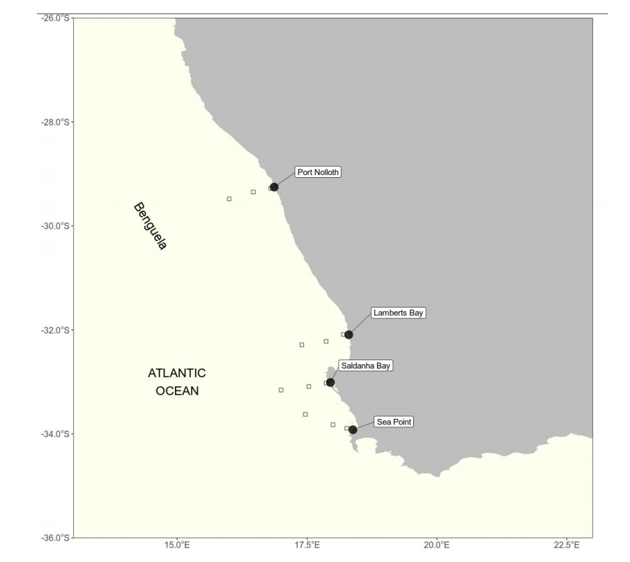
Fig.1. Map representing the study region along the west coast of South Africa. The black points represent the location of the in situ temperatures and approximations of the pixels used along the shore normal transect from the satellite sea surface temperatures, shown with black boxes. The black boxes are at 10km, 30km and 50km from the coastline.

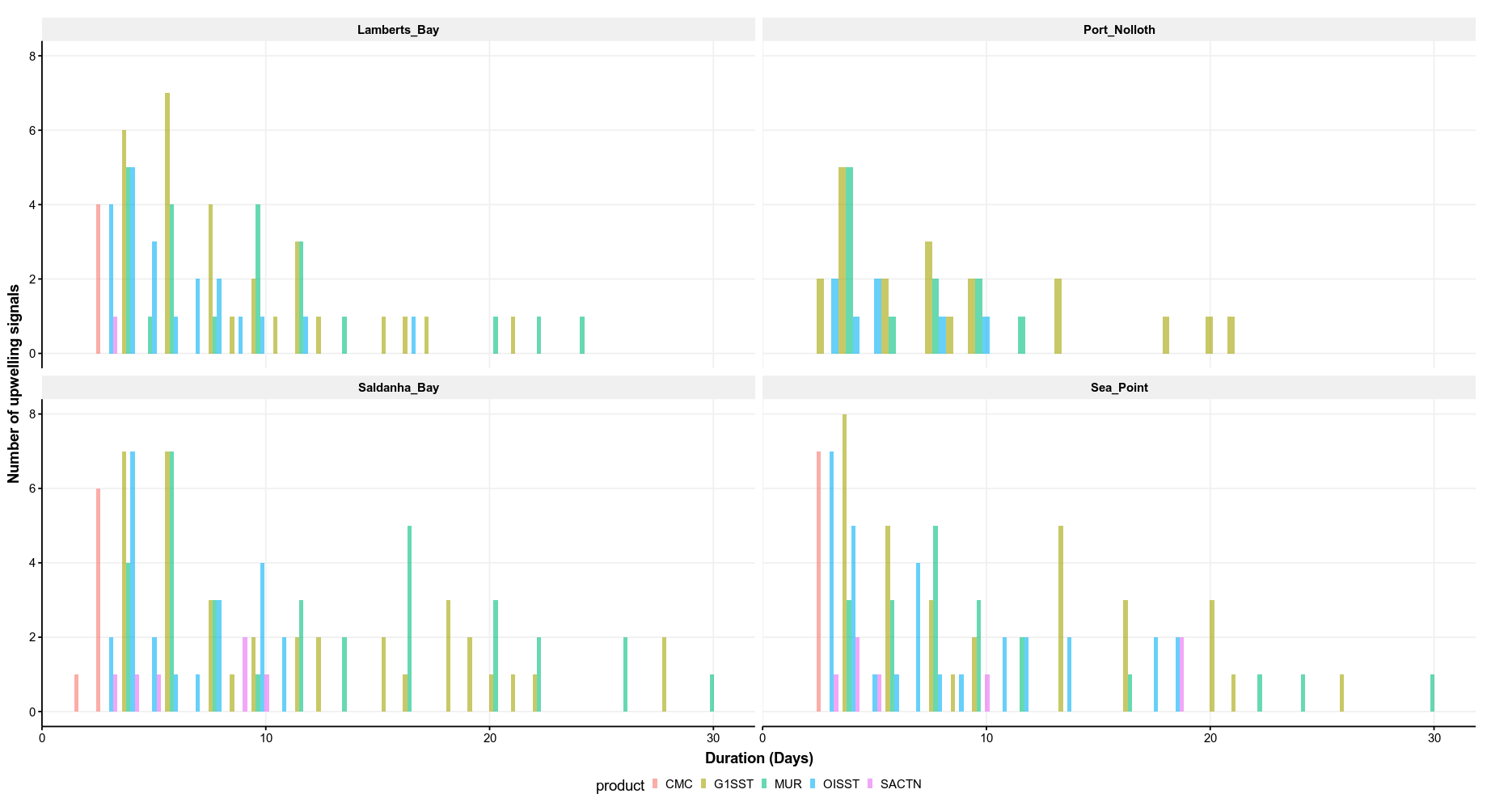
Fig.2. Graph showing the duration for each of the signals detected for the four satellite temperature products and the SACTN in situ collected product for the summer months (January, February and March) over a four year period.

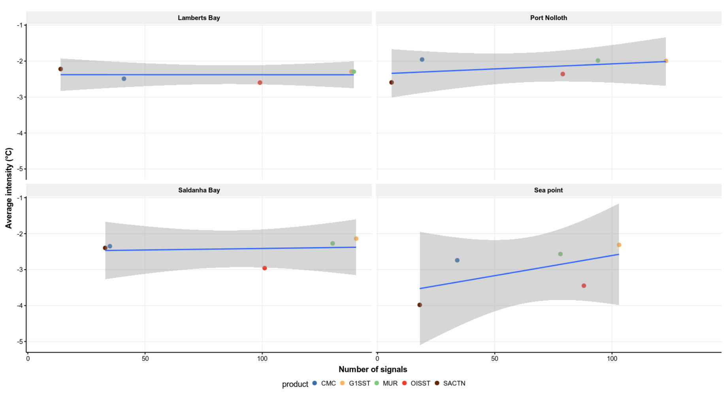
Fig.3. Plot showing the number of signals detected and the mean intensity over a four year period for each of the four sites along the west coast of South Africa.

Table 1
A- A perasons correlation coefficient represent the relationship between the number of pixels collected at a distance of 10km vs a disatnce of 30 km from the coastline and a corelation between the number of signals at 10 km and 50 km from the coastline. B-The number of upwelling signals detected in each of the SST products. The distance column indicates the various distances from the coastline (10, 30 and 50km) as seen in Fig.1. The signal column indicates the number of signals detected at each of these distances.
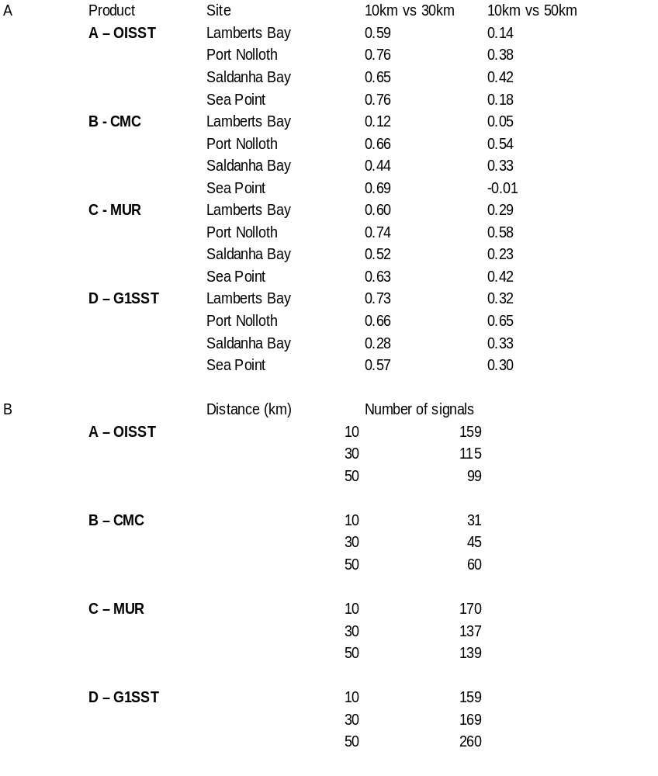

Table 2

A subset of the data comparing signals detected by satellite products and the in situ collected data over a period of four years from 2011 – 2014.

