Detecting patterns of upwelling variability in Eastern Boundary Upwelling Systems with special emphasis on the Benguela region

Amieroh Abrahams

University of the Western Cape, Department of Biodiversity and Conservation Biology,
Private, bag X 17, Bellville, 7535, South Africa.



A thesis submitted in fulfilment of the requirements for the degree of Magister Scientiae
in the Department of Biodiversity and Conservation Biology, Faculty of Science,
University of the Western Cape

Supervisor: Prof. A.J. Smit
Co supervisor: Dr. Robert Schlegel
October 2020

KEYWORDS

Upwelling

In situ data

Remotely-sensed data

Ocean

Wind

Code:R

ABSTRACT

Detecting patterns of upwelling variability in EBUS with special emphasis on the Benguela region

A. Abrahams
MSc. Thesis, Department of Biodiversity and Conservation Biology, University of the Western Cape.

Seawater temperature, be it global or regioal is important for the understanding of the biodiversity and aids in the understanding of the evolution and ecology of biology. Therefore, an understanding of the relationship between marine biodiversity and ocean temperatures is important for effective conservation planning. With the current anthropogenic forcing on the climate system, future patterns in biological, social and economic functioning may be estimated by observing past and future patterns. Absent from these, are the inclusion of upwelling, where deep cold water, rich in nutrients is pushed up to surface water. There is also an absence in knowledge with the changes of these events over time and detecting these events within a region.

Before analysing changes in upwelling it was first important to identify when upwelling was occuring. For this I made use of remotely-sensed data, in situ data and wind data. (Incomplete)

DECLARATION

I declare that “Detecting patterns of upwelling variability in EBUS with special emphasis on the Benguela region” is my own work, that it has not been submitted for any degree or examination at any university, and that all sources I have used or quoted have been indicated and acknowledged by complete references.

Full name: Amieroh Abrahams Date: October 2020

Signature: ..............................................

ACKNOWLEDGEMENTS

I would like to acknowledge my supervisors. The support provided by them during this process were only surpassed by their insight into the methods allowing the production of this research. Additionally, I would also like to acknowledge all of the sources that contributed to the collection of the in situ coastal temperature data used in the second chapter of this thesis. This research was supported bu the NRF Grant number SFH180604339745

TABLE OF CONTENTS

PREFACE

This masters thesis covers the research I have performed over the last two years. This printed body of work is static in nature, the data science upon which it has been built is not. Much of this work may be found at my GitHub page: https://github.com/AmierohAbrahams/.

CHAPTER 1 INTRODUCTION

Eastern boundary upwelling systems

Globally, there are four major eastern boundary upwelling systems (EBUS). Upwelling systems include the Benguela Current off south-western Africa, the Canary Current off north-western Africa together with its northern extension off the Iberian Peninsula of south-western Europe, the Peru-Humboldt Current off western South America, and the California Current off the western continental USA and north-western Mexico (Bakun 1990; Bakun et al., 2015 ; Pauly and Christensen, 1995). Each of these systems are characterized as vast regions of coastal ocean occurring along the western shores of continents bordering the Pacific and Atlantic Oceans. EBUS cover only 1% of the world’s ocean surface, but despite this these are among the most productive regions of the world (Pauly and Christensen, 1995). This is due to the systems exposure to coastal upwelling, which is defined as the process whereby cold, nutrient rich, high concentrated CO₂, low pH, and low oxygenated waters are pushed to the surface as a result of alongshore winds interacting with the earth’s rotation (Pauly and Christensen, 1995). As a result of upwelling, diverse marine fauna and flora are able to thrive in these areas due to the abundance of nutrients and favourable temperatures.

Upwelling is primarily caused by alongshore, equator ward winds. These winds are caused by cross-shore atmospheric pressure gradients, and these gradients occur predominantly during heating periods. Bakun proposed that if there was an increase in greenhouse gases, it would cause more heating during the day and more cooling during the night causing the temperature gradient to increase resulting in a strong pressure gradient, Ultimately effecting wind patterns and therefore upwelling. Several people have tried to model this using different datasets of SST and wind pattern data at various resolutions and initially found that increases in gases, such as CO₂ causes a reduction in trade winds, and therefore a reduction in upwelling. These models however, were based on coarse data and when higher resolutions were used, such as for the Benguela EBUS, the models have shown that upwelling will intensify in accordance to the upwelling intensification hypotheses (Hsieh and Boer, 1992; Lima and Wethey, 2012; Mote and Mantua, 2002).

Ecology and primary production within upwelling zones

The duration and intensity of coastal upwelling are known to play a critical role in the phenology of key marine ecosystem processes. Similarly, changes in the characteristics of upwelling are shown to cause large disturbances to ecosystems at several trophic levels (Wang et al., 2015). Cold, nutrient richupwelled waters fuels primary production as a consequence of the development of phytoplankton blooms (Cushing, 1971; McGillicuddy et al., 1998; Oschlies et al., 1998; Ryther, 1969) . In these upwelling systems, the high productivity supports vast and diverse marine populations. Mesoscale and sub-mesoscale oceanic movements are key in managing the exchange and transportation of organic resources and marine organisms from the coastal zone to the open ocean. Most of the world’s major fishing industries are dependent on upwelling, as this process brings nutrient rich waters into the euphotic zone, where it forms the foundation of a localized food web that ecologically differs from surrounding, non-upwelled regions (Barshis et al, 2011; Ryther, 1969). Whilst nutrients play a primary role in the survival of these systems, the cool temperatures of these waters are critical as well. There is an increasingly large body of research that has provided evidence showing that sea surface temperatures (SST) have and are continuing to increase, however some regions still show a lower or non-significant increase, and in some cases cooling trends are evident. Upwelling occurring along the Cape south coast is proven to have less of an economic importance in contrast to the west coast. Inshore regions and embayments that are protected from wind action are likely to be subjected to intense episodes of primary production (Graham et al., 1997). Biotic systems within the Benguela upwelling system may be negatively influenced by the changes in oxygen levels given their adaption to natural variable conditions (Capone and Hutchins, 2013).

For several decades, regime shifts have become an important factor of marine research. Regime shifts are often defined as a shift from one stable ecosystem state to another. This process affects several species within a short period of time (Blamey et al., 2012; Cury at al., 2005; Jarre et al., 2006). Regime shifts are thought to be driven by abiotic processes such as climate change (Blamey, 2012 ; Polovina, 2005). The southern Benguela upwelling system supports a wide variety of commercially-exploited fish species and exhibits substantial variability in both oceanographic and biological components. Over the past three decades, a number of species occurring within this region have undergone shifts in their distributions and Roy et al. (2007) associated these shifts to cooling waters along the inner shelf of the Agulhas bank on the south coast, east of Cape Agulhas (Blamey, 2012). This coast is associated with high levels of harmful toxic algal blooms, which negatively impact commercial and recreational interests along the coastal region. These harmful blooms are often attributed to flagellated species with the red tide representing dinoflagellate blooms (Pitcher et al. 1992; Pitcher, 1998). Formations of red tides are often related to the prevailing winds of the southern Benguela which govern most hydrodynamic processes on the continental shelf. Red tide events are greatest during the latter part of the upwelling season during transitions in the synoptic weather patterns which result in diminished upwelling activity and increased thermal stratification (Pitcher et al. 1992).

Atmosphere

Throughout regions surrounding the Benguela EBUS, the atmosphere is dominated by anticyclonic high-pressure cells with quasi-stationary positions. The South Atlantic Ocean High is situated along the west, drawing cool, dry air onto the west of the subcontinent (Van Heerden and Hurry, 1998). Solar heating during summer may result in the development of low-pressure cells, known as heat lows, which are absent during the winter (Tyson and Preston, 2000). As the anticyclones shift north during winter months, the cold westerlies have a substantial impact on the weather of the southern tip of the South African subcontinent (Van Heerden and Hurry, 1998). The atmospheric temperatures along the coastline are largely influenced by the Benguela Current (Van Heerden and Hurry, 1998), however upwelling systems may be forced by various atmospheric conditions (Hutchings, 2009; Lutjeharms, 2003; 1987; Roberts, 2010).

Sea surface temperature and data collection

Water temperature affects the survival, abundance, distribution and growth of marine species (Brooks 2005). As such, a clear understanding of the relationship between marine ecosystems and their thermal tolerance is necessary for conservation and management planning. Future predictions in biogeographical patterns and ecosystem functioning may also be estimated based on various climatic behaviours. Regardless of the objectives, whether it be studies based on climate change, extreme events, upwelling or ecosystem functioning, it is important that the research is conducted through accurate, reliable datasets. Unfortunately, not all data are created equally and under the same conditions and as such, not all datasets are appropriate for a particular task.

In situ data

Having coastal, in situ seawater temperature data is a rare privilege to researchers. Most biological and ecological research requires coastal temperature data. The South African Coastal Temperature Network (SACTN). The availability of the in situ collected coastal temperature data products for several decades provides a reliable source of accurate coastal seawater temperature data (Smit et al., 2013). SACTN has collected coastal seawater temperature along the South African coastline from as early as 1972, with contributions from a total of seven different organisations and governmental departments. At present, this dataset contains temperatures of 129 sites along the three distinct coasts of the South African coastline. Temperature recordings are still ongoing at many of these sites, but unfortunately, the durations and extents of these are uneven per site. Data collected for this region started on 13 September 1972 and concluded on 26 January 2017, with recordings still continuing daily. During the 1970s, a total of 11 time series began recording. A further 53 entries were added during the 1980s, 34 entries were added during the 1990s, and 18 entries were added during the 2000s.

The uneven and inconsistent nature of the SATCN dataset can be attributed to several factors. For instance, as a result of variances in the equipment used by the various organisations and governmental bodies who recorded the data. One problematic outcome of this sampling methodology was that, due to specific work of the South African Weather Service (SAWS) and Kwa-Zulu Natal Sharks Board (KZNSB), two thirds of the SACTN data that were sampled were obtained with hand-held thermometers and recorded at a data precision of 0.500 ◦ C, however, the current global standard is to make use of underwater temperature recorders (UTRs), which have a data precision of 0.001◦ C (Jarraud, 2008). Due of these inconsistencies, this dataset required verification from an independent source before its use in research. Smit et al. (2013) thoroughly compared the temperature data within the SACTN dataset to those of several remotely-sensed SST products and found bias results. Using these in situ collected temperature data along with remotely sensed SST data requires a clear understanding of the characteristics of the contributing data sources in order to understand how accurate, reliable and useful these long-term measurements are for use in climate change studies.

It should also be acknowledged that most of the time series within the SACTN dataset do not have meta-data records that meet the international climate change research requirements (Aguilar et al, 2003). Specifically, uncertainty lies within the drift of the instrument, who was sampling and where the exact sampling locations were collected throughout the collection period. There is certainty that all of the thermometer time series were collected by thermometers and that the UTR time series were collected by UTRs in this study. Given these issues associated with the mete-data, recent work has been started to develop a nation wide standard.

For this analysis, the seawater temperature data, obtained from the seven different sources, were combined and formatted into standardized comma delineated value (CSV) files which allowed for a fixed methodology to be used across the entire dataset. Prior to data analysis, all data points exceeding 35°C and/or below 0°C were removed as these were considered as outliers. These data points were then changed to NA (not available) so as to not interfere with analysis. All analyses were conducted in R software version 3.4.2 (http://www.r-project.org/).

Satellite data

Reliable datasets are often difficult to maintain and obtain. In the field of biological science research, it is often abiotic data products that are impaired thus leading to the use of satellite derived SST products for the study of specific fields such as coastal and marine ecology as well as oceanography. These datasets however, may be inaccurate along the coast and local in situ collected data should be used when possible (Smit et al., 2013). Remotely sensed data products are obtained by several different organisations worldwide. Satellites launched into space detect the infra-red light emitted by the ocean which is then taken as a proxy from SST. Given the extensive distance at which these satellites record data, a certain level of coarseness is displayed within the dataset. This is demonstrated as the size of the pixels one sees in the final product.

Satellite SST products undergo a range of quality control and validation processes (e.g. Reynolds and Smith, 1994; Brown et al., 1999; Martin et al., 2012), making the data reliable and more useful. As previously mentioned, satellites may show a warm or cold bias along the coastal region but are still useful for broader scale investigations (Smit et al., 2013, Smale and Wernberg, 2009; Castillo and Lima, 2010). Remotely-sensed SST products are obtained at different resolutions, and as a result do not represent the same level of bias against in situ collected seawater temperature.

Climate change

Climate change as a result of anthropogenic activities is a global concern of both scientific and political importance. As the human population grows, the rate of global warming increases, resulting in profound effects on marine and other ecosystems. Climbing temperatures create a host of additional changes to marine systems, such as rising sea levels, increased ocean stratification, decreased sea-ice extent, and altered patterns of ocean circulation and precipitation (Doney et al., 2011). Direct effects on ocean temperature changes and chemistry may alter the functioning and behaviour of marine organisms and in turn, these changes lead to a change in species integration and trophic pathways.

Significant research studies accept that climate change and variability have great impacts on marine ecosystems (Stenseth et al., 2002; Harley et al., 2006; Hoegh and Bruno, 2010). The Intergovernmental Panel on Climate Change (IPCC) predicts future projections with a mean increase in air temperature of 1.1°C by the 2020’s and 1.8°C by the 2040’s as a result of the increase of greenhouse gas concentrations (Solomon et al., 2007). A large amount of this heat will be absorbed by the world’s ocean. In current years, as a result of changes in air temperature, the heat content of the ocean has increased significantly. Given ocean warming in association with their physical changes such as sea level rise and declines in sea ice, marine life is expected to intensify in future decades. Global warming represents distinct warming and cooling periods throughout the 20th and 21st century (IPCC, 2007). Global warming however is not evenly distributed across the global ocean, and thus several regions are warming faster or slower than the global average (Levitus et al., 2000; Santos et al., 2012). In particular, the Atlantic Ocean contributes most to the increase of heat content (Nerem et al., 1999; Levitus et al., 2000).
As a result of climate change, research studies provide significant evidence relating to the increase in the warming of the ocean surface. This warming slowly propagates down through the water column and in turn increases thermal stratification (Gruber, 2011). Strong stratification limits the depth at which water is upwelled and hence controls the amount of nutrients brought up (Chhak and Di Lorenzo, 2007; Jacox and Edwards, 2011; Jocox et al., 2016). The interplay between upwelling winds and stratification determines the amount of nutrients present within the system and is therefore strongly linked to biological productivity. Globally, as a result of climate change, stratification of the water-column between 0 and 200 m has increased by an estimated 4% between 1971 to 2010 (Stocker et al., 2013). Increased ocean stratification as a result of surface warming may reduce the ventilation of deep-water masses. As the deep water is being upwelled to the surface, decreases in oxygen and pH levels are predicted with an increase in nutrient levels (Bakun et al., 2015). Generally, regional ocean climate oscillations like the Benguela Niño for the Benguela Current System impose considerable variability on temperatures and complicate attempts to assess long-term trends (Demarcq, 2009). It is predicted that these climate oscillations may increase the variance with climate change (Timmermann et al., 1999; Kuzmina et al., 2005; Sydeman, 2013) which may result in unusual trends.

As previously mentioned, upwelling winds in EBUSs are generated by pressure differences between continental thermal lows and oceanic highs. As warming intensifies, pressure gradients between land and sea increases, resulting in a greater intensity of upwelling winds (Bakun, 1990; 2010; 2015). In rare cases, projected upwelling increases may overcome the countervailing effects of upper-ocean warming and stratification to cause regional cooling (Auad et al., 2006). Research studies reveal declines in ocean oxygen levels as a result of ocean warming and reduced ventilation from stratification and circulation changes (Keeling et al., 2010). Similarly, low oxygen levels are also possible because of shifts in the composition of sinking organic material (Hofmann and Schellnhuber, 2009; Doney et al., 2011).

Climate change has severe ecological consequences on both plants and animals (Walther et al. 2002; Walther et al. 2009). In the past two decades, sea surface temperature has risen in many regions and this seasonal rise in temperature can act as an important cue in species survival, reproduction and abundance (Goodwin et al., 2013). The different responses of species as a result of climate change are important to understand as these changes affect, the trophic dynamics and fisheries yield of several regional ecosystems among many things (Murawski 1993; Friedland and Hare 2007). Understanding the relationship between global warming and climate change as a result of anthropogenic activity is a vast and challenging process. In a bid to further this understanding, Rockström et al. (2009) introduced the concept of planetary boundaries. According to this concept, within each of these boundaries exists a level of safety that should not be exceeded. According to this concept, the planetary boundary for biodiversity loss, has been surpassed (Steffen et al., 2015). Similarly, the safety boundary for warming of the globe by greenhouse gas emission has also been surpassed. The idea of planetary boundaries is essential in that it helps in understanding the threats humans cause via the continued destruction of the natural environment. Consequently, studies of anthropogenic influences on the ecosystem are generally divided into land or sea. Terrestrial ecosystems are more familiar to the general populace; whereas marine ecosystems are associated with high levels of primary production (Chavez et al., 2010) and are highly at risk as a result of climate change (Osterblom et al., 2017). Climate change has been proven to decrease primary production thus affecting trophic levels and leading to trophic turbulence and the destruction of marine fauna (Lewandowska et al., 2014; Dell et al., 2014, McCauley et al., 2015).

Climate change affects coastal species such as oysters, corals and, sea grass. Lord (2017) also found evidence that suggested that a change in climate as a result of rising sea temperatures may increase the spread of invasive species and increase the chances of an outbreak of diseases (Altizer et al., 2013). Research by Mead et al (2013) found that coastal ecosystems are at high risk as a result of climate change, later, Whitfield et al (2016) confirmed that coastal bio-diversity has been observed to be affected. Given the importance of primary productivity, it was determined that the Benguela upwelling system within the South African region should become the focus of this thesis.

Benguela

The area of study for this thesis will focus on the west coast of South Africa, which is an eastern boundary upwelling system. The Benguela EBUS is unique in that it is bounded at both the equatorward and poleward ends by warm water regimes. These currents are forced locally by the wind stress field off southwest Africa (Nelson and Hutchings, 1983; Fennel, 1999). This upwelling system stretches along the south-western coast of Africa from southern Angola to Cape Agulhas (Cole, 1999). Water is coldest and most persistent off the Namibian coast at 25°S and weakest at 17°S (Lutjeharms et al., 2003). The main upwelling period in the Benguela, north of 25°S extends mainly from March to November, peaking during August (Shannon, 1985), but upwelling persists throughout the year. Upwelling season in the northern Benguela extends between September and March, with very little upwelling taking place during winter (June-August). In the central Benguela and also at Cape Frio, upwelling is continuous throughout the year (Shannon, 1985). The cold Benguela waters are bound in the south by the warm Agulhas retroflexion region and in the north by the southward flowing Angola current. The flow of the Benguela is often considered to be topographically guided (Nelson and Hutchings, 1983; Barange, 1991). The Benguela system is split into northern and southern systems by a zone of intense perennial upwelling activity in the Luderitz region within the Namibian region (Shannon, 1986; Cole, 1999).

Upwelling in the northern Benguela is in phase with the seasonal insulation cycle, whereas in the southern Benguela it is not. This results in a pronounced seasonal cycle in SST in the north while in the south there is no clear SST cycle. The seasonal warming occurring during the late summer season off northern and central Namibia is a regular occurrence and is associated with warmer, higher salinity water of Angolan origin into the region (Jarre et al., 2006). There have been a number of warm and cool periods documented in the northern and southern Benguela (e.g. Stander and De Decker, 1969; Walker et al, 1984; Shannon, 1984; Boyd et al., 1986; Brainard et al., 1985). Little 1997 found a major climatic event in the northern Benguela region of anonymously warm water. This unusual warm water may have resulted due to reduced upwelling or an increase southward advection of warm water. Another warming event occurred during the summer and autumn months of 1984 (Shannon, 1986). The presence of this anomalous warm water during 1984 followed two cooler than normal years in the northern Benguela. Shannon et al. (1986) illustrated the warm (21-23°C) water near Walvis Bay as a large warm water patch offshore, west of Luderitz. The absence of upwelling between Walvis Bay and north of Luderitz is evident, however, the upwelling centre in the Benguela system (shannon1986), and upwelling was minimal. Interestingly, in the southern Benguela region, there was no evidence of any unusual patterns in temperature distributions. The seasonal temperature pattern within the northern Benguela was somewhat similar to that in the eastern equatorial Atlantic and the regular southward intrusion of warm water into the northern Benguela during the summer season. During these warming periods the equatorward wind stress over the northern Benguela region was stronger than normal; yet upwelling was suppressed by the southward movement of warm saline waters from the Angolan region.

Northward, the Benguela Current Upwelling system is linked by the Angola Benguela Front which converge between the Benguela current and the Benguela coastal current as well as the warm saline waters of the Angola Current (Peterson and Stramma, 1991). Research done by Yamagata and Iizuka (1995) discovered that coastal Kelvin waves, originating from equatorial Kelvin waves, carry the downwelling process southward. Southward, the coastal upwelling system is bounded by the Agulhas Bank. South of the African coast the warm Agulhas Current, western boundary current, flows in from the Indian Ocean and returns eastwards while generating warm eddies that spin off in a north-westerly direction in the Benguela current (Duncombe, 1991). The region surrounding the Benguela experiences a persistent along shore wind. This wind is associated with the St. Helena high pressure system. Lutjeharms and Meeuwis, (1987) also found a strong relationship between the intensity of upwelling signals and the strength and direction of prevailing winds. These favourable upwelling equatorial winds represent a maximum at 25°S and decrease towards the northern and southern boundaries of the Benguela upwelling system. Continental shelf bathymetry and upwelling favourable winds provide a large-scale upwelling mechanism in the southern Benguela, whereas local topography and meteorology create an alternating pattern of active and passive upwelling circulations along the coast. Winds occurring within the southern regions represent a seasonal variation, reaching a maximum during spring and summer months (Boyd et al., 1985; Fennel, 1999; Shannon and Nelson, 1996). Winds occurring within this region tend to show increasing patterns away from the coast whereas, winds occurring in the northern region exhibits relatively less seasonal variation (Shannon, 1985; Pitcher et al., 1992). Upwelling occurring along the south coast of the Cape Province within South Africa, specifically along the coastline is generated by local wind, with wind increasing somewhat away from the coast. This facilitated the idea of a wind stress curl, as discussed in Bakun and Nelson (1991) and Shannon and Nelson (1996).

Benguela Niños are defined as anomalous warm events occurring between the southward flowing Angola current and the Benguela upwelling system off south western Africa (Shannon, 1986). These warm events profoundly impact fisheries and the climate of this region. They are proven to induce unexpected rainfall events and drastically influence fish abundance and distribution (Boyer and Hempton, 2001; Rouault et al., 2003). Evidently, Benguela Niños are expressed as regions of abnormal, persistent high sea surface temperatures. Many researchers often associate the equatorial interannual variability pattern in the Atlantic to the ENSO phenomenon found within the Pacific region (Sutton et al., 2000; Zebiak, 1993). Benguela Niños have been recorded to occur in 1934, 1949, 1963, 1984 and 1995 (Gammelsrod et al., 1998; Shannon 1985; 1996). Servain (1985) suggested that eastern tropic oceans are governed by remote wind stress effects through equatorial wave dynamics. Anomalies in trade winds may result in Kelvin waves that propagate eastward along the equator, inducing a deepening or a lifting of the thermocline.

Analyses

The analyses conducted in this thesis varied according to the investigations performed. The one common source uniting all of the analyses was that they were conducted in R-programming language (R Core Team, 2017). This provided reproducibility for all of the analyses and visualisations used.
Problem statement:

With global warming continuing at a rapid pace, the amount of greenhouse gases within the atmosphere will subsequently increase in the future. This increase will undoubtedly have an impact on the world’s oceans and the marine life within it, both directly and indirectly. The oceanic process of coastal upwelling is one aspect that is likely to be affected as changes in global temperature will affect temperature and pressure gradients, and in turn affect alongshore winds which are responsible for driving the upwelling process within EBUS regions. Because upwelling is important for productivity within coastal systems, a decrease in this process will negatively impact marine fauna and flora as well as human activities such as fishing. To assess changes in upwelling signals, the aim of this investigation is to use SST and wind, data to monitor the durations and intensities of upwelling events within the Benguela EBUS. Atmospheric-ocean coupling is known to be affected by climate change, likely changing wind patterns and leading to upwelling favourable conditions (García-Reyes et al., 2015).

Aims and approach

The warming of the global climate as a result of anthropogenic activity, has negatively influenced both terrestrial and marine ecosystems, and ultimately inhibits humanity and ecological functioning (McCauley et al., 2015). This climate variability, manifested as increases in the frequency and duration of extreme events is regarded as a great threat. This investigation examines recent trends and variation in the frequency and duration of upwelling occurring in this region. Its aims to assess whether the intensity and duration of these signals may show any changes in frequency and intensity on a seasonal basis. In this research project, various satellite derived observations of sea surface temperature (SST) and wind data will be used to further investigate the Benguela upwelling system along the South African coastline.

Study1

The primary aim of the first study was to make use of various remotely sensed SST data, in-situ collected coastal seawater temperature data. It was also useful to examine how upwelling signals detected varied per dataset as these datasets are collected at different resolutions, with the assumption that high resolution data may reveal a more accurate detection of upwelling signals. It is hypothesised that the higher resolution data should be able to detect gradients better than the coarser resolution data and that signals are more visible closer to the coastline at a distance of 0 km rather than at a distance of 50 km. The testing of the hypothesis would be made possible with a series of analyses that allows one to select specific time periods from a range of datasets.
Study 2

The aim of the second study was to determine the changes in the occurrence, duration and intensity of upwelling signals within the four EBUS over a 30 year period. We hypothesized that climate change as a result of global warining resulted in changes in wind patterns and ultimately lead to changes in the duration and intensity of upwelling signals overtime. To investigate this hypothesis, it was required to identify upwelling centres within these systems.

Knowledge contrabution

The current knowledge of coastal waters are often obtained using remotely-sensed gridded SST products, this is made possible by the production of high resolution data; however, the long running products to be used for long-term analyses are not (Chao et al., 2009; Qiu et al, 2008). Smit et al. (2013) has shown that gridded SST products have a large warm bias in the nearshore, this motivated for necessity to observe the differences in upwelling signals given the various data products and at different distances from the coastline to allow for comparison between data products but also to demonstrate the difference existing between products of different resolutions. The final contribution of this thesis will also make is in the understanding of upwelling patterns within EBUS at a global scale. An the outcome as well as the methodology developed in this research may hen be taken by ecologist and conservationists.

Research assumptions

The central assumption of this project was that remotely-sensed SST data and in situ seawater temperature data may be compared. Remotely sensed SST data and in situ seawater temperature data were obtained at different resolutions and distances from the coastline so slight changes may be found within the different datasets. An additional assumption within this research focused on the effect of upwelling signals. Most research studies suggest changes in upwelling patterns overtime (Bakun, 1990; Bakun et al., 2010; Bakun et al., 2012). Some research has pointed towards changes in pressure gradients (Bakun et al., 1990) but for the purpose of this research, it was decided that the main focus would be to test if these hypotheses are valid within EBUS.

Conclusion

EBUS have been documented to be of the most productive regions of the world and is known for its ecological and economical benefits. It may therefore be assumed that incorrect upwelling detection and changes in upwelling patterns as a result of climate change will negatively influence these productive zones. Currently little is known about the changes in upwelling overtime so the first step is simply to create a method of identiifying upwelling and at which distance from the coastline is best to identify when this phenomenon is occuring.

In order to investigate upwelling changes and detection, the collection of SST, wind speed and direction are important. The detection of the upwelling phenomenon will represent an extensive body of work and so the application of these results to biotic factors will not be accomplished extensively in this thesis.. The important knowledge obtained by this research will branch out into different fields of study, with this it is critical that the work done within this thesis is accessible to other research groups. The ultimate goal to be achieved by this research is to identify when upwelling is occuring and the long term changes thereof.
CHAPTER 2
Upwelling signals: a comparison of sea surface temperature products in the Benguela

Abstract
Time series of accurate sea surface temperatures (SSTs) are needed to detect subtle signals. SST data are often provided as gridded products from satellite observations, typically at resolutions of 0.05°. This study was designed to examine whether the same upwelling patterns were detectable at varying distances from the coastline from satellite and in situ SST datasets, collected at different resolutions. The study uses wind and SST data to create an upwelling index (UI) for each of the sites that was used to identify upwelling signals. The results showed that a diffrence exist between SST products and between signals detected at different distances from the coastline. (Incomplete)

Keywords: Seawater temperature, coastal regions, code: R, upwelling

1. Introduction

Sea surface temperature (SST) is regarded as one of the most important ocean-atmosphere system and is particularly useful research tool in the scientific fields of meteorology and oceanography (Mesias et al., 2007; Harlaß et al., 2015). For over 150 years, SST data has been collected using in situ measurement techniques (Rayner et al., 2003); with satellite measurements of SST being available since the 1970s (Reynolds et al. 2013). Furthermore, over the past decade, techniques have been developed to allow the assimulation of different SST datasets from various in situ and satellite platforms. These are referred to as the Level-3 and Level-4 high resolution gap-free products. Previous studies demonstrated that satellite-based SST data are less accurate than in situ data due to the complexity of the oceanic and atmospheric conditions that need to be accounted for in deriving satellite SST products (Robinson et al., 1984; Brown et al., 1985; Minnett, 1991; Smit et al., 2013). These errors vary both regionally and temporally (Wick et al., 1992). In comparison to in situ SST measurements collected from ships, or buoys, a major advantage of satellite SST is their global coverage and near real time availability. SST datasets with a high level of accuracy, spatial completeness and fine-scale resolution are necessary for weather and climate forecasting and are of great importance for reliable climate change monitoring (Reynolds and Smith, 1995; Smith and Reynolds, 1998; Reynolds et al., 2002; Chao et al., 2009)

Long-term SST data have been obtained from two kinds of satellite remote sensors; thermal infrared (TIR) and microwave (MW), which show different weather sensitivity characteristics and accuracies (Li et al., 2013). Infrared remote sensor SST products are available from the 1970’s and may have a spatial resolution as fine as approximately a 4 km grid; however, they are unfortunately affected by the presence of clouds and other aerosols in the atmosphere. This is known to result in spatial discontinuity. MW SST products have a lower resolution than infrared SSTs at approximately a 25 km grid, with a much lower accuracy near coastlines(Li et al., 2013; Hain et al., 2011, Parinussa et al., 2008). By combining these different types of SST products, it is possible to take advantage of the strengths within both, and each sensor type can help produce an SST dataset with more spatial and temporal coverage and higher resolution.

For many applications, SST data are not used or provided at the full resolution of the sensors but are averaged over defined areas in order to produce a gridded product (Bulgin et al., 2016; Reynolds et al., 2002). Gridding in this way destroys more detailed information and as a result a gridded SST measurement is taken as an estimate of the average SST across a specific grid cell over a certain time period. Spatial sampling uncertainty and temporal averaging is present in gridded products as the full gridded cell is often not being observed as a result of interference due to the presence of clouds or aerosols, as previously mentioned. In existing daily global SST analysis products, typical grid resolution ranges from 0.05°×0.05° to 0.25° ×0.25°, or from approximately 5 to 25 km (e.g., Reynolds and Smith, 1994; Brasnett, 2008; Donlon et al., 2012). Small scale features can evolve during the course of the day, but the sensor sampling during this time is not dense enough for the sub-daily global analyses at a high spatial resolution (Reynolds and Chelton, 2010; Reynolds et al., 2013). Furthermore, considering that the satellites are passing over head only once every ~24 hours; therefore images are only captured at very specific times during the day. It bares mention that sensors can’t resolve small-scale features as they continue to evolve over the course of day; the reason being that the sensors are only looking at a restricted portion of the ocean for several minutes at a time; the exception being of-course, geo-stationary satellites like the POES (polar orbiting environmental satellite). To capture these small-scale features in a gridded analysis, it is suggested that the development of an improved analysis would have high resolution at small-scale features in regions of good coverage and lower resolution in areas of poor coverage (Reynolds et al., 2013).

In order to assess the suitability of a range of SST products for coastal application, this study aimed to observe patterns and trends in upwelling signals in the Benguela Upwelling System (BUS) across a range of localities and spatial scales off the South African West Coast. We selected an upwelling system because this physical process provides a strong signal of increasing and decreasing SST that is strongly localised to known centres of upwelling, and which relates to the coastal wind field that drives the offshore advection of water mass. Because upwelling is a well characterised oceanographic process, the resultant fluctuating SST signal should be observed across independent SST products – here we assess blended SST products covering a range of spatial grid resolutions from 0.05°×0.05° to 0.25° ×0.25°. We hypothesized that the higher resolution data should have a better fidelity at detecting these upwelling signals, some of which might only be confined to smaller spatial scales or localised closer to the shore.

The BUS is one of the four major Eastern Boundry Upwelling Systems (EBUS) (Bakun et al., 2015). EBUS are characterised as vast regions of coastal ocean occuring along the western shores of continents bordering the Pacific and Atlantic Oceans (Bakun, 1990; Pauly and Christensen, 1995; Bakun et al., 2015; Bakun et al., 2010). Coastal upwelling associated with EBUS is known to have a large influence on the associated ecosystem’s primary priductivity, and hence the abundance, diversity, distribution and production of marine organisms at all trophic levels (Bakun et al., 2010; 2015). According to the ‘Bakun hypothesis,’ an increase in greenhouse gases will result in an increase in day-time warming and night-time cooling and ultimately cause an increase in temperature gradients which will form stronger atmospheric pressure gradients (Bakun, 1990). It should be noted pressure gradients modulate the winds which ultimately affect the intensity and duration of upwelling (Bakun et al., 2010; Hsieh and Boer, 1992; Lima and Wethey, 2012; Mote and Mantua, 2002). Furthermore, it should also be understood that changes in sea surface temperatures indirectly affects coastal communities, and bears considerable, often far-reaching economic impacts as well (Murawski, 1993; Bakun et al., 2010). It is hypothesised that the higher resolution data should be able to detect gradients better than the coarser resolution data and that signals are more visible closer to the coastline at a distance of 0 km rather than at a distance of 50 km.

2. Methods

2.1 Site Selection

The South African coastline exhibits a large variation in seawater temperature and is divided into four bioregions (Smit et al., 2013; Mead et al., 2013). The western region of the coastline is dominated by the Benguela Current forming an Eastern Boundary Upwelling System (EBUS) (Hutchings et al, 2009), which provides a natural laboratory for this study. Annual mean coastal seawater temperatures within this region have a range of 12.3 ± 1.2°C at the Western limit near the Namibian border. Seasonal upwelling is controlled, with intense upwelling occuring throughout the summer months, by south-easterly trade winds and as a result reflects distinct temperature variations representing much lower temperatures within the upwelling cells over a fairly narrow continental shelf found from the Cape Peninsula to Cape Columbine. In order to examine upwelling patterns along the coastline, several sites from the SACTN dataset (Schlegel et al.,, 2016; 2017) along the west coast of South Africa (i.e. sites influenced by the Benguela current) were selected. As the main objective of this study was to simply ascertain whether or not the same upwelling signals were detected congruently throughout the various SST products; a study period of four years of data was sufficient in order to compare congruency among the detections between products. Four sites were selected, occuring at different regions in the benguela system, these include Port Nolloth, Lamberts Bay, Sea Point and Saldanha Bay (Fig.1.).

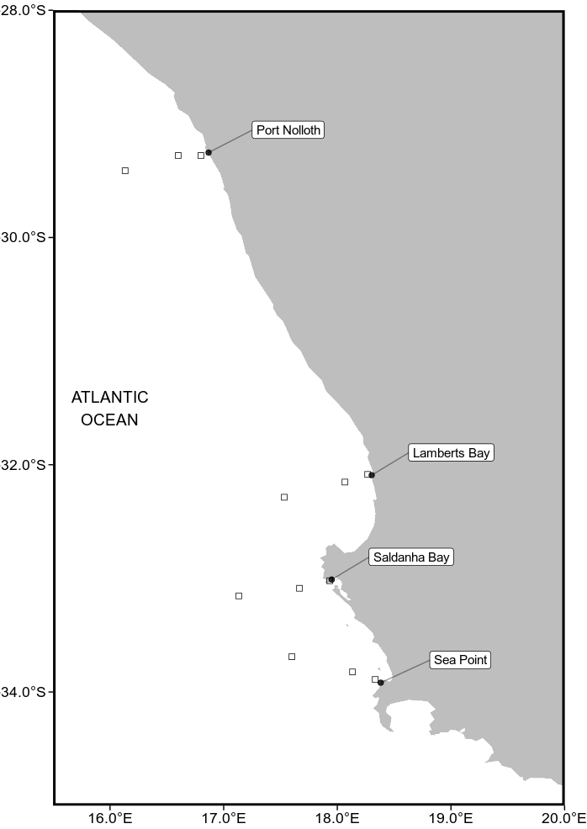

Fig.1. A map of the study region along the west coast of South Africa. The black points represent the location of the in situ temperatures and the empty boxes show the pixels used along the shore normal transect from the satellite sea surface temperatures (SST) time series. The black boxes are at 0 km, 25 km and 50 km from the coastline.

2.2 Datasets

This study uses four Level-4 remotely sensed temperature datasets; complied by a number of organisations. The AVHRR-only (Advanced Very High Resolution Radiometer) Optimally-Interpolated Sea Surface Temperature (OISST) dataset has been providing global SSTs for nearly four decades (Reynolds et al., 1994). OISST is a global 0.25° × 0.25° gridded daily SST product that assimilates both remotely sensed and in situ sources of data to create a gap free product (Banzon et al., 2016). The second is a version 3.0 Group for High Resolution Sea Surface Temperature (GHRSST) product with a 0.2° × 0.2° global grid resolution constructed by the Canadian Meteorological Center (CMC). It combines infrared satellite SST at numerous points in the time series from the AVHRR, the European Meteorological Operational-A (METOP-A) and Operational-B (METOP-B) platforms, as well as the microwave SST data from the Advanced Microwave Scanning Radiometer 2 in conjunction with in situ observations of SST from ships and buoys from the ICOADS program. The Multi-scale Ultra-high Resolution (MUR) Sea Surface Temperature Analysis is produced using satellite instruments with datasets spanning 1 June 2002 to present times. MUR provides SST data at a spatial resolution of 0.01° × 0.01° and is currently among the highest resolution SST datasets available. The final dataset used is the GHRSST analysis produced daily using a multi-scale two-dimensional variational (MS-2DVAR) blending algorithm on a global 0.01° grid known as G1SST. This product uses satellite data from a variety of sensors, such as AVHRR, the Advanced Along Track Scanning Radiometer (AATSR), the Spinning Enhanced Visible and Infrared Imager (SEVIRI), the Moderate Resolution Imaging Spectroradiometer (MODIS), and in situ data from drifting and moored buoys. We see that not all products are completely independent as they share the use of AVHRR SST data, but the amount of subsequent blending, the incorporation of other SST data sources, the different blending and interpolation approaches used, and the differing final grid resolutions make them comparable in this study.

Additionally, this study uses the South African Coastal Temperature Network (SACTN) dataset for its source of in situ temperature. This dataset consists of coastal seawater temperatures obtained from 129 sites along the South African coastline, measured daily from 1972 until 2017 (Schlegel et al., 2016, Schlegel and Smit, 2017). Of these, 80 were measured using hand-held thermometers and the remaining 45 were measured using underwater temperature recorders (UTRs). For this analysis, the data were combined and formatted into standardized comma seperated values (CSV) files which allowed for a fixed methodology to be used across the entire dataset. Prior to data analysis, all data points exceeding 35°C and/or below 0°C were removed as these were considered irregularities. These data points were then changed to NA (not available) so as to not interfere with analysis.

An advantage to using in situ data over satellite data is that they may provide a more accurate representation of the thermal properties closer to the coast, whereas satellite data often fails to accurately capture and represent temperature properties within the same spatial context; the result being in situ data can therefore more accurately explain upwelling signals within the coastal inshore environment. Further evidence by Smit et al. (2013) has shown that satellite data collected along the South African coastline may have a warm bias as high as 6°C over in situ temperatures within the nearshore environment.

In order to create a time series of each of the remotely sensed SST data products and to determine whether the same upwelling patterns exist on the broad-scale against the in situ time series., shore-normal transects of all Level-4 products were extended at West Coast stations where the in situ data in the SACTN database were available. Time series of SSTs were extracted at 0, 25 and 50 km along these shore-normal transect from the coast shown as black boxes in Fig. 1.
2.3 Wind data

Wind data were obtained using a wind instrument called the RM YOUNG Weather Transmitter. This compact instrument provides reliable and accurate measurements of four key meteorological variables. Ultrasonic wind speed and direction, atmospheric pressure, humidity and temperature sensors are carefully integrated into an enclosure optimized for durability, airflow and mitigation of solar radiation effects. Wind was an important variable for this study as wind direction and wind speed may have a direct influence on the intensity and duration of upwelling, consequently, wind data collected from 1989-01-01 to present were investigated for their relationship with upwelling at the sites for which SST time series were created. When the instrument collects wind data, the raw files are converted by the logger into a format readable by the metcap program, which draws the graphs and writes the data into excel spread-sheets in which they are stored for later use.

2.4 Defining and determining upwelling

In order to determine the change in upwelling signals at various distances from the coast and to test which dataset showed a clear, and visible representation of these signals, it was first necessary to define when upwelling was occurring; however, to accomplish this a set of threshold values for identifying when the phenomenon was taking place was required. Given that upwelling is primarily caused by alongshore, equatorward winds, both SST and wind data were used. The wind data were used to inform an upwelling index calculated using the formula presented in the work by Fielding and Davis (1989).

Upwelling Index = μ(cosθ − 160)

where μ represents the wind speed (m/s), θ represents the wind direction in degrees, and 160 is the orientation of the west coast (Jury 1980). The index relies heavily on wind speed and direction data in order to determine the presence of upwelling and its intensity. The above equation produces a value called the upwelling index. An upwelling index < 0 represents downwelling whilst an upwelling index > 0 represents upwelling (Fielding and Davis, 1989). When the upwelling index is greater than 0, SSTs usually drop, as expected, suggesting that upwelling is occuring. It was found that the drop in SST that coincided with a positive upwelling index was close to the seasonally varying 25th percentile threshold for SST, so this threshold temperature was used in combination with the upwelling index to determin when upwelling may be occuring. With the bottom threshold set for which temperatures may qualify as an upwelling signal it was then necessary to determine the number of consecutive days that must be exceeded for an upwelling signal to qualify as a discrete event. Here it must be noted that upwelling is known to vary on a seasonal basis and may also occur hourly (sub-daily). Therefore, the minimum duration for the classification of an upwelling signal was set as one day. The rationale being that data from the SACTN dataset as well as the satellite remotely sensed SST data are collected only at a daily resolution, preventing a temporally finer definition. With the upwelling index, temperature threshold, and duration for an upwelling signal established, the detect_event function from the heatwaveR package (Schlegel et al., 2018) was used to calculate metrics for the upwelling signals. Because upwelling signals were calculated relative to percentile exceedances, rather than an absolute definition such as temperatures below a fixed temperature threshold, upwelling signals could occur any time of the year, however, upwelling was shown to be more dominant during spring and summer months, as expected.

2.5 Statistical analyses

A series of ANOVA tests were used to compare the main effects of the chosen variables on the continuous variable. In this analysis the relationship between the SST products across the various selected study sites was established; factors used to correlate these relationships included duration, mean intensity and cumulative intensity. These analyses sought to test if significant differences occurred between sites and data products. A correlation analysis was constructed to determine if a signal detected at a distance of 0 km from the coastline would be visible at a distance of 25 km from the coastline and, similarly if the same trend could be observed when comparing the 0 to the 50 km offshore regions.

3. Results

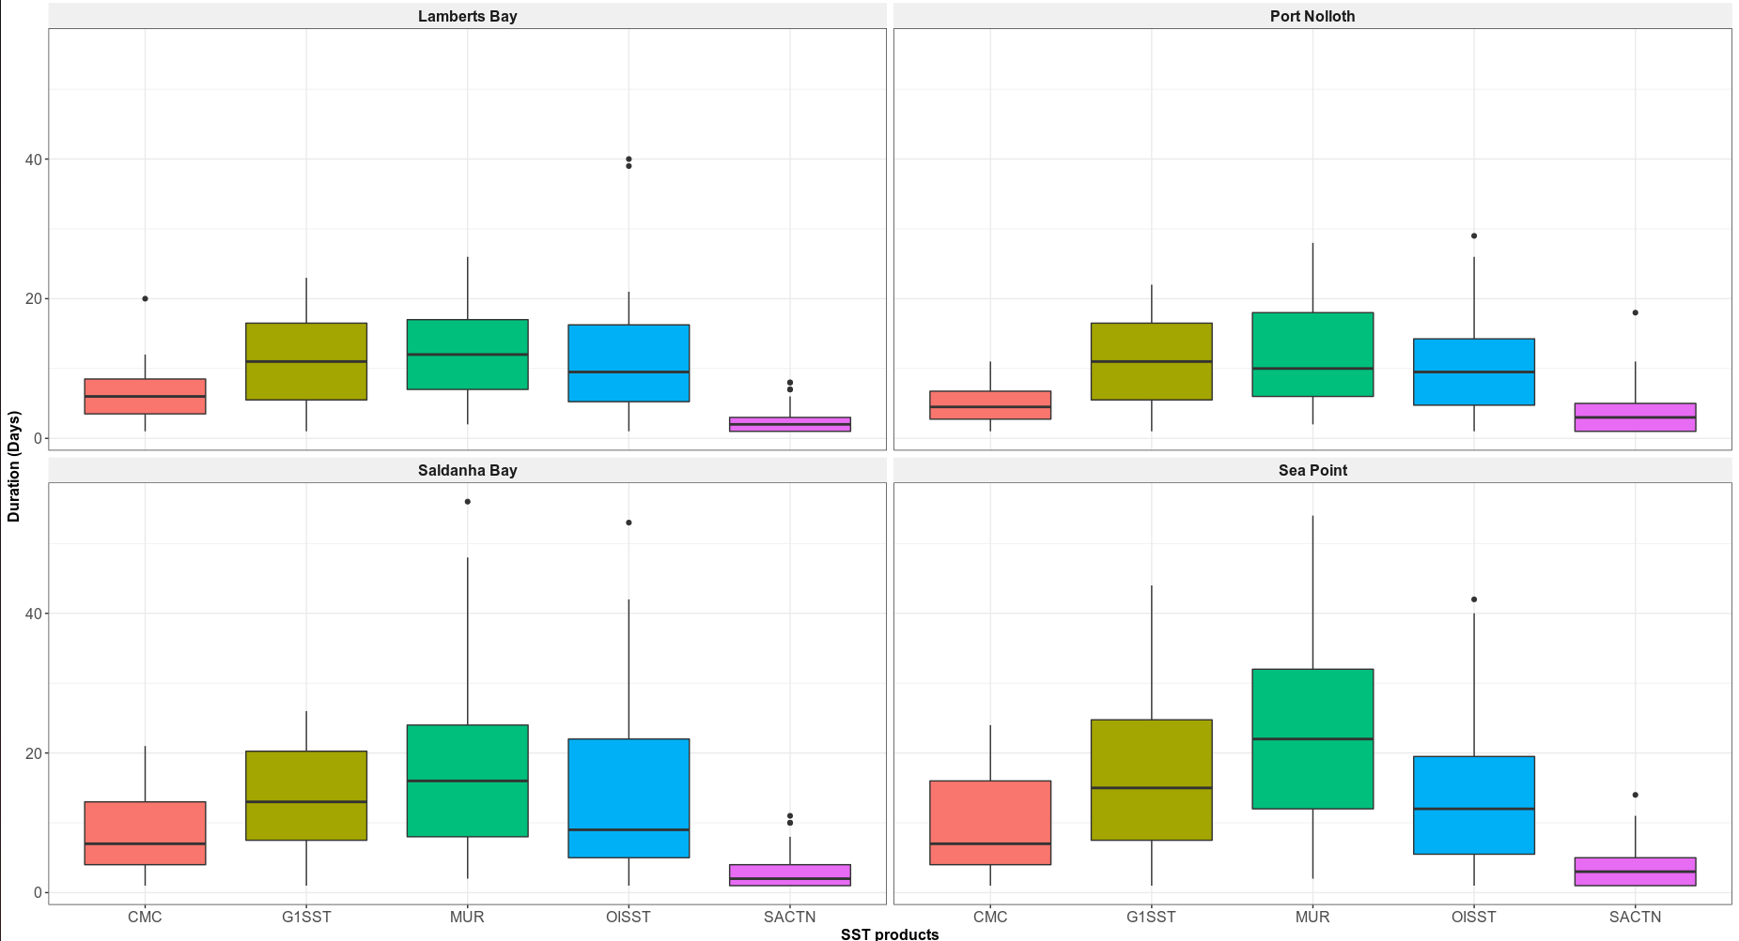
Fig.2. Graph showing the duration for each of the signals detected for the four satellite products and the SACTN in situ collected data for the summer months (December, January and February) over a four year period.

The durations of upwelling signals detected at each site were not uniformly detected across the five data products (Fig 2). At both Lamberts Bay and Port Nolloth, the durations of upwelling signals were noticeably lower to those of Saldanha Bay and Sea Point respectively, and appeared to last for a shorter number of days overall. Additionally, signal duration in Lamberts Bay and Port Nolloth both had narrower ranges to those of Saldanha Bay and Sea Point respectively across each of the data products.

Variation of the number of upwelling signals detected across all data products at each site also showed noticeable differences. The median upwelling duration at Lamberts Bay did not exceed 10 days. However, the ranges varied per product with the MUR dataset exhibiting the widest range as well as the maximum duration in comparison to other products. The CMC and SACTN products had relatively similar ranges, but the SACTN dataset had more outliers present. Conversely, Port Nolloth showed no major differences in detected durations between data products. The median duration of signals exceeded 10 days in the G1SST and MUR data products. A slight overlap was present in the overall ranges in the G1SST, MUR and OISST products. Here the OISST and MUR dataset also showed a large variance in maximum duration range.

Saldanha Bay showed differences in durations of signals detected between data products. Here, the OISST and MUR datasets both had comparatively larger medians, maximums, and overall ranges to the CMC and SACTN datasets respectively. In Sea Point the MUR data product represented the widest range, highest maximum and highest median, indicating that it has the greatest fluctuations in duration length. SACTN had a comparatively narrow overall range suggesting a high level of agreement in duration length between events and therefore greater consistency. CMC and OISST datasets were relatively similar but CMC has a lower median.

Table 1
A pairwise correlation coefficient of the relationship between the number of signals collected at a distance of 0 km versus a distance of 25 km from the coastline and a correlation between the number of signals at 0 km and 50 km from the coastline.

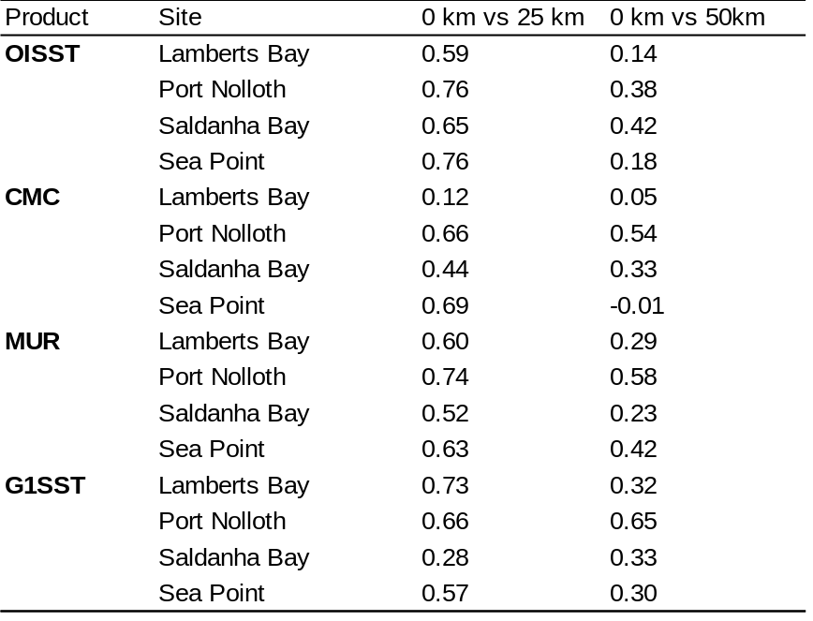

The OISST data for Lamberts Bay found to have a positive correlation between the number of upwelling signals at 0 km and 25 km away from the coastline (r = 0.59; Table 1). However, this relationship was not present further from the coastline as there was no apparent correlation in upwelling signals between 0 km and 50 km from the coastline (r = 0.14). At Port Nolloth and Sea Point a very high positive correlation was found to exist between the number of signals at 0 km and 25 km from the coastline (r = 0.76; r = 0.76) and again a poor correlation at 0 km and 50 km respectively (r = 0.38; r = 0.18). Saldanha Bay showed a similarly high correlation between upwelling signals at 0 km and 25 km (r = 0.65), but also had the highest rate of correlation for upwelling signals at 0 km and 50 km (r = 0.42).

The CMC data showed similar patterns to the OISST data with positive correlations between the number of upwelling signals at a distance of 0 km and 25 km from the coastline. Lamberts Bay had a low correlation (r = 0.12) at 0 km and 25 km from the coastline but when comparing the amount of signals detected at 0 km and 50 km the correlation was lower still (r = 0.05). Similar patterns are presented for Port Nolloth and Saldanha Bay with each having a stronger correlation at 0 km and 25 km, as well as 0 km and 50 km (Table 1), with the strongest correlation of r = 66 at 0 km and 25 km. At Sea Point however, a strong correlation was found between the number of upwelling signals at 0 km and 25 km (r = 0.69) but at a distance of 0 km and 50 km from the shore we see a negative correlation value (r = - 0.01).

The MUR data for Lamberts Bay (r = 0.60), Port Nolloth (r = 0.74) , Saldanha Bay (r = 0.52) and Sea Point (r = 0.63) all displayed relatively strong positive correlation between upwelling signals at 0 km and 25 km from the coastline. At Lamberts Bay and Saldanha Bay a poor correlation exists between 0 km and 50 km, r = 0.29 and r = 0.23 respectively. For the G1SST products we see similar patterns with Lamberts Bay having the strongest correlation (r = 0.73) in upwelling signals between 0 km compared to 25 km (r = 0.65). Port Nolloth shows a values of r = 0.66 at 0 km and 25 km and r = 0.65 between 0 km and 50 km. Saldanha Bay had a weaker correlation in upwelling signals at 0 km and 25 km (r = 0.28) and a stronger correlation at 0 km and 50 km (r = 0.33) within the G1SST dataset.

When comparing the number of upwelling signals at the various distances from the coastline (Table 2) it was observed that the number of signals detected in the OISST data decreased with an increase in distance from the coast. In the OISST product, 225 upweling signals were detected at a distance of 0 km from the coast, 221 signals were detected at a distance of 25 km and 179 signals were observed at the final distance of 50 km. However, the remaining products shows an increase in signals detected with an increase in distance from the coastline. At a distance of 0 km 222 signals were detected, the highest number of signals detected (240 signals) occurred at a distance of 25 km from the coastline, at distance of 50 km however, we see a slight increase in signals detected, with 225 signals. Far fewer signals were detected in the CMC dataset and these signals showed an increase in the number of signals as distance from the coastline increased. At a distance of 0 km, 141 signals were detected, at a distance of 50 km, 169 signals were detected. The G1SST dataset represented the highest number of signals detected and showed similar to the OISST dataset, the number of signals detected decreased as the distance from the coastline increased. A total of 353 signals detected at a distance of 0 km from the coastline, at a distance of 25 km 355 signals were detected with a final 335 upwelling signals observed at a distance of 50 km from the coastline.

The comparison of the upwelling metrics revealed that there was an overall significant difference between the durations of upwelling signals collected from the different products (Three-Way ANOVA: F = 7.31, SS = 1111, p <0.001), at the different distances (F = 4.40, SS = 223, p <0.03) and across the different sites (F = 6.34, SS = 963, p <0.001). The mean intensity of upwelling events also differed between data products (F = 52.16, SS = 40.5, p <0.05) and across sites (F = 41.58, SS = 32.30, p <0.05), as well as at different distances from the coastline (F = 265.35, SS = 68.70, p <0.002). Similarly, there were also a significant differences between the average cumulative intensity of signals detected across data products (F = 22.30, SS = 10604, p <0.001). This same pattern was present between sites (F = 2.722, SS = 1294, p = 0.001) and also between distances from the coastline (F = 44.66, SS = 7078, p <0.001).

Table 2
The number of upwelling signals detected in each of the SST products. The distance column indicates the various distances from the coastline (0, 25 and 50 km) as seen in Fig.1. The signal column indicates the number of signals detected at each of these distances.

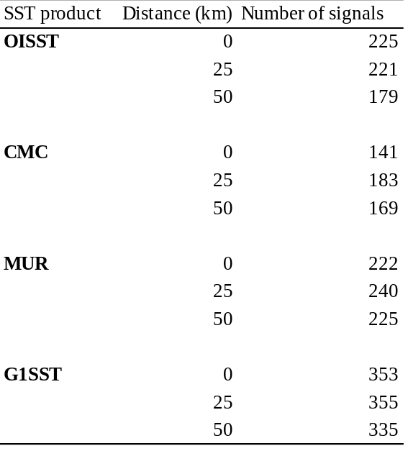

4. Discussion
We report here that upwelling signals detected by the highest resolution data, specifically those collected on a 0.01° grid (G1SST and MUR) displayed signals lasting for a longer duration when compared directly to the CMC, OISST and SACTN data products. Analysis of the OISST, CMC and SACTN datasets revealed that recorded signals often did not exceed a duration of 10 days. Additionally, the G1SST and MUR data products also showed a high abundance of signals detected at a duration of less than, or equal to 10 days. Furthermore, highest number of signals detected, were recorded
by the MUR and G1SST data products. This may be due to the errors in any satellite Level 4 product, that are a result of accumulation of errors from different sources, as well as the quantification of one component sampling error and thus requires us to focus on this error source alone (Liu et al., 2013).

MUR and G1SST products were the data sources that yield upwelling signals with the longest duration, often exceeding 10 days; the MUR and G1SST data products both rely heavily on satellite data sources whereas the CMC and OISST products are generated from a broader spectrum of data collection methods using multiple sources of satellite and in situ collected dataset. As a result, the MUR and G1SST products are more likely to be affected by contamination from clouds and aerosols (Ricciardulli et al., 2004). Consequently, the durations of upwelling signals derived from these products may be falsely detected at exaggerated lengths. On the other hand, datasets constructed from multiple data sources, particularly from ships and buoys, are inherently more reliable in terms of reducing the frequency of falsely detecting signals. The extended duration of upwelling signals detected by MUR and G1SST may be as a result of the microwave frequencies where land surfaces have a higher emissivity (0.9) compared to the ocean (0.4). Microwave observations in the proximity of land are affected by the warm emission of land entering the antenna near-in side-lobes. This warming of the microwave brightness temperatures is a source of errors in the TMI retrievals of coastal waters. Since infrared retrievals are not affected by land emission (if retrieved at least a few kilometres from the coast) (Ricciardulli et al., 2004). However, microwave instruments are able to retrieve SSTs in non-precipitating cloud-covered regions where IR instruments cannot (Wentz et al., 2001).

It is also evident that signals detected at a distance of 0 km from the coastline are often the same signal detected at the 25 km region. However, if a signal is detected at a distance of 0 km of the coast, it is rare that the corresponding signal will be identified at a distance 50 km. Thus it is preferable to obtain satellite SST as close as possible to the shoreline in order to identify when coastal upwelling is occuring. However, it should also be noted, that the use of SST pixels that transgress the land/sea boundary is always bad practice, and often this approach is not encouraged (Tang et al., 2003). Additionally, our findings reveal that signal count within the OISST and MUR datasets, decreases with an increase in distance from the coastline. Conversely, the G1SST and CMC datasets displayed an increase in upwelling signals with an increase in distance from the shoreline. Furthermore, it was also evident that dissimilarities existed between products and sites when comparing the upwelling metrics. This may be due to the occasional satellite instrument outages such as result from satellite manoeuvres, or specifically with the MUR dataset, MUR pixel are identified as cloudy or fall in the inter-swath gap. The presence of clouds causes gaps in the data. Gaps between successive swaths of some sensors also lead to sampling errors. Sensors with narrower swaths are subject to a larger gap than others. MUR has unresolved SST variability on scales of 25 km in regions where extensive clouds are present, due to only microwave SSTs being used. Using microwave SSTs can reduce the sampling error caused by clouds, but there are sampling errors caused by precipitation. It is also possible that less upwelling signals are being detected close to the coastline in the CMC and G1SST dataset because of land heating thus increasing the SST and making upwelling not detectable (Ricciardulli et al., 2004).

It is important to note that the data sources are intrinsically different in the ways in which they were obtained or recorded. Consequently, one should not be too surprised to find large discrepancies; for example the SACTN in situ collected SST product will reflect actual temperature of the water being measured, however instrumental differences exist; for example, whether the data were collected using a thermometer or an electric sensor. Satellite temperatures however, are collected remotely and sensors never have contact with the water. Here, bio-physical properties of IR and MW are related through complex algorithms to temperature (Minnett et al., 2002). Smit et al (2013) showed that warm and cold biases exist along the southern and western coastal region of South Africa, and the juncture between upwelling and non-upwelling regions have a tendency to influence on the variability and magnitude of the SST bias.

When comparing SST products, a small bias does indeed exist, and is a result of solar flux, cloud cover as well as wind strength (Dufois et al. 2012). In conclusion the different data products, as used within this study, over the same geographical region, specifically the Benguela upwelling system have yielded different results. While flagging techniques are supposed to occasionally flag good values (Kilpatrick et al., 2001), it was found that flagging may occasionally be too vigorous for EBUS (Dufois et al., 2012). For example, the flagging method used on an OISST reference test induces warm coastal bias in data from both the MUR and G1SST data during summer. It should, however be noted that this phenomenon can be explained by strong coastal SST gradients in these upwelling regions.

In the Benguela Upwelling system, as in many global regions, systematic, high resolution and wide coverage data sets of meteorological and oceanographic measurements are lacking. Global model outputs, reconstruction and reanalysis of datasets are potential solutions to this problem and thus provide data when none or only sparse information is available. Remotely sensed infrared SSTs have become a major data source and are instrumental in both oceanographic and atmospheric research (Dong et al., 2006). Despite the many factors that can influence how well the SST products reflect the climatological reality, these SSTs do show high degrees of correspondence with measurements obtained by buoys and other sources of in situ seawater temperatures measurements (Smit et al., 2013; Donlon et al., 2002). However, although SST products developed offshore and within the oceanic regions are being applied to the coastal regions, reports exist to inform users to exercise caution when using SST datasets in these coastal regions (Tittensor et al., 2010; Tyberghein et al., 2011). Warm and cold biases have already been reported in several regions such as Australia (Blanchette et al., 2008), South Africa (Dufois et al., 2012) and China (Tang et al., 2003).

It must, be kept in mind that variability does indeed exist, as described here in; the use of these products are dependent on their quality as well as homogeneity of the data. The spatial incompleteness and low accuracy problems associated with satellite SSTs limit product applications in oceanographic analyses, as well as air-sea temperature interaction studies. It is also evident that several physical processes such as inshore hydrodynamics operate in the mixed layer situated at the coastal region, and this may not be clearly detected by satellite temperature sensors. These processes include convection mixing due to cooling through evaporation, as well as tidal mixing and the injection of turbulence through breaking waves. Although progress in the analysis of sea surface temperature has been substantial in recent years, challenges do however remain. Improvements to the analyses are needed in areas where variability is substantial and sudden, namely near ocean fronts. Increased resolution and incorporation of in situ data would be among the avenues likely to yield a gain in accuracy within these areas (Brasnett Bruce, 2008). Studies often make use of broad scale phenomenon to define processes in the nearshore regions and vice versa; however, as illustrated within this study, events in the coastal region do not always coincide with or reflect those events of the offshore regions and vice versa.

Ample evidence suggests that satellite SST alone are not idea for coastal applications due to the presence of large biases. Contributing towards the magnitude of the biases are factors such as coastal proximity, presence of upwelling and coastal embayments. The coarser resolution of many existing SST products clearly has limitations in dynamic coastal regions, and the sampling capabilities in combination with the higher fidelity of moored buoys offer the potential for improving SST parameterizations in these regions. By excluding moored coastal buoys when merging multi-sensor SSTs, high- resolution analyses risk erroneously estimating the magnitude of the coastal SSTs; ultimately suppressing the high variability associated with small-scale processes in the coastal oceans. Data products representing upwelling signals with a duration exceeding 10 days may likely be related to an incorrect flagging of pixels affected by diurnal warming.

Finally, concerns about satellite temperature accuracy changes in the ocean should make the accurate monitoring of seawater temperature a priority. Our results demonstrate that upwelling signals are more accurately detected at a distance of 0 and 25 km from the coastline and that MUR and G1SST data products have detected (albeit potentially erroneously) more upwelling signals lasting for longer durations.

References

Bakun, A. 1990. Global climate change and intensification of coastal ocean upwelling. Science, 247(4939), pp.198-201.

Bakun, A., Field, D. B., Redondo‐Rodriguez, A.N.A. and Weeks, S .J. (2010). Greenhouse gas, upwelling‐favorable winds, and the future of coastal ocean upwelling ecosystems. Global Change Biology, 16(4), pp.1213-1228.

Bakun, A., Black, B. A., Bograd, S. J., Garcia-Reyes, M., Miller, A. J., Rykaczewski, R. R. and Sydeman, W. J. (2015). Anticipated effects of climate change on coastal upwelling ecosystems. Current Climate Change Reports, 1(2), pp.85-93.

Brasnett, B. (200)8. The impact of satellite retrievals in a global sea‐surface‐temperature analysis. Quarterly Journal of the Royal Meteorological Society, 134(636), pp.1745-1760.

Brown, O. B., Brown, J. W. and Evans, R. H. (1985). Calibration of advanced very high resolution radiometer infrared observations. Journal of Geophysical Research: Oceans, 90(C6), pp.11667-11677.

Bulgin, C.E., Embury, O. and Merchant, C. J. (2016). Sampling uncertainty in gridded sea surface temperature products and Advanced Very High Resolution Radiometer (AVHRR) Global Area Coverage (GAC) data. Remote Sensing of Environment, 177, pp.287-294.

Chao, Y., Li, Z., Farrara, J. D. and Hung, P. (2009). Blending sea surface temperatures from multiple satellites and in situ observations for coastal oceans. Journal of atmospheric and oceanic technology, 26(7), pp.1415-1426.

Donlon, C. J., Martin, M., Stark, J., Roberts-Jones, J., Fiedler, E. and Wimmer, W. (2012). The operational sea surface temperature and sea ice analysis (OSTIA) system. Remote Sensing of Environment, 116, pp.140-158.

Fielding, P. J. and Davis, C. L. (1989). Carbon and nitrogen resources available to kelp bed filter feeders in an upwelling environment. Marine Ecology Progress Series, pp.181-189.

Harlass, J., Latif, M. and Park, W. (2015). Improving climate model simulation of tropical Atlantic sea surface temperature: The importance of enhanced vertical atmosphere model resolution. Geophysical Research Letters, 42(7), pp.2401-2408.

HSIEH, W. W. and BOER, G. J. (1992). Global climate change and ocean upwelling. Fisheries Oceanography, 1(4), pp.333-338.

Hutchings, L., Van der Lingen, C. D., Shannon, L. J., Crawford, R. J. M., Verheye, H. M. S., Bartholomae, C. H., Van der Plas, A. K., Louw, D., Kreiner, A., Ostrowski, M. and Fidel, Q. (2009). The Benguela Current: An ecosystem of four components. Progress in Oceanography, 83(1-4), pp.15-32.

Jury, M. R. (1980). Characteristics of summer wind field and air sea interaction over the Cape Peninsula upwelling regions. M.Sc. Thesis. University of Cape Town, South Africa.

Li, A., Bo, Y., Zhu, Y., Guo, P., Bi, J. and He, Y. (2013). Blending multi-resolution satellite sea surface temperature (SST) products using Bayesian maximum entropy method. Remote sensing of environment, 135, pp.52-63.

Lima, F. P. and Wethey, D. S. (2012). Three decades of high-resolution coastal sea surface temperatures reveal more than warming. Nature communications, 3(1), pp.1-13.

Mead, A., Griffiths, C. L., Branch, G. M., McQuaid, C. D., Blamey, L. K., Bolton, J. J., Anderson, R. J., Dufois, F., Rouault, M., Froneman, P. W. and Whitfield, A. K. (2013). Human-mediated drivers of change—impacts on coastal ecosystems and marine biota of South Africa. African Journal of Marine Science, 35(3), pp.403-425.

Mesias, J. M., Bisagni, J. J. and Brunner, A. M. (2007). A high-resolution satellite-derived sea surface temperature climatology for the western North Atlantic Ocean. Continental Shelf Research, 27(2), pp.191-207.

Minnett, P. J. (1991). Consequences of sea surface temperature variability on the validation and applications of satellite measurements. Journal of Geophysical Research: Oceans, 96(C10), pp.18475-18489.

Mote, P. W. and Mantua, N. J. (2002). Coastal upwelling in a warmer future. Geophysical research letters, 29(23), pp.53-1.

Murawski, S. A. (1993). Climate change and marine fish distributions: forecasting from historical analogy. Transactions of the American Fisheries Society, 122(5), pp.647-658.

Parinussa, R. M., de Jeu, R. A., Holmes, T. R. and Walker, J. P. (2008). Comparison of microwave and infrared land surface temperature products over the NAFE'06 research sites. IEEE Geoscience and Remote Sensing Letters, 5(4), pp.783-787.

Pauly, D. and Christensen, V. (1995). Primary production required to sustain global fisheries. Nature, 374(6519), pp.255-257.

Rayner, N. A., Brohan, P., Parker, D. E., Folland, C. K., Kennedy, J. J., Vanicek, M., Ansell, T. J. and Tett, S. F. B. (2006). Improved analyses of changes and uncertainties in sea surface temperature measured in situ since the mid-nineteenth century: The HadSST2 dataset. Journal of Climate, 19(3), pp.446-469.

Reynolds, R. W. and Smith, T. M. (1994). Improved global sea surface temperature analyses using optimum interpolation. Journal of climate, 7(6), pp.929-948.

Reynolds, R. W. and Smith, T. M. (1995). A high-resolution global sea surface temperature climatology. Journal of Climate, 8(6), pp.1571-1583.

Reynolds, R. W., Rayner, N. A., Smith, T. M., Stokes, D. C. and Wang, W. (2002). An improved in situ and satellite SST analysis for climate. Journal of climate, 15(13), pp.1609-1625.

Reynolds, R. W. and Chelton, D. B. (2010). Comparisons of daily sea surface temperature analyses for 2007–08. Journal of climate, 23(13), pp.3545-3562.

Reynolds, R. W., Chelton, D. B., Roberts-Jones, J., Martin, M. J., Menemenlis, D. and Merchant, C. J. (2013). Objective determination of feature resolution in two sea surface temperature analyses. Journal of climate, 26(8), pp.2514-2533.

Ricciardulli, L. and Wentz, F. J. (2004). Uncertainties in sea surface temperature retrievals from space: Comparison of microwave and infrared observations from TRMM. Journal of Geophysical Research: Oceans, 109(C12).

Robinson, I. S., Wells, N. C. and Charnock, H. (1984). The sea surface thermal boundary layer and its relevance to the measurement of sea surface temperature by airborne and spaceborne radiometers. International Journal of Remote Sensing, 5(1), pp.19-45.

Schlegel, R. W. and Smit, A. J. (2016). Climate change in coastal waters: time series properties affecting trend estimation. Journal of Climate, 29(24), pp.9113-9124.
Schlegel, R. W., Oliver, E. C., Perkins-Kirkpatrick, S., Kruger, A. and Smit, A. J. (2017). Predominant atmospheric and oceanic patterns during coastal marine heatwaves. Frontiers in Marine Science, 4, p.323.

Smith, T. M. and Reynolds, R. W. (1998). A high-resolution global sea surface temperature climatology for the 1961–90 base period. Journal of Climate, 11(12), pp.3320-3323.

Smit, A. J., Roberts, M., Anderson, R. J., Dufois, F., Dudley, S. F., Bornman, T. G., Olbers, J. and Bolton, J. J. (2013). A coastal seawater temperature dataset for biogeographical studies: large biases between in situ and remotely-sensed data sets around the coast of South Africa. PLoS One, 8(12).

Wick, G. A., Emery, W. J. and Schluessel, P. (1992). A comprehensive comparison between satellite‐measured skin and multichannel sea surface temperature. Journal of Geophysical Research: Oceans, 97(C4), pp.5569-5595.

CHAPTER 3
Variation of upwelling signals detected in Eastern Boundry Upwelling Systems

Abstract

Global warming could lead to enhansed sea surface temperture (SST) cooling in EBUS as a result more intense upwelling favourable winds (Bakun, 1990), with likely contrasting implications for biodiversity and conservation within these regions. (Incomplete)

Keywords: Climate change, Upwelling, Seawater temperaturecoastal regions, , Code: R, coastal zone

Introduction

Four major eastern boundary upwelling systems (EBUS) can be recognised; each significantly impacting associated coastal systems. These systems are characterized as vast regions of coastal ocean occurring along the western shores of continents bordering the Pacific and Atlantic Oceans (Bakun, 1990; Pauly and Christensen, 1995; Bakun et al., 2015, Bakun et al., 2010). The EBUS span a wide range of latitudes and are therefore spatially heterogeneous environments; the here referred to systems are the California, Humboldt, Canary and Benguela current systems.

The California current is a broad, comparatively weak and shallow equatorward current spanning from central Baja California Mexico to British Columbian, Canada. Upwelling within this current is more intense within the central/northern California region as well as being highly seasonal within the Washington vicinity. This current is particularly famous for its high fishery and primary production potential.

The Humboldt Current is defined as the largest of the four currents, extending from the tip of the South American continent to the equator; here it connects with the equatorial current. At higher latitudes, coastal upwelling within this system is characterised by a marked seasonal cycle, with the upwelling season beginning in spring and extending throughout summer into the early autumn months. Thus the length of the upwelling season increases as latitude decreases. The Canary current extends from the Iberian Peninsula to West Africa, and is regarded as the most intense and persistent upwelling systems found off Northwest Africa. Lastly the Benguela Current extends from the southeast tip of Africa to Angola, with upwelling being registered as strongest just off the Lüderitz region off Namibia.

The Canary and Humboldt currents, specifically low-latitude currents tend to be net outgassing systems due to their relative warm waters and persistent upwelling, which are typically not fully compensated for by enhanced biological productivity. Mid-latitude systems such as the California and Benguela systems, with colder temperatures and greater biological production capacity become significant sources of carbon dioxide during some seasons. Upwelling greatly influences subsurface waters, vertical mixing as well as temperature changes within the marine environments. This complex interplay of biotic (biological) and abiotic (physical) processes, makes the EBUS of the world a popular focus for scientific research, as they are defined as high productivity regions covering <1% of the ocean area but provide up to 20% of the worlds fishery output. Therefore it is clear these regions provide both lucrative economic as well as significant recreational services to 10’s of millions of people living along these coastlines.

Variability in the biogeochemical properties of upwelled water will influence the ecology and productivity of EBUS. Variability in the rate of upwelling associated with changes in the local wind forcing, ventilation processes or the water pathways that supply the EBUS have the potential to influence oxygen and nutrient levels as well as the CO₂ concentration of upwelled waters. The timing and duration in addition to the intensity of coastal upwelling are known to have a critical effect in the phenology of key marine ecosystems therefore this research is of importance.

Recognising that the cross-shore atmospheric pressure gradients lead to alongshore, equatorward winds that drive coastal upwelling, Andrew Bakun (2010), proposed a hypothesis that an increase in greenhouse gasses would result in changes of wind patterns and ultimately influencing wind patterns. Global ocean temperatures are however increasing, and are expected to continue increasing as a result of climate change. It is also known that the EBUS sea surface temperatures (SST) are distinctively cooler than offshore regions at similar latitudes due to near-shore upwelling. Global trends of SST may be counteracted by upwelling intensification in the poleward regions of the EBUS. Therefore it is expected that trends in coastal temperature in EBUS will differ from regional and global patterns of temperature change. Thus, there is a continued debate with regards to the impact of climate change on coastal upwelling.

Current scientific consensus is that Global warming has been increasing at an extremely high rate due to a continual increase in atmospheric greenhouse gases, undoubtedly this will continue to impact both oceanic and terrestrial life, as it already has. The process of upwelling is one such factor that is predicted to change with an increase in global warming. The increased duration and intensity of upwelling in the higher latitudes, and the lack of such a trend in the lower latitudes will, as a result reduce the latitudinal gradient that exist within EBUS which would result in profound ecological impacts. On the local scale, climate mediated intensification of upwelling could aid to promote the productivity of marine ecosystems and by extent dependant fisheries, by bringing more nutrient rich waters to the surface. Alternatively, the increase supply in nutrients and poor oxygen water form depth could have adverse effects on marine life by allowing hypoxic conditions to develop over large areas of the coastal ocean causing largescale die-offs.

To assess the changes within the upwelling signals over a period of 30 years, the OISST temperature data and ERA 5 wind data will be used to compare changes in upwelling existing over the past 30 years, in addition to there being any changes in wind patterns over time within the EBUS; given the impact of climate change and hence changes in wind patterns which are predicted to influence the number of upwelling signals detected as well as the intensity of the signals detected. Having assessed the eastern boundary upwelling system within a context that comprised of broad and local-scale features, permitted us to assess if a variation existed within upwelling signals. We hypothesized that climate change resulted in changes in wind patterns and ultimately lead to changes in the duration and intensity of upwelling events overtime.

Methods

2.1 Data

We are specifically interested in observing variations in upwelling signals detected over a period of time. To evaluate if there are changes in duration, frequency and intensity, this study made use of the gridded data of the global 0.25° AVHRR-only Optimally-Interpolated Sea Surface Temperature (OISST). This data is constructed by combining different data collected from satellites, ships and buoys (Reynolds t al., 2007; Banzon et al., 2016). OISST provides global fields that are based on a combination of ocean temperature observations and in situ platforms. This data has been collected for more than four decades hence providing us with a long enough time series from which upwelling metrics and their rate of change can be calculated.

In order to detect variation in upwelling signals and wind patterns among the four EBUS (Bakun, 1990; Bakun et al, 2015), wind speed and direction were deemed as important variables along with temperature. Wind speed and direction variables were downloaded from the ERA5 climate reanalysis produced by ECMWF, providing hourly data on regular latitude-longitude grids at 0.25° x 0.25° resolution. This dataset was used to compute the upwelling index which was used identify when upwelling signals were present.
2.2 Upwelling identification

In order to determine whether changes exist in the frequency and duration of upwelling signals across EBUS it is important to first identify when upwelling was occurring; however, in order to do this a set of upwelling threshold values needed to be established in order to identify when the phenomenon was occurring; because upwelling is affected by wind, both wind and SST data were used. The wind data was used in order to calculate the upwelling index using the formula presented in Fielding and Davis (1989). The index relies on wind speed and wind direction data to determine the presence of upwelling. An upwelling index value of < 0 represents down-welling, and > 0 represents upwelling Fielding and Davis (1989). When the upwelling index > 0 the SST drops, as expected, thus suggesting that upwelling is occurring. This drop in SST that coincided with a positive upwelling index value was close to the seasonal variation of 25th percentile threshold for SST. Thus the SST and upwelling index value was used to determine when an upwelling phenomenon was occurring. It was then necessary to determine the number of consecutive days that must be exceeded for an upwelling signal to be identified as a discrete event. Here it must be noted that upwelling is known to vary on a seasonal basis and may also occur hourly (sub-daily). Therefore, the minimum duration for the classification of an upwelling signal was set as one day. The rationale behind this was that the OISST dataset are collected at a daily resolution. With the upwelling index, temperature and duration thresholds established, the detect_event function from the heatwaveR package (Schlegel et al., 2018) was used to calculate metrics for the upwelling signals. Because upwelling signals were calculated relative to percentile exceedances, rather than an absolute definition such as temperatures below a fixed temperature threshold, these signals could occur any time of the year, however, upwelling was shown to be more dominant during spring and summer months, as expected.

Results

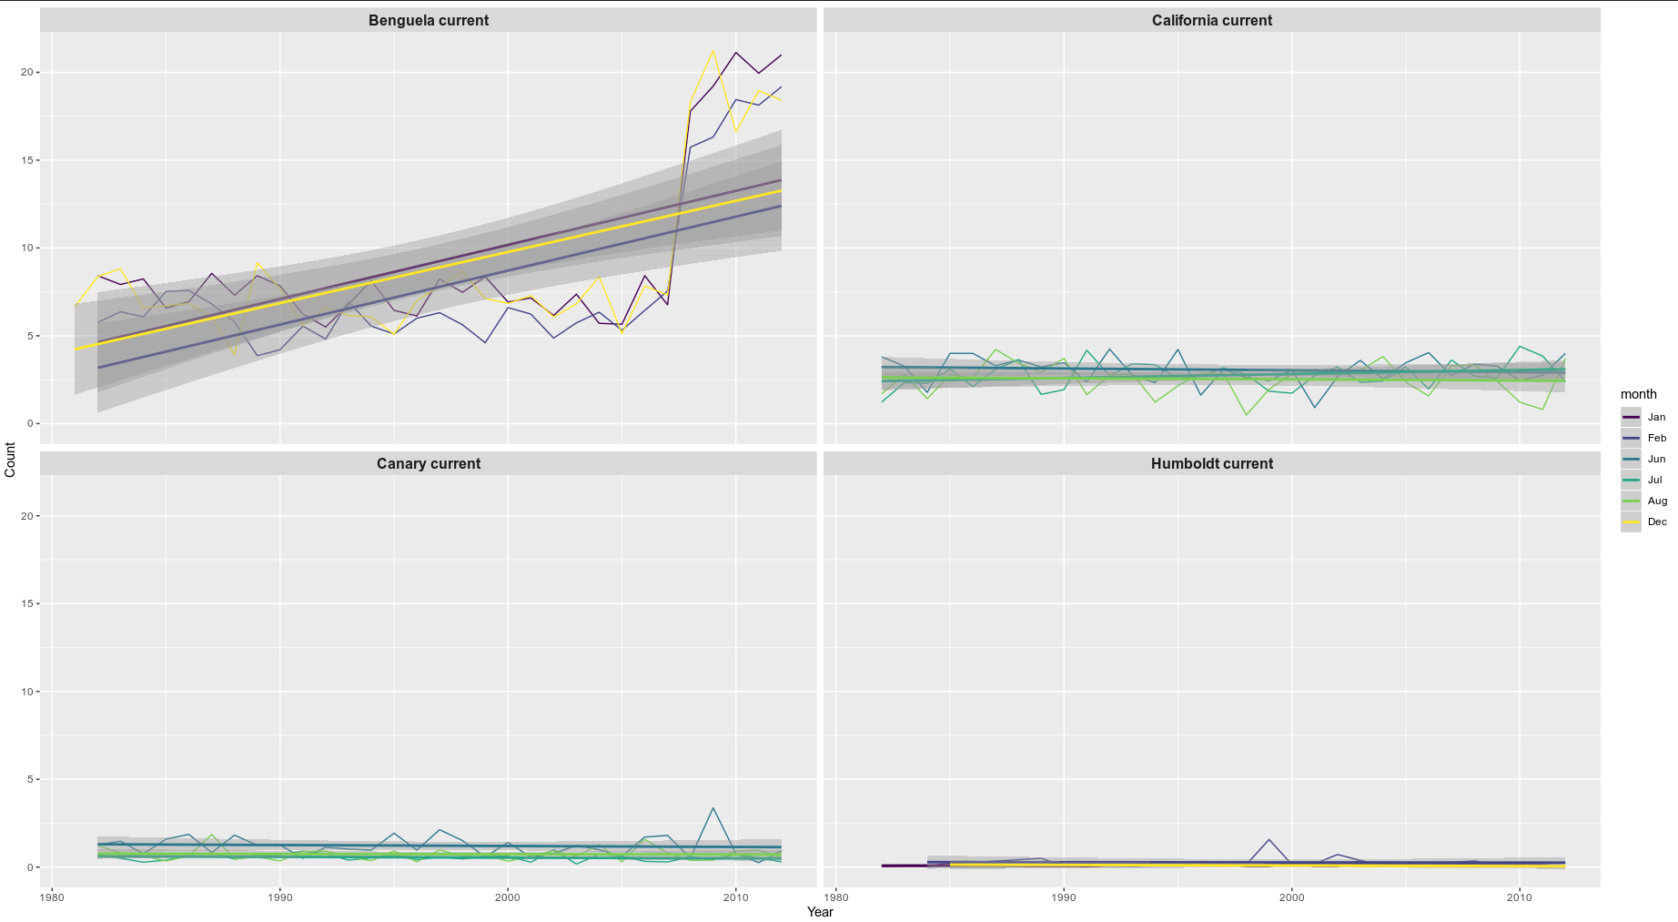
Figure 1: Wind blowing in a south easterly direction over a period of 30 years for the summer months in the southern and northern hemisphere
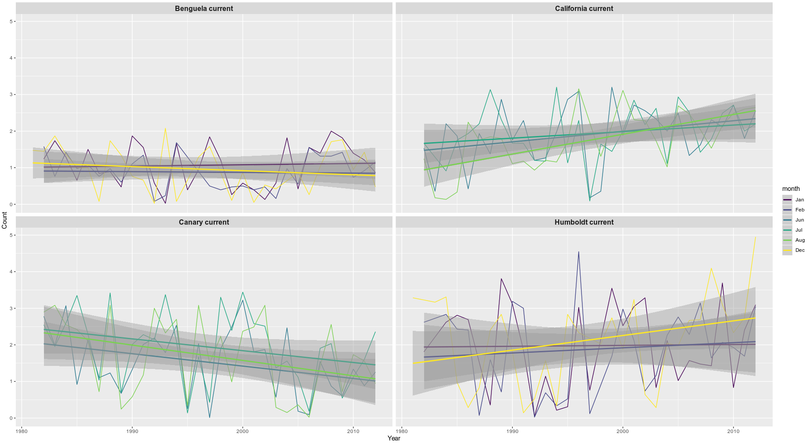
Figure 2: The count represents the number of upwelling signals detected over a period of 30 years for the summer months in the southern and northern hemisphere

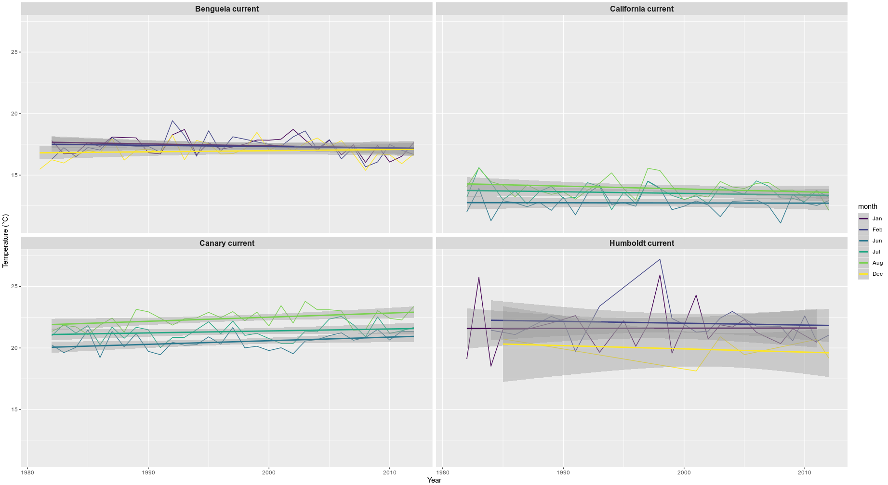
Figure 3: Mean SST for the summer months in the northern and southern hemisphere

ANOVA analyses shows that a significant difference exist (F = 74.02, SS = 178.9, p <0.002) between currents and between years (F = 30.09, SS = 1163.2, p <0.002)

CHAPTER 4 SYNTHESIS AND CONCLUSIONS

Brief summary

The intension behind the two data analyses chapters is briefly outlined under the following subheadings:

Upwelling in various SST products
In the first study of this thesis, we sought to make use of the SACTN in situ collected data and satellite SST products to compare upwelling signals between various SST products and at various distances from the coastline. This study is important in demonstrating the differences between SST products and their varied resolutions. Here upwelling signals are used as a known signal that exist in the data and allows for a known comparison between data products.

Upwelling in the EBUS
After demonstrating and identifying upwelling signals in the first study, the second study aimed to focus on upwelling signals within EBUS. Andrew Bakun, 1990 proposed that an increase in climate change resulting from greenhouse gasses may cause a change in pressure gradient, changing wind patterns and ultimately changing upwelling over prolonged periods of time. This study is important to observe changes in upwelling over a 30 year period and the ecological and economic impact this change has.

Contributions

SST analysis are often products resulting from blends both in situ and satellite analyses; the in situ collected data is used to provide a benchmark for temperature recordings, the satellite analyses is used to define the shape of the final product between the benchmarks. Thus it is proven that blended techniques is effective way to improve satellite coverage with eliminating a large portion of the bias that exist between the in situ and satellite data. Adjustments to correct for in-homogeneities in SSTs in recent years have a large impact on the resulting decadal-scale global temperature trends.

Changes to weather station equipment only had a modest effect over the past two centuries and can be corrected by using the metadata and interstation comparison (Menne and Williams Jr. 2009;Hausfather et al. 2016). By contrast SST have been measured using both floating buoys, insulated buckets, ship sensors, with each of these different systems measuring at different depths (Cowtan et al., 2018). Various methods are used to homogenize sea surface temperature observations, be it the use of metadata in order to determine the method used for a given observation, along with field replication and reconciliation of different observation types to correct for the heterogeneous observation systems (Folland and Parker 1995; Rayner et al., 2006; Kennedy et al. 2011). Another approach to homogenise SST is by making use of night time marine air temperature observation as a reference against which to correct the SST observations from ships. Given the various techniques and data resolution, different data products at different resolutions are predicted to show slight variation in their data.

As seen in chapter 2, the higher resolution data, the MUR and G1SST data products represented the highest number of upwelling signals detected. The signals detected often lasted for longer when compared to the OISST, CMC and SACTN data products. However, even though they detected signals with the longest duration, most of the signals detected lasted for a period of approximately 10 days as seen in the OISST, CMC and SACTN data products. The results also showed that upwelling varies at different distances from the coastline and that the higher resolution data would more likely detect upwelling at a further distance from the coastline compared to the lower resolution data.

The homogenization of the sea surface temperature record is challenging this is often as a result of changing observation platforms and variability in the observation protocol. Metadata and combination of external temperature sources have been used to homogenize the data products used within this thesis, with differing results. This uncertainty is known to arise from under-sampling of variability and the uncertainty in the estimated bias corrections (Rayner et al., 2005). It is also noted that different countries give different advice to their observing fleets concerning how best to measure SST. It has also been shown that modern SST buckets are prone to heat loss, especially when air and sea temperatures differences are large (Kent and Taylor 2006; Kent and Ka-plan 2006). Similarly they also show that engine intake SST has displayed a biased warm trend in the past but has shown a cold bias since the 1990s. Specifically, the MUR data ingests 1-km resolution of MODIS SST, the MUR data also improves the analysed feature resolution y an order of magnitude over most of the existing SST analyses products from approximately 100 km down to 10 km. The MUR data also agrees with the 0.25° ×0.25°-gridded GMPE median SST analysis to 0.36°C on average, where differences among the existing SST analyses are large (Castro et al., 2016). The MUR data product makes use of a MRVA interpolation method (Chin et al., 2014), this method avoids truncation of the geolocation information and preserves intra-grid features. However, differences are large between the data products that make up the MUR dataset and this affects the accuracy of the SST. The other SST products contributing to the MUR SST data product such as the MODIS SST has shown to incorporate a small bias, this is expected due to solar heating in the morning and afternoon. This bias is dependent on solar flux and wind strength (Gentemann et al., 2003). However, while SST flagging techniques are supposed to occasionally flag good values (Kilpatrick et al., 2001), it was found that flagging may be too vigorous and too systematic in upwelling regions, and SST values in some regions are not representative during summer and peak upwelling seasons (Dufois et al., 2012).

A flagging method based on the OISST data induces a warm bias during summer. This is explained by the strong SST gradient in the coastal region that cannot be accurately represented by the large scale OISST product. The warm bias however does not however present the same extent in all EBUS, but also a decrease of this bias is also different in the various systems (Dufois et al., 2012). For example, the southern Benguela, which exhibits the strongest warm bias, presents the strongest zonal SST gradients. On the contrary, in the California system, which presents the weakest climatological zonal SST gradients, the bias is almost completely removed in the new Pathfinder data (Dufois et al., 2012). The presence of aerosols affected satellite SST retrievals as data products often cannot make retrievals during cloud-covered regions which is extremely dominant in the Southern ocean (Dong et al., 2006). Research by Ricciardulli et al. (2004) suggests that both infrared and microwave observation of the ocean temperature can benefit from their comparison. For example, the comparison of SSTs obtained from of a number of IR algorithms with other independent SST observations (TMI, Reynolds OI or buoys) can help identify the optimal IR algorithm in terms of accuracy.

Limitations

The first study in this thesis would have benefited more if a longer time series was used for this comparison between data products. However, data collection for the G1SST data product only started in 2010. This dataset was used because of its high resolution and hence was seen as important for this research. The focus of this chapter, however was not to compare trends in the analyses but rather just to compare differences in SST products. Hence, the length of the time series used here was not critical. The wind data used in this chapter was also provided by the SAWS and lacks meta-data records.

The final study in this thesis was by far the more ambitious of the two. However, we should not have included observation in changes of wind patterns in the second study of this thesis. Although the study of wind and observations in changes overtime is important, this could have been the focus of a separate chapter. The second chapter’s major limitation was in the methodology created by only analysing past signals; a more comprehensive methodology could test random time series for patterns, as well as use other time series in order to better validate the results. We would also suggest that when using high resolution satellite derived SST, or alternatively the use of optimal interpolated data, should be regarded with extreme care in coastal nearshore regions of the EBUS (especially during peak upwelling seasons). Even if the analyses for both of these studies were perfect, we still need to improve both the in situ and satellite observations. There are now new efforts in place to allow for a careful more accurate examination of satellite algorithms and utilise multiple sensors.

Further research

The detect_event() function in the heatwaveR package, providing several metrics used in order to quantify the event, the cumulative intensity is of high importance as this is most relevant ecologically, as it is used to quantify the risk that upwelling may have on the ecosystem. This would then allow one to determine the impact one of the signals on a system. Ultimately this would be of high importance for conservation, as well as studies into food and economic security associated with upwelling. Understanding upwelling, its changes and it’s the effect on coastal systems will prove necessary if coastal ecosystems are to truly be conserved.

More work must also be done on the improvement of the methodology of atmospheric and oceanographic states during upwelling. Specifically, it is of our interest to share the code developed and used within this thesis in order to allow for improvement in usability and reproducibility of this research. Once all of these variables are quantified and inducted into its calculations, this knowledge should then be paired with forecast products to see how effective and accurate this research is. The main goal of this thesis was not to predict events or signals but rather to conduct an investigation into observe changes in upwelling over time and to compare SST products. Ultimately it is hoped forecasting upwelling signals and the adoption of subsequent future policies to better prepare for these phenomena will result in positive economic impacts.

Bibliography
It must be noted that this bibliography contains all of the references for Chapters 1 and 4 only. This may mean that some sources cited in Chapters 2 and 3 are not found here.

Aguilar, E., Auer, I., Brunet, M., Peterson, T.C. and Wieringa, J., 2003. Guidance on metadata and homogenization. Wmo Td, 1186(January 2003), pp.1-53.

Altizer, S., Ostfeld, R.S., Johnson, P.T., Kutz, S. and Harvell, C.D., 2013. Climate change and infectious diseases: from evidence to a predictive framework. science, 341(6145), pp.514-519.

Auad, G., Miller, A. and Di Lorenzo, E., 2006. Long‐term forecast of oceanic conditions off California and their biological implications. Journal of Geophysical Research: Oceans, 111(C9).

Bakun, A., 1990. Global climate change and intensification of coastal ocean upwelling. Science, 247(4939), pp.198-201.

Bakun, A. and Nelson, C.S., 1991. The seasonal cycle of wind-stress curl in subtropical eastern boundary current regions. Journal of Physical Oceanography, 21(12), pp.1815-1834.

Bakun, A., Black, B.A., Bograd, S.J., Garcia-Reyes, M., Miller, A.J., Rykaczewski, R.R. and Sydeman, W.J., 2015. Anticipated effects of climate change on coastal upwelling ecosystems. Current Climate Change Reports, 1(2), pp.85-93.

Barange, M., Gibbons, M.J. and Carola, M., 1991. Diet and feeding of Euphausia hanseni and Nematoscelis megalops (Euphausiacea) in the northern Benguela Current: ecological significance of vertical space partitioning. Marine Ecology Progress Series, pp.173-181.

Barshis, D.J., Sotka, E.E., Kelly, R.P., Sivasundar, A., Menge, B.A., Barth, J.A. and Palumbi, S.R., 2011. Coastal upwelling is linked to temporal genetic variability in the acorn barnacle Balanus glandula. Marine Ecology Progress Series, 439, pp.139-150.

Blamey, L.K., Howard, J.A., Agenbag, J. and Jarre, A., 2012. Regime-shifts in the southern Benguela shelf and inshore region. Progress in Oceanography, 106, pp.80-95.
Brown, O.B., Minnett, P.J., Evans, R., Kearns, E., Kilpatrick, K., Kumar, A., Sikorski, R. and Závody, A., 1999. MODIS infrared sea surface temperature algorithm algorithm theoretical basis document version 2.0. University of Miami, 31, pp.098-33.

Boyd, P.A.S.A.J. and ARMSTRONG, M.J., 1985. The influence of large-scale environmental processes on neritic fish populations in the Benguela Current system. Calif. Coop. Oceanic Fish. Inv. Rep, 26, pp.72-92.

Boyer, D.C. and Hampton, I., 2001. An overview of the living marine resources of Namibia. African Journal of Marine Science, 23, pp.5-35.

Brainard, D.R.M.R.E., NORTON, J.G. and Box831, P.O., 1985. Anomalous warm events in eastern boundary current systems. California Cooperative Oceanic Fisheries Investigations, Report, 26, pp.51-64.

Brooks, K.M., 2005. The effects of water temperature, salinity, and currents on the survival and distribution of the infective copepodid stage of sea lice (Lepeophtheirus salmonis) originating on Atlantic salmon farms in the Broughton Archipelago of British Columbia, Canada. Reviews in Fisheries Science, 13(3), pp.177-204.

Capone, D.G. and Hutchins, D.A., 2013. Microbial biogeochemistry of coastal upwelling regimes in a changing ocean. Nature Geoscience, 6(9), pp.711-717.

Castillo, K.D. and Lima, F.P., 2010. Comparison of in situ and satellite‐derived (MODIS‐Aqua/Terra) methods for assessing temperatures on coral reefs. Limnology and Oceanography: Methods, 8(3), pp.107-117.

Castro, S.L., Wick, G.A. and Steele, M., 2016. Validation of satellite sea surface temperature analyses in the Beaufort Sea using UpTempO buoys. Remote Sensing of Environment, 187, pp.458-475.

Chavez, F.P., Messié, M. and Pennington, J.T., 2010. Marine primary production in relation to climate variability and change.

Chhak, K. and Di Lorenzo, E., 2007. Decadal variations in the California Current upwelling cells. Geophysical Research Letters, 34(14).

Chin, T.M., Vazquez-Cuervo, J. and Armstrong, E.M., 2014. On “gridless” interpolation and subgrid data density. Journal of Atmospheric and Oceanic Technology, 31(7), pp.1642-1652.

Cole, D., 1999. Franz Boas: the early years, 1859-1906. Douglas & McIntyre.

Cowtan, K., Rohde, R. and Hausfather, Z., 2018. Evaluating biases in sea surface temperature records using coastal weather stations. Quarterly Journal of the Royal Meteorological Society, 144(712), pp.670-681.

Cury, P.M., Shannon, L.J., Roux, J.P., Daskalov, G.M., Jarre, A., Moloney, C.L. and Pauly, D., 2005. Trophodynamic indicators for an ecosystem approach to fisheries. ICES Journal of Marine Science, 62(3), pp.430-442.

Cushing, D.H., 1971. Upwelling and the production of fish. In Advances in marine biology (Vol. 9, pp. 255-334). Academic Press.

Demarcq, H., 2009. Trends in primary production, sea surface temperature and wind in upwelling systems (1998–2007). Progress in Oceanography, 83(1-4), pp.376-385.

Dell, A.I., Pawar, S. and Savage, V.M., 2014. Temperature dependence of trophic interactions are driven by asymmetry of species responses and foraging strategy. Journal of Animal Ecology, 83(1), pp.70-84.3.

Doney, S.C., Ruckelshaus, M., Duffy, J.E., Barry, J.P., Chan, F., English, C.A., Galindo, H.M., Grebmeier, J.M., Hollowed, A.B., Knowlton, N. and Polovina, J., 2011. Climate change impacts on marine ecosystems.

Dong, S., Gille, S.T., Sprintall, J. and Gentemann, C., 2006. Validation of the Advanced Microwave Scanning Radiometer for the Earth Observing System (AMSR‐E) sea surface temperature in the Southern Ocean. Journal of Geophysical Research: Oceans, 111(C4).

Dufois, F., Penven, P., Whittle, C.P. and Veitch, J., 2012. On the warm nearshore bias in Pathfinder monthly SST products over Eastern Boundary Upwelling Systems. Ocean Modelling, 47, pp.113-118.

Duncombe Rae, C.M., 1991. Agulhas retroflection rings in the South Atlantic Ocean: an overview. South African Journal of Marine Science, 11(1), pp.327-344.

Fennel, W., 1999. Theory of the Benguela upwelling system. Journal of Physical Oceanography, 29(2), pp.177-190.

Folland, C.K. and Parker, D.E., 1995. Correction of instrumental biases in historical sea surface temperature data. Quarterly Journal of the Royal Meteorological Society, 121(522), pp.319-367.

Friedland, K.D. and Hare, J.A., 2007. Long-term trends and regime shifts in sea surface temperature on the continental shelf of the northeast United States. Continental Shelf Research, 27(18), pp.2313-2328.

Gammelsrød, T., Bartholomae, C.H., Boyer, D.C., Filipe, V.L.L. and O’toole, M.J., 1998. Intrusion of warm surface water along the Angolan Namibian Coast in February–March 1995: the 1995 Benguela niño. African Journal of Marine Science, 19.

García-Reyes, M., Sydeman, W.J., Schoeman, D.S., Rykaczewski, R.R., Black, B.A., Smit, A.J. and Bograd, S.J., 2015. Under pressure: climate change, upwelling, and eastern boundary upwelling ecosystems. Frontiers in Marine Science, 2, p.109.

Goodwin, C.E., Strain, E.M., Edwards, H., Bennett, S.C., Breen, J.P. and Picton, B.E., 2013. Effects of two decades of rising sea surface temperatures on sublittoral macrobenthos communities in Northern Ireland, UK. Marine environmental research, 85, pp.34-44.

Graham, W.M. and Largier, J.L., 1Bakun, A. and Nelson, C.S., 1991. The seasonal cycle of wind-stress curl in subtropical eastern boundary current regions. Journal of Physical Oceanography, 21(12), pp.1815-1834.997. Upwelling shadows as nearshore retention sites: the example of northern Monterey Bay. Continental Shelf Research, 17(5), pp.509-532.

Gruber, N., 2011. Warming up, turning sour, losing breath: ocean biogeochemistry under global change. Philosophical Transactions of the Royal Society A: Mathematical, Physical and Engineering Sciences, 369(1943), pp.1980-1996.

Harley, C.D., Randall Hughes, A., Hultgren, K.M., Miner, B.G., Sorte, C.J., Thornber, C.S., Rodriguez, L.F., Tomanek, L. and Williams, S.L., 2006. The impacts of climate change in coastal marine systems. Ecology letters, 9(2), pp.228-241.

Hausfather, Z., Cowtan, K., Menne, M.J. and Williams Jr, C.N., 2016. Evaluating the impact of US historical climatology network homogenization using the US climate reference network. Geophysical Research Letters, 43(4), pp.1695-1701.

Hoegh-Guldberg, O. and Bruno, J.F., 2010. The impact of climate change on the world’s marine ecosystems. Science, 328(5985), pp.1523-1528.

Hofmann, M. and Schellnhuber, H.J., 2009. Oceanic acidification affects marine carbon pump and triggers extended marine oxygen holes. Proceedings of the National Academy of Sciences, 106(9), pp.3017-3022.
HSIEH, W.W. and BOER, G.J., 1992. Global climate change and ocean upwelling. Fisheries Oceanography, 1(4), pp.333-338.

Hutchings, L., Van der Lingen, C.D., Shannon, L.J., Crawford, R.J.M., Verheye, H.M.S., Bartholomae, C.H., Van der Plas, A.K., Louw, D., Kreiner, A., Ostrowski, M. and Fidel, Q., 2009. The Benguela Current: An ecosystem of four components. Progress in Oceanography, 83(1-4), pp.15-32.

Jacox, M.G. and Edwards, C.A., 2012. Upwelling source depth in the presence of nearshore wind stress curl. Journal of Geophysical Research: Oceans, 117(C5).

Jacox, M.G., Hazen, E.L., Zaba, K.D., Rudnick, D.L., Edwards, C.A., Moore, A.M. and Bograd, S.J., 2016. Impacts of the 2015–2016 El Niño on the California Current System: Early assessment and comparison to past events. Geophysical Research Letters, 43(13), pp.7072-7080.

Jarraud, M., 2008. Guide to meteorological instruments and methods of observation (WMO-No. 8). World Meteorological Organisation: Geneva, Switzerland, 29.

Jarre, A., Moloney, C.L., Shannon, L.J., Fréon, P., Van der Lingen, C.D., Verheye, H.M., Hutchings, L., Roux, J.P. and Cury, P., 2006. 11 Developing a basis for detecting and predicting long-term ecosystem changes. In Large Marine Ecosystems (Vol. 14, pp. 239-272). Elsevier.

Kennedy J, Rayner N, Smith R, Parker D, Saunby M. 2011a. Reassessing biases and other uncertainties in sea surface temperature observations temperature measurement and sampling uncertainties. data release description and methods. Journal of Geophysical Research Atmospheres 116(14), doi:10.1029/2010JD015218.

Kent, E.C. and Kaplan, A., 2006. Toward estimating climatic trends in SST. Part III: Systematic biases. Journal of Atmospheric and Oceanic Technology, 23(3), pp.487-500.

Kuzmina, S.I., Bengtsson, L., Johannessen, O.M., Drange, H., Bobylev, L.P. and Miles, M.W., 2005. The North Atlantic Oscillation and greenhouse‐gas forcing. Geophysical Research Letters, 32(4).

Levitus, S., Antonov, J.I., Boyer, T.P. and Stephens, C., 2000. Warming of the world ocean. Science, 287(5461), pp.2225-2229.

Lewandowska, A.M., Boyce, D.G., Hofmann, M., Matthiessen, B., Sommer, U. and Worm, B., 2014. Effects of sea surface warming on marine plankton. Ecology letters, 17(5), pp.614-623.

Lima, F.P. and Wethey, D.S., 2012. Three decades of high-resolution coastal sea surface temperatures reveal more than warming. Nature communications, 3(1), pp.1-13.

Little, M.G., Schneider, R.R., Kroon, D., Price, B., Summerhayes, C.P. and Segl, M., 1997. Trade wind forcing of upwelling, seasonally, and Heinrich events as a response to sub‐Milankovitch climate variability. Paleoceanography, 12(4), pp.568-576.

Lord, J.P., 2017. Impact of seawater temperature on growth and recruitment of invasive fouling species at the global scale. Marine ecology, 38(2), p.e12404.

Lutjeharms, J.R.E. and Meeuwis, J.M., 1987. The extent and variability of South-East Atlantic upwelling. South African Journal of Marine Science, 5(1), pp.51-62.

Lutjeharms, J.R.E., Penven, P. and Roy, C., 2003. Modelling the shear edge eddies of the southern Agulhas Current. Continental Shelf Research, 23(11-13), pp.1099-1115.

Martin, M., Dash, P., Ignatov, A., Banzon, V., Beggs, H., Brasnett, B., Cayula, J.F., Cummings, J., Donlon, C., Gentemann, C. and Grumbine, R., 2012. Group for High Resolution Sea Surface temperature (GHRSST) analysis fields inter-comparisons. Part 1: A GHRSST multi-product ensemble (GMPE). Deep Sea Research Part II: Topical Studies in Oceanography, 77, pp.21-30.

McCauley, D.J., Pinsky, M.L., Palumbi, S.R., Estes, J.A., Joyce, F.H. and Warner, R.R., 2015. Marine defaunation: animal loss in the global ocean. Science, 347(6219), p.1255641.

McGillicuddy, D.J., Robinson, A.R., Siegel, D.A., Jannasch, H.W., Johnson, R., Dickey, T.D., McNeil, J., Michaels, A.F. and Knap, A.H., 1998. Influence of mesoscale eddies on new production in the Sargasso Sea. Nature, 394(6690), pp.263-266.

Mead, A., Griffiths, C.L., Branch, G.M., McQuaid, C.D., Blamey, L.K., Bolton, J.J., Anderson, R.J., Dufois, F., Rouault, M., Froneman, P.W. and Whitfield, A.K., 2013. Human-mediated drivers of change—impacts on coastal ecosystems and marine biota of South Africa. African Journal of Marine Science, 35(3), pp.403-425.

Menne, M.J. and Williams Jr, C.N., 2009. Homogenization of temperature series via pairwise comparisons. Journal of Climate, 22(7), pp.1700-1717.

Mote, P.W. and Mantua, N.J., 2002. Coastal upwelling in a warmer future. Geophysical research letters, 29(23), pp.53-1.

Murawski, S.A., 1993. Climate change and marine fish distributions: forecasting from historical analogy. Transactions of the American Fisheries Society, 122(5), pp.647-658.

Nerem, R.S., Chambers, D.P., Leuliette, E.W., Mitchum, G.T. and Giese, B.S., 1999. Variations in global mean sea level associated with the 1997–1998 ENSO event: Implications for measuring long term sea level change. Geophysical research letters, 26(19), pp.3005-3008.

Nelson, G. and Hutchings, L., 1983. The Benguela upwelling area. Progress in Oceanography, 12(3), pp.333-356.

Oschlies, A. and Garcon, V., 1998. Eddy-induced enhancement of primary production in a model of the North Atlantic Ocean. Nature, 394(6690), pp.266-269.

Österblom, H., Crona, B.I., Folke, C., Nyström, M. and Troell, M., 2017. Marine ecosystem science on an intertwined planet. Ecosystems, 20(1), pp.54-61.

Pauly, D. and Christensen, V., 1995. Primary production required to sustain global fisheries. Nature, 374(6519), pp.255-257.

Pitcher, G.C., Boyd, A.J., Horstman, D.A. and Mitchell-Innes, B.A., 1998. Subsurface dinoflagellate populations, frontal blooms and the formation of red tide in the southern Benguela upwelling system. Marine Ecology Progress Series, 172, pp.253-264.

Pitcher, G.C., Brown, P.C. and Mitchell-Innes, B.A., 1992. Spatio-temporal variability of phytoplankton in the southern Benguela upwelling system. South African Journal of Marine Science, 12(1), pp.439-456.

Peterson, R.G. and Stramma, L., 1991. Upper-level circulation in the South Atlantic Ocean. Progress in oceanography, 26(1), pp.1-73.
Yamagata, T. and Iizuka, S., 1995. Simulation of the tropical thermal domes in the Atlantic: A seasonal cycle. Journal of physical oceanography, 25(9), pp.2129-2140.

Polovina, J.J., 2005. Climate variation, regime shifts, and implications for sustainable fisheries. Bulletin of Marine Science, 76(2), pp.233-244.

Rayner, N.A., Brohan, P., Parker, D.E., Folland, C.K., Kennedy, J.J., Vanicek, M., Ansell, T.J. and Tett, S.F.B., 2006. Improved analyses of changes and uncertainties in sea surface temperature measured in situ since the mid-nineteenth century: The HadSST2 dataset. Journal of Climate, 19(3), pp.446-469.

Reynolds, R.W. and Smith, T.M., 1994. Improved global sea surface temperature analyses using optimum interpolation. Journal of climate, 7(6), pp.929-948.

Ricciardulli, L. and Wentz, F.J., 2004. Uncertainties in sea surface temperature retrievals from space: Comparison of microwave and infrared observations from TRMM. Journal of Geophysical Research: Oceans, 109(C12)..

Roberts, M., Share, A., Johnson, A., Brundrit, G. and Rossouw, M., 2010. The grand challenge of developing in situ observational oceanography in South Africa.

Rouault, M., Florenchie, P., Fauchereau, N. and Reason, C.J., 2003. South East tropical Atlantic warm events and southern African rainfall. Geophysical Research Letters, 30(5).

Roy, C., Van der Lingen, C.D., Coetzee, J.C. and Lutjeharms, J.R.E., 2007. Abrupt environmental shift associated with changes in the distribution of Cape anchovy Engraulis encrasicolus spawners in the southern Benguela. African Journal of Marine Science, 29(3), pp.309-319.

Ryther, J.H., 1969. Photosynthesis and fish production in the sea. Science, 166(3901), pp.72-76.

Santos, F., Gomez-Gesteira, M., Decastro, M. and Alvarez, I., 2012. Differences in coastal and oceanic SST trends due to the strengthening of coastal upwelling along the Benguela current system. Continental Shelf Research, 34, pp.79-86.

Shannon, L.V., 1985. The Benguela ecosystem. I: Evolution of the Benguela physical features and processes. Oceanography and Marine Biology, 23, pp.105-182.

Shannon, L.V., Boyd, A.J., Brundrit, G.B. and Taunton-Clark, J., 1986. On the existence of an El Niño-type phenomenon in the Benguela system. Journal of marine Research, 44(3), pp.495-520.

Shannon, L.V., Crawford, R.J.M. and Duffy, D.C., 1984. Pelagic fisheries and warm events: a comparative study. South African journal of science.

Shannon, L.V. and Nelson, G., 1996. The Benguela: large scale features and processes and system variability. In The south atlantic (pp. 163-210). Springer, Berlin, Heidelberg.

Servain, J., Picaut, J. and Busalacchi, A.J., 1985. Interannual and seasonal variability of the tropical Atlantic Ocean depicted by sixteen years of sea-surface temperature and wind stress. In Elsevier oceanography series (Vol. 40, pp. 211-237). Elsevier.

Smale, D.A. and Wernberg, T., 2009. Satellite-derived SST data as a proxy for water temperature in nearshore benthic ecology. Marine Ecology Progress Series, 387, pp.27-37.

Smit, A.J., Roberts, M., Anderson, R.J., Dufois, F., Dudley, S.F., Bornman, T.G., Olbers, J. and Bolton, J.J., 2013. A coastal seawater temperature dataset for biogeographical studies: large biases between in situ and remotely-sensed data sets around the coast of South Africa. PLoS One, 8(12).

Solomon, S., Manning, M., Marquis, M. and Qin, D., 2007. Climate change 2007-the physical science basis: Working group I contribution to the fourth assessment report of the IPCC (Vol. 4). Cambridge university press.

Stander, G.H. and De Decker, A.H.B., 1969. Some physical and biological aspects of an oceanographic anomaly off South West Africa in 1963. Department of Commerce, Division of Fisheries.

Steffen, W., Richardson, K., Rockström, J., Cornell, S.E., Fetzer, I., Bennett, E.M., Biggs, R., Carpenter, S.R., De Vries, W., De Wit, C.A. and Folke, C., 2015. Planetary boundaries: Guiding human development on a changing planet. Science, 347(6223), p.1259855.

Stenseth, N.C., Mysterud, A., Ottersen, G., Hurrell, J.W., Chan, K.S. and Lima, M., 2002. Ecological effects of climate fluctuations. Science, 297(5585), pp.1292-1296.

Stocker, T.F., Qin, D., Plattner, G.K., Tignor, M., Allen, S.K., Boschung, J., Nauels, A., Xia, Y., Bex, V. and Midgley, P.M., 2013. Climate change 2013: The physical science basis. Contribution of working group I to the fifth assessment report of the intergovernmental panel on climate change, 1535.

Sutton, R.T., Jewson, S.P. and Rowell, D.P., 2000. The elements of climate variability in the tropical Atlantic region. Journal of Climate, 13(18), pp.3261-3284.

Sydeman, W.J., Santora, J.A., Thompson, S.A., Marinovic, B. and Lorenzo, E.D., 2013. Increasing variance in North Pacific climate relates to unprecedented ecosystem variability off California. Global Change Biology, 19(6), pp.1662-1675.

Timmermann, A., Oberhuber, J., Bacher, A., Esch, M., Latif, M. and Roeckner, E., 1999. Increased El Niño frequency in a climate model forced by future greenhouse warming. Nature, 398(6729), pp.694-697.

Tyson, P.D. and Preston-Whyte, R.A., 2000. Weather and climate of southern Africa. Oxford University Press.

Van Heerden, J. and Hurry, L., 1998. Southern Africa's weather patterns: An introductory guide. Collegium.

Whitfield, A.K., James, N.C., Lamberth, S.J., Adams, J.B., Perissinotto, R., Rajkaran, A. and Bornman, T.G., 2016. The role of pioneers as indicators of biogeographic range expansion caused by global change in southern African coastal waters. Estuarine, Coastal and Shelf Science, 172, pp.138-153.

Walker, N.A.N.C.Y., Taunton-Clark, J. and Pugh, J., 1984. Sea temperatures off the South African west coast as indicators of Benguela warm events. South African journal of science.

Walther, G.R., Post, E., Convey, P., Menzel, A., Parmesan, C., Beebee, T.J., Fromentin, J.M., Hoegh-Guldberg, O. and Bairlein, F., 2002. Ecological responses to recent climate change. Nature, 416(6879), p.389.

Walther, G.R., Roques, A., Hulme, P.E., Sykes, M.T., Pyšek, P., Kühn, I., Zobel, M., Bacher, S., Botta-Dukat, Z., Bugmann, H. and Czucz, B., 2009. Alien species in a warmer world: risks and opportunities. Trends in ecology & evolution, 24(12), pp.686-693.

Wang, D., Gouhier, T.C., Menge, B.A. and Ganguly, A.R., 2015. Intensification and spatial homogenization of coastal upwelling under climate change. Nature, 518(7539), pp.390-394.

Zebiak, S.E., 1993. Air–sea interaction in the equatorial Atlantic region. Journal of Climate, 6(8), pp.1567-1586.

