Upwelling signals: a comparison of sea surface temperature products in the Benguela

Amieroh Abrahams ^{a,*}, Albertus J. Smit ª, Robert W. Schlegel ^{b}
ªDepartment of Biodiversity and Conservation Biology, University of the Western Cape, Private Bag X17, Bellville 7535, South Africa
^{b}Department of Oceanography, Dalhousie University, South St 6299, Halifax, Canada

Abstract
Time series of accurate Sea Surface Temperatures (SSTs) are needed to detect subtle signals. SST data are often provided as gridded products, typically at resolutions of order 0.05° from satellite observations. This study was designed to examine whether the same upwelling patterns were discemble at varying distances from the coastline and if this was apparent from satellite and in situ SST datasets, collected at different resolutions. The study made use of wind data to determine the upwelling index (UI) for each of the sites. The UI value was used to identify upwelling signals. Analyses of temperature time series data from four sites along the west coast of South Africa were conducted.

Keywords: Seawater temperature, climate change, coastal regions, code: R, variability, upwelling

1. Introduction

Sea surface temperature (SST) are regarded as one of the most important parameters within the global ocean-atmosphere system, and is particularly useful research tool in the scientific fields of meteorology and oceanography (Mesias et al., 2007). For over 150 years, SST data has been collected using in situ measurement techniques (Rayner et al., 2003); with satellite measurements of SST being available since the 1970s. Furthermore, over the past decade, techniques have been developed to allow a combination of different SST datasets available from the various in situ and satellite platforms. These are referred to as the Level-3 and Level-4 high resolution gap-free products. Previous studies demonstrated that satellite-based SST data are less accurate than in situ data due to the complexity of the oceanic and atmospheric conditions that need to be accounted for in deriving satellite SST products(Robinson et al., 1984; Brown et al., 1985; Minnett, 1991). These errors vary both regionally and temporally (Wick, 1992). In comparison to in situ SST measurements established from ships, or buoys, a major advantage of satellite SST is their reliable global coverage and near real time availability. SST datasets with a high level of accuracy, spatial completeness and fine resolutions are necessary for weather and climate forecasting and is of great importance for reliable climate change monitoring (Reynolds and Smith, 1995; Smith and Reynolds, 1998; Reynolds et al., 2002; Chao et al., 2009)

Long-term SST data have been obtained from two kinds of satellite remote sensors; specifically, thermal infrared (TIR) and microwave (MW) remote sensors, which show different weather sensitivity characteristics and accuracies (Li et al., 2013). Infrared remote sensor SST products have high spatial resolution ranging at approximately a 4km grid as well as having a long history; however, they are unfortunately affected by the presence clouds and significantly large amounts of aerosols in the atmosphere. This is known to result in spatial discontinuity. MW SST products have a lower resolution than infrared SSTs at approximately a 25km grid, with a much lower accuracy near coastlines(Li et al., 2013; Hain et al., 2011, Parinussa et al., 2008). However, by combining these SST products, it is possible to take advantage of the strengths within both of these data types, and each sensor type could help produce an SST dataset with more spatial and temporal coverage and higher resolution.

For many applications, SST data are not used or provided at the full resolution of the sensors but are averaged over defined areas in order to produce a gridded product. For datasets with long time series observations, this approach is often necessary to reduce the volume of the data produced; however, gridding in this way destroys more detailed information and as a result a gridded SST measurement is taken as an estimate of the average SST across a specific grid cell over a certain time period. Spatial sampling uncertainty and temporal averaging is present in gridded products as the full gridded cell is often not being observed as a result of interference due to the presence of clouds or aerosols, as previously mentioned. In existing daily global SST analysis products, typical grid resolution ranges from 0.05°×0.05° to 0.25° ×0.25°, or from approximately 5 to 25 km (e.g., Reynolds and Smith, 1994; Brasnett, 2008; Donlon et al., 2012). However, due to spatial and temporal averaging applied for interpolation, the actual resolution of the physical features can be substantially coarser than grid resolutions (Reynolds and Chelton, 2010; Reynolds et al., 2013) In some cases, the SST analysis fields may be smoothed to satisfy the operational requirements. Small scale features can evolve during the course of the day, but the sensor sampling during this time is not dense enough for the sub-daily global analyses at a high spatial resolution (Reynolds and Chelton, 2010; Reynolds et al., 2013). To capture these small-scale features in a gridded analysis, it is suggested that the development of an improved analysis would have high resolution at small-scale features in regions of good coverage and lower resolution in areas of poor coverage (Reynolds et al., 2013).

In order to assess the suitability of a range of SST products for coastal application, this study aimed to observe patterns and trends in upwelling signals in the Benguela Upwelling System (BUS) across a range of localities and spatial scales off the South African West Coast. We selected an upwelling system because this physical process provides a strong signal of increasing and decreasing SST that is strongly localised to known centres of upwelling, and which relates to the coastal wind field that drives the offshore advection of water mass. Because upwelling is a well characterised oceanographic process, the resultant fluctuating SST signal should be observed across independent SST products – here we assess blended SST products covering a range of spatial grid resolutions from 0.05°×0.05° to 0.25° ×0.25°. We hypothesized that the higher resolution data should have a better fidelity at detecting these upwelling signals, some of which might only be confined to smaller spatial scales or localised closer to the shore.

The BUS is one of the four major Eastern Boundry Upwelling Systems (EBUS) (Bakun et al., 2015). EBUS are characterised as vast regions of coastal ocean occuring along the western shores of continents bordering the Pacific and Atlantic Oceans (Bakun, 1990; Pauly and Christensen, 1995; Bakun et al., 2015; Bakun et al., 2010). Coastal upwelling associated with EBUS is known to have a large influence on the associated ecosystem’s primary priductivity, and hence the abundance, diversity, distribution and production of marine organisms at all trophic positions (Bakun et al., 2010; 2015). Climate change associated trends in the coupled atmosphere-marine climate that drive the BUS affect both economic and socio-economic important sub-systems, which in turn affect many residents inhibating the coastline as well as those who derive their livelihoods and resources from the BUS.

In order to resolve signals that may be indicative of climate change, a long time series of spatially and temporally complete SSTs are important. Anthropogenic climate change has become an issue of global concern as it has been shown to have negatively affected marine and terrestrial ecosystems (Hoegh-Guldberg and Bruno, 2010; IPCC, 2015) by largely influencing coastal species such as corals, muscles and oysters (Hoegh-Guldberg and Bruno, 2010). The consequences of these changes are shown to have had direct effects on the functioning of marine ecosystems, with consequences across all trophic positions (Doney et al., 2011). According to the ‘Bakun hypothesis,’ an increase in greenhouse gases will result in an increase in day-time warming and night-time cooling and ultimately cause an increase in temperature gradients which will form stronger atmospheric pressure gradients (Bakun, 1990). It should be noted pressure gradients modulate the winds which ultimately affect the intensity and duration of upwelling (Bakun et al., 2010; Hsieh and Boer, 1992; Lima and Wethey, 2012; Mote and Mantua, 2002). Furthermore, it should also be understood that changes in sea surface temperatures indirectly affects coastal communities, and bears considerable, often far-reaching economic impacts as well (Murawski, 1993; Murawski et al., 2000, Bakun et al., 2010). It is hypothesised that the higher resolution data should be able to detect gradients better than the coarser resolution data and that signals are more visible closer to the coastline at a distance of 10 km rather than at a distance of 50 km.

2. Methods

2.1 Site Selection

The South African coastline exhibits a large variation in seawater temperature and is divided into four bioregions (Smit et al., 2013; Mead et al., 2013). The western region of the coastline is dominated by the Benguela Current forming an Eastern Boundary Upwelling System (EBUS) (Hutchings et al, 2009), which provides a natural laboratory for this study. Annual mean coastal seawater temperatures within this region have a range of 12.3 ± 1.2°C at the Western limit near the Namibian border. Seasonal upwelling is controlled, with intense upwelling occuring throughout the summer months, by south-easterly trade winds and as a result reflects distinct temperature variations representing much lower temperatures within the upwelling cells over a fairly narrow continental shelf found from the Cape Peninsula to Cape Columbine. In order to examine upwelling patterns along the coastline, several sites from the SACTN dataset (Schlegel et al.,, 2016; 2017) along the west coast of South Africa (i.e. sites influenced by the Benguela current) were selected. Since temperature data were not evenly recorded for each of the sites (Schlegel et al.,, 2016; 2017) , the entire dataset was narrowed to only those sites with a time series of longer than 30 years. This yielded a total of four sites within the Benguela region (Fig.1.).

2.2 Datasets

This study incorporates four Level-4 remotely sensed temperature datasets; complied by a number of organisations. The AVHRR-only Optimally-Interpolated Sea Surface Temperature (OISST) dataset has been providing global SSTs for more than four decades (Reynolds et al., 1994). OISST is a global 0.25° × 0.25° gridded daily SST product that assimilates both remotely sensed and in situ sources of data to create a gap free product (Banzon et al., 2016). The CMC dataset constitutes the second dataset. It is a version 3.0 Group for High Resolution Sea Surface Temperature (GHRSST) dataset with a 0.2° × 0.2° global grid resolution constructed by the Canadian Meteorological Center (CMC). It combines infrared satellite SST at numerous points in the time series from the AVHRR, the European Meteorological Operational-A (METOP-A) and Operational-B (METOP-B) platforms, as well as the microwave SST data from the Advanced Microwave Scanning Radiometer 2 in conjunction with in situ observations of SST from ships and buoys from the ICOADS program (refs for CMC). The Multi-scale Ultra-high Resolution (MUR) Sea Surface Temperature Analysis is produced using satellite instruments with datasets spanning 1 June 2002 to present times. MUR provides SST data at a spatial resolution of 0.01° × 0.01° and is currently among the highest resolution SST datasets available. The final dataset used is the Group for High Resolution Sea Surface Temperature (GHRSST) analysis produced daily using a multi-scale two-dimensional variational (MS-2DVAR) blending algorithm on a global 0.01° grid known as G1SST. G1SST uses satellite data from a variety of sensors, with some of the popular sensors being the Advanced Very High Resolution Radiometer (AVHRR), the Advanced Along Track Scanning Radiometer (AATSR), the Spinning Enhanced Visible and Infrared Imager (SEVIRI), the Moderate Resolution Imaging Spectroradiometer (MODIS) to mention a few, and in addition in situ data from drifting and moored buoys. We see that not all products are completely independent as they share the use of AVHRR SST data, but the amount of subsequent blending, the incorporation of other SST data sources, the different blending and interpolation approaches used, and the differing final grid resolutions make them comparable in this study.

Additionally, this study sought to incorporate the South African Coastal Temperature Network (SACTN) data served as the in situ temperature dataset used in this study. This dataset consists of coastal seawater temperatures obtained from 129 sites along the South African coastline, measured daily from 1972 until 2017 (Schlegel et al., 2016, Schlegel and Smit, 2017). Of these, 80 were measured using hand-held thermometers and the remaining 45 were measured using underwater temperature recorders (UTRs). For this analysis, the data were combined and formatted into standardized comma delineated values (CSV) files which allowed for a fixed methodology to be used across the entire dataset. Prior to data analysis, all data points exceeding 35°C and/or below 0°C were removed as these were considered as outliers. These data points were then changed to NA (not available) so as to not interfere with analysis.

An advantage to using in situ data over satellite data is that they may provide a more accurate representation of the thermal properties closer to the coast, whereas satellite data often fails to accurately capture and represent temperature properties within the same spatial context; the result being in situ data can therefore more accurately explain upwelling signals within the coastal inshore environment. Further evidence by Smit et al. (2013) has shown that satellite data collected along the South African coastline represents a warm bias reaching as high as 6°C over in situ temperatures within the nearshore environment.

In order to create a time series of each of the remotely sensed SST data products and to determine whether the same upwelling patterns exist on the broad-scale against the in situ time series. Shore-normal transects of all Level-4 products were extended at West Coast stations where the in situ data in the SACTN database were available. Time series of SSTs were extracted at 10, 30, 50km along these shore-normal transect from the coast shown as black boxes in Fig. 1. Time series represent the mesoscale temperature features associated with upwelling.

2.3 Wind data

The data was obtained using a wind instrument called the RM YOUNG Weather Transmitter measures four key meteorological variables with one compact instrument. This device provides reliable and accurate measurements. Ultrasonic wind speed and direction, atmospheric pressure, humidity and temperature sensors are carefully integrated into an enclosure optimized for durability, airflow and mitigation of solar radiation effects. Wind was an important variable for this study as wind direction and wind speed may have a direct influence on the intensity and duration of upwelling, consequently, wind data were investigated for its impact on upwelling at the specific sites for which we extracted SST time series. When the instrument collects wind data, the raw files gets converted by the logger into metcap program which draws the graphs and also writes the data into excel spread sheet and stores the data for later use

2.4 Defining and determining upwelling

In order to determine the change in upwelling signals at various distances from the coast and to test which dataset showed a clear, and visible representation of these signals, it was first necessary to define when upwelling was occurring; however, to accomplish this a set of threshold values for identifying when the phenomenon was taking place was required. Given that upwelling is primarily caused by alongshore, equatorward winds, both SST and wind data were used. The wind data were used to inform an upwelling index calculated using the formula presented in the work by Fielding and Davis (1989).

Upwelling Index = μ(cosθ − coastal angle)

where μ represents the wind speed (m/s), θ represents the wind direction in degrees, and coastal angle is the angle in degrees of each of the transects perpendicular to the coastline. The index relies heavily on wind speed and direction data in order to determine the presence of upwelling and its intensity. The above equation produces a value called the upwelling index: upwelling index < 0 represents downwelling whilst upwelling index > 0 represents upwelling (Fielding and Davis, 1989). When the upwelling index is greater than 0, SSTs usually drop, as expected, suggesting that upwelling was occuring. It was found that the drop in SST that coincided with a positive upwelling index was close to seasonally varying 25th percentile threshold for SST. With the bottom threshold set for temperatures that must exceed to quantify as an upwelling signal it was then necessary to determine the number of consecutive days that must be exceeded for an upwelling signal to qualify as a discrete event. Here it must be noted that upwelling is known to vary on a seasonal basis and may also occur hourly (sub-daily). Therefore, the minimum duration for the classification of an upwelling signal was set as 1 day. The rationale being that data from the SACTN dataset as well as the satellite remotely sensed SST data are collected only at a daily resolution, preventing a temporally finer definition. With the upwelling index, temperature threshold, and duration for an upwelling signal established, the detect_event() function from the heatwaveR() package (Schlegel et al., 2018) was used to calculate metrics for the upwelling signals. Because upwelling signals were calculated relative to percentile exceedances, rather than an absolute definition such as temperatures above a fixed temperature threshold, upwelling signals could occur any time of the year, however, upwelling was shown to be more dominant during spring and summer months, as expected. It must also be stated that due to irregular sampling efforts in the SACTN dataset the spatial and temporal distributions of upwelling is not necessarily even.

3. Results

When observing the duration of the number of upwelling signals detected for the four SST products as well as the in situ data for Lamberts Bay, it is evident that the MUR and G1SST products detected signals lasting for the longest duration amongst the number of signals detected (Fig. 2.). The CMC data product shows a total of 4 signals being detected with them lasting for approximately three days, these were the only signals detected over this specific period. Furthermore, the MUR and G1SST datasets often detected the most signals present. Upwelling signals detected by the OISST data never exceeded a duration of 20 days with only one signal lasting for 18 days, with the majority of signals lasting for approximately 5 – 10 days. The most signals detected in the OISST data, a total of 5 signals, lasted for approximately 5 days. One signal was detected by the in situ collected SACTN dataset which lasted for a total of approximately 3 days.

Similarly, the most detected signals at Port Nolloth appeared in the G1SST and MUR datasets (Fig. 2.); a total of 5 signals lasting for approximately 4 days for both the MUR and G1SST products respectively. Signals detected by the G1SST data lasted for the longest duration often exceeding 20 days. Signals detected by both OISST and MUR did not exceed a duration of approximately 10 days, with most signals detected lasting for roughly only 4 days. No upwelling signals were detected by the CMC data product and the SACTN data.

Saldanha Bay detected the most signals over the four year period, with all of the data products detecting upwelling signals. Sea surface temperature data obtained from the G1SST and MUR data product yet again represent signals lasting for a much longer duration when compared to the other data products. The CMC data product collected a total of 6 signals lasting for approximately 3 days, and both the OISST and G1SST detected a total of 7 signals lasting for 7 days. It is evident that most of the signals detected at this location lasted for less than 10 days, with several upwelling signals being detected in the SACTN dataset as well, again none of these signals exceeded a duration of 10 days.

Following the trend, the majority of signals detected at Sea Point lasted for a duration of less than 10 days; and again the G1SST and MUR temperature products continue to show the longest duration of signals, in particular, the longest signal detected by the MUR dataset and lasting for 30 days. One signal was detected by the SACTN dataset, lasting for approximately 19 days. Furthermore, the CMC and OISST data recorded a total of 7 signals lasting for approximately 3 days and the G1SST dataset detecting 8 signals lasting for approximately 4 days.

When comparing the number of signals detected over a period of four years, it is evident that in the OISST and MUR data products that the number of signals detected significantly decreases as distance increases further from the coastline. In the OISST data a total of 159 upwelling signals were detected at a distance of 10km from the coastline. At a distance of 30 km 115 signals were detected and at a 50 km from the coastline a total of 99 signals were detected, thus representing a continual decline. Hence, at a distance closer to the coastline, approximately 60 more signals were detected as compared to that of 50 km offshore. The MUR dataset shows similar patterns with 170 upwelling signals detected at 10km, 137 signals detected at 30 km, and at a distance of 50 km from the coastline 139 signals were detected.

In the CMC and G1SST dataset however, we notice that the amount of signals detected increased at a further distance from the coastline. At a distance of 10km the CMC data describes a total of 31 signals, at 30 km an extra 14 signals were detected and at a distance of 50km from the coastline a total of 60 signals were detected. This is also observable in the G1SST dataset, showing more signals detected at a further distance from the coastline. Here, at 50km 260 upwelling signals were detected as compared to 159 signals registered at 10 km off the coastline.

The OISST data for Lamberts Bay found to have a positive correlation between the number of upwelling signals at 10 km and 30 km away from the coastline (r = 0.59; Table 1). However, this relationship was not present further from the coastline as there was no apparent correlation in upwelling signals between 10 km and 50 km from the coastline (r = 0.14). At Port Nolloth and Sea Point a very high positive correlation was found to exist between the number of signals at 10km and 30 km from the coastline (r = 0.76; r = 0.76) and again a poor correlation at 10 km and 50 km respectively (r = 0.38; r = 0.18). Saldanha Bay showed a similarly high correlation between upwelling signals at 10km and 30km (r = 0.65), but also had the highest rate of correlation for upwelling signals at 10 km and 50 km (r = 0.42).

The CMC data showed similar patterns to the OISST data with positive correlations between the number of upwelling signals at a distance of 10 km and 30 km from the coastline. Lamberts Bay had a low correlation (r = 0.12) at 10 km and 30km from the coastline but when comparing the amount of signals detected at 10 km and 50 km the correlation was lower still (r = 0.05). Similar patterns are presented for Port Nolloth and Saldanha Bay with each having a stronger correlation at 10 km and 30 km, as well as 10 km and 50 km (Table 1). At Sea Point however, a strong correlation was found between the number of upwelling signals at 10 km and 30 km (r = 0.69) but at a distance of 10 km and 50 km from the shore we see a negative correlation value (r = - 0.01).

Lamberts Bay (r = 0.60), Port Nolloth (r = 0.74) , Saldanha Bay (r = 0.52) and Sea Point (r = 0.63) all displaying relatively strong positive correlation between upwelling signals at 10 km and 30 km from the coastline. At Lamberts Bay and Saldanha Bay a poor correlation exists between 10 km and 50 km, r = 0.29 and r = 0.23 respectively. For the G1SST products we see similar patterns with Lamberts Bay having the strongest correlation (r = 0.73) in upwelling signals between 10 km compared to 30 km (r = 0.65). Port Nolloth shows a values of r = 0.66 at 10 km and 30 km and r = 0.65 between 10 km and 50 km. Saldanha Bay had a weaker correlation in upwelling signals at 10 km and 30 km (r = 0.28) and a stronger correlation at 10 km and 50 km (r = 0.33) within the G1SST dataset.

When comparing the number of upwelling signals at the various distances from the coastline (Table 2) it was observed that the number of signals detected in the OISST data decreased with an increase in distance from the coast. In the OISST product, 160 upweling signals were detected at a distance of 10 km from the coast, 115 signals were detected at a distance of 30 km and 99 signals were observed at the final distance of 50 km. Similarly in the MUR datavthe highest number of signals detected (171 signals) occurred at a distance of 10 km from the coastline, at a distance of 30 km 138 signals were detected, at distance of 50 km however, we see a slight increase in signals detected, with 140 signals. Far fewer signals were detected in the CMC dataset and these signals showed however shows an increase in the number of signals as distance from the coastline increased. At a distance of 10 km, 31 signals were detected . At s diatnace of 50 km, 60 signals were detected. The G1SST dataset showed similar patterns with a total of 160 signals detected at a distance of 10 km from the coastline, at a distance of 30 km 170 signals were detected with a final 182 upwelling signals observed at a distance of 50 km from the coastline.

The results comparisons of the various upwelling metrics revealed that there was an overall significant difference between the durations of upwelling signals collected from the different products (Three-Way ANOVA: F =3.11, SS = 5927, p <0.01) and across the different sites (F =3.11, SS = 251, p <0.02). The mean intensity of upwelling events also differed across data products across the various sites (F =23.37, SS = 22.7, p <0.05). The mean intensity of upwelling signals significantly differed across sites (F =23.44, SS = 22.8, p <0.05), as well as at different distances from the coastline (F =268.28, SS = 86.8, p <0.001). Similarly, there were also a significant differences between the average cummulative intensity of signals detected across data products (F = 31.50, SS = 7483, p <0.001). This same pattern was present between sites (F = 5.00, SS = 1187, p = 0.001) and also between distances from the coastline (F = 78.42, SS = 6208, p <0.001).

4. Discussion
In the Benguela Upwelling system, as in many global regions, systematic, high resolution and wide coverage data sets of meteorological and oceanographic measurements are lacking. Global model outputs, reconstruction and reanalysis of datasets are potential solutions to this problem and thus provide data when none or only sparse information is available. Remotely sensed infrared SSTs have become a major data source and are instrumental in both oceanographic and atmospheric research (Dong et al., 2006). Despite the many factors that can influence how well the SST products reflect the climatological reality, these SSTs do bare a marked similarity to corresponding measurements obtained by buoys and other sources of in situ seawater temperatures representative of the ocean’s surface waters (Smit et al., 2013; Donlon et al., 2002). This is largely true, however, for oceanic regions; although SST products developed offshore and within the oceanic regions are being applied to the coastal regions, reports exist to inform users to exercise caution when using SST datasets in these coastal regions (Tittensor et al., 2010; Tyberghein et al., 2011). Warm and cold biases have already been reported in several regions such as Australia (Blanchette et al., 2008), South Africa (Dufois et al., 2012) and China (Tang et al., 2003).

When comparing SST products, a small bias does indeed exist, and is a result of solar flux, cloud cover as well as wind strength (Dufois et al. 2012). In conclusion the different data products, as used within this study, over the same geographical region, specifically the Benguela upwelling system have yielded different results. While flagging techniques are supposed to occasionally flag good values (Kilpatrick et al., 2001), it was found that flagging may occasionally be too vigorous for EBUS (Dufois et al.,2012). For example, the flagging method used on an OISST reference test induces warm coastal bias in data from both the MUR and G1SST data during summer. It should, however be noted that this phenomenon can be explained by strong coastal SST gradients in these upwelling regions.

We report here that upwelling signals detected by the highest resolution of data, specifically collected at a 0.01° (G1SST and MUR) displayed periods of increased duration when compared directly to the CMC, OISST and SACTN data products. Moreover, this data demonstrated that signals detected often exceeded a duration of 20 days for each of the four sites during the summer months. Evidently, analysis of the OISST, CMC and SACTN datasets revealed that recorded signals often did not exceed a duration of 10 days. Additionally, the G1SST and MUR data products also showed a high abundance of signals detected at a duration of less than, or equal to 10 days. Furthermore, highest number of signals detected, were register by the MUR and G1SST data products. Smit et al (2013) showed that warm and cold biases exist along the southern and western coastal region of South Africa, and the juncture between upwelling and non-upwelling regions have a tendency to influence on the variability and magnitude of the SST bias.

It is important to note that the data sources are intrinsically different in the ways in which they were obtained or recorded. Consequently, one should not be too surprised to find large discrepancies; for example the SACTN in situ collected SST product will reflect actual temperature of the water being measured, however instrumental differences exist; for example, whether the data was collected using a thermometer or an electric sensor. Satellite temperatures however, are conducted remotely and sensors never have contact with the water. Here, biophysical properties such as IR and MW are related through complex and often inadequate algorithms to temperature (Minnett et al., 2002).

It must, however be kept in mind that variability does indeed exist, as described here within; the use of these products are dependent on their quality as well as homogeneity of the data. The spatial incompleteness and low accuracy problems associated with satellite SSTs limit product applications in oceanographic analyses, as well as air-sea temperature interaction studies. It is also evident that several physical processes such as inshore hydrodynamics operate in the mixed layer situated at the coastal region, and this may not be clearly detected by satellite temperature sensors. These processes include convection mixing due to cooling through evaporation, as well as tidal mixing and the injection of turbulence through breaking waves. These phenomena homogenise the first few meters of the water column and therefore minimise the accuracy of temperature recordings.

It is also often evident that signals detected at a distance of 10 km from the coastline are indeed the same signal detected at the 30 km region. However, if a signal is detected at a distance of 10 km of the coast, it is extremely rare that that corresponding signal will be identified at a distance 50 km. The occurrence of which could be the result of the inshore hydrodynamic processes, as previously mentioned. Thus it is tempted to suggest that for coastal applications it would be preferable to obtain satellite SST as close as possible to the shoreline. However, it should also be noted, that the use of SST pixels that transgress the land/sea boundary is always bad practice, and often this approach is not encouraged (Tang et al., 2003). Additionally, our findings reveal that signal count within the OISST and MUR datasets, decreases with an increase in distance from the coastline. Conversely, the MUR and CMC datasets displayed an increase in upwelling signals with an increase in distance from the shoreline. Furthermore, it was also evident that dissimilarities existed between products and sites when comparing the upwelling metrics.

Results also highlighted that the MUR and G1SST products were the only data sources yielding upwelling signals with the longest duration, often exceeding 15 days; the MUR and G1SST data products both rely heavily on satellite data sources whereas the CMC and OISST products are generated from a broader spectrum of data collection methods using multiple sources and in situ collected datasets. As a result, the MUR and G1SST products are more likely to be affected by contamination from clouds and aerosols, which they likely often fail to detect. Consequently, the durations of upwelling signals derived from these products may be falsely detected at exaggerated lengths. On the other hand, datasets constructed from multiple data sources, particularly from ships and buoys, are inherently more reliable in terms of reducing the frequency of falsely detecting phantom signals.

Ample evidence suggests that satellite SST alone are not idea for coastal applications due to the presence of large biases. Contributing towards the magnitude of the biases are factors such as coastal proximity, presence of upwelling and coastal embayments. The coarser resolution of many existing analysed SST products clearly has limitations in dynamic coastal regions, and the sampling capabilities in combination with the higher fidelity of moored buoys offer the potential for improving SST parameterizations in these regions. By excluding moored coastal buoys when merging multi-sensor SSTs, high- resolution analyses risk erroneously estimating the magnitude of the coastal SSTs; ultimately suppressing the high variability associated with small-scale processes in the coastal oceans. Incorporation of coastal moorings into the next generation of SST analyses ought to be a priority, but will require further extended and detailed measurements. (Castro et al., 2012). Several operational and scientific activities related to the retrieval and dissemination of the Sea Surface Temperature (SST) estimates from satellite data have been conducted; while a combination of satellite and in situ measurements has been successfully used as input data for some global analyses of the SST (Reynolds et al., 2007; Donlon et al., 2011). Data products representing upwelling signals with a duration exceeding 10 days may likely be related to an incorrect flagging of pixels affected by diurnal warming. As G1SST also includes day-time images, in addition to simply flagging the areas where wind speeds are less than 4 ms⁻¹.

While our evidence shows that the satellite SST shows slight differences, the large temperature range along the South African coastline means that the SST data will show similar pattern to at least the major biologically determined coastal provinces (Smit et al, 2013). Seasonal changes are detected by SSTs clearly shows distinct temperature patterns fitting the climatic characteristics of western region of South Africa despite the biases that exist. Although progress in the analysis of sea surface temperature has been substantial in recent years, challenges do however remain. Improvements to the analyses are needed in areas where variability is substantial and sudden, namely near ocean fronts. Increased resolution and incorporation of information from an ocean circulation model would be among the avenues likely to yield a gain in accuracy within these areas (Brasnett Bruce, 2008). Studies often make use of broad scale phenomenon to define processes in the nearshore regions and vice versa; however, as illustrated within this study, events in the coastal region do not always coincide with or reflect those events of the offshore regions and vice versa.

Finally, concerns about satellite temperature accuracy changes in the ocean should make the accurate monitoring of seawater temperature a priority. Our results demonstrate that upwelling signals are more accurately detected at a distance of 10 and 30 km from the coastline and that MUR and G1SST data products have detected (albeit potentially erroneously) more upwelling signals lasting for longer durations.

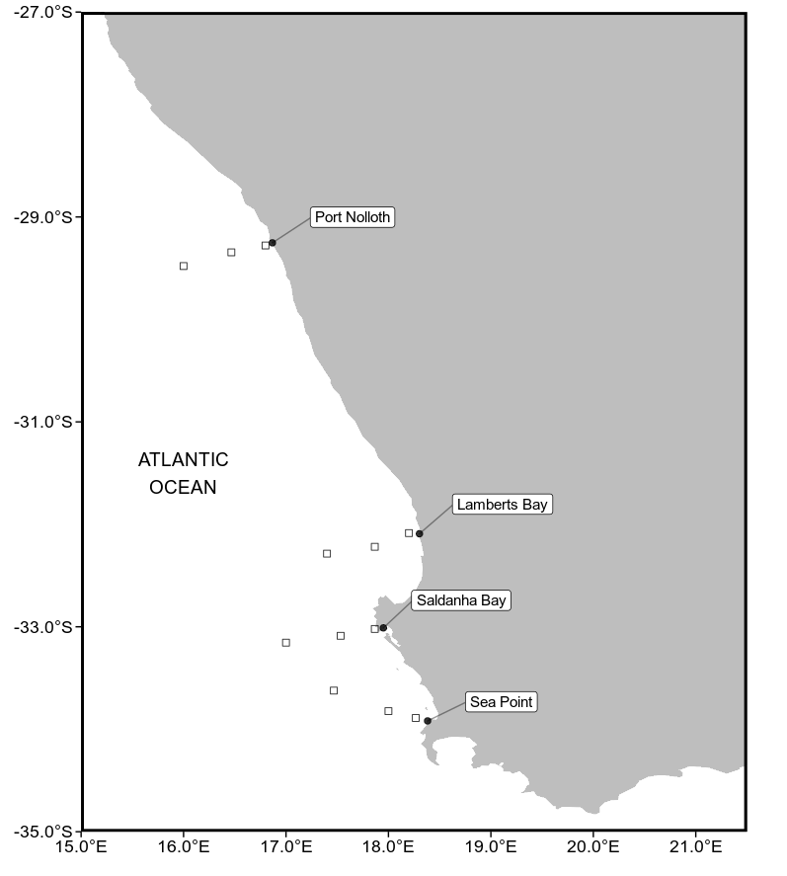
Fig.1. Map representing the study region along the west coast of South Africa. The black points represent the location of the in situ temperatures and approximations of the pixels used along the shore normal transect from the satellite sea surface temperatures, shown with black boxes. The black boxes are at 10km, 30km and 50km from the coastline.

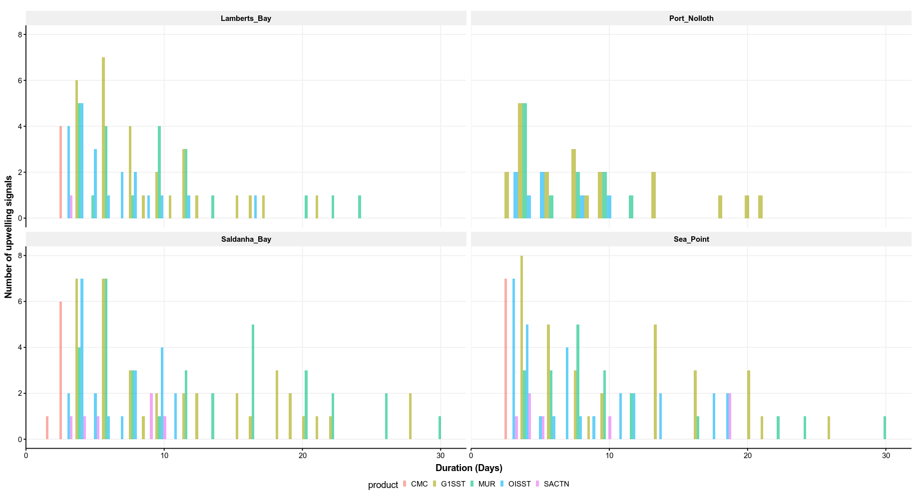

Fig.2. Graph showing the duration for each of the signals detected for the four satellite temperature products and the SACTN in situ collected data for the summer months (December, January and February) over a four year period.

Table 1
A pairwise correlation coefficient represent the relationship between the number of pixels collected at a distance of 10km versus a distance of 30 km from the coastline and a correlation between the number of signals at 10 km and 50 km from the coastline.

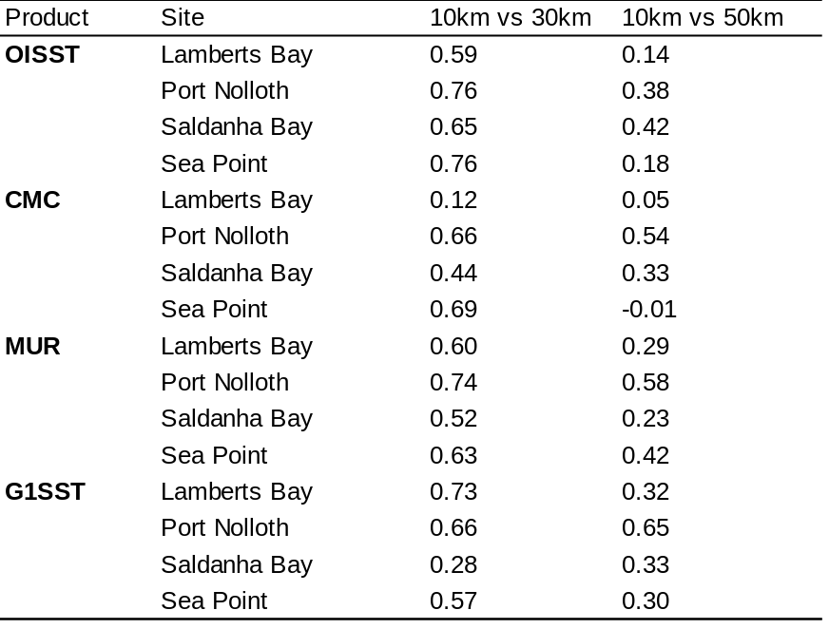

Table 2
The number of upwelling signals detected in each of the SST products. The distance column indicates the various distances from the coastline (10, 30 and 50km) as seen in Fig.1. The signal column indicates the number of signals detected at each of these distances.

