## Methods

## Site selection

On a broad scale, the South African coastline exhibits a large variation in seawater temperature and is divided into four bioregions, each with contrasting temperatures [@smit, @mead]. The western region of the coastline is dominated by the Benguela Current forming an Eastern Boundry Upwelling System (EBUS) [@hutchings], which provides a natural laboratory for this study. Annual mean coastal seawater temperature within this region represents a coastal seawater temperature range of 12.3 ± 1.2°C at the Western limit near the Namibian border. Seasonal upwelling is controlled by south-easterly trade winds and as a result reflects distinct temperature variations representing much lower temperatures within the upwelling cells over a fairly narrow continental shelf found from the Cape Peninsula to Cape Columbine. This region represents monthly mean temperatures at generally intermediate at cold and warm temperatures [@luning]. In order to accurately examine upwelling patterns at various distances from the coast, several sites were selected providing a more accurate representation. The appropriate sites along the west coast of South Africa (i.e. sites influenced by the Benguela current) were selected. Since temperature data were not evenly recorded for each of the sites, the entire dataset was narrowed to only those sites with a time series of longer than 30 years. This yielded a total of five sites within the Benguela region (Fig 1).

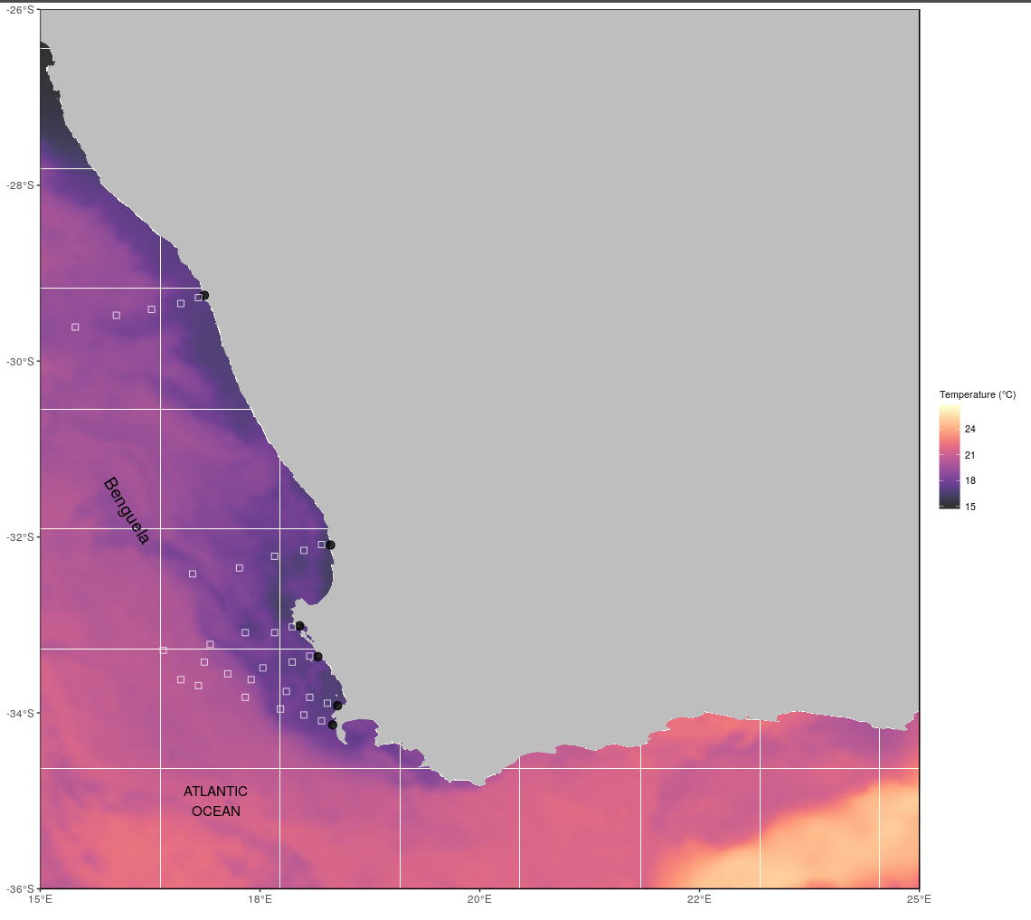

## Temperature data sources

The South African Coastal Temperature Network (SACTN) data served as the *in situ* temperature dataset used in this study. This dataset consists of coastal seawater temperatures obtained from 129 sites along the South African coastline. The SACTN has collected SST data along the coastline of South Africa from as early as 1972 till present date, with contributions made from several organisations and governmental departments. As a result, temperatures within these datasets were obtained by using different methods and instruments, such as hand held thermometers or Underwater temperature reorders( UTRs). The precision of the instruments used vary accordingly, with hand-held thermometers recording temperatures at a precision of 0.5°C as opposed to the underwater temperature recorders which have an instrument precision of 0.001°C. The duration and extent of recordings per sites were uneven with the longest time series in the dataset being that of Gordons Bay which started on 13 September 1972 and concluded on 26 January 2017. During the 1970s, a total of 11 time series began recording. A further 53 entries were added during the 1980s, 34 during the 1990s, and 18 entries were added during the 2000s. Recordings are still ongoing at many of these sites.

This study also made use of a range of remotely sensed temperature datasets. Satellites provide a system of large spatial and temporal data retrieval. Remotely sensed SST products are produced by a number of organisations across the globe. The AVHRR-only Optimally-Interpolated Sea Surface Temperature (OISST) was used to determine SST within the study region. The AVHRR datasets have been providing global SSTs for more than four decades (Reynolds and Smith, 1994; Pearce et al 2006). OISST is a global 1/4° gridded, daily SST product that assimilates both remotely sensed and in situ sources of data to create a level-4 gap free product (Banzon et al., 2016). The Multi-scale Ultra-high Resolution (MUR) Sea Surface Temperature Analysis, the second dataset, was produced using satellite instruments with datasets spanning 1 June 2002 to present times (PO.DAAC, https://podaac.jpl.nasa.gov/). MUR provides SST data at a spatial resolution of 0.01° in longitude-latitude coordinates and are currently among the highest resolution SST datasets available. The CMC dataset constitutes the third dataset and is a version 3.0 Group for High Resolution Sea Surface Temperature (GHRSST) Level 4 dataset with a 10km resolution constructed by the Canadian Meteorological Center (CMC). The CMC dataset combines infrared satellite SST at numerous points in the time series from the AVHRR, the European Meteorological Operational-A (METOP-A) and Operational-B (METOP-B) platforms, and microwave SST data from the Advanced Microwave Scanning Radiometer 2 in conjunction with in situ observations of SST from ships and buoys from the ICOADS program.

An advantage of using of *in situ* data over satellite data is that they provide a more accurate representation of the thermal properties closer to the coast where satellite temperatures do not capture temperature properties well and can therefore more accurately explain upwelling within the coastal inshore environment. Smit et al (2013) have shown that satellite data collected along the South African coastline represent a warm bias reaching as high as 6°C over *in situ* temperatures within the nearshore environment.

In order to create a time series of each of the remotely sensed SST data and also to compare whether the same upwelling patterns exist on the broad-scale against the *in situ* time series, shore-normal transects were extended from the *in situ* sites along the west coast of South Africa. Temperature values from the various satellite datasets were extracted at multiple distances from the coast. These distances were 15 x 15 km, 25 X 25 km and 50 X 50 km pixels along the transect (Fig. 1). The daily sea surface temperatures obtained from the various remotely sensed datasets within each of the transects were initiated in order to produce offshore, broad-scale time series that could accurately be used as a dataset to be compared against the *in situ* time series.

## Wind data

Wind action was an important variable in this study as it was hypothesised that wind direction and wind speed may have a direct influence on upwelling, consequently, wind action was investigated for its impact on upwelling at specific sites along the west coast of South Africa. Wind data was obtained from the South African Weather Service (SAWS), and were provided at three-hour resolutions. Specific wind characteristics were measured, namely; wind direction (dirw) and wind speed (spw). Since the wind data were modelled at three-hour resolutions, they were converted into daily data points in order to compare them with the temperature data. The circular() function in R software was then used to create circular objects around the wave data in order to calculate the daily wind parameters. ERA5 hourly data on pressure levels was used as a second wind source. This dataset comprised of u and v variables from 1973 to present.

With temperature and wind values now corresponding to their respective sites and dates, the hypothesis testing upwelling patterns at different distances from the coastline could now be tested. To do this, it was important to identify upwelling.

# Defining and determining upwelling

In order to determine the change in upwelling signals at different distances from the coastline and to test which dataset showed clear, visible representation of these events, it was first necessary to define when upwelling was occurring. The next aim was to determine a threshold value to identify when upwelling was occurring within this region. Given that upwelling is primarily caused by alongshore, equator ward winds, it was necessary to consider both temperature and wind values. To determine the upwelling condition, an upwelling index was calculated using the formula presented in Fielding and Davis (1989). The upwelling index provided an indication of the intensity of the upwelling process taking place using the following equation:

$$ UpwellingIndex = μ{(Cosθ − coastal angle)} $$

In this expression, μ represents the wind speed (m/s) and θ represents the wind direction which is measured in degrees. The coastal angle is the angle of each of the sites perpendicular to the coastline. The index relies heavily on wind speed and direction data in order to determine the intensity of upwelling likely to occur. Thereafter, the 'exceedance' function within the heatwaveR package was used to determine the consecutive number of days at or above which the upwelling index value was ment to be. Here, it was specified that the minimum duration for upwelling was 1 day with a threshold value obtained from the upwelling index as 1. In order to obtain a more approved threshold value, a percentile value was determined. To determine changes within the upwelling values, the 'detect event' function within the heatwaveR package was used. Thereafter, to determine the upwelling event metrics ( frequency and intensity) the detect event function was used as a first filter with a threshold of 25th percentile. Values obtained from the upwelling index were used as a second threshold. An R script (https://github.com/AmierohAbrahams/Upwelling_MCS) was used to calculate the individual upwelling events for both the *in situ* and remotely sensed SST data. Because upwelling events were calculated relative to percentile exceedances, rather than an absolute definition such as periods with temperatures above a fixed temperature threshold, upwelling events occurred any time of the year with upwelling shown to be more dominant during spring and summer months. For the use of the heatwaveR package it was best to use a time series of 30years.

