

Integrative Health Center
2024 - 2025
SCREENING INTEGRATIVE HEALTH REPORT FOR business, engineering and organic agriculture students

Purpose:
Most university students belong to young adulthood with age ranges between 18 – 26 years old. Many reports identified this phase as biologically, and psychologically stage that influences university students' attitude and decision-making. According to previous reports, there is a high prevalence of risky behaviours among college students, such as eating disorders, anxiety, and depression, as well as tobacco/ vaping products usage. Accordingly, our aim is to implement holistic health screening for students at Heliopolis University for Sustainable Development regardless their faculty or study level. A self-completion questionnaire was administered through Computer-Assisted Group Interviewing about health, lifestyle and dietary habits as well as self-evaluation.
Total number of Students screened in different faculties:
Faculty | Number of Students
Engineering | 35
Business and Economics | 32
Organic Agriculture | 134
Comment:
The Faculty of Organic Agriculture has the highest student enrollment, while Engineering and Business have significantly fewer students. This indicates a greater interest or focus on Organic Agriculture.

- Demographic information:
- Gender:
Faculty | Female (%) | Male (%)
Business and Economics | 53.10% | 46.90%
Engineering | 25.70% | 74.30%
Organic Agriculture | 62.70% | 37.30%

Figure 1
Comment:
Organic Agriculture has the highest female representation (62.7%) and overall student count. Engineering is male dominated (74.3%), while Business shows a more balanced gender distribution. This reflects varying gender trends across faculties, with Organic Agriculture attracting more female students.

- Age range:
Age Range | Business | Engineering | Agriculture
18–20 | 68.80% | 68.60% | 61.20%
21–23 | 25.00% | 22.90% | 37.30%
>23 | 6.30% | 8.60% | 1.50%

Comment:
Most students across all faculties fall within the 18–20 age range, with the highest in Business and Engineering. Organic Agriculture has a slightly older student profile, showing the highest percentage (37.3%) in the 21–23 age group. Students over 23 are a small minority in all faculties.

Figure 2
- Marital status:
Faculty | Single | Engaged | Married
Business and Economics | 100.00% | 0.00% | 0.00%
Engineering | 88.60% | 8.60% | 2.90%
Organic Agriculture | 96.30% | 3.00% | 0.70%

Figure 3
Comment:
Most students are single across all faculties. Business students are all single, while a small percentage of Engineering and Agriculture students are engaged or married.

- Accommodation:
Faculty | With Parents | Student Housing | University Dorms | Rented Apartment
Business and Economics | 96.90% | 0.00% | 0.00% | 3.10%
Engineering | 85.70% | 5.70% | 2.90% | 5.70%
Organic Agriculture | 87.30% | 9.70% | 1.50% | 1.50%

Figure 4
Comment:
Most students live with their parents. Student housing is slightly more more common in Agriculture, while few use dorms or rented apartments.

- Travel Duration:
Faculty | Less than 15 min | 15–30 min | 31–60 min | More than 1 hour
Business & Economics | 0.50% | 4.00% | 4.50% | 7.00%
Engineering | 1.00% | 6.00% | 2.00% | 8.50%
Organic Agriculture | 6.50% | 13.40% | 18.90% | 27.90%

Figure 5

Comment:
Most students (43.3%) study for more than 1 hour, especially those in Organic Agriculture. Business and Economics students spend the least time studying overall.

- Student’s health & lifestyle information:
- Body mass index (BMI):
N.B:
- under 18.5 – This is described as underweight.
- between 18.5 and 24.9 – This is described as the 'healthy range'.
- between 25 and 29.9 – This is described as overweight.
- between 30 and 39.9 – This is described as obesity.
- 40 or over – This is described as severe obesity.

Faculty | Underweight | Healthy Range | Overweight | Obese | Not Defined
Business and Economics | 9.40% | 50.00% | 34.40% | 6.30% | 0.00%
Engineering | 8.60% | 45.70% | 34.30% | 11.40% | 0.00%
Organic Agriculture | 5.20% | 56.00% | 24.60% | 11.20% | 3.00%

Figure 6
Comment:
Most students fall within the healthy BMI range, especially in Organic Agriculture (56%). Business and Economics shows the highest rate of overweight and obesity combined (40.7%), indicating a potential concern. Underweight cases are low across all faculties.

- Do you suffer from illnesses?

Faculty | Yes | No
Business & Economics | 37.50% | 62.50%
Engineering | 28.60% | 71.40%
Organic Agriculture | 41.00% | 59.00%

Figure 7
- Do you have any of the following medical condition/s?
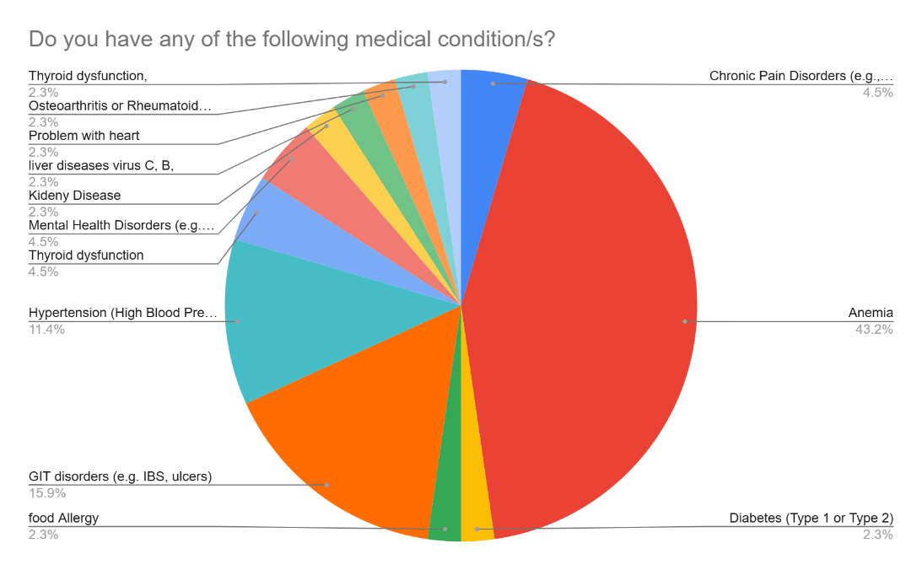

Figure 8a: Organic Agriculture

• Anemia is the most prevalent condition, accounting for 43.2% of respondents. This indicates a significant public health concern, possibly linked to nutritional deficiencies or other systemic factors.
• Gastrointestinal (GIT) disorders (e.g., IBS, ulcers) are the second most common, representing 15.9% of cases, followed by hypertension at 11.4%, suggesting lifestyle and dietary factors may be contributing to these conditions.
• Conditions such as chronic pain disorders (4.5%) and mental health disorders (4.5%) also appear, reflecting the presence of chronic and psychosocial health issues.
• Several conditions, including thyroid dysfunction, osteoarthritis/rheumatoid disorders, heart problems, liver disease, kidney disease, food allergies, and diabetes, each account for 2.3%, indicating relatively low but noteworthy prevalence.

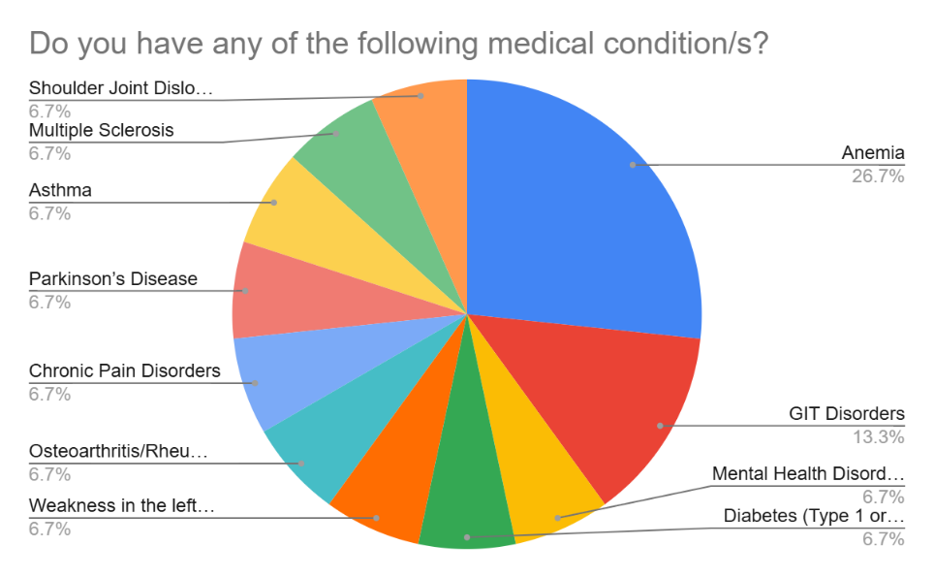
Figure 8b: Business and Economics

• Anemia is the most common condition, affecting 26.7% of respondents, making it the primary health concern within the surveyed population.
• Gastrointestinal (GIT) disorders rank second with 13.3%, indicating notable digestive health challenges.
• Multiple other conditions—mental health disorders, diabetes (Type 1 or 2), osteoarthritis/rheumatologic issues, chronic pain disorders, Parkinson’s disease, asthma, multiple sclerosis, shoulder joint dislocation, and weakness in the left side—each account for 6.7% of respondents.
• The diversity of conditions suggests a wide range of chronic and systemic health issues rather than dominance by a single secondary condition after anemia.

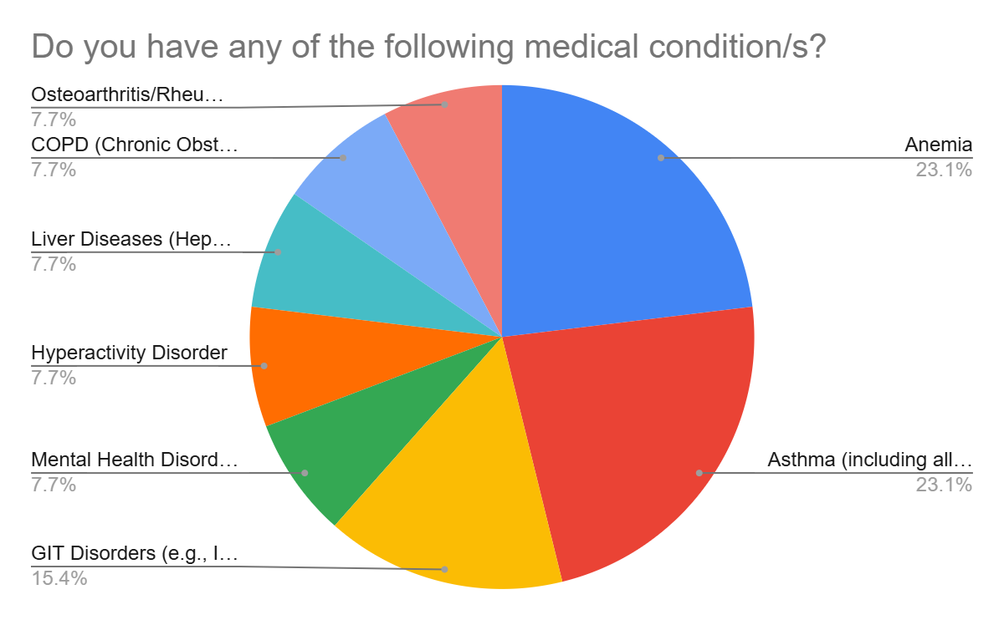

Figure 8c: Engineering

• Anemia and Asthma are the most common conditions, each representing 23.1% of the sample. This indicates significant health concerns related to both respiratory and hematologic systems.
• Gastrointestinal (GIT) disorders rank third at 15.4%, highlighting a considerable burden of digestive health issues.
• Other conditions—including mental health disorders, hyperactivity disorder, liver diseases, COPD (Chronic Obstructive Pulmonary Disease), and osteoarthritis/rheumatologic disorders—each account for 7.7% of respondents.
• The distribution indicates two dominant conditions (anemia and asthma) and a fairly even spread among other chronic health problems.

- Do you have a history of cancer?
Faculty | Yes | No
Business & Economics | 3.10% | 96.90%
Engineering | 0.00% | 100.00%
Organic Agriculture | 0.00% | 100.00%

Figure 9
Comment:
A history of cancer was reported by only one participant (3.1%) from the Business & Economics faculty, while no cases were reported in the Engineering or Organic Agriculture faculties. This indicates a very low prevalence of cancer history among the study sample.

- Have you undergone any previous surgeries?
Surgery Type | Business & Economics | Engineering | Organic Agriculture
Laparoscopic Surgery | 0.00% | 0.00% | 16.70%
Appendectomy | 22.20% | 0.00% | 16.70%
Plastic/Reconstructive Surg. | 0.00% | 0.00% | 11.10%
Eye Surgery | 44.40% | 50.00% | 27.80%
Knee Surgery | 0.00% | 0.00% | 11.10%
Heart Surgery | 0.00% | 0.00% | 5.60%
Gallbladder Removal | 11.10% | 0.00% | 5.60%
Back Surgery | 11.10% | 0.00% | 5.60%
Tumor Removal | 11.10% | 0.00% | 0.00%
Bariatric Surgery | 0.00% | 50.00% | 0.00%

Figure 10
Comment:
Eye surgery was the most common across all faculties, particularly in Engineering (50%) and Business & Economics (44.4%). Organic Agriculture had the highest overall surgical history, with a wider distribution of different surgeries. Bariatric and tumor removal surgeries were reported only in one faculty each.

- Are there doctors or therapists who treat you?
Category | Business & Economics | Engineering | Organic Agriculture
1 Doctor | 68.40% | 82.40% | 73.20%
2 Doctors | 10.50% | 17.60% | 12.50%
3+ Doctors | 21.10% | 0.00% | 14.30%

Figure 11
Comment:
Most participants saw only one doctor, especially in Engineering. Few visited two doctors, and even fewer saw three or more, with no Engineering participants in that group.

- Please list all the medications you are currently taking for chronic health conditions:
Category | Business & Economics | Engineering | Organic Agriculture
1- Medication | 50.00% | 50.00% | 82.90%
2- Medication | 37.50% | 50.00% | 5.70%
3+ Medication | 12.50% | 0.00% | 11.40%

Figure 12
Comment:
Most students across all fields take only one medication, especially in Organic Agriculture (82.9%). Engineering students are split evenly between one and two medications, while Business & Economics students show the highest percentage (12.5%) taking three or more medications.

- How many hours do you typically sleep each night?
Sleep Duration | Business & Economics | Engineering | Organic Agriculture
Less than 5 hours | 18.80% | 20.00% | 13.40%
5 to 7 hours | 50.00% | 62.90% | 57.50%
8 to 9 hours | 31.30% | 17.10% | 29.10%

Figure 13
Comment:
Most students across all faculties sleep 5 to 7 hours, especially in Engineering (62.9%). Organic Agriculture students have the healthiest sleep pattern, with the lowest percentage sleeping less than 5 hours (13.4%). Business & Economics students show a more balanced sleep distribution.

- How many cigarettes do you smoke on an average day?
Smoking Status | Business & Economics | Engineering | Organic Agriculture
I do not smoke | 87.50% | 91.40% | 89.60%
6–10 cigarettes/day | 6.30% | 5.70% | 3.00%
11–20 cigarettes/day | 6.30% | 2.90% | 4.50%
More than 20/day | 0.00% | 0.00% | 3.00%

Comment:
Most students do not smoke, with the highest rate in Engineering. Heavy smoking is rare across all faculties.

Figure 14

- Dietary and lifestyle Habits
- How often do you buy organic foods?
Status | Business & Economics | Engineering | Organic Agriculture
Daily | 18.80% | 17.10% | 3.70%
Several times a week | 37.50% | 37.10% | 24.60%
Once a week | 12.50% | 22.90% | 13.40%
Rarely or never | 31.30% | 22.90% | 58.20%

Figure 15
Comment:
Most students in Business & Economics and Engineering buy organic foods regularly, with over 50% doing so at least several times a week. In contrast, most Organic Agriculture students (58.2%) rarely or never buy organic foods, which is unexpectedly high given their field.

- How often do you eat vegetables per week?
Frequency | Business & Economics | Engineering | Organic Agriculture
Daily | 43.75% | 42.86% | 43.28%
Several times a week | 43.75% | 40.00% | 39.55%
Once a week | 9.38% | 11.43% | 8.96%
Rarely or never | 3.13% | 5.71% | 8.21%

Figure 16
Comment:
Most students from all faculties eat vegetables regularly, though a small group still has low weekly intake.

- How often do you eat fruits per week?
Frequency | Business & Economics | Engineering | Organic Agriculture
Daily | 25.00% | 40.00% | 23.88%
Several times a week | 59.38% | 40.00% | 51.49%
Once a week | 15.63% | 11.43% | 16.42%
Rarely or never | 0.00% | 8.57% | 8.21%

Figure 17
Comment:
Most students eat fruit several times a week. Daily intake is highest in Engineering. Few students, mainly in Organic Agriculture, rarely eat fruit.

- How often do you eat red meat per week?
Frequency | Business & Economics | Engineering | Organic Agriculture
Daily | 9.38% | 5.71% | 3.73%
Several times a week | 59.38% | 57.14% | 44.78%
Once a week | 28.13% | 22.86% | 38.06%
Rarely or never | 3.13% | 14.29% | 13.43%

Figure 18
Comment:
Most students eat red meat several times a week. Daily consumption is low, while a notable portion, especially in some faculties, eat it only once a week or rarely.

- How often do you eat poultry per week?
Frequency | Business & Economics | Engineering | Organic Agriculture
Daily | 3.13% | 8.57% | 14.18%
Several times a week | 68.75% | 71.43% | 58.96%
Once a week | 15.63% | 14.29% | 23.13%
Rarely or never | 12.50% | 5.71% | 3.73%

Figure 19
Comment:
Most students consume poultry several times a week, especially in Engineering and Business & Economics. Daily intake is highest in Organic Agriculture, while rarely or never eating poultry is least common overall.

- How often do you eat fish per week?
Frequency | Business & Economics | Engineering | Organic Agriculture
Daily | 3.13% | 0.00% | 1.49%
Several times a week | 31.25% | 11.43% | 15.67%
Once a week | 40.63% | 37.14% | 48.51%
Rarely or never | 25.00% | 51.43% | 34.33%

Figure 20
Comment:
Fish is mostly consumed once a week or rarely, with low daily intake across all faculties.

- How often do you eat processed/canned meat/fish per week?

Frequency | Business & Economics | Engineering | Organic Agriculture
Daily | 0.00% | 2.86% | 3.73%
Several times a week | 21.88% | 11.43% | 17.91%
Once a week | 31.25% | 22.86% | 23.88%
Rarely or never | 46.88% | 62.86% | 54.48%

Figure 21
Comment:
Most students consume processed or canned meat/fish rarely or never. Weekly or daily consumption is low across all faculties.

- How often do you eat high-fat or fried foods?
Frequency | Business & Economics | Engineering | Organic Agriculture
Daily | 3.13% | 14.29% | 15.67%
Several times/week | 50.00% | 40.00% | 50.00%
Once a week | 40.63% | 28.57% | 21.64%
Rarely or never | 6.25% | 17.14% | 12.69%

Figure 22
Comment:
Most students eat high-fat or fried foods several times a week, with Organic Agriculture showing the highest frequent intake. Engineering students consume them less often.

- How often do you eat foods high in sugar/desserts?
Frequency | Business & Economics | Engineering | Organic Agriculture
Daily | 6.25% | 31.43% | 21.64%
Several times/week | 40.63% | 20.00% | 37.31%
Once a week | 40.63% | 25.71% | 28.36%
Rarely or never | 12.50% | 22.86% | 12.69%

Figure 23
Comment:
Most students eat sugary foods at least weekly. Organic Agriculture students have the highest frequent intake, while Engineering and Business students show more balanced patterns.

- How often do you eat Baladi bread?
Frequency | Business & Economics | Engineering | Organic Agriculture
Daily | 50.00% | 45.71% | 58.96%
Several times/week | 21.88% | 25.71% | 26.12%
Once a week | 15.63% | 2.86% | 5.22%
Rarely or never | 12.50% | 25.71% | 9.70%

Figure 24
Comment:
Most students consume Baladi bread regularly, with the majority eating it daily or several times a week across all faculties.

- What type of fat do you always use in cooking?
Type of Fat/Oil | Business & Economics | Engineering | Organic Agriculture
Corn oil | 9.38% | 5.71% | 14.93%
Natural butter | 18.75% | 17.14% | 29.10%
Olive oil | 31.25% | 25.71% | 12.69%
Margarine | 12.50% | 11.43% | 8.96%
Cotton seed oil | 3.13% | 2.86%
Sunflower oil | 21.88% | 37.14% | 32.84%
Mixed types | 3.13% |  | 1.49%
Not specified | – | 2.86%

Figure 25
Comment:
Most students prefer using vegetable oils like sunflower or olive oil in cooking. Use
of animal fats or margarine is less common. This reflects a general trend toward lighter, plant-based cooking fats.

- At what level do you estimate your daily physical activity?
Physical Activity Level | Business & Economics | Engineering | Organic Agriculture
Low | 18.75% | 28.57% | 31.34%
Moderate | 59.38% | 48.57% | 60.45%
High | 21.88% | 22.86% | 8.21%

Figure 26
Comment:
Most students show moderate activity, especially in Organic Agriculture. Low activity is highest in Organic Agriculture, while high activity is most common in Business & Economics.

- Do you have a regular fitness routine?
Activity | Business & Economics | Engineering | Organic Agriculture
None | 21.88% | 31.43% | 38.06%
Walking | 37.50% | 31.43% | 40.30%
Gym exercises | 21.88% | 11.43% | 11.94%
Sport | 18.75% | 22.86% | 8.96%
Unspecified | 0% | 2.86% | 0.75%

Figure 27
Comment:
Most students do not follow a regular fitness routine, indicating a need to promote
consistent physical activity across all faculties.

- Women's health, Are your periods regular?
Period Regularity | Business & Economics | Engineering | Organic Agriculture
Yes | 64.71% | 88.89% | 76.19%
No | 17.65% | 0.00% | 21.43%
Not specified | 23.53% | 11.11% | 2.38%

Figure 28
Comment:
Most students report regular periods, especially in Engineering. Business & Economics had the highest rate of unspecified answers.

- Student’s self-evaluation information:

Question | Faculty | Agree (%) | Disagree (%)
Q1: I feel happy with my life | Business & Economics | 81.30% | 18.70%
 | Engineering | 77.10% | 22.90%
 | Organic Agriculture | 79.90% | 20.10%
Q2: I feel calm and relaxed | Business & Economics | 59.40% | 40.60%
 | Engineering | 80.00% | 20.00%
 | Organic Agriculture | 52.20% | 47.80%
Q3: I feel supported and connected to my family and community | Business & Economics | 84.40% | 15.60%
 | Engineering | 80.00% | 20.00%
 | Organic Agriculture | 79.90% | 20.10%
Q4: I feel financially stable and secure | Business & Economics | 78.10% | 21.90%
 | Engineering | 80.00% | 20.00%
 | Organic Agriculture | 78.40% | 21.60%
Q5: I have a purpose in life that I am working to achieve | Business & Economics | 90.63% | 9.38%
 | Engineering | 82.86% | 17.14%
 | Organic Agriculture | 88.81% | 11.19%
Q6: I have confidence in my opinions | Business & Economics | 81.25% | 18.75%
 | Engineering | 82.86% | 17.14%
 | Organic Agriculture | 88.81% | 11.19%
Q7: Life has been a continuous process of learning, changing, and growth | Business & Economics | 93.75% | 6.25%
 | Engineering | 85.71% | 14.29%
 | Organic Agriculture | 79.85% | 20.15%

Figure 29/a

Figure 29/B

