

Integrative Health Center
2024 - 2025
Screening Integrative Health Report for Company Employees

Purpose:
Health screening programs are crucial tools to figure out persistent population health problems. It can be challenging for employees to maintain a healthy lifestyle for various reasons. These may include long days sitting in an office chair, repetitive physical movements causing strain on the body, or sustained stress leading to burnout and fatigue.
A crucial first step in preserving a healthy workplace and promoting employee wellbeing is conducting corporate health screening. Businesses have a significant influence on reducing a variety of community health problems. Early identification of health risks results in reduced absenteeism, increased productivity, and earlier interventions as well as demonstrating concern for staff well-being.
Description:
The Integrative health screening program was designed to evaluate the health and well-being of different population with subsequent personalized recommendations that can be provided to help employees achieving better health. This service is offered regularly to all employees at SEKEM companies.

- Demographic information:
- Gender:
Company | Female | Male
Isis | 42.60% | 57.40%
Lotus | 30.00% | 70.00%
Atos | 46.20% | 53.80%
Mizan | 33.30% | 66.70%
Nature Tex | 49.30% | 50.70%

Figure 1
Comment:
Overall, male participants (55.6%) slightly outnumbered females (44.4%). The gender balance was nearly equal in Nature Tex and Atos, while Lotus and Mizan showed higher male representation.

- Age range:
Age Range | Isis | Lotus | Atos | Nature Tex | Mizan
20–29 | 31.20% | 7.40% | 23.80% | 22.66% | 0.00%
30–39 | 28.42% | 29.62% | 9.52% | 36.00% | 100.00%
40–49 | 22.10% | 29.62% | 33.33% | 25.33% | 0.00%
50–59 | 17.68% | 14.81% | 28.57% | 12.00% | 0.00%
>60 | 0.00% | 18.55% | 4.76% | 2.67% | 0.00%

Comment:
The data show that most employees across companies are within the 20–39 age range, particularly in Nature Tex and Lotus, indicating a relatively young to mid-aged workforce. Atos and Mizan have older age distributions, with Mizan entirely in the 30–39 group. The >60 age group is minimal across all companies, suggesting limited senior staff presence.

Figure 2

- Marital status:
Status | Isis | Lotus | Atos | Nature Tex |  | Mizan
Single | 16.84% | 7.40% | 19.04% | 10.66% | 0%
Engaged | 6.31% | 0% | 0% | 2.67% | 0%
Married | 75.78% | 92.59% | 80.95% | 80.02% | 100%
Divorced | 1.05% | 0% | 0% | 1.33% | 0%
Widowed | 0% | 0% | 0% | 5.33% | 0%

Figure 3
Comment:
Most employees are married, especially in Lotus and Mizan, while singles are mainly in Isis and Atos.

- Travel Duration:
Duration | Isis | Lotus | Atis | Nature Tex | Mizan
<30 min | 42.10% | 25.92% | 23.80% | 50.66% | 50%
31–60 min | 33.68% | 55.55% | 38.09% | 26.66% | 50%
>1 hour | 24.22% | 18.53% | 38.09% | 22.68% | 0%

Figure 4
Comment:
Most employees travel less than an hour to work, with Nature Tex and Mizan showing shorter commutes, while Atos has a higher share of employees traveling over an hour.

Health information:
- Body mass index (BMI):
N.B:
- Under 18.5 – This is described as underweight.
- Between 18.5 and 24.9 – This is described as the 'healthy range'.
- Between 25 and 29.9 – This is described as overweight.
- Between 30 and 39.9 – This is described as obesity.
+40 or over – This is described as severe obesity.

Status | Isis | Lotus | Atos | Nature Tex | Mizan
Underweight | 2% | 0% | 0% | 5% | 13%
Normal | 39% | 35% | 56% | 34% | 38%
Overweight | 42% | 45% | 22% | 42% | 25%
Obese | 17% | 20% | 22% | 18% | 25%

Figure 6
Comment:
Most employees fall within the normal or overweight range, with overweight being the most common in most companies. Obesity and underweight cases are less frequent but still present.

- Do you have any of the following medical condition/s?

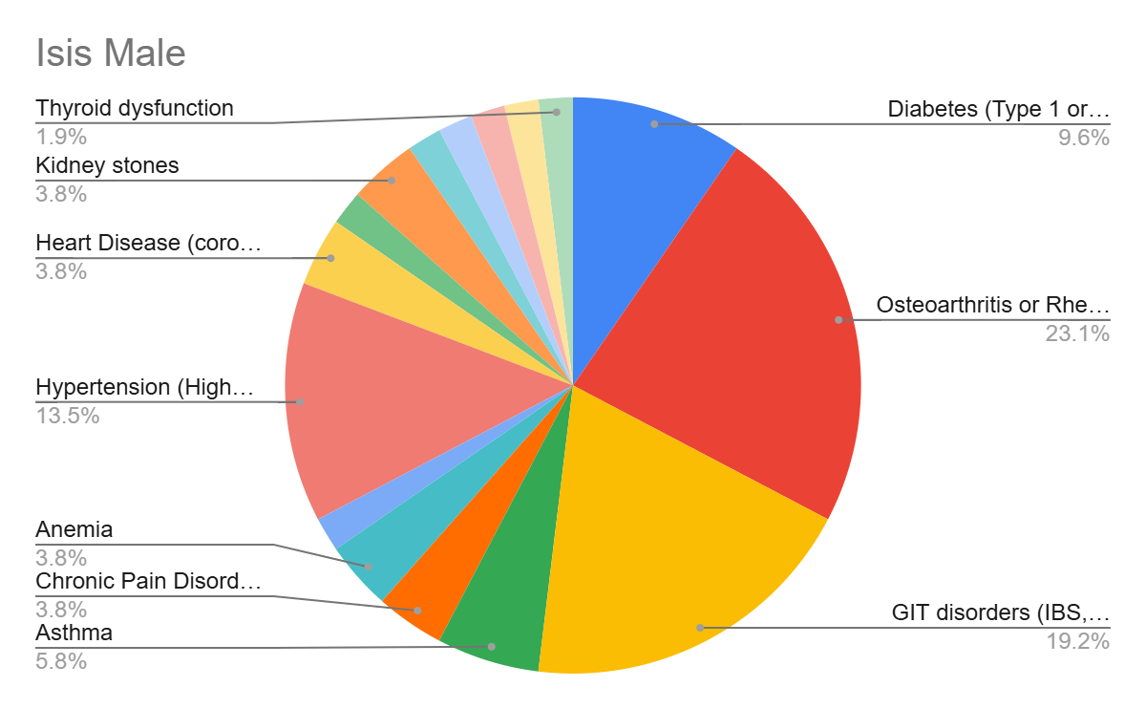
Figure 7a: Isis
Figure 7a: Isis

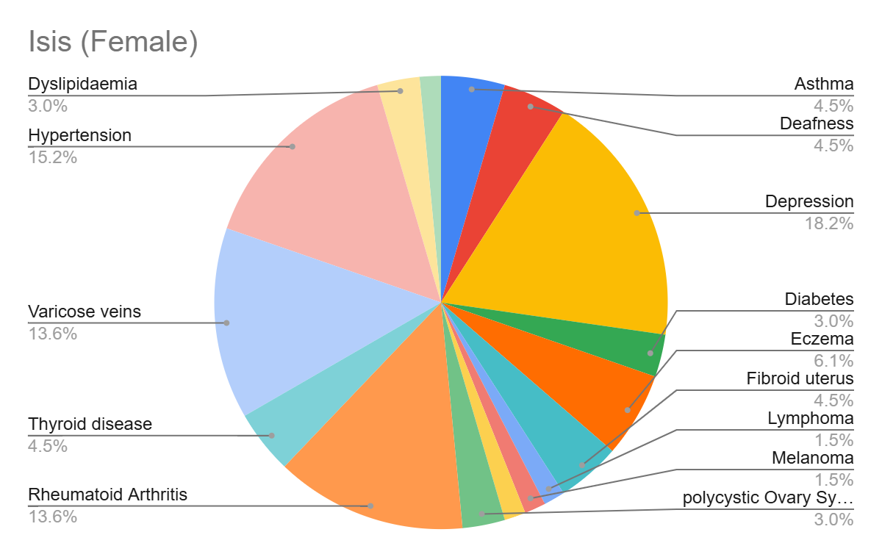
Figure 7b: Isis

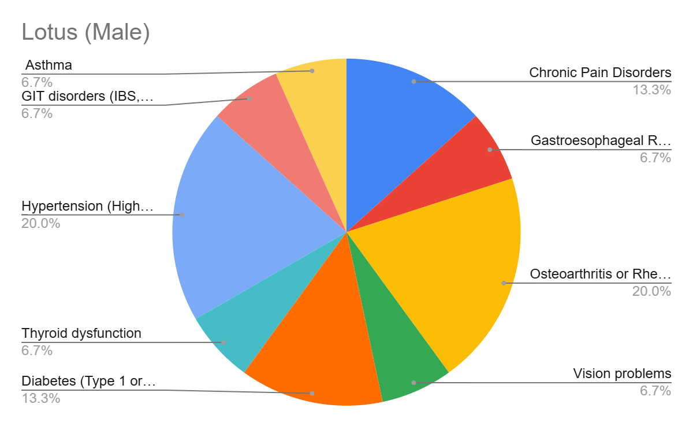

Figure 8a: Lotus
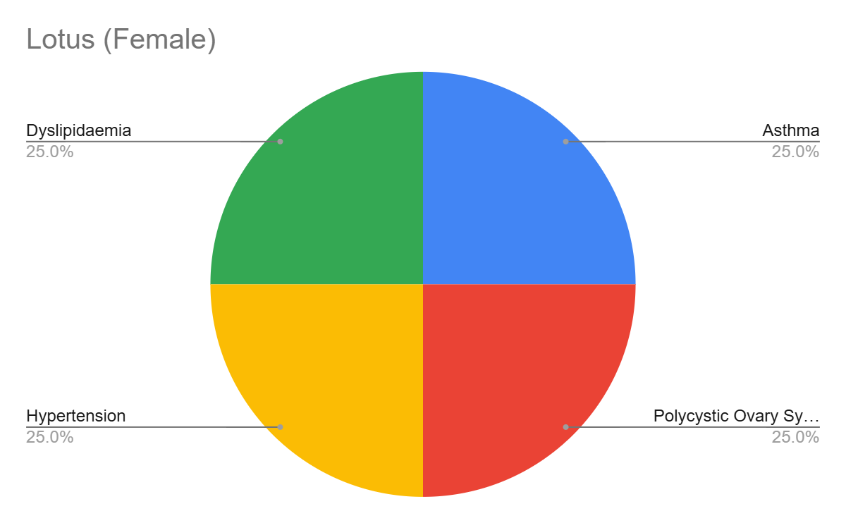

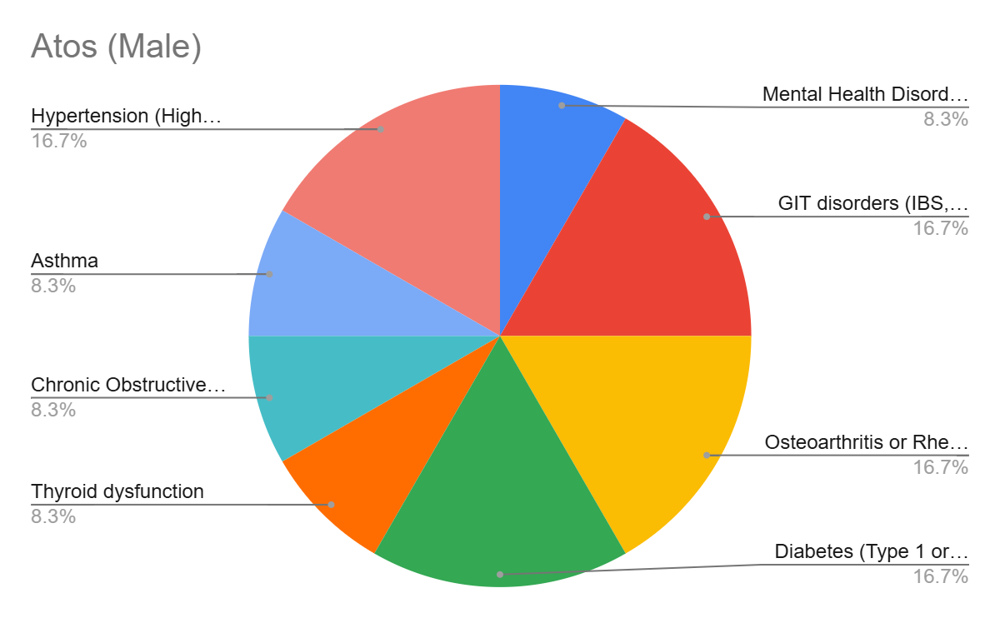

Figure 8b: Lotus

Figure 9a: Atos

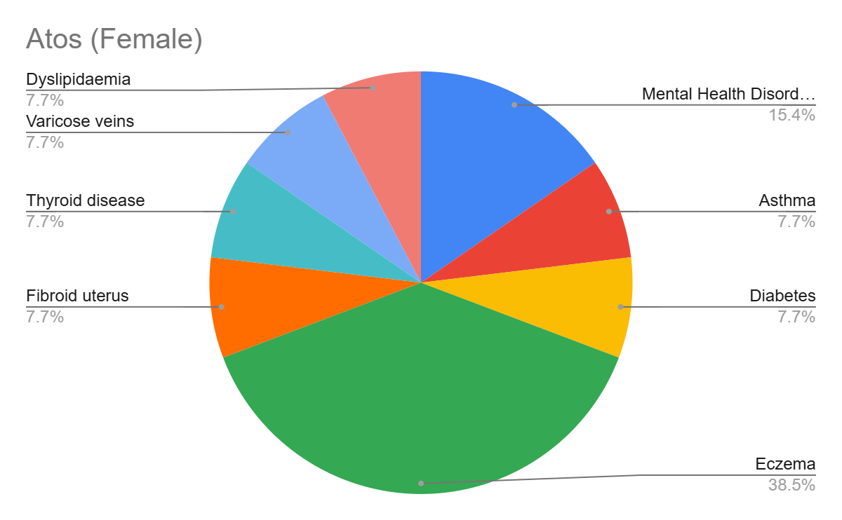
Figure 9b: Atos
•

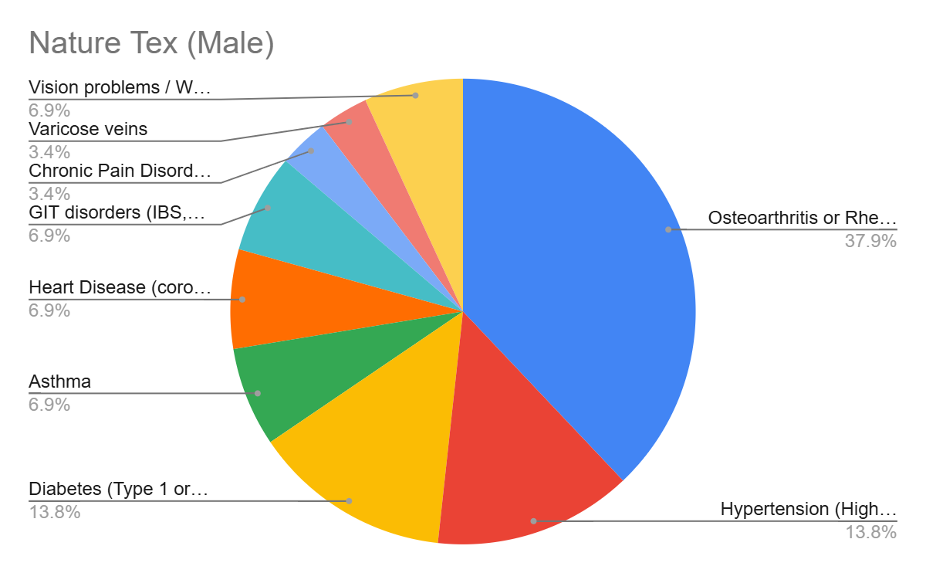

Figure 10a: Nature Tex
•

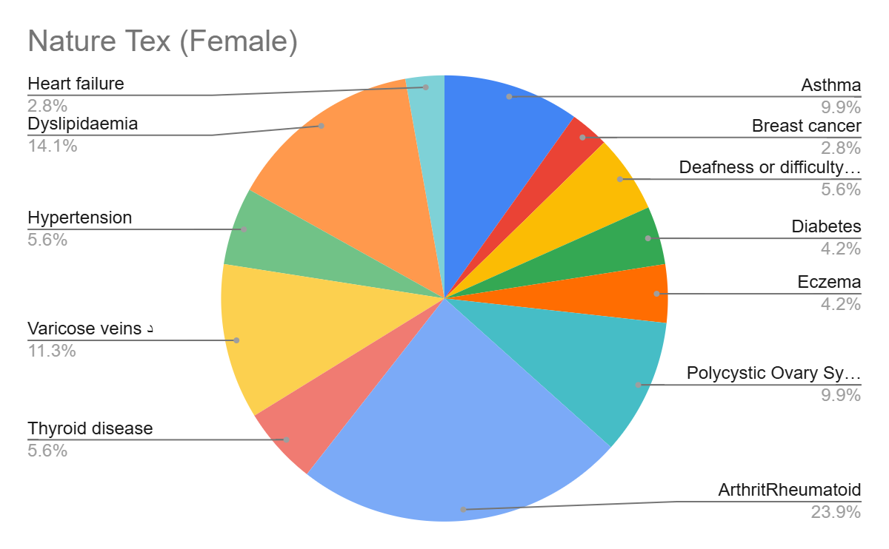

Figure 10b: Nature Tex
•

- Do you have a history of cancer?
Company | Yes | No
Atos | 0.00% | 100.00%
Isis | 2.15% | 97.85%
Lotus | 0.00% | 100.00%
Nature Tex | 0.00% | 100.00%
Miazn | 0.00% | 100.00%

Figure 11
Comment:
The data shows that almost all departments reported a 100% “No” response, indicating a complete lack of positive outcomes or participation across most units. Only the ISIS department recorded a minimal “Yes” rate of 2.15%.

- Have you undergone any previous surgeries?
Surgery | Atos | ISIS | Lotus | Nature Tex | Mizan
Laparoscopic | 10% | 5.4% | 7.1% | 5.5% | 0%
Appendectomy | 5% | 4.3% | 7.1% | 4.1% | 0%
Eye | 0% | 2.1% | 7.1% | 4.1% | 50%
Knee | 10% | 7.5% | 0% | 13.7% | 0%
Heart | 5% | 1.1% | 0% | 1.4% | 0%
Cancer | 0% | 1.1% | 0% | 0% | 0%
Plastic/Reconstructive | 0% | 0% | 0% | 4.1% | 0%
Gallbladder | 0% | 0% | 0% | 1.4% | 0%
Tonsillectomy | 0% | 1.1% | 0% | 2.7% | 0%
Childbirth | 0% | 0.0% | 0% | 0% | 0%
Other | 15% | 1% | 25% | 2.7% | 0%
No Surgery | 55% | 78.5% | 50% | 60.3% | 50%

Figure 12
Comment:
Most employees had no surgeries, highest in Isis (78.5%). Common surgeries included knee, laparoscopic, and appendectomy, with eye surgeries notable in Mizan (50%). Overall, surgery rates were low across companies.

- Please list all the medications you are currently taking for chronic health conditions:
Category | Atos | Isis | Lotus | Nature Tex | Mizan
No Medication | 63.2% | 73.1% | 57.7% | 78.7% | 100%
1 Medication | 21.1% | 14.00% | 26.9% | 12.00% | 0.00%
2 Medications | 10.5% | 7.5% | 7.7% | 6.7% | 0.00%
3+ Medications | 5.2% | 5.4% | 7.7% | 2.6% | 0.00%

Figure 13
Comment:
Most participants reported no medication use, highest in Mizan (100%) and lowest in Lotus (57.7%). Lotus showed the greatest medication use overall, while Mizan reported none.

- How many hours do you typically sleep each night?
Sleep Duration | Atos | Isis | Lotus | Nature Tex | Mizan
<5 hrs | 14.30% | 8.60% | 7.7% | 14.9% | 0.00%
5–7 hrs | 66.70% | 65.6% | 57.7% | 64.2% | 100.0%
8–9 hrs | 19.00% | 25.8% | 34.6% | 20.9% | 0.00%

Figure 14
Comment:
Most participants sleep 5–7 hours, especially in all companies. Lotus and ISIS show higher 8–9 hour sleep rates, while Atos and Nature Tex have more short sleepers (<5 hours).
.

- How many cigarettes do you smoke on an average day?
Smoking Status | Atos | Isis | Lotus | Nature Tex | Mizan
I do not smoke | 100.00% | 79.60% | 82.10% | 83.30% | 100.00%
6–10 cigarettes/day | 0.00% | 12.90% | 17.90% | 12.50% | 0.00%
11–20 cigarettes/day | 0.00% | 5.40% | 0.00% | 2.80% | 0.00%
More than 20/day | 0.00% | 2.10% | 0.00% | 2.80% | 0.00%

Comment:
Most participants are non-smokers, especially in Atos and Mizan (100%). Isis, Lotus, and Nature Tex show small proportions of smokers, mainly consuming 6–10 cigarettes per day. Overall, smoking prevalence is very low across all companies.
Figure 15

- Dietary and lifestyle Habits
- How often do you buy organic foods?
Frequency | Atos | Isis | Lotus | Nature Tex | Mizan
Daily | 28.60% | 18.30% | 14.30% | 4.20% | 100.0%
Several times/week | 38.10% | 32.30% | 7.10% | 25.00% | 0.00%
Once a week | 19.00% | 26.90% | 35.70% | 11.10% | 0.00%
Rarely or never | 14.30% | 22.60% | 42.90% | 59.70% | 0.00%

Figure 16
Comment:
Mizan shows the highest frequency, with all respondents buying organic foods daily. In contrast, Nature Tex and Lotus have the lowest engagement, as most buy rarely or never. Atos and ISIS show more balanced buying habits.

- How often do you eat vegetables per week?
Status | Isis | Lotus | Atos | Mizan | Nature Tex
Daily | 56.79% | 45.00% | 66.67% | 33.33% | 44.59%
Several/week | 29.63% | 47.50% | 28.21% | 66.67% | 39.86%
Once a week | 11.11% | 2.50% | 5.13% | 0.00% | 12.84%
Rarely/never | 1.85% | 5.00% | 0.00% | 0.00% | 2.70%

Figure 17
Comment:
Most employees reported eating vegetables daily or several times a week, indicating generally healthy eating habits across companies.

- How often do you eat fruits per week?
Status | Isis | Lotus | Atos | Mizan | Nature Tex
Daily | 19.75% | 30.00% | 23.08% | 0.00% | 15.54%
Several/week | 34.57% | 32.50% | 48.72% | 100.00% | 47.30%
Once a week | 33.95% | 27.50% | 20.51% | 0.00% | 25.68%
Rarely/never | 11.73% | 10.00% | 7.69% | 0.00% | 11.49%

Figure 18
Comment:
Most employees consume fruits regularly, with the highest frequency being several times per week, while rare or no consumption is minimal across companies.

- How often do you eat red meat per week?
Status | Isis | Lotus | Atos | Mizan | Nature Tex
Daily | 3.10% | 5.00% | 5.10% | 0.00% | 2.00%
Several/week | 25.90% | 30.00% | 43.60% | 66.70% | 24.30%
Once a week | 40.10% | 47.50% | 30.80% | 0.00% | 29.10%
Rarely/never | 30.90% | 17.50% | 20.50% | 33.30% | 44.60%

Figure 19
Comment:
Most staff consume red meat weekly, with higher frequent intake in IT and Administration, while Services and Faculty show lower consumption.

- How often do you eat poultry per week?
Status | Isis | Lotus | Atos | Mizan | Nature Tex
Daily | 2.50% | 7.50% | 7.70% | 0.00% | 4.70%
Several/week | 37.70% | 32.50% | 61.50% | 100.00% | 51.40%
Once a week | 53.70% | 57.50% | 28.20% | 0.00% | 39.20%
Rarely/never | 6.20% | 2.50% | 2.60% | 0.00% | 4.70%

Figure 20
Comment:
Poultry is most commonly eaten once a week among employees in Isis and Lotus, whereas Atos and Mizan show higher consumption several times per week. Nature Tex has a moderate pattern with few daily or rare consumers.

- How often do you eat fish per week?
Status | Isis | Lotus | Atos | Mizan | Nature Tex
Daily | 2.50% | 7.50% | 7.70% | 0.00% | 1.40%
Several/week | 37.70% | 32.50% | 61.50% | 100.00% | 27.00%
Once a week | 53.70% | 57.50% | 28.20% | 0.00% | 50.00%
Rarely/never | 6.20% | 2.50% | 2.60% | 0.00% | 21.60%

Figure 21
Comment:
Fish is most frequently consumed once a week among employees in Isis, Lotus, and Nature Tex. Atos shows higher several-times-per-week consumption, while a small portion—particularly in Nature Tex—rarely or never eat fish.

- How often do you eat processed/canned meat/fish per week?
Status | Isis | Lotus | Atos | Mizan | Nature Tex
Daily | 2.50% | 7.50% | 7.70% | 0.00% | 1.40%
Several/week | 37.70% | 32.50% | 61.50% | 100.00% | 27.00%
Once a week | 53.70% | 57.50% | 28.20% | 0.00% | 50.00%
Rarely/never | 6.20% | 2.50% | 2.60% | 0.00% | 21.60%

Figure 22
Comment:
Canned and processed foods are most consumed once a week in Isis, Lotus, and Nature Tex. Atos shows a higher rate of frequent (several times/week) consumption, while Nature Tex also includes a notable share who rarely or never eat these products.

- How often do you eat high-fat or fried foods?
Status | Isis | Lotus | Atos | Mizan | Nature tex
Daily | 25.30% | 30.00% | 20.50% | 0.00% | 23.00%
Daily, Several times a week | 1.20% | 0.00% | 0.00% | 0.00% | 0.00%
Several/week | 36.40% | 25.00% | 28.20% | 33.30% | 31.80%
Once a week | 14.20% | 17.50% | 17.90% | 66.70% | 17.60%
Once a week, Rarely or never | 1.20% | 0.00% | 0.00% | 0.00% | 2.00%
Rarely/never | 21.00% | 27.50% | 33.30% | 0.00% | 25.70%
Undefined | 0.60% | 0.00% | 0.00% | 0.00% | 0.00%

Figure 23
Comment:
Most participants in Isis and Nature Tex reported frequent fried food consumption, while Lotus, Atos, and Mizan showed lower weekly intake levels.

- How often do you eat foods high in sugar/desserts?
Status | Isis | Lotus | Atos | Mizan | Nature tex
Daily | 14.20% | 12.50% | 17.90% | 0.00% | 16.20%
Several/week | 24.10% | 12.50% | 17.90% | 100.00% | 37.20%
Once a week | 26.50% | 32.50% | 25.60% | 0.00% | 22.30%
Rarely/never | 35.20% | 42.50% | 38.50% | 0.00% | 24.30%

Figure 24
Comment:
Most participants in Lotus and Atos reported lower dessert consumption, with a higher share in the rarely/never category. In contrast, Nature Tex and Isis showed more frequent dessert intake, indicating a greater preference for sweets among their employees.

- How often do you eat Baladi bread?
Status | Isis | Lotus | Atos | Mizan | Nature tex
Daily | 80.90% | 85.00% | 92.30% | 100.00% | 58.80%
Several/week | 11.10% | 10.00% | 2.60% | 0.00% | 26.40%
Once a week | 4.30% | 5.00% | 5.10% | 0.00% | 5.40%
Rarely/never | 3.70% | 0.00% | 0.00% | 0.00% | 9.50%

Figure 25
Comment:
Most participants in all companies reported daily consumption of Baladi bread, especially in Isis, Lotus, and Atos, where it forms a staple food. Nature Tex showed slightly lower daily intake but still high overall consumption, indicating that Baladi bread remains a primary dietary component across all workplaces.

- How many liters of water do you drink daily?

Status | Isis | Lotus | Atos | Mizan | Nature tex
Less than one liter | 16.70% | 7.50% | 12.80% | 0.00% | 10.80%
One liter | 29.00% | 30.00% | 20.50% | 33.30% | 21.60%
Two liters | 30.20% | 42.50% | 30.80% | 0.00% | 33.80%
More than two liters | 24.10% | 20.00% | 35.90% | 66.70% | 33.80%

Figure 26
Comment:
Most participants in Isis, Lotus, and Nature Tex reported drinking two Liters or more of water daily, reflecting good hydration habits. Atos showed a balanced distribution, while Mizan participants mostly consumed more than two Liters, though their sample size was small.

