
SCREENING INTEGRATIVE HEALTH REPORT FOR HELIOPOLIS UNIVERSITY ACADEMICDS STAFF

Integrative Health Center 2024 - 2025

Purpose:
Health screening programs are crucial tools to figure out persistent population health problems. It can be challenging for employees to maintain a healthy lifestyle for various reasons. These may include long days sitting in an office chair, repetitive physical movements causing strain on the body, or sustained stress leading to burnout and fatigue. A crucial first step in preserving a healthy workplace and promoting employee wellbeing is conducting corporate health screening. Businesses have a significant influence on reducing a variety of community health problems. Early identification of health risks results in reduced absenteeism, increased productivity, and earlier interventions as well as demonstrating concern for staff well-being.

Description:
The Integrative health screening program was designed to evaluate the health and well- being of different population with subsequent personalized recommendations that can be provided to help employees achieving better health. This service is offered regularly to all employees at SEKEM companies and HU departments.
Total number of staff members in different departments:

Faculty | Count
Faculty of Physiotherapy | 16
Faculty of Business Administration | 12
Faculty of Pharmacy | 53
Faculty of Agriculture | 14
Faculty of Engineering | 16
Core | 16
Total | 127

Comment:
The data represents the participation of 127 academic staff in the health screening across various faculties, with the Faculty of Pharmacy having the highest participation (53 staff).

Demographic information:

Gender:

Faculty | Female | Male
Faculty of Physiotherapy | 87.50% | 12.50%
Faculty of Business Administration | 58.30% | 41.70%

Faculty of Pharmacy | 83.00% | 17.00%
Faculty of Agriculture | 71.40% | 28.60%
Faculty of Engineering | 62.50% | 37.50%
Core | 58.80% | 41.20%
Percentage
Faculty of Physiotherapy
Faculty of Pharmacy
Faculty of Agriculture
Faculty of Engineering
Core

Figure 1
Gender
100.00%
90.00%
80.00%
70.00%
60.00%
50.00%
40.00%
30.00%
20.00%
10.00%
0.00%
Gender
Female
Male
Faculty of Business Administration
Comment:
The data shows that female participation is highest in Faculty of Physiotherapy (87.5%) and Faculty of Pharmacy (83%), with Faculty of Business Administration and Core showing a more balanced gender distribution. Faculty of Engineering and Faculty of Agriculture have slightly more male participation.

Age range:

Age Range | Physiothera py | Administratio n | Pharma cy | Agricultu re | Engineering | Core
20–29 | 31.25% | 41.67% | 41.51% | 21.43% | 56.25% | 35.29  %
30–39 | 25.00% | 33.33% | 26.42% | 28.57% | 18.75% | 29.41  %
40–49 | 31.25% | 16.67% | 22.64% | 14.29% | 6.25% | 35.29

 |  |  |  |  |  | %
 |  |  |  |  |  | 11.76
50–59 | 6.25% | 0.00% | 7.55% | 14.29% | 12.50% %
>60 | 6.25% | 8.33% | 1.89% | 21.43% | 6.25% 5.88%
Age Range
60.00%

50.00%

40.00%

30.00%

20.00%

10.00%

0.00%

Faculty
20–29 30–39 40–49 50–59 >60
Percentage
Physiotherapy
Administration
Pharmacy
Agriculture
Engineering
Core

Figure 2
Comment:
Most faculties have a higher concentration of younger individuals, especially in the 20–29 age range. The Faculty of Agriculture stands out with a notable proportion of individuals aged >60. The Core category shows a more even age distribution.
  - Marital status:

Status | Physiothera py | Business Administration | Pharmac y | Agriculture | Engineering | Core
Single | 25.00% | 41.67% | 37.74% | 42.86% | 56.25% | 52.94  %
Engaged | 6.25% | 16.67% | 1.89% | 0.00% | 0.00% | 0.00%
Married | 56.25% | 33.33% | 56.60% | 57.14% | 43.75% | 47.06  %
Divorced | 12.50% | 8.33% | 1.89% | 7.14% | 0.00% | 0.00%
Widowed | 0.00% | 0.00% | 1.89% | 0.00% | 0.00% | 0.00%

Percentage
Physiotherapy
Business Administration
Pharmacy
Agriculture
Engineering
Core

Figure 3
Marital status
60.00%

50.00%

40.00%

30.00%

20.00%

10.00%

0.00%

Faculty
Single Engaged Married Divorced Widowed
Comment:
Most individuals are Married, especially in Pharmacy and Agriculture. Single individuals are more common in Business Administration and Core, while Engaged and Widowed individuals represent a small portion across all faculties. Divorced individuals are mostly in Physiotherapy.
  - Travel Duration:

Duration | Physiotherap y | Business Administratio n | Pharmac y | Agriculture | Engineering | Core
<15 min | 6.25% | 0.00% | 9.43% | 14.29% | 25.00% | 23.53%
15–30 min | 18.75% | 58.33% | 35.85% | 14.29% | 56.25% | 17.65%
31–60 min | 68.75% | 25.00% | 28.30% | 42.86% | 18.75% | 17.65%
>1 hour | 6.25% | 16.67% | 26.42% | 42.86% | 12.50% | 41.18%

Percentage
Physiotherapy
Pharmacy
Agriculture
Engineering
Core

Figure 4
Travel Duration
80.00%
70.00%
60.00%
50.00%
40.00%
30.00%
20.00%
10.00%
0.00%

Faculty
<15 min 15–30 min 31–60 min >1 hour
Business Administration

Comment:
Most students, especially in Faculty of Physiotherapy, spend 31–60 minutes traveling to the university. Faculty of Business Administration has more students traveling 15–30 minutes, while Core and Faculty of Agriculture show notable travel times of
over 1 hour

  - How long have you been employed at Heliopolis University?
Employment Duration | Physiothera py | Business Administrati on | Pharmac y | Agriculture | Engineering | Core
<1 yr | 43.75% | 41.67% | 20.75% | 21.43% | 62.50% | 17.65  %
1–5 yrs | 50.00% | 50.00% | 45.28% | 35.71% | 37.50% | 52.94  %
6–10 yrs | 6.25% | 8.33% | 28.30% | 35.71% | 0.00% | 11.76  %
10+ yrs | 0.00% | 0.00% | 5.66% | 7.14% | 0.00% | 17.65  %

Percentage
Physiotherapy
Pharmacy
Agriculture
Engineering
Core

Figure 5
Employment Duration
70.00%
60.00%
50.00%
40.00%
30.00%
20.00%
10.00%
0.00%

Faculty
<1 yr 1–5 yrs 6–10 yrs 10+ yrs
Business Administration

Comment:
Most individuals in Physiotherapy and Core have 1–5 years of experience, while
Engineering has the highest percentage in the <1 yr category. Pharmacy and
Agriculture show a mix of experience, with fewer individuals in the 6–10 years or 10+ years range.

Health information:

Body mass index (BMI):
N.B:
- under 18.5 – This is described as underweight.
- between 18.5 and 24.9 – This is described as the 'healthy range'.
- between 25 and 29.9 – This is described as overweight.
- between 30 and 39.9 – This is described as obesity.
- 40 or over – This is described as severe obesity.

Status | Physiotherapy | Business | Pharmacy | Agriculture | Engineering | Core
Underweight | 0% | 0% | 6% | 0% | 0% | 0%

Normal | 44% | 42% | 49% | 50% | 31% | 53%
Overweight | 31% | 33% | 25% | 33% | 50% | 27%
Obese | 25% | 25% | 21% | 17% | 19% | 20%
Precentage

Figure 6
BMI Status
60%
50%
40%
30%
20%
10%
0%
Physiotherapy Business (%) Pharmacy (%) Agriculture (%) Engineering (%) Core (%) (%)
Faculty
Underweight Normal Overweight Obese
Comment:
Overweight is most common, especially in Security and HR; normal weight prevails in Agriculture and IT.

Do you have any of the following medical condition/s?
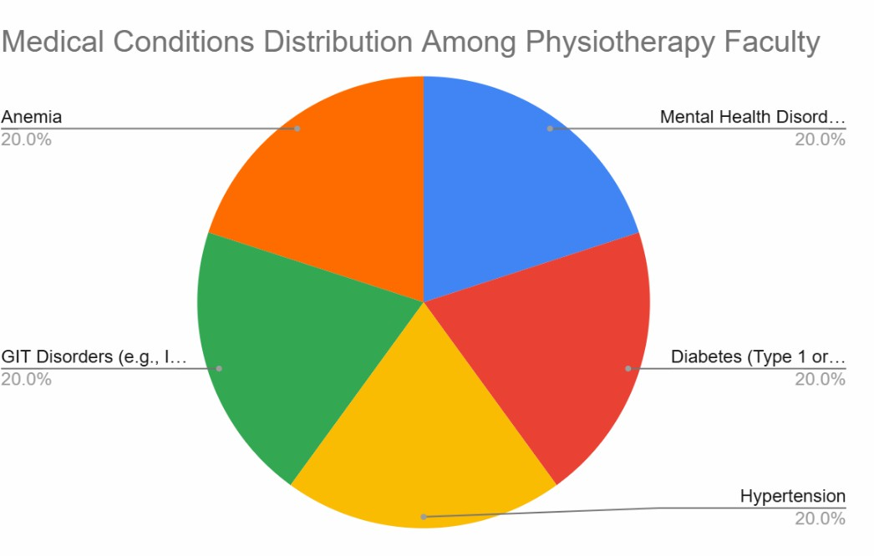
Figure 7a: Physiotherapy Staff

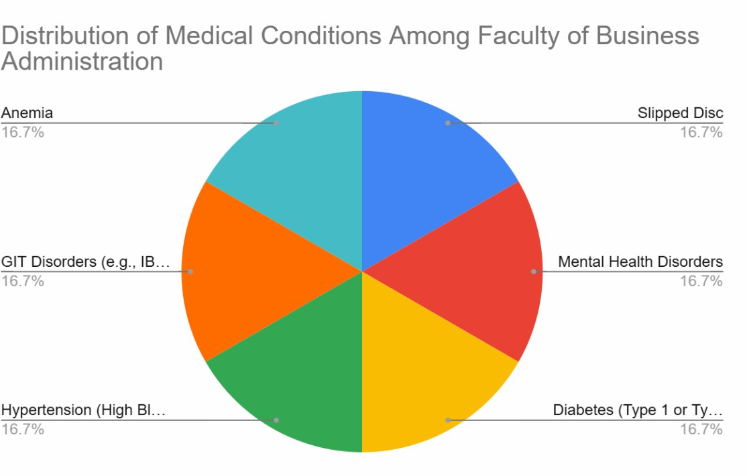

Figure 7b: Business Administration Staff

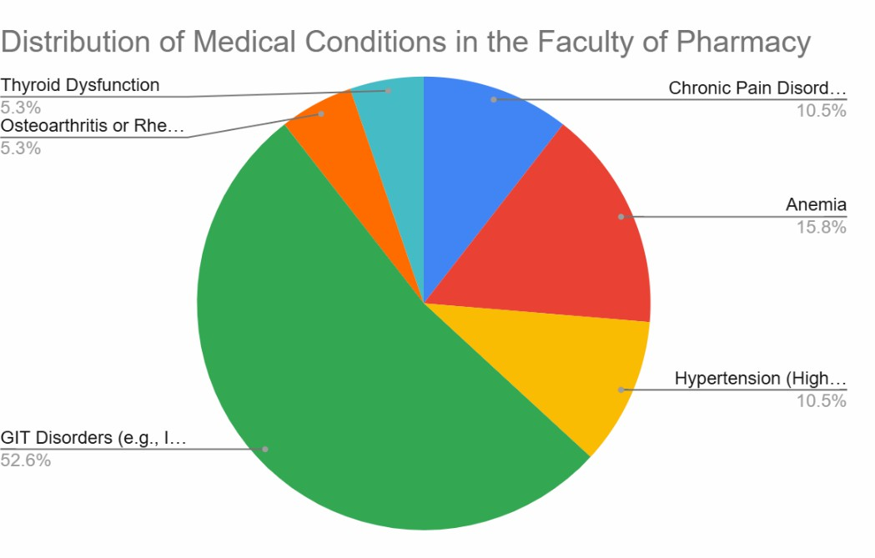
Figure 7c: Pharmacy staff

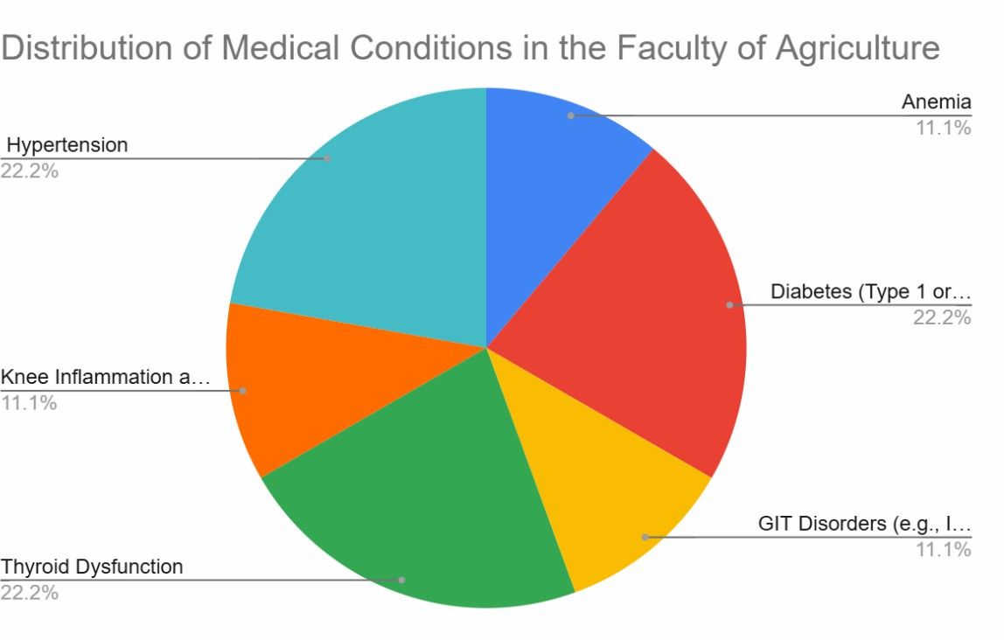

Figure 7d: Agriculture staff
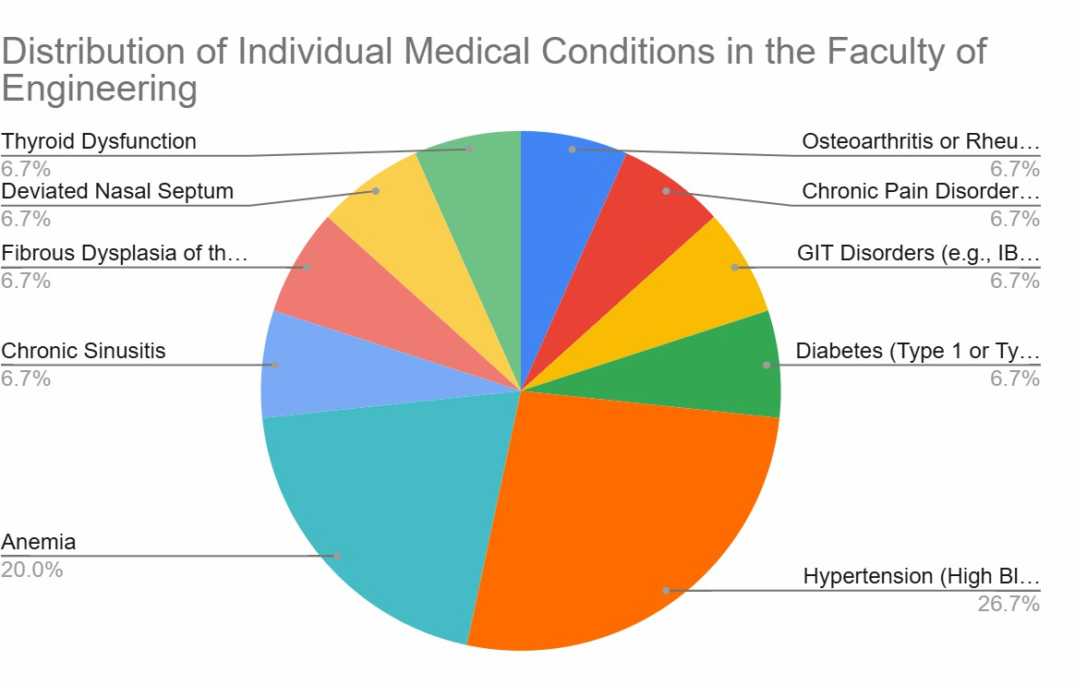

Figure 8e: Engineering staff

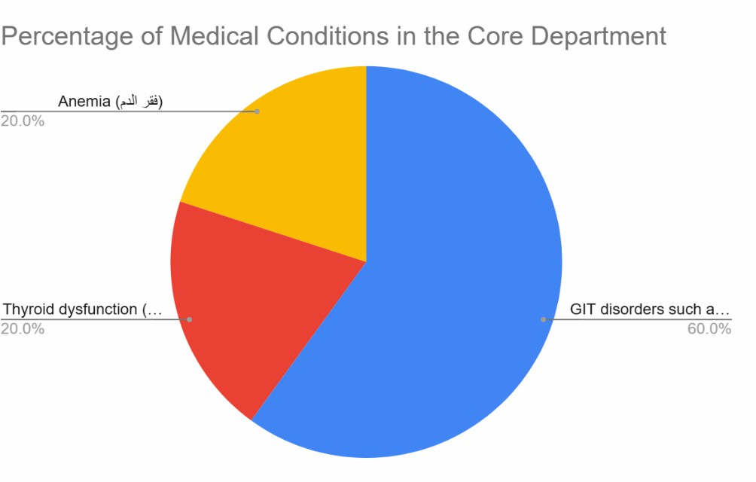
Figure 8f: Core staff

Do you have a history of cancer?

History | Physiotherapy | Business | Pharmacy | Agriculture | Engineering | Core
yes | 0.00% | 0 | 1.89% | 7.14% | 0 | 0
no | 100% | 100% | 98.11% | 92.86% | 100% | 100%
11

Comment:
The survey shows that most respondents across all faculties have limited awareness of the history of cancer, with only a small percentage in Pharmacy acknowledging it.

Figure 9

Have you undergone any previous surgeries?

Surgery | physiotherapy | business | pharmacy | agriculture | engineering | core
appendectomy / bariatric | 6.25% | 33.33% | 7.55% | 28.57% | 0% | 0%
tonsillectomy | 6.25% | 8.33% | 1.89% | 0% | 0% | 0%
benign tumor removal | 6.25% | 0% | 0% | 0% | 0% | 0%
plastic / reconstructive | 6.25% | 0% | 0% | 0% | 0% | 0%
no surgery | 37.50% | 58.33% | 71.70% | 42.86% | 81.25% | 94.12%
knee surgery | 6.25% | 0% | 0% | 0% | 0% | 0%
ganglion cyst excision | 6.25% | 0% | 0% | 0% | 0% | 0%
gallbladder removal | 6.25% | 0% | 1.89% | 7.14% | 0% | 0%
eye surgery | 12.50% | 0% | 3.77% | 7.14% | 0% | 0%
CS | 6.25% | 0% | 5.66% | 0% | 0% | 0%
cystectomy | 0% | 0% | 1.89% | 0% | 0% | 0%
phlebectomy | 0% | 0% | 1.89% | 0% | 0% | 0%
sewing | 0% | 0% | 1.89% | 0% | 0% | 0%
labor | 0% | 0% | 1.89% | 0% | 0% | 0%
pacemaker | 0% | 0% | 0% | 7.14% | 0% | 0%
pilonidal sinus | 0% | 0% | 0% | 7.14% | 0% | 0%
laparoscopic | 0% | 0% | 0% | 0% | 6.25% | 0%
hemorrhoids | 0% | 0% | 0% | 0% | 12.50% | 0%
fistulectomy | 0% | 0% | 0% | 0% | 0% | 5.88%

12

Figure 10

Comment:
The data shows that "no surgery" is most common in Engineering and Core faculties. Other surgeries, like appendectomy and gallbladder removal, are more common in Business and Agriculture. Certain surgeries have very low responses across all faculties.

- Please list all the medications you are currently taking for chronic health conditions

Medication Category | Physiotherapy | Business | Pharmacy | Agriculture | Engineering | Core
blood pressure | 11.76% | 0% | 5.66% | 21.43% | 12.50% | 0%
anemia | 5.88% | 0% | 1.89% | 0% | 0% | 0%
gastrointestinal medications | 11.76% | 0% | 5.66% | 0% | 0% | 5.88%
no medications | 64.71% | 63.64% | 60.38% | 21.43% | 62.50% | 88.24%
anti-inflammatory | 5.88% | 9.09% | 1.89% | 14.29% | 6.25% | 0%
pain management | 0% | 9.09% | 5.66% | 14.29% | 12.50% | 0%
heart medications | 0% | 9.09% | 0% | 0% | 0% | 0%
others | 0% | 9.09% | 11.32% | 7.14% | 0% | 0%
antihistamines | 0% | 0% | 1.89% | 0% | 0% | 0%
thyroid meds | 0% | 0% | 1.89% | 7.14% | 6.25% | 0%
isotretinoin | 0% | 0% | 1.89% | 0% | 0% | 0%
cholesterol | 0% | 0% | 1.89% | 7.14% | 0% | 5.88%
diabetes | 0% | 0% | 0% | 7.14% | 0% | 0%

Figure 11

Comment:
Most faculties report high "no medications" usage, especially in Core (88.24%) and Physiotherapy (64.71%). Specific medications like blood pressure and gastrointestinal meds are more common in Physiotherapy and Agriculture. Other medications are used in smaller amounts across various faculties.

- How many hours do you typically sleep each night
Hours f Sleep Physiotherapy
%
Business
%
Core %
Hours of Sleep | Physiotherapy | Business | Pharmacy | Agriculture | Engineering | Core
< 5 hours | 13.33% | 16.67% | 5.56% | 20.00% | 0% | 4.00%
5–7 hours | 80.00% | 75.00% | 79.63% | 73.33% | 82.35% | 60.00%
8–9 hours | 13.33% | 8.33% | 12.96% | 0% | 11.76% | 4.00%

Figure 12

Comment:
Most respondents sleep 5-7 hours, with Engineering having the highest percentage. Sleep durations under 5 hours are most common in Physiotherapy and Agriculture, while few report 8-9 hours of sleep.

- How many cigarettes do you smoke on an average day?

Cigarettes | Physiotherapy | Business | Pharmacy | Agriculture | Engineering | Core
Don’t smoke | 93.75% | 75.00% | 98.11% | 92.86% | 100% | 100%
Other | 6.25% | 0% | 1.89% | 7.14% | 0% | 0%
6–9 cigarettes | 0% | 25.00% | 0% | 0% | 0% | 0%
Precentage

Figure 13

Comment:
Most respondents sleep 5-7 hours, with Engineering having the highest percentage. Sleep durations under 5 hours are most common in Physiotherapy and Agriculture, while few report 8-9 hours of sleep.

Dietary and lifestyle Habits

How often do you buy organic food?
Organic food | Physiotherapy | Business | Pharmacy | Agriculture | Engineering | Core
Daily | 12.50% | 16.67% | 0% | 7.69% | 25.00% | 11.76%
Once a week | 18.75% | 33.33% | 43.40% | 23.08% | 25.00% | 29.41%
Rarely or never | 43.75% | 25.00% | 39.62% | 38.46% | 25.00% | 35.29%
Several times a week | 25.00% | 25.00% | 16.98% | 30.77% | 25.00% | 23.53%
Comment:
Most respondents consume organic food "rarely or never," especially in Pharmacy and Agriculture. "Once a week" consumption is higher in Business and Pharmacy, while daily consumption is low across all faculties.

Figure 14

How often do you eat vegetables per week?

Vegetable consumption | Physiotherapy | Business | Pharmacy | Agriculture | Engineering | Core
Daily | 56.25% | 25.00% | 45.28% | 50.00% | 75.00% | 58.82%
Once a week | 12.50% | 8.33% | 3.77% | 0% | 0% | 0%
Several times a week | 31.25% | 58.33% | 50.94% | 50.00% | 25.00% | 41.18%
Rarely or never | 0% | 8.33% | 0% | 0% | 0% | 0%

Figure 16
Comment:
Vegetable consumption is highest "daily," particularly in Engineering (75%) and Physiotherapy (56.25%). "Several times a week" is common in Business and Pharmacy, with minimal "once a week" or "rarely/never" consumption.

How often do you eat fruits per week?

Fruits Consumption | Physiotherapy | Business | Pharmacy | Agriculture | Engineering | Core
Daily | 50.00% | 16.67% | 30.19% | 28.57% | 37.50% | 17.65%
Once a week | 12.50% | 41.67% | 5.66% | 14.29% | 12.50% | 11.76%
Several times a week | 31.25% | 33.33% | 60.38% | 57.14% | 50.00% | 70.59%
Rarely or never | 6.25% | 8.33% | 3.77% | 0% | 0% | 0%

17
Figure 17

Comment:
Fruit consumption is highest "daily" in Physiotherapy (50%) and Engineering (37.5%). "Several times a week" is most common in Core (70.59%) and Pharmacy (60.38%).

How often do you eat red meat per week?

Red Meat Consumption | Physiotherapy | Business | Pharmacy | Agriculture | Engineering | Core
Daily | 6.25% | 0% | 3.77% | 0% | 12.50% | 5.88%
Once a week | 62.50% | 50.00% | 32.08% | 28.57% | 31.25% | 17.65%
Several times a week | 25.00% | 25.00% | 60.38% | 42.86% | 50.00% | 58.82%
Rarely or never | 6.25% | 25.00% | 3.77% | 28.57% | 6.25% | 17.65%

Figure 18
Comment:
Red meat consumption is highest "once a week" in Physiotherapy (62.5%) and "several times a week" in Pharmacy (60.38%) and Engineering (50%). "Rarely or never" is most common in Agriculture and Core.

How often do you eat poultry per week?
Poultry Consumption | Physiotherapy | Business | Pharmacy | Agriculture | Engineering | Core
Daily | 12.50% | 16.67% | 5.66% | 0% | 0% | 5.88%
Once a week | 31.25% | 8.33% | 22.64% | 28.57% | 25.00% | 11.76%
Several times a week | 50.00% | 66.67% | 71.70% | 71.43% | 75.00% | 76.47%
Rarely or never | 6.25% | 8.33% | 0% | 0% | 0% | 5.88%

Figure 19
Comment:
Poultry consumption is highest "several times a week," especially in Engineering (75%) and Core (76.47%). "Once a week" consumption is notable in Physiotherapy (31.25%) and Pharmacy (22.64%). "Rarely or never" consumption is minimal across most faculties. Overall, poultry consumption is frequent, particularly in Engineering and Core.

How often do you eat fish per week?

Fish Consumption | Physiotherapy | Business | Pharmacy | Agriculture | Engineering | Core
Daily | 0% | 0% | 1.89% | 0% | 0% | 0%
Once a week | 81.25% | 50.00% | 67.92% | 71.43% | 50.00% | 58.82%
Several times a week | 0% | 8.33% | 1.89% | 14.29% | 12.50% | 5.88%
Rarely or never | 18.75% | 41.67% | 28.30% | 14.29% | 37.50% | 35.29%

Figure 20
Comment:
Fish is mostly consumed weekly, with high frequency in Agriculture and low intake in HR and Services.

- How often do you eat processed/canned meat/fish per week?
Eat processed/canned meat/fish | Physiotherapy | Business | Pharmacy | Agriculture | Engineering | Core
Daily | 0% | 0% | 1.89% | 0% | 0% | 0%
Once a week | 6.25% | 25.00% | 16.98% | 21.43% | 18.75% | 5.88%
Several times a week | 6.25% | 0% | 1.89% | 0% | 18.75% | 5.88%
Rarely or never | 87.50% | 75.00% | 79.25% | 78.57% | 62.50% | 88.24%

Figure 21
Comment:
Processed/canned meat/fish consumption is mostly "rarely or never," with the highest in Physiotherapy (87.5%) and Core (88.24%). "Several times a week" is higher in Engineering (18.75%).

How often do you eat high-fat or fried foods?

High fat/fried food Consumption | Physiotherapy | Business | Pharmacy | Agriculture | Engineering | Core
Daily | 12.50% | 0% | 0% | 0% | 6.25% | 29.41%
Once a week | 25.00% | 66.67% | 47.17% | 28.57% | 25.00% | 35.29%
Several times a week | 37.50% | 16.67% | 30.19% | 42.86% | 31.25% | 29.41%
Rarely or never | 25.00% | 16.67% | 22.64% | 28.57% | 37.50% | 5.88%

Figure 22
Comment:
High fat/fried food is most consumed "several times a week," especially in Agriculture (42.86%) and Engineering (31.25%). Business has the highest "once a week" consumption (66.67%), with minimal daily intake. "Rarely or never" is highest in Core (35.29%) and Physiotherapy (25%).

- How often do you eat foods high in sugar/desserts?

Sugary food/desserts Consumption | Physiotherapy | Business | Pharmacy | Agriculture | Engineering | Core
Daily | 25.00% | 8.33% | 15.09% | 14.29% | 25.00% | 23.53%
Once a week | 31.25% | 25.00% | 41.51% | 35.71% | 6.25% | 17.65%
Several times a week | 25.00% | 50.00% | 26.42% | 21.43% | 37.50% | 35.29%
Rarely or never | 18.75% | 16.67% | 16.98% | 28.57% | 31.25% | 23.53%

Figure 23
Comment:
Sugary food/dessert consumption is highest "once a week" in Pharmacy (41.51%) and Business (25%). "Several times a week" is common in Business (50%) and Engineering (37.5%), with daily consumption notable in Physiotherapy and Engineering (25%).

- How often do you eat Baladi bread?

Baladi Bread Consumption | Physiotherapy | Business | Pharmacy | Agriculture | Engineering | Core
Daily | 50.00% | 25.00% | 39.62% | 57.14% | 50.00% | 64.71%
Once a week | 6.25% | 25.00% | 13.21% | 14.29% | 6.25% | 11.76%
Several times a week | 37.50% | 33.33% | 35.85% | 28.57% | 37.50% | 11.76%
Rarely or never | 6.25% | 16.67% | 11.32% | 28.57% | 6.25% | 5.88%

Figure 24
Comment:
Baladi bread is most consumed "daily," especially in Core (64.71%) and Agriculture (57.14%). "Several times a week" consumption is notable in Physiotherapy and Engineering. "Rarely or never" consumption is low across faculties.

- What type of fat do you always use in cooking?

Fats used in cooking | Physiotherapy | Business | Pharmacy | Agriculture | Engineering | Core
Corn Oil | 38% | 10% | 24% | 13% | 19% | 15%
Natural Butter | 38% | 50% | 40% | 25% | 50% | 25%
Sunflower Oil | 25% | 20% | 36% | 38% | 19% | 20%
Olive Oil | 0% | 20% | 6% | 13% | 13% | 10%
Cottonseed Oil | 0% | 10% | 0% | 0% | 0% | 0%
Others | 0% | 10% | 0% | 0% | 0% | 30%

Figure 25
Comment:
Natural butter is most used in Business and Engineering, while sunflower oil is common in Pharmacy and Agriculture. Corn oil is popular in Physiotherapy, and olive oil is used the least across faculties.

- At what level do you estimate your daily physical activity?

Physical activity level | Physiotherapy | Business | Pharmacy | Agriculture | Engineering | Core
Low | 31% | 17% | 21% | 29% | 6% | 12%
Moderate | 56% | 83% | 68% | 57% | 81% | 82%
High | 13% | 0% | 11% | 14% | 13% | 6%

Figure 26
Comment:
Most respondents report "moderate" physical activity, especially in Business (83%) and Core (82%). "Low" activity is highest in Physiotherapy (31%) and Agriculture (29%), while "high" activity is least reported.

- Do you have a regular fitness routine?

Regular fitness routine | Physiotherapy | Business | Pharmacy | Agriculture | Engineering | Core
Gym exercises | 13% | 0% | 8% | 7% | 13% | 0%
Walking | 44% | 67% | 34% | 36% | 56% | 47%
None | 44% | 33% | 57% | 43% | 25% | 47%
Sports | 0% | 0% | 2% | 14% | 6% | 6%

Figure 27

Comment:
Walking is the most common fitness routine, especially in Business (67%) and Engineering (56%). Gym exercises are less common, and many, particularly in Pharmacy (57%) and Core (47%), report no regular fitness routine.

- Are your periods regular?
Period regularity | Physiotherapy | Business | Pharmacy | Agriculture | Engineering | Core
Yes | 81% | 50% | 68% | 50% | 19% | 41%
No | 0% | 0% | 11% | 7% | 31% | 18%
Blank | 19% | 50% | 21% | 43% | 50% | 41%

Figure 28

Comment:
Most respondents report regular periods, especially in Physiotherapy (81%) and Pharmacy (68%). Blank responses are highest in Business (50%) and Engineering (50%).

Academics’s self-evaluation information:

Question | Physiotherap y | Business | Pharmacy | Agriculture | Engineering | Core
Q1, I feel happy with my life Agree | 88% | 92% | 89% | 100% | 94% | 88%
Q1 Disagree | 12% | 8% | 11% | 0% | 6% | 12%
Q2 feel calm and relaxed Agree | 69% | 33% | 51% | 69% | 81% | 44%
Q2 Disagree | 31% | 67% | 49% | 31% | 19% | 56%
Q3, I feel supported by family / community Agree | 88% | 100% | 92% | 86% | 100% | 88%
Q3 Disagree | 12% | 0% | 8% | 14% | 0% | 12%
Q4, I feel financially stable and secure Agree | 56% | 67% | 43% | 50% | 81% | 31%
Q4 Disagree | 44% | 33% | 57% | 50% | 19% | 69%
Q5 Purpose in life  Agree 28 | 100% | 100% | 96% | 93% | 100% | 94%
Q5 Disagree | 0% | 0% | 4% | 7% | 0% | 6%
Q6 Confidence in opinions Agree | 88% | 92% | 92% | 100% | 100% | 88%

Q6 Disagree | 12% | 8% | 8% | 0% | 0% | 12%
Q7 life is
learning,
changing, growth
Agree | 100% | 100% | 98% | 100% | 100% | 100%
Q7 Disagree | 0% | 0% | 2% | 0% | 0% | 0%

a
Percentage
Self -Evaluation
120%

100%

80%

60%

40%

20%
0%
Q1 Agree Q1 Disagree Q2 Agree Q2 Disagree Q3 Agree Q3 Disagree Q4 Agree Q4 Disagree
Physiotherapy Business Pharmacy Agriculture Engineering Core

Figure 28/a
Q
u
e
ti
ns
120%

100%

80%

60%

40%

20%
e
0%
Q5 Agree
Q5 Disagree
Q6 Agree
Q6 Disagree
Q7 Agree
Q7 Disagree
physiotherapy business pharmacy agriculture engineering Core
Percentage

Figure 28/B
Q
u
st
io
ns

