

Integrative Health Center
2024 - 2025
SCREENING INTEGRATIVE HEALTH REPORT FOR HELIOPOLIS UNIVERSITY administrative staff

Purpose:
Health screening programs are crucial tools to figure out persistent population health problems. It can be challenging for employees to maintain a healthy lifestyle for various reasons. These may include long days sitting in an office chair, repetitive physical movements causing strain on the body, or sustained stress leading to burnout and fatigue.
A crucial first step in preserving a healthy workplace and promoting employee wellbeing is conducting corporate health screening. Businesses have a significant influence on reducing a variety of community health problems. Early identification of health risks results in reduced absenteeism, increased productivity, and earlier interventions as well as demonstrating concern for staff well-being.
Description:
The Integrative health screening program was designed to evaluate the health and well-being of different population with subsequent personalized recommendations that can be provided to help employees achieving better health. This service is offered regularly to all employees at SEKEM companies and HU departments.
Total number of staff members in different departments:
Department | Count
Administrative & Management | 52
Academic Support (Non-Teaching) | 20
Agriculture & Environmental Services | 9
Facility & Operational Support | 38
Technical & IT Support | 8
Finance & Accounting | 2
Security & Safety | 33
Human Resources | 4
Total | 166
Comment:
The distribution shows a strong emphasis on Administrative & Management and Facility & Operational Support roles, together making up over half of the total staff. Security & Safety also has a significant presence, while departments like Finance & Human Resources are minimally staffed.

- Demographic information:
- Gender:
Department | Female | Male
Administrative & Management | 51.90% | 48.10%
Academic Support (Non-Teaching) | 60.00% | 40.00%
Agriculture & Environmental Services | 11.10% | 88.90%
Facility & Operational Support | 18.40% | 81.60%
Technical & IT Support | 0.00% | 100.00%
Finance & Accounting | 0.00% | 100.00%
Security & Safety | 0.00% | 100.00%
Human Resources | 25.00% | 75.00%

Figure 1
Comment:
The data shows that females are mostly present in administrative and academic roles, while technical, security, and operational departments are heavily male dominated. Gender balance is lacking in several areas.

- Age range:
Age Range | Admin&Mgmt | AcadSupport | Agric | Facility | IT | Finance | Security | HR
20–29 | 26.90% | 15.00% | 22.20% | 15.80% | 50.00% | 0.00% | 3.00% | 0.00%
30–39 | 36.50% | 45.00% | 22.20% | 47.40% | 25.00% | 0.00% | 57.60% | 100.00%
40–49 | 21.20% | 15.00% | 11.10% | 23.70% | 25.00% | 100.00% | 21.20% | 0.00%
50–59 | 9.60% | 20.00% | 33.30% | 7.90% | 0.00% | 0.00% | 18.20% | 0.00%
>60 | 5.80% | 5.00% | 11.10% | 5.30% | 0.00% | 0.00% | 0.00% | 0.00%
Figure 2

Comment:
This data shows that the 30–39 age group dominates most departments, especially HR (100%) and Security (57.6%), indicating a mid-career workforce. The 20–29 group is most present in IT (50%), reflecting younger talent. Older age groups (50+) are less represented overall, with noticeable presence only in Finance and Agriculture.

- Marital status:
Status | Admin | Acad | Agric | Facility | IT | Finance | Sec. | HR
Single | 26.90% | 75% | 11.10% | 7.90% | 37.50% | 0% | 6.10% | 0%
Engaged | 3.80% | 0% | 22.20% | 2.60% | 0% | 0% | 0% | 0%
Married | 57.70% | 15% | 66.70% | 84.20% | 50% | 100% | 93.90% | 100%
Divorced | 11.50% | 10% | 0% | 5.30% | 12.50% | 0% | 0% | 0%
Widowed | 0% | 0% | 0% | 0% | 0% | 0% | 0% | 0%

Figure 3
Comment:
Most staff are married, especially in Facility and Security. Single status is common in Academic Support and IT. Engaged and divorced are minimal; widowed absent.

- Travel Duration:
Duration | Adm | Acad | Agric | Fac | IT | Fin | Sec | HR
<15 min | 11.50% | 0% | 0% | 18.40% | 12.50% | 100% | 6.10% | 25%
15–30 min | 26.90% | 20% | 22.20% | 15.80% | 0% | 0% | 0% | 0%
31–60 min | 30.80% | 60% | 0% | 18.40% | 50% | 0% | 33.30% | 75%
>1 hour | 30.80% | 20% | 77.80% | 47.40% | 37.50% | 0% | 63.60% | 25%

Figure 5
Most staff commute over 30 minutes, especially in Security and Facility. Short commutes are rare except in HR and Facility.

- How long have you been employed at Heliopolis University?
Employment Duration | Adm | Ac | Ag | Fa | IT | Fi | Se | HR
<1 yr | 23% | 0% | 22% | 0% | 13% | 0% | 0% | 0%
1–5 yrs | 29% | 35% | 0% | 45% | 63% | 100% | 36% | 100%
6–10 yrs | 21% | 30% | 0% | 37% | 0% | 0% | 39% | 0%
10+ yrs | 27% | 35% | 78% | 18% | 13% | 0% | 24% | 0%

Figure 6
Comment:
Most employees have 1–5 years or 10+ years of experience, with notable stability Finance and HR.
Ask ChatGPT

- Health information:
- Body mass index (BMI):
N.B:
- under 18.5 – This is described as underweight.
- between 18.5 and 24.9 – This is described as the 'healthy range'.
- between 25 and 29.9 – This is described as overweight.
- between 30 and 39.9 – This is described as obesity.
- 40 or over – This is described as severe obesity.

Status | Adm | Ac | Ag | Fa | IT | Fi | Se | HR
Underweight | 2% | 0% | 0% | 5% | 13% | 0% | 0% | 0%
Normal | 39% | 35% | 56% | 34% | 38% | 0% | 15% | 0%
Overweight | 42% | 45% | 22% | 42% | 25% | 50% | 61% | 50%
Obese | 17% | 20% | 22% | 18% | 25% | 50% | 24% | 50%

Figure 6
Comment:
Overweight is most common, especially in Security and HR; normal weight prevails in Agriculture and IT.

- Do you have any of the following medical condition/s?

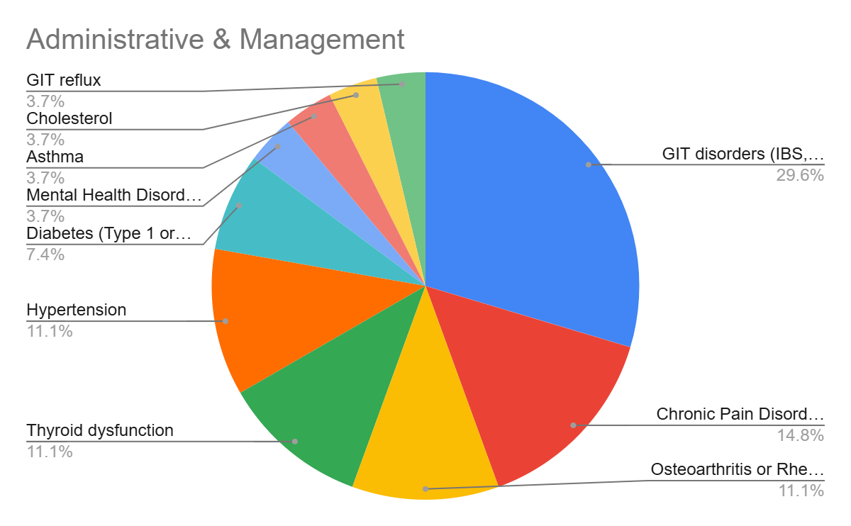

Figure 8a: Administrative & Management

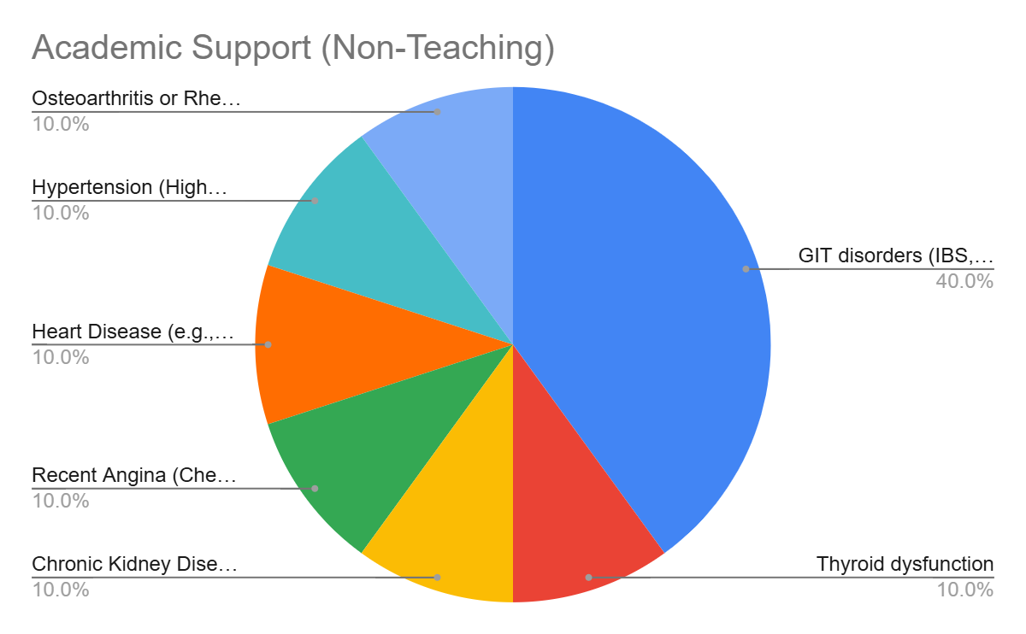

Figure 8b: Academic Support (Non-Teaching)

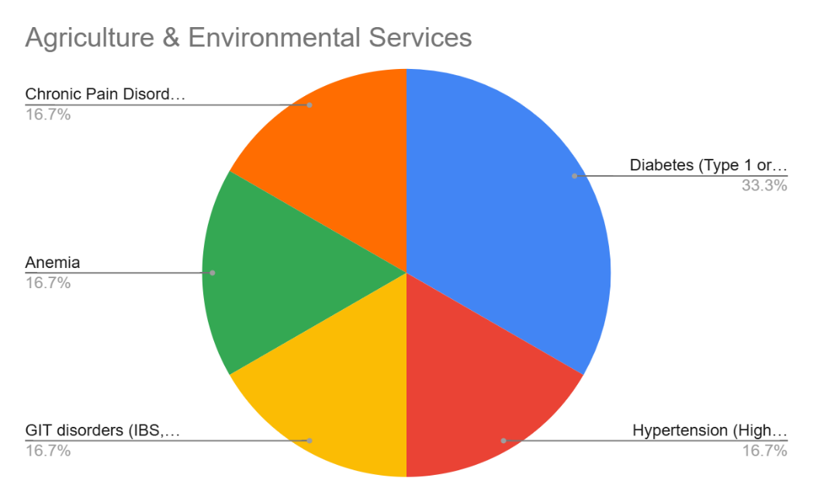

Figure 8c: Agriculture & Environmental Services

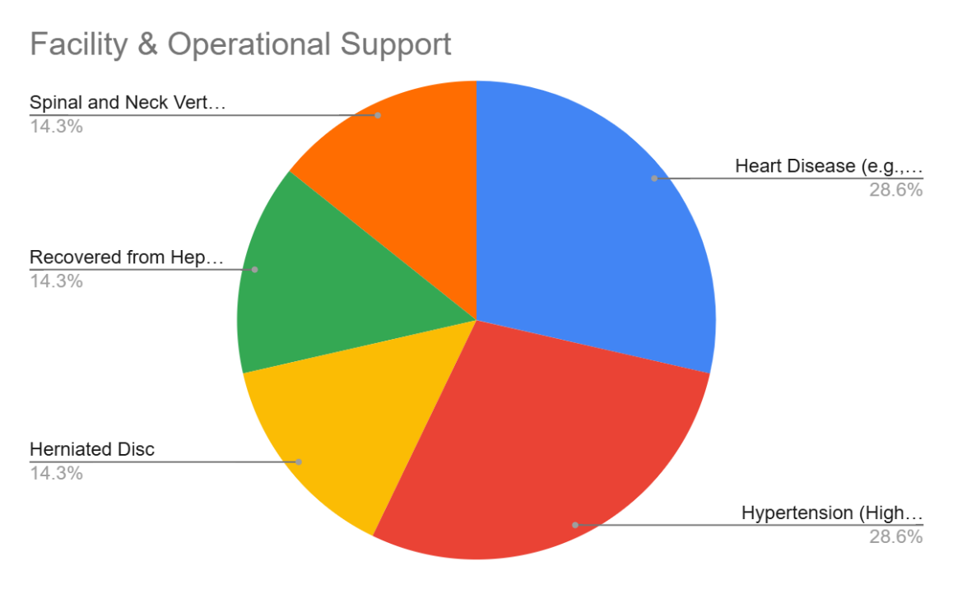

Figure 8d: Facility & Operational Support

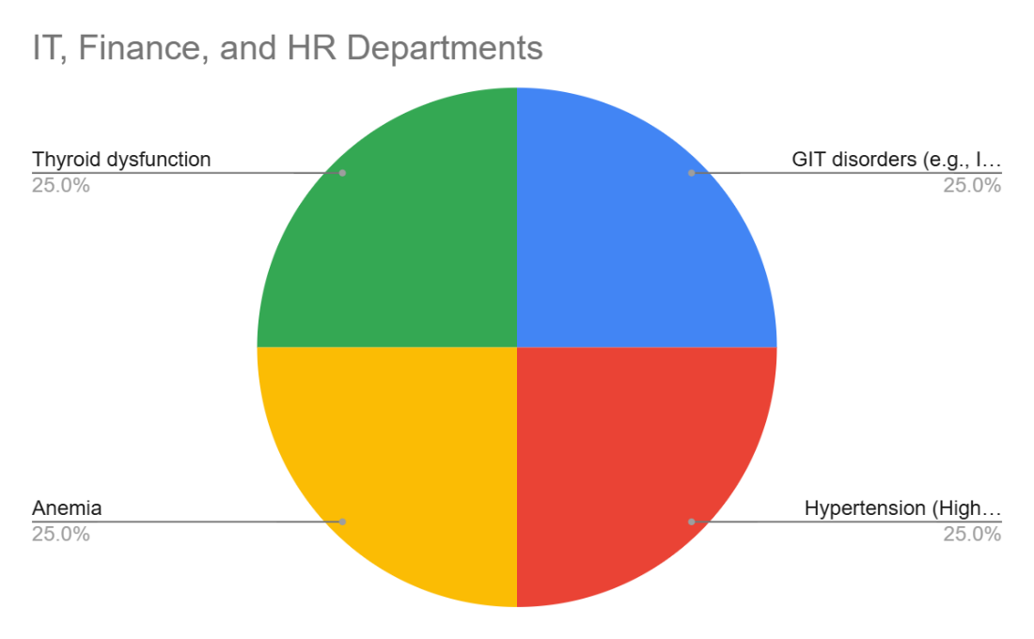

Figure 8e: IT, Finance, and HR Departments
•

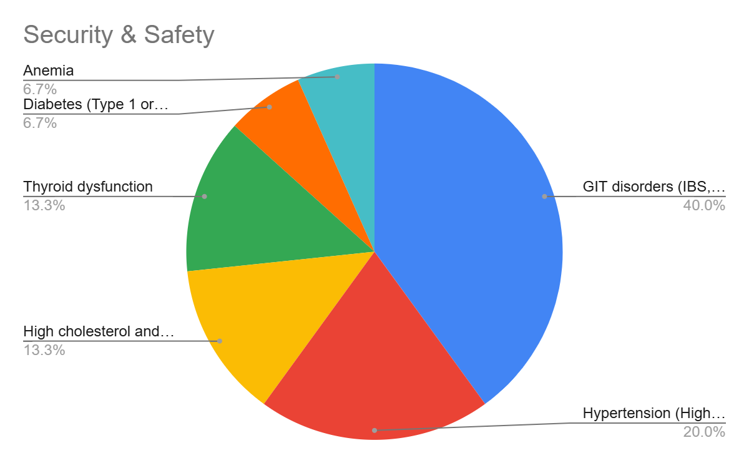
Figure 8f: Security & Safety

- Do you have a history of cancer?
Department | Yes (%) | No (%)
Admin | 1.92% | 98.08%
Academic | 5.00% | 95.00%
Agriculture | 0.00% | 100.00%
Facility | 0.00% | 100.00%
IT | 0.00% | 100.00%
Security | 0.00% | 100.00%
HR | 0.00% | 100.00%

Figure 9
Comment:
Very few departments reported a history of cancer, with only minimal cases in Academic (5%) and Admin (1.92%). All other departments reported none.

- Have you undergone any previous surgeries?
Surgery | Ad | Ac | Ag | Fa | IT | Fi | Se | HR
Laparoscopic | 4% | 10% | 0% | 3% | 0% | 25% | 6% | 0%
Appendectomy | 13% | 10% | 0% | 8% | 0% | 0% | 6% | 0%
Eye | 6% | 5% | 0% | 0% | 0% | 0% | 0% | 0%
Knee | 6% | 5% | 11% | 3% | 0% | 0% | 0% | 0%
Heart | 2% | 0% | 0% | 5% | 0% | 0% | 0% | 0%
Cancer | 4% | 0% | 0% | 0% | 0% | 0% | 0% | 0%
Plastic/Reconstructive | 2% | 0% | 0% | 0% | 0% | 0% | 0% | 0%
Gallbladder | 2% | 0% | 0% | 3% | 0% | 0% | 3% | 0%
Tonsillectomy | 2% | 0% | 0% | 0% | 0% | 0% | 0% | 0%
Childbirth | 0% | 15% | 0% | 0% | 0% | 0% | 0% | 25%
Other | 6% | 5% | 0% | 3% | 0% | 25% | 3% | 50%
No Surgery | 54% | 50% | 89% | 76% | 100% | 50% | 82% | 25%

Figure 10
Comment:
Most departments show a high percentage of staff with no surgery history, especially in IT (100%) and Agricultural Services (89%). Common surgeries include appendectomy, laparoscopic, and knee procedures, while childbirth and plastic/reconstructive surgeries appear mainly among academic support and HR staff.

- Please list all the medications you are currently taking for chronic health conditions:
Category | Admin (%) | Acad (%) | Agric (%) | Facility (%) | IT (%) | Finance (%) | Sec. (%) | HR (%)
1 Medication | 70.00% | 57.10% | 75.00% | 60.00% | 50.00% | – | 72.70% | –
2 Medications | 15.00% | 14.30% | 25.00% | 20.00% | 50.00% | – | 27.30% | 100.00%
3+ Medications | 15.00% | 28.60% | 0.00% | 30.00% | 0.00% | – | 9.10% | 0.00%

Figure 11
Comment:
Most staff take only one medication, with few on multiple medications. Taking several medications is rare overall but slightly higher in Facility and Academic departments.

- How many hours do you typically sleep each night?
Sleep Duration | Adm | Ac | Ag | Fa | IT | Fi | Se | HR
<5 hrs | 7.70% | 25.00% | 0.00% | 5.30% | 12.50% | 0.00% | 6.10% | 0.00%
5–7 hrs | 75.00% | 55.00% | 100.00% | 71.10% | 87.50% | 100.00% | 78.80% | 100.00%
8–9 hrs | 17.30% | 20.00% | 0.00% | 23.70% | 0.00% | 0.00% | 15.20% | 0.00%

Figure 12
Comment:
Most staff across all departments reported sleeping 5–7 hours, especially in IT, Finance, and HR (100%). Very few reported sleeping less than 5 hours, with the highest in Academic (25%). Sleep durations of 8–9 hours were less common overall.

- How many cigarettes do you smoke on an average day?
Smoking Status | Adm | Ac | Ag | Fa | IT | Fi | Se | HR
I do not smoke | 90.40% | 90.00% | 88.90% | 84.20% | 62.50% | 100.00% | 72.70% | 100.00%
6–10 cigarettes/day | 5.80% | 5.00% | 11.10% | 10.50% | 25.00% | 0.00% | 24.20% | 0.00%
11–20 cigarettes/day | 3.80% | 0.00% | 0.00% | 2.60% | 12.50% | 0.00% | 3.00% | 0.00%
More than 20/day | 0.00% | 0.00% | 0.00% | 0.00% | 0.00% | 0.00% | 0.00% | 0.00%
Undefined | 0.00% | 5.00% | 0.00% | 2.60% | 0.00% | 0.00% | 0.00% | 0.00%

Comment:
Most staff are non-smokers across all departments, with occasional light smoking more common in Security and IT.

Figure 13

- Dietary and lifestyle Habits
- How often do you buy organic foods?
Frequency | Adm | Ac | Ag | Fa | IT | Fi | Se | HR
Daily | 0.00% | 0.00% | 0.00% | 15.80% | 0.00% | 0.00% | 15.20% | 0.00%
Several times/week | 32.70% | 45.00% | 11.10% | 7.90% | 25.00% | 50.00% | 30.30% | 50.00%
Once a week | 25.00% | 35.00% | 66.70% | 44.70% | 25.00% | 0.00% | 12.10% | 0.00%
Rarely or never | 42.30% | 20.00% | 22.20% | 31.60% | 50.00% | 50.00% | 42.40% | 50.00%

Figure 14
Comment:
Most staff engage in the activity at least weekly, especially in Academic and Agricultural departments. Daily engagement is low, while "rarely or never" is more common in Admin and Security.
Ask ChatGPT

- How often do you eat vegetables per week?
Frequency | Adm | Ac | Ag | Fa | IT | Fi | Se | HR
Daily | 42.30% | 65.00% | 44.40% | 42.10% | 62.50% | 50.00% | 54.50% | 50.00%
Several/week | 44.20% | 25.00% | 44.40% | 42.10% | 25.00% | 50.00% | 39.40% | 50.00%
Once a week | 7.70% | 10.00% | 11.10% | 15.80% | 12.50% | 0.00% | 6.10% | 0.00%
Rarely/never | 5.80% | 0.00% | 0.00% | 0.00% | 0.00% | 0.00% | 0.00% | 0.00%

Figure 15
Comment:
Most staff eat vegetables daily or several times a week, but some consume them only weekly or rarely, highlighting a need to encourage healthier habits.
Ask ChatGPT

- How often do you eat fruits per week?
Frequency | Adm | Ac | Ag | Faculty | IT | Fi | Se | HR
Daily | 15.40% | 20.00% | 0.00% | 10.50% | 25.00% | 50.00% | 9.10% | 50.00%
Several/week | 55.80% | 60.00% | 88.90% | 39.50% | 50.00% | 50.00% | 30.30% | 50.00%
Once a week | 17.30% | 15.00% | 11.10% | 39.50% | 25.00% | 0.00% | 54.50% | 0.00%
Rarely/never | 11.50% | 5.00% | 0.00% | 10.50% | 0.00% | 0.00% | 6.10% | 0.00%

Figure 16
Comment:
Most staff eat Fruits several times a week, especially in Agriculture (89%) and Academic (60%), while daily consumption remains low in many departments, suggesting inconsistent healthy eating habits.

- How often do you eat red meat per week?
Frequency | Adm | Ac | Ag | Faculty | IT | Fi | Se | HR
Daily | 1.90% | 0.00% | 0.00% | 0.00% | 0.00% | 0.00% | 0.00% | 0.00%
Several/week | 44.20% | 35.00% | 22.20% | 5.30% | 50.00% | 0.00% | 6.10% | 25.00%
Once a week | 44.20% | 45.00% | 66.70% | 63.20% | 50.00% | 100.00% | 45.50% | 75.00%
Rarely/never | 9.60% | 20.00% | 11.10% | 31.60% | 0.00% | 0.00% | 48.50% | 0.00%

Figure 17
Comment:
Most staff consume red meat weekly, with higher frequent intake in IT and Administration, while Services and Faculty show lower consumption.

- How often do you eat poultry per week?
Frequency | Adm | Ac | Ag | Faculty | IT | Fi | Se | HR
Daily | 1.92% | 0.00% | 0.00% | 2.63% | 0.00% | 0.00% | 0.00% | 0.00%
Several times/week | 61.54% | 45.00% | 22.22% | 15.79% | 12.50% | 0.00% | 21.21% | 100.00%
Once a week | 36.54% | 55.00% | 77.78% | 76.32% | 87.50% | 100.00% | 63.64% | 0.00%
Rarely or never | 0.00% | 0.00% | 0.00% | 5.26% | 0.00% | 0.00% | 15.15% | 0.00%

Figure 18
Comment:
Poultry is mainly consumed weekly, with higher frequent intake in Admin and Academic staff. Rare consumption is minimal.

- How often do you eat fish per week?
Frequency | Adm | Ac | Ag | Faculty | IT | Fi | Se | HR
Daily | 0.00% | 0.00% | 0.00% | 0.00% | 0.00% | 0.00% | 0.00% | 0.00%
Several times/week | 7.69% | 10.00% | 77.78% | 2.63% | 12.50% | 0.00% | 6.06% | 0.00%
Once a week | 59.62% | 65.00% | 22.22% | 78.95% | 87.50% | 100.00% | 42.42% | 0.00%
Rarely or never | 32.69% | 25.00% | 0.00% | 18.42% | 0.00% | 0.00% | 51.52% | 100.00%

Figure 19
Comment:
Fish is mostly consumed weekly, with high frequency in Agriculture and low intake in HR and Services.

- How often do you eat processed/canned meat/fish per week?
Frequency | Adm | Ac | Ag | Faculty | IT | Fi | Se | HR
Daily | 0.00% | 0.00% | 11.11% | 2.63% | 25.00% | 0.00% | 0.00% | 25.00%
Several times/week | 11.54% | 5.00% | 0.00% | 5.26% | 25.00% | 0.00% | 0.00% | 0.00%
Once a week | 17.31% | 25.00% | 22.22% | 13.16% | 12.50% | 0.00% | 9.09% | 0.00%
Rarely or never | 71.15% | 70.00% | 77.78% | 78.95% | 37.50% | 100.00% | 90.91% | 75.00%

Figure 20
Comment:
Canned meat is rarely consumed across most departments, with slightly higher intake in a few areas like Administration or Faculty, if any. Overall, it's not a common protein source among staff.

- How often do you eat high-fat or fried foods?
Frequency | Adm | Ac | Ag | Fa | IT | Fi | Se | HR
Daily | 7.70% | 5.00% | 11.10% | 18.40% | 37.50% | 0.00% | 12.10% | 25.00%
Several times/week | 51.90% | 55.00% | 33.30% | 23.70% | 25.00% | 0.00% | 21.20% | 0.00%
Once a week | 23.10% | 15.00% | 44.40% | 23.70% | 12.50% | 50.00% | 12.10% | 75.00%
Rarely or never | 17.30% | 25.00% | 11.10% | 34.20% | 25.00% | 50.00% | 54.50% | 0.00%

Figure 21
Comment:
Frequent consumption of high-fat or fried foods is common, especially in Administrative, Academic, and IT staff, while Services staff report the lowest intake.

- How often do you eat foods high in sugar/desserts?
Frequency | Adm | Ac | Ag | Fa | IT | Fi | Se | HR
Daily | 13.50% | 10.00% | 11.10% | 2.60% | 37.50% | 0.00% | 3.00% | 50.00%
Several times/week | 44.20% | 40.00% | 11.10% | 18.40% | 37.50% | 50.00% | 21.20% | 25.00%
Once a week | 34.60% | 40.00% | 55.60% | 44.70% | 12.50% | 0.00% | 45.50% | 25.00%
Rarely or never | 7.70% | 10.00% | 22.20% | 34.20% | 12.50% | 50.00% | 30.30% | 0.00%

Figure 22
Comment:
Most staff eat high-fat or fried foods several times a week or once a week, with daily intake highest in IT (38%) and HR (50%). Rare or no consumption is more common in Faculty and Services.

- How often do you eat Baladi bread?
Frequency | Adm | Ac | Ag | Fa | IT | Fi | Se | HR
Daily | 50.00% | 65.00% | 77.80% | 92.10% | 75.00% | 0.00% | 81.80% | 75.00%
Several times/week | 36.50% | 35.00% | 11.10% | 7.90% | 12.50% | 50.00% | 15.20% | 25.00%
Once a week | 5.80% | 0.00% | 11.10% | 0.00% | 12.50% | 50.00% | 3.00% | 0.00%
Rarely or never | 7.70% | 0.00% | 0.00% | 0.00% | 0.00% | 0.00% | 0.00% | 0.00%

Figure 23
Comment:
Daily consumption of Baladi bread is very common across all departments, especially in Faculty (92%) and Services (82%), while rarely or never eating it is uncommon.

- What type of fat do you always use in cooking?
Type of Fat/Oil | Adm | Ac | Ag | Fa | IT | Fi | Se | HR
Corn oil | 21.20% | 25.00% | 44.40% | 21.10% | 0.00% | 100.00% | 33.30% | 25.00%
Natural butter | 30.80% | 25.00% | 44.40% | 31.60% | 12.50% | 0.00% | 15.20% | 0.00%
Olive oil | 5.80% | 20.00% | 0.00% | 2.60% | 12.50% | 0.00% | 36.40% | 0.00%
Margarine | 0.00% | 0.00% | 0.00% | 2.60% | 0.00% | 0.00% | 0.00% | 0.00%
Cotton seed oil | 1.90% | 0.00% | 0.00% | 0.00% | 0.00% | 0.00% | 12.10% | 0.00%
Sunflower oil | 34.60% | 30.00% | 11.10% | 39.50% | 62.50% | 0.00% | 0.00% | 75.00%
Mixed types | 5.80% | 0.00% | 0.00% | 2.60% | 12.50% | 0.00% | 3.00% | 25.00%

Figure 24
Comment:
Sunflower oil is the most commonly used fat overall, especially in IT (63%) and HR (75%). Natural butter is also popular in several departments. Olive oil and corn oil show varied but lower use, while margarine and cottonseed oil are rarely chosen.

- At what level do you estimate your daily physical activity?
Physical Activity Level | Adm | Ac | Ag | Fa | IT | Fi | Se | HR
Low | 25.00% | 15.00% | 11.10% | 31.60% | 12.50% | 0.00% | 6.10% | 50.00%
Moderate | 69.20% | 80.00% | 55.60% | 57.90% | 75.00% | 100.00% | 87.90% | 50.00%
High | 5.80% | 5.00% | 33.30% | 10.50% | 12.50% | 0.00% | 6.10% | 0.00%

Figure 25
Comment:
Most staff report moderate physical activity, especially in Academic (80%) and Services (88%). Low activity is notable in Faculty (32%) and HR (50%), while high activity levels are generally low across departments.

- Do you have a regular fitness routine?
Activity | Adm | Ac | Ag | Fa | IT | Fi | Se | HR
None | 48.10% | 15.00% | 22.20% | 48.50% | 50.00% | 50.00% | 12.10% | 75.00%
Walking | 36.50% | 65.00% | 66.70% | 48.50% | 37.50% | 37.50% | 72.70% | 25.00%
Gym Exercises | 11.50% | 5.00% | 0.00% | 3.00% | 12.50% | 0.00% | 0.00% | 0.00%
Sport | 3.80% | 15.00% | 11.10% | 15.20% | 12.50% | 50.00% | 15.20% | 0.00%

Figure 26
Comment:
Most staff either don’t exercise or only walk; few do gym or sports. This shows low engagement in regular fitness routines across departments.
Ask ChatGPT

- Women's health, Are your periods regular?
Period Regularity | Adm | Ac | Ag | Fa | IT | Fi | Se | HR
Yes | 70% | 75% | 0% | 29% | – | – | – | 100%
No | 15% | 25% | 100% | 57% | – | – | – | 0%
Not specified | 15% | 0% | 0% | 14% | – | – | – | 0%

Comment:
Most Adm, Ac, and HR staff report regular periods, while Ag and Fa show more irregularity. Missing data limits conclusions for other departments.
Ask ChatGPT

- Student’s self-evaluation information:
Question | Adm | Ac | Ag | Fa | IT | Fi | Se | HR
Q1 Agree: I feel happy with my life | 88% | 90% | 89% | 87% | 100% | 100% | 85% | 100%
Q1 Disagree | 12% | 10% | 11% | 13% | 0% | 0% | 15% | 0%
Q2 Agree: I feel calm and relaxed | 60% | 55% | 89% | 79% | 88% | 100% | 85% | 100%
Q2 Disagree | 40% | 45% | 11% | 21% | 12% | 0% | 15% | 0%
Q3 Agree: I feel supported by family/community | 96% | 95% | 89% | 95% | 100% | 100% | 91% | 75%
Q3 Disagree | 4% | 5% | 11% | 5% | 0% | 0% | 9% | 25%
Q4 Agree: I feel financially stable and secure | 50% | 50% | 78% | 79% | 63% | 50% | 52% | 100%
Q4 Disagree | 50% | 50% | 22% | 21% | 37% | 50% | 48% | 0%
Q5 Agree: Purpose in life | 98% | 100% | 100% | 97% | 88% | 100% | 97% | 75%
Q5 Disagree | 2% | 0% | 0% | 3% | 12% | 0% | 3% | 25%
Q6 Agree: Confidence in opinions | 90% | 80% | 100% | 89% | 75% | 100% | 82% | 75%
Q6 Disagree | 10% | 20% | 0% | 11% | 25% | 0% | 18% | 25%
Q7 Agree: Life is learning, changing, growth | 96% | 95% | 100% | 97% | 100% | 100% | 91% | 100%
Q7 Disagree | 4% | 5% | 0% | 3% | 0% | 0% | 9% | 0%

Figure 28/a

Figure 28/B

