

Integrative Health Center
2025 - 2026
SCREENING INTEGRATIVE HEALTH REPORT FOR
NEWCOMERS

Purpose:
Most university students belong to young adulthood with age ranges between 18 – 26 years old. Many reports identified this phase as biologically, and psychologically stage that influences university students' attitude and decision-making. According to previous reports, there is a high prevalence of risky behaviours among college students, such as eating disorders, anxiety, and depression, as well as tobacco/ vaping products usage. Accordingly, our aim is to implement holistic health screening for students at Heliopolis University for Sustainable Development regardless their faculty or study level. A self-completion questionnaire was administered through Computer-Assisted Group Interviewing about health, lifestyle and dietary habits as well as self-evaluation.
Findings:
Total number of Students screened at different Faculties:
Faculty | Number of Students | Percentage
Pharmacy | 212 | 56.90%
Physical Therapy | 31 | 8.30%
Agriculture | 82 | 22.00%
Engineering | 47 | 12.60%
Blank | 1 | 0.30%
Total | 373 | 100%
Comment:
The data shows that most students are in the Pharmacy faculty (56.90%), followed by Agriculture (22.00%) and Engineering (12.60%). Physical Therapy has the smallest share at 8.30%, with 0.30% listed as "Blank." The total student count is 373.

- Demographic information:
- Gender:
Faculty | Female | Male
Agriculture | 68.29% | 31.71%
Engineering | 29.79% | 70.21%
Pharmacy | 57.08% | 42.92%
Physical Therapy | 64.52% | 35.48%
Blank | 100.00% | 0.00%

Figure 1
Comment:
Pharmacy and Physical Therapy have more females, while Engineering has a higher male percentage. Agriculture shows a balanced distribution, and Blank is entirely female.

- Age range:
Faculty | Age 18-20 | Age 21-23
Agriculture | 96.34% | 3.66%
Engineering | 95.74% | 4.26%
Pharmacy | 99.53% | 0.47%
Physical Therapy | 96.77% | 3.23%
Blank | 100.00% | 0.00%

Comment:
Most participants are in the 18-20 age group, with Pharmacy having the highest at 99.53%. The "Blank" category has only one participant, aged 18-20.

Figure 2
- Marital status:
Faculty | Single | Engaged | Married
Agriculture | 98.78% | 1.22% | 0.00%
Engineering | 97.87% | 2.13% | 0.00%
Pharmacy | 99.06% | 0.47% | 0.47%
Physical Therapy | 100.00% | 0.00% | 0.00%
Blank | 100.00% | 0.00% | 0.00%

Figure 3
Comment:
Most participants are single, with minimal engagement and marriage percentages, particularly in Pharmacy.

- Accommodation:
Faculty | With Parents | Student Housing | University Dorms | Rented Private Apartment
Agriculture | 80.49% | 4.88% | 0.00% | 12.20%
Engineering | 85.11% | 6.38% | 0.00% | 4.26%
Pharmacy | 81.60% | 8.96% | 2.36% | 4.72%
Physical Therapy | 80.65% | 0.00% | 3.23% | 6.45%
Blank | 0.00% | 0.00% | 0.00% | 0.00%

Figure 4

Comment:
Most students live with parents, followed by those in rented private apartments. Pharmacy has the highest student housing and dorm percentages.

- Travel Duration:
Faculty | <15 min | 15–30 min | 31–60 min | >1 hour
Agriculture | 10.98% | 21.95% | 26.83% | 40.24%
Engineering | 4.26% | 38.30% | 25.53% | 31.91%
Pharmacy | 8.02% | 28.77% | 25.94% | 37.26%
Physical Therapy | 9.68% | 25.81% | 38.71% | 25.81%
Blank | 0.00% | 0.00% | 100.00% | 0.00%

Figure 5
Comment:
Most students have a travel time of over 1 hour, with Pharmacy and Agriculture having the highest percentages in this category.

- Student’s health & lifestyle information:
- Body mass index (BMI):
N.B:
- under 18.5 – This is described as underweight.
- between 18.5 and 24.9 – This is described as the 'healthy range'.
- between 25 and 29.9 – This is described as overweight.
- between 30 and 39.9 – This is described as obesity.
- 40 or over – This is described as severe obesity.
Faculty | Underweight | Healthy Range | Overweight | Obese | Undefined
Agriculture | 3.66% | 48.78% | 25.61% | 21.95% | 0.00%
Engineering | 12.77% | 42.55% | 27.66% | 10.64% | 6.38%
Pharmacy | 7.58% | 59.24% | 18.96% | 13.74% | 0.47%
Physical Therapy | 12.90% | 64.52% | 9.68% | 12.90% | 0.00%
Blank | 100.00% | 0.00% | 0.00% | 0.00% | 0.00%

Figure 6
Comment:
The data shows that most students are within the healthy weight range, particularly in Physical Therapy and Pharmacy. However, a significant percentage of students in Agriculture, Engineering, and Pharmacy are overweight or obese, indicating a need for health awareness and interventions.

- Do you have any of the following medical condition/s?

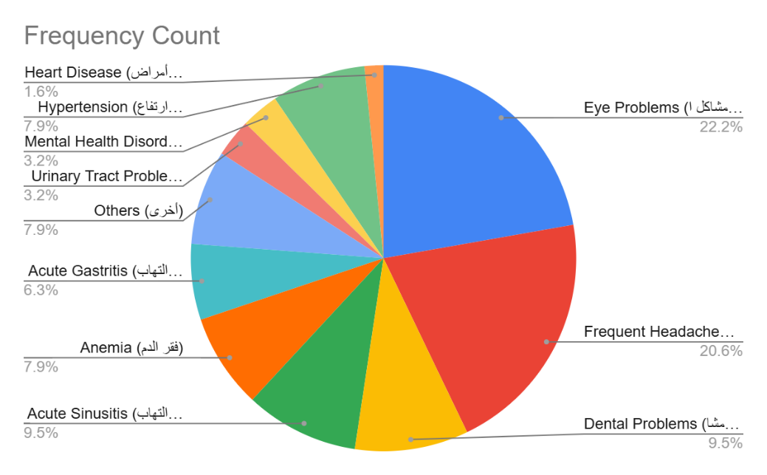
Figure 7a (Agriculture)

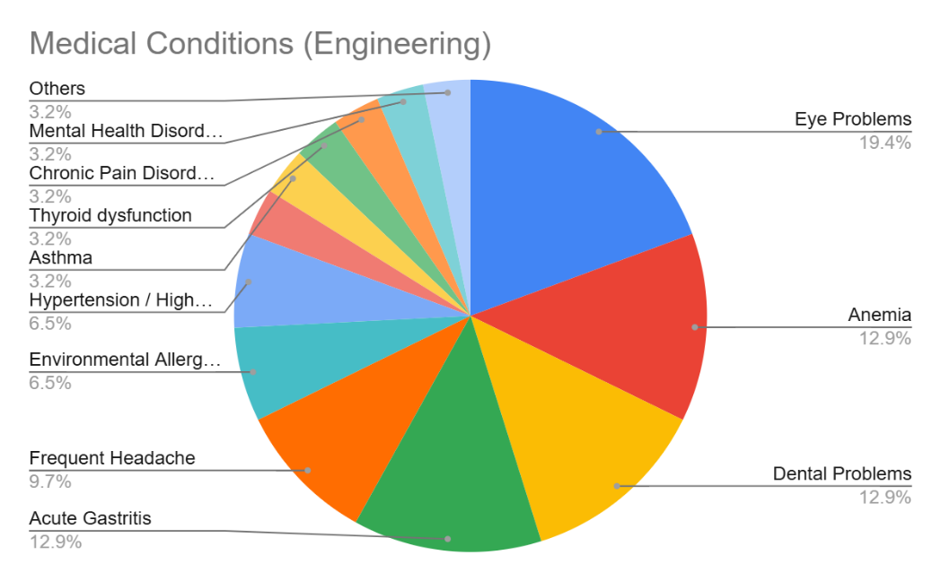

Figure 7b (Engineering)
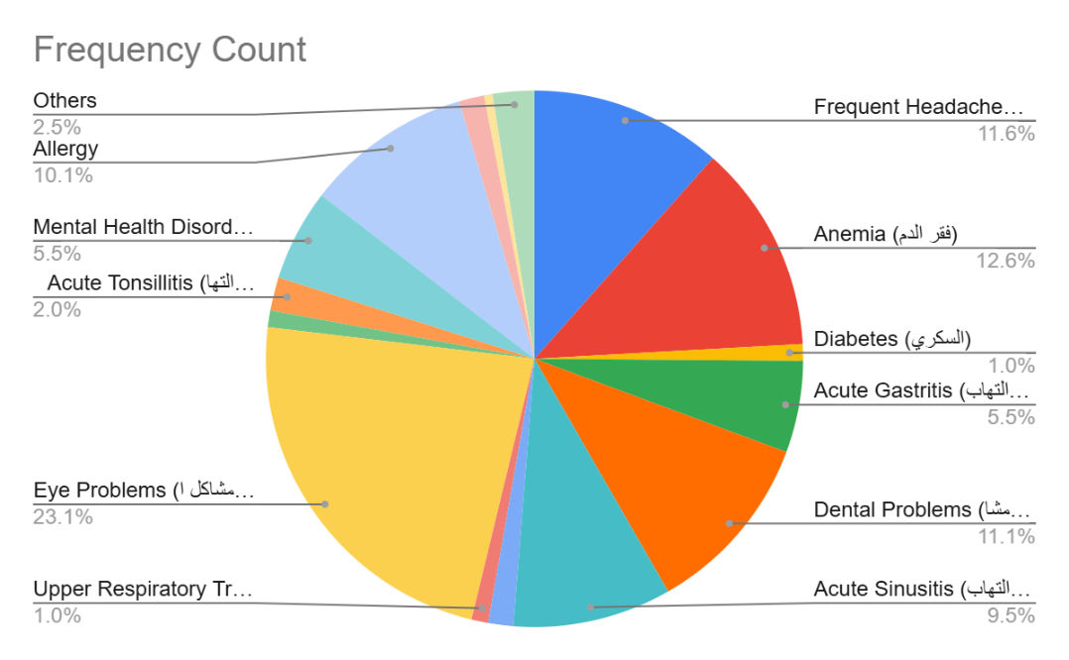
Figure 7c (Pharmacy)

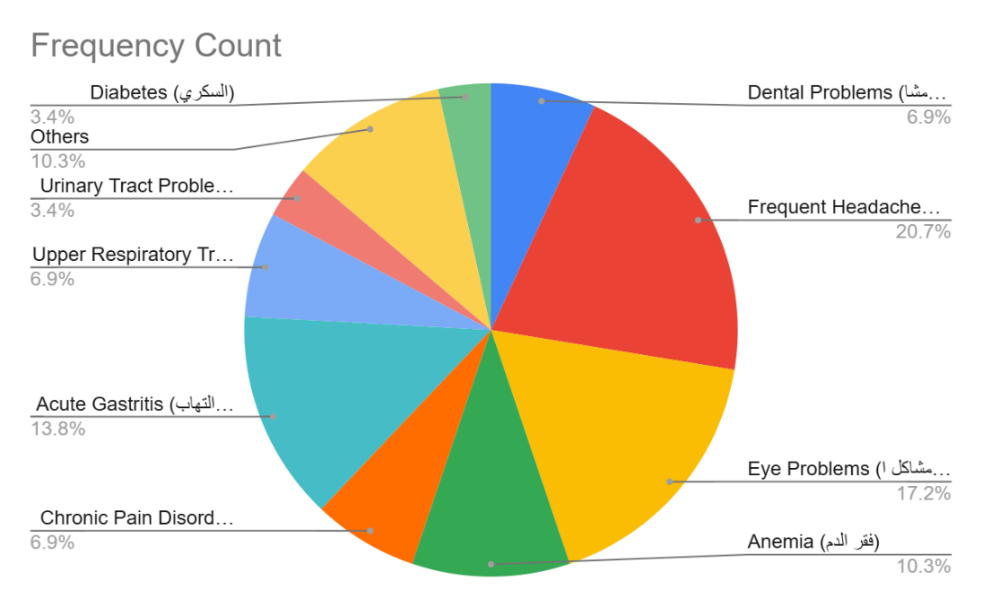
Figure 7d (Physiotherapy)

- Do you have a history cancer?

Faculty | Yes | No
Agriculture | 1.22% | 98.77%
Engineering | 0% | 100%
Pharmacy | 0% | 100%
Physical Therapy | 3.22% | 96.77%
Blank | 0% | 100%

Figure 8
Comment:
The data shows a very low prevalence of cancer across faculties, with Agriculture having 1.22%, Physical Therapy 3.22%, and Engineering and Pharmacy reporting no cases. This highlights minimal reported cancer cases, suggesting a need for continued health awareness and screenings.

- Have you undergone any previous surgeries?
Surgery Type | Agriculture | Engineering | Pharmacy | Physical Therapy | Blank
No Surgery | 86.59% | 89.36% | 90.57% | 87.10% | 100%
Appendectomy | 4.88% | 2.13% | 3.77% | 3.23% | 0%
Tendon Repair | 0% | 2.13% | 0.47% | 0% | 0%
Eye Surgery | 1.22% | 0% | 0.47% | 3.23% | 0%
Shoulder Surgery | 0% | 0% | 0% | 3.23% | 0%
Knee Surgery | 2.44% | 2.13% | 1.42% | 0% | 0%
Gallbladder Removal | 0% | 0% | 0.47% | 0% | 0%
Plastic/Reconstructive Surgery | 1.22% | 4.26% | 1.89% | 0% | 0%
Hernia Surgery | 0% | 0% | 0.47% | 0% | 0%
Tonsil/Adenoid Removal | 0% | 0% | 0.94% | 3.23% | 0%
Ganglion Cyst Removal | 0% | 0% | 0.47% | 0% | 0%
Bariatric Surgery | 1.22% | 0% | 0% | 0% | 0%
Fistula Surgery | 1.22% | 0% | 0% | 0% | 0%
Bladder Augmentation | 1.22% | 0% | 0% | 0% | 0%

Figure 9
Comment:
This bar chart displays the percentage distribution of various surgery types across fields like Agriculture, Engineering, Pharmacy, and Physical Therapy, providing a clear comparison of the prevalence of different surgeries within each category.

- Are there doctors or therapists who treat you?
Category | Agriculture | Engineering | Pharmacy | Physical Therapy | Blank
Zero | 64.63% | 65.96% | 71.70% | 64.52% | 0.00%
1- doctor | 29.27% | 21.28% | 20.28% | 29.03% | 100.00%
2- doctor | 4.88% | 4.26% | 5.19% | 6.45% | 0.00%
3+ doctor | 1.22% | 6.38% | 2.83% | 0.00% | 0.00%

Figure 10
Comment:
The data shows that most people in all fields (Agriculture, Engineering, Pharmacy, Physical Therapy) visit zero or one doctor. Pharmacy has the highest percentage of people seeing multiple doctors, while Agriculture has the most people not visiting any doctor.

- Please list all the medications you are currently taking for chronic health conditions:
Category | Agriculture | Engineering | Pharmacy | Physical Therapy | Blank
No Medication | 85.37% | 81.25% | 89.62% | 93.55% | 100%
1- Medication | 10.98% | 14.58% | 8.49% | 6.45% | 0%
2- Medication | 2.44% | 2.08% | 1.42% | 0% | 0%
3+ Medication | 1.22% | 0% | 0% | 0% | 0%

Comment:
Most people in all categories (Agriculture, Engineering, Pharmacy, Physical Therapy) have no medication. Pharmacy has the highest percentage of individuals with no medication (89.62%). The proportion of people taking 1 medication is small, with Physical Therapy showing the lowest (6.45%). Very few people use 2 or more medications across all fields.

Figure 11

- How many hours do you typically sleep each night?
Sleep Duration | Agriculture | Engineering | Pharmacy | Physical Therapy | Blank
Less than 5 hours | 4.88% | 0% | 1.89% | 3.23% | 0%
5 to 7 hours | 48.78% | 51.06% | 63.21% | 48.39% | 0%
8 to 9 hours | 46.34% | 48.94% | 34.91% | 48.39% | 100%

Figure 12
Comment:
Most people in all fields sleep 5 to 7 hours, with Pharmacy having the highest percentage. 8 to 9 hours is the second most common, particularly in Engineering and Physical Therapy, while very few sleep less than 5 hours.

- How many cigarettes do you smoke on an average day?
Smoking Status | Agriculture | Engineering | Pharmacy | Physical Therapy | Blank
I do not smoke | 97.56% | 95.74% | 96.73% | 96.77% | 100%
6–10 cigarettes | 0% | 4.26% | 1.89% | 0% | 0%
11–20 cigarettes | 1.22% | 0% | 0.47% | 0% | 0%
More than 20 cigarettes | 0% | 0% | 0% | 0% | 0%
Use smoking products | 1.22% | 0% | 0.94% | 3.23% | 0%

Comment:
Most people across all fields (Agriculture, Engineering, Pharmacy, Physical Therapy) do not smoke, with over 95% in each category. A small percentage uses 6–10 cigarettes or smoking products (e.g., vapes), while very few smoke 11–20 cigarettes. There is no significant use of more than 20 cigarettes.

Figure 13

- Dietary and lifestyle Habits
- How often do you buy organic foods?
Frequency | Agriculture | Engineering | Pharmacy | Physical Therapy | Blank
Daily | 24.39% | 14.89% | 16.98% | 9.68% | 0%
Several times a week | 31.71% | 21.28% | 27.36% | 22.58% | 100%
Once a week | 13.41% | 25.53% | 18.87% | 32.26% | 0%
Rarely or Never | 30.49% | 38.30% | 36.79% | 35.48% | 0%

Figure 14
Comment:
The data shows the varying frequency of buying organic food across different categories. It highlights how often individuals from fields like Agriculture, Engineering, Pharmacy, and Physical Therapy purchase organic food, with differences in habits between the groups.

- How often do you eat vegetables per week?
Frequency | Agriculture | Engineering | Pharmacy | Physical Therapy | Blank
Daily | 35.37% | 38.30% | 41.50% | 41.94% | 0%
Several times a week | 53.66% | 48.94% | 46.70% | 38.71% | 100%
Once a week | 3.66% | 8.51% | 7.55% | 12.90% | 0%
Rarely or never | 7.32% | 4.26% | 4.25% | 6.45% | 0%

Figure 15
Comment:
Most people in all fields eat vegetables several times a week, with a smaller percentage eating them daily. Very few consume them once a week or rarely/never.

- How often do you eat fruits per week?
Frequency | Agriculture | Engineering | Pharmacy | Physical Therapy | Blank
Daily | 31.71% | 27.66% | 30.19% | 35.48% | 0%
Several times a week | 58.54% | 51.06% | 59.43% | 51.61% | 100%
Once a week | 6.10% | 14.89% | 6.13% | 9.68% | 0%
Rarely or Never | 3.66% | 6.38% | 4.25% | 3.23% | 0%

Figure 16
Comment:
The data shows how students across different faculties (Agriculture, Engineering, Pharmacy, Physical Therapy) consume fruits. Most students eat fruits several times a week, with a significant number consuming them daily. A smaller portion consumes fruits once a week or rarely/never.

- How often do you eat red meat per week?
Frequency | Agriculture | Engineering | Pharmacy | Physical Therapy | Blank
Daily | 8.54% | 8.51% | 6.13% | 12.90% | 0%
Several times a week | 63.41% | 68.09% | 65.38% | 54.84% | 100%
Once a week | 20.73% | 19.15% | 23.11% | 19.35% | 0%
Rarely or Never | 7.32% | 4.26% | 5.66% | 12.90% | 0%

Figure 17
Comment:
Most students across all faculties consume fruits several times a week, with Pharmacy and Engineering showing the highest percentages. Daily consumption is also common, especially in Physical Therapy. Very few students eat fruits once a week or rarely/never.

- How often do you eat poultry per week?
Frequency | Agriculture | Engineering | Pharmacy | Physical Therapy | Blank
Daily | 12.20% | 6.38% | 5.19% | 19.35% | 0%
Several times a week | 73.17% | 80.85% | 76.42% | 64.52% | 100%
Once a week | 10.98% | 10.64% | 16.51% | 12.90% | 0%
Rarely or Never | 3.66% | 2.13% | 1.89% | 3.23% | 0%

Figure 18
Comment:
For poultry consumption, the data indicates that most students across all faculties consume poultry several times a week, with Pharmacy and Engineering showing the highest percentages in this category. Daily poultry consumption is less frequent, and very few students consume poultry once a week or rarely/never.

- How often do you eat fish per week?
Frequency | Agriculture | Engineering | Pharmacy | Physical Therapy | Blank
Daily | 4.88% | 0% | 0.94% | 0% | 0%
Several times a week | 35.37% | 19.15% | 24.53% | 25.81% | 0%
Once a week | 35.37% | 34.04% | 36.79% | 45.16% | 100%
Rarely or Never | 24.39% | 46.81% | 37.74% | 29.03% | 0%

Figure 19
Comment:
For fish consumption, most students across all faculties consume fish once a week or several times a week, with Physical Therapy leading in the once-a-week category. Daily fish consumption is low, and rarely or never consumption is more common in Engineering and Physical Therapy.

preference for poultry among students.
Let me know if you need the percentage table or a longer analysis.

- How often do you eat processed/canned meat/fish per week?
Frequency | Agriculture | Engineering | Pharmacy | Physical Therapy | Blank
Daily | 4.88% | 2.13% | 2.36% | 0% | 0%
Several times a week | 37.80% | 38.30% | 18.87% | 9.68% | 100%
Once a week | 18.29% | 14.89% | 22.17% | 35.48% | 0%
Rarely or Never | 39.02% | 44.68% | 56.60% | 54.84% | 0%

Figure 20
Comment:
Most students across all faculties consume canned or processed foods rarely or never, with Agriculture and Engineering showing some several times a week consumption. Daily consumption is minimal, and once a week consumption is common in Agriculture and Pharmacy.
Once a week consumption is also notable, especially in Agriculture and Pharmacy.

preference for poultry among students.
Let me know if you need the percentage table or a longer analysis.

- How often do you eat high-fat or fried foods?
Frequency | Agriculture | Engineering | Pharmacy | Physical Therapy | Blank
Daily | 19.51% | 10.64% | 12.26% | 12.90% | 0%
Several times a week | 50.00% | 59.57% | 50.47% | 61.29% | 100%
Once a week | 18.29% | 21.28% | 23.11% | 22.58% | 0%
Rarely or Never | 12.20% | 8.51% | 14.15% | 3.23% | 0%

Figure 21
Comment:
Most respondents across all fields engage several times a week (50-61%), with daily participation lower but still notable in Agriculture, Pharmacy, and Physical Therapy. The Blank category has only one response, marking 100% for "several times a week."

- How often do you eat Baladi bread?
Frequency | Agriculture | Engineering | Pharmacy | Physical Therapy | Blank
Daily | 58.54% | 59.57% | 63.68% | 64.52% | 0%
Several times a week | 26.83% | 25.53% | 26.89% | 22.58% | 100%
Once a week | 9.76% | 10.64% | 2.83% | 6.45% | 0%
Rarely or Never | 4.88% | 4.26% | 6.60% | 6.45% | 0%

Figure 22
Comment:
Most people consume Baldi bread daily (58-64%), with a smaller group eating it several times a week (22-27%).

- How often do you drink tea/coffee?
Frequency | Agriculture | Engineering | Pharmacy | Physical Therapy | Blank
Daily | 46.34% | 38.30% | 0% | 0% | 0%
2–3 times daily | 30.49% | 25.53% | 22.17% | 19.35% | 0%
Once daily | 0% | 0% | 52.36% | 51.61% | 0%
Never | 23.17% | 36.17% | 25.47% | 29.03% | 100%

Comment:
Most respondents consume tea and coffee 2-3 times daily, with percentages ranging from 19-30% across fields. A significant portion, especially in Pharmacy and Physical Therapy, consume it once daily (52-51%). Never consuming tea or coffee ranges from 23-36%, with Blank showing a 100% for "Never."

Figure 23

- How many spoons of sugar do you always add to your drink?
Frequency | Agriculture | Engineering | Pharmacy | Physical Therapy | Blank
One Spoon | 25.61% | 25.53% | 21.23% | 16.13% | 0%
Two Spoons | 46.34% | 38.30% | 43.40% | 29.03% | 100%
More than two | 23.17% | 34.04% | 24.53% | 38.71% | 0%
Never | 4.88% | 2.13% | 10.84% | 16.13% | 0%

Figure 24
Comment:
Most respondents consume 2 spoons of sugar per week, with percentages ranging from 29-46% across fields. More than two spoons is the second most common, particularly in Physical Therapy and Engineering. A smaller percentage never consume sugar, especially in Engineering and Agriculture.

- What type of fat do you always use in cooking?
Type of Fat/Oil | Agriculture | Engineering | Pharmacy | Physical Therapy | Blank
Corn oil | 29.27% | 12.77% | 31.13% | 12.90% | 0%
Natural butter | 21.95% | 27.66% | 24.05% | 16.13% | 0%
Olive oil | 10.98% | 10.64% | 16.98% | 12.90% | 0%
Margarine | 0% | 0% | 0% | 0% | 0%
Cotton seed oil | 3.66% | 0% | 1.89% | 0% | 0%
Sunflower oil | 34.15% | 46.81% | 25.94% | 54.84% | 100%
Natural ghee | 0% | 0% | 0% | 0% | 0%
Undefined | 0% | 2.13% | 0.47% | 0% | 0%

Figure 25
Comment:
Most new students consume sunflower oil (25-54%), followed by corn oil and natural butter in varying amounts across fields. Olive oil is also commonly used, especially in Pharmacy. Cotton seed oil and margarine are consumed less frequently, with natural ghee being almost unused. Overall, sunflower oil appears to be the most popular choice among students.

- How many liters of water do you drink daily?
Water Consumption | Agriculture | Engineering | Pharmacy | Physical Therapy | Blank
Less than one liter | 19.51% | 8.51% | 10.38% | 9.68% | 0%
One liter (4 glasses) | 40.24% | 29.79% | 35.38% | 29.03% | 100%
Two liters (8 glasses) | 28.05% | 36.17% | 38.22% | 45.16% | 0%
More than two liters | 12.20% | 25.53% | 16.98% | 16.13% | 0%

Figure 26
Comment:
Most students across all faculties consume one litre (4 glasses) of water daily, with Pharmacy and Physical Therapy showing the highest consumption. Two litres (8 glasses) is also a common choice, especially in Physical Therapy and Pharmacy. More than two litres are less frequent, but it still accounts for a notable portion in Engineering. A smaller number of students, especially in Agriculture and Engineering, consume less than one litre of water daily. Overall, the data shows a strong preference for consuming at least one to two litres of water per day.

- Do you have a regular fitness routine?
Activity | Agriculture | Engineering | Pharmacy | Physical Therapy | Blank
None | 28.05% | 10.64% | 21.70% | 19.35% | 0%
Walking | 41.46% | 40.43% | 44.81% | 38.71% | 100%
Gym exercises | 24.39% | 31.91% | 20.75% | 29.03% | 0%
Practice Sport (swimming, football, others) | 6.10% | 17.02% | 12.74% | 12.90% | 0%

Figure 27
Comment:
Most students across all faculties engage in walking (38-45%), with gym exercises being the second most common activity (20-32%). Physical Therapy and Engineering students also participate in sports like swimming or football (12-17%). A notable portion, particularly in Agriculture and Pharmacy, report doing no physical activity (21-28%).

- Student’s self-evaluation information:

