

Integrative Health Center
2024 - 2025
SCREENING INTEGRATIVE HEALTH REPORT FOR pharmacy students

Purpose:
Most university students belong to young adulthood with age ranges between 18 – 26 years old. Many reports identified this phase as biologically, and psychologically stage that influences university students' attitude and decision-making. According to previous reports, there is a high prevalence of risky behaviours among college students, such as eating disorders, anxiety, and depression, as well as tobacco/ vaping products usage. Accordingly, our aim is to implement holistic health screening for students at Heliopolis University for Sustainable Development regardless their faculty or study level. A self-completion questionnaire was administered through Computer-Assisted Group Interviewing about health, lifestyle and dietary habits as well as self-evaluation.
Findings:
Total number of Students screened at different levels:
Year | Number of Students
Year 1 | 351
Year 2 | 73
Year 3 | 81
Year 4 | 14
Year 5 | 104
Comment:
The data indicates a significantly higher number of students in Year 1 (352), followed by a sharp decline in subsequent years, reaching the lowest point in Year 4 (14).

- Demographic information:
- Gender:
Year | Female | Male | Total
Year 1 | 57.39% | 42.61% | 351
Year 2 | 58.90% | 41.10% | 73
Year 3 | 60.49% | 39.51% | 81
Year 4 | 71.43% | 28.57% | 14
Year 5 | 73.08% | 26.92% | 104

Figure 1
Comment:
The data shows a consistent increase in the percentage of female students from Year 1 to Year 5, indicating stronger female enrolment in pharmacy programs.

- Age range:

Year | Age 17–20 | Age 21–23 | Age >23
Year 1 | 98.29% | 1.42% | 0.28%
Year 2 | 91.78% | 8.22% | 0.00%
Year 3 | 51.85% | 46.91% | 1.23%
Year 4 | 7.14% | 92.86% | 0.00%
Year 5 | 0.00% | 90.38% | 9.62%

Figure 2
Comment:
The data shows a clear age progression across academic years, with most Year 1 students aged 17–20, and older age groups (21–23 and >23) becoming more prominent in later years, especially Years 4 and 5.
4o

- Marital status:
Year | Single | Engaged | Married | Widowed | Divorced
Year 1 | 99.72% | 0.28% | 0.00% | 0.00% | 0.00%
Year 2 | 97.26% | 2.74% | 0.00% | 0.00% | 0.00%
Year 3 | 93.83% | 4.94% | 1.23% | 0.00% | 0.00%
Year 4 | 85.71% | 7.14% | 7.14% | 0.00% | 0.00%
Year 5 | 81.73% | 15.38% | 2.88% | 0.00% | 0.00%

Figure 3
Comment:
The data shows that most pharmacy students across all academic years are single, with a gradual decrease in single status and a slight rise in engaged or married status in higher years. This trend likely reflects increased age, maturity, and life planning by the time students reach later academic stages, especially Year 5. The near absence of widowed or divorced statuses aligns with the relatively young age of the student population.

- Accommodation:
Year | With Parents | Student Housing | University Dorms | Rented Private Apartment
2 | 71.23% | 23.29% | 0.00% | 5.48%
3 | 61.73% | 23.46% | 2.47% | 12.35%
4 | 71.43% | 14.29% | 0.00% | 14.29%
5 | 75.24% | 13.33% | 1.90% | 9.52%

Figure 4

- Travel Duration:
Year | <15 min | 15–30 min | 31–60 min | >1 hour
2 | 10.96% | 32.88% | 26.03% | 30.14%
3 | 25.93% | 14.81% | 17.28% | 41.98%
4 | 0.00% | 14.29% | 42.86% | 42.86%
5 | 16.35% | 18.27% | 21.15% | 44.23%

Figure 5

Comment:
Most students in Years 3 and 5 spend over an hour commuting, while Years 2 and 4 have more varied travel times. Overall, longer travel durations increase in later years.

- Student’s health & lifestyle information:
- Body mass index (BMI):
N.B:
- under 18.5 – This is described as underweight.
- between 18.5 and 24.9 – This is described as the 'healthy range'.
- between 25 and 29.9 – This is described as overweight.
- between 30 and 39.9 – This is described as obesity.
- 40 or over – This is described as severe obesity.

Year | Underweight | Healthy Range | Overweight | Obese
Year 1 | 8.50% | 70.70% | 19.40% | 1.40%
Year 2 | 4.10% | 63.00% | 20.50% | 12.30%
Year 3 | 4.90% | 60.50% | 28.40% | 6.20%
Year 4 | 21.40% | 42.90% | 28.60% | 7.10%
Year 5 | 7.70% | 48.10% | 30.80% | 13.50%

Figure 6
Comment:
The data shows a decline in healthy BMI levels over the years, with a noticeable rise in overweight and obesity rates. This suggests increasing health risks among students as they advance academically, highlighting the need for early health interventions.

- Do you suffer from illnesses?

Year | No | Yes
Year 1 | 84.05% | 15.95%
Year 2 | 71.23% | 28.77%
Year 3 | 69.14% | 30.86%
Year 4 | 64.29% | 35.71%
Year 5 | 36.54% | 63.46%

Figure 7
- Do you have any of the following medical condition/s?

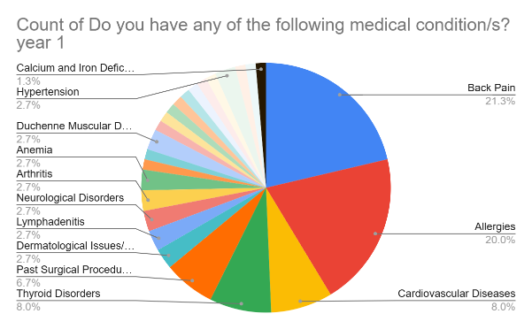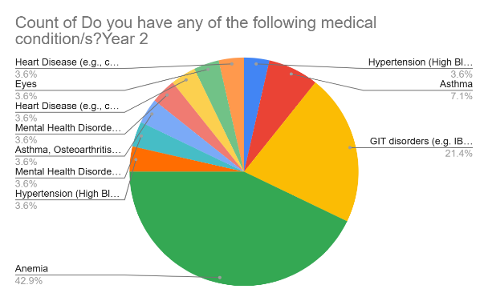

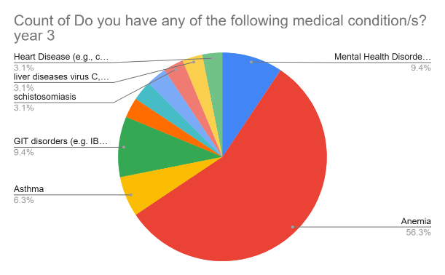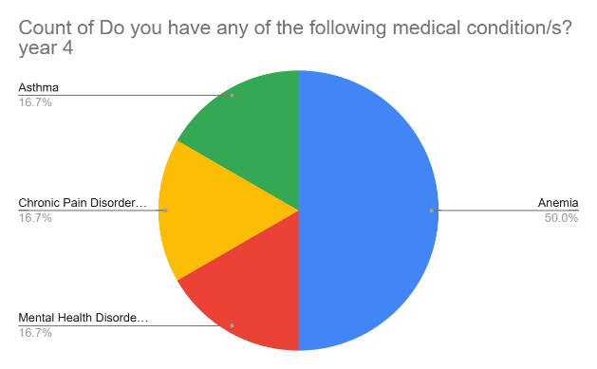

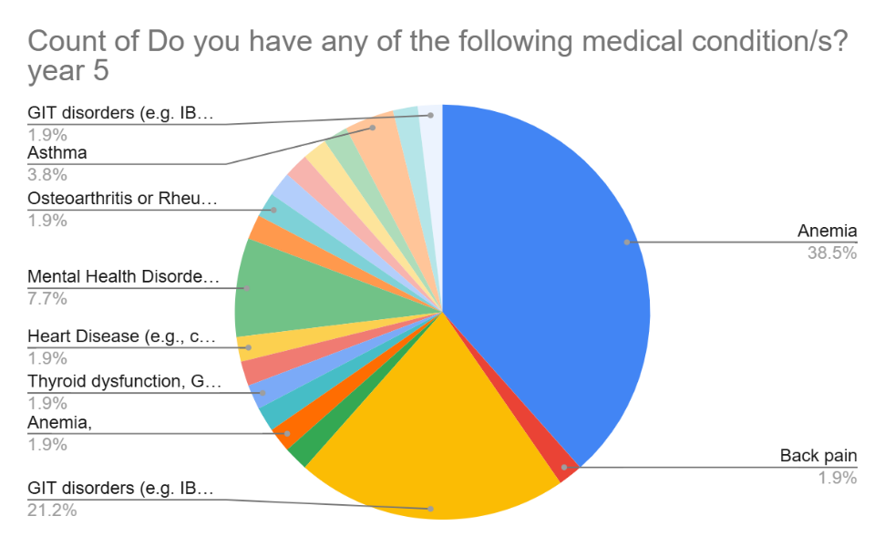

- Do you have a history of cancer?

Year | Yes | No
Year 2 | 0.00% | 100.00%
Year 3 | 3.70% | 96.30%
Year 4 | 14.30% | 85.70%
Year 5 | 1.90% | 98.10%

Figure 8
Comment:
Cancer prevalence appears to peak in Year 4 (14.3%), which may indicate a specific exposure, risk factor, or reporting anomaly in that group. The percentages are otherwise low in other years, especially in Year 2 (0%) and Year 5 (1.9%). This suggests that cancer cases are not consistently distributed across the years and may warrant further investigation to determine possible environmental, lifestyle, or demographic factors influencing this spike in Year 4.

- Have you undergone any previous surgeries?
Surgery Status | Year 2 | Year 3 | Year 4 | Year 5
No Surgery | 95.90% | 76.50% | 85.70% | 79.80%
Appendectomy | 1.40% | 7.40% | 0.00% | 6.70%
Back Surgery | 0.00% | 0.00% | 0.00% | 1.00%
Eye Surgery | 2.70% | 9.90% | 0.00% | 12.50%
Cancer Surgery | 0.00% | 1.20% | 7.10% | 0.00%
Knee Surgery | 0.00% | 1.20% | 7.10% | 0.00%
Gallbladder Removal | 0.00% | 1.20% | 0.00% | 0.00%
Heart Surgery | 0.00% | 2.50% | 0.00% | 0.00%

Figure 9
Comment:
Most participants reported no history of surgery across all years, with the highest in Year 2 (95.9%). The most common surgeries were appendectomy and eye surgery, especially in Years 3 and 5. Major surgeries like cancer, heart, and knee procedures were rare, indicating a generally healthy or younger population.

- Are there doctors or therapists who treat you?
Category | Year 1 | Year 2 | Year 3 | Year 4 | Year 5
1- doctor | 65.20% | 76.50% | 65.90% | 55.60% | 55.40%
2- doctor | 19.60% | 14.70% | 22.00% | 22.20% | 21.40%
3+- doctor | 15.20% | 8.80% | 9.80% | 22.20% | 21.40%

Figure 10
Comment:
The data shows a consistent reliance on 1-year doctors, with lower and stable percentages for more experienced doctors, suggesting limited retention or progression.

- Please list all the medications you are currently taking for chronic health conditions:
Category | Year 1 | Year 2 | Year 3 | Year 4 | Year 5
1- Medication | 71.40% | 75.00% | 85.70% | 20.00% | 44.40%
2- Medication | 15.50% | 25.00% | 14.30% | 40.00% | 27.80%
3+ Medication | 13.00% | 0.00% | 0.00% | 40.00% | 27.80%
Figure 12

Comment:
The data shows that 1-Medication was dominant in the first three years but dropped sharply in years 4 and 5. In contrast, 2- and 3+ Medication categories increased notably in the last two years, indicating a shift toward more diverse or advanced medication use over time.

- How many hours do you typically sleep each night?
Sleep Duration | Year 2 | Year 3 | Year 4 | Year 5
Less than 5 hours | 13.70% | 24.70% | 7.10% | 14.40%
5 to 7 hours | 65.80% | 50.60% | 57.10% | 60.60%
8 to 9 hours | 20.50% | 24.70% | 35.70% | 25.00%
Figure 13

Comment:
The data shows that 5 to 7 hours of sleep is the most common duration across all years. Less than 5 hours peaks in year 3, while 8 to 9 hours increases in year 4, suggesting some improvement in sleep patterns before declining slightly in year 5.

- How many cigarettes do you smoke on an average day?
Smoking Status | Year 2 | Year 3 | Year 4 | Year 5
I do not smoke | 97.30% | 91.40% | 100.00% | 99.00%
6–10 cigarettes | 2.70% | 2.50% | 0.00% | 1.00%
11–20 cigarettes | 0.00% | 4.90% | 0.00% | 0.00%
More than 20 cigarettes | 0.00% | 1.20% | 0.00% | 0.00%

Comment:
The data shows that the vast majority of individuals do not smoke across all years, with rates consistently above 91%. Smoking is minimal, and heavier smoking (11+ cigarettes) is nearly nonexistent, indicating a generally low prevalence of smoking in the population.

Figure 14

- Dietary and lifestyle Habits
- How often do you buy organic foods?
Frequency | Year 1 | Year 2 | Year 3 | Year 4 | Year 5
Daily | 13.40% | 28.20% | 16.00% | 21.40% | 14.40%
Several times a week | 39.30% | 42.30% | 23.50% | 28.60% | 23.10%
Once a week | 14.80% | 16.90% | 19.80% | 14.30% | 19.20%
Rarely or Never | 32.50% | 12.70% | 40.70% | 35.70% | 43.30%

Figure 15
Comment:
Year 2 students show the highest interest in buying organic food, while Years 3 and 5 have the most who rarely or never purchase it. Other years show moderate buying habits.

- How often do you eat vegetables per week?
Frequency | Year 1 | Year 2 | Year 3 | Year 4 | Year 5
Daily | 35.30% | 37.00% | 27.20% | 28.60% | 32.70%
Several times a week | 44.40% | 45.20% | 54.30% | 57.10% | 43.30%
Once a week | 13.40% | 9.60% | 12.30% | 7.10% | 13.50%
Rarely or never | 6.80% | 8.20% | 6.20% | 7.10% | 10.60%

Figure 16
Comment:
Most participants eat fruits and vegetables several times a week, followed by daily consumption. Rare or no intake is minimal, indicating generally healthy eating habits across the years.

- How often do you eat fruits per week?

Frequency | Year 1 | Year 2 | Year 3 | Year 4 | Year 5
Daily | 35.30% | 19.20% | 28.40% | 7.10% | 19.20%
Several times a week | 44.40% | 54.80% | 44.40% | 71.40% | 46.20%
Once a week | 13.40% | 13.70% | 18.50% | 7.10% | 22.10%
Rarely or never | 6.80% | 12.30% | 8.60% | 14.30% | 12.50%

Figure 17
Comment:
Most participants consume fruits and vegetables several times a week, with daily intake being common in earlier years. Rare consumption is minimal, indicating generally positive dietary habits.

Frequency | Year 2 | Year 3 | Year 4 | Year 5
Daily | 6.85% | 11.11% | 0.00% | 2.88%
Several times a week | 57.53% | 54.32% | 50.00% | 54.81%
Once a week | 24.66% | 24.69% | 42.86% | 34.62%
Rarely or never | 10.96% | 9.88% | 7.14% | 7.69%
- How often do you eat red meat per week?

Figure 18
Comment:
Red meat is most consumed several times a week, while daily intake is low, and a small proportion of students consume it rarely or never.

- How often do you eat poultry per week?
Frequency | Year 2 | Year 3 | Year 4 | Year 5
Daily | 13.70% | 14.81% | 0.00% | 5.77%
Several times a week | 53.42% | 51.85% | 85.71% | 63.46%
Once a week | 23.29% | 23.46% | 14.29% | 17.31%
Rarely or never | 9.59% | 9.88% | 0.00% | 13.46%

Figure 19
Comment:
Poultry is mainly consumed several times a week across all years, with minimal daily intake. Rare or no consumption is low, indicating moderate to high preference for poultry among students.
Let me know if you need the percentage table or a longer analysis.

Frequency | Year 2 | Year 3 | Year 4 | Year 5
Daily | 0.00% | 7.40% | 0.00% | 0.00%
Several times a week | 24.70% | 16.00% | 14.30% | 13.50%
Once a week | 41.10% | 38.30% | 57.10% | 45.20%
Rarely or never | 34.20% | 38.30% | 28.60% | 41.30%
- How often do you eat fish per week?

Figure 20
Comment:
Fish is mainly consumed once a week, followed by rare or no consumption. Daily intake is negligible, indicating limited regular fish consumption among students.

preference for poultry among students.
Let me know if you need the percentage table or a longer analysis.

- How often do you eat processed/canned meat/fish per week?
Frequency | Year 2 | Year 3 | Year 4 | Year 5
Daily | 5.50% | 9.90% | 0.00% | 1.90%
Several times a week | 27.40% | 24.70% | 7.10% | 15.40%
Once a week | 26.00% | 28.40% | 28.60% | 17.30%
Rarely or never | 41.10% | 37.00% | 64.30% | 65.40%

Figure 21
Comment:
Processed food consumption is frequent among students, with most reporting intake several times a week. Daily consumption is low, but overall intake remains high, especially in later years.

preference for poultry among students.
Let me know if you need the percentage table or a longer analysis.

Frequency | Year 1 | Year 2 | Year 3 | Year 4 | Year 5
Daily | 22.80% | 6.80% | 14.80% | 7.10% | 9.60%
Several times a week | 40.50% | 27.40% | 42.00% | 35.70% | 51.00%
Once a week | 25.10% | 52.10% | 25.90% | 35.70% | 27.90%
Rarely or never | 11.70% | 13.70% | 17.30% | 21.40% | 11.50%
- How often do you eat high-fat or fried foods?

Figure 22
Comment:
Fried food consumption is frequent among students, especially in later years, with most consuming it several times a week. Daily intake is low, while once-a-week consumption is common in Year 2.

- How often do you eat foods high in sugar/desserts?
Frequency | Year 1 | Year 2 | Year 3 | Year 4 | Year 5
Daily | 16.81% | 15.07% | 16.05% | 14.29% | 13.46%
Several times/week | 37.89% | 45.21% | 41.98% | 50.00% | 40.38%
Once a week | 26.50% | 27.40% | 24.69% | 28.57% | 31.73%
Rarely or never | 18.80% | 12.33% | 17.28% | 7.14% | 14.42%

Figure 23
Comment:
Most students consume sweets several times a week, especially in Years 2 and 4. Daily consumption is moderate, while a notable minority report once-a-week or rare consumption. Overall, the trend suggests frequent intake of sweetened foods among students.

- How often do you eat Baladi bread?
Frequency | Year 2 | Year 3 | Year 4 | Year 5
Daily | 42.50% | 46.90% | 50.00% | 52.90%
Several times a week | 38.40% | 24.70% | 28.60% | 28.80%
Once a week | 9.60% | 22.20% | 14.30% | 2.90%
Rarely or never | 9.60% | 6.20% | 7.10% | 15.40%

Figure 24
Comment:
Bladi bread consumption among students is mostly daily, increasing to over half by Year 5. Several times a week is the next common frequency, while few students eat it rarely or never. This shows bladi bread is a regular part of students’ diets.

- What type of fat do you always use in cooking?
Type of Fat/Oil | Year 2 (%) | Year 3 (%) | Year 4 (%) | Year 5 (%)
Corn oil | 27.40% | 18.50% | 28.60% | 17.30%
Natural butter | 20.50% | 18.50% | 7.10% | 26.00%
Olive oil | 26.00% | 21.00% | 7.10% | 8.70%
Margarine | 5.50% | 4.90% | 0.00% | 1.00%
Cotton seed oil | 2.70% | 8.60% | 7.10% | 3.80%
Sunflower oil | 17.80% | 28.40% | 50.00% | 43.30%

Figure 25
Comment:
Sunflower oil is the most used fat among students, especially in Year 4 and Year 5. Corn oil and olive oil are also popular, particularly in earlier years. Natural butter use increases significantly by Year 5. Margarine and cotton seed oil are the least used
overall. This suggests a preference for plant-based oils, with a gradual rise in natural butter use.

- At what level do you estimate your daily physical activity?
Physical Activity Level | Year 2 | Year 3 | Year 4 | Year 5
Low | 34.20% | 32.10% | 21.40% | 43.30%
Moderate | 57.50% | 64.20% | 64.30% | 52.90%
High | 8.20% | 3.70% | 14.30% | 3.80%

Figure 26
Comment:
Moderate physical activity is the most common across all years, while high activity remains consistently low. Notably, low activity increases significantly in Year 5, suggesting a decline in physical engagement.

- Do you have a regular fitness routine?
Activity | Year 2 | Year 3 | Year 4 | Year 5
None | 43.80% | 32.10% | 28.60% | 44.20%
Walking | 34.20% | 45.70% | 50.00% | 43.30%
Gym exercises | 16.40% | 17.30% | 14.30% | 6.70%
Sport | 5.50% | 4.90% | 7.10% | 5.80%

Figure 27
Comment:
Many students are inactive, especially in Years 2 and 5. Walking is the most common activity, while gym exercises and sports are less popular. Overall, inactivity remains high.

- Women's health, Are your periods regular?
Period Regularity | Year 1 | Year 2 | Year 3 | Year 4 | Year 5
Yes | 78.60% | 79.10% | 83.70% | 80.00% | 81.60%
No | 21.40% | 20.90% | 16.30% | 20.00% | 18.40%

Figure 28
Comment:
Most participants across all year’s report having regular periods, with percentages
consistently above 78%, indicating general menstrual regularity in the population
studied.

- Student’s self-evaluation information:
Question | Year 2 Agree | Year 2 Disagree | Year 3 Agree | Year 3 Disagree | Year 4 Agree | Year 4 Disagree % | Year 5 Agree % | Year 5 Disagree %
Q1: I feel happy with my life | 90.40% | 9.60% | 84.00% | 16.00% | 78.60% | 21.40% | 84.60% | 15.40%
Q2: I feel calm and relaxed | 76.70% | 23.30% | 63.00% | 37.00% | 50.00% | 50.00% | 52.90% | 47.10%
Q3: I feel supported and connected to my family and community | 93.20% | 6.80% | 78.80% | 21.20% | 85.70% | 14.30% | 80.80% | 19.20%
Q4: I feel financially stable and secure | 93.20% | 6.80% | 79.00% | 21.00% | 83.30% | 16.70% | 73.10% | 26.90%

Question | Year 2 Agree | Year 2 Disagree | Year 3 Agree | Year 3 Disagree | Year 4 Agree | Year 4 Disagree | Year 5 Agree | Year 5 Disagree
Q5: I have a purpose in life that I am working to achieve | 90.40% | 9.60% | 85.20% | 14.80% | 100.00% | 0.00% | 86.50% | 13.50%
Q6: I have confidence in my opinions | 89.00% | 11.00% | 72.80% | 27.20% | 78.60% | 21.40% | 80.80% | 19.20%
Q7: For me, life has been a continuous process of learning, changing, and growth. | 94.50% | 5.50% | 88.90% | 11.10% | 100.00% | 0.00% | 92.30% | 7.70%

Figure 29/a

Figure 29/B

