|  |  |  |  |
| --- | --- | --- | --- |
| **Page:1 of 2** | **Certificate Number:**  **Date of Calibration:** | |  |
| **Customer & Equipment Specifications: مشخصات متقاضی و تجهیز:** | | | |
| **Instrument name:** | | **Customer name:** | |
| **Resolution:** | | **Address:** | |
| **ID / Serial number:** | | **Date of Calibration:** | |
| **Range of instrument:** | | **Date of issue:** | |
| **Range of calibration:** | | **Re-Cal. Date (Client):** | |
| **Manufacturer:** | | **Location:** | |
| **Reception Number:** | | **Form No. :** | |
| **شرایط کالیبراسیون : Calibration Condition:** | | | |

3**Reference Standards:**

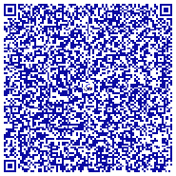1. Hydraulic hand pump with Digital test gauge

2.Pneumatic & Vacuum hand pump with Digital test gauge

**Traceability:**

Reference PCU. 925H Weight Set No. A8363/A8364 Cert No. D20044 Treaceable to DKD

Reference PCU. 944H Weight Set No. A8351 Cert No. D20043 Treaceable to DKD

The Reference Standards are traceable calibrated to national and international metrology institute.

**Ambient Condition:**  Temp. : (23±2) °C Rel. Hum. : (35~55) %

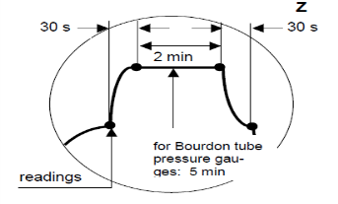**Calibration Procedure:** Comparison: Due to Standards (IDS 0340 Standard).

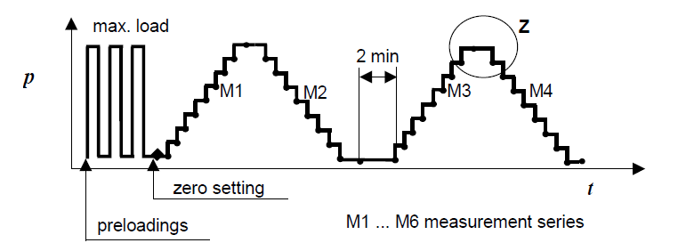

**Uncertainty:** The expanded uncertainty of measurment is estimated for accreditation in accordance with the referance document EA-4/02 related to European co-operation organization, with attention to coverage factor k=2 for normal distribution,providing a level of confidence of approximately 95%.

**Vocabulary:**

|  |  |
| --- | --- |
| **Applied pressure Reference Value:** | **مقدار واقعی، مقدار واقعی خوانده شده از روی نمایشگر تجهیز مرجع** |
| **Applied pressure * DUT :** | **مقدار خوانده شده، مقدار خوانده شده از روی نمایشگر تجهیز تحت کالیبراسیون** |
| **Measurement Error:** | **مقدار خوانده شده منهای مقدار واقعی** |
| **Hysteresis Error:** | **خطای پسماند** |
| **Maximum Permissible Error:** | **بیشینه خطای مجاز (خطای مجاز قطعی و پذیرش آن برعهده سیستم مدیریت اندازه گیری کاربر (مشتری) می باشد.)** |

**Measurement Results:** We hereby certify that the calibration result are the data shown in the attached sheet/sheets. As Follows page 2.

|  |  |
| --- | --- |
| **Page:2 of 2** | **Certificate Number:**  **Date of Calibration:** |

|  |
| --- |
| **نتایج کالیبراسیون : Calibration Results:** |

« **All of Measurements are in bar** »

|  |  |  |  |  |  |  |
| --- | --- | --- | --- | --- | --- | --- |
| **Measurement**  **Error** | **Average**  **Applied pressure**  **Reference Value** | **Applied pressure Reference Value** | | | | **Applied pressure**  **\*DUT**  **M0** |
| **M4** | **M3** | **M2** | **M1** |
| **bar** | **bar** | **bar** | **bar** | **bar** | **bar** | **bar** |
|  |  |  |  |  |  |  |

***DUT: Device Under Test***

|  |  |  |  |  |  |
| --- | --- | --- | --- | --- | --- |
| **Expanded Uncertainty** | **Maximum Permissible Error** | **δpL** | **Hysteresis Error**  **δpL** | **δpi’** | **δpi** |
| **bar ±** | **bar ±** | **bar** | **bar** | **bar** | **bar** |
|  |  |  |  |  |  |

${δp}_{i}=\left|M_{0}-Avearge\left(M_{1},M_{3}\right)\right|$

$${ δp}_{i’}=\left|M_{0}-Avearge\left(M_{2},M_{4}\right)\right|$$

$Hysteresis error:$ ${δp}_{h} = \left|{δp}_{i} - {δp}_{i’}\right|$

${δp}_{L}$ $=$ $\left|δpi+ δpi’\right|/2$

**Error result:**

All of errors are within permissible tolerance.

**Important:**

1-The user should determine the suitability of the instrument for its intended use.

2-Copyright of this certificate is owned by ASD Lab.. and may not be reproduced other than in full except with prior written approval of ASD Lab..

**………………………………………………………………...........End of Calibration…………………………………………………………………**

**در صورت دریافت هرگونه کپی از این سند، اصل گواهینامه را نیز مطالبه کرده تا حصول اطمینان از اعتبار سند حاصل گردد.**