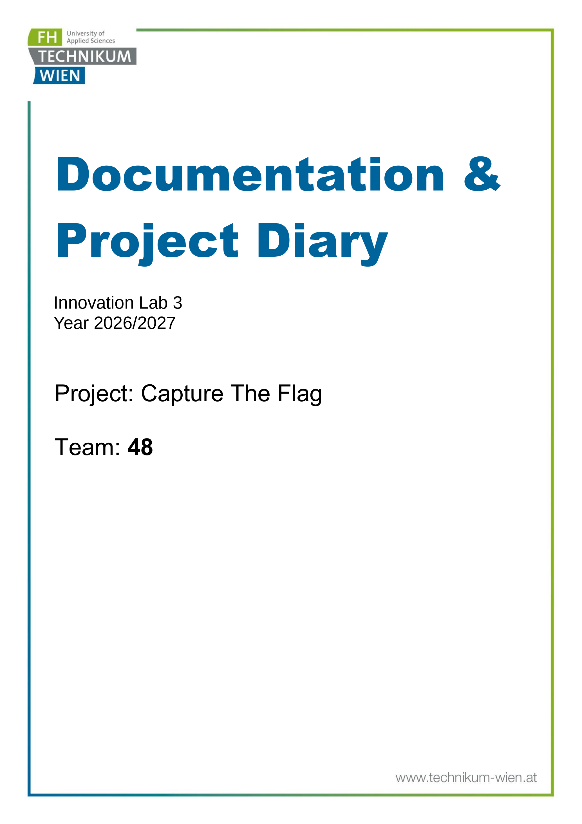

1. General Information
Project name: Capture The Flag
Supervisor: FH-Prof. DI Alexander Mense
Innovation Lab 3 WS2026/27
Project team:
Kasmi Mohamed Amin, if24b120@technikum-wien.at, project manager
Kluge Viktoria, if24b234@technikum-wien.at
Khouja Yusuf, if24b011@technikum-wien.at
Hashkeil Mahmoud, if25b198@technikum-wien.at
Ahmed Muaz, if24b241@technikum-wien.at
Management Summary of the Project
The Capture The Flag project provides a practical cybersecurity training platform for students at FH Technikum Wien. Across the first two Innovation Lab semesters, the project evolved from a prototype into a largely functional platform that combines a web frontend, backend services, LDAP-based authentication, static and Docker-based challenges, terminal access and user progress functionality.
Innovation Lab 2 focused on preparing the platform for real use: deployment to FH infrastructure, authentication and user management, backend and frontend improvements, scoreboard and progress tracking, security hardening, testing and CI/CD. At the start of Innovation Lab 3, the team considers most of this scope implemented. The first sprint will therefore verify the actual state of the system and identify the remaining gaps rather than assuming that every planned item is complete.
Innovation Lab 3 Goal
Further develop and mature the existing CTF platform into a practical cybersecurity training environment for FH Technikum Wien students, with improvements prioritized according to technical needs, user feedback and educational value.
Semester 3 Priorities
- Assess the current end-to-end platform and establish a verified Inno 3 backlog.
- Improve stability, maintainability, usability and security where the assessment shows meaningful gaps.
- Extend platform features or challenge functionality when they provide clear value for students or administrators.
- Improve the cybersecurity learning experience through better challenge presentation, supporting material, feedback or progress features.
- Validate the platform under realistic conditions and use findings or user feedback to guide iteration.
- Improve deployment, monitoring, documentation and handover so future teams can continue the project efficiently.
Framework Conditions and Project Environment
The project continues to build on the technical environment established in Innovation Lab 2. The stack may be adjusted during the semester where a change is justified by maintainability, security, reliability or operational needs.
- Backend: Java 21, Spring Boot 3.4, PostgreSQL 16
- Frontend: Next.js 15, React 19, TypeScript 5, Tailwind CSS
- Terminal: Node.js with xterm.js
- Authentication: LDAP (OpenLDAP)
- Containerization: Docker and Docker Compose
- Deployment target: Ubuntu 24.04 VM on FH Technikum Wien infrastructure
Infrastructure
- Server: FH VM with limited CPU, RAM and storage resources
- Access: FH internal network and VPN
Constraints
- Challenge containers must be managed carefully because the available infrastructure is limited.
- Intentionally vulnerable challenge environments must remain isolated from the platform and host infrastructure.
- GDPR and FH Technikum Wien data-protection requirements apply.
- The project must remain understandable and maintainable for future student teams.
- The semester scope must remain flexible enough to react to technical findings and user feedback.

Semester Roadmap
Sprint 1 - Platform Assessment and Inno 3 Planning
Review the complete platform after Innovation Lab 2. Verify what is working, what is only partially implemented and what still needs attention. Review frontend, backend, authentication, challenge infrastructure, scoreboard/progress, deployment, tests, CI/CD, security and documentation. Create and prioritize the Inno 3 backlog based on evidence.
Sprint 2 - Stabilization and Technical Improvements
Address high-priority issues discovered during the assessment. Possible work includes bug fixes, API cleanup, validation, error handling, database improvements, authentication refinements, container lifecycle improvements, technical debt reduction and security fixes.
Sprint 3 - Platform and User Experience Improvements
Improve workflows that affect real student or administrator usage. Depending on findings, this can include navigation, challenge presentation, terminal usability, progress visualization, filtering, feedback, profile functionality or administrative workflows.
Sprint 4 - Training Content and Platform Extension
Extend the platform where additional functionality or content has educational value. Possible topics include challenge improvements, new challenge types, hints, explanations, learning resources, difficulty metadata, structured learning paths, content-management functions or other useful platform extensions.
Sprint 5 - Testing, Security and Operational Readiness
Evaluate the system under realistic conditions. Conduct integration, end-to-end, usability, security, container-isolation and resource tests as appropriate. Improve logging, monitoring, deployment reliability or backup procedures where the results justify the effort.
Sprint 6 - Final Improvements, Documentation and Handover
Complete the highest-priority remaining work, finalize documentation, record known limitations and future backlog items, and prepare the source code, architecture, deployment and operational information for handover.
Collaboration & Tooling
GitHub - project repository (source code, branches, pull requests and technical collaboration)
Jira - project board (backlog management, sprint planning and task tracking)
- WhatsApp - team communication and coordination
Remarks
The roadmap intentionally defines areas of work rather than rigid feature commitments. Tasks may be reprioritized according to the platform assessment, supervisor feedback, user feedback and available development capacity. The detailed solution specification and project diary will be extended during the semester.

2. Brief Description of the Project
Project Overview
The goal of the Capture The Flag project is to provide a long-term cybersecurity training environment for students at FH Technikum Wien. Capture-the-Flag exercises allow students to apply concepts from web security, cryptography, reverse engineering, forensics, binary exploitation and related areas in a controlled environment.
During the previous semesters, a working platform was developed with static and Docker-based challenges, LDAP-based authentication, web-based challenge access, terminal functionality and mechanisms for submissions, points and progress. Innovation Lab 3 builds on this existing platform rather than restarting the project.
Current State at the Start of Innovation Lab 3
The team considers almost all of the Innovation Lab 2 scope implemented. However, implementation status alone is not enough to determine production readiness. Sprint 1 will therefore verify the current state and distinguish between code that exists, functionality that works, functionality that is tested and functionality that is reliably deployed.
Area | Semester-start assumption | Inno 3 focus
Authentication & user management | Largely implemented | Verify production behavior, permissions, sessions and edge cases.
Challenge management & Docker challenges | Largely implemented | Validate container lifecycle, isolation and resource handling.
Frontend / Next.js architecture | Implemented | Refine usability, error states and maintainability where needed.
Scoreboard & progress tracking | Largely implemented | Verify data correctness and improve presentation if useful.
Deployment to FH infrastructure | Implemented / requires validation | Confirm reproducibility, stability and operational procedures.
Testing & CI/CD | Requires assessment | Measure actual coverage and pipeline reliability before committing to new work.
Security hardening | Ongoing | Reassess rate limiting, authorization, container isolation and error handling.
Monitoring, logging & backup | Requires assessment | Improve only where it clearly supports reliable operation.
Goals of the Semester
- Validate the current implementation and identify the most important remaining gaps.
- Increase the practical value of the platform for students and administrators.
- Improve quality, security, reliability and maintainability where necessary.
- Extend challenges, learning resources or platform features when they support the educational goal.
- Use realistic testing and feedback to guide the semester backlog.
- Prepare clear documentation and handover material for continued development.
Value for Users
Students: A practical environment for applying cybersecurity knowledge through hands-on tasks rather than theory alone.
Lecturers: A reusable platform for practical exercises, demonstrations and structured cybersecurity training.
FH Technikum Wien: A university-owned environment that can support long-term cybersecurity education, student activities and future CTF initiatives.
Future project teams: A maintainable and documented system that can be extended without repeating the original onboarding work.
Challenges
- Security: vulnerable applications must be isolated from the host and core services.
- Infrastructure: multiple challenge environments may compete for limited CPU, memory and storage.
- Technical debt: the project has evolved across semesters and some design choices may need refinement.
- Prioritization: many useful improvements are possible, but semester time is limited.
- Usability: a technically correct platform must still be understandable and practical for students.
- Continuity: decisions and operational knowledge must be documented for future teams.
Scope of the Project
The scope of Innovation Lab 3 is the continued improvement, validation and extension of the existing CTF platform. The semester may include work in the following areas:
- backend and API development
- frontend and user experience
- challenge functionality and challenge content
- authentication, authorization and user management
- scoreboard, progress and student feedback
- administration and content-management functionality
- deployment and infrastructure
- security and container isolation
- testing and CI/CD
- logging, monitoring and operational tooling
- documentation and handover
- community or collaboration features where they directly support the CTF training goal
Outside the Scope
Innovation Lab 3 does not aim to rebuild the entire platform from scratch. Large infrastructure changes, major technology migrations or unrelated features will only be pursued if the platform assessment shows a clear benefit. The team is also not committing in advance to a fixed number of new challenges; content work will be prioritized according to educational value and available capacity.
Implementation Approach
The project follows an agile, evidence-driven process. The semester begins with a platform assessment and backlog refinement. During each sprint, the team selects high-value tasks, clarifies requirements, implements and tests the work, reviews the result and adjusts subsequent priorities. This allows the project to respond to technical findings, supervisor input and real user feedback without losing the overall semester goal.
Definition of Done for Inno 3 Work Items
Where applicable, a task should not be considered complete merely because code exists. The team should distinguish between implementation, verification and operational readiness. A feature is considered complete when its expected behavior is implemented, integrated, reviewed or tested at an appropriate level, and documented when future maintainers need to understand or operate it.

3. Specification of the Solution
Status of this section: Living specification. It is intentionally not fully prefilled at the beginning of Innovation Lab 3. The specification will be extended before each sprint once the corresponding scope has been agreed and understood.

3.1 Confirmed System Environment
The following environment is inherited from Innovation Lab 2 and forms the starting point for Innovation Lab 3. It may be adjusted later where a change is justified and agreed.
- Backend: Java 21, Spring Boot 3.4 and PostgreSQL 16.
- Frontend: Next.js 15, React 19, TypeScript 5 and Tailwind CSS.
- Authentication and user management: LDAP / OpenLDAP.
- Challenge environments: static challenges and Docker / Docker Compose based interactive challenges.
- Terminal functionality: Node.js with xterm.js where required.
- Deployment target: FH Technikum Wien infrastructure, currently an Ubuntu 24.04 virtual machine.
Known system boundaries:
- University networking, VPN access and institutional directory services are external dependencies.
- Intentionally vulnerable challenge environments must remain isolated from the host and unrelated platform components.
- Personal data must remain within the intended FH environment and be handled according to GDPR and FH Technikum Wien requirements.

3.2 Sprint 1 Specification - Platform Assessment and Backlog Refinement
Sprint 1 is the only sprint specified in detail at the semester start. Its purpose is to verify the actual state inherited from Innovation Lab 2 before committing to later implementation work.
Initial user stories:
- As a project team, we want to review the frontend, backend, authentication, challenge infrastructure, deployment, testing, CI/CD, security and documentation so that we have an evidence-based view of the current platform state.
- As a project team, we want to distinguish between functionality that exists in code, functionality that works, functionality that is tested and functionality that is reliably deployed so that incomplete work is not treated as finished.
- As a project team, we want to convert the audit findings into a prioritized Inno 3 backlog so that later sprints focus on the most valuable technical and educational improvements.
Expected Sprint 1 outputs:
- Verified implementation-status overview for the main platform areas.
- List of remaining defects, risks, technical debt and operational gaps.
- Prioritized backlog for the following sprints.
- Updated technical notes where the actual system differs from the previous documentation.

3.3 Specification for Later Sprints
This subsection will be extended during the semester. Before each sprint, the team will add the relevant epics or user stories, interfaces, acceptance criteria and - where useful - mockups, architecture diagrams, database diagrams or sequence diagrams. Later-sprint features are intentionally not written here as if they were already fixed requirements.

3.4 Baseline Quality Requirements
The following baseline requirements remain applicable while the detailed sprint specification evolves:
- Security: authentication, authorization and container isolation must protect the core platform and FH infrastructure.
- Reliability: core platform functions should behave consistently under realistic student usage.
- Maintainability: changes should remain understandable and reasonably documented for future project teams.
- Usability: the main student workflow should remain understandable without extensive instructions.
- Performance: the platform should use the available FH infrastructure efficiently; concrete load targets should be validated during testing rather than assumed.
- Privacy: personal data should be limited to what is necessary and handled according to GDPR and FH Technikum Wien requirements.

4. Effort Estimation
Status: Completed. The team estimated the effort required for Innovation Lab 3 using the Delphi method. The agreed results per work package are listed in the table below.
The following work packages can be used as the basis for the Delphi estimation:
- Sprint 1 - Platform assessment and planning
- Sprint 2 - Stabilization and technical improvements
- Sprint 3 - Platform and user-experience improvements
- Sprint 4 - Training content and platform extension
- Sprint 5 - Testing, security and operational readiness
- Sprint 6 - Final improvements, documentation and handover
Work package | Team / estimator | Low (h) | High (h) | Agreed / average (h)
Sprint 1 | Team 48 (Delphi consensus) | 20 | 30 | 25
Sprint 2 | Team 48 (Delphi consensus) | 45 | 65 | 55
Sprint 3 | Team 48 (Delphi consensus) | 50 | 80 | 65
Sprint 4 | Team 48 (Delphi consensus) | 45 | 75 | 60
Sprint 5 | Team 48 (Delphi consensus) | 50 | 80 | 65
Sprint 6 | Team 48 (Delphi consensus) | 40 | 60 | 50
Total | — | 250 | 390 | 320
Using the Delphi method, the team estimated the effort required for Innovation Lab 3. The average estimated workload is approximately 320 hours for the whole team, corresponding to approximately 64 hours per team member. The estimates may be refined as the backlog and sprint scope become clearer.

5. Delivery
Planned delivery scope: This section describes what should be handed over if it is part of the work actually completed during Innovation Lab 3. It will be finalized at the end of the semester so that it reflects the real delivered state rather than planned-but-unfinished work.
- Source code and configuration for the frontend, backend, challenge components and supporting services.
- Current system architecture and data-storage documentation.
- Required infrastructure / hardware information for the deployed environment.
- List or reference for relevant third-party frameworks, libraries, licenses and copyrights.
- Installation and deployment instructions, including required components, configuration and database migration steps where applicable.
- Operational information such as start/stop procedures, logging, monitoring, backup/recovery and troubleshooting where these are part of the final solution.
- Known limitations and a backlog / recommendations for future project teams.
The exact handover contents should be reviewed with the supervisor and updated near the end of the semester.

6. Our Project Diary
Status of this section: Maintained continuously during Innovation Lab 3. It is intentionally not prefilled with future events or retrospective statements. Add entries as meetings, implementation work, problems, tests and decisions actually occur.

Diary Entry Template
Date
Sprint / meeting
Participants
What happened / work completed
Problems / challenges
Decisions and rationale
Next steps
Evidence (screenshots, photos, Jira/GitHub references, test results, diagrams)
Duplicate the diary-entry table as needed during the semester. At the end of the semester, add a short retrospective covering major achievements, delays, lessons learned, remaining limitations and recommendations for the next team.

