**UNITED INTERNATIONAL UNIVERSITY**



LAB PROJECT

COMPUTER NETWORKS LABORATORY

CSE 324

**SMART CITY AUTOMATIN SYSTEM**

**Submitted to :**

**Sumit Tarafder**

Md. Amimul Basher

011-161-075

Md. Ahsan Habib Shuvo

011-161-068

Julker Nien Akib

011-142-157

**Features**:

Smart Environment Control

Smart Home Security

Smart Fire Alarm and Mailing

Smart Violation Control and Mailing

**Server Used:**

Home server (www.home.com)

Email server(www.security.com)

Office server (www.office.com)

DNS server

Routing and DHCP configured.

**Smart Environment control:**

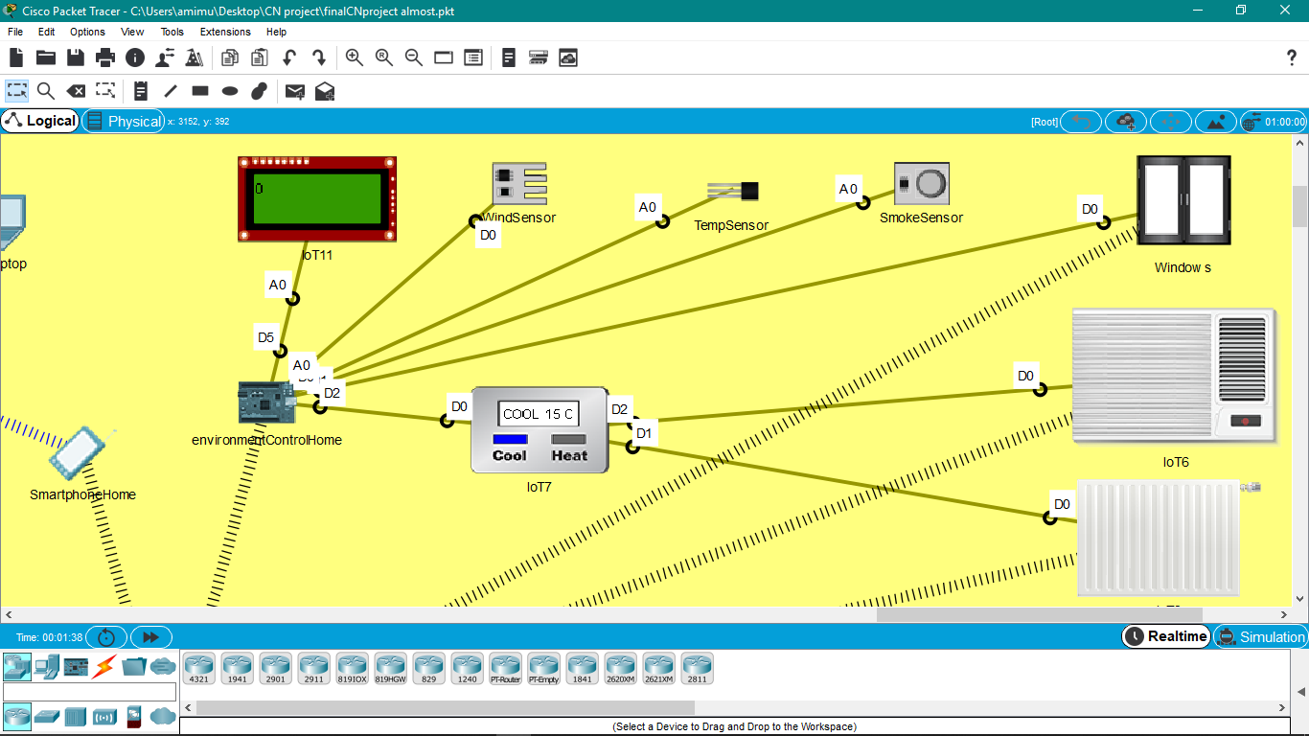

Code used:

var wind = 0;

var smoke = 0;

var temp = 0;

function setup(){

pinMode(1, INPUT);

pinMode(0, OUTPUT);

pinMode(5, OUTPUT);

pinMode(A1, INPUT);

pinMode(A0, INPUT);

}

function loop (){

// value = analogRead(1);

temp = analogRead(A0);

console.log("temp: "+ temp);

smoke = analogRead(A1);

console.log("smoke: " + smoke);

wind = digitalRead(1);

delay(500);

console.log("wind: "+wind);

digitalWrite(5, wind);

if(wind == 1023 && smoke === 0){

customWrite(0, 0);

}

else{

customWrite(0, 1);

}

if(temp > 500)

{

customWrite(2, 1);

}

else

{

customWrite(2, 2);

}

}

**Window:**

IOT components:

* Smoke sensor
* Wind sensor
* Window
* MCU

We set an automation system here. If smoke is detected into the room then the window will automatically be opened. And if there is dust and wind flow then the door will be closed. But we gave priority to smoke as smoke can occur for fire then windows will be opened at this time.

**Environment:**

IOT components:

* Temperature sensor
* Thermostat
* AC
* Furnace

We made an automation system here also. If the temperature is high then the AC will be opened through Thermostat and if temperature is low then the Furnace will be started automatically.

**Smart Home Security System:**

IOT components:

* MCU
* Motion sensor
* Webcam
* Fan
* Light

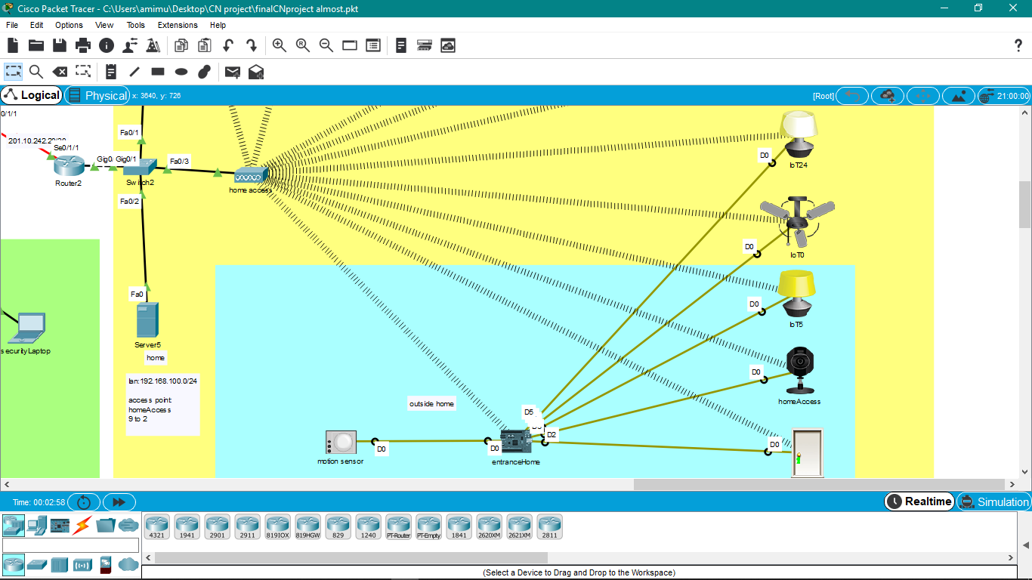

Code used:

var count = 0;

function setup(){

pinMode(0, INPUT);

pinMode(1, OUTPUT);

pinMode(2, OUTPUT);

pinMode(3, OUTPUT);

pinMode(4, OUTPUT);

pinMode(5, OUTPUT);

}

while(count <= 10000000)

{

if(digitalRead(0) == HIGH)

{

customWrite(1, 2);

customWrite(2, 1);

customWrite(3, 1);

customWrite(4, 2);

customWrite(5, 2);

count = 0;

}else

{

delay(1000);

count++;

if(count >25)

{

customWrite(1, 0);

}

count++;

if(count >50)

{

customWrite(4, 1);

}

customWrite(2, 0);

customWrite(3, 0);

}

}

We made an automation system here also. If the motion sensor detects motion then the door, indoor and outdoor light, webcam and fan will be turn on automatically only if the door is not locked before. And after some time the outdoor light will be turned off automatically. Firstly the Fan will run with high speed. The speed of fan will decrease automatically after some time.

**Smart Violence Detection and Mailing:**

IOT components:

* SBC
* Mail server
* Sound Sensor
* Home Theater(sound box)
* Volt meter

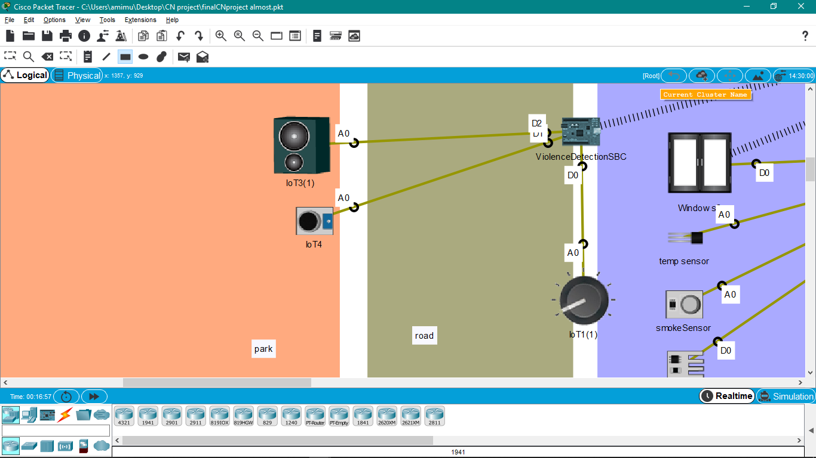

If you raise the volume using voltmeter that exceed the limit then the SBC will automatically send email to the security room.

Code used:

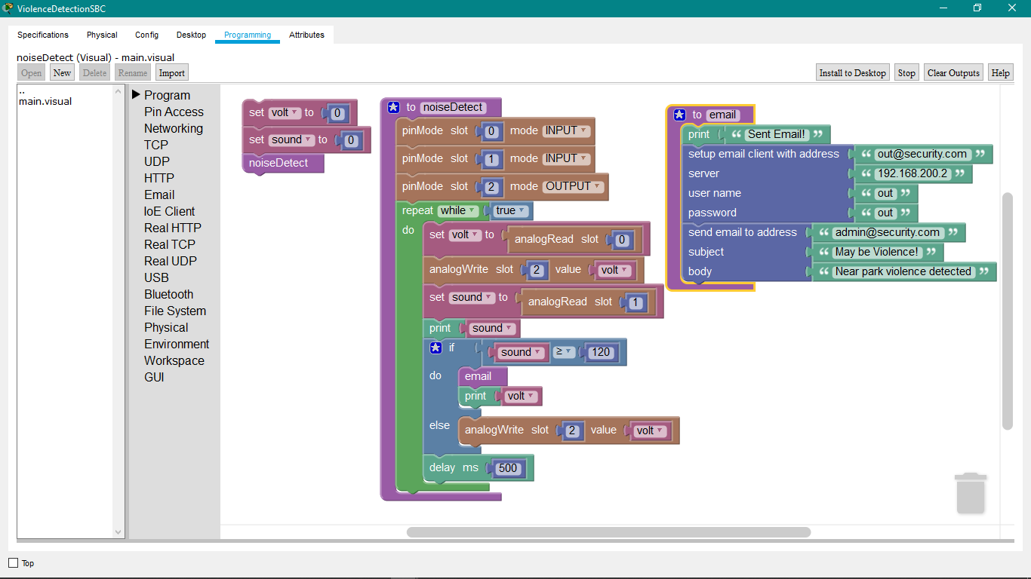

We made an automation system here also. We know that in park, there have limited sound. But sometimes if violation occurs then sound will go higher. So we made a limit on sound. If it exceeds then it will automatically send email to security room.

So that authority can take steps immediately.

**Smart Fire Alarm and Mailing:**

IOT components:

* SBC
* Mail server
* Fire detector
* Sprinkler
* Siren
* Heater element

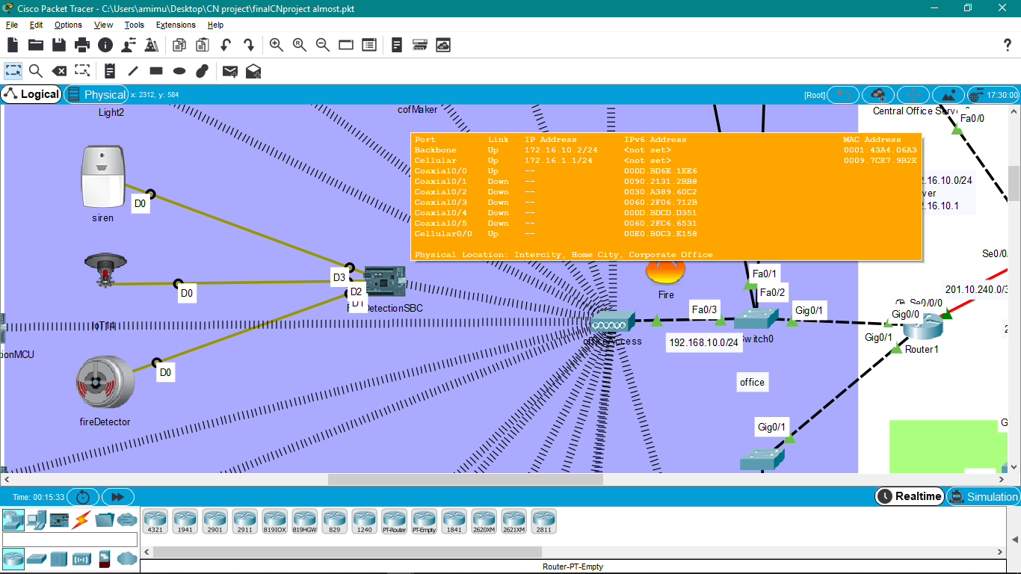

If you take the fire element near fire detector then sprinkler and siren will turn on and the SBC will automatically send an email to security room.

Code used:

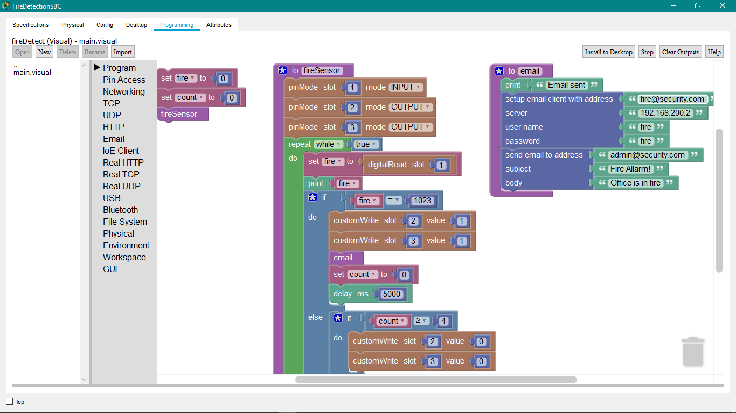

We made an automation system here also. If we take the heater element near to the fire detector then fire detector will send a value to the SBC and through SBC the sprinkler and siren will be one and email will automatically be sent to security room.

**Future Enhancement:**

We will try to supply solar electricity based on requirement.