MODULES
Module 1: Authentication & Authorization
A. Admin Authentication
- Admin Login
- Admin Logout
- Session Management
B. User Authentication
- User Login
- User Registration/Signup
- User Logout
- Session Management
C. Role Management
- Admin Role (Full Access)
- User Role (View Only + Download)

Module 2: Student Management
A. Admin Functions
- Add Student
- View Students List
- Update Student
- Delete Student
- Search Student (by ID, Name, Email)
B. User Functions
- View Students List
- Search Student

Module 3: Subject Management
A. Admin Functions
- Add Subject
- View Subjects List
- Update Subject
- Delete Subject
B. User Functions
- View Subjects List

Module 4: Marks Management
A. Admin Functions
- Enter Marks (Internal 1, Internal 2, Assignment)
- View All Marks
- Update Marks
- Delete Marks
- Calculate Average (Automatic)
B. User Functions
- View All Marks

Module 5: Attendance Management
A. Admin Functions
- Enter Attendance (Total Classes, Present Classes)
- View All Attendance
- Update Attendance
- Delete Attendance
- Calculate Percentage (Automatic)
B. User Functions
- View All Attendance

Module 6: Dashboard & Analytics
A. Dashboard Statistics (Admin & User)
- Total Students Count
- Total Subjects Count
- Average Marks (Overall)
- Average Attendance (Overall)
B. Data Visualizations
- Subject-wise Average Marks (Bar Chart)
- Attendance Distribution - Good vs Low (Pie Chart)
- Student Performance Overview (Bar Chart)

Module 7: Student Analytics
A. Individual Student Analysis (Admin & User)
- View Student Profile
- Subject-wise Marks
- Subject-wise Attendance
- Overall Average Marks
- Overall Average Attendance
- Performance Status (Excellent/Good/Needs Improvement/Poor)
- Attendance Status (Good/Low)

Module 8: Results Management
A. Results Generation (Admin & User)
- View All Student Results
- Filter Results by Student
- Subject-wise Result Breakdown
- Overall Average Calculation
- Performance Grading
- Pass/Fail Status
B. Result Export
- Download Individual Student Result (PDF)
- Download All Results (PDF)
- Result Sheet Generation
C. Result Statistics
- Students With Marks Count
- Passed Students Count
- Failed Students Count
- Class Average

Module 9: User Management
A. Admin Functions
- View All Users
- Update User Role (Admin ↔ User)
- Delete User

DATABASE TABLES
- users
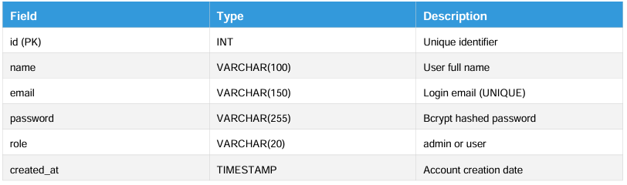
- students
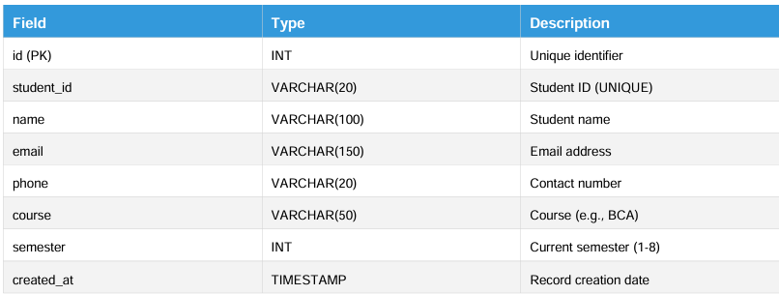
- subjects
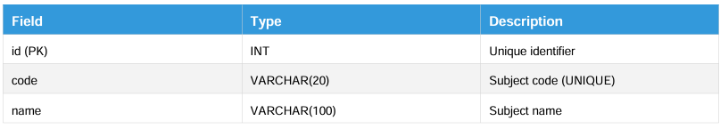
- marks
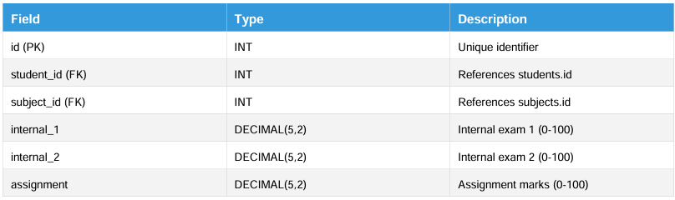
- attendance
