
⧹
⧹
503-01 Major- Advance Web Designing Project Report on
EDUANALYTICS
Submitted For Partial Fulfilment Towards the
THIRD YEAR BACHELOR OF COMPUTER APPLICATION [TYBCA][SEM 5]
YEAR: 2026-2027
Submitted To:
M.K. INSTITUTE OF COMPUTER STUDIES, BHARUCH

Submitted By:
Khatri Amin Salimbhai
Khan Anas Kamruddin
Jadav Sehbaj Daudbhai
Exam Seat No: 2163,2161,2154
Roll No.:24B055,24B052,24B043

INTERNAL GUIDE:
Ms. Meghna Vithlani

Certificate
This is to certify that following students of TYBCA (Semester-5)
- Khatri Amin Salimbhai Seat No. 2163___________
- Khan Anas Kamruddin________Seat No. 2161__________
- Jadav Sehbaj Daudbhai________Seat No. 2154__________
have satisfactorily completed their minor project entitled “EDUANALYTICS ” in the Paper-Major-503-01 Advance Web Designing under my guidance, for consideration in Partial Fulfillment for the TYBCA Semester V, Veer Narmad South Gujarat University, Surat (VNSGU), during the academic year 202 -2 .

Date: ______________ Signature: ________________
(Internal Guide)
(Ms. Meghna N. Vithlani)

College Seal

External Examiner Sign:

Index
No. | Title | Page No.
1 | Project Profile | 4
2 | Project Introduction | 5
3 | Scope and Objective | 6
4 | Tools and Technologies used | 8
5 | Tables design / Collection specification | 9
6 | ERD (Entity Relationship Diagram) | 11
7 | UML Use Case Diagram | 13
8 | Screen Shots | 15
9 | Future Enhancement | 23
1.0 Project Profile

Project Name : | EDUANALYTICS
Developed By : | Khatri Amin Salimbhai,24b055  Khan Anas Kamruddin,24b052  Jadav Sehbaj Daudbhai,24b043
College Details : | Name : M.K.Institute of computer studies Address : Old NH-8,College Campus,  Bharuch Phone : 02642 225637  Email-id : mkinstitute@gmail.com  Website : www.mkics.in
Internal Guide : | Meghna Vithlani
Front End : | React,Bootstrap 5,Jquery,Css
Back End : | Mysql
Server Side Scripting language: | Php
2.0 Project Introduction
The EduAnalytics system is a web-based student performance analytics application designed to manage students, subjects, marks and attendance and to analyze academic performance. The system provides separate functions for administrators and users. It helps administrators maintain academic data and user accounts, while users can view the analytics dashboard, check subject-wise performance and download result sheets. The system is built with a React frontend, a PHP (MySQL) REST API backend and a MySQL database.
In most institutes, student marks and attendance are maintained in registers or simple spreadsheets. Calculating subject averages, grades, pass / fail results and attendance percentages must be done by hand, which is slow and error-prone. EduAnalytics removes this manual work: it stores the academic data once, computes all averages, grades and attendance status automatically, and presents them through dashboards, charts and printable result sheets.
The application is designed to reduce as much as possible the errors that occur while entering data. Validations are applied on marks (0 to 100) and attendance (present classes cannot exceed total classes), and live previews are shown while entering records. No formal technical knowledge is needed for the user to use this system. Thus, by all this, it proves that the system is user-friendly.
2.1 Project Definition
EduAnalytics – Student Performance Analytics System, with which you can conveniently manage the academic records of your institute from one easy-to-use online platform. It keeps students, subjects, marks and attendance in a single database and produces analytics, grades, results and printable mark sheets on demand.
Modules of the System
The system consists of two roles – Admin and User – and ten functional areas: User Registration & Login, Role Management & Access Control, Dashboard, Student Management, Subject Management, Marks Management, Attendance Management, Results, Student Analytics and User Administration (admin only). Admin adds subjects and students and enters marks and attendance; the dashboard, analytics and results modules then process this data for every user of the system.
3.0 Scope and Objective
3.1 Scope
Scope for Admin
• Sign up and login with e-mail address and password.
• Add new students (roll no, name, e-mail, phone, course, semester).
• View all students in a searchable list and search by name, roll number or e-mail.
• Edit existing student details and delete a student.
• Add new subjects (subject code and subject name) and edit or delete them.
• Enter marks for a student in a subject (Internal 1, Internal 2, Assignment), edit and delete mark records.
• Record attendance per student per subject (total classes and present classes), edit and delete attendance records.
• View the dashboard with KPI cards and charts (subject-wise average marks, attendance distribution, student averages).
• View student-wise analytics, results, grades and class statistics.
• Download the printable Statement of Marks (result PDF).
• Manage user accounts – change a user's role between admin and user, and delete user accounts.
Scope for Users
• Register a new account and login with e-mail address and password.
• View the analytics dashboard (KPI cards and charts).
• View student analytics for a selected student – average marks, performance badge, average attendance and subject-wise details.
• View results with subject-wise grades, pass / fail status and class statistics.
• Download the Statement of Marks as a printable PDF.
• View-only access – non-admin users cannot add, edit or delete any data.

3.2 Objective
• The basic objective of this web application is to provide an online platform for recording and analyzing student performance from anywhere.
• Administrator can easily maintain students, subjects, marks and attendance from one place.
• The system automatically calculates subject averages, grades, pass / fail results and attendance percentages – no manual calculation is needed.
• Institute-level statistics are shown instantly through KPI cards, bar charts and a pie chart on the dashboard.
• Every student's subject-wise performance can be reviewed on the Student Analytics page.
• A professional Statement of Marks can be generated and downloaded as a PDF with letterhead, signatures and page footers.
• Role-based access keeps the data safe: only admins can modify records, while users can only view and download results.
4.0 Tools and Technologies
4.1 System Technologies
• HTML5
• CSS3
• JavaScript (ES6+)
• React
• React Router
• Bootstrap
• Recharts 3 (charts)
• Axios (HTTP requests)
• PHP
• MySQL
4.2 Tools Used for Development
• Visual Studio Code
• Git (version control)
4.3 Software Requirements
• Front End: React 19 + Vite (Node.js runtime)
• Back End: PHP with mysqli extension
• Database: MySQL 5.7 or above
• Web Server: Apache 2.4 (WAMPServer 3.x – 64 bit)
• Operating System: Windows 10 and Windows 11
• Browser Support: Google Chrome, Microsoft Edge
5.0 Table Design
The EduAnalytics database (eduanalytics) has five tables – users, students, subjects, marks and attendance. Marks and attendance are linked to students and subjects through foreign keys with cascade drop, so that when a student or subject is removed, its related academic records are removed automatically. The tables are designed as follows.
Table: Users
Column | Type | Null | Description
id | INT | Not Null | Primary key, auto increment
name | VARCHAR(100) | Not Null | Full name of the user
email | VARCHAR(150) | Not Null | Unique login e-mail address
password | VARCHAR(255) | Not Null | Password
role | VARCHAR(20) | Not Null | admin or user; default 'admin'
created_at | TIMESTAMP | Not Null | Account creation date-time

Table: Students
Column | Type | Null | Description
id | INT | Not Null | Primary key, auto increment
student_id | VARCHAR(20) | Not Null | Unique roll / enrolment no
name | VARCHAR(100) | Not Null | Student name
email | VARCHAR(150) | Nullable | Student e-mail address
phone | VARCHAR(20) | Nullable | Student mobile number
course | VARCHAR(50) | Nullable | Course name (e.g. BCA)
semester | INT | Nullable | Current semester
created_at | TIMESTAMP | Not Null | Record creation date-time

Table: Subjects
Column | Type | Null | Description
id | INT | Not Null | Primary key, auto increment
code | VARCHAR(20) | Not Null | Unique subject code
name | VARCHAR(100) | Not Null | Subject name

Table: Marks
Column | Type | Null | Description
id | INT | Not Null | Primary key, auto increment
student_id | INT | Not Null | Foreign key → students(id)
subject_id | INT | Not Null | Foreign key → subjects(id)
internal_1 | DECIMAL(5,2) | Not Null | Internal assessment 1 (0–100)
internal_2 | DECIMAL(5,2) | Not Null | Internal assessment 2 (0–100)
assignment | DECIMAL(5,2) | Not Null | Assignment marks (0–100)

Table: Attendance
Column | Type | Null | Description
id | INT | Not Null | Primary key, auto increment
student_id | INT | Not Null | Foreign key → students(id)
subject_id | INT | Not Null | Foreign key → subjects(id)
total_classes | INT | Not Null | Total classes held; default 0
present_classes | INT | Not Null | Classes attended; default 0

6.0 ERD (Entity Relationship Diagram)
An Entity Relationship Diagram (ERD) is a structural diagram that describes the entities (tables) stored in a database, their attributes (columns) and the relationships between them. Rectangles stand for entities, ellipses stand for attributes and diamonds stand for relationships. In an ERD the primary key (PK) uniquely identifies each record of an entity, whereas a foreign key (FK) establishes a link between two entities. The ERD is drawn at the design stage so that the complete data structure of the system can be understood before implementation.
The EduAnalytics database has five entities – USERS, STUDENTS, SUBJECTS, MARKS and ATTENDANCE. The relationships between them are as follows:
• USERS – Manages → STUDENTS : the admin user manages student records.
• STUDENTS – Scores → MARKS : a student scores marks in subjects; each mark record is also Awarded_in a SUBJECT.
• STUDENTS – Generates → ATTENDANCE : attendance is generated per student; each attendance record is Tracked_for a SUBJECT.
• MARKS and ATTENDANCE both hold composite links (student_id + subject_id) to STUDENTS and SUBJECTS, with cascade delete.

ER DIAGRAM
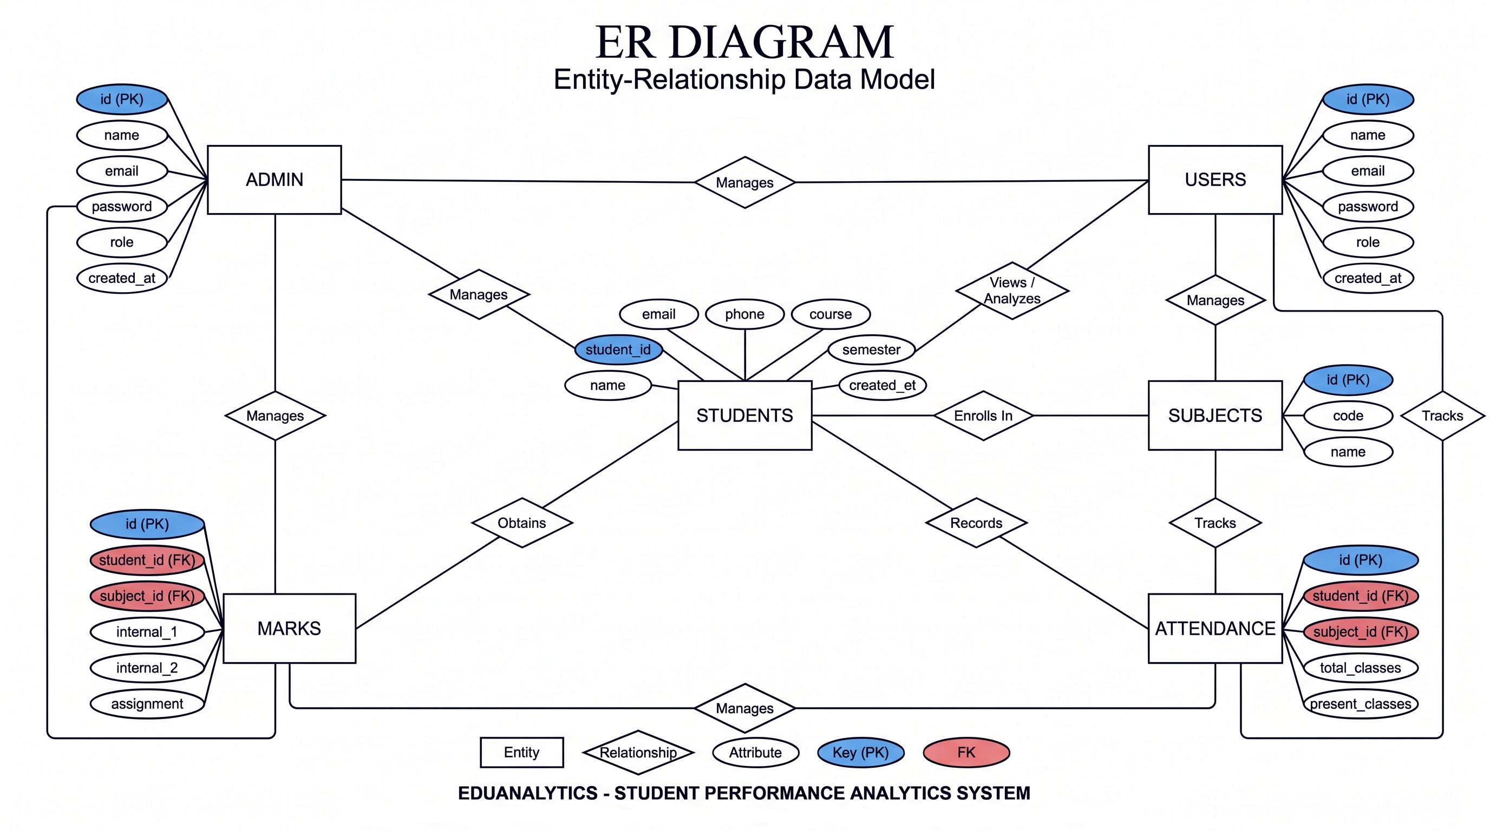
EDUANALYTICS

Figure 6.1 : ER Diagram of EduAnalytics System
7.0 UML Use Case Diagram
A Use Case Diagram is a behavioral diagram of UML that shows the functionality of a system from the user's point of view. It contains actors (stick figures), use cases (ovals) and the relationships between them. An association connects an actor to a use case it performs; an <<include>> relationship means one use case always involves another; and an <<extend>> relationship means one use case optionally extends another. Use case diagrams are prepared during analysis to identify all the services the system must provide.
In the EduAnalytics system there are two actors – Admin and User. The use cases of the system are Sign Up, Login, Validate Credentials, Manage Students, Manage Subjects, Enter Marks, Manage Attendance, Manage Users, View Dashboard, View Student Analytics, View Results, Download Result PDF and Logout. Both Login use cases include the Validate Credentials use case, and Download Result PDF extends View Results.
• Admin : Sign Up, Login (<<include>> Validate Credentials), Manage Students, Manage Subjects, Enter Marks, Manage Attendance, Manage Users, Logout.
• User : Sign Up, Login (<<include>> Validate Credentials), View Dashboard, View Student Analytics, View Results, Download Result PDF (<<extend>> View Results), Logout.

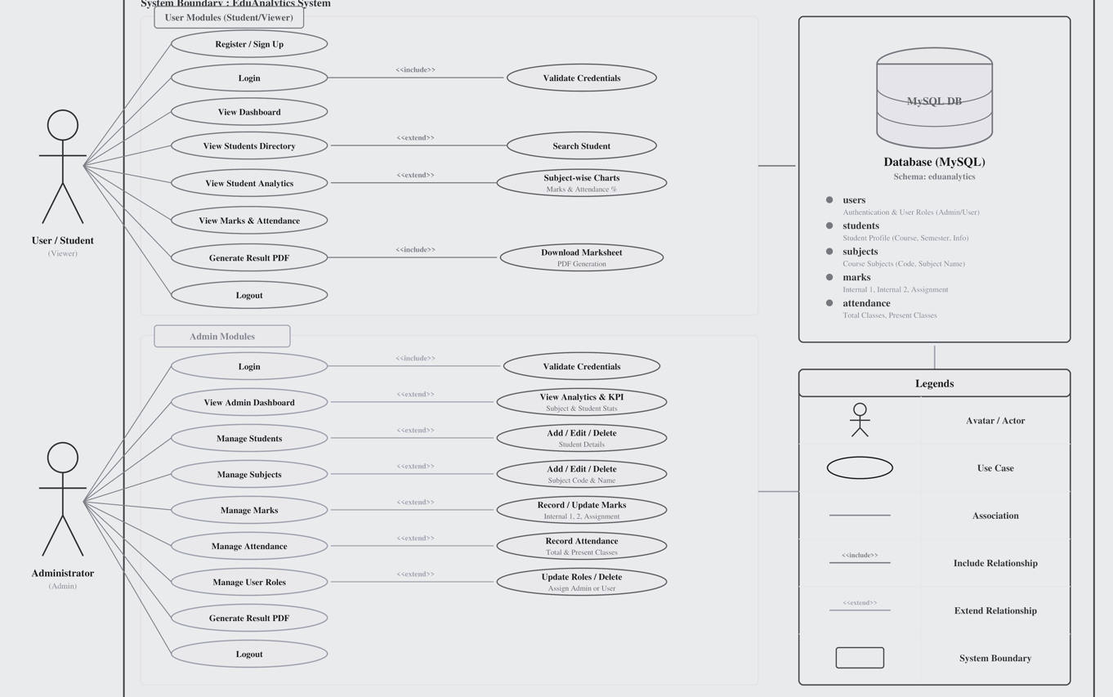

Figure 7.1 : UML Use Case Diagram of EduAnalytics System
8.0 Screen Shots
User Side :
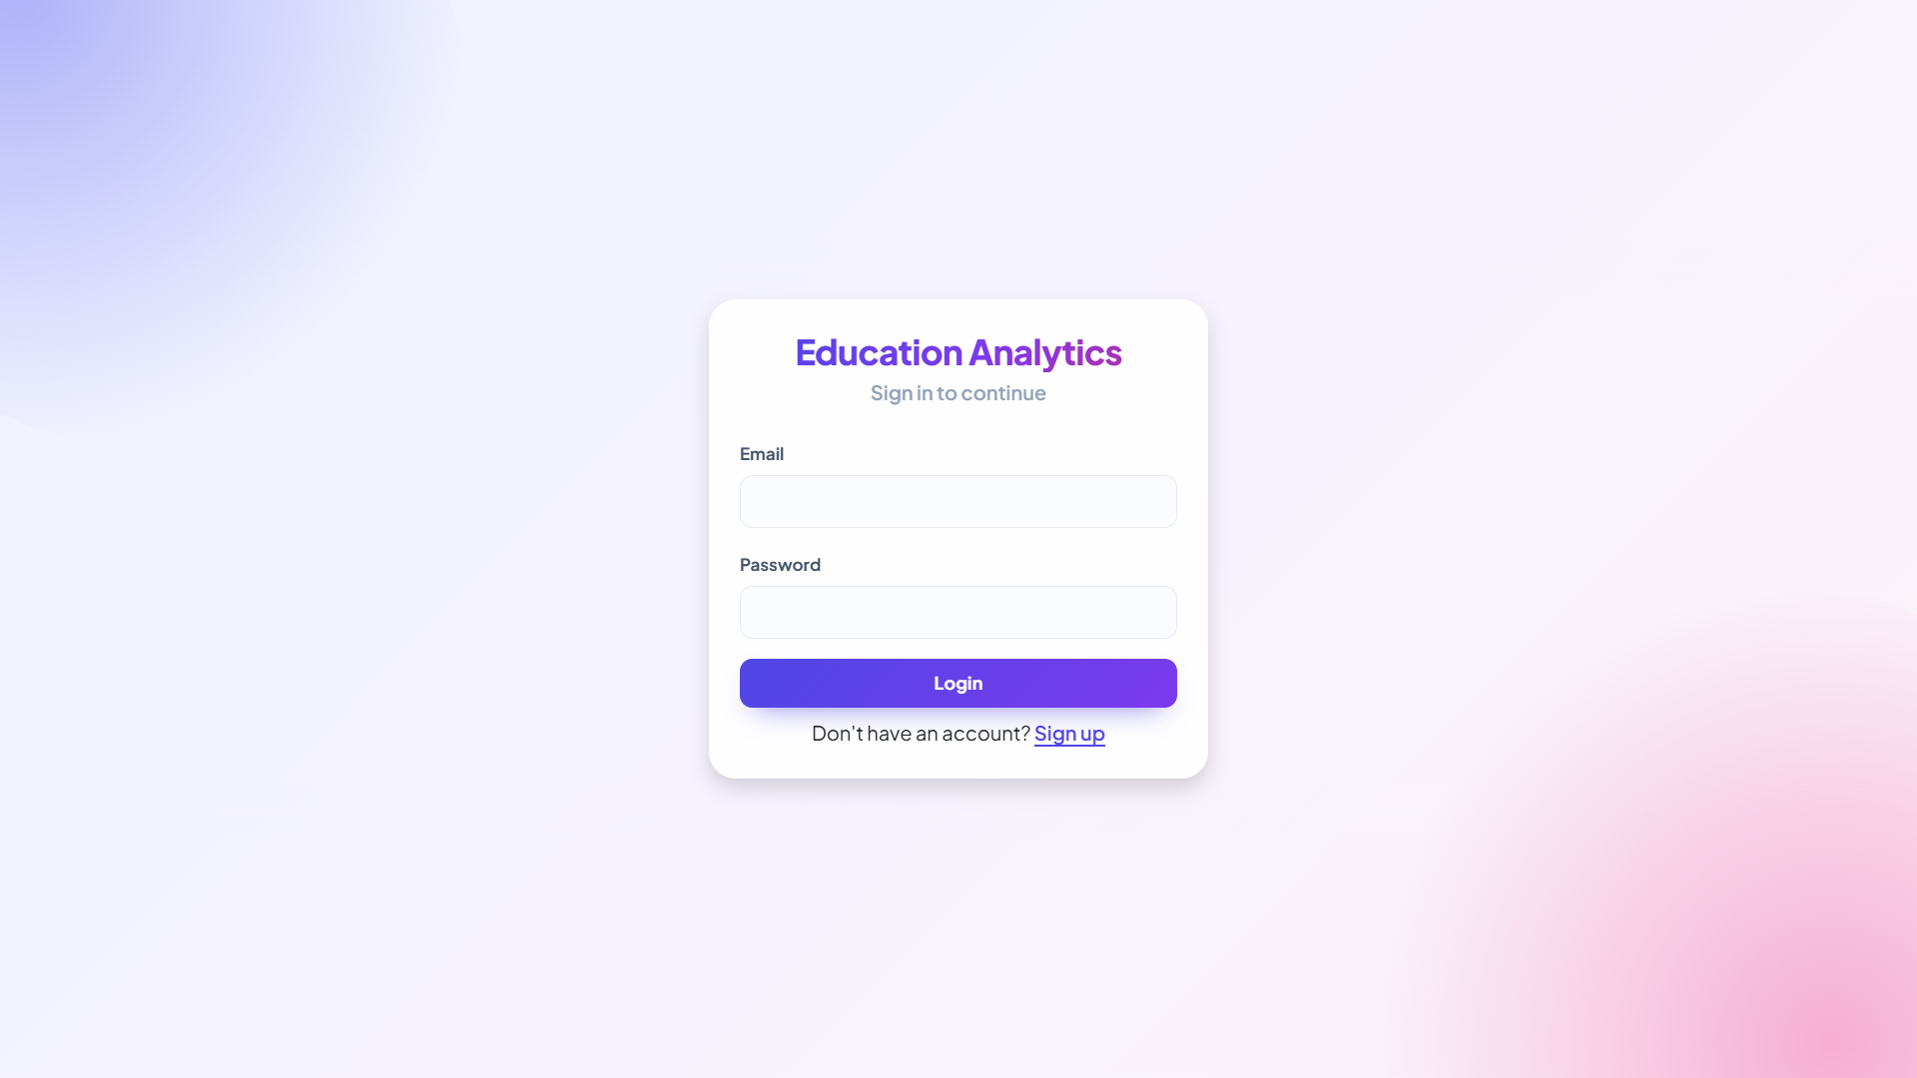Login Page : both admin and user can login here.
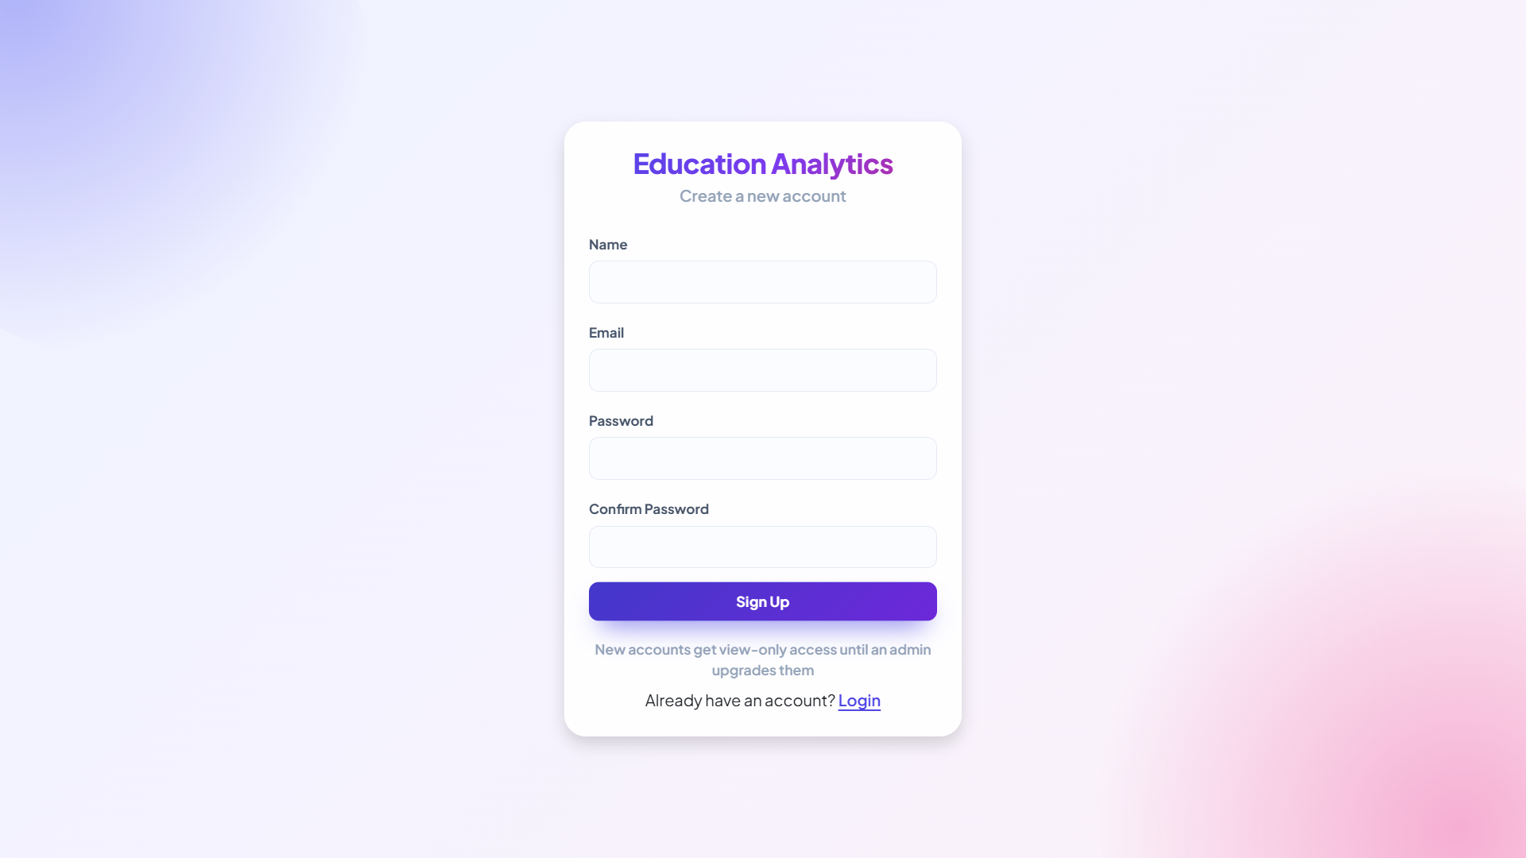User Registration : user can register a new account here.
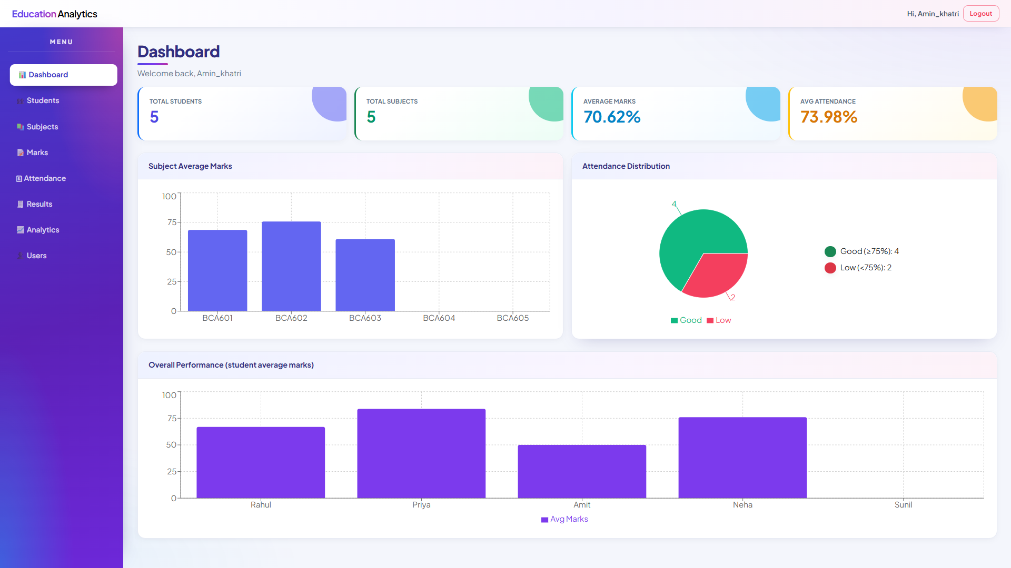Dashboard : users can see KPI cards and charts of subject averages, attendance distribution and student averages.
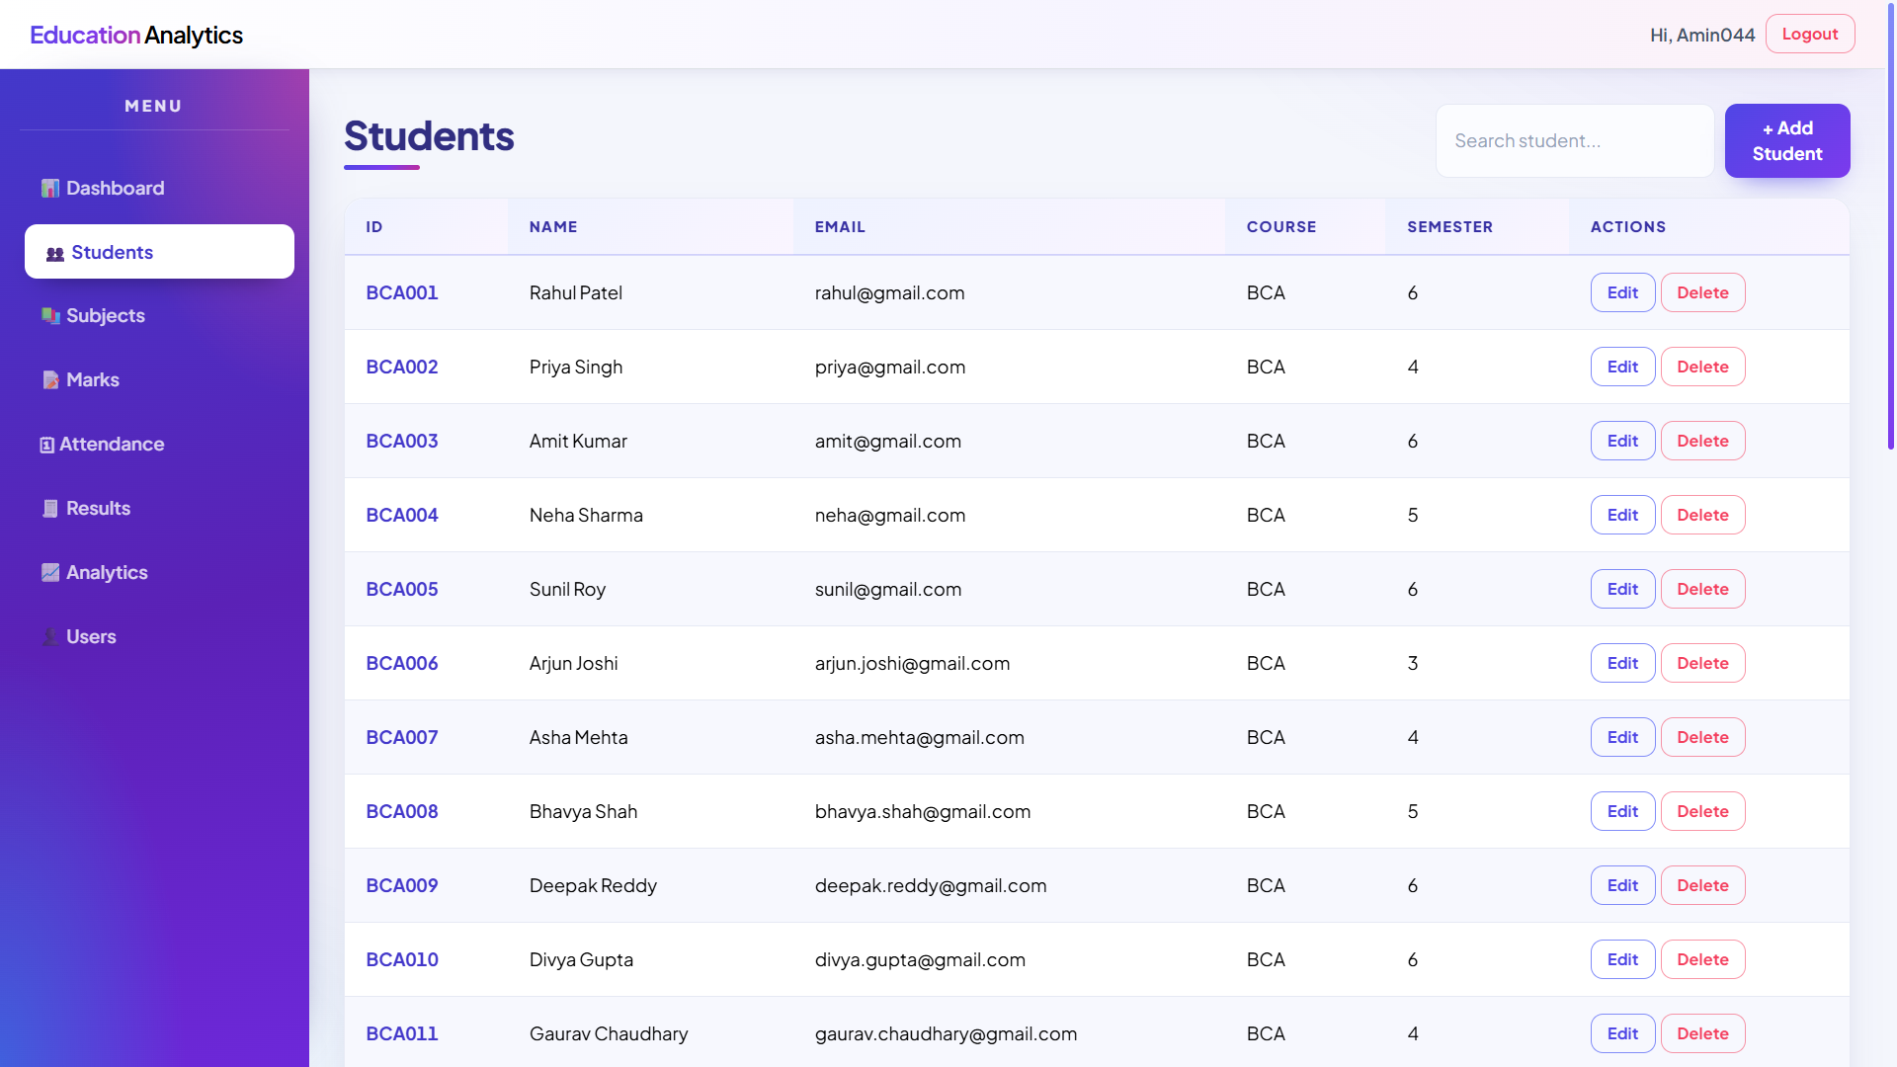Students Page : admin can add, search, edit and delete students.

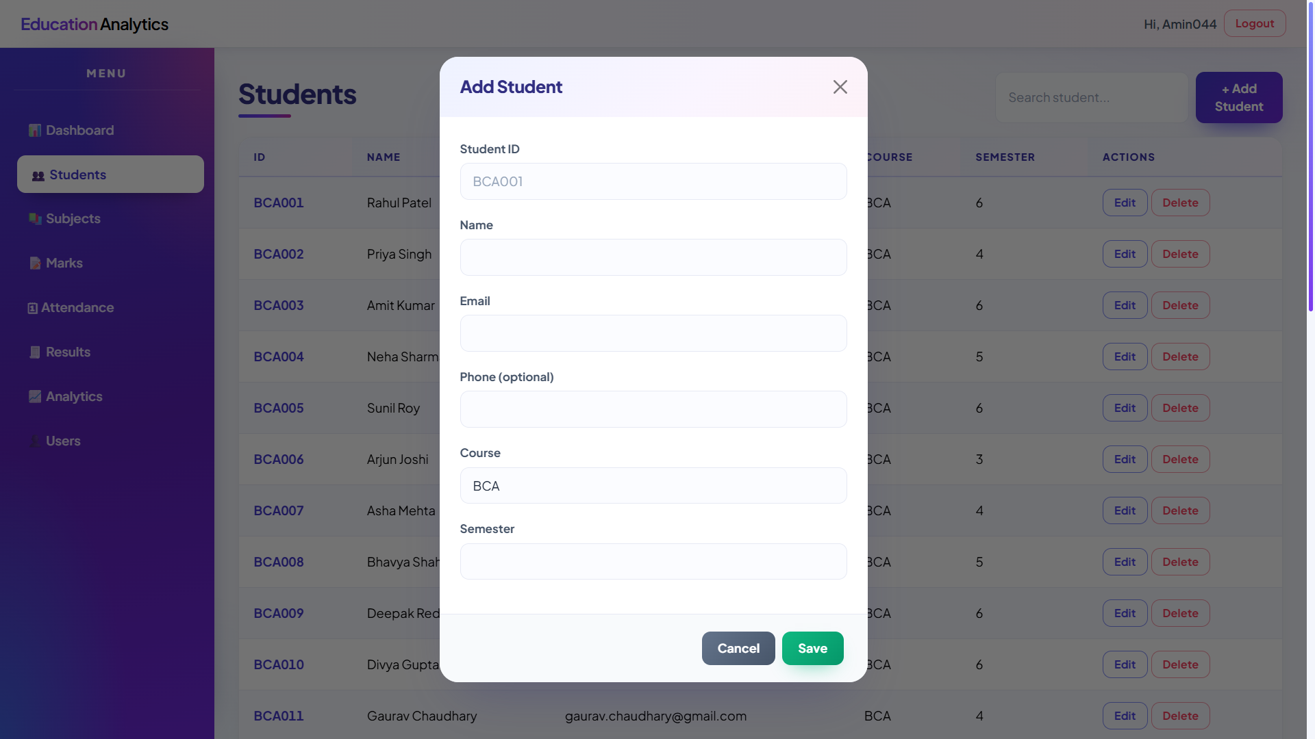
Students Form Page : admin can add, search, edit and delete students.

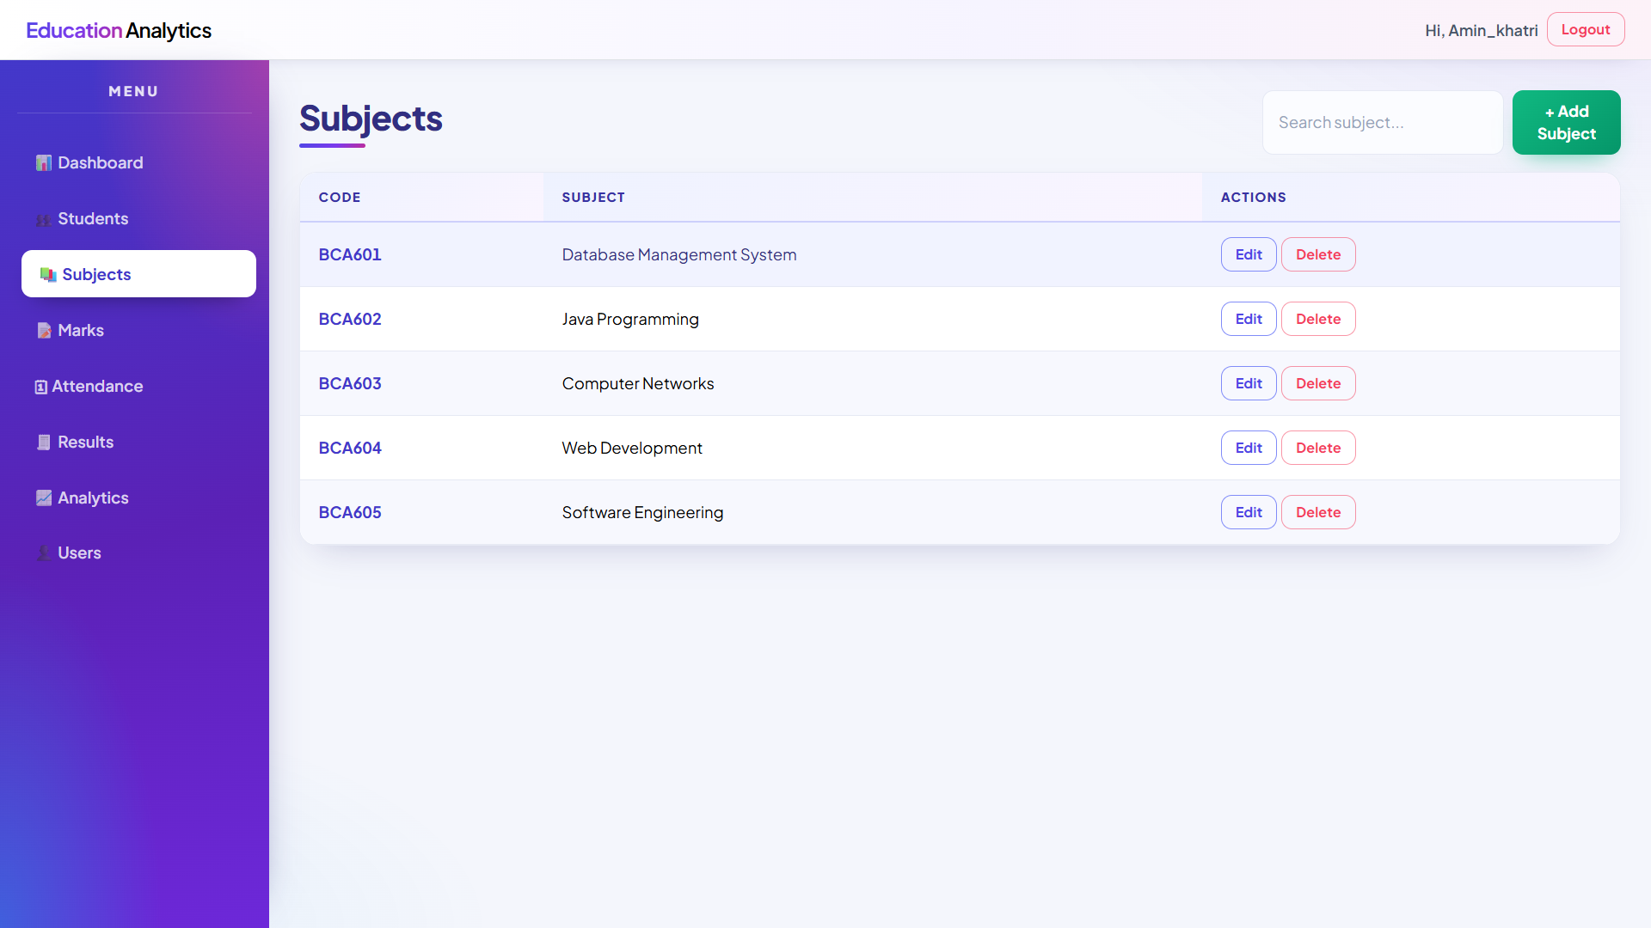Subjects Page : admin can add, edit and delete subjects.

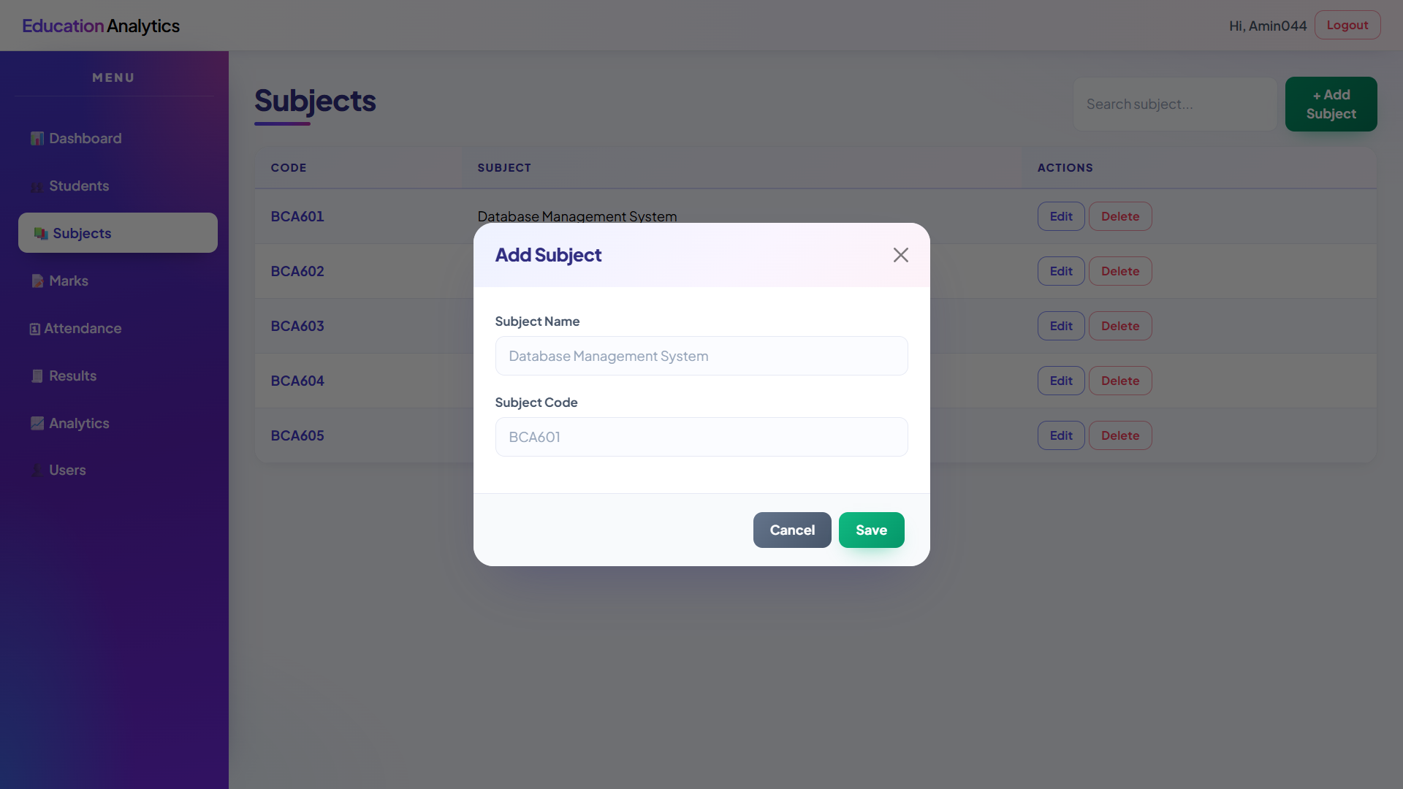
Subjects Form Page : admin can add, edit and delete subjects.

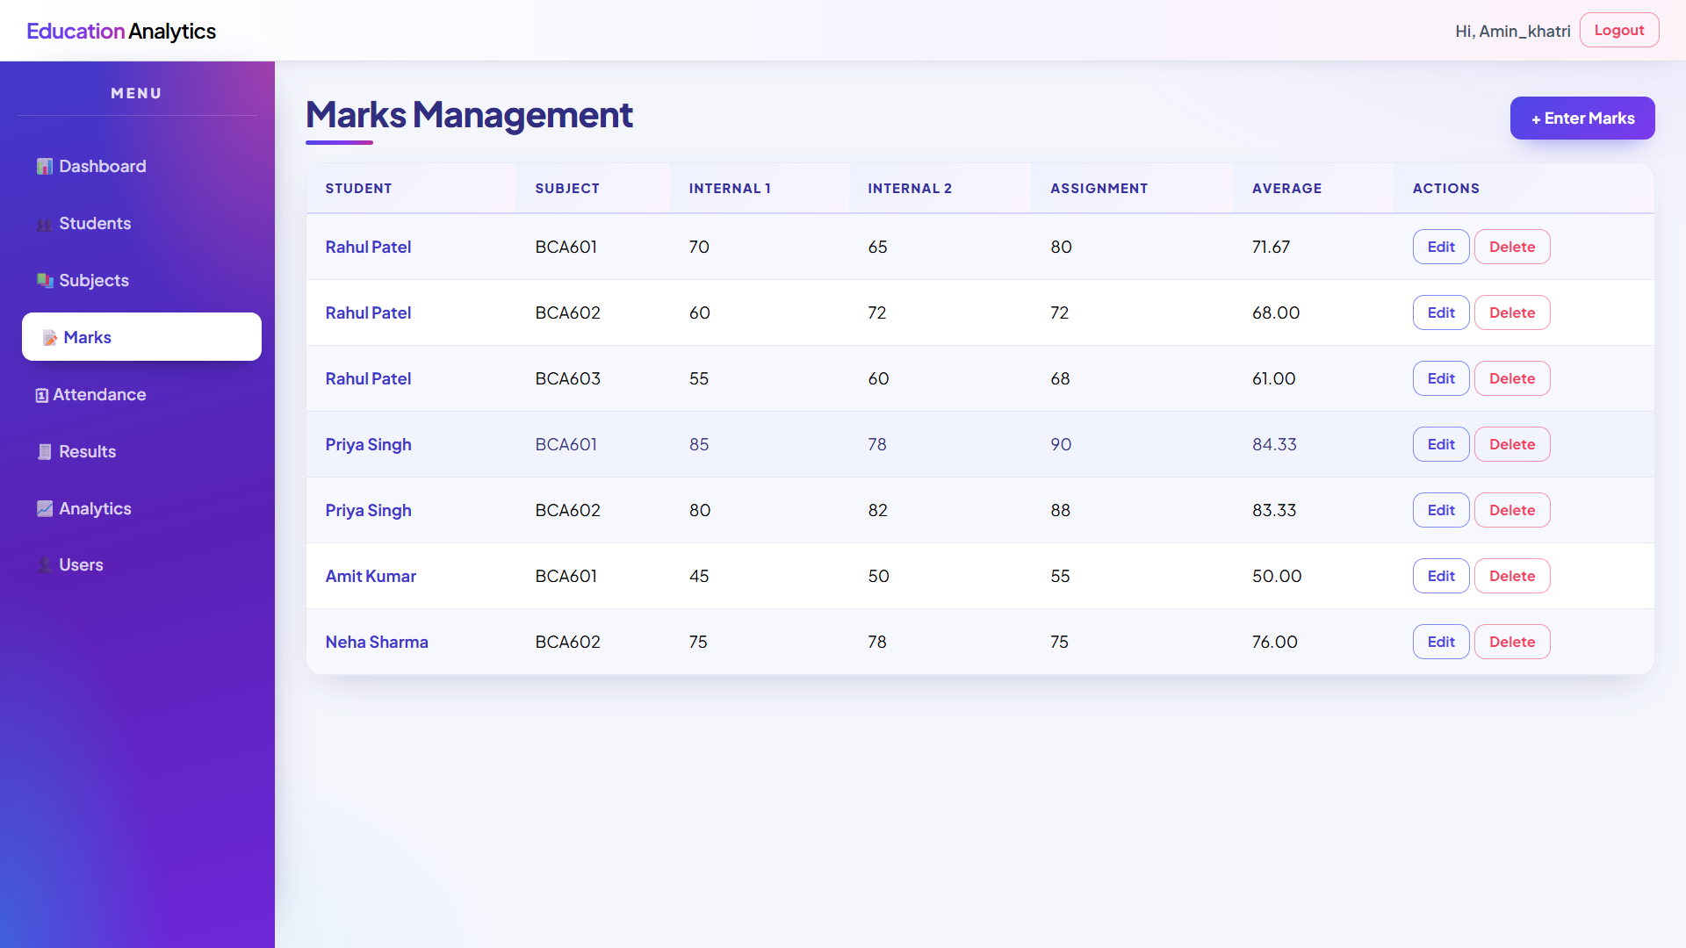Marks Page : admin can enter, edit and delete marks with a live average preview.

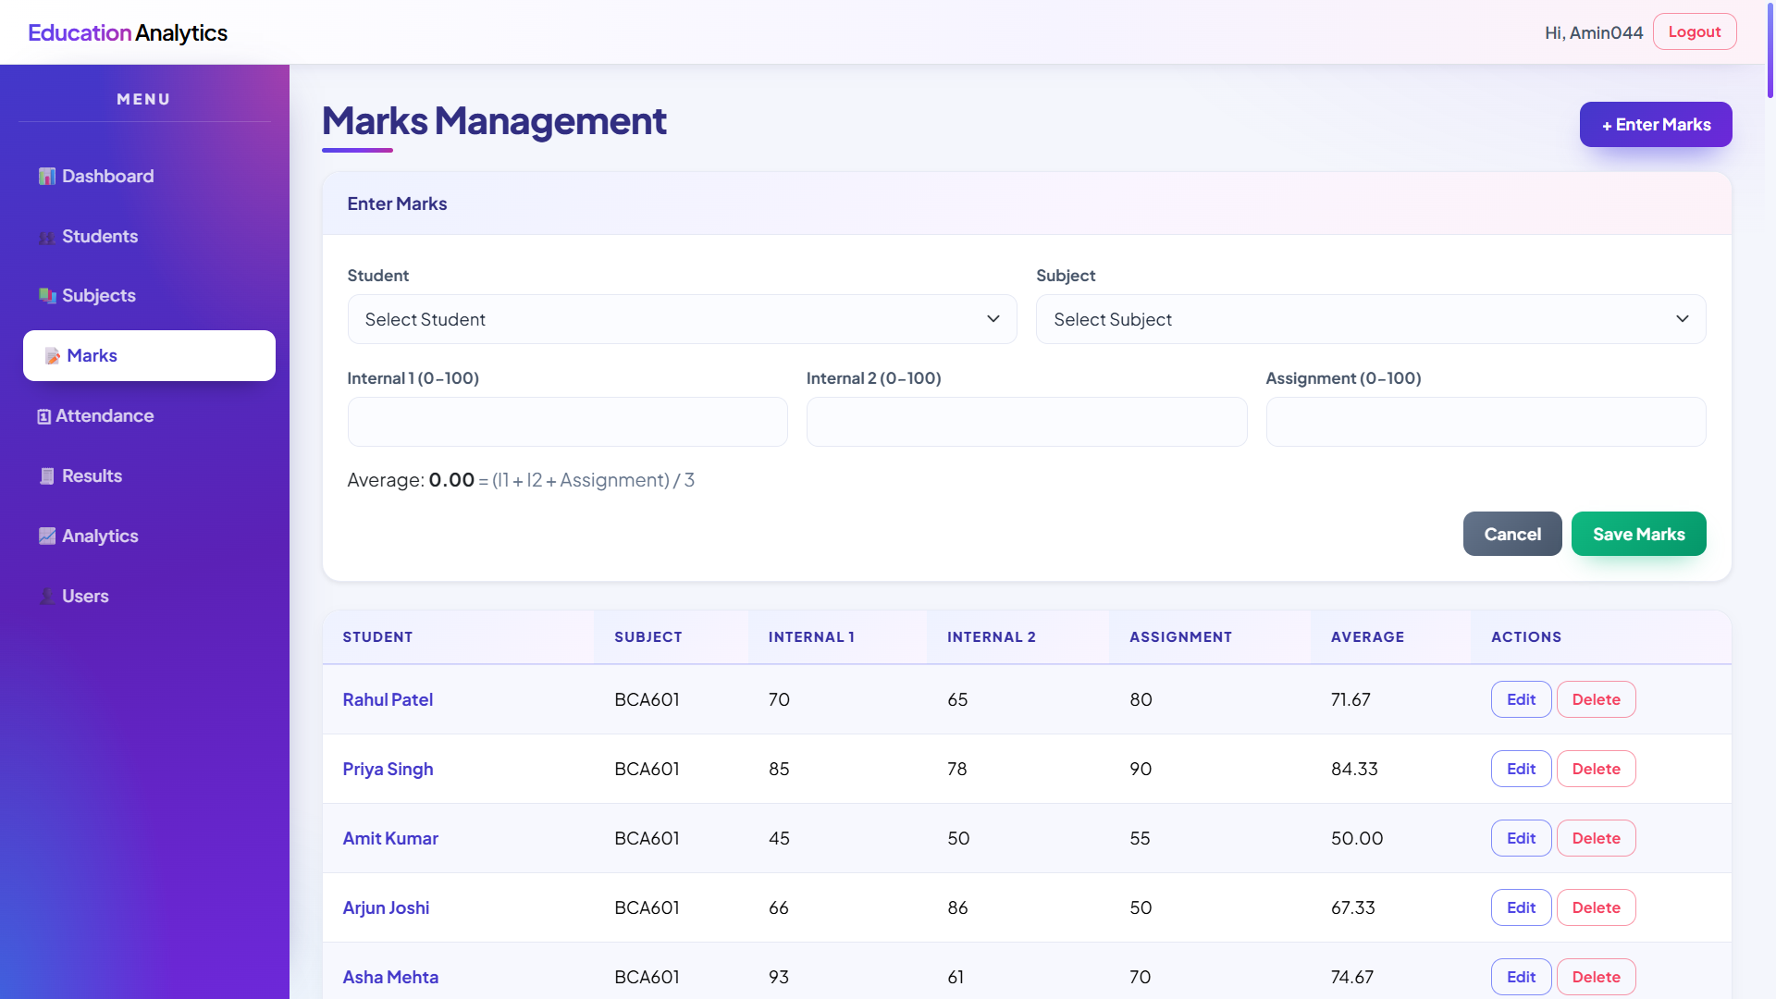
Marks Form Page : admin can enter, edit and delete marks with a live average preview.

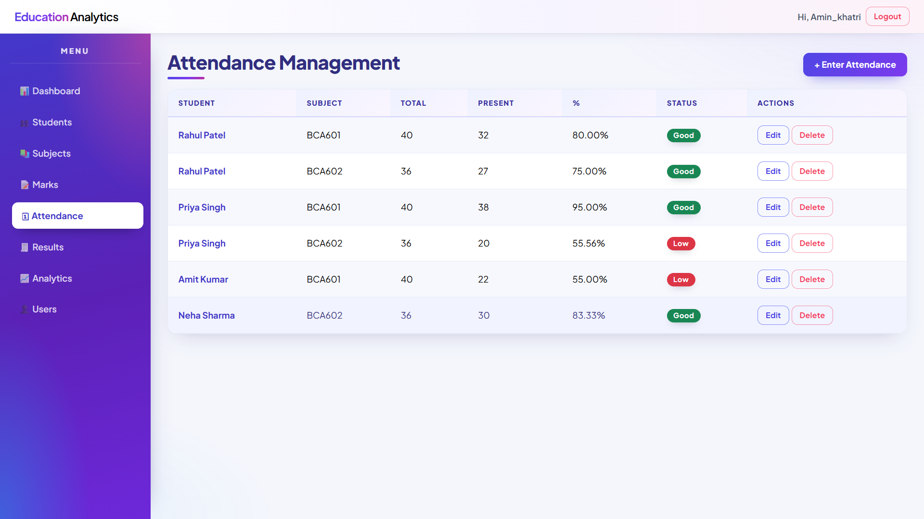Attendance Page : admin can record attendance with a live percentage preview and Good / Low status badges.

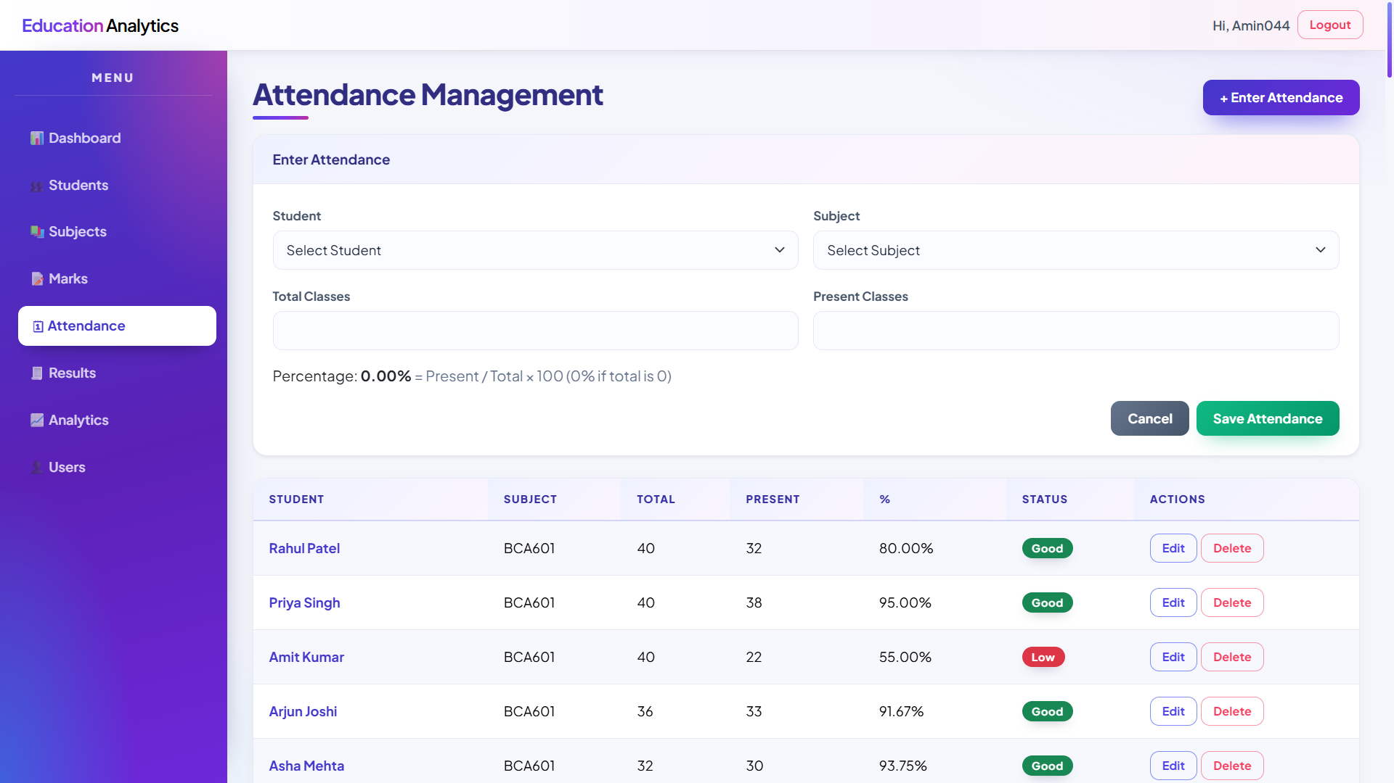
Attendance Form Page : admin can record attendance with a live percentage preview and Good / Low status badges.

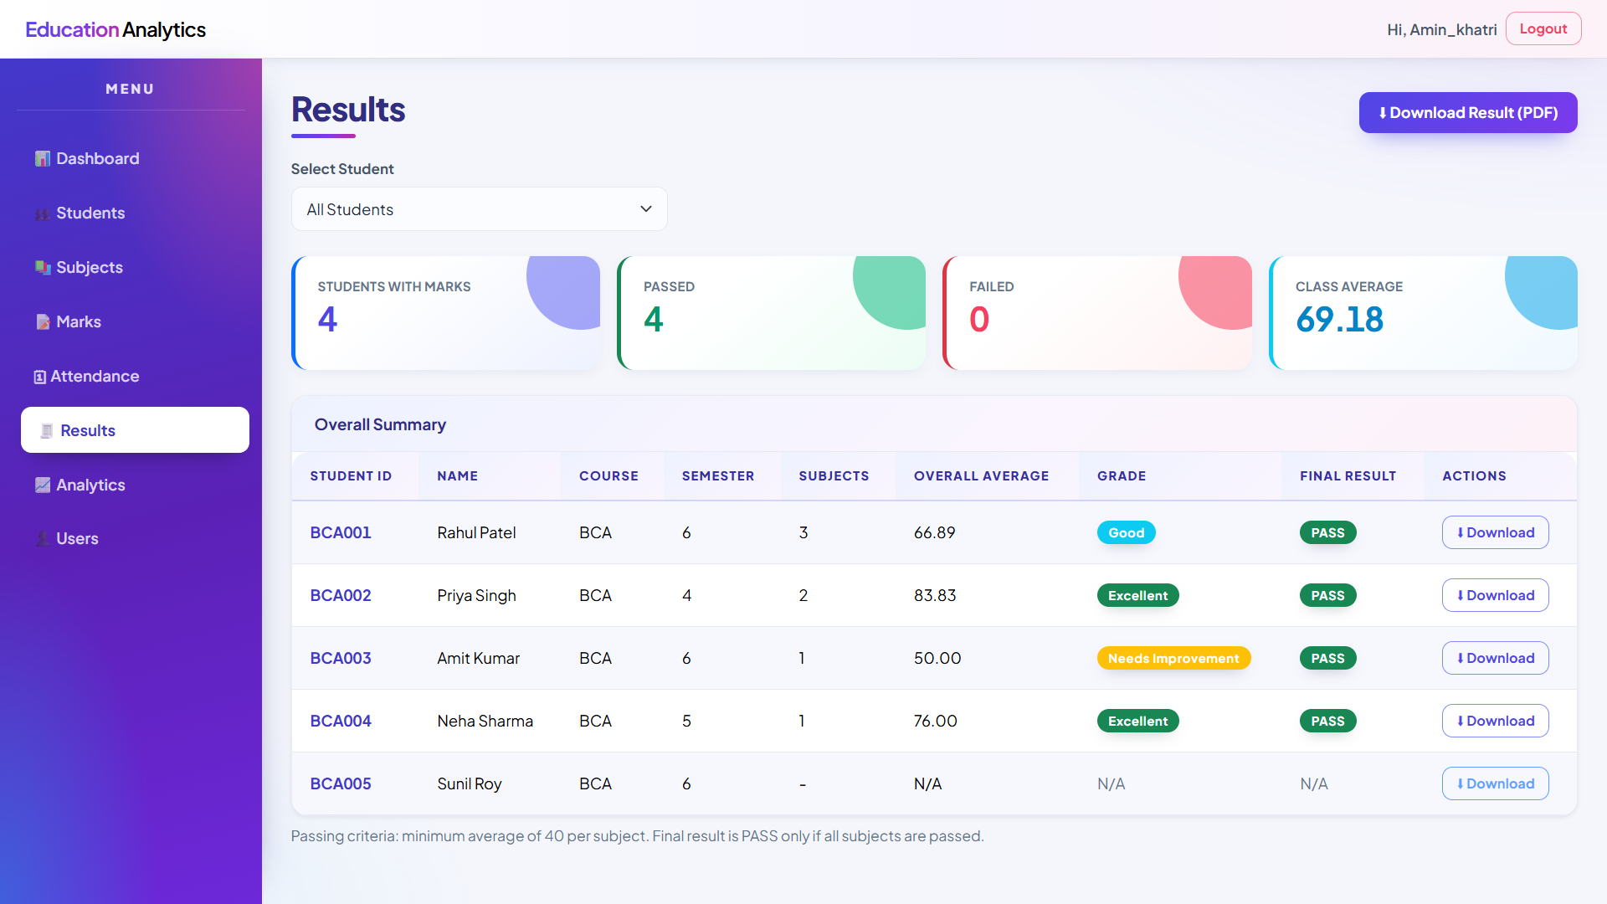Results Page : grades, pass / fail status and class statistics with Statement of Marks download.
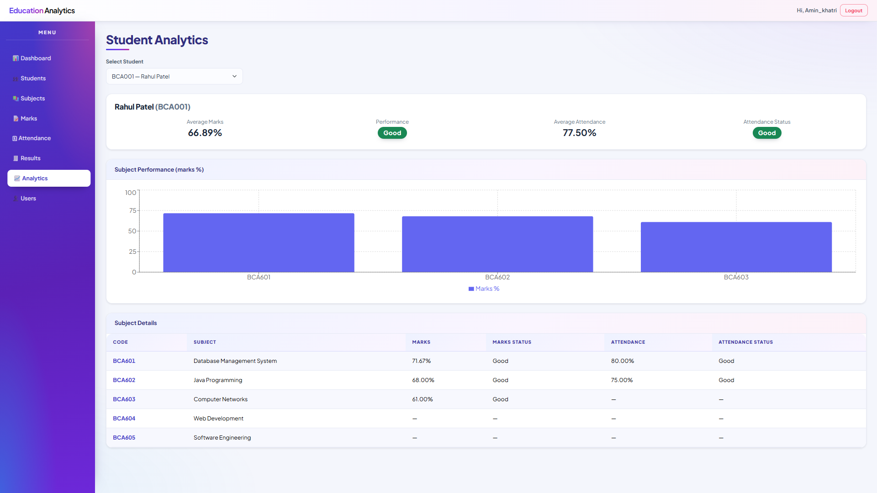Student Analytics Page : subject-wise marks and attendance of a selected student with charts.
Admin Module :
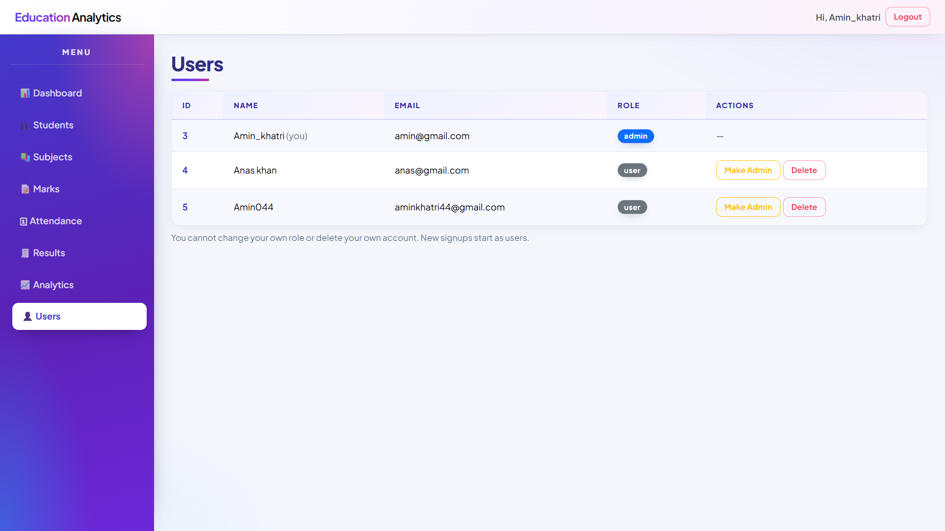Manage Users : admin can change a user's role and delete user accounts.
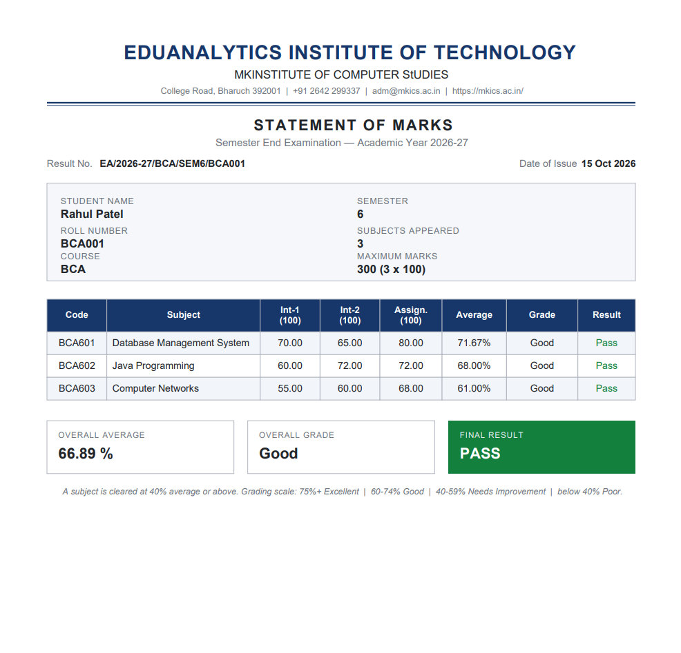Statement of Marks (PDF) : printable result sheet with letterhead, signatures and page footer.
9.0 Future Enhancement
In future this web application will be serving as a complete solution for institute-level academic analytics that includes the following features:
• Import of students, marks and attendance in bulk from Excel / CSV files.
• Export of dashboards, analytics and reports as PDF and Excel files.
• Automatic e-mail / SMS alerts to students for low attendance and failed subjects.
• OTP-based password reset and profile management for users.
• CGPA / percentage calculation, class rank and merit list generation.
• Parent login to view the ward's performance report.
• Session and year management so that past academic years can be archived.
• Dark mode and fully mobile-responsive layout.
• Cloud deployment with regular automated database backups.

