SEC DOCUMENTATION
FOR MINOR PROJECT

PROJECT NAME
EDUANALYTICS
Student Performance Analytics System
React | PHP REST API | MySQL
Submitted By : | Khatri Amin Salimbhai
Roll No. : | 24B055
Semester : | 5
Seat No. : | 2163

Table of Contents
1. Introduction 3
2. Modules and Main Functions 4
2.1 User Registration & Login 4
2.2 Role Management & Access Control 4
2.3 Dashboard Module 4
2.4 Student Management 4
2.5 Subject Management 4
2.6 Marks Management 4
2.7 Attendance Management 5
2.8 Results Module 5
2.9 Student Analytics Module 5
2.10 User Administration (Admin only) 5
2.11 Overall Functional Flow 5
3. System Design 6
3.1 UML Use Case Diagram 6
3.2 ER Diagram 7
3.3 Data Flow Diagram: Level 0 8
3.4 Data Flow Diagram: Level 1 (User Side) 9
3.5 Data Flow Diagram: Admin Side 10
3.6 Data Flow Diagram: Level 2 11
4. Database Design 12
4.1 USERS Table 12
4.2 STUDENTS Table 12
4.3 SUBJECTS Table 12
4.4 MARKS Table 13
4.5 ATTENDANCE Table 13
5. Data Dictionary 14

1. Introduction
The EduAnalytics system is a web-based student performance analytics application designed to manage students, subjects, marks and attendance and to analyse academic performance. The system provides separate functions for administrators and users.
It helps administrators maintain academic data and user accounts, while users can view the analytics dashboard, check subject-wise performance and download result sheets.
The system is built with a React frontend, a PHP (MySQL) REST API backend and a MySQL database.
Technology Summary
Layer | Technology
Frontend | React (web interface, dashboards and charts)
Backend | PHP REST API
Database | MySQL (schema: eduanalytics)
User Roles | Admin (full access) and User (view-only)

2. Modules and Main Functions
The system is divided into the following modules. Each module and its main functions are described below.

2.1 User Registration & Login
- Register new accounts through the signup page.
- Login with e-mail address and password.
- Validate password and confirm password on signup.
- Store the logged-in user and token in browser local storage.
- New accounts are created with the view-only “user” role.
- Logout from the system.

2.2 Role Management & Access Control
- Two system roles: Admin and User.
- Protected routes redirect unauthenticated users to the login page.
- The Users page is accessible to admins only.
- The sidebar shows the Users menu item only for admin users.
- Non-admin users see “View only” labels instead of edit / delete buttons.

2.3 Dashboard Module
- Display KPI cards: Total Students, Total Subjects, Average Marks, Average Attendance.
- Display a bar chart of subject-wise average marks.
- Display a pie chart of attendance distribution (Good ≥ 75% vs Low < 75%).
- Display a bar chart of overall student averages.
- Show loading and empty states when no records exist.

2.4 Student Management
- Add a new student (roll no, name, e-mail, phone, course, semester).
- View all students in a searchable list.
- Search students by name, roll number or e-mail.
- Edit existing student details.
- Delete a student (related marks and attendance are removed automatically).

2.5 Subject Management
- Add a new subject (subject code and subject name).
- View the subject catalogue with search by code or name.
- Edit the subject code and name.
- Delete a subject along with its marks and attendance records.

2.6 Marks Management
- Enter marks for a student in a subject (Internal 1, Internal 2, Assignment).
- Validate that marks are numbers between 0 and 100.
- Show a live average preview: (Internal 1 + Internal 2 + Assignment) / 3.
- View all mark records with the calculated average.
- Edit and delete mark records.

2.7 Attendance Management
- Record total classes and present classes per student per subject.
- Validate that present classes do not exceed total classes.
- Show a live attendance percentage preview.
- Display Good (≥ 75%) and Low (< 75%) status badges on every row.
- Edit and delete attendance records.

2.8 Results Module
- Build a result sheet for every student with subject-wise averages.
- Grade subjects: Excellent ≥ 75, Good ≥ 60, Needs Improvement ≥ 40, Poor < 40.
- Mark a subject as Pass (average ≥ 40) or Fail; final result is PASS only if all subjects pass.
- Show class-level statistics: students with marks, passed, failed and class average.
- Filter the result list by a single student.
- Download a printable “Statement of Marks” PDF with letterhead, signatures and page footers.

2.9 Student Analytics Module
- Select a student to view their performance summary.
- Show average marks, performance badge, average attendance and attendance status.
- Display a bar chart of subject-wise marks percentage.
- Show a subject detail table with marks status and attendance status.

2.10 User Administration (Admin only)
- List all registered users with their roles.
- Change a user’s role between admin and user.
- Delete a user account (the logged-in account cannot delete itself).
- Manage users from the Users page in the sidebar.

2.11 Overall Functional Flow
- Signup / Login with e-mail and password.
- Admin adds subjects and students.
- Admin enters marks and attendance for each student.
- Dashboard shows institute-wide KPIs and charts.
- Student Analytics shows subject-wise performance for one student.
- Results shows grades, pass / fail and class statistics.
- Download the Statement of Marks as a PDF.
- Admin promotes or deletes user accounts.
- Logout clears the session.

3. System Design
This chapter presents the analysis and design diagrams of the EduAnalytics system: the UML use case diagram, the entity-relationship (ER) diagram and the data flow diagrams (DFD) at different levels.

3.1 UML Use Case Diagram
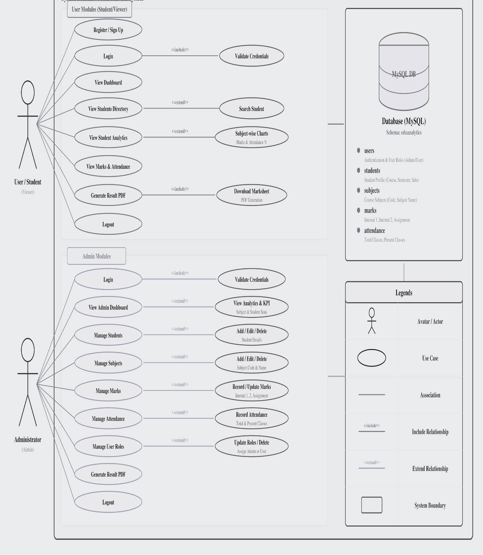
Figure 3.1: UML Use Case Diagram for EduAnalytics

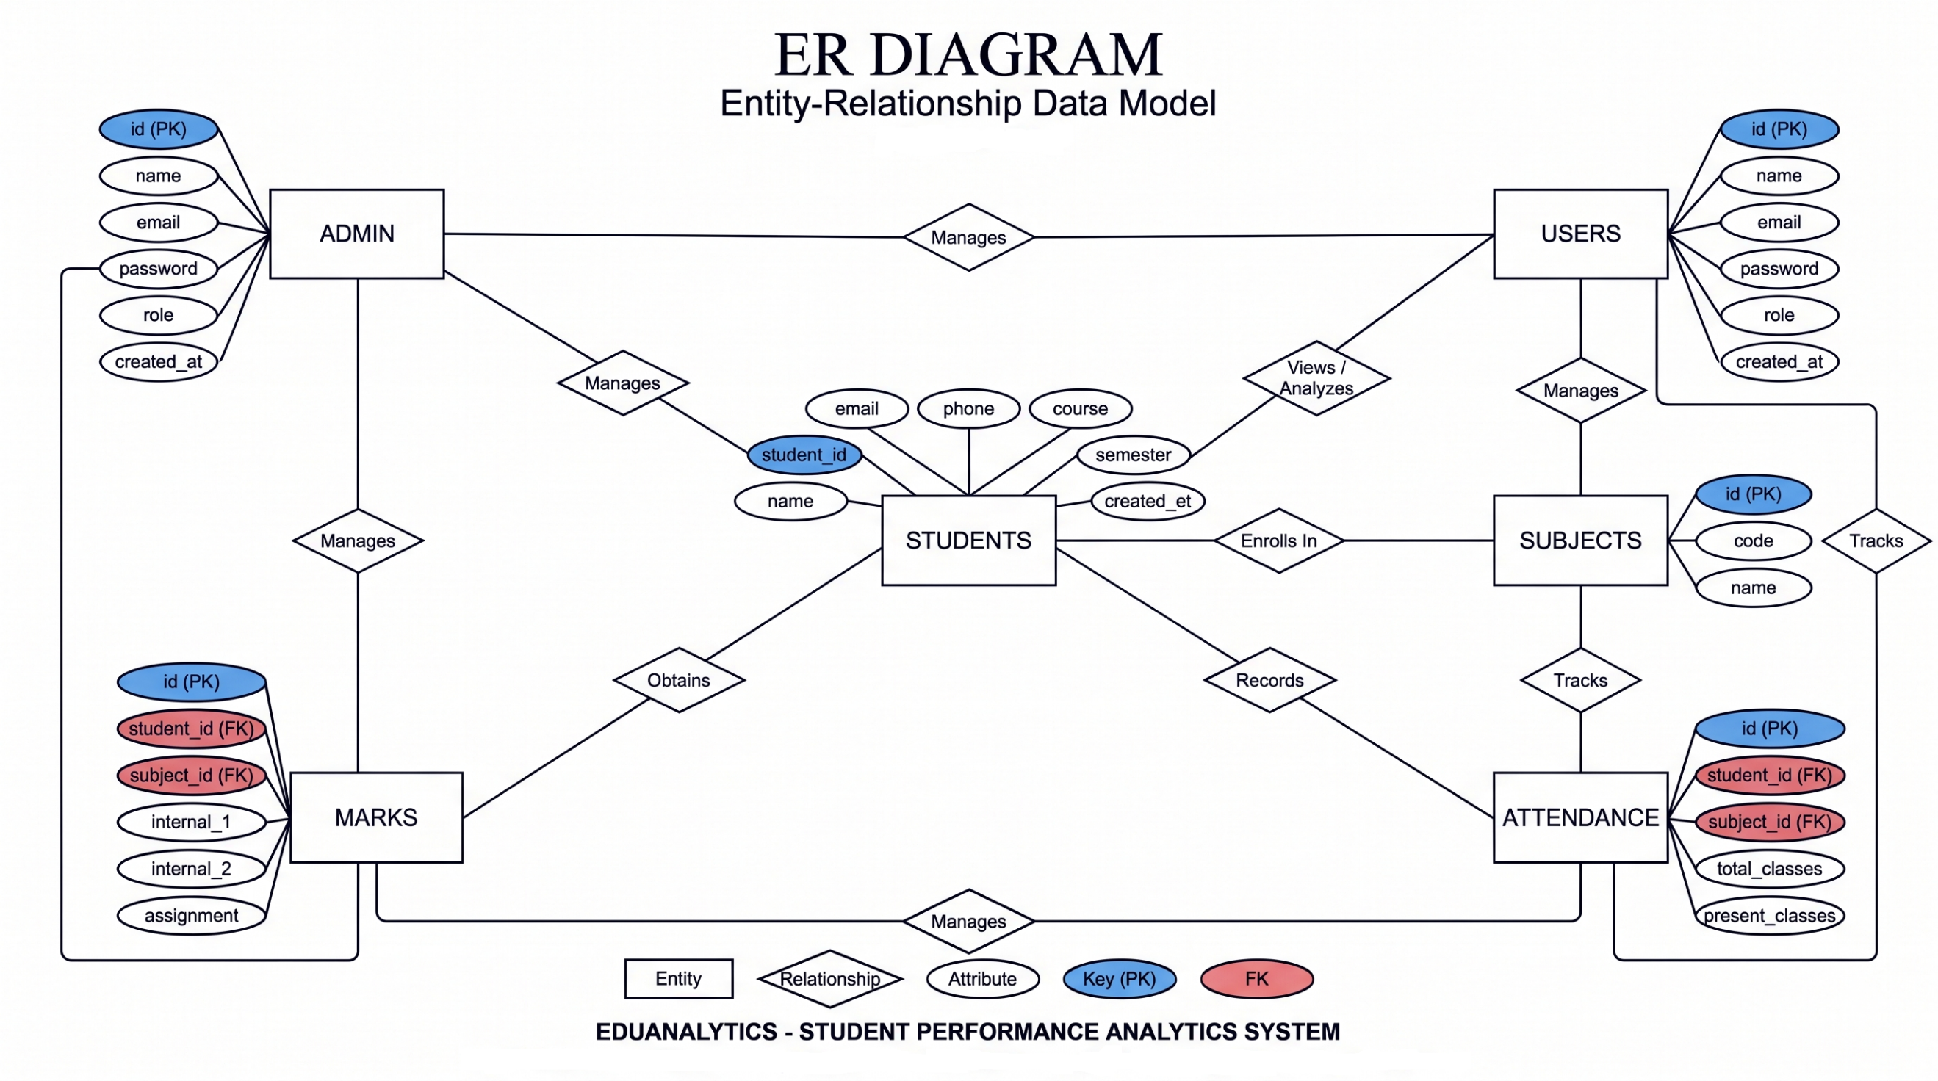
3.2 ER Diagram

Figure 3.2: ER Diagram of the EduAnalytics System

3.3 Data Flow Diagram: Level 0
The context-level diagram shows the EduAnalytics system as a single process interacting with its two external entities, the User / Student and the Admin.
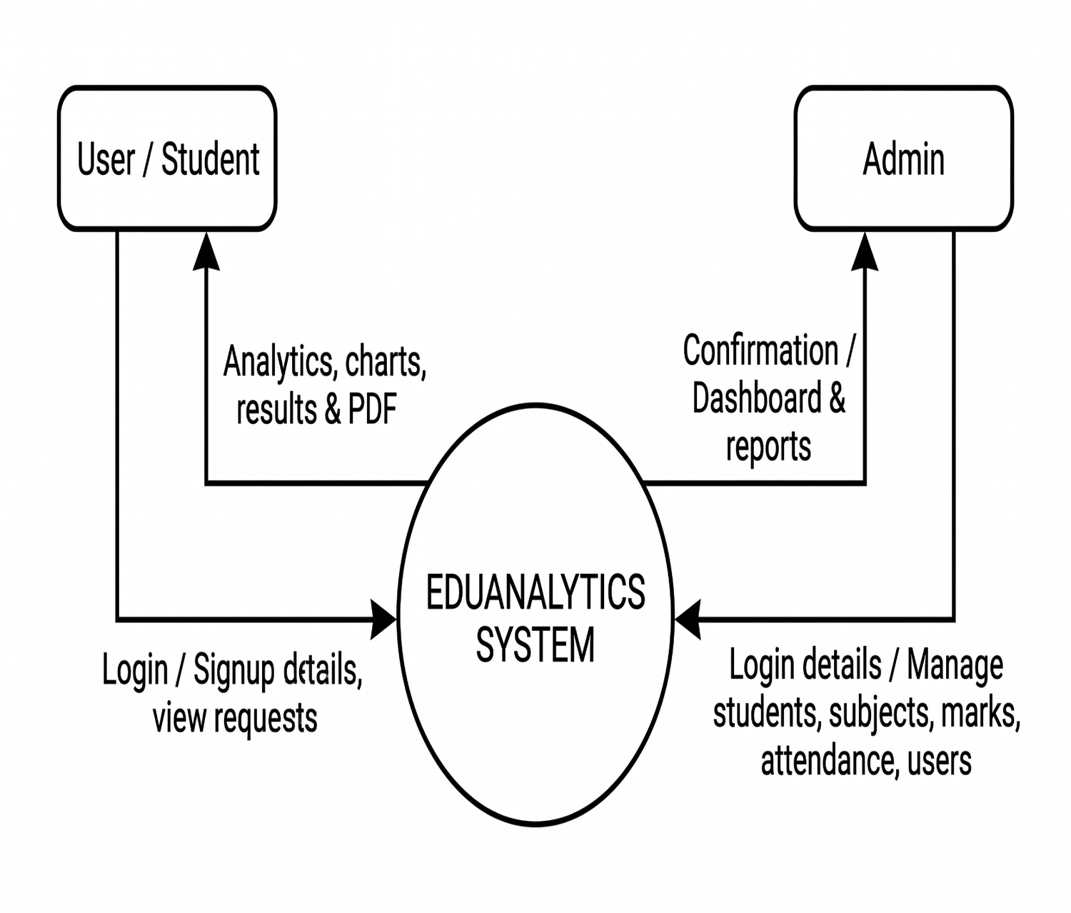
Figure 3.3: DFD Level 0 of the EduAnalytics System

3.4 Data Flow Diagram: Level 1 (User Side)
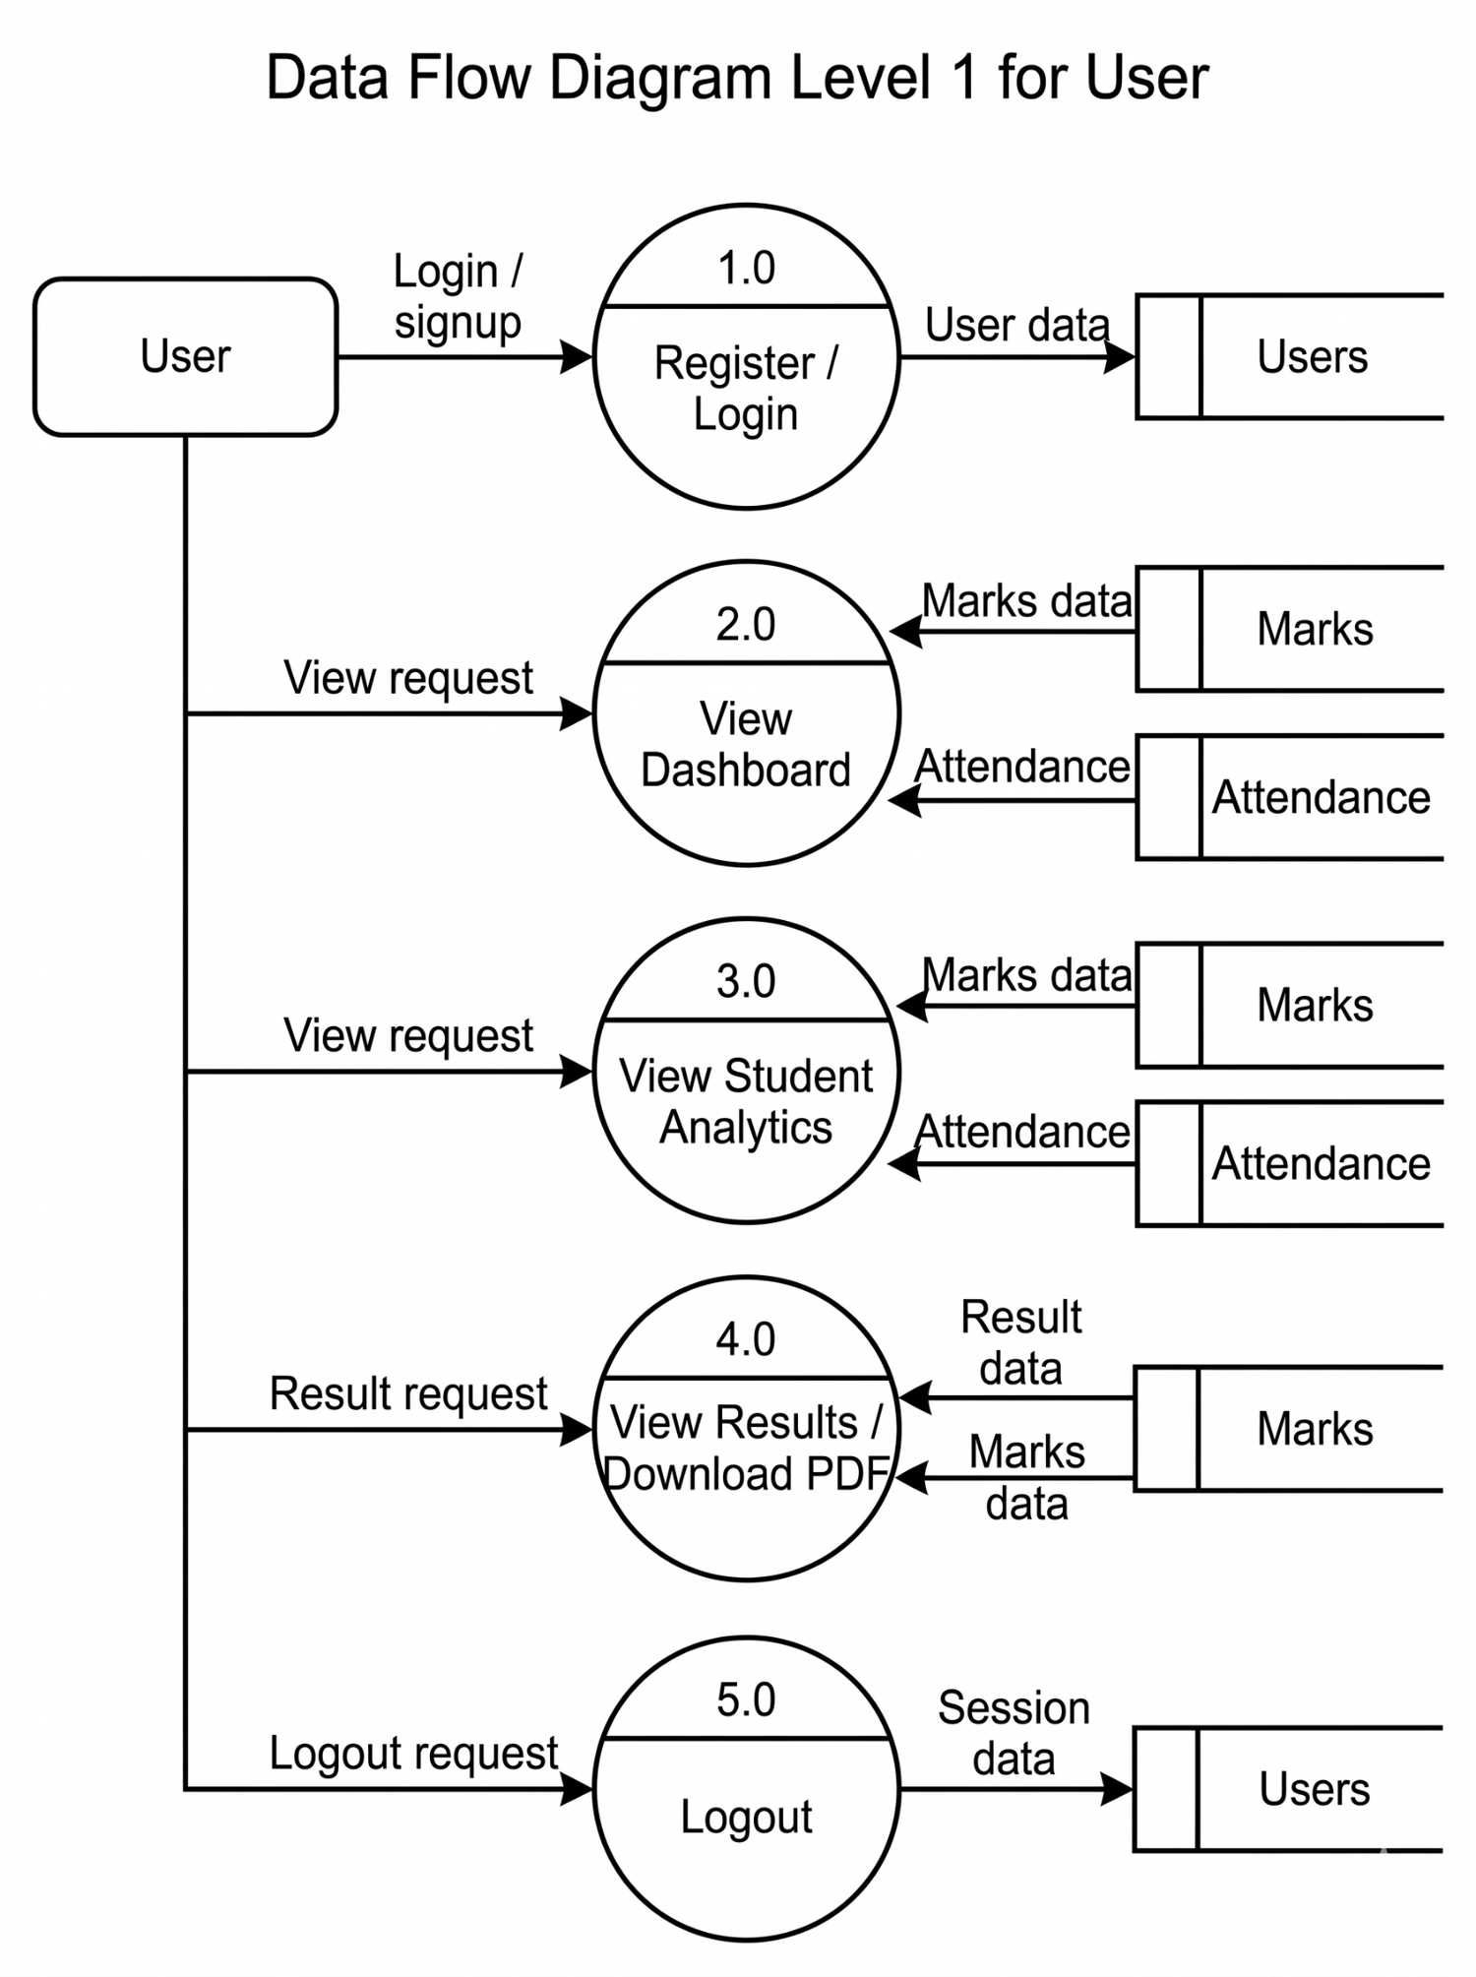
Figure 3.4: DFD Level 1 for User

3.5 Data Flow Diagram: Admin Side
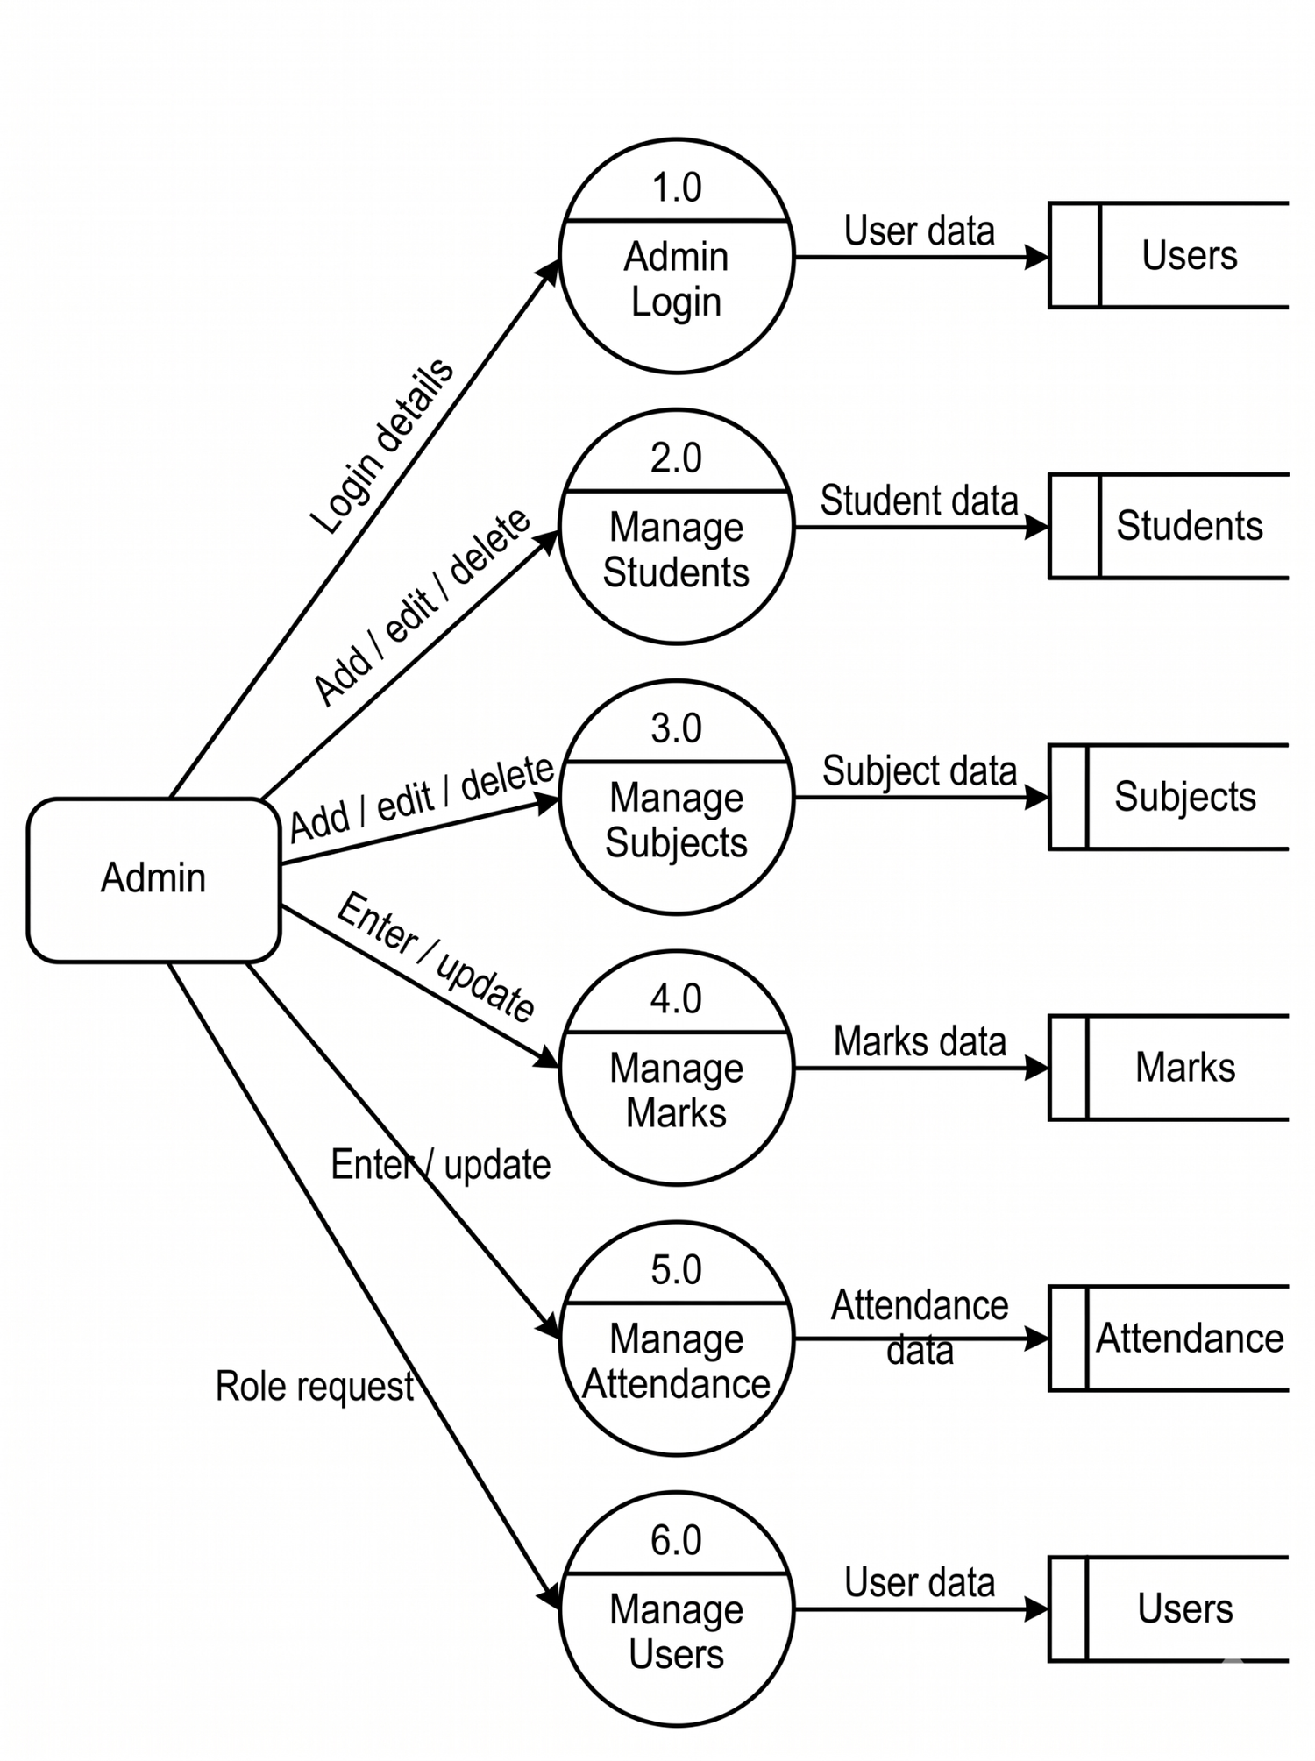
Figure 3.5: DFD Admin Side Level of the EduAnalytics System

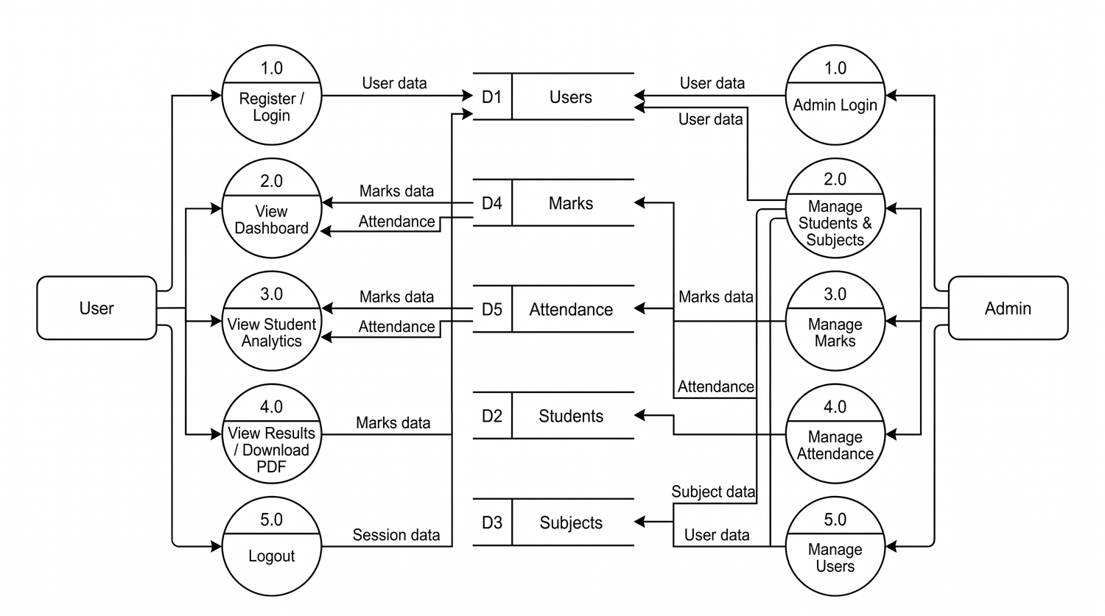
3.6 Data Flow Diagram: Level 2

Figure 3.6: DFD Level 2 of the EduAnalytics System

4. Database Design
The database consists of five tables: users, students, subjects, marks and attendance. The marks and attendance tables reference students and subjects through foreign keys with ON DELETE CASCADE, so related records are removed automatically when a student or subject is deleted.
Key legend: PK = Primary Key, UQ = Unique Key, FK = Foreign Key

4.1 USERS Table
Field Name | Data Type | Key | Description
id | INT | PK | Unique user id
name | VARCHAR(100) |  | User full name
email | VARCHAR(150) | UQ | Unique login e-mail address
password | VARCHAR(255) |  | Bcrypt hashed password
role | VARCHAR(20) |  | User role: admin / user
created_at | TIMESTAMP |  | Date & time of registration

4.2 STUDENTS Table
Field Name | Data Type | Key | Description
id | INT | PK | Unique student id
student_id | VARCHAR(20) | UQ | Roll number, e.g. BCA001
name | VARCHAR(100) |  | Student full name
email | VARCHAR(150) |  | Student e-mail address
phone | VARCHAR(20) |  | Student mobile number
course | VARCHAR(50) |  | Course name, e.g. BCA
semester | INT |  | Current semester (1 to 8)
created_at | TIMESTAMP |  | Date & time student added

4.3 SUBJECTS Table
Field Name | Data Type | Key | Description
id | INT | PK | Unique subject id
code | VARCHAR(20) | UQ | Subject code, e.g. BCA601
name | VARCHAR(100) |  | Subject name

4.4 MARKS Table
Field Name | Data Type | Key | Description
id | INT | PK | Unique mark record id
student_id | INT | FK | FK → students.id (ON DELETE CASCADE)
subject_id | INT | FK | FK → subjects.id (ON DELETE CASCADE)
internal_1 | DECIMAL(5,2) |  | First internal test marks (0 to 100)
internal_2 | DECIMAL(5,2) |  | Second internal test marks (0 to 100)
assignment | DECIMAL(5,2) |  | Assignment marks (0 to 100)

4.5 ATTENDANCE Table
Field Name | Data Type | Key | Description
id | INT | PK | Unique attendance record id
student_id | INT | FK | FK → students.id (ON DELETE CASCADE)
subject_id | INT | FK | FK → subjects.id (ON DELETE CASCADE)
total_classes | INT |  | Total classes held for the subject
present_classes | INT |  | Number of classes attended by the student

5. Data Dictionary
The data dictionary lists every field used across the EduAnalytics database along with its data type, nullability, the tables in which it appears and its purpose.
Sr. No. | Field Name | Type | Null / Default | Table(s) Used | Description / Purpose
1 | id | INT | No | Users, Students, Subjects, Attendance, Marks | Primary key that uniquely identifies each record in its respective table.
2 | student_id | INT (Attendance, Marks); VARCHAR(20) (Students) | No | Students, Attendance, Marks | Identifies a student. In Students it is the student’s unique institutional/student code; in Attendance and Marks it links a record to a student.
3 | subject_id | INT | No | Attendance, Marks | References the related subject so attendance and marks can be recorded for that subject.
4 | total_classes | INT | No (default 0) | Attendance | Stores the total number of classes held for the student’s subject.
5 | present_classes | INT | No (default 0) | Attendance | Stores how many classes the student attended, helping calculate attendance percentage.
6 | internal_1 | DECIMAL(5,2) | No (default 0.00) | Marks | Stores the student’s score in the first internal assessment.
7 | internal_2 | DECIMAL(5,2) | No (default 0.00) | Marks | Stores the student’s score in the second internal assessment.
8 | assignment | DECIMAL(5,2) | No (default 0.00) | Marks | Stores the student’s assignment score for the subject.
9 | name | VARCHAR(100) | No | Users, Students, Subjects | Stores the name of the user, student, or subject, depending on the table.
10 | email | VARCHAR(150) | No (Users); Yes (Students) | Users, Students | Stores an email address for account/contact purposes. It is required for Users and optional for Students.
11 | phone | VARCHAR(20) | Yes | Students | Stores the student’s contact number; it is optional.
12 | course | VARCHAR(50) | Yes | Students | Stores the course or programme in which the student is enrolled; it is optional.
13 | semester | INT | Yes | Students | Stores the student’s current semester; it is optional.
14 | created_at | TIMESTAMP | Yes (default CURRENT_TIMESTAMP) | Users, Students | Records when the user/student record was created; the database supplies the current timestamp by default.
15 | code | VARCHAR(20) | No | Subjects | Stores the subject code used to identify a subject; the code is unique in the Subjects table.
16 | password | VARCHAR(255) | No | Users | Stores the account password value (normally a securely hashed password) for authentication.
17 | role | VARCHAR(20) | No (default admin) | Users | Identifies the user’s role, such as admin, so the system can distinguish access levels.

