
Adama Science and Technology University
__________________________________________
Department of Computer Science and Engineering
__________________________________________
Online File Sharing System
__________________________________________
Project Report Document
Author: Name: Amin Beshir
ID: A/UR4113/09
Submitted to: Adama Science and Technology University ICT directorate
Date: 2022/02/10

Approved by: ______________________________ Signature: _________________________

ABSTRACT

The objective of this application will manage a file-sharing site. The Institute can create an employee’s database, each one with his assigned folder. Within this folder, the employee can upload its files or download the one already in the folder already uploaded by the Institute itself. When the Institute uploads a file in an employee folder, the employee will receive an email alerting him of the new file and with a link to download it without logging in to the File Sharing System. The employee can also log into the system at any time and lock for previously uploaded files.

Every user normally thinks about how to store information on files for future usage. Sometimes he used to share his data with another person’s also that is called public data which can be shared with others. But some data may be protected means private only for limited persons or single usage. That’s why the Institute creates a database for employee’s to store their data in the form of files. This system can give permissions to the users to create a new file throw this application. Then the user can able to upload his information into that particular file. Now he needs to put folder sharing options whether the folder information is public or private.

In the form of administration, the admin can upload information from his side. Then admin will send the Notifications or emails to users for their newly uploaded information. If the user wants that information then he had a facility to download the information and save it into his personnel folder for further usage. The admin information is completely public for all users. The details of Uploading and downloading information are displayed to every user separately. The maximum number of space a user can be used is 2 GB only. Whenever users upload or download the application can calculate the size of the file and adjust the maximum space a user using.

Table Of Contents
Contents
ABSTRACT 1
INTRODUCTION TO PROJECT 3
ORGANIZATION PROFILE 3
PURPOSE OF THE PROJECT 4
PROBLEM IN EXISTING SYSTEM 4
SOLUTION OF THESE PROBLES 5
SYSTEM ANALYSIS 5
2.1 INTRODUCTION 5
2.2 ANALYSIS MODEL 5
2.3 STUDY OF THE SYSTEM 8
NUMBER OF MODULES 8
2.4 System Requirement Specifications 11
Hardware Requirements 11
Software Requirements 11
2.5 PRAPOSED SYSTEM 11
2.7 PROCESS MODEL USED WITH JUSTIFICATION 13
Feasibility Report 13
3.1. TECHNICAL FEASIBILITY 13
3.2. OPERATIONAL FEASIBILITY 14
3.3. ECONOMICAL FEASIBILITY 15
SOFTWARE REQUIREMENT SPECIFICATION 15
INTRODUCTION 15
DEVELOPERS RESPONSIBILITIES OVERVIEW: 15
4.1. FUNCTIONAL REQUIREMENTS 16
The outputs should be defined in terms of the following points: 16
4.2. PERFORMANCE REQUIREMENTS 20
SELECTED SOFTWARE 21
5.1 INTRODUCTION TO .NET FRAMEWORK 21
Principal design features 21
5.2 ASP.NET 26
SERVER APPLICATION DEVELOPMENT 26
5.3 C#.NET 30
DATASETS AND DATAADAPTERS 32
5.4 SQL SERVER -2005 33
SYSTEM DESIGN 37
6.1. INTRODUCTION 37
6.2 NORMALIZATION 38
6.3 E-R Diagrams 39
6.4 DATA FLOW DIAGRAMS 40
6.5 DATA DICTIONARY 49
6.6 UML DIAGRAMS 53
User Use Case Diagram 55
Sequence Diagrams 57
Activity Diagrams: 66
SYSTEM TESTING AND IMPLEMENTATION 68
INTRODUCTION 68
8.2. STRATEGIC APPROACH TO SOFTWARE TESTING 68
8.3. UNIT TESTING 69
3. CONDITIONAL TESTING 70
4. DATA FLOW TESTING 70
5. LOOP TESTING 70
SYSTEM SECURITY 71
9.1 INTRODUCTION 71
9.3 SECURITY SOFTWARE 72
CONCLUSION 73
FUTURE IMPROVEMENT 74
BIBLIOGRAPHY 74

List of Figures
Figure 1 Spiral Model 10
Figure 2 class diagram 43
Figure 3 dataflow diagram 47
Figure 4 log in dataflow diagram 48
Figure 5 1st level admin dataflow diagram 48
Figure 6 2nd level admin dataflow diagram 49
Figure 7 Administrator Track User Login Details dataflow diagram 49
Figure 8 1st level user details dataflow diagram 50
Figure 9 2nd level user details dataflow diagram 50
Figure 10 User Folder Creation dataflow diagram 51
Figure 11 User File Uploading dataflow diagram 51

INTRODUCTION TO PROJECT
The Online File Sharing System is a web based application. The main purpose of this project is to allow a number of clients to use the same file or file by some combination of being able to read or view it, write to or modify it, copy it/print it, and share it. The Institute can create an employee’s database, each one with his assigned folder. Within this folder, the employee can upload its files or download the one already in the folder already uploaded by the Institute itself. When the Institute uploads a file in an employee’s folder, the employee will receive an email alerting him of the new file and with a link to download it without logging in the File Sharing System. The employee can also log into the system any time and lock for previously uploaded files.

PURPOSE OF THE PROJECT
The project is fully integrated with Employee Relationship Management (ERM) solution and developed in a manner that is easily manageable, time saving and relieving one from manual.
The purpose of this system will manage a file sharing site. The Institute can create an employee’s database, each one with his assigned folder. Within this folder, the employee can upload its files or download the one already in the folder already uploaded by the Institute itself. When the Institute uploads a file in an employee’s folder, the employee will receive an email alerting him of the new file and with a link to download it without logging in the File Sharing System. The employee can also log into the system any time and lock for previously uploaded files.

PROBLEM IN EXISTING SYSTEM
The existing system is a semi-automated system. Here this system needs to save the information in the form of excel sheets or Disk Drives. There is no sharing is possible if the data is in the form of Disk drives. This system gives us very little security for saving data; some data may be lost due to mismanagement. It’s a limited system and fewer users friendly. Searching for particular information is very critical it takes a lot of time. The users cannot able to restrict the file-sharing options. The users only know his information not others. It is very critical to share public information to all users.

SOLUTION OF THESE PROBLES
The development of this new system contains the following activities, which try to automate the entire process keeping in the view of database integration approach. User Friendliness is provided in the application with various controls provided by system Rich User Interface. The system makes the overall project management much easier and flexible. It can be accessed over the Intranet. Various classes have been used for file uploading and down loading. The user information files can be stored in centralized database which can be maintained by the system. This can give the good security for user information because data is not in client machine. Authentication is provided for this application only registered users can access. User can share is data to others, and also he can get data from others. There is no risk of data management at any level while the project development is under process. Report generation features is provided using Data reports to generate different kind of reports.

SYSTEM ANALYSIS

INTRODUCTION
After analyzing the requirements of the task to be performed, the next step is to analyze the problem and understand its context. The first activity in the phase is studying the existing system and other is to understand the requirements and domain of the new system. Both the activities are equally important, but the first activity serves as a basis of giving the functional specifications and then successful design of the proposed system. Understanding the properties and requirements of a new system is more difficult and requires creative thinking and understanding of existing running system is also difficult, improper understanding of present system can lead diversion from solution.

ANALYSIS MODEL

SDLC METHDOLOGIES
This document play a vital role in the development of life cycle (SDLC) as it describes the complete requirement of the system. It means for use by developers and will be the basic during testing phase. Any changes made to the requirements in the future will have to go through formal change approval process.
SPIRAL MODEL was defined by Barry Boehm in his 1988 article, “A spiral Model of Software Development and Enhancement. This model was not the first model to discuss iterative development, but it was the first model to explain why the iteration models.
As originally envisioned, the iterations were typically 6 months to 2 years long. Each phase starts with a design goal and ends with a client reviewing the progress thus far. Analysis and engineering efforts are applied at each phase of the project, with an eye toward the end goal of the project.
The steps for Spiral Model can be generalized as follows:
- The new system requirements are defined in as much details as possible. This usually involves interviewing a number of users representing all the external or internal users and other aspects of the existing system.
- A preliminary design is created for the new system.
- A first prototype of the new system is constructed from the preliminary design. This is usually a scaled-down system, and represents an approximation of the characteristics of the final product.
- A second prototype is evolved by a fourfold procedure:
- Evaluating the first prototype in terms of its strengths, weakness, and risks.
- Defining the requirements of the second prototype.
- Planning an designing the second prototype.
- Constructing and testing the second prototype.
- At the employee option, the entire project can be aborted if the risk is deemed too great. Risk factors might involved development cost overruns, operating-cost miscalculation, or any other factor that could, in the employee’s judgment, result in a less-than-satisfactory final product.
- The existing prototype is evaluated in the same manner as was the previous prototype, and if necessary, another prototype is developed from it according to the fourfold procedure outlined above.
- The preceding steps are iterated until the employee is satisfied that the refined prototype represents the final product desired.
- The final system is constructed, based on the refined prototype.
- The final system is thoroughly evaluated and tested. Routine maintenance is carried on a continuing basis to prevent large scale failures and to minimize down time.

The following diagram shows how a spiral model acts like:

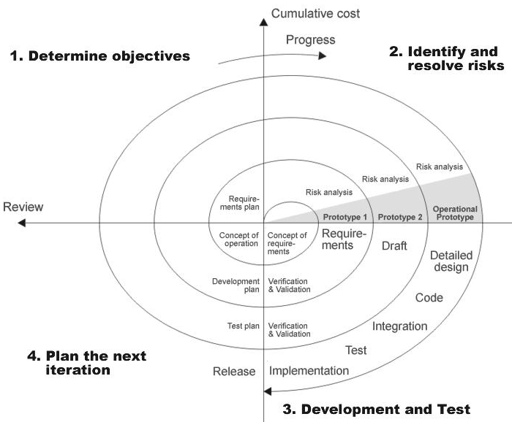
Figure 1 Spiral Model

STUDY OF THE SYSTEM
In the flexibility of the uses the interface has been developed a graphics concept in mind, associated through a browser interface. The GUI’S at the top level have been categorized as
- Administrative user interface
- The operational or generic user interface
The administrative user interface concentrates on the consistent information that is practically, part of the organizational activities and which needs proper authentication for the data collection. The interfaces help the administrations with all the transactional states like Data insertion, Data deletion and Data updating along with the extensive data search capabilities.
The operational or generic user interface helps the users upon the system in transactions through the existing data and required services. The operational user interface also helps the ordinary users in managing their own information helps the ordinary users in managing their own information in a customized manner as per the assisted flexibilities

NUMBER OF MODULES
The system after careful analysis has been identified to be presented with the following modules:
The Modules involved are
- Administration
- Users
- File Uploading and Downloading
- File Sharing
- Registration
- Search
- Reports
- Authentication

Administration

Administrator has an authentication to monitoring the complete system. He can have all the privileges. Administrator can register user directly, and delete the information of a registered users.
He verifies the information uploads into the system by the users. If any mismanagement done by the user immediately he can delete the information uploaded earlier by the user.
File Type: Administrator can add different type of file types, therefore user can upload files for that file types only. The file types normally
- Word File
- PDF file
- Text File
- Images
- Video/Audio File
Search User: Administrator having the advanced search facilities for searching the users. The search criteria is goes to
- Search by First Name and Last Name
- Search by Registration Date
- Search by Login Id
- Search by Country, State, and City Details
User Login Tracking: User Login Tracking can be done by administrator. For tracking the user details administrator must provide the user id and date of on which he needs to track the user details.
Users
User is nothing but a registered user. A registered user directly uploads information into the system. Before uploading he needs to specify his credentials for authentication.
The upload files have 3 types of priorities.
- Public priority
- Private priority
- Partial Public priority
The definition of Public priority means, the files which are uploaded in to the system, those are shared by all the users which are registered in the system.
Private priority means, the accessibility of the uploaded file only by the user itself. Other users don’t have any permission for downloading.
Partial public priority means while uploading the file the user can choose some other users which are registered into the system, and give accessibility of the file to them.

File Uploading and Downloading
All registered user having authority to upload any file into the system, admin can track all uploaded files. Based on the priority users can down load file from the system. For file uploading and downloading the system provides a good user interface for easy to use. User can save the downloading file with his desired location.
File Sharing
For every uploading file user can put priority. Private means no accessibility for other users. It’s simply personal. Public means every user can access that file. Partial public means user can choose a list of other users and give accessibility.
Registration
The system has a process of registration. Every user need to submit his complete details in the form of registration. Whenever a user registration completed automatically user can get a user id and password. By using that user id and password user can log into the system.
Search
Different kind of search available to users as well as administrator. A user can search other users for giving file sharing option. Administrator can search the files which are uploaded into the system for tracking.
Reports
Different kind of reports is generated by the system.
- User Reports.
- File Uploading and Downloading status report.
- User Login Logout tracking report.
Authentication:
Authentication is nothing but providing security to the system. Here every must enter into the system throw login page. The login page will restrict the UN authorized users. A user must provide his credential like user Id and password for log into the system. For that the system maintains data for all users. Whenever a user enters his user id and password, it checks in the database for user existence. If the user is exists he can be treated as a valid user. Otherwise the request will throw back.
In this system authentication is made of using
- Virtual Key Boards
- Password Encryption Algorithms
Password Encryption Algorithms: The registered user password can be stored in the database in the form of encrypted by using SHA1 Algorithm.

System Requirement Specifications

Hardware Requirements:
- PIV 2.8 GHz Processor and Above
- RAM 512MB and Above
- HDD 40 GB Hard Disk Space and Above

Software Requirements:
- WINDOWS OS (XP / 2000 / 200 Server / 2003 Server)
- Visual Studio .Net 2008 Enterprise Edition
- Internet Information Server 5.0 (IIS)
- Visual Studio .Net Framework (Minimal for Deployment) version 3.5
- SQL Server 2005 Enterprise Edition

PRAPOSED SYSTEM
The development of this new system contains the following activities, which try to automate the entire process keeping in the view of database integration approach. User Friendliness is provided in the application with various controls provided by system Rich User Interface. The system makes the overall project management much easier and flexible. It can be accessed over the Intranet. Various classes have been used for file uploading and down loading. The user information files can be stored in centralized database which can be maintained by the system. This can give the good security for user information because data is not in client machine. Authentication is provided for this application only registered users can access. User can share is data to others, and also he can get data from others. There is no risk of data management at any level while the project development is under process. Report generation features is provided using Data reports to generate different kind of reports.

NEED FOR COMPUTERIZATION
We all know the importance of computerization. The world is moving ahead at lightning speed and everyone is running short of time. One always wants to get the information and perform a task he/she/they desire(s) within a short period of time and too with amount of efficiency and accuracy. The application areas for the computerization have been selected on the basis of following factors:
- Minimizing the manual records kept at different locations.
- There will be more data integrity.
- Facilitating desired information display, very quickly, by retrieving information from users.
- Facilitating various statistical information which helps in decision-making?
- To reduce manual efforts in activities that involved repetitive work.
Updating and deletion of such a huge amount of data will become easier.

FUNCTIONAL FEATURES OF THE MODEL
As far as the project is developed the functionality is simple, the objective of the proposal is to strengthen the functioning of Audit Status Monitoring and make them effective and better. The entire scope has been classified into five streams knows as Coordinator Level, management Level, Auditor Level, User Level and State Web Coordinator Level. The proposed software will cover the information needs with respect to each request of the user group viz. accepting the request, providing vulnerability document report and the current status of the audit.

INPUT AND OUTPUT
The major inputs and outputs and major functions of the system are follows:
Inputs:
Admin enter his user id and password for login. User enters his user id and password for login. User Create new folder for personnel usage. Admin enter user id or date for track the user login information. New user gives his completed personnel, address and phone details for registration. Admin gives different kind of user information for search the user data. User gives his user id, hint question, answer for getting the forgotten password. User gives the folder permission for sharing the folder to other users.

Outputs:
Admin can have his own home page. Users enter their own home page. The user defined folders can store in the centralized database. Admin will get the login information of a particular user. The new user’s data will be stored in the centralized database. Admin get the search details of different criteria. User can get his forgot password. The user folder having permission for private or public purpose.

PROCESS MODEL USED WITH JUSTIFICATION

ACCESS CONTROL FOR DATA WHICH REQUIRE USER AUTHENTICAION
The following commands specify access control identifiers and they are typically used to authorize and authenticate the user (command codes are shown in parentheses)
USER NAME (USER)
The user identification is that which is required by the server for access to its file system. This command will normally be the first command transmitted by the user after the control connections are made (some servers may require this).
PASSWORD (PASS)
This command must be immediately preceded by the user name command, and, for some sites, completes the user's identification for access control. Since password information is quite sensitive, it is desirable in general to "mask" it or suppress type out.

Feasibility Report
Preliminary investigation examine project feasibility, the likelihood the system will be useful to the organization. The main objective of the feasibility study is to test the Technical, Operational and Economical feasibility for adding new modules and debugging old running system. All system is feasible if they are unlimited resources and infinite time. There are aspects in the feasibility study portion of the preliminary investigation:
- Technical Feasibility
- Operational Feasibility
- Economical Feasibility

TECHNICAL FEASIBILITY
The technical issue usually raised during the feasibility stage of the investigation includes the following:
- Does the necessary technology exist to do what is suggested?
- Do the proposed equipments have the technical capacity to hold the data required to use the new system?
- Will the proposed system provide adequate response to inquiries, regardless of the number or location of users?
- Can the system be upgraded if developed?
- Are there technical guarantees of accuracy, reliability, ease of access and data security?
Earlier no system existed to cater to the needs of ‘Secure Infrastructure Implementation System’. The current system developed is technically feasible. It is a web based user interface for audit workflow at NIC-CSD. Thus it provides an easy access to the users. The database’s purpose is to create, establish and maintain a workflow among various entities in order to facilitate all concerned users in their various capacities or roles. Permission to the users would be granted based on the roles specified. Therefore, it provides the technical guarantee of accuracy, reliability and security. The software and hard requirements for the development of this project are not many and are already available in-house at NIC or are available as free as open source. The work for the project is done with the current equipment and existing software technology. Necessary bandwidth exists for providing a fast feedback to the users irrespective of the number of users using the system.

OPERATIONAL FEASIBILITY
Proposed projects are beneficial only if they can be turned out into information system. That will meet the organization’s operating requirements. Operational feasibility aspects of the project are to be taken as an important part of the project implementation. Some of the important issues raised are to test the operational feasibility of a project includes the following: -
- Is there sufficient support for the management from the users?
- Will the system be used and work properly if it is being developed and implemented?
- Will there be any resistance from the user that will undermine the possible application benefits?

This system is targeted to be in accordance with the above-mentioned issues. Beforehand, the management issues and user requirements have been taken into consideration. So there is no question of resistance from the users that can undermine the possible application benefits.
The well-planned design would ensure the optimal utilization of the computer resources and would help in the improvement of performance status.

ECONOMICAL FEASIBILITY

A system can be developed technically and that will be used if installed must still be a good investment for the organization. In the economical feasibility, the development cost in creating the system is evaluated against the ultimate benefit derived from the new systems. Financial benefits must equal or exceed the costs.
The system is economically feasible. It does not require any addition hardware or software. Since the interface for this system is developed using the existing resources and technologies available at NIC, There is nominal expenditure and economical feasibility for certain.

SOFTWARE REQUIREMENT SPECIFICATION

The software, Site Explorer is designed for management of web sites from a remote location.

INTRODUCTION
Purpose: The main purpose for preparing this document is to give a general insight into the analysis and requirements of the existing system or situation and for determining the operating characteristics of the system.
Scope: This Document plays a vital role in the development life cycle (SDLC) and it describes the complete requirement of the system. It is meant for use by the developers and will be the basic during testing phase. Any changes made to the requirements in the future will have to go through formal change approval process.

DEVELOPERS RESPONSIBILITIES OVERVIEW:
The developer is responsible for:
- Developing the system, which meets the SRS and solving all the requirements of the system?
- Demonstrating the system and installing the system at client's location after the acceptance testing is successful.
- Submitting the required user manual describing the system interfaces to work on it and also the documents of the system.
- Conducting any user training that might be needed for using the system.
- Maintaining the system for a period of one year after installation.

FUNCTIONAL REQUIREMENTS
OUTPUT DESIGN
Outputs from computer systems are required primarily to communicate the results of processing to users. They are also used to provides a permanent copy of the results for later consultation. The various types of outputs in general are:
- External Outputs, whose destination is outside the organization.
- Internal Outputs whose destination is within organization and they are the
- User’s main interface with the computer.
- Operational outputs whose use is purely within the computer department.
- Interface outputs, which involve the user in communicating directly.
OUTPUT DEFINITION
The outputs should be defined in terms of the following points:
    - Type of the output
    - Content of the output
    - Format of the output
    - Location of the output
    - Frequency of the output
    - Volume of the output
    - Sequence of the output
It is not always desirable to print or display data as it is held on a computer. It should be decided as which form of the output is the most suitable.
For Example
    - Will decimal points need to be inserted
    - Should leading zeros be suppressed.
Output Media:
In the next stage it is to be decided that which medium is the most appropriate for the output. The main considerations when deciding about the output media are:
- The suitability for the device to the particular application.
- The need for a hard copy.
- The response time required.
- The location of the users
- The software and hardware available.
Keeping in view the above description the project is to have outputs mainly coming under the category of internal outputs. The main outputs desired according to the requirement specification are:
The outputs were needed to be generated as a hot copy and as well as queries to be viewed on the screen. Keeping in view these outputs, the format for the output is taken from the outputs, which are currently being obtained after manual processing. The standard printer is to be used as output media for hard copies.
INPUT DESIGN
Input design is a part of overall system design. The main objective during the input design is as given below:
- To produce a cost-effective method of input.
- To achive the highest possible level of accuracy.
- To ensure that the input is acceptable and understood by the user.
INPUT STAGES:
The main input stages can be listed as below:
- Data recording
- Data transcription
- Data conversion
- Data verification
- Data control
- Data transmission
- Data validation
- Data correction
INPUT TYPES:
It is necessary to determine the various types of inputs. Inputs can be categorized as follows:
- External inputs, which are prime inputs for the system.
- Internal inputs, which are user communications with the system.
- Operational, which are computer department’s communications to the system?
- Interactive, which are inputs entered during a dialogue.
INPUT MEDIA:
At this stage choice has to be made about the input media. To conclude about the input media consideration has to be given to;
- Type of input
- Flexibility of format
- Speed
- Accuracy
- Verification methods
- Rejection rates
- Ease of correction
- Storage and handling requirements
- Security
- Easy to use
- Portability
Keeping in view the above description of the input types and input media, it can be said that most of the inputs are of the form of internal and interactive. As
Input data is to be the directly keyed in by the user, the keyboard can be considered to be the most suitable input device.

ERROR AVOIDANCE
At this stage care is to be taken to ensure that input data remains accurate form the stage at which it is recorded up to the stage in which the data is accepted by the system. This can be achieved only by means of careful control each time the data is handled.

ERROR DETECTION
Even though every effort is make to avoid the occurrence of errors, still a small proportion of errors is always likely to occur, these types of errors can be discovered by using validations to check the input data.
DATA VALIDATION
Procedures are designed to detect errors in data at a lower level of detail. Data validations have been included in the system in almost every area where there is a possibility for the user to commit errors. The system will not accept invalid data. Whenever an invalid data is keyed in, the system immediately prompts the user and the user has to again key in the data and the system will accept the data only if the data is correct. Validations have been included where necessary.
The system is designed to be a user friendly one. In other words the system has been designed to communicate effectively with the user. The system has been designed with popup menus.

USER INTERFACE DESIGN
It is essential to consult the system users and discuss their needs while designing the user interface:
USER INTERFACE SYSTEMS CAN BE BROADLY CLASIFIED AS:
- User initiated interface the user is in charge, controlling the progress of the user/computer dialogue. In the computer-initiated interface, the computer selects the next stage in the interaction.
- Computer initiated interfaces
In the computer initiated interfaces the computer guides the progress of the user/computer dialogue. Information is displayed and the user response of the computer takes action or displays further information.
USER_INITIATED INTERGFACES
User initiated interfaces fall into tow approximate classes:
- Command driven interfaces: In this type of interface the user inputs commands or queries which are interpreted by the computer.
- Forms oriented interface: The user calls up an image of the form to his/her screen and fills in the form. The forms oriented interface is chosen because it is the best choice.
COMPUTER-INITIATED INTERFACES
The following computer – initiated interfaces were used:
- The menu system for the user is presented with a list of alternatives and the user chooses one; of alternatives.
- Questions – answer type dialog system where the computer asks question and takes action based on the basis of the users reply.
Right from the start the system is going to be menu driven, the opening menu displays the available options. Choosing one option gives another popup menu with more options. In this way every option leads the users to data entry form where the user can key in the data.
ERROR MESSAGE DESIGN:
The design of error messages is an important part of the user interface design. As user is bound to commit some errors or other while designing a system the system should be designed to be helpful by providing the user with information regarding the error he/she has committed.
This application must be able to produce output at different modules for different inputs.

PERFORMANCE REQUIREMENTS
Performance is measured in terms of the output provided by the application.
Requirement specification plays an important part in the analysis of a system. Only when the requirement specifications are properly given, it is possible to design a system, which will fit into required environment. It rests largely in the part of the users of the existing system to give the requirement specifications because they are the people who finally use the system. This is because the requirements have to be known during the initial stages so that the system can be designed according to those requirements. It is very difficult to change the system once it has been designed and on the other hand designing a system, which does not cater to the requirements of the user, is of no use.
The requirement specification for any system can be broadly stated as given below:
- The system should be able to interface with the existing system
- The system should be accurate
- The system should be better than the existing system
The existing system is completely dependent on the user to perform all the duties

SELECTED SOFTWARE

INTRODUCTION TO PHP

5.2 ASP.NET

SERVER APPLICATION DEVELOPMENT
Server-side applications in the managed world are implemented through runtime hosts. Unmanaged applications host the common language runtime, which allows your custom managed code to control the behavior of the server. This model provides you with all the features of the common language runtime and class library while gaining the performance and scalability of the host server.
The following illustration shows a basic network schema with managed code running in different server environments. Servers such as IIS and SQL Server can perform standard operations while your application logic executes through the managed code.

SERVER-SIDE MANAGED CODE

ASP.NET is the hosting environment that enables developers to use the .NET Framework to target Web-based applications. However, ASP.NET is more than just a runtime host; it is a complete architecture for developing Web sites and Internet-distributed objects using managed code. Both Web Forms and XML Web services use IIS and ASP.NET as the publishing mechanism for applications, and both have a collection of supporting classes in the .NET Framework.
XML Web services, an important evolution in Web-based technology, are distributed, server-side application components similar to common Web sites. However, unlike Web-based applications, XML Web services components have no UI and are not targeted for browsers such as Internet Explorer and Netscape Navigator. Instead, XML Web services consist of reusable software components designed to be consumed by other applications, such as traditional client applications, Web-based applications, or even other XML Web services. As a result, XML Web services technology is rapidly moving application development and deployment into the highly distributed environment of the Internet.
If you have used earlier versions of ASP technology, you will immediately notice the improvements that ASP.NET and Web Forms offers. For example, you can develop Web Forms pages in any language that supports the .NET Framework. In addition, your code no longer needs to share the same file with your HTTP text (although it can continue to do so if you prefer). Web Forms pages execute in native machine language because, like any other managed application, they take full advantage of the runtime. In contrast, unmanaged ASP pages are always scripted and interpreted. ASP.NET pages are faster, more functional, and easier to develop than unmanaged ASP pages because they interact with the runtime like any managed application.
The .NET Framework also provides a collection of classes and tools to aid in development and consumption of XML Web services applications. XML Web services are built on standards such as SOAP (a remote procedure-call protocol), XML (an extensible data format), and WSDL ( the Web Services Description Language). The .NET Framework is built on these standards to promote interoperability with non-Microsoft solutions.
For example, the Web Services Description Language tool included with the .NET Framework SDK can query an XML Web service published on the Web, parse its WSDL description, and produce C# or Visual Basic source code that your application can use to become a client of the XML Web service. The source code can create classes derived from classes in the class library that handle all the underlying communication using SOAP and XML parsing. Although you can use the class library to consume XML Web services directly, the Web Services Description Language tool and the other tools contained in the SDK facilitate your development efforts with the .NET Framework.
If you develop and publish your own XML Web service, the .NET Framework provides a set of classes that conform to all the underlying communication standards, such as SOAP, WSDL, and XML. Using those classes enables you to focus on the logic of your service, without concerning yourself with the communications infrastructure required by distributed software development.
Finally, like Web Forms pages in the managed environment, your XML Web service will run with the speed of native machine language using the scalable communication of IIS.

ACTIVE SERVER PAGES.NET
ASP.NET is a programming framework built on the common language runtime that can be used on a server to build powerful Web applications. ASP.NET offers several important advantages over previous Web development models:
- Enhanced Performance. ASP.NET is compiled common language runtime code running on the server. Unlike its interpreted predecessors, ASP.NET can take advantage of early binding, just-in-time compilation, native optimization, and caching services right out of the box. This amounts to dramatically better performance before you ever write a line of code.
- World-Class Tool Support. The ASP.NET framework is complemented by a rich toolbox and designer in the Visual Studio integrated development environment. WYSIWYG editing, drag-and-drop server controls, and automatic deployment are just a few of the features this powerful tool provides.
- Power and Flexibility. Because ASP.NET is based on the common language runtime, the power and flexibility of that entire platform is available to Web application developers. The .NET Framework class library, Messaging, and Data Access solutions are all seamlessly accessible from the Web. ASP.NET is also language-independent, so you can choose the language that best applies to your application or partition your application across many languages. Further, common language runtime interoperability guarantees that your existing investment in COM-based development is preserved when migrating to ASP.NET.
- Simplicity. ASP.NET makes it easy to perform common tasks, from simple form submission and client authentication to deployment and site configuration. For example, the ASP.NET page framework allows you to build user interfaces that cleanly separate application logic from presentation code and to handle events in a simple, Visual Basic - like forms processing model. Additionally, the common language runtime simplifies development, with managed code services such as automatic reference counting and garbage collection.
- Manageability. ASP.NET employs a text-based, hierarchical configuration system, which simplifies applying settings to your server environment and Web applications. Because configuration information is stored as plain text, new settings may be applied without the aid of local administration tools. This "zero local administration" philosophy extends to deploying ASP.NET Framework applications as well. An ASP.NET Framework application is deployed to a server simply by copying the necessary files to the server. No server restart is required, even to deploy or replace running compiled code.

- Scalability and Availability. ASP.NET has been designed with scalability in mind, with features specifically tailored to improve performance in clustered and multiprocessor environments. Further, processes are closely monitored and managed by the ASP.NET runtime, so that if one misbehaves (leaks, deadlocks), a new process can be created in its place, which helps keep your application constantly available to handle requests.
- Customizability and Extensibility. ASP.NET delivers a well-factored architecture that allows developers to "plug-in" their code at the appropriate level. In fact, it is possible to extend or replace any subcomponent of the ASP.NET runtime with your own custom-written component. Implementing custom authentication or state services has never been easier.
- Security. With built in Windows authentication and per-application configuration, you can be assured that your applications are secure.

LANGUAGE SUPPORT
The Microsoft .NET Platform currently offers built-in support for three languages: C#, Visual Basic, and Java Script.
WHAT IS ASP.NET WEB FORMS?
The ASP.NET Web Forms page framework is a scalable common language runtime programming model that can be used on the server to dynamically generate Web pages.

Intended as a logical evolution of ASP (ASP.NET provides syntax compatibility with existing pages), the ASP.NET Web Forms framework has been specifically designed to address a number of key deficiencies in the previous model. In particular, it provides:

- The ability to create and use reusable UI controls that can encapsulate common functionality and thus reduce the amount of code that a page developer has to write.
- The ability for developers to cleanly structure their page logic in an orderly fashion (not "spaghetti code").
- The ability for development tools to provide strong WYSIWYG design support for pages (existing ASP code is opaque to tools).

ASP.NET Web Forms pages are text files with an .aspx file name extension. They can be deployed throughout an IIS virtual root directory tree. When a browser client requests .aspx resources, the ASP.NET runtime parses and compiles the target file into a .NET Framework class. This class can then be used to dynamically process incoming requests. (Note that the .aspx file is compiled only the first time it is accessed; the compiled type instance is then reused across multiple requests).

An ASP.NET page can be created simply by taking an existing HTML file and changing its file name extension to .aspx (no modification of code is required). For example, the following sample demonstrates a simple HTML page that collects a user's name and category preference and then performs a form post back to the originating page when a button is clicked:

ASP.NET provides syntax compatibility with existing ASP pages. This includes support for <% %> code render blocks that can be intermixed with HTML content within an .aspx file. These code blocks execute in a top-down manner at page render time.

CODE-BEHIND WEB FORMS

ASP.NET supports two methods of authoring dynamic pages. The first is the method shown in the preceding samples, where the page code is physically declared within the originating .aspx file. An alternative approach--known as the code-behind method--enables the page code to be more cleanly separated from the HTML content into an entirely separate file.

INTRODUCTION TO ASP.NET SERVER CONTROLS

In addition to (or instead of) using <% %> code blocks to program dynamic content, ASP.NET page developers can use ASP.NET server controls to program Web pages. Server controls are declared within an .aspx file using custom tags or intrinsic HTML tags that contain a runat="server" attributes value. Intrinsic HTML tags are handled by one of the controls in the System.Web.UI.HtmlControls namespace. Any tag that doesn't explicitly map to one of the controls is assigned the type of System.Web.UI.HtmlControls.HtmlGenericControl.

Server controls automatically maintain any client-entered values between round trips to the server. This control state is not stored on the server (it is instead stored within an <input type="hidden"> form field that is round-tripped between requests). Note also that no client-side script is required.

In addition to supporting standard HTML input controls, ASP.NET enables developers to utilize richer custom controls on their pages. For example, the following sample demonstrates how the <asp:adrotator> control can be used to dynamically display rotating ads on a page.

- ASP.NET Web Forms provide an easy and powerful way to build dynamic Web UI.
- ASP.NET Web Forms pages can target any browser client (there are no script library or cookie requirements).
- ASP.NET Web Forms pages provide syntax compatibility with existing ASP pages.
- ASP.NET server controls provide an easy way to encapsulate common functionality.
- ASP.NET ships with 45 built-in server controls. Developers can also use controls built by third parties.
- ASP.NET server controls can automatically project both uplevel and downlevel HTML.
- ASP.NET templates provide an easy way to customize the look and feel of list server controls.
- ASP.NET validation controls provide an easy way to do declarative client or server data validation.

5.3 C#.NET

ADO.NET OVERVIEW

ADO.NET is an evolution of the ADO data access model that directly addresses user requirements for developing scalable applications. It was designed specifically for the web with scalability, statelessness, and XML in mind.
ADO.NET uses some ADO objects, such as the Connection and Command objects, and also introduces new objects. Key new ADO.NET objects include the Dataset, Data Reader, and Data Adapter.

The important distinction between this evolved stage of ADO.NET and previous data architectures is that there exists an object -- the DataSet -- that is separate and distinct from any data stores. Because of that, the DataSet functions as a standalone entity. You can think of the DataSet as an always disconnected recordset that knows nothing about the source or destination of the data it contains. Inside a DataSet, much like in a database, there are tables, columns, relationships, constraints, views, and so forth.

A DataAdapter is the object that connects to the database to fill the DataSet. Then, it connects back to the database to update the data there, based on operations performed while the DataSet held the data. In the past, data processing has been primarily connection-based. Now, in an effort to make multi-tiered apps more efficient, data processing is turning to a message-based approach that revolves around chunks of information. At the center of this approach is the DataAdapter, which provides a bridge to retrieve and save data between a DataSet and its source data store. It accomplishes this by means of requests to the appropriate SQL commands made against the data store.

The XML-based DataSet object provides a consistent programming model that works with all models of data storage: flat, relational, and hierarchical. It does this by having no 'knowledge' of the source of its data, and by representing the data that it holds as collections and data types. No matter what the source of the data within the DataSet is, it is manipulated through the same set of standard APIs exposed through the DataSet and its subordinate objects.

While the DataSet has no knowledge of the source of its data, the managed provider has detailed and specific information. The role of the managed provider is to connect, fill, and persist the DataSet to and from data stores. The OLE DB and SQL Server .NET Data Providers (System.Data.OleDb and System.Data.SqlClient) that are part of the .Net Framework provide four basic objects: the Command, Connection, DataReader and DataAdapter. In the remaining sections of this document, we'll walk through each part of the DataSet and the OLE DB/SQL Server .NET Data Providers explaining what they are, and how to program against them.
The following sections will introduce you to some objects that have evolved, and some that are new. These objects are:

- Connections. For connection to and managing transactions against a database.
- Commands. For issuing SQL commands against a database.
- DataReaders. For reading a forward-only stream of data records from a SQL Server data source.
- DataSet. For storing, Remoting and programming against flat data, XML data and relational data.
- DataAdapters. For pushing data into a DataSet, and reconciling data against a database.

When dealing with connections to a database, there are two different options: SQL Server .NET Data Provider (System.Data.SqlClient) and OLE DB .NET Data Provider (System.Data.OleDb). In these samples we will use the SQL Server .NET Data Provider. These are written to talk directly to Microsoft SQL Server. The OLE DB .NET Data Provider is used to talk to any OLE DB provider (as it uses OLE DB underneath).
Connections:
Connections are used to 'talk to' databases, and are represented by provider-specific classes such as SqlConnection. Commands travel over connections and resultsets are returned in the form of streams which can be read by a DataReader object, or pushed into a DataSet object.

Commands:
Commands contain the information that is submitted to a database, and are represented by provider-specific classes such as SqlCommand. A command can be a stored procedure call, an UPDATE statement, or a statement that returns results. You can also use input and output parameters, and return values as part of your command syntax. The example below shows how to issue an INSERT statement against the Northwind database.

DataReaders:
The DataReader object is somewhat synonymous with a read-only/forward-only cursor over data. The DataReader API supports flat as well as hierarchical data. A DataReader object is returned after executing a command against a database. The format of the returned DataReader object is different from a recordset. For example, you might use the DataReader to show the results of a search list in a web page.

DATASETS AND DATAADAPTERS:

DataSets
The DataSet object is similar to the ADO Recordset object, but more powerful, and with one other important distinction: the DataSet is always disconnected. The DataSet object represents a cache of data, with database-like structures such as tables, columns, relationships, and constraints. However, though a DataSet can and does behave much like a database, it is important to remember that DataSet objects do not interact directly with databases, or other source data. This allows the developer to work with a programming model that is always consistent, regardless of where the source data resides. Data coming from a database, an XML file, from code, or user input can all be placed into DataSet objects. Then, as changes are made to the DataSet they can be tracked and verified before updating the source data. The GetChanges method of the DataSet object actually creates a second DatSet that contains only the changes to the data. This DataSet is then used by a DataAdapter (or other objects) to update the original data source.
The DataSet has many XML characteristics, including the ability to produce and consume XML data and XML schemas. XML schemas can be used to describe schemas interchanged via WebServices. In fact, a DataSet with a schema can actually be compiled for type safety and statement completion.

DATAADAPTERS (OLEDB/SQL)

The DataAdapter object works as a bridge between the DataSet and the source data. Using the provider-specific SqlDataAdapter (along with its associated SqlCommand and SqlConnection) can increase overall performance when working with a Microsoft SQL Server databases. For other OLE DB-supported databases, you would use the OleDbDataAdapter object and its associated OleDbCommand and OleDbConnection objects.
The DataAdapter object uses commands to update the data source after changes have been made to the DataSet. Using the Fill method of the DataAdapter calls the SELECT command; using the Update method calls the INSERT, UPDATE or DELETE command for each changed row. You can explicitly set these commands in order to control the statements used at runtime to resolve changes, including the use of stored procedures. For ad-hoc scenarios, a CommandBuilder object can generate these at run-time based upon a select statement. However, this run-time generation requires an extra round-trip to the server in order to gather required metadata, so explicitly providing the INSERT, UPDATE, and DELETE commands at design time will result in better run-time performance.
- ADO.NET is the next evolution of ADO for the .Net Framework.
- ADO.NET was created with n-Tier, statelessness and XML in the forefront. Two new objects, the DataSet and DataAdapter, are provided for these scenarios.
- ADO.NET can be used to get data from a stream, or to store data in a cache for updates.
- There is a lot more information about ADO.NET in the documentation.
- Remember, you can execute a command directly against the database in order to do inserts, updates, and deletes. You don't need to first put data into a DataSet in order to insert, update, or delete it.
Also, you can use a DataSet to bind to the data, move through the data, and navigate data relationships

5.4 SQL SERVER -2005

A database management, or DBMS, gives the user access to their data and helps them transform the data into information. Such database management systems include dBase, paradox, IMS, SQL Server and SQL Server. These systems allow users to create, update and extract information from their database.
A database is a structured collection of data. Data refers to the characteristics of people, things and events. SQL Server stores each data item in its own fields. In SQL Server, the fields relating to a particular person, thing or event are bundled together to form a single complete unit of data, called a record (it can also be referred to as raw or an occurrence). Each record is made up of a number of fields. No two fields in a record can have the same field name.
During an SQL Server Database design project, the analysis of your business needs identifies all the fields or attributes of interest. If your business needs change over time, you define any additional fields or change the definition of existing fields.

SQL SERVER TABLES
SQL Server stores records relating to each other in a table. Different tables are created for the various groups of information. Related tables are grouped together to form a database.
PRIMARY KEY
Every table in SQL Server has a field or a combination of fields that uniquely identifies each record in the table. The Unique identifier is called the Primary Key, or simply the Key. The primary key provides the means to distinguish one record from all other in a table. It allows the user and the database system to identify, locate and refer to one particular record in the database.

RELATIONAL DATABASE
Sometimes all the information of interest to a business operation can be stored in one table. SQL Server makes it very easy to link the data in multiple tables. Matching an employee to the department in which they work is one example. This is what makes SQL Server a relational database management system, or RDBMS. It stores data in two or more tables and enables you to define relationships between the table and enables you to define relationships between the tables.
FOREIGN KEY
When a field is one table matches the primary key of another field is referred to as a foreign key. A foreign key is a field or a group of fields in one table whose values match those of the primary key of another table.
REFERENTIAL INTEGRITY
Not only does SQL Server allow you to link multiple tables, it also maintains consistency between them. Ensuring that the data among related tables is correctly matched is referred to as maintaining referential integrity.
DATA ABSTRACTION
A major purpose of a database system is to provide users with an abstract view of the data. This system hides certain details of how the data is stored and maintained. Data abstraction is divided into three levels.
Physical level: This is the lowest level of abstraction at which one describes how the data are actually stored.
Conceptual Level: At this level of database abstraction all the attributed and what data are actually stored is described and entries and relationship among them.
View level: This is the highest level of abstraction at which one describes only part of the database.
ADVANTAGES OF RDBMS
- Redundancy can be avoided
- Inconsistency can be eliminated
- Data can be Shared
- Standards can be enforced
- Security restrictions ca be applied
- Integrity can be maintained
- Conflicting requirements can be balanced
- Data independence can be achieved.

DISADVANTAGES OF DBMS
A significant disadvantage of the DBMS system is cost. In addition to the cost of purchasing of developing the software, the hardware has to be upgraded to allow for the extensive programs and the workspace required for their execution and storage. While centralization reduces duplication, the lack of duplication requires that the database be adequately backed up so that in case of failure the data can be recovered.
FEATURES OF SQL SERVER (RDBMS)
SQL SERVER is one of the leading database management systems (DBMS) because it is the only Database that meets the uncompromising requirements of today’s most demanding information systems. From complex decision support systems (DSS) to the most rigorous online transaction processing (OLTP) application, even application that require simultaneous DSS and OLTP access to the same critical data, SQL Server leads the industry in both performance and capability.
SQL SERVER is a truly portable, distributed, and open DBMS that delivers unmatched performance, continuous operation and support for every database.
SQL SERVER RDBMS is high performance fault tolerant DBMS which is specially designed for online transactions processing and for handling large database application.
SQL SERVER with transactions processing option offers two features which contribute to very high level of transaction processing throughput, which are
- The row level lock manager
ENTERPRISE WIDE DATA SHARING
The unrivaled portability and connectivity of the SQL SERVER DBMS enables all the systems in the organization to be linked into a singular, integrated computing resource.
PORTABILITY
SQL SERVER is fully portable to more than 80 distinct hardware and operating systems platforms, including UNIX, MSDOS, OS/2, Macintosh and dozens of proprietary platforms. This portability gives complete freedom to choose the database server platform that meets the system requirements.
OPEN SYSTEMS
SQL SERVER offers a leading implementation of industry –standard SQL. SQL Server’s open architecture integrates SQL SERVER and non –SQL SERVER DBMS with industry’s most comprehensive collection of tools, application, and third party software products SQL Server’s Open architecture provides transparent access to data from other relational database and even non-relational database.
DISTRIBUTED DATA SHARING
SQL Server’s networking and distributed database capabilities to access data stored on remote server with the same ease as if the information was stored on a single local computer. A single SQL statement can access data at multiple sites. You can store data where system requirements such as performance, security or availability dictate.
UNMATCHED PERFORMANCE
The most advanced architecture in the industry allows the SQL SERVER DBMS to deliver unmatched performance.

SOPHISTICATED CONCURRENCY CONTROL
Real World applications demand access to critical data. With most database Systems application becomes “contention bound” – which performance is limited not by the CPU power or by disk I/O, but user waiting on one another for data access. SQL Server employs full, unrestricted row-level locking and contention free queries to minimize and in many cases entirely eliminates contention wait times.
NO I/O BOTTLENECKS
SQL Server’s fast commit groups commit and deferred write technologies dramatically reduce disk I/O bottlenecks. While some database write whole data block to disk at commit time, SQL Server commits transactions with at most sequential log file on disk at commit time, On high throughput systems, one sequential writes typically group commit multiple transactions. Data read by the transaction remains as shared memory so that other transactions may access that data without reading it again from disk. Since fast commits write all data necessary to the recovery to the log file, modified blocks are written back to the database independently of the transaction commit, when written from memory to disk.

SYSTEM DESIGN

6.1. INTRODUCTION

Software design sits at the technical kernel of the software engineering process and is applied regardless of the development paradigm and area of application. Design is the first step in the development phase for any engineered product or system. The designer’s goal is to produce a model or representation of an entity that will later be built. Beginning, once system requirement have been specified and analyzed, system design is the first of the three technical activities -design, code and test that is required to build and verify software.
The importance can be stated with a single word “Quality”. Design is the place where quality is fostered in software development. Design provides us with representations of software that can assess for quality. Design is the only way that we can accurately translate an employee’s view into a finished software product or system. Software design serves as a foundation for all the software engineering steps that follow. Without a strong design we risk building an unstable system – one that will be difficult to test, one whose quality cannot be assessed until the last stage.
During design, progressive refinement of data structure, program structure, and procedural details are developed reviewed and documented. System design can be viewed from either technical or project management perspective. From the technical point of view, design is comprised of four activities – architectural design, data structure design, interface design and procedural design.

6.2 NORMALIZATION
It is a process of converting a relation to a standard form. The process is used to handle the problems that can arise due to data redundancy i.e. repetition of data in the database, maintain data integrity as well as handling problems that can arise due to insertion, updating, deletion anomalies.
Decomposing is the process of splitting relations into multiple relations to eliminate anomalies and maintain anomalies and maintain data integrity. To do this we use normal forms or rules for structuring relation.
Insertion anomaly: Inability to add data to the database due to absence of other data.
Deletion anomaly: Unintended loss of data due to deletion of other data.
Update anomaly: Data inconsistency resulting from data redundancy and partial update
Normal Forms: These are the rules for structuring relations that eliminate anomalies.
FIRST NORMAL FORM:
A relation is said to be in first normal form if the values in the relation are atomic for every attribute in the relation. By this we mean simply that no attribute value can be a set of values or, as it is sometimes expressed, a repeating group.
SECOND NORMAL FORM:
A relation is said to be in second Normal form is it is in first normal form and it should satisfy any one of the following rules.
- Primary key is a not a composite primary key
- No non key attributes are present
- Every non key attribute is fully functionally dependent on full set of primary key.

THIRD NORMAL FORM:
A relation is said to be in third normal form if their exits no transitive dependencies.
Transitive Dependency: If two non key attributes depend on each other as well as on the primary key then they are said to be transitively dependent.
The above normalization principles were applied to decompose the data in multiple tables thereby making the data to be maintained in a consistent state.

6.3 E-R Diagrams
  - The relation upon the system is structure through a conceptual ER-Diagram, which not only specifics the existential entities but also the standard relations through which the system exists and the cardinalities that are necessary for the system state to continue.
  - The entity Relationship Diagram (ERD) depicts the relationship between the data objects. The ERD is the notation that is used to conduct the date modeling activity the attributes of each data object noted is the ERD can be described resign a data object descriptions.
  - The set of primary components that are identified by the ERD are
  - Data object
  - Relationships
  - Attributes
  - Various types of indicators.
The primary purpose of the ERD is to represent data objects and their relationships.

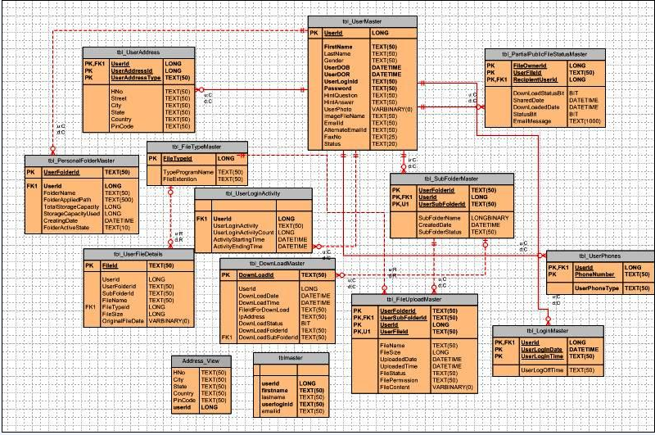
Figure 2 class diagram

6.4 DATA FLOW DIAGRAMS
A data flow diagram is graphical tool used to describe and analyze movement of data through a system. These are the central tool and the basis from which the other components are developed. The transformation of data from input to output, through processed, may be described logically and independently of physical components associated with the system. These are known as the logical data flow diagrams. The physical data flow diagrams show the actual implements and movement of data between people, departments and workstations. A full description of a system actually consists of a set of data flow diagrams. Using two familiar notations Yourdon, Gane and Sarson notation develops the data flow diagrams. Each component in a DFD is labeled with a descriptive name. Process is further identified with a number that will be used for identification purpose. The development of DFD’S is done in several levels. Each process in lower level diagrams can be broken down into a more detailed DFD in the next level. The lop-level diagram is often called context diagram. It consists a single process bit, which plays vital role in studying the current system. The process in the context level diagram is exploded into other process at the first level DFD.
The idea behind the explosion of a process into more process is that understanding at one level of detail is exploded into greater detail at the next level. This is done until further explosion is necessary and an adequate amount of detail is described for analyst to understand the process.
Larry Constantine first developed the DFD as a way of expressing system requirements in a graphical from, this lead to the modular design.
A DFD is also known as a “bubble Chart” has the purpose of clarifying system requirements and identifying major transformations that will become programs in system design. So it is the starting point of the design to the lowest level of detail. A DFD consists of a series of bubbles joined by data flows in the system.
DFD SYMBOLS:
In the DFD, there are four symbols
- A square defines a source(originator) or destination of system data
- An arrow identifies data flow. It is the pipeline through which the information flows
- A circle or a bubble represents a process that transforms incoming data flow into outgoing data flows.
- An open rectangle is a data store, data at rest or a temporary repository of data

Process that transforms data flow.

Source or Destination of data
Data flow
Data Store

CONSTRUCTING A DFD:
Several rules of thumb are used in drawing DFD’S:
- Process should be named and numbered for an easy reference. Each name should be representative of the process.
- The direction of flow is from top to bottom and from left to right. Data traditionally flow from source to the destination although they may flow back to the source. One way to indicate this is to draw long flow line back to a source. An alternative way is to repeat the source symbol as a destination. Since it is used more than once in the DFD it is marked with a short diagonal.
- When a process is exploded into lower level details, they are numbered.
- The names of data stores and destinations are written in capital letters. Process and dataflow names have the first letter of each work capitalized.
A DFD typically shows the minimum contents of data store. Each data store should contain all the data elements that flow in and out.
Questionnaires should contain all the data elements that flow in and out. Missing interfaces redundancies and like is then accounted for often through interviews.
SAILENT FEATURES OF DFD’S
- The DFD shows flow of data, not of control loops and decision are controlled considerations do not appear on a DFD.
- The DFD does not indicate the time factor involved in any process whether the dataflow take place daily, weekly, monthly or yearly.
- The sequence of events is not brought out on the DFD.

TYPES OF DATA FLOW DIAGRAMS
- Current Physical
- Current Logical
- New Logical
- New Physical

CURRENT PHYSICAL:
In Current Physical DFD process label include the name of people or their positions or the names of computer systems that might provide some of the overall system-processing label includes an identification of the technology used to process the data. Similarly data flows and data stores are often labels with the names of the actual physical media on which data are stored such as file folders, computer files, business forms or computer tapes.
CURRENT LOGICAL:
The physical aspects at the system are removed as much as possible so that the current system is reduced to its essence to the data and the processors that transforms them regardless of actual physical form.
NEW LOGICAL:
This is exactly like a current logical model if the user were completely happy with the user were completely happy with the functionality of the current system but had problems with how it was implemented typically through the new logical model will differ from current logical model while having additional functions, absolute function removal and inefficient flows recognized.
NEW PHYSICAL:
The new physical represents only the physical implementation of the new system.

RULES GOVERNING THE DFD’S

PROCESS
- No process can have only outputs.
- No process can have only inputs. If an object has only inputs than it must be a sink.
- A process has a verb phrase label.

DATA STORE
- Data cannot move directly from one data store to another data store, a process must move data.
- Data cannot move directly from an outside source to a data store, a process, which receives, must move data from the source and place the data into data store
- A data store has a noun phrase label.
SOURCE OR SINK
The origin and /or destination of data.
- Data cannot move direly from a source to sink it must be moved by a process
- A source and /or sink has a noun phrase land

DATA FLOW
- A Data Flow has only one direction of flow between symbols. It may flow in both directions between a process and a data store to show a read before an update. The later is usually indicated however by two separate arrows since these happen at different type.
- A join in DFD means that exactly the same data comes from any of two or more different processes data store or sink to a common location.
- A data flow cannot go directly back to the same process it leads. There must be at least one other process that handles the data flow produce some other data flow returns the original data into the beginning process.
- A Data flow to a data store means update (delete or change).
- A data Flow from a data store means retrieve or use.
A data flow has a noun phrase label more than one data flow noun phrase can appear on a single arrow as long as all of the flows on the same arrow move together as one package.
DFD Diagrams:
Context Level (0th level DFD)
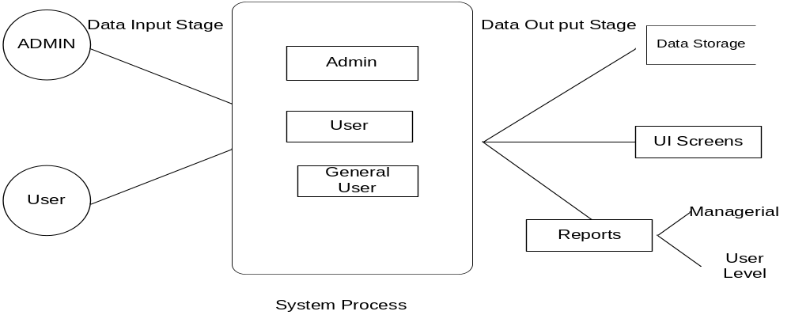
Figure 3 dataflow diagram

Login DFD
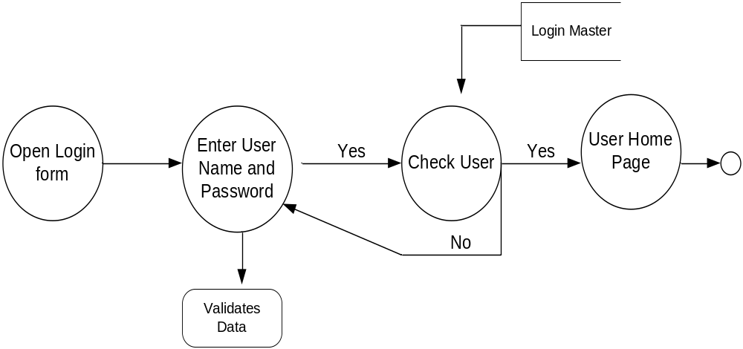
Figure 4 log in dataflow diagram

Admin Details Data Flow
1st level DFD

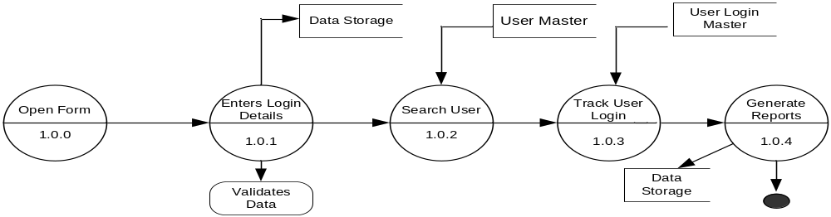
Figure 5 1st level admin dataflow diagram

2nd level DFD (Admin)
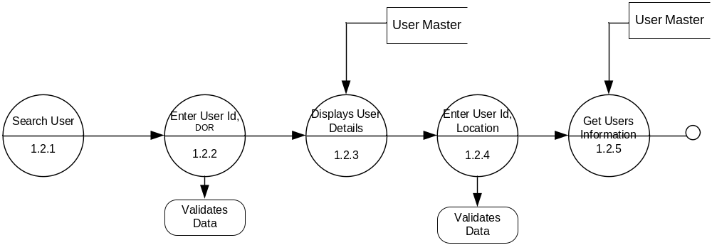
Figure 6 2nd level admin dataflow diagram
Administrator Track User Login Details
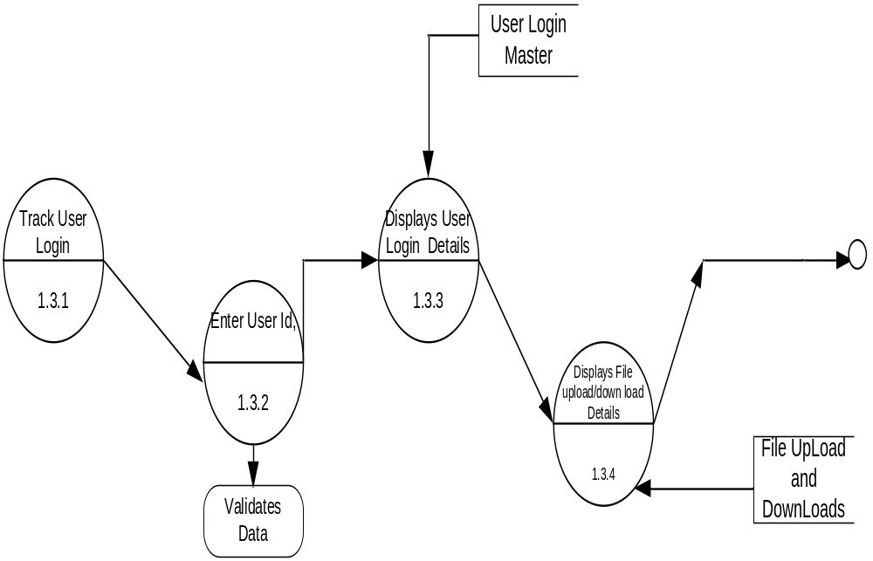
Figure 7 Administrator Track User Login Details dataflow diagram

User Details Data Flow
1st level DFD
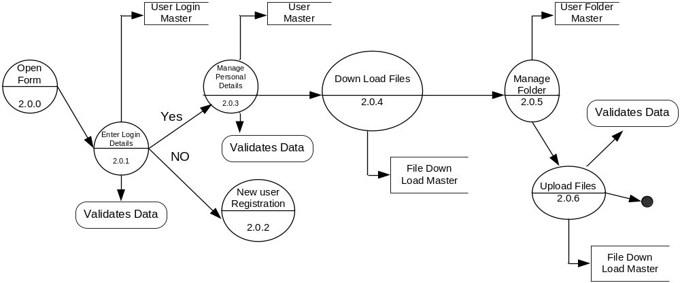
Figure 8 1st level user details dataflow diagram
2nd Level DFD

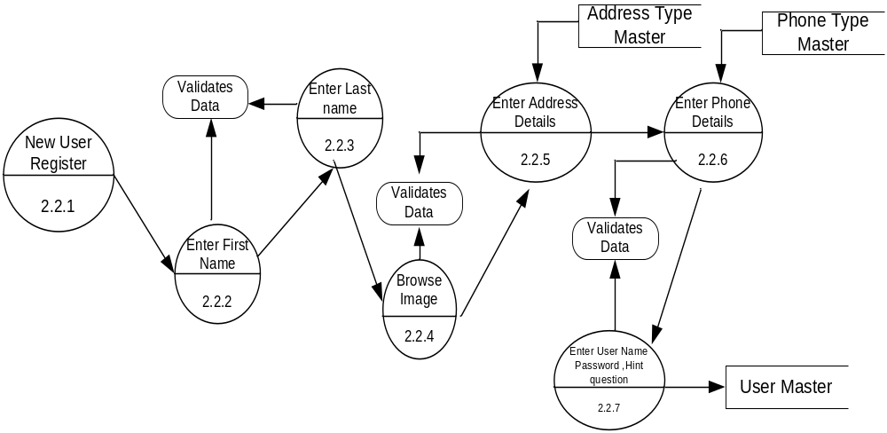
Figure 9 2nd level user details dataflow diagram

User Folder Creation

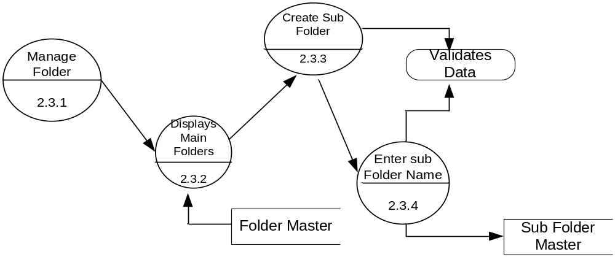
Figure 10 User Folder Creation dataflow diagram

User File Uploading

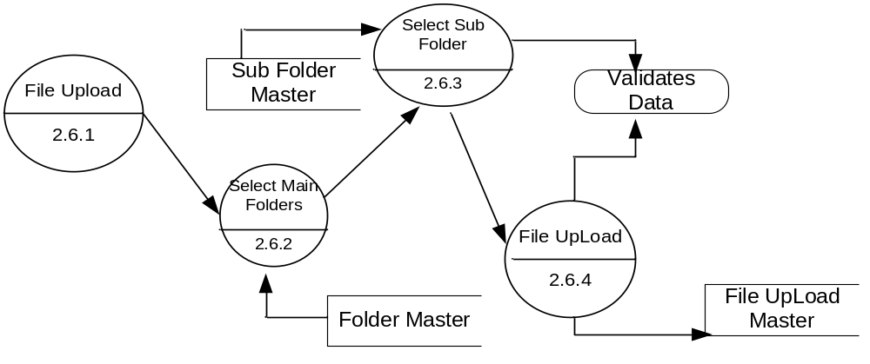
Figure 11 User File Uploading dataflow diagram

6.5 DATA DICTIONARY
After carefully understanding the requirements of the client the entire data storage requirements are divided into tables. The below tables are normalized to avoid any anomalies during the course of data entry.
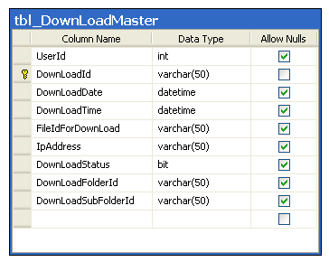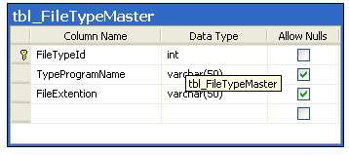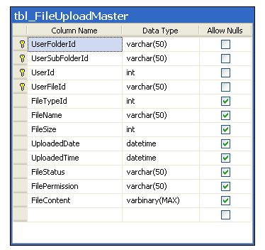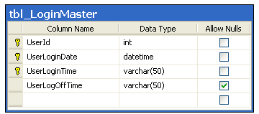
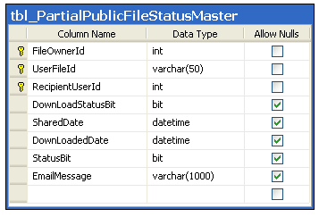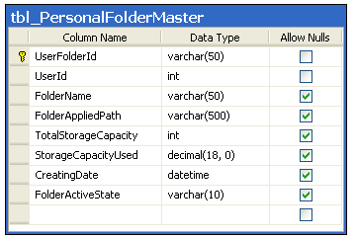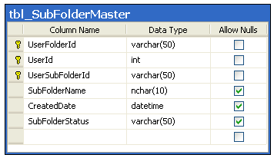
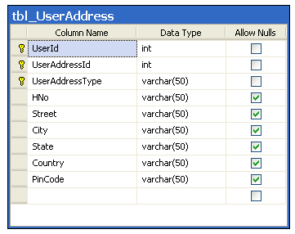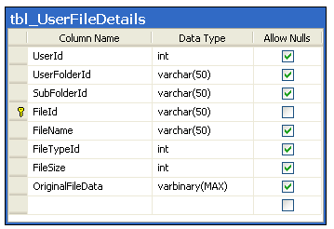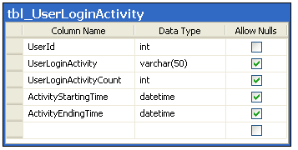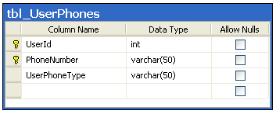
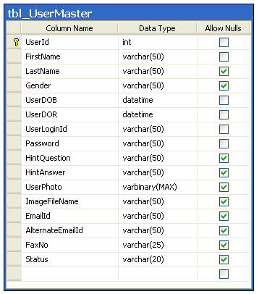

6.6 UML DIAGRAMS
Use Case Diagrams:
Overview Use Case Diagram:
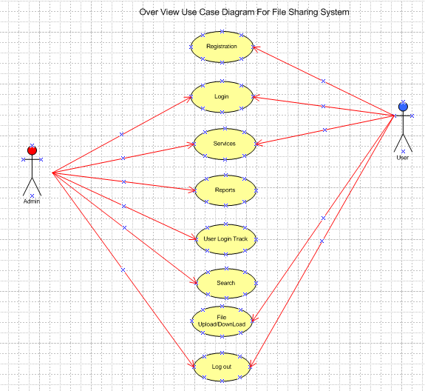

User Use Case Diagram:

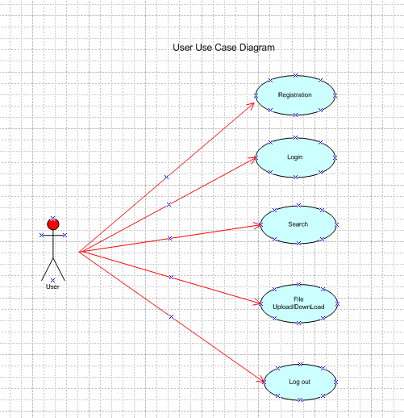

Use Case Diagram for File Upload/Download:

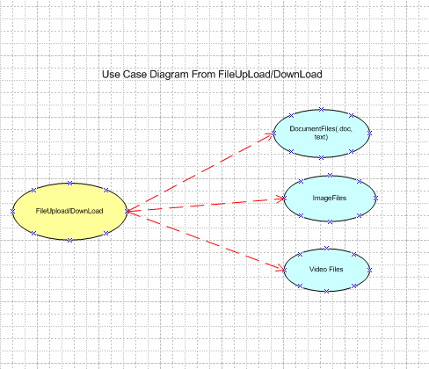

Sequence Diagrams
Login Sequence:
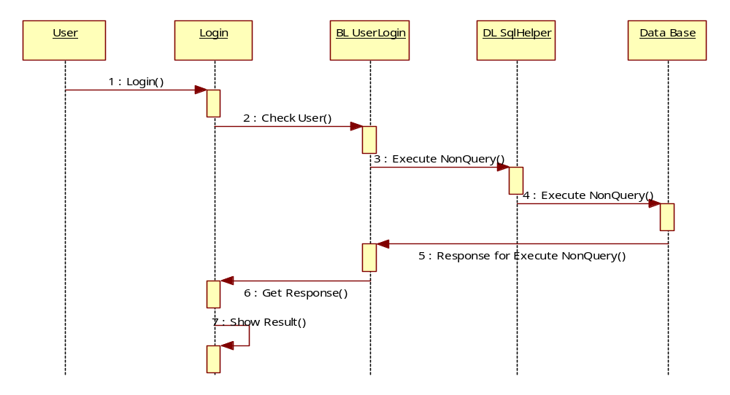
User Registration
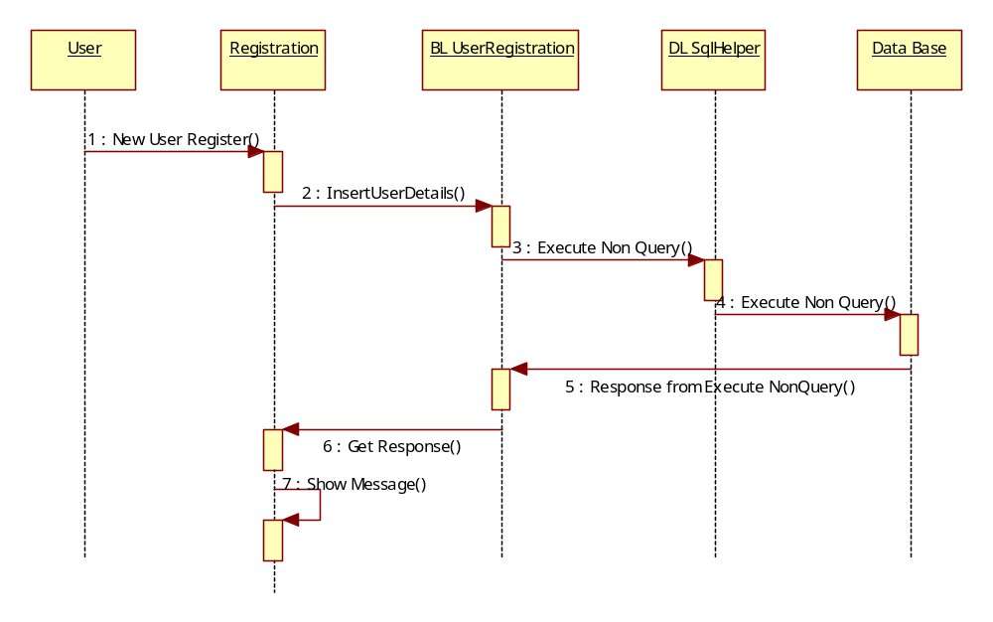
New Folder Creation
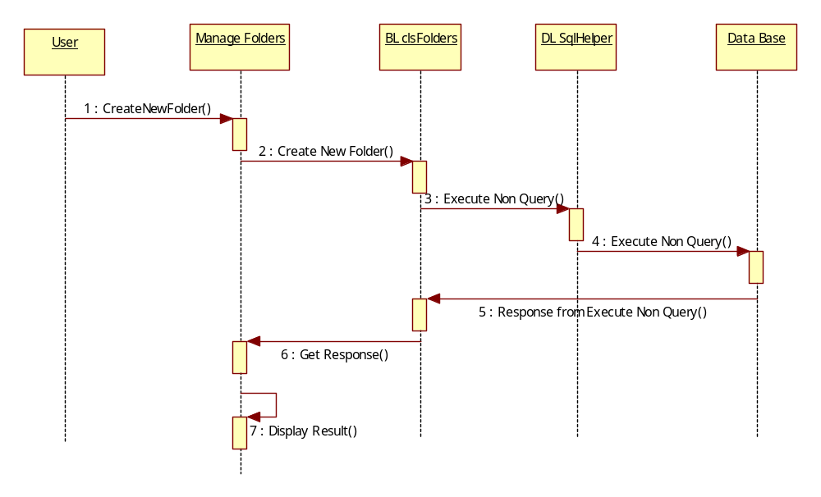
New Sub Folder Creation
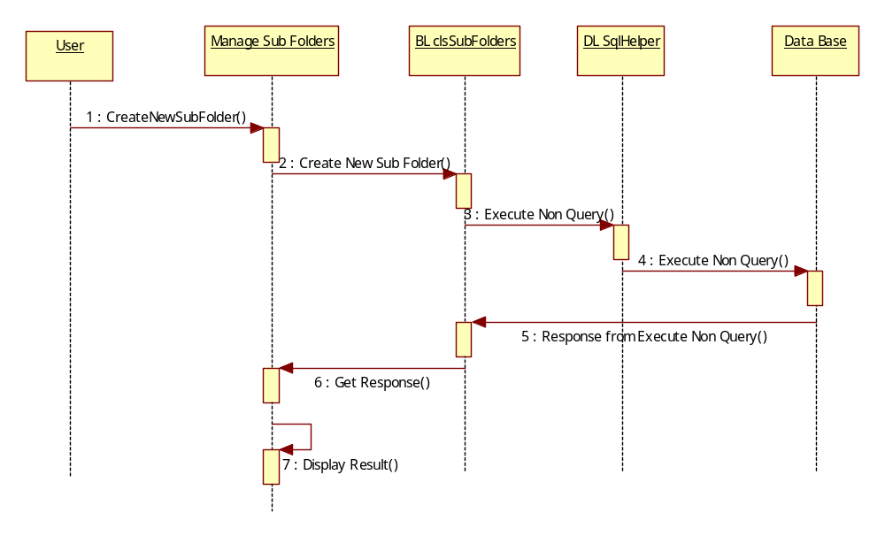
User File Upload
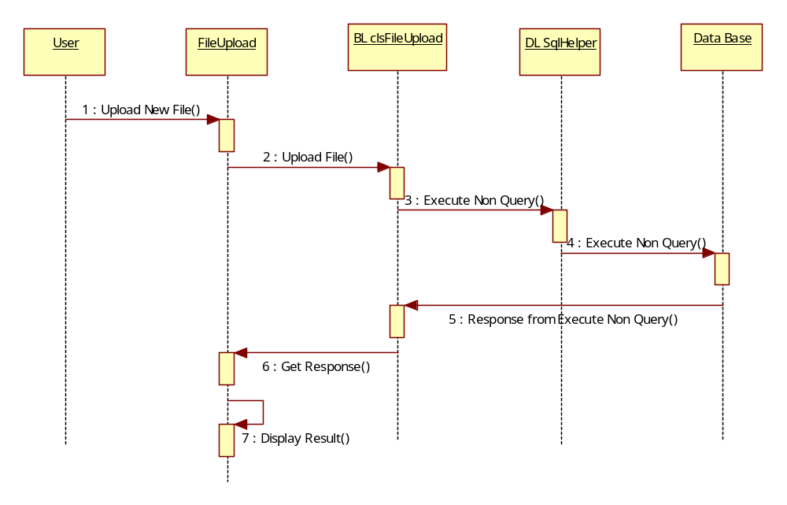
User File Downloading
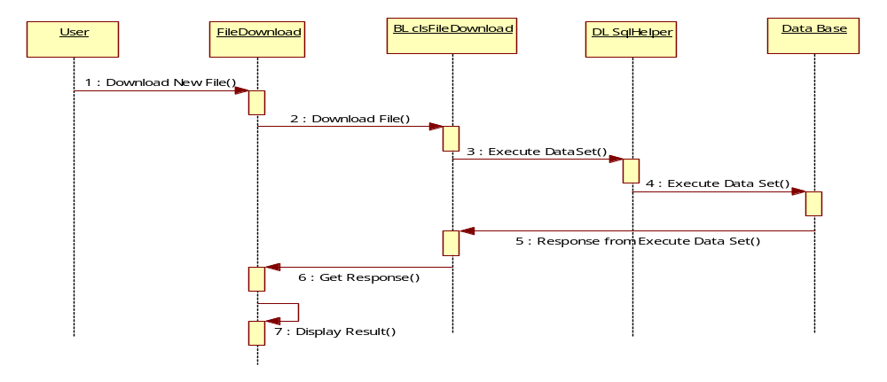

Administration Login
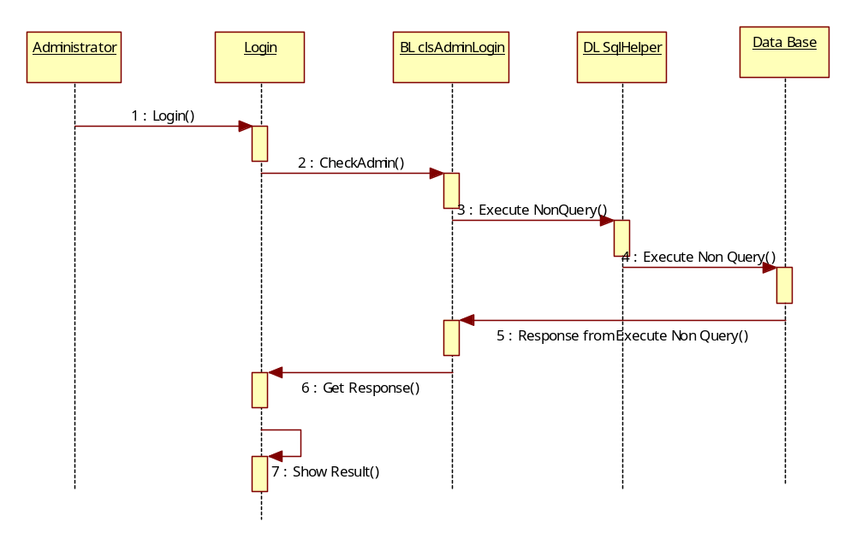
Admin Track User Login and LogOut Track Details
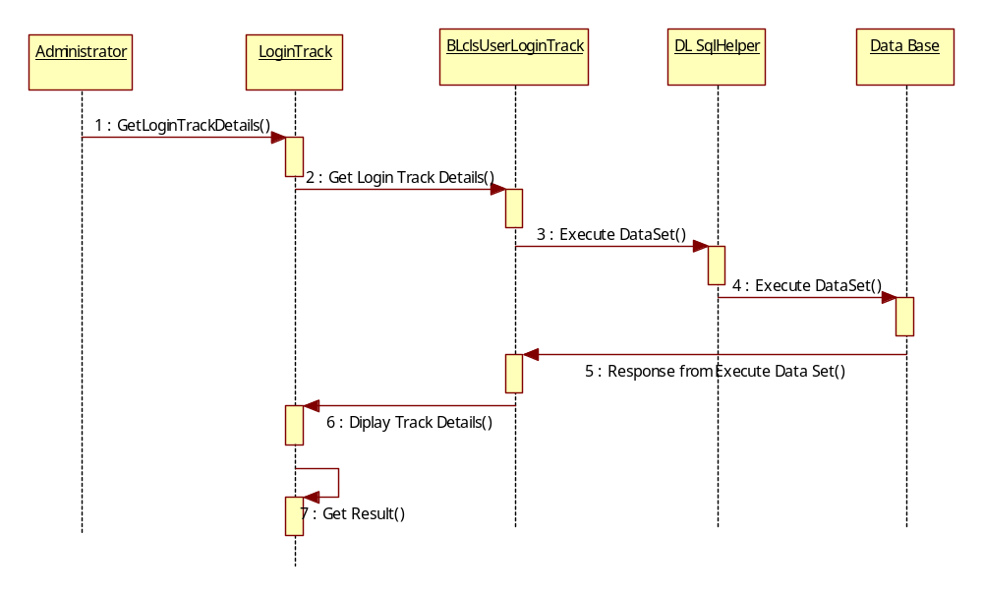
Collabration Diagrams
Login Collabration
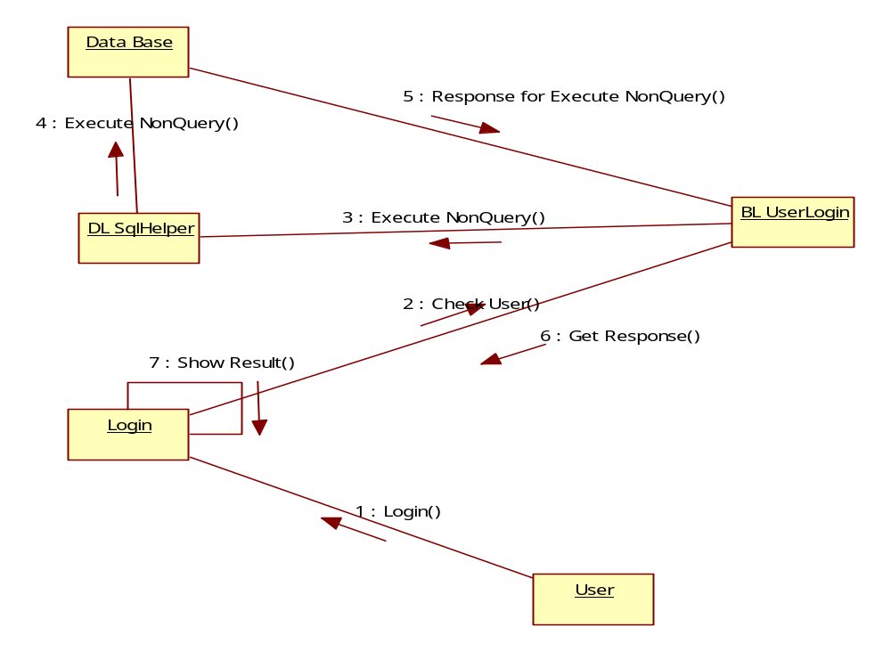
User Registration
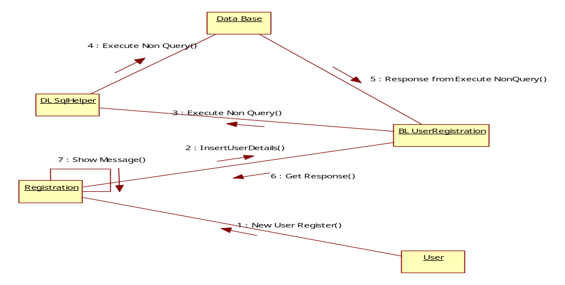
User New Folder Creation
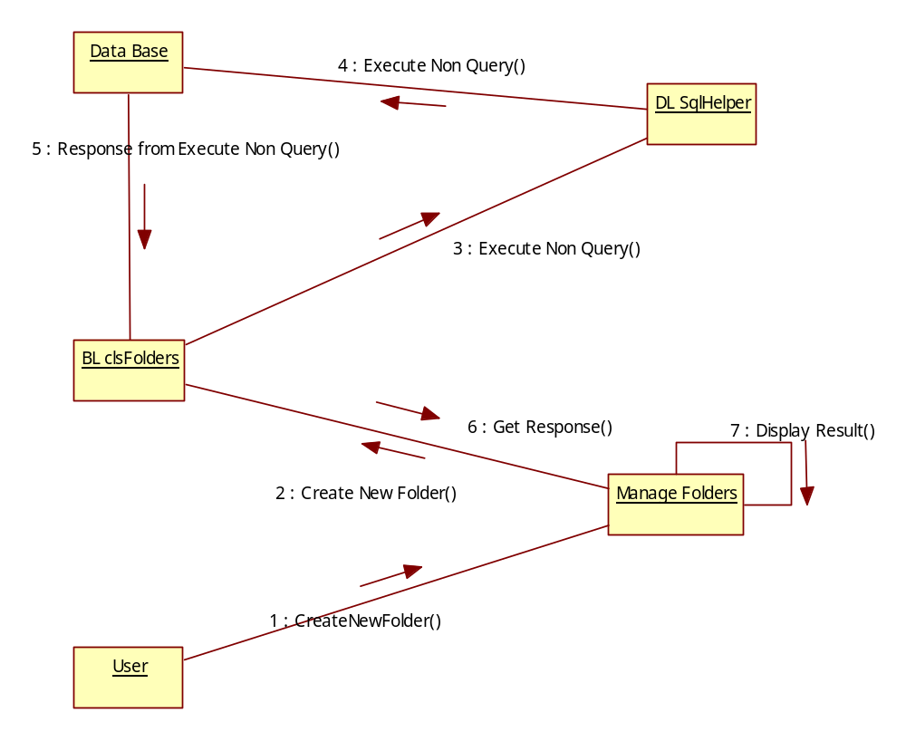
User New Sub Folder Creation
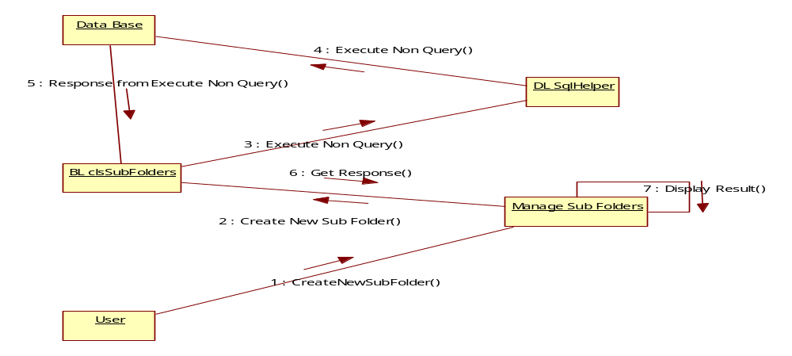

User File Uploading
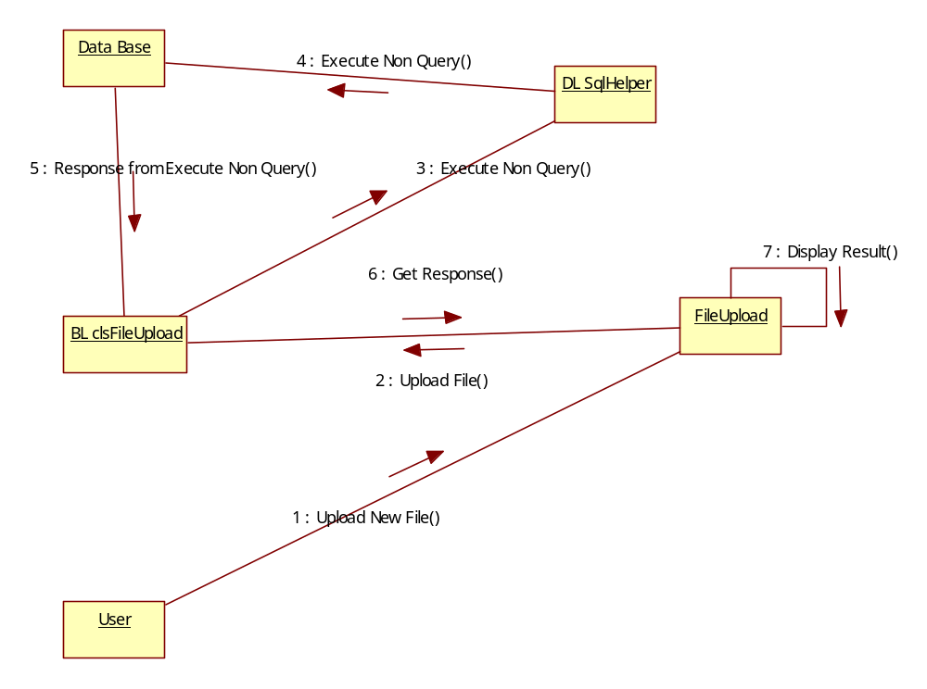
User File down Loading
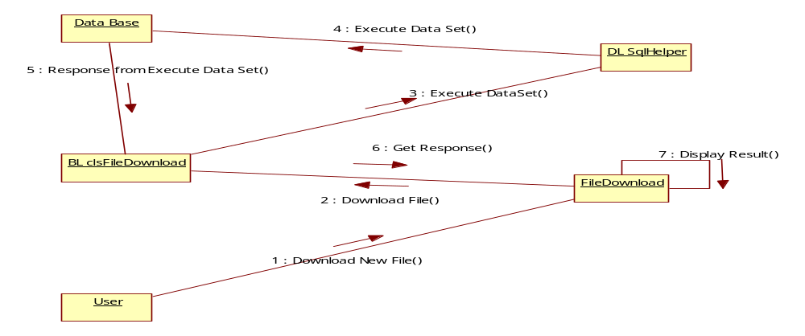Administrator Login
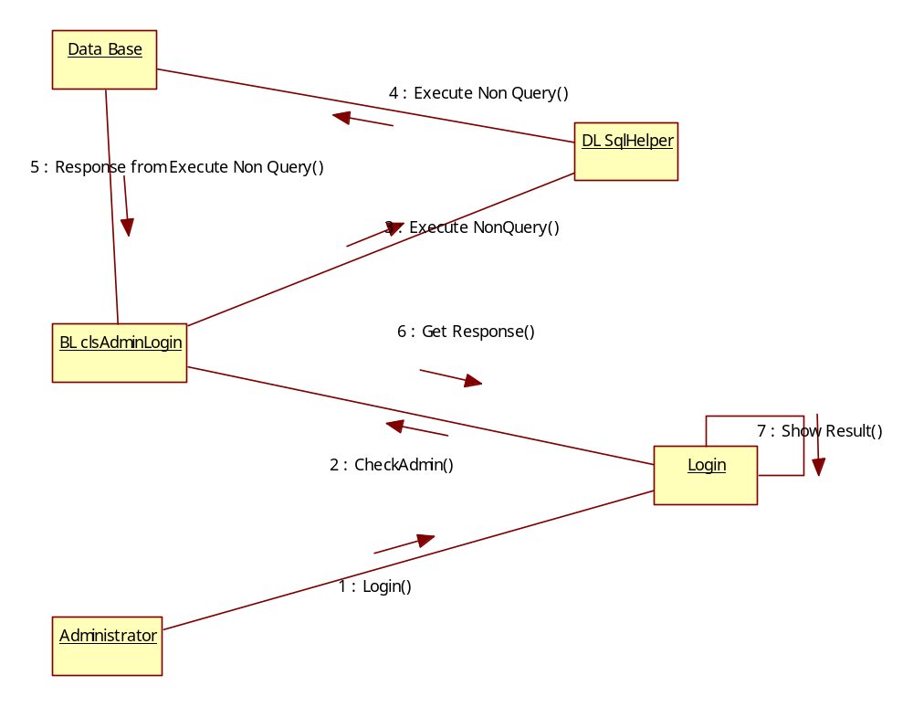

Administrator Login Tracking
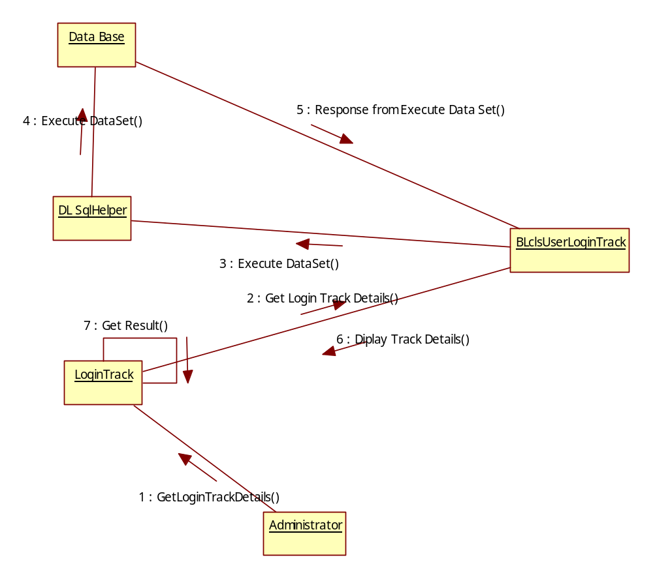

Activity Diagrams:
Login Activity
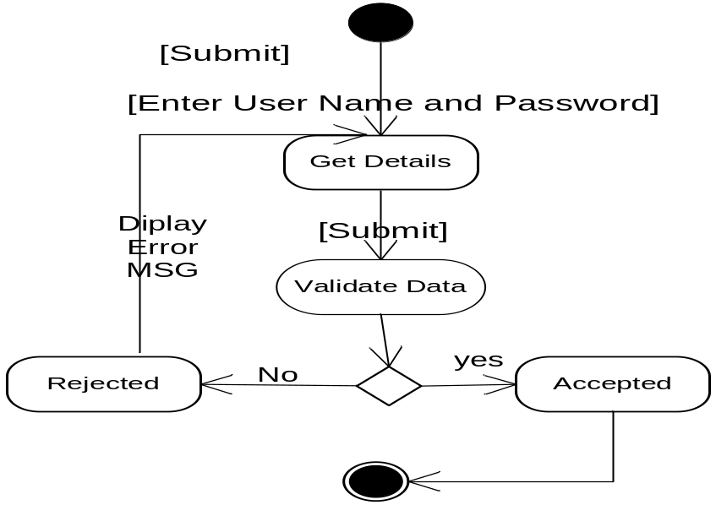
User Registration Activity:
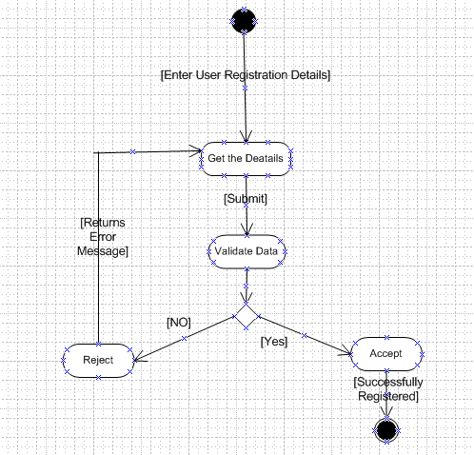

File Upload/Down Load Activity:
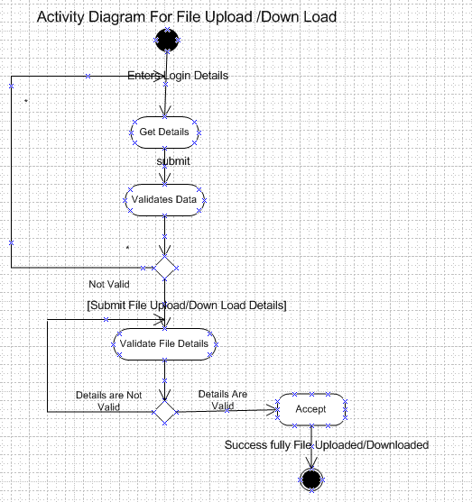

OUTPUT SCREENS

SYSTEM TESTING AND IMPLEMENTATION

INTRODUCTION
Software testing is a critical element of software quality assurance and represents the ultimate review of specification, design and coding. In fact, testing is the one step in the software engineering process that could be viewed as destructive rather than constructive.
A strategy for software testing integrates software test case design methods into a well-planned series of steps that result in the successful construction of software. Testing is the set of activities that can be planned in advance and conducted systematically. The underlying motivation of program testing is to affirm software quality with methods that can economically and effectively apply to both strategic to both large and small-scale systems.

8.2. STRATEGIC APPROACH TO SOFTWARE TESTING
The software engineering process can be viewed as a spiral. Initially system engineering defines the role of software and leads to software requirement analysis where the information domain, functions, behavior, performance, constraints and validation criteria for software are established. Moving inward along the spiral, we come to design and finally to coding. To develop computer software we spiral in along streamlines that decrease the level of abstraction on each turn.
A strategy for software testing may also be viewed in the context of the spiral. Unit testing begins at the vertex of the spiral and concentrates on each unit of the software as implemented in source code. Testing progress by moving outward along the spiral to integration testing, where the focus is on the design and the construction of the software architecture. Talking another turn on outward on the spiral we encounter validation testing where requirements established as part of software requirements analysis are validated against the software that has been constructed. Finally we arrive at system testing, where the software and other system elements are tested as a whole.

UNIT TESTING

MODULE TESTING

SUB-SYSTEM TESING

SYSTEM TESTING

ACCEPTANCE TESTING
Component Testing
Integration Testing
User Testing

8.3. UNIT TESTING
Unit testing focuses verification effort on the smallest unit of software design, the module. The unit testing we have is white box oriented and some modules the steps are conducted in parallel.
1. WHITE BOX TESTING
This type of testing ensures that
- All independent paths have been exercised at least once
- All logical decisions have been exercised on their true and false sides
- All loops are executed at their boundaries and within their operational bounds
- All internal data structures have been exercised to assure their validity.
To follow the concept of white box testing we have tested each form .we have created independently to verify that Data flow is correct, All conditions are exercised to check their validity, All loops are executed on their boundaries.
2. BASIC PATH TESTING
Established technique of flow graph with Cyclomatic complexity was used to derive test cases for all the functions. The main steps in deriving test cases were:
Use the design of the code and draw correspondent flow graph.
Determine the Cyclomatic complexity of resultant flow graph, using formula:
V(G)=E-N+2 or
V(G)=P+1 or
V(G)=Number Of Regions
Where V(G) is Cyclomatic complexity,
E is the number of edges,
N is the number of flow graph nodes,
P is the number of predicate nodes.
Determine the basis of set of linearly independent paths.

3. CONDITIONAL TESTING
In this part of the testing each of the conditions were tested to both true and false aspects. And all the resulting paths were tested. So that each path that may be generate on particular condition is traced to uncover any possible errors.

4. DATA FLOW TESTING
This type of testing selects the path of the program according to the location of definition and use of variables. This kind of testing was used only when some local variable were declared. The definition-use chain method was used in this type of testing. These were particularly useful in nested statements.

5. LOOP TESTING
In this type of testing all the loops are tested to all the limits possible. The following exercise was adopted for all loops:
All the loops were tested at their limits, just above them and just below them.
All the loops were skipped at least once.
For nested loops test the inner most loop first and then work outwards.
For concatenated loops the values of dependent loops were set with the help of connected loop.
Unstructured loops were resolved into nested loops or concatenated loops and tested as above.
Each unit has been separately tested by the development team itself and all the input have been validated.

SYSTEM SECURITY

9.1 INTRODUCTION
The protection of computer based resources that includes hardware, software, data, procedures and people against unauthorized use or natural
Disaster is known as System Security.
System Security can be divided into four related issues:
- Security
- Integrity
- Privacy
- Confidentiality
SYSTEM SECURITY refers to the technical innovations and procedures applied to the hardware and operation systems to protect against deliberate or accidental damage from a defined threat.
DATA SECURITY is the protection of data from loss, disclosure, modification and destruction.
SYSTEM INTEGRITY refers to the power functioning of hardware and programs, appropriate physical security and safety against external threats such as eavesdropping and wiretapping.
PRIVACY defines the rights of the user or organizations to determine what information they are willing to share with or accept from others and how the organization can be protected against unwelcome, unfair or excessive dissemination of information about it.
CONFIDENTIALITY is a special status given to sensitive information in a database to minimize the possible invasion of privacy. It is an attribute of information that characterizes its need for protection.

9.3 SECURITY SOFTWARE

System security refers to various validations on data in form of checks and controls to avoid the system from failing. It is always important to ensure that only valid data is entered and only valid operations are performed on the system. The system employee’s two types of checks and controls:

CLIENT SIDE VALIDATION
Various client side validations are used to ensure on the client side that only valid data is entered. Client side validation saves server time and load to handle invalid data. Some checks imposed are:
- VBScript in used to ensure those required fields are filled with suitable data only. Maximum lengths of the fields of the forms are appropriately defined.
- Forms cannot be submitted without filling up the mandatory data so that manual mistakes of submitting empty fields that are mandatory can be sorted out at the client side to save the server time and load.
- Tab-indexes are set according to the need and taking into account the ease of user while working with the system.

SERVER SIDE VALIDATION
Some checks cannot be applied at client side. Server side checks are necessary to save the system from failing and intimating the user that some invalid operation has been performed or the performed operation is restricted. Some of the server side checks imposed is:
- Server side constraint has been imposed to check for the validity of primary key and foreign key. A primary key value cannot be duplicated. Any attempt to duplicate the primary value results into a message intimating the user about those values through the forms using foreign key can be updated only of the existing foreign key values.

- User is intimating through appropriate messages about the successful operations or exceptions occurring at server side.

- Various Access Control Mechanisms have been built so that one user may not agitate upon another. Access permissions to various types of users are controlled according to the organizational structure. Only permitted users can log on to the system and can have access according to their category. User- name, passwords and permissions are controlled o the server side.

- Using server side validation, constraints on several restricted operations are imposed.

CONCLUSION

It has been a great pleasure for me to work on this exciting and challenging project. This project proved good for me as it provided practical knowledge of not only programming in ASP.NET and C#.Net web based application and no some extent Windows Application and SQL Server, but also about all handling procedure related with “Online File Sharing System”. It also provides knowledge about the latest technology used in developing web enabled application and client server technology that will be great demand in future. This will provide better opportunities and guidance in future in developing projects independently.
BENEFITS:
The project is identified by the merits of the system offered to the user. The merits of this project are as follows: -
- It’s a web-enabled project.
- This project offers user to enter the data through simple and interactive forms. This is very helpful for the client to enter the desired information through so much simplicity.
- The user is mainly more concerned about the validity of the data, whatever he is entering. There are checks on every stages of any new creation, data entry or updation so that the user cannot enter the invalid data, which can create problems at later date.
- Sometimes the user finds in the later stages of using project that he needs to update some of the information that he entered earlier. There are options for him by which he can update the records. Moreover there is restriction for his that he cannot change the primary data field. This keeps the validity of the data to longer extent.
- User is provided the option of monitoring the records he entered earlier. He can see the desired records with the variety of options provided by him.
- From every part of the project the user is provided with the links through framing so that he can go from one option of the project to other as per the requirement. This is bound to be simple and very friendly as per the user is concerned. That is, we can sat that the project is user friendly which is one of the primary concerns of any good project.
- Data storage and retrieval will become faster and easier to maintain because data is stored in a systematic manner and in a single database.
- Decision making process would be greatly enhanced because of faster processing of information since data collection from information available on computer takes much less time then manual system.
- Allocating of sample results becomes much faster because at a time the user can see the records of last years.
- Easier and faster data transfer through latest technology associated with the computer and communication.
- Through these features it will increase the efficiency, accuracy and transparency,

LIMITATIONS:
- The size of the database increases day-by-day, increasing the load on the database back up and data maintenance activity.
- Training for simple computer operations is necessary for the users working on the system.

FUTURE IMPROVEMENT

- It can be implemented to upload files with an huge amount of size with the support of various file formats.

- This System being web-based and an undertaking of Cyber Security Division, needs to be thoroughly tested to find out any security gaps.

- A console for the data centre may be made available to allow the personnel to monitor on the sites which were cleared for hosting during a particular period.

- Moreover, it is just a beginning; further the system may be utilized in various other types of auditing operation viz. Network auditing or similar process/workflow based applications...

BIBLIOGRAPHY

- FOR .NET INSTALLATION
www.support.mircosoft.com
- FOR DEPLOYMENT AND PACKING ON SERVER
www.developer.com
www.15seconds.com
- FOR SQL
www.msdn.microsoft.com
- FOR ASP.NET
Asp.Net 3.5 Unleashed
www.msdn.microsoft.com/net/quickstart/aspplus/default.com
www.asp.net
www.fmexpense.com/quickstart/aspplus/default.com
www.asptoday.com
www.aspfree.com
www.4guysfromrolla.com/index.aspx
- Software Engineering (Roger’s Pressman)

