### 1- Which event will take place if there is a port security violation on switch S1 interface Fa0/1, as given below?

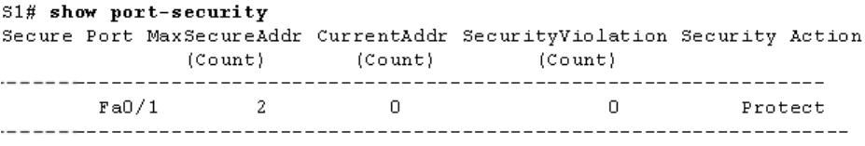

A. A notification is sent

B. A syslog message will be logged

C. Packets with unknown source addresses will be dropped

D. The interface will go into error-disabled state

### 2- You need to determine the VLAN ID that will be placed in a frame as it exits your Cisco IOS ISR interface of GigabitEthernet 0/0.20. Which command will you use?

a. Show ip route

b. Show mac-address table dynamic

c. Show interface gigabitethernet 0/0.20

d. Show ip arp

e. Show interfaces trunk

f. Show vlan

g. Show interface gigabitethernet 0/0.20 switchport

### 3- Which security violation mode should be configured, so that a notification is sent and a frame with the unknown source MAC address is dropped, once the maximum number of MAC addresses is reached?

A. restrict

B. warning

C. protect

D. shutdown

### 

### 4- What address can be used to summarize networks 172.31.1.0/24, 172.31.2.0/24, 172.31.3.0/24, and 172.31.4.0/24?

A. 172.31.0.0/21

B. 172.31.1.0/22

C. 172.31.0.0 255.255.255.248

D. 172.31.0.0 255.255.252.0

### 5- What route would have the lowest administrative distance?

a. a route received through the EIGRP routing protocol

b. directly connected network

c. route received through the OSPF routing protocol

d. static route

### 6- The network administrator configures the router with the ip route 172.16.1.0 255.255.255.0 172.16.2.2 command. How will this route appear in the routing table?

a. S 172.16.1.0 is directly connected, Serial0/0

b. S 172.16.1.0 [1/0] via 172.16.2.2

c. C 172.16.1.0 [1/0] via 172.16.2.2

d. C 172.16.1.0 is directly connected, Serial0/0

### 7- Choose the correct definition for the native Vlan.

a. is a VLAN that is configured to carry user-generated traffic.

b. is assigned to an 802.1Q trunk port that support the transmission of untagged

traffic

c. is any VLAN configured to access the management capabilities of a switch.

d. is Vlan 1 that cannot be renamed or deleted.

## 

## Part II: Troubleshooting question:

Consider the following topology and correct the configurations on both switches:

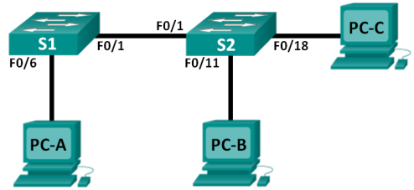

### Addressing Table and Switch Port Assignment Specifications

**Device IP Address**

* PC-A 192.168.10.2/24
* PC-B 192.168.10.3/24
* PC-C 192.168.20.3/24

**Ports Assignment Network**

* F0/6-12 VLAN 10 – Students 192.168.10.0/24
* F0/13-18 VLAN 20 – Faculty 192.168.20.0/24
* F0/19-24 VLAN 30 – Guest 192.168.30.0/24

**Switch S1 Configuration:**

hostname S1

vlan 10

name Students

vlan 20

name Faculty

vlan 30

name Guest

interface range f0/1-24

switchport mode access

shutdown

interface range f0/7-12

switchport access vlan 10

interface range f0/13-18

switchport access vlan 2

interface range f0/19-24

switchport access vlan 30

**Switch S2 Configuration:**

hostname S2

vlan 10

Name Students

vlan 20

Name Faculty

vlan 30

Name Guest

interface f0/1

switchport mode trunk

switchport trunk allowed vlan 1,10,2,30

interface range f0/2-24

switchport mode access

shutdown

interface range f0/13-18

switchport access vlan 20

interface range f0/19-24

switchport access vlan 30

Shutdown

### Switch Security questions:

1. enable  
   Conf t  
   Interface fastEthernet 0/6  
   Switchport port-security
2. (enable / conf t / interface fastEthernet 0/6)  
   Switchport port-security maximum 1
3. (enable / conf t / interface fastEthernet 0/6)  
   Switchport port-security mac-address sticky
4. (enable / conf t / interface fastEthernet 0/6)  
   Switchport port-security violation shutdown
5. Disable all the remaining unused ports (use the range keywords to apply this configuration to all the ports simultaneously)  
   (enable / conf t)  
   Interface range fastEthernet 0/3-24, gigabitEthernet 0/1-2  
   Shutdown

### Inter-vlans configuration:

## Part III: Router configuration: