Road Casualty Statistics Report (Year: 2022)

1. Overview of the Dataset

Number of Records: 61,352

Number of Columns: 20

2. Data Cleaning

Handling Missing Values: Checked and addressed any missing values in the dataset.

Data Types: Ensured appropriate data types for each column.

Duplicates: No duplicate records found.

3. Exploratory Data Analysis (EDA)

Casualty Distribution by Age:

Visualized the distribution of casualties across different age groups. Most common age is 18.

Casualty Severity Analysis:

Explored the distribution of casualty severity (e.g., slight, serious). Most casualties have severity level 3.

Geographical Analysis:

Geographic data available in 'lsoa_of_casualty'. A map can be generated to show the distribution of casualties.

4. Time Analysis

Accident Distribution by Year:

The dataset is for the year 2022; check for any noticeable trends or patterns in the number of accidents over the year.

5. Detailed Analysis by Columns

accident_reference: Most repeated value is '010377133' with 16 occurrences.

vehicle_reference: Most repeated value is '1' with 30,563 occurrences.( unique value for each vehicle in a singular accident. Can be used to join a Casualty to a vehicle)

casualty_reference: Most repeated value is '1' with 41,263 occurrences.( unique value for each casualty in a singular accident (historical years may be unique to a singular vehicle in a road accident))

casualty_class: Most repeated value is '1' with 35,917 occurrences.( Driver or rider)

sex_of_casualty: Most repeated value is '1' with 32,056 occurrences.( Male)

age_of_casualty: Most repeated value is '18' with 1,395 occurrences.

age_band_of_casualty: Most repeated value is '6' with 11,246 occurrences. (26 – 35 years old)

casualty_severity: Most repeated value is '3' with 41,600 occurrences.( Slight)

pedestrian_location: Most repeated value is '0' with 44,701 occurrences.( Not a Pedestrian)

pedestrian_movement: Most repeated value is '0' with 44,700 occurrences.( Not a Pedestrian)

car_passenger: Most repeated value is '0' with 44,398 occurrences.( Not car passenger)

bus_or_coach_passenger: Most repeated value is '0' with 51,363 occurrences.( Not a bus or coach passenger)

pedestrian_road_maintenance_worker: Most repeated value is '0' with 51,037 occurrences.(no)

casualty_type: Most repeated value is '9' with 27,697 occurrences.( Car occupant)

casualty_home_area_type: Most repeated value is '1' with 42,465 occurrences.( Urban area)

casualty_imd_decile: Most repeated value is '2' with 6,657 occurrences.( More deprived 10-20%)

lsoa_of_casualty: Most repeated value is 'E01004242' with 17 occurrences.

6. Conclusion and Recommendations

The dataset provides valuable insights into road casualty statistics for the year 2022.

Specific focus areas for further analysis include age distribution, casualty severity, and geographical patterns.

7. Visualizations

Visualizations such as histograms and age distribution plots will be included in the final report.

|  |  |  |
| --- | --- | --- |
| **Column Name** | **Most Repeated Value** | **Number of Occurrences** |
| accident_reference | 010377133 | 16 |
| vehicle_reference | 1 | 30563 |
| casualty_reference | 1 | 41263 |
| casualty_class | 1 | 35917 |
| sex_of_casualty | 1 | 32056 |
| age_of_casualty | 18 | 1395 |
| age_band_of_casualty | 6 | 11246 |
| casualty_severity | 3 | 41600 |
| pedestrian_location | 0 | 44701 |
| pedestrian_movement | 0 | 44700 |
| car_passenger | 0 | 44398 |
| bus_or_coach_passenger | 0 | 51363 |
| pedestrian_road_maintenance_worker | 0 | 51037 |
| casualty_type | 9 | 27697 |
| casualty_home_area_type | 1 | 42465 |
| casualty_imd_decile | 2 | 6657 |
| lsoa_of_casualty | E01004242 | 17 |

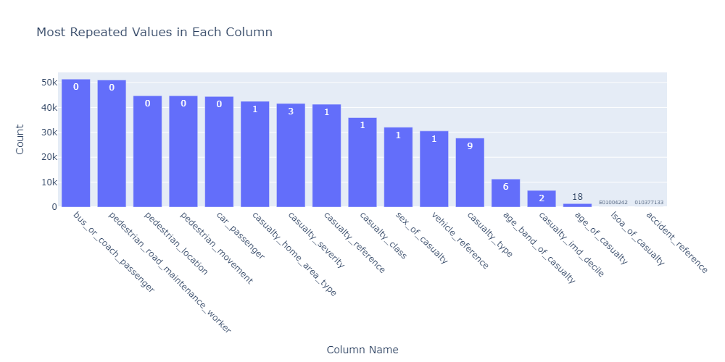

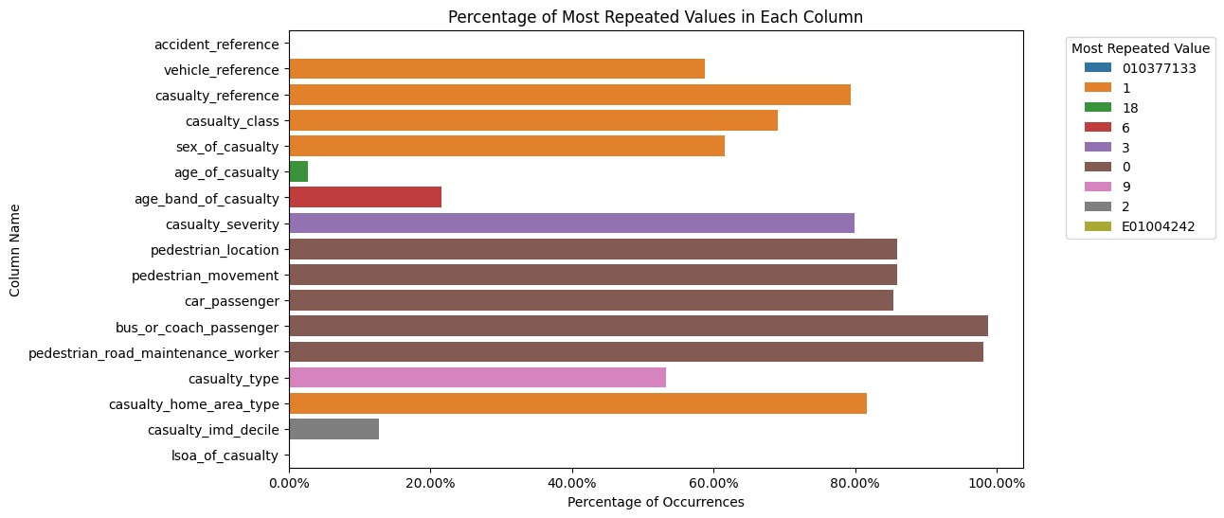

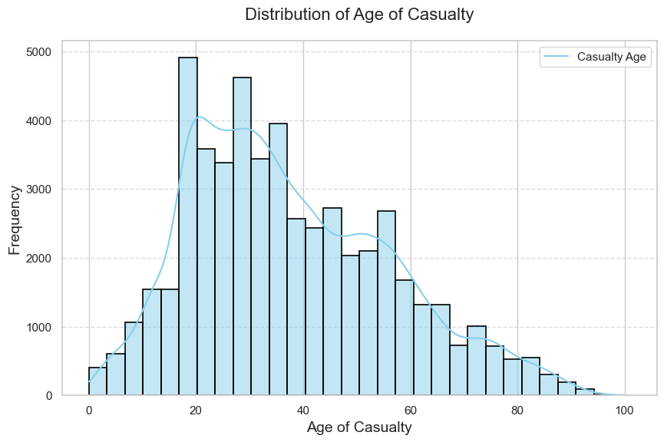

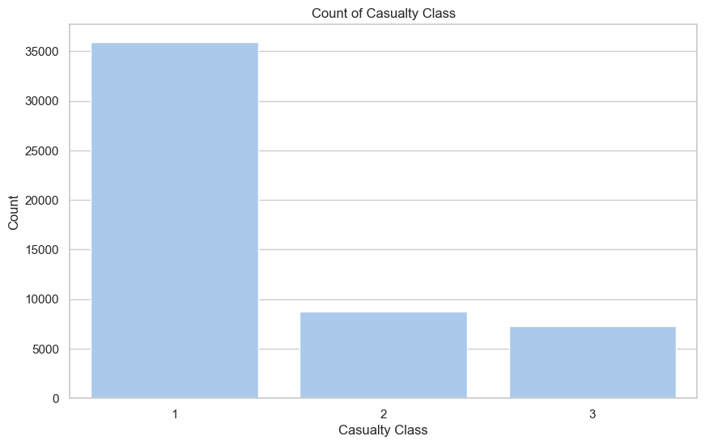

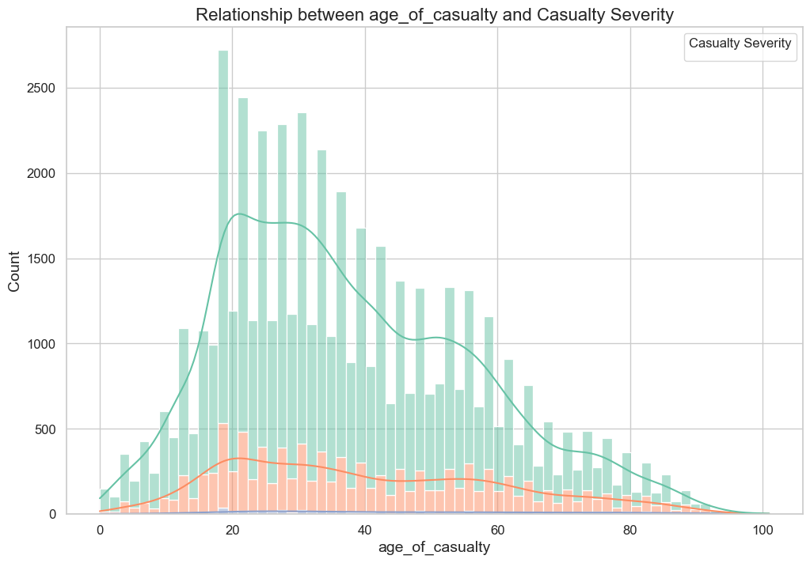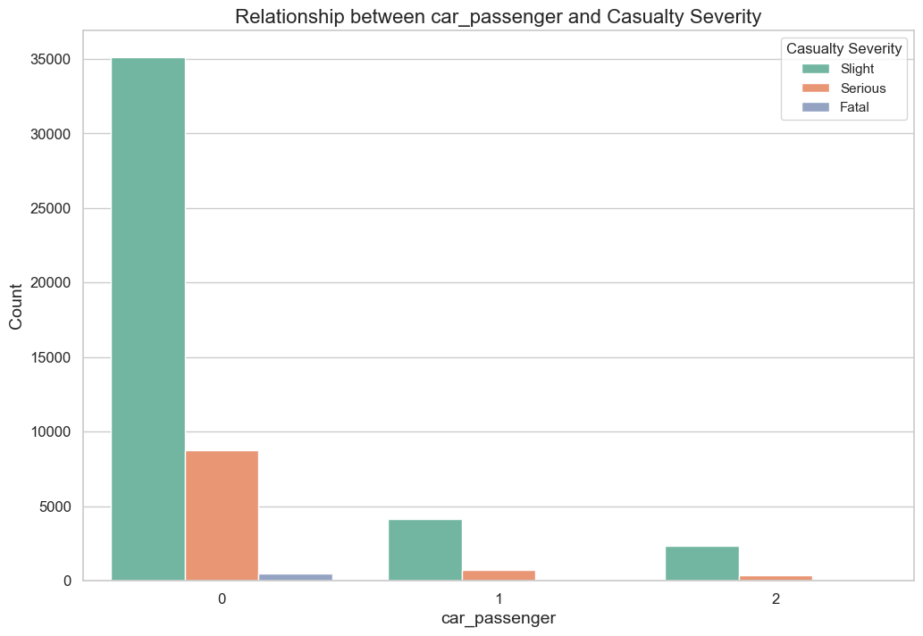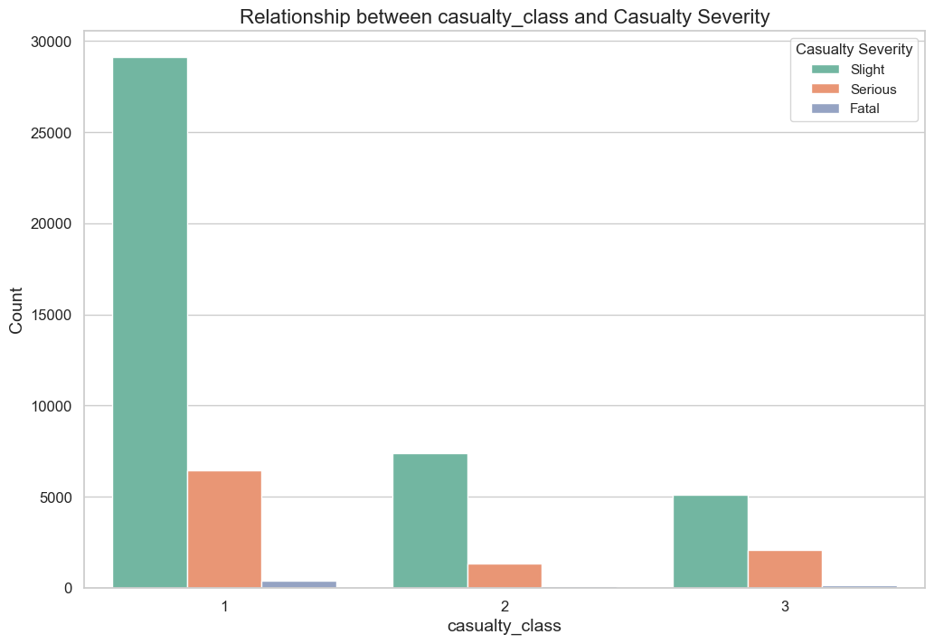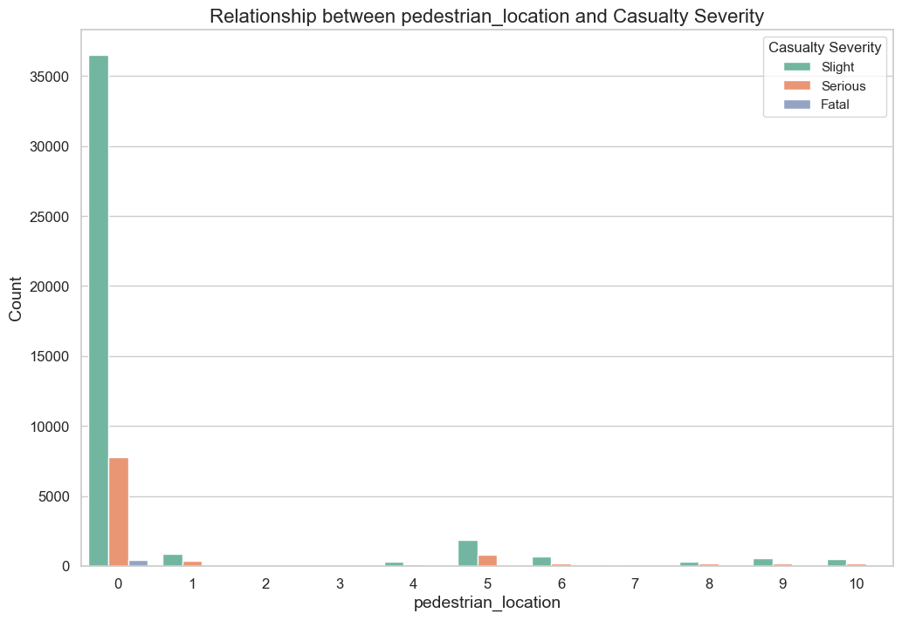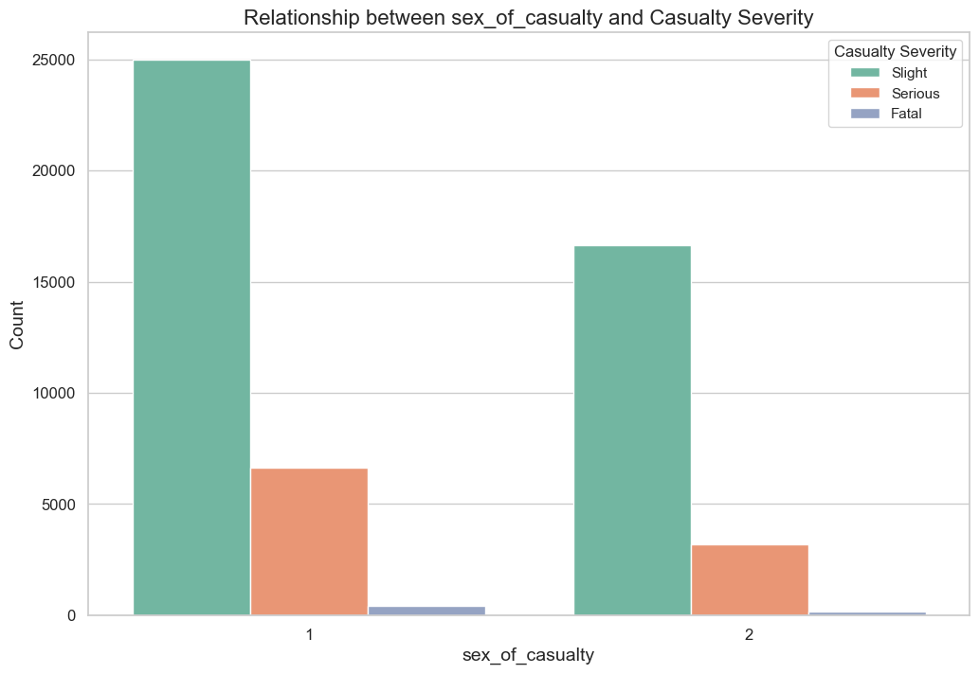

Analysis of Road Casualty Statistics - Feedback and Recommendations

1. Key Observations:

- The dataset primarily involves male drivers or riders in the age group of 26 – 35 years.

- Slight injuries are the most common casualty severity, with urban areas showing higher occurrences.

- Non-pedestrian casualties are predominant, with a notable number of car occupants.

- Casualties are more common in areas with higher deprivation (IMD Decile 2) and urban locations.

2. Feedback:

- Targeted Awareness Campaigns: Design awareness campaigns targeting the age group of 26 – 35 years, focusing on safe driving practices and road etiquette.

- Urban Safety Measures: Collaborate with local authorities to implement targeted safety measures in urban areas, including improved signage, speed limits, and traffic calming measures.

- Pedestrian Safety Initiatives: Implement initiatives to improve pedestrian safety, especially in urban environments, to reduce non-pedestrian casualties.

- Public Transport Safety: Promote safety measures for bus and coach passengers, including education on proper behavior and safety protocols during travel.

- Focus on Deprived Areas: Address road safety issues in areas with higher deprivation by collaborating with local communities and implementing targeted interventions.

3. Recommendations:

- Data-Driven Decision Making: Continue analyzing the dataset to identify specific factors contributing to accidents, enabling more targeted interventions.

- Collaboration: Work closely with relevant authorities, local communities, and safety organizations to implement and enforce road safety measures.

- Education and Training: Promote driver education programs, safe driving courses, and pedestrian safety training to enhance awareness.

- Infrastructure Improvement: Invest in road infrastructure improvements, such as well-maintained roads, better lighting, and pedestrian-friendly crossings.

4. Continuous Monitoring:

- Establish a system for continuous monitoring and evaluation of road safety measures to assess their effectiveness.

- Regularly update road safety policies based on ongoing analysis and emerging trends.

5. Community Engagement:

- Engage with the local community to raise awareness and involve them in road safety initiatives.

- Encourage reporting of unsafe road conditions or practices to address issues promptly.

6. Multi-Agency Approach:

- Collaborate with law enforcement, healthcare, and other relevant agencies for a comprehensive approach to road safety.

7. Public Awareness:

- Launch public awareness campaigns to educate the community about the importance of road safety and responsible road use.

8. Long-Term Vision:

- Develop a long-term road safety strategy that considers evolving traffic patterns, emerging technologies, and community needs.

Implementing a combination of targeted interventions, education, and community engagement is essential for achieving a meaningful reduction in road accidents. Regularly assessing the impact of these measures will provide valuable insights for ongoing improvement.