**Introduction:** The railway system is a very significant part of the transportation system in Bangladesh. It provides a cheaper and safer travelling facility. But sometimes rail systems collapse due to accidents, routing problems, crossing etc. So, this work aims to generate schedules for the railway system to minimize the driving time and avoid collisions between trains. And another aim is to generate an optimal train schedule.

Fig:

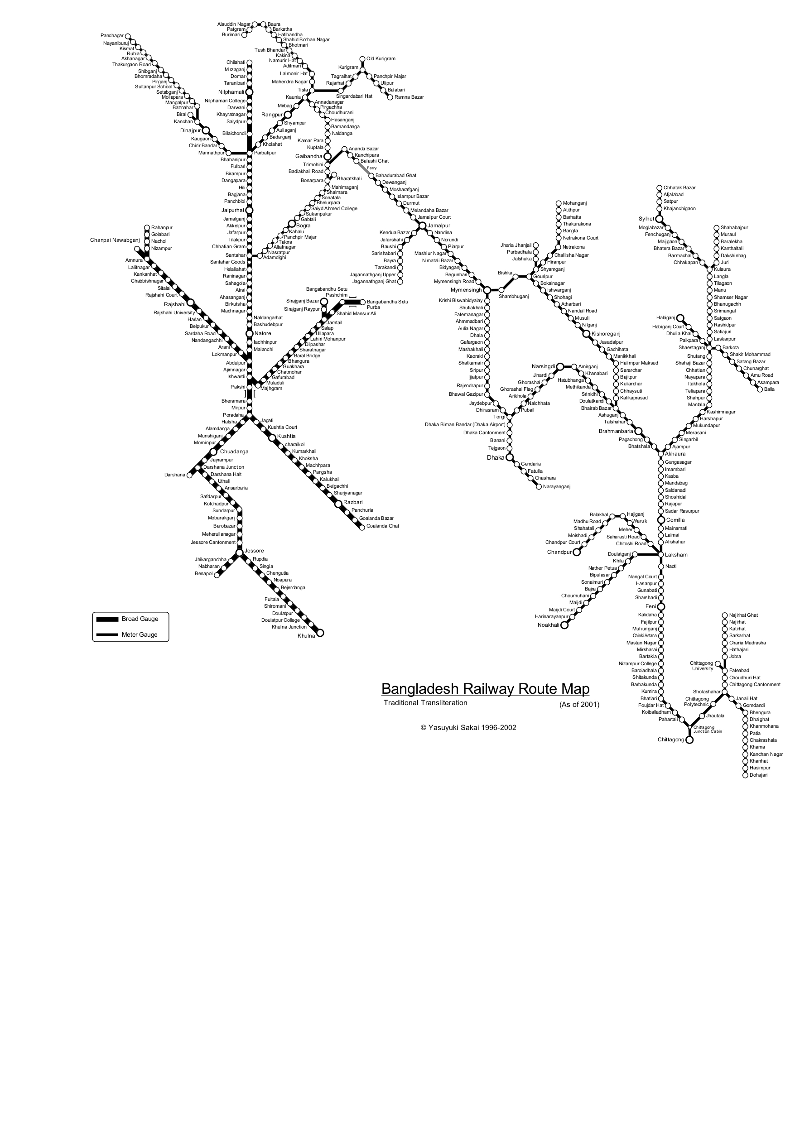

Figure-1.1: Bangladesh Railway Route Map

Credit: Yasuyuki Sakai 1996-2002

**Motivation:** Bangladesh is still a developing country. Most peoples choose cost-effective and safer transportation. Besides these other transportation like the bus is more costly and insecure than the train. People are likely to avoid bus or other road transportation services because of traffic jams and poor transportation systems due to bad road conditions.

And railway system could play a vital role to meet passenger's demands. But delays, accidents and scheduled disasters can cause a significant loss. So it is very important to make the train schedule optimal. Since train scheduling is extremely sensitive and related to a massive number of people, scheduling train becomes an attractive research area for us. Those are the main motivations for us to make an optimal train schedule.

**Problem Statement:** The train Scheduling system is a continuous system. Train routes always stay busy. So proper scheduling is very important. Time-saving and safe journeys are major challenges in this digital age. To optimize train drive time, avoid train collisions and prevent train schedule disasters by choosing correct routes, we proposed to develop a train scheduling model using automated temporal planning.

By completing this thesis, We may expect to get the solutions to the following problem statements:

1. Can the scheduling domain model be developed using temporal planning specifications?

2. Can an automated schedule be generated using the model?

3. Is the generated schedule correct?

4. Is the generated schedule capable of optimising the train schedule?

5. Is the model can generate schedules in optimal time?

**Thesis Outline:** Total 6 chapters in our thesis. Chapter 1 consists introduction to the Bangladesh Railway System, the motivation of our thesis and the problem statement of our thesis topic. Chapter 2 describe the background and the related work. Chapter 3 consists of. Chapter 4 describes the methodology of the thesis. This chapter explained how domain models and problem models of train scheduling use automated temporal planning.

Chapter 5 explained the experimental setup and analysis of the result. Conclusion and future work

explained in chapter 6.