# CONTENTS

|  |  |  |
| --- | --- | --- |
| **Chapter** | **Statements** | ***Page No.*** |
| **Chapter I** | **Introduction** | *11-19* |
| 1.1 Introduction | *11* |
| 1.2 Research Background and Statement of the Problem | *12* |
|  | 1.3 Objective of the study | *13* |
| 1.4 The Research Question | *14* |
|  | 1.5 Definition of Terms | *14-17* |
| 1.6 Significance of the research | *17* |
|  | 1.7 Organization of the Paper | *18* |
| 1.8 Summary | *19* |
| **Chapter II** | **Literature Review, Hypotheses And Item**  **Development** | *20-33* |
| 2.1 Introduction | *20* |
| 2.2 Theoretical background | *20-23* |
|  | 2.3 Literature Review | *24-26* |
|  | 2.4 Research Gap | *26* |
| 2.5 Proposed conceptual model and Hypotheses | *27* |
|  | 2.6 Hypothesis development | *28-33* |
| 2.8 Summary | *33* |
| **Chapter III** | **Research Methodology** | *34-39* |
|  | 3.1 Introduction | *34* |
| 3.2 Research Paradigm | *34* |
|  | 3.3 Research Design | *35* |

|  |  |  |
| --- | --- | --- |
|  | 3.4 Sampling | *35* |
|  | 3.5 Measurement Scale | *36* |
| 3.6 Questionnaire design | *37* |
|  | 3.7 Data Collection | *38* |
| 3.8 Data Analysis | *38* |
|  | 3.8 Pilot Test | *39* |
| 3.9 Summary | *39* |
| **Chapter IV** | **Data Analysis and Findings** | *40-66* |
| 4.1 Introduction | *40* |
| 4.2 Results | *40-48* |
| 4.3 Factor Analysis | *48-51* |
| 4.4 Measurement Model Assessment | *54-62* |
| **Chapter V** | 4.5 Structural Model | *62-64* |
| 4.5.1 Path Relationships | *64-65* |
| 4.6 Summary | *66* |
| **Discussion** | *67-71* |
| 5.1 Introduction | *67* |
| 5.2 Role of artificial intelligence and machine learning in digital marketing strategies | *67-70* |
|  | 5.3 Implication of the study | *70-71* |
| 5.3 Summary | *71* |
| **Chapter VI** | **Conclusion** | *72-75* |
|  | 6.1 Limitations of Study and Future Research | *72* |
|  | 6.2 Conclusion | *74* |
|  | Disclaimer | *75* |
|  | **Reference** | *76-79* |
|  | **Appendix** | *80-84* |

**List of Abbreviation**

|  |  |
| --- | --- |
| TAI | Transformative Artificial Intelligence |
| AI | Artificial Intelligence |
| ML | Machine Learning |
| DM | Digital Marketing |
| WOM | Word-Of-Mouth |
| PBA | Permission-Based Approach |
| SEM | Structural Equation Modelling |
| SEO | Search Engine Optimization |
| SMM | Social Media Marketing |

## Chapter I Introduction

### 1.1 Introduction

Artificial intelligence (AI), a computer-based system that executes technological tasks without human intervention, is critical for real-time and data-driven decision-making in Bangladesh's digital marketing sector (Shaik, 2023). The digital marketing industry has been completely transformed by the swift development of artificial intelligence (AI) and machine learning (ML) technology (Chaitanya et al., 2023). Artificial intelligence (AI) is evolving into a valuable tool for digital marketers. It learns how to collect information from individuals or groups of people and convert them into big brand ambassadors. Furthermore, investing in artificial intelligence is safe (Murgai, 2018). The world is shifting from manual to digital, with AI playing an increasingly important role in machine learning, deep learning, cognitive computing, and digital marketing. According to Salesforce's report, 51% of marketing leaders utilize AI, with 24% planning to do so within the next two years (P. Singh et al., 2023). Implementing artificial intelligence (AI) in organizations can improve decision-making efficiency and production (Knight, 2015). Technological advancements enhance business activities by expanding customer reach and utilizing digital marketing platforms. AI, an advanced digital tool, integrates cloud computing, network devices, and digital content. The rapid progress of information and communication technology has revolutionized the digital marketing landscape, necessitating businesses to create and use excellent data for quick decision-making, resulting in benefits for diverse organizations via digital agency and machine learning tools (Miklosik et al., 2019). A new wave of innovation and expansion in corporate tactics has been brought about by the integration of artificial intelligence (AI) in marketing, which has profoundly disrupted and transformed enterprise operations. Chintalapati and Pandey did a thorough investigation of the function and implications of AI in modern marketing, highlighting the technology's disruptive potential (Ziakis & Vlachopoulou, 2023). AI provides marketers with massive amounts of customer data, allowing them to better understand consumer behavior, preferences, and decision-making processes. It also improves customer service, internet engagement, and content development (Rathore, 2016). Companies utilize AI software to streamline processes, cut costs, and increase output. Adopting AI development is critical for future marketing initiatives (Murgai, 2018). Since the early twentieth century, digital marketing has expanded dramatically, with advances in artificial intelligence and data mining transforming decision-making from data-driven to knowledge-based. However, marketing science fails to apply AI effectively due to qualitative, quantitative, and strategic issues, as well as professional experience and competence in a continuously changing environment (Zohuri & Mossavar Rahmani, 2020). Technology improvements have enabled firms to offer wide product offers through digital marketing channels, such as AI research (Gkikas & Theodoridis, 2019a).

The introductory chapter outlines Introduction, background and statement of the problem, objectives, literature review, the research question, definition of the terms, and significance of the research.

### 1.2 Research Background and Statement of the Problem

The existing literature finds machine learning in the field of digital marketing to be worthy of further investigation. Machine learning developments have created new prospects for digital marketing companies. But there is a void in the literature regarding how machine learning affects various sorts of marketing (Ullal et al., 2021). The influence of AI and ML on digital marketing is changing the way firms connect with customers, optimize marketing strategies, and drive corporate success (Chaitanya et al., 2023). Marketers and researchers are still struggling to grasp the breadth of options that ML applications provide for developing and retaining a competitive business advantage (De Mauro et al., 2022). This article analyzes the use of machine learning in marketing analysis, as well as its potential, implementation, and attitudes regarding its active usage in strategic and operational marketing management (Miklosik et al., 2019b). In the present literature, there are no obvious drawbacks to applying machine learning to marketing analytics tools (Sarath Kumar Boddu et al., 2022). The study goes on to analyze the various domains of digital marketing where artificial intelligence has made an appearance. Companies use artificial intelligence software every day to optimize their own operations, minimize overhead, reduce turnaround time, and boost production (Murgai, 2018). The tremendous improvements in data and communications technology in the public and commercial sectors over the last several years have resulted in the formation of a new digital marketing ecosystem (Sarath Kumar Boddu et al., 2022). Implementing artificial intelligence (AI) in Digital Marketing increases efficiency because operations are automated depending on instructions (Bashang, 2023).

According to existing research, AI's involvement in digital marketing is still in its early stages, with strong conversion rates and ROIs due to its significant technological progress (Gkikas & Theodoridis, 2019b). The literature that are currently being published has insufficient research on the use of artificial intelligence and machine learning in modern digital marketing. Despite substantial study in topics such as search engine optimization, consumer behavior, web construction, and targeted advertising, there is a scarcity of scientific publications on artificial intelligence in digital marketing (Gkikas & Theodoridis, 2019b). The purpose of this research is to investigate and explain the significant effect of artificial intelligence (AI) and machine learning (ML) on contemporary digital marketing techniques. This research looks to provide a comprehensive understanding of how AI and ML can optimize marketing approaches, shape marketing strategies, enhance customer experience, enhance customer engagement, and revolutionize the overall landscape of digital marketing by examining the transformative capabilities of these advanced technologies, thereby offering valuable insights for businesses and marketers navigating the dynamic digital ecosystem.

### 1.3 Objective of the study

The main objective of this study is to formulate a theoretical framework for examining the impact of artificial intelligence and machine learning on modern digital marketing techniques. The objectives of the study are to:

1. RO-1: Identify important areas of digital marketing where AI and machine learning have the most influence (e.g., personalization, automation, analytics, and decisionmaking).
2. RO-2: Compare the effectiveness of artificial intelligence and machine learningpowered marketing initiatives versus traditional approaches.
3. RO-3: Investigate the factors affecting the application of AI and ML in digital marketing strategies.
4. RO-4: Examine the degree and magnitude of the influences of those factors on the intention and usage of AI and ML in digital marketing.

### 1.4 The Research Question

It is felt necessary to investigate the factors affecting the application of AI and ML in current digital marketing practices among people. Thus, this research attempts to fill the gap by investigating the following research question:

RQ-1: What variables influence the acceptance and deployment of AI and machine learning technology in modern digital marketing strategies?

RQ-2: How do factors affect the effective usage of AI and machine learning tools in digital marketing campaigns?

RQ-3: How can artificial intelligence and machine learning efforts affect the success and overall performance of digital marketing campaigns when they are integrated and utilized?

These research questions are intended to investigate the fundamental factors driving the adoption of AI and machine learning in digital marketing, to better understand the role of user behavior in exploiting these technologies, and to assess the overall influence on the performance of digital marketing campaigns.

### 1.5 Definition of Terms

**1.5.1 Transformative :** The field of Transformative Artificial Intelligence (TAI) studies how sophisticated artificial intelligence (AI) is affecting society, from generalpurpose technologies to potentially revolutionary changes that require careful policy considerations (Bloom & Reenen, 2013)(Gruetzemacher & Whittlestone, 2019). In the context of transformative AI (TAI), the notion of the transformative role in AI involves drawing a distinction between three levels: narrowly transformative AI, transformative AI, and radically transformative AI. This distinction is made in order to promote clearer discussion, anticipate a range of societal consequences, and direct research efforts in the

AI research community (Gruetzemacher & Whittlestone, 2022). Contemporary marketing is becoming more and more sophisticated, automated, and data-driven (Chintalapati & Pandey, 2022a).

**1.5.2 Artificial Intelligence (AI):** Artificial intelligence (AI) refers to computational approaches that mimic human intelligence by utilizing communication and learning via mental skills such as synthesis and analysis, with a focus on knowledge representation, search, perception, and inference to enable data-driven decision-making (Theodoridis & Gkikas, 2019). Artificial intelligence (AI) is transforming modern life by simulating human cognitive capabilities through advanced analytics and machine learning. It improves digital marketing, decision-making, and corporate growth (Thilagavathy & Praveen Kumar, 2021).

**1.5.3 Machine Learning (ML):** Machine learning, a subset of AI, enables digital marketers to create algorithms that learn from data on their own, improving personalization, optimizing advertising, and improving customer experiences in the digital environment (Chaitanya et al., 2023). Machine learning enables computers to learn independently from data, boosting decision-making, automating complicated analysis, and revolutionizing numerous fields through evidence-based forecasts and decision-making (Bayoude et al., 2018).

**1.5.4 Digital Marketing (DM):** Digital marketing enhances consumer interaction by harnessing the internet's dynamic landscape to develop trust, tailor information, and create customer-centric environments, thereby increasing brand influence and sales (Theodoridis & Gkikas, 2019). Digital marketing is the process of showcasing, promoting, and selling goods and services through electronic devices and online platforms. Consumers, rivals, and market conditions all play a role in the decision-making process (Gkikas & Theodoridis, 2019b). Natural language processing, image identification, chatbots, and voice assistants are all emerging technologies with enormous potential (Chang, 2023).

**1.5.5 Chatbots:** Chatbots are automated software applications that communicate with people via text and offer assistance with specific tasks. Chatbots are artificial intelligence programs that simulate human conversation, influencing interpersonal interactions and social conventions. Their popularity has increased along with the expansion of the internet, with an emphasis on emotions and agency. They are employed in data collection, internet commerce, marketing, advertising, entertainment, and hybrid threats to sway public opinion (ZEMČÍK, 2019). Chatbots and voice-based assistants are computer programs that receive user input and provide intelligent responses using AI engines. They interact via text-based interfaces, with the added burden of converting speech to text (Rozga, 2018).

**1.5.6 Advertisement Refinement (AR):** The process of optimizing advertisements for higher efficacy is known as advertisement refinement. To better connect with the target audience and accomplish campaign objectives, it entails refining every element—from targeting and messaging to visuals and delivery channels. Refining an advertisement can improve targeting, make it more relevant, increase engagement, and ultimately make marketing efforts more effective.

**1.5.7 Email Marketing (EM):** Delivering tailored emails to a specific audience in order to advertise goods, services, or interactions is known as email marketing. Artificial intelligence has the potential to increase open and click-through rates in emails by customizing the subject line, content, and send time for every receiver. Moreover, email marketing efforts can be automated with it (Singh & Ahmed, 2023). Email marketing promotes businesses online by providing content, offers, and events to present to potential customers. It helps businesses retain clients and motivates them to make purchases by providing personalized offers based on their requirements and preferences (Paulo et al., 2022).

**1.5.8 Automated Content Creation (AC):** Automated content creation is the use of technology, such as AI algorithms and software, to develop and produce content without direct human intervention. This technology can help with digital marketing by streamlining content development processes, increasing efficiency, and enhancing scalability. AIpowered solutions may greatly improve content generation and optimization, making marketing materials more search engine- friendly and allowing marketers to focus on engaging tales and new techniques, resulting in a larger audience (Singh & Ahmed, 2023).

Several companies employ AI to automate content development. This technical breakthrough has made content production faster and easier (Sarath Kumar Boddu et al., 2022).

**1.5.9 Sentiment analysis in social media (SA):** Sentiment analysis is an interdisciplinary field that investigates people's attitudes, beliefs, and feelings about diverse entities. It encompasses natural language processing, computational linguistics, information retrieval, machine learning, and artificial intelligence. The field has expanded since before 2003, with the rise of machine learning techniques (Beigi et al., 2016a). Sentiments from social media provide current and inclusive information (Yue et al., 2019). Sentiment analysis aids in understanding human dynamics, behaviors, trends, attitudes, and emotions, whilst spatial-temporal data from social sensors provides insights into activities based on physical location (Ali et al., 2017).

**1.5.10 Personalized Recommendation (PR):** Personalization in marketing means creating and providing content and goods that are relevant to client preferences, thereby lowering cognitive burden (Ali et al., 2017). Personalization is the act of delivering the correct product or service to the right customer at the right time and place, and it includes functionality, content, user interface, channel, and information access. It might be explicit or implicit, user-driven, transaction-driven, or context-driven, and categorized according to user engagement. Recommendation systems (RSs) are widely utilized in e-commerce to boost the visibility of consumption trends and niche markets, directing customers with unique preferences. They give a business a competitive edge by drawing in clients, fostering customer loyalty, and raising engagement (Stalidis et al., 2023).

### 1.6 Significance of the research

This study provides the following information in an effort to further knowledge about artificial intelligence and machine learning in the context of modern digital marketing techniques:

1. Expanding current models to include AI/ML aspects such as personalized suggestion and sentiment analysis in social media provides a more complete understanding of AI and machine learning's impact on digital marketing.
2. Seeking to empower businesses to fully utilize the promise of AI and ML, enabling a more efficient and productive digital marketing environment in the modern era.
3. Marketers, business executives, and decision-makers will benefit from insights that will help them with strategy planning, budget allocation, and technology adoption in digital marketing.
4. By investigating the transformative function of AI in digital marketing, this study contributes to a better understanding of how customer behavior changes in response to technological advances.
5. Helping governmental bodies and organizations make well-informed decisions on the distribution of resources for AI and ML projects in the field of digital marketing by offering insightful advice.

**1.7 Organization of the Research**

1. The introductory chapter outlines Introduction, background and statement of the problem, objectives, the research question, definition of the terms, and significance of the research.
2. This chapter is a comprehensive review of the relevant literature and articles to build a theoretical foundation, identify research gaps, propose a conceptual framework, develop hypotheses, and develop items.
3. Chapter 3 provides a description of the method used to collect and analyze the data in order to go with the research objectives and research questions. This chapter contains research design, data collection method, sampling design, which embraces the target population, sampling frame and location, sampling elements, sampling technique and sampling size, data collection method, measurement scale, data analysis technique, and a pilot test.
4. Chapter 4 presents the empirical results of this study. The analysis was conducted using the statistical techniques discussed in Chapter 4. This chapter follows the widely accepted reporting method of PLS analysis. First, evaluate the validity and reliability of the measurement model. After evaluating the quality of the measurement model, the structural model is then verified. This chapter also includes the demographics of the respondents.
5. Chapter 5 presents a discussion of the results and interpretation of quantitative data analysis. By applying a structural equation model (SEM) based on PLS, the estimation results show the degree and extent of the relationship between the constructs studied. The discussion of the results and their interpretation is based on the anticipated hypotheses and statistical estimates. This chapter discusses the results of each hypothesis.
6. Chapter 6 is about the discussion of the data analysis reported in the previous chapter. This final chapter includes the contributions of the research, recommendations for future research, and limitations.

### 1.8 Summary

This chapter provides background information and an overview of the research approach used in this paper. The assessment of the literature on the research topic revealed areas where crucial components had not been examined, leading to the research questions raised here. This chapter has created the research questions that will be used to determine the study's aims. The significance of the study and the definitions of relevant words have been examined. Finally, the report's structure was outlined. The next chapter discusses the theoretical framework, literature evaluation, research gap hypotheses, item construction, and a primary research model.

## Chapter II Literature Review and Hypotheses

### 2.1 Introduction

This chapter is a comprehensive review of the relevant literature and articles to build a theoretical foundation, identification research gap, proposed conceptual framework, hypotheses development.

### 2.2 Theoretical background

This study of the literature examines how machine learning and artificial intelligence affect digital marketing tactics by combining academic papers with current research. The use of digital platforms and technology to market goods, services, or brands to a specific audience is known as digital marketing and its goals include raising brand awareness, generating leads, increasing website traffic, boosting conversions, and cultivating client loyalty (Chaitanya et al., 2023).

The term digital marketing was first introduced and utilized in 1990. Nowadays, developing countries like Bangladesh are witnessing a sharp increase in the digital marketing industries, with a focus on mobile phones, social networking, web development, video sharing, games, and digital advertisements (Shalauddin, 2022). Digital marketing in Bangladesh has grown in popularity since 2012, but marketers are confused whether to utilize it or not because it takes time to appreciate its benefits. The future of digital marketing is bright because customers are going to accept new technologies and solutions (Tabassum, 2019). Digital marketing in Bangladesh provides an opportunity for firms to engage with customers, but it also poses problems such as low digital literacy, a skills gap in the industry, infrastructure issues, cultural diversity, and localization. The government of Bangladesh is encouraging digitization through high-tech parks and tax advantages, allowing businesses to communicate with customers, offer targeted marketing, and collect data (Hassan, 2023). Innovative thinking and a global perspective are essential for 21stcentury approaches like digital marketing, which have transcended traditional marketing philosophy. 2015 saw Bangladesh rise to prominence as a new player in this field (Khatun, 2016). Bangladesh is investing in blockchain, IoT, and big data to increase productivity and competitiveness, and it is deploying AI to improve business procedures and meet Sustainable Development Goals (Islam et al., 2024). According to (Accenture, 2019), since AI's arrival in digital marketing, more than 80% of marketing professionals feel that it is now necessary to achieve their goals.

There has been a little research on AI and Ml's application in digital marketing (Gkikas & Theodoridis, 2019b). Prior to beginning the current inquiry, relevant research was reviewed. To illustrate how machine learning and artificial intelligence have influenced digital marketing in a variety of ways, a multifaceted model has been developed. This model consists of six main factors, including chatbots, email marketing, advertisement refinement, automated content creation, sentiment analysis in social media, and personalized recommendation. By utilizing these six components, artificial intelligence and machine learning can be implemented in digital marketing. There are also some fundamental components in each of these parameters that affect machine learning and artificial intelligence.

Chatbots is a popular digital marketing tool that improves the customer experience by offering personalized, text-based communication, automating customer support duties, and freeing up human agents to focus on complicated issues along the user's journey (Abdelkader, 2023). Anthropomorphism, social presence, and perceived delight are component factors of chatbots that may influence customers' intention to buy (Supakchaya et al., 2021). Advertisement refinement can be considered a way that artificial intelligence (AI) improves ads and distribution, especially in PPC campaigns, with Google and Facebook dominating in the United States, and potentially identifying new marketing communications (Sarath Kumar Boddu et al., 2022). Email marketing is a direct marketing tactic that makes use of electronic mail to offer promotional messages, foster customer loyalty, attract new clients, and improve connections with merchants as well as brand awareness (Ghavamilahiji, 2016). According to Rehman et al., (2014), email marketing is a low-cost direct marketing method used by over 80% of organizations that enables them to track customer behaviors, contact millions of individuals in seconds, and reach millions of people. AI-powered content marketing and web technologies have significantly influenced corporate communication, leading to a growing need for content personalization, automated insights, and narrative science recommender systems (Chintalapati & Pandey, 2022a). AI-powered tools aid in content curation, promoting, and boosting engagement by sharing relevant content from external sources and planning accordingly (Sundqvist, 2023). The multidisciplinary field of sentiment analysis, which is becoming a greater priority in social media decision-making scenarios, studies people's beliefs, attitudes, and emotions using computational and natural language processing (NLP) methods (Beigi et al., 2016b). Sentiment analysis, which use machine learning to identify user-generated content, is a valuable method for predicting sales performance and product classification on social media platforms (Bloom & Reenen, 2013). Artificial Intelligence (AI) algorithms are transforming marketing through personalized product recommendations and predictions, increased consumer loyalty, and improved conversion rates that ultimately strengthen competitive advantage (Varmavuo, 2020). Recommender systems offer individualized recommendations based on user preferences and behaviors by utilizing algorithms and artificial intelligence. They are critical to the user experience and sales in e-commerce. Knowledge-based, hybrid, item-based, user-based, reinforcement learning, content-based, and demographic-based filters are some examples of the different types (Pleskach et al., 2023).

Abdelkader, (2023) conducted the study on how chatbots affect customer experience in digital marketing and found that the relationship is moderated by things like comfort and familiarity with technology, and he discovered that personalization, relevance, accuracy, and convenience are some of the factors that affect chatbots. The study of Baabdullah et al., (2022) revealed that the virtual flow experience with chatbots is greatly influenced by readability, transparency, personalization, responsiveness, and ubiquitous connectivity, which improves the quality and happiness of communication. The following elements influence advertisement refinement: digital marketing campaign optimization, channel performance, consumer impact measurement, and market performance (Theodoridis & Gkikas, 2019). AI tools enable businesses to create unique advertisements using customer data, enhancing promotion efficiency and product differentiation and providing a competitive edge (Thilagavathy & Praveen Kumar, 2021). Email marketing is influenced by several variables, such as a permission-based approach without spamming, costeffectiveness, customer connection building, useful information, and instant feedback.

Marketers utilize customer segmentation and personalization tactics to guarantee that their messages are relevant to their target demographic (Type & Hatem, 2022). E-marketing is greatly influenced by demographic factors such as age, income level, gender, etc. (Ghavamilahiji, 2016). A lot of factors influence email marketing success, including attractive subject lines, attractive incentives, high response rates, email length, customer response rate, and the use of pictures in the message (Javadian Dehkordi et al., 2012). Personalization has a significant impact on email marketing (Rehman et al., 2014). AIpowered automated content creation is influenced by components such as content development and curation, the need for content personalization, automated insights, and narrative science approaches (Chintalapati & Pandey, 2022a). AI-powered content generation is affected by relevant and popular content (Sundqvist, 2023). Prior searches and content-creation technologies like Wordsmith, Word AI, TubeBuddy, and Articoolo have an impact on automated content creation (Nair & Gupta, 2020). Sentiment analysis on social media is influenced by various factors, including user opinions and experiences, the development of machine learning techniques, access to datasets, and the popularity of social media platforms (Beigi et al., 2016). Researchers are using machine learning-based sentiment analysis techniques such as Bigram, speech tags, emoticons, and Unigram. For sentiment analysis, both positive and negative reviews are evaluated (Santy et al., 2021). When conducting sentiment analysis on social media, elements including user-generated content, image-centric sentiment analysis, and brand popularity all have a significant impact (Capatina et al., 2020). Personalized recommendations are influenced by past purchase behavior and preferences, user behavior, trust and loyalty building when employing AI and ML in digital marketing (Varmavuo, 2020). Personalized recommendation is impacted by hybrid recommender systems and knowledge-based recommender systems (Pleskach et al., 2023). Elements such as consumer behavior, advanced AI algorithms, user-tailored experiences on websites, consumer behavior and preferences, customer experiences and loyalty influence personalized recommendations (Varmavuo, 2020).

According to Domo.com, firms employ 2.5 quintillion bytes of daily data to customize, target audiences, uncover market needs, and drive growth through artificial intelligence and machine learning (Theodoridis & Gkikas, 2019).

### 2.3 Literature Review

Anca, (2023) conducted a study on how artificial intelligence (AI) is transforming digital marketing tactics by providing greater efficacy and efficiency. Businesses are utilizing artificial intelligence (AI) to make compelling commercials, personalize products, and comprehend client needs in light of the growing number of online users. Professionals need to change to stay up-to-date with emerging technologies like voice assistants, chatbots, picture recognition, and natural language processing, which have enormous promise.

Taufik & Kurniawan, (2023) investigated the role of artificial intelligence (AI) in technological innovation in digital marketing. With a focus on its applications and effects on effectiveness and efficiency. AI has revolutionized advertising management and consumer contact by enhancing efficacy, customization, and targeting. For additional advantages, the article suggests that machine learning and other AI subfields be developed further.

Bayoude et al., (2018) found that machine learning technology has significantly transformed the digital marketing landscape, with 84% of organizations implementing or expanding its use in 2018. It allows for accurate prediction and analysis of consumer behavior, improving understanding and optimizing interactions. 97% of executives believed the future of marketing depends on machine learning's potential.

Sarath Kumar Boddu et al., (2022) focused on AI's potential in digital marketing, highlighting its potential to replace physical and cognitive activities, but lacked an understanding of marketers' attitudes towards AI and its use in operational and strategic management.

Thilagavathy & Praveen Kumar, (2021) discovered the current relationship between artificial intelligence (AI) and digital marketing, emphasizing the latter's potential for app development. Artificial intelligence is a vital component of marketing since it improves client engagement, efficiency, and service delivery. By using cutting-edge technology like search engines, advertisements, and predictive customer service, it assists businesses in better understanding their customers' demands and generating income through increased sales.

Ma & Sun, (2020) examined the possibilities of machine learning in marketing research, emphasizing its capacity to handle massive amounts of data, deliver excellent prediction performance, and provide adaptable model architectures. He also reviews academic research and industry developments influenced by AI.

Huang & Rust, (2021) suggested a three-phase structure for strategic marketing planning that makes use of AI for consumer understanding, market analysis, and data collection. The system incorporates thinking AI for market analysis, feeling AI for consumer comprehension, and mechanical AI for data collection. Using the 4Ps and 4Cs, it is applied to several marketing domains to demonstrate the strategic usage of AI.

Chaitanya et al., (2023) explored the impact of AI and ML on digital marketing techniques such as client segmentation, personalized targeting, content production, and experience improvement. It emphasizes the difficulties, ethical concerns, and changing role of marketers in this AI-driven landscape. The article underlines the importance of businesses adapting to and embracing emerging technologies.

Social media and the internet have an impact on business procedures and consumer behavior, according to Dwivedi et al., (2020). It demonstrates the advantages of digital marketing, like lower costs, more visibility for the business, and higher sales, but it also draws attention to drawbacks like unfavorable word-of-mouth and an obtrusive online presence. The essay examines digital content management, AI, augmented reality marketing, and moral dilemmas in social and digital marketing.

Khadse et al., (2021) demonstrated that the advancement of technology has changed industries toward digital marketing, with tools like social media monitoring available to marketers. Artificial intelligence (AI) is enabling work automation, increased efficiency, and less human effort. With three corporate examples, this article suggests a study agenda for how AI will transform marketing tactics and consumer behavior in areas such as ecommerce, the food chain, and IT.

The study by Gkikas & Theodoridis, (2019) examined the relationship between computer science and marketing science, with a particular emphasis on how AI and digital marketing interact. It draws attention to the dearth of specialized research on AI applications and suggests a machine learning model for several facets of digital marketing.

Digital marketing in Bangladesh is gaining popularity, with smartphone adoption and government internet promotion being important opportunities. Improving this requires infrastructural improvements as well as international payment service providers (Khatun, 2016). AI is transforming marketing practices, offering competitive advantages. However, marketers face challenges in transforming big data into valuable marketing solutions. Existing literature lacks best practices and third-party data role. Further research is needed to understand the fundamental requirements of big data in designing marketing solutions (Varmavuo, 2020).

**2.4 Research Gap**

In the literature review section, some well-known literature has been reviewed. By reading those articles, it is known how the digital marketing idea was born, how people came to know about it, and the impact of digital marketing on employment generation in Bangladesh. But in this research paper, researchers are trying to show the role of artificial intelligence and machine learning in contemporary digital marketing and present the current scenario. There has been very little research published on the use of AI and machine learning in digital marketing conducted in Bangladesh, and even the research that has been conducted has not produced a conceptual model that demonstrates the ways in which AI and machine learning have impacted digital marketing. A few studies have been conducted, and from this, the idea has been taken to develop a model. There are some elements in this model that have an impact on digital marketing. We have added two new elements of AI and machine learning that impact digital marketing: sentiment analysis in social media and personalized recommendations. Finally, we have created an innovative model, and the components of this model impact digital marketing.

### 2.5 Proposed conceptual model and Hypotheses

This proposed conceptual model is depicted in figure with the added determinants being shaded.

**Chatbots**

**Advertisement**

**Refinement**

**Email marketing**

**Automated Content**

**creation**

**Sentiment analysis in**

**social media**

**Personalized**

**recommendation**

**AI and ML in digital**

**marketing**

Figure 2.1: Conceptual model and suggested hypothesis.

|  |  |
| --- | --- |
| **Constructs** | **References** |
| Chatbots (C) | (Supakchaya et al., 2021)**,** (Abdelkader, 2023)**, (**Baabdullah et al.,  2022) |
| Advertisement  Refinement (AR) | (Theodoridis & Gkikas, 2019), (Thilagavathy & Praveen Kumar,  2021) |
| Email Marketing  (EM) | (Gohary & O.A.S, 2022)**,** (Ghavamilahiji, 2016)**,** (Javadian  Dehkordi et al., 2012)**,** (Rehman et al., 2014) |
| Automated content creation  (ACC) | (Chintalapati & Pandey, 2022b)**,** (Sundqvist, 2023)**,** (Nair & Gupta,  2020) |
| Sentiment analysis in social media (SAISM) | (Beigi et al., 2016b)**,** (Santy et al., 2021), (Al-Otaibi et al., 2022),  (Taherdoost & Madanchian , 2023), (Capatina et al., 2020) |
| Personalized  Recommendation  (PR) | (Varmavuo, 2020), (Pleskach et al., 2023) |

### 2.6 Hypothesis development

**2.7 2.6.1 Chatbots:**

Chatbots are Artificial Intelligence (AI) and Machine Learning (ML) machine agents that act as natural language user interfaces for data and service providers; they are typically created for mobile messaging applications. Major internet companies such as Google, Facebook, and Microsoft are promoting chatbots as the next big thing in technology (Brandtzaeg & Følstad, 2017). Since the 1960s, computer programs known as chatbots have been created to simulate human conversation and amuse users. They can be applied in a variety of fields, including e-commerce, education, information retrieval, and business (Abu Shawar & Atwell, 2007). Chatbots, or text messaging-based conversational agents, have gained popularity in recent years but have a low penetration rate. Understanding firsttime consumers' usage patterns can help shape future chatbot design. Users prefer chatbots that use natural language or turn-based interfaces. Future designs should clarify capabilities, maintain discussion context, handle dialog errors, and gracefully conclude interactions (Jain et al., 2018). Chatbots are artificial intelligence (AI) computer programs that mimic human communication, improving efficiency and consumer happiness. They are emerging as a new avenue for commercial communication, particularly in niche markets. A well-thought-out digital marketing plan is necessary to accomplish objectives and make wise choices. Chatbots can lead consumers through the sales process and offer personalized customer care (Salkovska et al., 2021). The following hypothesis is therefore proposed:

***H1: Chatbots has a direct positive impact on using AI and ML in digital marketing.***

**2.6.2 Advertisement Refinement:**

Advertisement refinement is the act of improving and optimizing advertising content, techniques, or campaigns to increase its efficacy, reach, and resonance with the intended audience. This entails fine-tuning numerous elements such as messaging, images, targeting, and distribution channels to improve results and satisfy specific marketing goals (Taufik & Kurniawan, 2023). Artificial intelligence (AI) helps optimize commercials and distribution. Google and Facebook dominate PPC efforts in the United States, according to marketing experts. Artificial intelligence can help advertisers uncover new opportunities. Marketers are using marketing communications for PPC ads. Artificial intelligence can boost advertising by preventing competitors from using certain platforms (Sarath Kumar Boddu et al., 2022). Advertisement refining has a significant impact on the efficacy of digital marketing initiatives. As technology and customer behaviors evolve, digital marketers must constantly adjust their adverts in order to remain relevant and achieve optimal outcomes. Advertisement refining has a variety of effects on digital marketing: Creative optimization, adaptive messaging, multichannel consistency, and data-driven decision-making (De Mauro et al., 2022). Digital marketers utilize A/B testing as a technique to evaluate digital campaigns, select the most effective advertisement, and determine the best targeting approach. To ascertain whether prospective enhancements of alternative approaches are noteworthy in comparison to a well-established default, randomized trials are utilized. It is usual procedure to send a small number of patients or traffic to the alternative and maintain control (V. Singh et al., 2023). The following hypothesis is therefore proposed:

***H2: Advertisement Refinement has a direct positive impact on using AI and ML in digital marketing.***

**2.6.3 Email Marketing:**

E-mail marketing is a type of email-based marketing that sends advertisements, promotions, and marketing activities to specific subscribers. It has advantages such as costeffectiveness, creating consumer relationships, and delivering immediate feedback. However, it can produce spam reports, reducing the sendability of enterprise emails and thus alienating consumers. Small businesses use email for communications, information exchange, and customer assistance, yet there are still concerns about spam and client alienation ( Gohary & O.A.S., 2022). Social media and email marketing are two forms of digital marketing that are widely used by businesses. Email marketing and social media are especially good at boosting customer interaction, which affects purchase intent. Businesses can promote products and build customer relationships with digital marketing tools at a lesser cost, which increases sales volume (Nawaz & Kaldeen, 2020). Email marketing strategies efficiently and lawfully target customers and enhance product sales in electronic stores (Sabbagh, 2021). Email marketing is a form of communication in which messages are delivered over email in order to establish trust, loyalty, and brand exposure. It is a lowcost promotional and consumer contact tool that is extremely responsive. It can be quantified in three ways: offer, website, and communication time/sequence (Nawaz & Kaldeen, 2020). Businesses can reach customers directly through email by using email marketing, which is a popular way to advertise goods and services. It facilitates the building of ties with clients and prospective customers. A professional campaign requires current software for email marketing, which is a subset of internet marketing. Value is a notion with roots in economics, management, marketing, social psychology, and psychology. By boosting worldwide product sales and distributing promotional or advertising messages to numerous audiences, professional marketing can result in large financial gains (Sabbagh, 2021). Thus, the following hypothesis is proposed:

***H3: Email Marketing has a direct positive impact on using AI and ML in digital marketing.***

**2.6.4 Automated Content Creation:**

According to Kandefer, (2024) any blogs, articles, or social media updates produced by Artificial Intelligence (AI) rather than human authors are considered automated content, also commonly known as machine-generated content. It is not a science fiction from the future; rather, it is a technology that is currently in use in a variety of fields, including digital marketing, e-commerce, journalism, and education. Automation technologies are being used more and more in digital marketing to streamline operations. However, automated content generation is currently being employed extensively in the field of digital marketing, and it has emerged as one of the most promising uses of marketing automation out of all those that are currently available. According to Nair & Gupta, (2020) content creation uses machine learning to create relevant content based on previous searches, while curation involves consistently sharing relevant digital information. Marketing automation leverages machine learning techniques to tailor customer communications, including topic lines and timing. HubSpot, Marketo, Pardot, Oracle Eloqua, Ontraport, and AdRoll are examples of common tools. Marketo offers tailored messaging, Pardot speeds up processes, Ontraport manages CRM systems, and HubSpot collects data from social media efforts.

According to Gołąb & Andrzejak, (2023) AI-powered technologies make it possible to search for and organize the appropriate distribution of popular content. According to Nair & Gupta, (2021) it is all about discussing how sharing and utilizing pertinent content from outside sources might increase engagement levels, authorize them, and promote them and machine learning would enable that to occur. The following hypotheses is therefore proposed:

***H4: Automated content creation has a direct positive impact on using AI and ML in digital marketing.***

**2.6.5 Sentiment analysis in social media:**

Sentiment analysis is a technique that divides opinions conveyed in text into positive, negative, and neutral categories. It has diverse applications, such as business intelligence, politics, and sociology. With the rise of social media, there is an increased demand for sentiment mining, especially in disaster situations (Beigi et al., 2016b). On social media sites like Twitter and Facebook, sentiment analysis is a tool used to forecast sales performance and product classification. It categorizes user-generated material using machine learning according to factors like sentiment, subject, or theme. Social media images can be utilized to differentiate between client conclusions, and sentiment analysis both visually and textually can be applied to large-scale content (Bloom & Reenen, 2013). As a branch of artificial intelligence, sentiment analysis helps marketers make more informed decisions by helping them comprehend the feelings and opinions of their target audience. It has been widely used by brands to compare goods and services since the late 1990s. Sentiment analysis driven by AI is essential for businesses as it offers valuable insights into consumer comments and service situations. Sentiment analysis used to identify ambiguity in words and views, used in algorithms to predict and evaluate feelings from text data (Hamed Taherdoost 1, 2023). Machine learning-based sentiment analysis research focuses mostly on social media platforms such as Twitter and Facebook, employing unigrams, bigrams, part-of-speech tags, and emoticons. AI approaches categorize user-generated content based on criteria such as tone, sentiment, and topic, allowing marketers to monitor feelings towards competing companies and new items (Capatina et al., 2020). Sentiment analysis in social media is the method of determining the emotional tone of online material using natural language processing. It helps organizations evaluate public opinion, recognize trends, and modify marketing plans to line with customer attitudes, thereby improving brand reputation and engagement. Thus, the following hypothesis are posited:

***H5: Sentiment analysis in social media has a direct positive impact on using AI and ML in digital marketing.***

**2.6.6 Personalized Recommendation:**

Personalized recommendations boost engagement and brand attachment while improving client loyalty. Artificial intelligence-driven personalization tools and tailored content have resulted in increased consumer happiness and revenues for businesses (Varmavuo, 2020). Recommender systems that use algorithms, data analysis, and AI are critical in e-commerce for improving user experiences, driving sales, and providing personalized recommendations. They enhance shopping experiences, stimulate repeat visits, and facilitate cross-selling and upselling methods (Pleskach et al., 2023). Top service companies utilize recommendation agents, which are programmed to learn about their clients' preferences, to generate tailored recommendations that will draw clients in, boost their level of happiness, and give them a competitive advantage (Shen, 2014). Personalization in marketing means creating and providing content and goods that are tailored to customer preferences, thereby lowering fatigue and cognitive load by shortening decision-making time (Chandra et al., 2022). Personalization is the act of offering individualized material to individuals depending on their interests. It seeks to send the correct message at the right moment, and studies suggest that personalized messages are more effective than non-personalized ones (Madarász,2021). Personalized recommendations are critical in online shopping, with platforms employing recommender and review systems to increase conversion rates and encourage alternative product selections (Basu, 2021). AI and ML personalize marketing by using customer data to generate tailored experiences. Predictive analytics may identify client preferences and provide personalized information, recommendations, and offers. This level of customization boosts client engagement, contentment, and conversion rates (Chaitanya et al., 2023). AI personalizes information, recommendations, and ads for specific users, increasing engagement. This type of personalization not only boosts engagement, but it also promotes client retention and loyalty. Thus, the following hypothesis are posited:

***H6: Personalized Recommendation has a direct positive impact on using AI and ML in digital marketing.***

### 2.7 Summary

This chapter has presented the literature review, theoretical framework and hypotheses which addressed various aspects of the research. The conceptual grounding of the study has been postulated through reviews of relevant theories and literature. Relying on the structure developed by analyzing existing theoretical frameworks, this chapter also reviewed relevant contemporary empirical studies. Finally, a preliminary research model is constructed (which is later fine-tuned and contextualized by a field study) to attain the research objectives.

## Chapter III Research Methodology

### 3.1 Introduction

The theme is picked and fixed up based on analyzing the substantial effect of artificial intelligence (AI) and machine learning (ML) on modern digital marketing tactics. Then the required data for analysis is collected from both primary and secondary data sources. By using a structured questionnaire, primary data was collected from 400 educated, business owners, Digital marketing professionals, and experienced people about digital technology and marketing (the data was analyzed using the partial least squares approach) through interviews with government employees, non-government employees, teachers of universities, students of various universities, and students of Bangabandhu Sheikh Mujibur Rahman Science and Technology University. Chapter 3 provides a description of the method used to collect and analyze the data in order to go with the research objectives and research questions. This chapter contains a research paradigm, research design, data collection method, sampling design that embraces the target population, sampling frame and location, sampling elements, sampling technique and sampling size, data collection method, measurement scale, data analysis technique, and a pilot test.

### 3.2 Research Paradigm

A paradigm is a set of assumptions or beliefs that serve as a framework for how we perceive and understand our surroundings (Suppe, 1977, cited in Deshpande, 1983). Guba and Lincoln (1994) defined a paradigm as a set of fundamental ideas (or metaphysics) that deal with first principles and determine the nature of the world, the individual's place in it, and the range of possible interactions to the world and its constituent elements. In reality, a paradigm consists of the principles or philosophies that guide a person, professional, or researcher in selecting difficult issues, developing models and theories, establishing criteria for methodology, instrument design, and data collection, and providing principles, procedures, and methods appropriate for investigating similar phenomena (Filstead, 1979, cited in Deshpande, 1983). Several paradigms or dichotomies have shaped research approaches in the fields of behavioral studies, business, information science, and social sciences, such as positivism versus interpretivism, quantitative versus qualitative, induction versus deduction, and exploratory versus confirmatory (Fitzgerald & Howcroft, 1998). Generally, most research in business, behavioral studies, social sciences, and information systems has been governed by two main scientific paradigms: positivism and interpretivism (Hudson & Ozanne, 1988; Marsden & Littler, 1996).

The positivist research paradigm seeks to explain behavior or phenomena through causal relationships using the methods and principles of the natural science model, whereas the interpretivist approach seeks to interpret the intersubjective meanings of a phenomenon using multiple explanations or realities rather than one causal relationship or theory (Denzin & Lincoln, 1994; Neuman, 2006; Creswell 2003). Critical research takes a critical stance toward commonly held assumptions about organizations and information systems, with the goal of criticizing the status quo "through the exposure of what are believed to be deep-seated, structural contradictions within social systems" (Myers & Klein, 2011, p.19).

Even though a mixed-method approach was used, particularly in the field study that served as the basis for examining and refining the initial research model, this study is primarily guided by the positivist research paradigm because it makes extensive use of quantitative methods to measure the variables objectively and establish causal relationships among the constructs being studied.

### 3.3 Research Design

The study used a mixed-methods research design, which included an exploratory, comprehensive quantitative survey. Descriptive research covers many types of surveys and fact-finding questions. Positivist research paradigm: this study applies a descriptive research design to apply artificial intelligence and machine learning in digital marketing, which include chatbots, advertisement refinement, email marketing, automated content creation, sentiment analysis in social media, and personalized recommendation. This study adopts the survey method to collect quantitative data to attain research objectives.

### 3.4 Sampling

The target population of this study was the educated and experienced people about digital technology and marketing in Bangladesh specially government employees, nongovernment employees, teachers of universities, students of various universities, and students of Bangabandhu Sheikh Mujibur Rahman Science and Technology University. Data were collected from 408 people living different places in Bangladesh based on stratified sampling technique. This study also collects some data through online survey methods by using Google forms.

Stratified sampling is a highly successful strategy for gathering data since it divides a population into subgroups or strata depending on relevant criteria. In this case, the targeted respondents are educated and have expertise in digital technology and marketing. By guaranteeing a representative sample from each stratum, this approach improves the precision and perceptiveness of data analysis. In the area of digital technology and marketing, stratified sampling is particularly useful when there are

discrete subgroups with differing viewpoints, allowing for a more thorough grasp of

Bangladesh's diversified population of educated and experienced persons.

### 3.5 Measurement Scale

#### 3.5.1 Nominal Scale

Nominal scale is used in Part A of the demographic profile in this study’s questionnaire, which included age, profession, education, income, gender, marital status, and living zone. In addition, this scale is also applied to the part about general information that concerns the general questions of online behavior.

#### 3.5.2 Ordinal Scale

The ordinary scale of measurement is used with the 6-Likert scale to measure the variables affecting the usage of AI and ML in digital marketing strategies. This scale collects information based on the target respondents measurement of the level of agreement or disagreement on the constructed statements in the range of 6 = strongly agree, 5 = agree, 4 = moderately agree, 3=moderately disagree, 2 = disagree, and 1 = strongly disagree in each series of the statement. This scale is also used to measure the behavioral intention to use AI and ML in digital marketing and the actual usage behavior of the respondents.

#### 3.5.3 Interval Scale

Interval scaleis used in the survey to categorize the respondent’s age and measure the variables of level of difference. Subsequently, the interval scaleis also used to collect information about the income level of the target respondents, which is part of the demographic information.

### 3.6 Questionnaire design

Structured questionnaires are known as questionnaires. Within the survey strategy, one of the most popular methods for collecting data is the questionnaire. It offers an effective means of gathering responses from a large sample before quantitative analysis because every individual (respondent) is asked to answer an identical set of questions.

A 47-item survey instrument was developed to achieve research goals. Firstly, the survey included a series of items to identify participants’ perceptions related to the usage of AI and ML in digital marketing, as outlined by the constructs of the conceptual model. The second was to identify the level of the respondent’s knowledge about AI and digital marketing. Finally, the demographics of the participants were noted.

Before constructing the questionnaire, a large amount of related material was reviewed and examined. The elements of the questionnaire were derived from existing literature. And, using the elements, the researcher created their own questionnaire. At the first stage of questionnaire development, 11 factors were chosen, then the questionnaire was 67, and then 6 factors were taken after considering everything, and finally 47 questions were developed with the help of the researcher's supervisor. The instrument was tested on 26 individuals, and based on their feedback, some questions were excluded before implementing the survey with the entire sample population.

An e-questionnaire was developed in Google Form and delivered to the target population online, through Facebook Messenger, and through personal invitations via email. Online surveys can be used as an efficient and useful means to study consumer desire to use digital technology in marketing, such as artificial intelligence, machine learning, internet, e-mail marketing, and chatbots.

### 3.7 Data Collection

#### 3.7.1 Primary Data Collection

The study was largely based on the primary data collected through the survey method. Two methods of data collection were used: the online survey and the manual distribution of a paper survey.

After getting the pre-test questionnaires from 26 respondents, the data were tested to check the validity of the questionnaire. 47 questions were included in the structured questionnaire for the paper survey. Each respondent took a few minutes to complete the questionnaire properly. Finally, a total of 408 effective questionnaires were attained for further analysis. The researcher prepared the final questionnaire in Google Form for the online survey. A total of 170 responses were achieved from the online survey.

#### 3.7.2 Secondary Data Collection

The secondary data and information were collected from a range of sources. Different publications related to the research issue are also collected from Websites, journals, periodicals, and the thesis report of both home and abroad for conceptual development.

### 3.8 Data Analysis

The research model for this study is tested using the partial least squares (PLS) in SEM. The Smart PLS version 4.00 is used to assess the measurement and structural models obtained.

The PLS-SEM follows a two-step process that involves separate assessments of the measurement model and the structural model. The first step is to examine the measures’ reliability and validity according to certain criteria associated with formative and reflective measurement model specification. Figure 3 summarizes the validity guidelines of the measurement model and structural model evaluation. The structural model can only be analyzed after the measurement model has been validated successfully. In PLS, a structural model can be evaluated using the coefficient of determination (R2) and the path coefficients.

|  |  |  |  |
| --- | --- | --- | --- |
| **Measurement**  **Model** | **Validity Type** | **Criterion** | **Guidelines** |
| Internal consistency | CR | CR>0.7 (exploratory study)  CR>0.8 (advance research)  CR<0.6 (lack reliability) |
| Indicator reliability | Indicator Loadings | Item’s loading >0.7 and significant at least at the 0.05 Level. |
| Convergent validity | AVE | AVE>0.50 |
| Discriminant  Validity | Cross loading | Item’s loading of each indicator is highest for its designated constructs. |
|  |  |
| **Structural**  **Model** | Model Validity | (R2) | 0.67- substantial  0.333- moderate  0.190- weak |
| Model Validity | Path  Coefficients | At least 0.100 and at significance of 0.05. |

Table 3.1: Validity Guidelines in Structural Equation Modelling

### 3.8 Pilot Test

A pilot study was conducted to measure the reliability level of the questionnaire items. To do so, 50 questionnaires were given to the individual students. The sample size for the pilot study was selected based on almost 12.50% of the total sample size of the research survey. Data collected from the primary survey was tested by SPSS version 22 software. Based on this result, the final questionnaire was prepared and distributed.

### 3.9 Summary

This chapter's main focus was on the methods and processes used to achieve the study's goals. Because the study used a mixed-method research approach, the methodologies and procedures used to carry out the qualitative field study and quantitative survey were detailed separately in various parts. The methodology of collecting data through field interviews, as well as the procedures for analyzing the data, were presented. The questionnaire's design and structure, reliability and validity tests, data processing methodologies, and hypothesis testing were all thoroughly explained. The following chapter analyzes the field interviews and investigates the findings.

## Chapter IV Data Analysis and Findings

### 4.1 Introduction

This chapter presents the empirical results of this study. The analysis was conducted using the statistical techniques (SPSS) and follows the widely accepted reporting method of PLS analysis. First, evaluate the validity and reliability of the measurement model. After evaluating the quality of the measurement model, the structural model is then verified. This chapter also includes the demographics of respondents.

### 4. 2 Results

**4.2.1 Demographic profile of the respondents:**

Our respondents are 408. They are different from each other. Their age, education, income level, gender, marital status and district are different.

|  |  |  |  |  |  |
| --- | --- | --- | --- | --- | --- |
|  |  | **1. Your Age** | |  |  |
|  |  | Frequency | Percent | Valid Percent | Cumulative Percent |
| Valid | 18-27 Years | 371 | 90.9 | 90.9 | 90.9 |
| 28-37 Years | 31 | 7.6 | 7.6 | 98.5 |
| 38-47 Years | 5 | 1.2 | 1.2 | 99.8 |
| 48-57 Years | 1 | .2 | .2 | 100.0 |
| Total | 408 | 100.0 | 100.0 |  |

From the chart, it has been found that 90.9% of the total respondents’ age limit between 18 to 27 years and 7.6 % are 28-37 years, 1.2 % of the total respondents are 38-47 years and .2% age limit is 48-57 years.

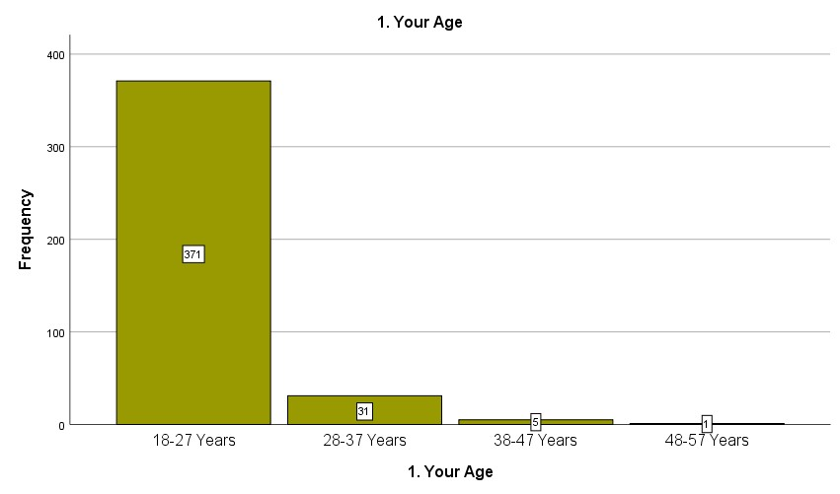

**4.2.2 Profession of the respondents:**

|  |  |  |  |  |  |
| --- | --- | --- | --- | --- | --- |
|  |  | **2. Profession** | |  |  |
|  |  | Frequency | Percent | Valid Percent | Cumulative  Percent |
| Valid | Student | 345 | 84.6 | 84.6 | 84.6 |
| Govt. Employee | 28 | 6.9 | 6.9 | 91.4 |
| Non-Govt. Employee | 13 | 3.2 | 3.2 | 94.6 |
| Businessman | 7 | 1.7 | 1.7 | 96.3 |
| Unemployed | 15 | 3.7 | 3.7 | 100.0 |
| Total | 408 | 100.0 | 100.0 |  |

From the chart, it has been found that 84.6 % of the total respondents are students, while 6.9% are government employees, 3.2% are non-government employees, 1.7% are businessmen, and 3.7% are unemployed, respectively.

**4.2.3 Education of the respondents:**

|  |  |  |  |  |  |
| --- | --- | --- | --- | --- | --- |
|  |  | **3. Education** | |  |  |
|  |  | Frequency | Percent | Valid Percent | Cumulative  Percent |
| Valid | SSC Level | 2 | .5 | .5 | .5 |
|  | HSC Level | 8 | 2.0 | 2.0 | 2.5 |
| Graduation Level | 300 | 73.5 | 73.5 | 76.0 |
| Post-Graduation Level | 90 | 22.1 | 22.1 | 98.0 |
| Doctoral Level | 2 | .5 | .5 | 98.5 |
| More | 6 | 1.5 | 1.5 | 100.0 |
| Total | 408 | 100.0 | 100.0 |  |

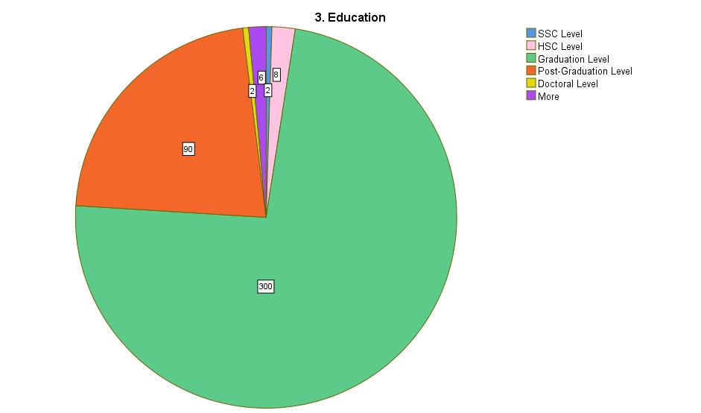

**4.2.4 Income of the respondents:**

From the chart, it has been found that 33.8% of the total respondents’ monthly income is less than 10,000 Tk. while 24.3% are between 10,000 and 20,000, 15.7% are between 20,001 and 30,000, 12.0% are between 30,001 and 40,000, 8.8% are between 40,001 and 50000, and 5.4% are Tk. 50,001 and above.

|  |  |  |  |  |  |
| --- | --- | --- | --- | --- | --- |
|  | **4. Your/Your Parents’ Monthly Income** | | | |  |
|  |  | Frequency | Percent | Valid Percent | Cumulative  Percent |
| Valid | Less than Tk.10, 000 | 138 | 33.8 | 33.8 | 33.8 |
| Tk. 10,001 – 20,000 | 99 | 24.3 | 24.3 | 58.1 |
| Tk. 20,001 - 30,000 | 64 | 15.7 | 15.7 | 73.8 |
| Tk. 30,001 - 40,000 | 49 | 12.0 | 12.0 | 85.8 |
| Tk. 40,001 - 50,000 | 36 | 8.8 | 8.8 | 94.6 |
| Tk. 50,001 and above | 22 | 5.4 | 5.4 | 100.0 |
| Total | 408 | 100.0 | 100.0 |  |

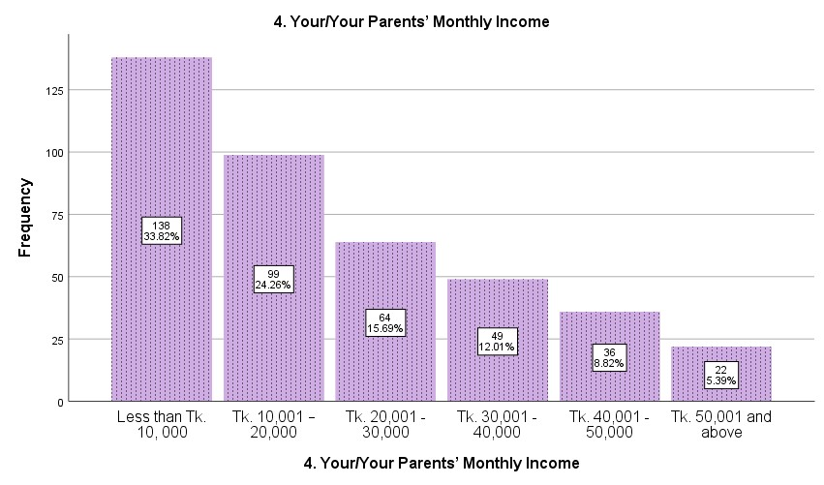

**4.2.5 Gender of the respondents:**

From the chart it has been found that 63.0% of the total respondents are male where as 37.0% of the total respondents are female.

|  |  |  |  |  |  |
| --- | --- | --- | --- | --- | --- |
|  |  |  | **5. Gender** |  |  |
|  |  | Frequency | Percent | Valid Percent | Cumulative Percent |
| Valid | Male | 257 | 63.0 | 63.0 | 63.0 |
| Female | 151 | 37.0 | 37.0 | 100.0 |
| Total | 408 | 100.0 | 100.0 |  |

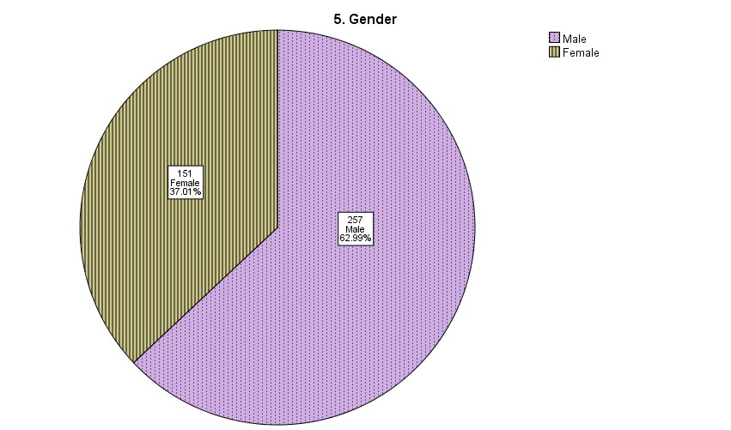

**4.2.6 Marital Status of the respondents:**

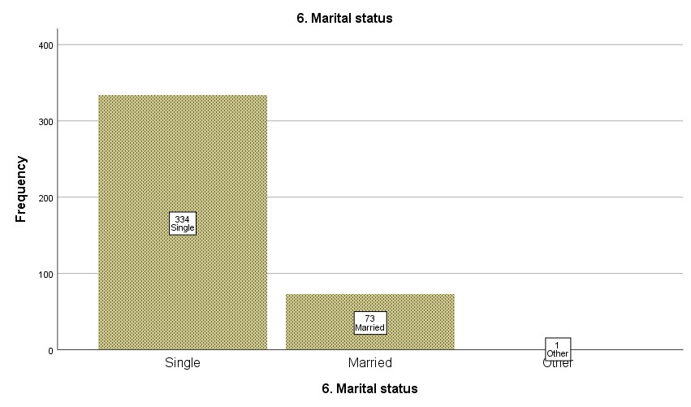

|  |  |  |  |  |  |
| --- | --- | --- | --- | --- | --- |
|  |  | **6. Marital status** | | |  |
|  |  | Frequency | Percent | Valid Percent | Cumulative Percent |
| Valid | Single | 334 | 81.9 | 81.9 | 81.9 |
| Married | 73 | 17.9 | 17.9 | 99.8 |
| Other | 1 | .2 | .2 | 100.0 |
| Total | 408 | 100.0 | 100.0 |  |

From the chart, it has been found that 81.9 percent of the total respondents’ marital status is single, 17.9% of the total respondents are married, and .2% of the total respondents' is other.

**4.2.7 Respondent Comes from:**

From the chart, it has been found that 6.6% of the total respondents are from Rajshahi division, 17.9% are from Dhaka division, 6.9% are from Chattogram division, 49.5% are from Khulna division, 6.1% are from Barishal, 2.9% are from Sylhet, 6.6% are from Rangpur, and 3.4% are from Mymensingh division.

|  |  |  |  |  |  |
| --- | --- | --- | --- | --- | --- |
|  |  | **7. You are from which Division** | | |  |
|  |  | Frequency | Percent | Valid Percent | Cumulative Percent |
| Valid | Rajshahi | 27 | 6.6 | 6.6 | 6.6 |
| Dhaka | 73 | 17.9 | 17.9 | 24.5 |
| Chattogram | 28 | 6.9 | 6.9 | 31.4 |
| Khulna | 202 | 49.5 | 49.5 | 80.9 |
| Barishal | 25 | 6.1 | 6.1 | 87.0 |
| Sylhet | 12 | 2.9 | 2.9 | 90.0 |
| Rangpur | 27 | 6.6 | 6.6 | 96.6 |
| Mymensingh | 14 | 3.4 | 3.4 | 100.0 |
| Total | 408 | 100.0 | 100.0 |  |

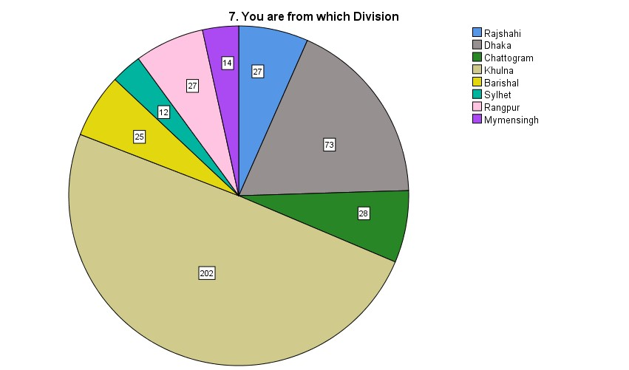

**4.2.8 How familiar are you with the terms "Artificial Intelligence (AI)" and "Machine Learning (ML)"?**

|  |  |  |  |  |  |
| --- | --- | --- | --- | --- | --- |
|  |  | Frequency | Percent | Valid Percent | Cumulative  Percent |
| Valid | Extremely Familiar | 69 | 16.9 | 16.9 | 16.9 |
| Very Familiar | 198 | 48.5 | 48.5 | 65.4 |
| Moderately Familiar | 112 | 27.5 | 27.5 | 92.9 |
| Slightly Familiar | 29 | 7.1 | 7.1 | 100.0 |
| Total | 408 | 100.0 | 100.0 |  |

**4.2.9 How would you describe your understanding of digital marketing?**

|  |  |  |  |  |  |
| --- | --- | --- | --- | --- | --- |
|  |  | Frequency | Percent | Valid Percent | Cumulative Percent |
| Valid | Advanced | 103 | 25.2 | 25.2 | 25.2 |
| Intermediate | 142 | 34.8 | 34.8 | 60.0 |
| Basic | 156 | 38.2 | 38.2 | 98.3 |
| Novice | 7 | 1.7 | 1.7 | 100.0 |
| Total | 408 | 100.0 | 100.0 |  |

**4.2.10 If you were to learn more about AI and ML in the context of digital marketing, what format would you prefer?**

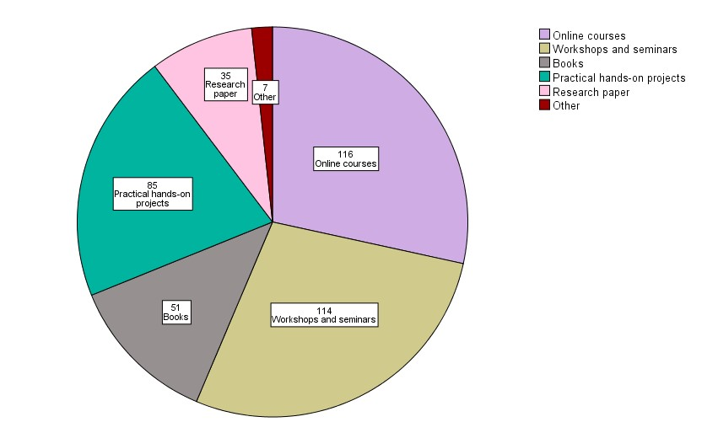

**4.2.11 In your opinion, how effective are AI and ML in enhancing the effectiveness of digital marketing strategies?**

|  |  |  |  |  |  |
| --- | --- | --- | --- | --- | --- |
|  |  | Frequency | Percent | Valid Percent | Cumulative Percent |
| Valid | Strongly Effective | 97 | 23.8 | 23.8 | 23.8 |
| Very Effective | 165 | 40.4 | 40.4 | 64.2 |
| Effective | 115 | 28.2 | 28.2 | 92.4 |
| Neutral | 28 | 6.9 | 6.9 | 99.3 |
| Ineffective | 1 | .2 | .2 | 99.5 |
| Very Ineffective | 2 | .5 | .5 | 100.0 |
| Total | 408 | 100.0 | 100.0 |  |

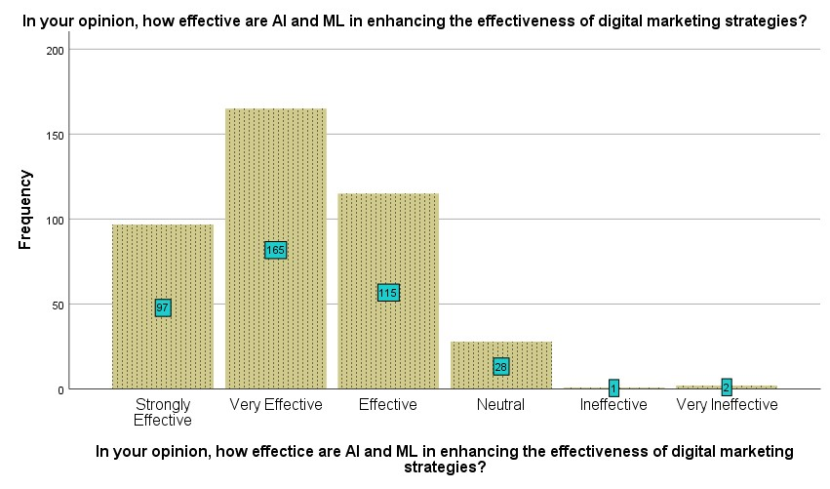

**4.2.12 Would you be interested in learning more about AI and ML applications in Digital Marketing?**

|  |  |  |  |  |  |
| --- | --- | --- | --- | --- | --- |
|  |  | Frequency | Percent | Valid Percent | Cumulative Percent |
| Valid | Yes | 372 | 91.2 | 91.2 | 91.2 |
| No | 36 | 8.8 | 8.8 | 100.0 |
| Total | 408 | 100.0 | 100.0 |  |

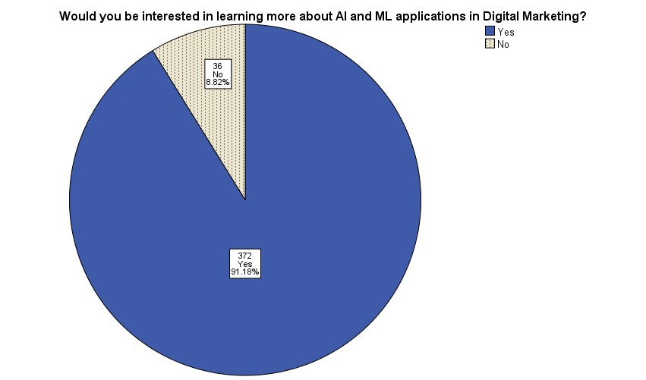

#### 4.3 Factor Analysis

In this context, factor reduction technique is deeply used because of the reason that maximum items are borrowed from existing literature, we wanted to check that whether the elements support the respective factors.

##### 4.3.1 Chatbots

|  |  |
| --- | --- |
| **Co** | **mponent Matrixa** |
|  | Component |
| 1 |
| CB1 | .671 |
| CB2 | .624 |
| CB3 | .684 |
| CB4 | .622 |
| CB5 | .571 |

We have gone through in the factor reduction technique and seen that the variables represent the factor (**Chatbots**).Because the elements exist in one component.

##### 4.3.2 Advertisement Refinement

|  |  |
| --- | --- |
| **Co** | **mponent Matrixa** |
|  | Component |
| 1 |
| AR1 | .587 |
| AR2 | .714 |
| AR3 | .674 |
| AR4 | .381 |
| AR5 | .613 |

After gone through in the factor reduction technique and seen that the variables represent the factor (**Advertisement Refinement**).Because the elements exist in one component.

##### 4.3.3 Email Marketing

|  |  |
| --- | --- |
| **Co** | **mponent Matrixa** |
|  | Component |
| 1 |
| EM1 | .503 |
| EM2 | .674 |
| EM3 | .645 |
| EM4 | .609 |
| EM5 | .681 |

We can say Cost Effectiveness, Instant Feedback, High Number of Responses, PermissionBased Approach these elements support the construct due to the analysis in the factor reduction technique and seen that the variables represent the factor (**Email Marketing**). Because the elements exist in one component.

**4.3.4 Automated Content Creation:**

|  |  |
| --- | --- |
| **Co** | **mponent Matrixa** |
|  | Component |
| 1 |
| AC1 | .600 |
| AC2 | .676 |
| AC3 | .692 |
| AC4 | .610 |
| AC5 | .657 |

We have gone through in the factor reduction technique and seen that the variables represent the factor (**Automated Content Creation)**.Because the elements exist in one component.

##### 4.3.5 Sentiment analysis in social media

|  |  |
| --- | --- |
| **Co** | **mponent Matrixa** |
|  | Component |
| 1 |
| SA1 | .620 |
| SA2 | .632 |
| SA3 | .666 |
| SA4 | .604 |
| SA5 | .613 |

We have gone through in the factor reduction technique and seen that variables of sentiment analysis in social media strongly represent the factor. Trends & Popularity, Content Creation Tools, Data-Driven Recommendations these are supportive elements of sentiment analysis in social media.

##### 4.3.6 Personalized Recommendation

|  |  |
| --- | --- |
| **Component Matrixa** | |
|  | Component |
| 1 |
| PR1 | .582 |
| PR2 | .710 |
| PR3 | .670 |
| PR4 | .691 |
| PR5 | .638 |

We have gone through in the factor reduction technique and seen that the variables represent the factor (Personalized Recommendation).Because the elements exist in one component.

**4.3.7 Artificial Intelligence and Machine Learning in Digital Marketing.**

|  |  |
| --- | --- |
| **Component Matrixa** | |
|  | Component |
| 1 |
| AI and ML in DM1 | .686 |
| AI and ML in DM2 | .713 |
| AI and ML in DM3 | .424 |
| AI and ML in DM4 | .713 |
| AI and ML in DM5 | .549 |

We have gone through in the factor reduction technique and seen that the variables represent the factor (AI & ML in DM).Because the elements exist in one component.

### Table 4.1: Mean and Standard Deviation

|  |  |  |  |
| --- | --- | --- | --- |
| **Item Code** | **Item Description** | **Mean** | **Std.**  **Deviation** |
|  | **Chatbots** |  |  |
| **CB1** | The information provided by chatbots is **transparent** regarding product details and pricing. | 4.9534 | .91145 |
| **CB2** | Chatbots tailor their responses **based on the preferences** of the stakeholder. | 4.8407 | .93083 |
| **CB3** | The information provided by chatbots is **accurate** in guiding the decision-making process. | 4.6593 | 1.06962 |
| **CB4**: | **The availability** of chatbots across **various digital platforms** enhances your overall experience as a customer | 4.7475 | 1.05500 |
| **CB5**: | Interacting with chatbots in e-commerce is more **convenient** than traditional methods. | 4.8088 | 1.14232 |
|  | **Advertisement Refinement** |  |  |
| **AR1** | The **personalized** content in **digital marketing campaigns** effectively captures attention | 5.0196 | .87813 |
| **AR2** | The digital marketing **channels** that have been selected for advertising (such as social media, email, and search) suit my interests. | 4.9583 | .98924 |

|  |  |  |  |
| --- | --- | --- | --- |
| **AR3** | The **impact** of digital marketing campaigns on **customers** (e.g., brand perception, purchase behavior) is accurately **measured** | 4.7181 | 1.12224 |
| **AR4** | It is believed that **personal data** in the context of digital marketing campaigns is handled appropriately. | 4.1373 | 1.32293 |
| **AR5** | The alignment of campaigns with **market dynamics** is essential for sustained success. | 4.7353 | 1.12969 |
|  | **Email Marketing** |  |  |
| **EM1** | Email marketing is a **cost-effective** way for businesses to reach their target audience | 4.9338 | 1.02453 |
| **EM2** | It is appreciated receiving **instant feedback** or responses when interacting with email campaigns | 4.6324 | 1.14636 |
| **EM3** | **Permission-based** email marketing is essential for avoiding **spam**-related issues. | 4.8309 | 1.05072 |
| **EM4** | Email marketing yields a **high number of responses** compared to other digital marketing methods | 4.4951 | 1.23622 |
| **EM5** | Email marketing that is performed by  **demographic segmentation** (such as age, gender, income level, and education) enhances the effectiveness of marketing campaigns. | 4.7353 | 1.08532 |
|  | **Automated Content Creation** |  |  |
| **AC1** | AI-based content creation ensures the content's **popularity** with the targeted audience and keeps up with current **trends** | 4.8922 | .98547 |
| **AC2** | **Tools** like Wordsmith & Word AI contribute to the effectiveness and ease of AI-driven **content creation**. | 4.7279 | .96219 |
| **AC3** | AI-generated **personalized content** increases overall engagement by meeting the unique demands and interests of each individual consumer | 4.7377 | 1.02420 |
| **AC4** | Content that is **recommended by data-driven** insights has a positive impact on the success of  digital marketing campaigns | 4.6863 | 1.00593 |
| **AC5** | Marketing campaigns are more successful when automated creation of content is driven by **customer data analysis.** | 4.8603 | 1.07808 |

|  |  |  |  |
| --- | --- | --- | --- |
|  | **Sentiment Analysis in Social Media** |  |  |
| **SA1** | The adoption of advanced **machine learning techniques** has significantly improved the accuracy of sentiment analysis on social media | 4.9804 | .97114 |
| **SA2** | **User reviews and comments** on social media provide valuable insights into brand perception | 4.9657 | 1.02009 |
| **SA3** | **Emoticons** (Convey emotions and attitudes) contribute significantly to the overall sentiment expressed in social media content. | 4.7525 | 1.13899 |
| **SA4** | The choice of **machine learning algorithms** significantly impacts the accuracy of sentiment analysis models. | 4.7279 | .97739 |
| **SA5** | Sentiment analysis should consider **brand popularity and user-generated content** for effective digital marketing strategies | 4.8799 | 1.02441 |
|  | **Personalized Recommendation** |  |  |
| **PR1** | Personalized suggestions enhance people’s **loyalty** to the digital platform. | 4.9877 | 1.04322 |
| **PR2** | The recommendations that are received by customers consider both current **preferences and past order history** | 4.8431 | .98385 |
| **PR3** | **The combination of different recommendation** approaches enhances the quality of suggestions. | 4.8995 | 1.01691 |
| **PR4** | It is appreciable when **websites** provide a personalized and **tailored experience** based on preferences. | 4.7402 | 1.10222 |
| **PR5** | The use of **advanced AI algorithms** improves the accuracy of recommendations. | 4.8824 | 1.13505 |
|  | **AI and ML in Digital Marketing** |  |  |
| **AI and ML in DM1** | Implementing AI and ML in digital marketing strategies results in an increased **return on investment.** | 4.7721 | .98115 |
| **AI and ML in DM2** | AI and ML tools effectively analyze customer behavior and enhance overall **customer experience.** | 4.8922 | .89395 |
| **AI and ML in DM3** | AI and ML technologies contribute to the **professional production** of digital marketing content. | 4.9265 | .91640 |
| **AI and ML in DM4** | AI and ML contribute significantly to the **improvement of website design** and overall digital marketing strategies. | 4.9853 | 1.02776 |
| **AI and ML in DM5** | AI and ML-driven customization in digital marketing positively impacts **sales development**. | 4.5098 | 1.16876 |

The analysis of the measurement model started with the analysis of mean and standard deviation (SD) of the samples. The results in **table 4.1** suggested that mean scores were in between 4.13 to 5.01 and SD scores were between 0.87 and 1.32. So the data trend was found satisfactory. This study examined validity and reliability for the measurement items and their constructs using SPSS algorithm procedure.

#### 4.4 Measurement Model Assessment

The research model of this study was tested using partial least squares (PLS). Smart PLS version 4 was used to evaluate the measurement and structural models of this study. The statistical program evaluates the psychometric attributes of the measurement model and estimates the parameters of the structural model.

##### 4.4.1 Indicator Reliability

The indicator reliability of the measurement model is measured by looking at the item loadings. According to the guiding principle of validity, when the loading of each item is at least 0.70 (≥ 0.70; in exploratory studies loadings of 0.40 are acceptable; Hair, Ringle, & Sarstedt, 2013). Accepted cut off point in this study is ≥ 0.535. Based on the PLS-SEM analysis, all items except AI & ML in DM (.535) showed a loading of more than 0.6 **(Table 4.2**). It suggested that indicators used in this research are reliable with minimum loading scores 0.70. Therefore, it can be said that all items in this study exceeded 0.6, showing satisfactory indicator reliability.

##### 4.4.2 Discriminant Validity

As discussed in Chapter 3, a measurement model has discriminant validity when 1) the square root of the AVE exceeds the inter-correlations between the respective construct and all other constructs, and 2) the indicators’ loadings are higher against their respective construct compared to other constructs. The study also assessed the discriminant validity at item level comparing the loadings and cross-loadings of the measures. The loading of items within a construct (shown in columns) should be greater than the loading of any other item in order to prove discriminant validity among the constructs (Barclay et al., 1995). **Table 4.2** shows the loadings and cross-loadings **(Table 4.4)** of items and constructs in the cross-loading matrix. The cross-loading matrix displayed high correlations between constructs and relevant measurement items. All reflective constructs of the model showed high correlation, with their respective measurement items being also significantly higher than the items in the same column measuring other constructs, the only exception being EM1 (.450) and SA (.502) represents a very low correlation. Finally, it was concluded that the model now demonstrated discriminant validity.

The study verified the discriminant validity of the instruction by examining the AVE of individual latent constructs to determine if the value is greater than the squared correlation between constructs and all other construct (Koufteros, 1998). **Table 4.3** shows that square root of the AVE score (diagonal element in bold) were all highest than the correlation among the constructs (off diagonal elements) in the row and column.

##### 4.4.3 Internal Consistency Reliability

When the composite reliability (CR) of each structure exceeds a threshold of 0.7, the measurement model has satisfactory internal consistency reliability. **Table 4.3** shows that the CR range for each construct in this study was 0.717 to 0.791, except 0.535 and this was above the recommended threshold of 0.7.

Composite reliability is considered to be superior to the traditional measures of consistency because it is not influenced by the number of indicators (Hanlon, 2001). Constructs with a coefficient value of 0.70 or more in the estimates of composite reliability were accepted as reliable for further analysis (as suggested by Igbaria et al., 1997; Barclay et al., 1995; Hair et al., 2011). As shown in **Table 4.3** all constructs met this criterion. The reflective construct competitiveness had the lowest AI and ML in DM of 0.535 while Personalized Recommendation Use in Digital Marketing had the highest of 0.791. Therefore, the results show that the items used to represent the structure have satisfactory internal consistency reliability.

##### 4.4.4 Convergent Validity

In this study, the measurement model’s convergent validity is assessed by examining its average variance extracted (AVE) value. Convergent validity is adequate when constructs have an average variance extracted (AVE) value of at least 0.5 or more (≥ 0.5) (Hair et al., 2013). According to, **(Fornell & Larcker, 1981)**, Convergent validity is adequate when constructs have an average variance extracted (AVE) value of at least 0.4 or more (≥ 0.4). **Table 4.3** shows that all constructs have AVE exceeding 0.5 except for AR (0.45) & AI and ML in DM (0.39); on the other hand, sentiment analysis (0.49), however, this values are very close to 0.5, the minimum value for adequate convergence, and thus are accepted for further analysis. This result shows that the study’s measurement model has demonstrated adequate convergent validity.

### Table 4.2: Loading Matrix

|  |  |  |  |
| --- | --- | --- | --- |
| **Item Code** | **Item Description** | **Loading**  **(test 1)** | **Loading**  **(test 2)** |
|  | **Chatbots** |  |  |
| **CB1** | The information provided by chatbots is **transparent** regarding product details and pricing. | .63 | .63 |
| **CB2** | Chatbots tailor their responses **based on the preferences** of the stakeholder. | .53 | .53 |
| **CB3** | The information provided by chatbots is **accurate** in guiding the decision-making process. | .69 | .70 |
| **CB4**: | **The availability** of chatbots across **various digital platforms** enhances your overall experience as a customer | .63 | .63 |

|  |  |  |  |
| --- | --- | --- | --- |
| **CB5**: | Interacting with chatbots in e-commerce is more **convenient** than traditional methods. | .65 | .66 |
|  | **Advertisement Refinement** |  |  |
| **AR1** | The **personalized** content in **digital marketing campaigns** effectively captures attention | .59 | .60 |
| **AR2** | The digital marketing **channels** that have been selected for advertising (such as social media, email, and search) suit my interests. | .64 | .64 |
| **AR3** | The **impact** of digital marketing campaigns on **customers** (e.g., brand perception, purchase behavior) is accurately **measured** | .82 | .83 |
| **AR4** | It is believed that **personal data** in the context of digital marketing campaigns is handled appropriately. | .64 | .64 |
| **AR5** | The alignment of campaigns with **market dynamics** is essential for sustained success. | .55 | .56 |
|  | **Email Marketing** |  |  |
| **EM1** | Email marketing is a **cost-effective** way for businesses to reach their target audience | .45 | .45 |
| **EM2** | It is appreciated receiving **instant feedback** or responses when interacting with email campaigns | .66 | .67 |
| **EM3** | **Permission-based** email marketing is essential for avoiding **spam**-related issues. | .60 | .60 |
| **EM4** | Email marketing yields a **high number of responses** compared to other digital marketing methods | .69 | .69 |
| **EM5** | Email marketing that is performed by **demographic segmentation** (such as age, gender, income level, and education) enhances the effectiveness of marketing campaigns. | .67 | .67 |
|  | **Automated Content Creation** |  |  |
| **AC1** | AI-based content creation ensures the content's **popularity** with the targeted audience and keeps up with current **trends** | .63 | .63 |
| **AC2** | **Tools** like Wordsmith & Word AI contribute to the effectiveness and ease of AI-driven **content creation**. | .60 | .60 |

|  |  |  |  |
| --- | --- | --- | --- |
| **AC3** | AI-generated **personalized content** increases overall engagement by meeting the unique demands and interests of each individual consumer | .74 | .74 |
| **AC4** | Content that is **recommended by data-driven** insights has a positive impact on the success of  digital marketing campaigns | .62 | .63 |
| **AC5** | Marketing campaigns are more successful when automated creation of content is driven by **customer data analysis.** | .60 | .61 |
|  | **Sentiment Analysis in Social Media** |  |  |
| **SA1** | The adoption of advanced **machine learning techniques** has significantly improved the accuracy of sentiment analysis on social media | .50 | .50 |
| **SA2** | **User reviews and comments** on social media provide valuable insights into brand perception | .80 | .80 |
| **SA3** | **Emoticons** (Convey emotions and attitudes) contribute significantly to the overall sentiment expressed in social media content. | .60 | .60 |
| **SA4** | The choice of **machine learning algorithms** significantly impacts the accuracy of sentiment analysis models. | .77 | .77 |
| **SA5** | Sentiment analysis should consider **brand popularity and user-generated content** for effective digital marketing strategies | .66 | .67 |
|  | **Personalized Recommendation** |  |  |
| **PR1** | Personalized suggestions enhance people’s **loyalty** to the digital platform. | .54 | .54 |
| **PR2** | The recommendations that are received by customers consider both current **preferences and past order history** | .67 | .68 |
| **PR3** | **The combination of different recommendation** approaches enhances the quality of suggestions. | .67 | .67 |
| **PR4** | It is appreciable when **websites** provide a personalized and **tailored experience** based on preferences. | .74 | .74 |
| **PR5** | The use of **advanced AI algorithms** improves the accuracy of recommendations. | .64 | .64 |
|  | **AI and ML in Digital Marketing** |  |  |
| **AI and ML in DM1** | Implementing AI and ML in digital marketing strategies results in an increased **return on investment.** | .68 | .69 |
| **AI and ML in DM2** | AI and ML tools effectively analyze customer behavior and enhance overall **customer experience.** | .71 | .71 |
| **AI and ML in DM3** | AI and ML technologies contribute to the **professional production** of digital marketing content. | .75 | .75 |
| **AI and ML in DM4** | AI and ML contribute significantly to the **improvement of website design** and overall digital marketing strategies. | .75 | .76 |
| **AI and ML in DM5** | AI and ML-driven customization in digital marketing positively impacts **sales development**. | .74 | .74 |

### Table 4.3: Psychometric properties for the constructs

|  |  |  |  |
| --- | --- | --- | --- |
| **Overview** |  |  |  |
|  | **AVE** | **Composite Reliability** | **R Square** |
| **CB** | **0.50** | **0.767** | **0** |
| **AR** | **0.45** | **0.717** | **0** |
| **EM** | **0.52** | **0.757** | **0** |
| **AC** | **0.55** | **0.779** | **0** |
| **SA** | **0.49** | **0.747** | **0** |
| **PR** | **0.56** | **0.791** | **0** |
| **AI & ML in**  **DM** | **0.39** | **0.535** | **0.341** |

**Table 4.4: The Cross Loading Output Using Smart PLS4**

|  |  |  |  |  |  |  |  |
| --- | --- | --- | --- | --- | --- | --- | --- |
| **Cross Loading** | AC | AI and  ML in  DM | AR | CB | EM | PR | SA |
| AC1 | **0.633** | 0.206 | 0.322 | 0.334 | 0.31 | 0.326 | 0.386 |
| AC2 | **0.600** | 0.135 | 0.375 | 0.411 | 0.498 | 0.411 | 0.406 |
| AC3 | **0.742** | 0.252 | 0.371 | 0.386 | 0.429 | 0.446 | 0.408 |
| AC4 | **0.627** | 0.192 | 0.394 | 0.344 | 0.391 | 0.373 | 0.336 |
| AC5 | **0.609** | 0.155 | 0.37 | 0.358 | 0.43 | 0.463 | 0.421 |
| AIandMLinDM1 | 0.122 | **0.686** | 0.055 | 0.064 | 0.152 | 0.105 | 0.12 |
| AIandMLinDM2 | 0.242 | **0.713** | -0.001 | 0.077 | -0.052 | 0.001 | -0.021 |
| AIandMLinDM3 | 0.242 | **0.750** | 0.04 | 0.146 | 0.108 | 0.038 | 0.086 |
| AIandMLinDM4 | 0.222 | **0.754** | 0.215 | 0.193 | 0.21 | 0.217 | 0.358 |
| AIandMLinDM5 | 0.224 | **0.742** | 0.379 | 0.164 | 0.161 | 0.132 | 0.188 |
| AR1 | 0.233 | 0.136 | **0.595** | 0.203 | 0.267 | 0.294 | 0.307 |
| AR2 | 0.396 | 0.189 | **0.643** | 0.36 | 0.354 | 0.368 | 0.366 |
| AR3 | 0.391 | 0.384 | **0.826** | 0.351 | 0.376 | 0.313 | 0.402 |
| AR4 | 0.233 | 0.091 | **0.644** | 0.269 | 0.21 | 0.091 | 0.143 |
| AR5 | 0.432 | 0.188 | **0.555** | 0.351 | 0.398 | 0.374 | 0.404 |
| CB1 | 0.306 | 0.139 | 0.26 | **0.630** | 0.314 | 0.377 | 0.345 |
| CB2 | 0.375 | 0.095 | 0.303 | **0.531** | 0.378 | 0.425 | 0.361 |
| CB3 | 0.361 | 0.172 | 0.355 | **0.698** | 0.383 | 0.353 | 0.364 |
| CB4 | 0.398 | 0.164 | 0.327 | **0.631** | 0.299 | 0.372 | 0.391 |
| CB5 | 0.349 | 0.189 | 0.336 | **0.657** | 0.36 | 0.337 | 0.31 |
| EM1 | 0.268 | 0.106 | 0.151 | 0.154 | **0.450** | 0.267 | 0.187 |
| EM2 | 0.332 | 0.174 | 0.312 | 0.38 | **0.666** | 0.317 | 0.341 |
| EM3 | 0.402 | 0.152 | 0.35 | 0.325 | **0.603** | 0.437 | 0.434 |
| EM4 | 0.438 | 0.217 | 0.404 | 0.412 | **0.692** | 0.351 | 0.346 |
| EM5 | 0.475 | 0.171 | 0.385 | 0.353 | **0.672** | 0.421 | 0.483 |
| PR1 | 0.368 | 0.116 | 0.292 | 0.295 | 0.343 | **0.541** | 0.411 |
| PR2 | 0.415 | 0.144 | 0.353 | 0.444 | 0.407 | **0.678** | 0.52 |
| PR3 | 0.391 | 0.158 | 0.276 | 0.364 | 0.36 | **0.672** | 0.452 |
| PR4 | 0.446 | 0.199 | 0.372 | 0.393 | 0.38 | **0.741** | 0.458 |
| PR5 | 0.413 | 0.151 | 0.286 | 0.392 | 0.41 | **0.642** | 0.436 |
| SA1 | 0.318 | 0.115 | 0.33 | 0.31 | 0.345 | 0.411 | **0.502** |
| SA2 | 0.433 | 0.37 | 0.412 | 0.338 | 0.382 | 0.443 | **0.803** |
| SA3 | 0.411 | 0.184 | 0.336 | 0.446 | 0.394 | 0.505 | **0.603** |
| SA4 | 0.304 | 0.177 | 0.304 | 0.379 | 0.349 | 0.396 | **0.773** |
| SA5 | 0.408 | 0.158 | 0.346 | 0.32 | 0.41 | 0.471 | **0.668** |

**Source: Field Study**

The second assessment of discriminant validity is to check the indicators loading on all structural correlations. The output of cross loadings are generated by the SmartPLS4 algorithm function. **Table 4.4** shows the output of cross-loading between structures and indicators. **Table 4.4** also shows that the load of all measurement items is higher than their respective intended latent variables compared to other variables. The table also demonstrated that the loading of each block is higher than any other block in the same rows and columns. Loading clearly separates each latent variable in the conceptual model. Therefore, the cross-loading output confirms that the second assessment of the discriminant validity of the measurement model is satisfied. Therefore, the study concluded that the measurement model has determined its discriminant validity.

**Table 4.5: Inter-correlation Matrix**

|  |  |  |  |  |  |  |  |  |
| --- | --- | --- | --- | --- | --- | --- | --- | --- |
|  | **Correlations** | | | | |  |  |  |
|  |  | CB | AR | EM | AC | SA | PR | AI and  ML in  DM |
| CB | Pearson  Correlation | 1 | .492** | .287** | .243** | .190** | .356** | .416** |
| Sig. (2-tailed) |  | .000 | .000 | .000 | .000 | .000 | .000 |
| N | 408 | 408 | 408 | 408 | 408 | 408 | 408 |
| AR | Pearson  Correlation | .299* | 1 | .212** | .173** | .346** | .236** | .588** |
| Sig. (2-tailed) | .000 |  | .000 | .000 | .000 | .000 | .000 |
| N | 408 | 408 | 408 | 408 | 408 | 408 | 408 |
| EM | Pearson  Correlation | .331** | .212** | 1 | .214** | .216** | .144** | .102* |
| Sig. (2-tailed) | .000 | .000 |  | .000 | .000 | .000 | .000 |
| N | 408 | 408 | 408 | 408 | 408 | 408 | 408 |
| AC | Pearson  Correlation | .243** | .173** | .214** | 1 | .296** | .314** | .099* |
| Sig. (2-tailed) | .000 | .000 | .000 |  | .000 | .000 | .000 |
| N | 408 | 408 | 408 | 408 | 408 | 408 | 408 |
| SA | Pearson  Correlation | .190** | .346** | .216** | .296** | 1 | .322** | .226** |
| Sig. (2-tailed) | .000 | .000 | .000 | .000 |  | .000 | .000 |
|  | N | 408 | 408 | 408 | 408 | 408 | 408 | 408 |
| PR | Pearson  Correlation | .356** | .236** | .144** | .314** | .322** | 1 | .328** |
| Sig. (2-tailed) | .000 | .000 | .000 | .000 | .000 |  | .000 |
| N | 408 | 408 | 408 | 408 | 408 | 408 | 408 |
| AI and ML in DM | Pearson  Correlation | .287** | .331** | .403** | .265** | .226** | .342** | 1 |
| Sig. (2-tailed) | .000 | .000 | .000 | .000 | .000 | .000 |  |
| N | 408 | 408 | 408 | 408 | 408 | 408 | 408 |
| **. Correlation is significant at the 0.01 level (2-tailed). | | | | | |  |  |  |

The findings of inter-correlation matrix suggested that adequate discriminant validity of the measurement model (see Table 4.5). The above discussed dimensions and their accepted assessments scores confirmed the validity and reliability of the measurement model of current study.

#### 4.5 Structural Model

To assess nomological (denoting principles that resembles laws) validity, a structural model was developed which comprised 7 variables. The path co-efficient and t-values were calculated address the effects of the construct and their underlying relationships according to the proposed theoretical framework. The hypothesized relationships between the construct could be calculated by two methods, namely “bootstrap” or “jackknife”(Gefen et al. 2000).” Bootstrap” is popularly used within the PLS framework as it produces both a t- values and R^2 value.

The technique which bootstrapping employs for calculating the t-statistic is similar to the traditional t-test that is also used to interpret the significance of the paths between study constructs (Barclay et al. 1995) interpreted in a similar way in multiple regression analysis, the R^2 value is also used to indicate the explanatory power of exogenous variable within a model. In other words, this value estimates the variance associated with the endogenous construct; thus the proposed overall model could be evaluated. It is important to note that PLS had some advantage as it was ideal for assessing the path loadings and structural relationship between the study construct which could handle both formatting and reflective construct (Chin & Newsted,1999;Hanlon, 2001); it also did not require the normal distribution of the data.

The structural model deals with testing the hypothesized relationships. As stated earlier the bootstrap method has been used to test the hypotheses. The detailed result of path coefficient and t-statistics are summarized in **Table 4.5**

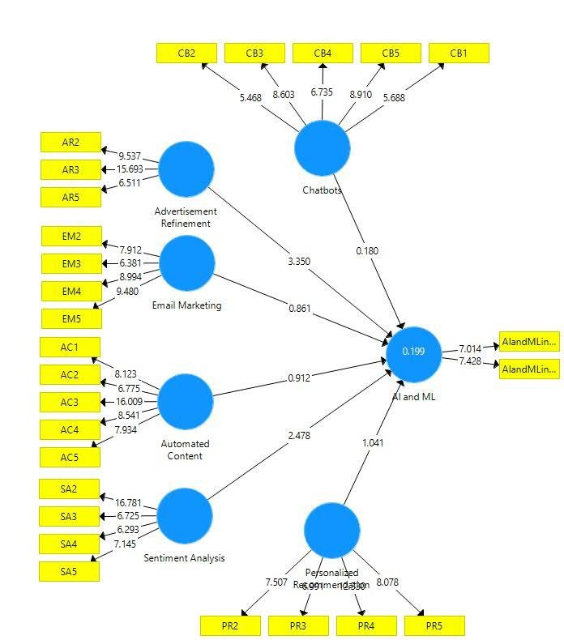

### Figure 4.1: The comprehensive model estimates

CB = Chatbots, AR = Advertisement Refinement, EM= Email Marketing, AC= Automated

Content Creation, SA= Sentiment Analysis in Social Media, PR = Personalized Recommendation, AI = Artificial Intelligence, ML = Machine Learning, DM = Digital Marketing.

### Table 4.6 Result of the structural model

|  |  |  |  |  |  |
| --- | --- | --- | --- | --- | --- |
|  |  | Coefficient(β) | T Statistics | Significant | Comment |
| H1 | CB -> AI and ML in  DM | -0.010 | 0.177 |  | Rejected |
| H2 | AR -> AI and ML in  DM | 0.306 | 3.341 | *** | Accepted |
| H3 | EM -> AI and ML in  DM | -0.058 | 0.862 |  | Rejected |
| H4 | AC -> AI and ML in  DM | 0.164 | 1.897 | ** | Accepted |
| H5 | SA -> AI and ML in  DM | 0.250 | 2.482 | *** | Accepted |
| H6 | PR -> AI and ML in DM | 0.213 | 2.047 | *** | Accepted |

#### 4.5.1 Path Relationships

In the structural model, each path connecting two latent variables represents one hypothesis. Based on the analysis of the structural model, researchers can confirm or reject each hypothesis, and can also understand the strength of the relationship between dependent variables and independent variables. Using SmartPLS4 algorithm output, check the relationship between independent variables and dependent variables. However, in SmartPLS4, the t-statistics for all paths are generated using the SmartPLS4 bootstrap function in order to test the significance level. Based on the t statistic output, the significance level of each relationship is determined. **Table 4.6** lists the path coefficients for all the hypothetical paths, the observed t-statistics and P-values. Using the results of the path assessment, determine the acceptance or rejection of the proposed hypothesis.

#### 4.5.2 Hypotheses Testing

In order to validate the proposed hypothesis and structural model, the path coefficients between the two latent variables were evaluated. Based on previous studies, the value of the path coefficient needs to be at least 0.1 to account for some influence within the model (Hair, Ringle & Sarstedt, 2011; Wetzels, Odekerken-Schröder & Van Oppen, 2009). Assessment of the path coefficient **(refer Table 4.6)** shows that all proposed hypotheses are supported, except for H1 and H3. From the analysis results, the supported hypothesis expected the sign direction (i.e., positive value) and consisted of path coefficient values (β) in the range of -0.058 to 0.306 **(see Table 4.6).**

### Table 4.7 Summary of Hypothesis Testing

|  |  |  |
| --- | --- | --- |
|  | **Hypothesis statement** | **Result** |
| H1 | Chatbots has a direct positive impact on using AI and ML in digital marketing. | Rejected |
| H2 | Advertisement Refinement has a direct positive impact on using AI and ML in digital marketing. | Accepted |
| H3 | Email Marketing has a direct positive impact on using AI and ML in digital marketing. | Rejected |
| H4 | Automated content creation has a direct positive impact on using AI and ML in digital marketing. | Accepted |
| H5 | Sentiment analysis in social media has a direct positive impact on using AI and ML in digital marketing. | Accepted |
| H6 | Personalized Recommendation has a direct positive impact on using AI and ML in digital marketing. | Accepted |

#### 4.6 Summary

This chapter has presented the results of the quantitative analysis of a nation-wide survey conducted in Bangladesh to study application of IT in tourism and hospitality industry. The study employed PLS-based structural equation modelling (SEM) with a data set of 408 samples in Bangladesh used for data analysis. The nature of the study (practical and exploratory), and the nature of the variables under study (reflective and formative) justified the use of the PLS technique as the main analytical tool. The procedures of data collection, data screening by investigating possible biases and data analysis were elaborated in detail.

The analysis of the data by PLS4 was performed in two stages (assessment of the measurement model and structural model estimation) which were reported separately. The measurement model was assessed by estimating the convergent validity and discriminant validity of the constructs. The convergent validity of the reflective indicators was examined by item loadings while weights of the items and absence of multicollinearity among them were the criteria for the formative indicators. Composite reliability and AVE were also computed to test convergent validity. The study examined the square root of AVE and inter-construct correlations for construct level discriminant validity, and the item crossloading matrix for item level discriminant validity of the study constructs. The hypotheses of the study were tested by estimating the structural model. The magnitude and degree of the estimates were examined by path coefficient and critical ratio (t-statistic) while the nomological validity was examined. The implications of these results and outcomes are discussed in Chapter 5.

**Chapter V**

## Discussion

### 5.1 Introduction

This chapter presents the discussion of the results and interpretation of quantitative data analysis. By applying a structural equation model (SEM) based on PLS, the estimation results show the degree and extent of the relationship between the constructs studied. The discussion of the results and their interpretation is based on the anticipated hypotheses and statistical estimates. This chapter discusses the results of each hypothesis.

**5.2 Role of Artificial Intelligence and Machine Learning in Digital**

### Marketing

The study explored the use of artificial intelligence and machine learning in digital marketing, assessing the influence of chatbots, advertisement refinement, email marketing, automated content creation, sentiment analysis in social media, and personalized recommendations. A total of six hypotheses were developed and tested using structural equation modeling technique. Assessment of the path relationships provides mixed findings.

**5.2.1 HYPOTHESIS H1**

Chatbots are artificial intelligence-driven software agents or computer programs that mimic human speech in a natural language setting (Zečević et al., 2020). Past studies (Zečević et al., 2020) have confirmed that , 1. The use of chatbots in advertising contributes to positive campaign outcomes and 2. The use of chatbots in advertising enhances user experience. Customers will probably appreciate engaging with chatbots, according to Kushwaha et al. (2021), and the results support this claim with a significance level of 95% or higher.

Variables such as transparency, personalization, accuracy, ubiquitous connectivity, and convenience have been used for chatbots to examine the impact of chatbots in digital marketing. The study found a negative correlation (β = -0.010, t = 0.177) between chatbots and the employment of AI and ML in digital marketing, which was rejected. This study has an indirect and detrimental impact on digital marketing, and there is no significant influence of chatbots on the use of AI and ML in digital marketing.

That means Chatbots plays a less important role in Digital Marketing.

**5.2.2 HYPOTHESIS** *H2*

The practice of improving and refining advertising content to make it more relevant and effective for the target audience is known as advertisement refinement. To study the influence of advertisement refinement on employing AI & ML in digital marketing, variables such Digital Marketing Campaign Optimization, Channel Performance, Customer influence Measurement, Customer Data Privacy, and Market Performance have been employed. Some studies have found no evidence to support advertisement refinement that has a significant impact on the use of AI and ML in Digital marketing (Wu et al., 2008; Gupta & Dogra,2017; Mutluet et al.,2017;Islam, Khan, Ramayah, & Hossain, 2011 and

Lu, & Su, 2009). The study found a significant positive correlation (β =0.306, t =3.341) between advertisement refinement and the application of AI and ML in digital marketing and was supported.

That means that advertisement refinement is critical in digital marketing, and marketers may utilize user data to design adverts more accurately, optimizing targeting and content for higher engagement and conversion rates.

**5.2.3 HYPOTHESIS** *H3*

Email marketing entails sending commercial messages to potential clients via software that maintains segmented lists depending on customer preferences and spending habits (Bala & Verma, 2018). To investigate the impact of email marketing on the use of AI and ML in digital marketing, variables such as cost effectiveness, instant feedback, permission-based approach, high number of responses, and demographic factors were used. The study shows that there is no significant relationship between email marketing (β =-0.058, t =0.862) and the use of AI and ML in digital marketing. Thus, the hypothesis was rejected. According to the result, there is no statistically significant relationship between EM and the use of AI and ML in DM.

**5.2.4 HYPOTHESIS**  *H4*

Automated content creation is the practice of creating digital marketing content, such as articles, social media postings, and advertisements, automatically using software and algorithms without requiring direct human involvement (Ibukun et al., 2022). To explore the impact of automated content creation on the usage of AI and ML in digital marketing, elements such as trends and popularity, content creation tools, content personalization, data-driven recommendations, and customer data analysis were considered. The statistical analysis of the questions related to hypothesis H4 revealed a positive correlation and significant result, but not highly significant (β = 0.164, t =1.897). Thus, *H4* is accepted. That is to say that automated content creation positively influences the use of AI and ML in digital marketing.

**5.2.5 HYPOTHESIS** *H5*

Sentiment analysis in social media is the act of calculating and categorizing the emotional tone of online content, allowing digital marketers to measure public opinion and modify marketing efforts accordingly. The impact of sentiment analysis in social media on the application of AI and ML in digital marketing was examined using variables such as the rise of machine learning techniques, user opinions and experiences, emoticons, machine learning algorithms, brand popularity, and user-generated content.

Sentiment analysis in social media has a direct positive impact on the use of AI & ML in DM. The statistical analysis of the questions related to hypothesis H5 revealed a highly significant result with (β= 0.250, t= 2.482).Thus *H5* is accepted. That is to say that sentiment analysis in social media positively influence digital marketing.

**5.2.6 HYPOTHESIS** *H6*

Personalized recommendation is the process of making tailored suggestions or information to individuals based on their interests, activity, or demographics. It is commonly used in digital marketing to improve user experience and engagement (Gupta & Dogra, 2020). The impact of sentiment analysis in social media on the use of AI and ML in digital marketing was investigated using variables such as Trust and Loyalty Building, Customer Preferences and Past Order History, Hybrid Recommender Systems, User-Tailored Website Experiences, and Advanced AI-Algorithms.

The statistical analysis of the questions relevant to hypothesis H6 revealed a highly significant positive result (β = 0.213, t= 2.047), Thus H6 was accepted that means personalized recommendation has a direct positive impact on the use of AI & ML in Digital marketing.

#### 5.3 Implications of the Study

The findings of the current study can be used in a variety of ways. They can be employed in future information research by academics who wish to learn more about digital marketing. The results contribute to a better understanding of the inherent elements in that setting. Similarly, results assist practitioners and marketers in understanding the elements that influence the application of AI and ML in Digital Marketing, allowing marketers to make informed decisions based on the results.

This study identified six variables as statistically significant predictors of the use of AI and ML in digital marketing: chatbots, advertisement refinement, email marketing, automated content generation, sentiment analysis in social media, and personalized recommendations. As a result, corporate and governmental organizations would do well to focus on elements that improve specific parts of each of the qualities. Thus, it is proposed that the Bangladesh government create campaigns on how to employ AI and ML in digital marketing, as well as promote the Internet and its E-commerce services.

This study effectively used a mixed-method research strategy to answer the key research issues, resulting in some unique findings. Unlike most studies in the adoption field, which use a single method, this study used a mixed method to collect data, combining qualitative and quantitative methodologies. The qualitative method used a field study to collect data, whereas the quantitative method used a survey. The overall design and implementation of the study were difficult on several levels, as the study examined the innovation application phenomena from a developing country perspective, whereas most theories have been developed from a developed country perspective, particularly an American perspective. The mixed-method research approach was appropriate and made significant contributions, including developing a comprehensive research model that explored a few new constructs, variables, and measurement items; investigating the causal links between the study variables; testing hypotheses; and drawing inferences based on reliable and valid research outcomes.

#### 5.4 Summary

This chapter has discussed the structural equation modeling (SEM) estimates presented in Chapter 4. The results have been interpreted to support the hypothesis. This chapter examined the impact of AI and ML antecedent elements on digital marketing. Analyzing the use of AI and machine learning in digital marketing is critical. The final chapter gives the conclusion and future research directions.

## Chapter VI

### Conclusion

The discussion of data analysis was reported in the previous chapter. This final chapter includes limitations of study and future research recommendations.

#### 6.1 Limitations of Study and Future Research

Throughout the research process, certain limitations in this study were discovered. The following is a list of the constraints. It is crucial to understand and acknowledge these limitations in order to better enable future research projects to address this particular case.

The variables were limited to only six although there are so many other factors of AI & ML that can influence Digital Marketing that were not examined in this study. This research would have provided better results if it included some moderating factors.

Simple English was used in the questionnaire survey's design. Even though English is the international language, some individuals still have trouble understanding it in Simple English. Consequently, the outcomes derived from these participants may differ from the precise outcome.

The researcher didn't get any financial assistance during the entire research process.

Because the literature review on the role of AI and ML in digital marketing was relatively limited, the researcher had difficulties finding all of the information, comparing and contrasting it, and doing the research effectively.

Furthermore, there has been minimal research on AI and ML in DM in developing nations such as Bangladesh, making it difficult for the researcher to grasp the concept and design a conceptual model accordingly.

The Government of Bangladesh is not fully aware of the usage of artificial intelligence and machine learning in digital marketing, so he has to prioritize this area for the country's development.

The data was analyzed using only 408 respondents. If the sample size is raised by a high number of respondents, the results may more accurately reflect the causes.

In addition, some respondents expressed their misunderstandings in questionnaires. As a result, respondent misunderstanding is heightened, resulting in biased data that does not reflect respondent's real thoughts.

Nonetheless, this research was done in only four months, which is insufficient time. Time constraints have hampered the study's ability to properly grasp and analyze the role of AI and ML in DM.

Furthermore, there is a limitation in the distribution of data collected: 90.9% of respondents are between the ages of 18 and 27 years old, which may not accurately reflect the variables of those who are older than 27.

In conclusion, while various limitations are acknowledged and addressed in the current investigation, these limitations do not diminish the importance of the findings. Nonetheless, the current study will serve as a foundation for additional analysis and discussion in future research.

This study has numerous limitations, despite its significant contribution to the field by examining the use of AI and ML in DM from the perspective of developing nations and analyzing the impact of many variables on these technologies and their implications for organizational performance. This study has, by definition, examined the impact of several factors on the application of AI and ML in digital marketing. Both Bangladesh and industry are affected by the results.

The researcher investigated the transformative role of AI and ML in digital marketing but did not examine the societal impact of integrating Artificial intelligence and machine learning into digital marketing tactics, which might be considered a limitation of the study.

#### 6.2 CONCLUSION

This study clarified how machine learning and artificial intelligence are revolutionizing contemporary digital marketing strategies. The study compared the effectiveness of AI and ML to traditional methods, examined factors influencing their use, and identified important areas where they influence digital marketing through a thorough literature review and empirical analysis. The results provide useful information for companies navigating the ever-changing digital landscape by advancing our understanding of how these cutting-edge tools optimize marketing strategies, make plans, and boost overall performance.

An extensive review of the literature has shown how AI and ML technologies are transforming various aspects of digital marketing, such as chatbots, advertisement refinement, email marketing, automated content creation, sentiment analysis in social media, and personalized recommendations. The proposed conceptual model and hypotheses serve as a foundation for studying the direct positive effects of these technologies on digital marketing strategies. This study helps to fill a gap in the existing literature by providing insights into the changing environment of AI and ML integration in digital marketing tactics.

After the continual process of testing, sampling, analysis, and justifications, the conclusion is that the research question has been given feedback and all research objectives have been fulfilled. The findings obtained from the research clearly express that chatbots, advertisement refinement, email marketing, automated content creation, sentiment analysis in social media, and personalized recommendations are determinants influencing the use of AI and ML in digital marketing. As well, advertisement refinement, sentiment analysis in social media, and personalized recommendations have a strong correlation with the actual use of AI and ML in digital marketing in Bangladesh. However, chatbots, email marketing, and automated content creation do not have significant effects on the use of AI and ML in digital marketing.

Several suggestions have been made if a study of this nature is to be carried out in the future. Further research should study other variables and elements that have an important role in the use of artificial intelligence and machine learning in digital marketing other than chatbots, advertisement refinement, email marketing, automated content creation, sentiment analysis in social media, and personalized recommendations in order to gain more knowledge about digital marketing. As only one researcher is involved in this study, it limits the generalizability and exploration of the findings. Hence, it is vital for future research to include research from different institutions in order to diagnose the determinant factors that lead to the use of AI and ML in digital marketing strategies. In addition to the distribution of the questionnaire, interviews need to be carried out in order to further strengthen the findings of the study.

**References:**

Abdelkader, O. A. (2023). ChatGPT's influence on customer experience in digital marketing: Investigating the moderating roles. *Heliyon*, *9*(8).

Anca, P. (2023). THE ROLE OF ARTIFICIAL INTELLIGENCE IN DIGITAL

MARKETING STRATEGIES. *Annals of'Constantin Brancusi'University of Targu-Jiu.*

*Economy Series/Analele Universităţii'Constantin Brâncuşi'din Târgu-Jiu Seria Economie*,

(3).

Baabdullah, A. M., Alalwan, A. A., Algharabat, R. S., Metri, B., & Rana, N. P. (2022). Virtual agents and flow experience: An empirical examination of AI-powered chatbots. *Technological Forecasting and Social Change*, *181*, 121772.

Bayoude, K., Ouassit, Y., Ardchir, S., & Azouazi, M. (2018). How machine learning potentials are transforming the practice of digital marketing: state of the art. *Periodicals of Engineering and Natural Sciences*, *6*(2), 373-379.

Beigi, G., Hu, X., Maciejewski, R., & Liu, H. (2016). An overview of sentiment analysis in social media and its applications in disaster relief. *Sentiment analysis and ontology engineering: An environment of computational intelligence*, 313-340.

Boddu, R. S. K., Santoki, A. A., Khurana, S., Koli, P. V., Rai, R., & Agrawal, A. (2022). An analysis to understand the role of machine learning, robotics and artificial intelligence in digital marketing. *Materials Today: Proceedings*, *56*, 2288-2292.

Brandtzaeg, P. B., & Følstad, A. (2017). Why people use chatbots. In *Internet Science: 4th International Conference, INSCI 2017, Thessaloniki, Greece, November 22-24, 2017, Proceedings 4* (pp. 377-392). Springer International Publishing.

Chaitanya, K., Saha, G. C., Saha, H., Acharya, S., & Singla, M. (2023). The Impact of Artificial Intelligence and Machine Learning in Digital Marketing Strategies. *European Economic Letters (EEL)*, *13*(3), 982-992.

Chintalapati, S., & Pandey, S. K. (2022). Artificial intelligence in marketing: A systematic literature review. *International Journal of Market Research*, *64*(1), 38-68.

De Mauro, A., Sestino, A., & Bacconi, A. (2022). Machine learning and artificial intelligence use in marketing: a general taxonomy. *Italian Journal of Marketing*, *2022*(4), 439-457.

Dehkordi, G. J., Rezvani, S., Rahman, M. S., Nahid, F. F. N., & Jouya, S. F. (2012). A conceptual study on E-marketing and its operation on firm's promotion and understanding customer's response. *International Journal of Business and Management*, *7*(19), 114.

Dwi Santy, R., I Habibillah, M., R Dimyati, Y., SS Nofia, V., Luckyardi, S., T Gaol, V. L., & Oktafiani, D. (2021). Artificial intelligence as human behavior detection for auto personalization function in social media marketing. *International Journal of Research and Applied Technology (INJURATECH)*, *1*(1).

El-Gohary, H. O. (2010). The impact of E-marketing practices on market performance of small business enterprises. An empirical investigation.

GhavamiLahiji, S. (2016). The effect of email marketing on buyers’ behavior. *International Journal of Innovative and Applied Research*, *4*(1), 77-80.

Gkikas, D. C., & Theodoridis, P. K. (2019). Artificial intelligence (AI) impact on digital marketing research. In *Strategic Innovative Marketing and Tourism: 7th ICSIMAT, Athenian Riviera, Greece, 2018* (pp. 1251-1259). Springer International Publishing.

Gruetzemacher, R., & Whittlestone, J. (2019). Defining and unpacking transformative AI. *arXiv preprint arXiv:1912.00747*, *1133*.

Gruetzemacher, R., & Whittlestone, J. (2022). The transformative potential of artificial intelligence. *Futures*, *135*, 102884.

Hassan, S. (2023). Opportunities and challenges of digital marketing in Bangladesh.

Huang, M. H., & Rust, R. T. (2021). A strategic framework for artificial intelligence in marketing. *Journal of the Academy of Marketing Science*, *49*, 30-50.

Islam, M. T., Hasan, M. M., Redwanuzzaman, M., & Hossain, M. K. (2024). Practices of artificial intelligence to improve the business in Bangladesh. *Social Sciences & Humanities Open*, *9*, 100766.

Khadse, K., Jadhav, T., Holkar, M., Pawar, V., & Bacchewar, Y. (2021). Applications of Artificial Intelligence in Digital Marketing for Various Sectors like E-commerce, IT and Food Chain with Reference to ASEAN Countries as India and Singapore. *Journal of Management Research*, *13*(1), 40-55.

KHATUN, M. M. (2016). Opportunities and Challenges of Digital Marketing in Bangladesh.

Ma, L., & Sun, B. (2020). Machine learning and AI in marketing–Connecting computing power to human insights. *International Journal of Research in Marketing*, *37*(3), 481-504.

Miklosik, A., Kuchta, M., Evans, N., & Zak, S. (2019). Towards the adoption of machine learning-based analytical tools in digital marketing. *Ieee Access*, *7*, 85705-85718.

Murgai, A. (2018). Transforming digital marketing with artificial intelligence. *International Journal of Latest Technology in Engineering, Management & Applied Science*, *7*(4), 259-262.

Nair, K., & Gupta, R. (2021). Application of AI technology in modern digital marketing environment. *World Journal of Entrepreneurship, Management and Sustainable Development*, *17*(3), 318-328.

Pleskach, V., Bulgakova, O., Zosimov, V., Vashchilina, E., & Tumasoniene, I. (2023). An E-Commerce Recommendation Systems Based on Analysis of Consumer Behavior Models.

Rehman, F. U., Nawaz, T., Ilyas, M., & Hyder, S. (2014). A comparative analysis of mobile and email marketing using AIDA model. *Journal of Basic and Applied Scientific Research*, *4*(6), 38-49.

Shalauddin, M. (2022). Digital marketing in Bangladesh: A comprehensive analysis of challenge and prospects.

Shawar, B. A., & Atwell, E. (2007). Chatbots: are they really useful?. *Journal for Language Technology and Computational Linguistics*, *22*(1), 29-49.

Siripipatthanakul, S., Nurittamont, W., Phayaphrom, B., & Nuanchaona, S. (2021). Factors affecting consumer’s purchase intention of chatbot commerce in Thailand. *Nuanchaona, S., Siripipatthanakul, S., Nurittamont, W., & Phayaphrom, B.(2021). Factors affecting consumer’s purchase intention of chatbot commerce in Thailand. International Journal of Business, Marketing and Communication*, *1*(3), 1-13.

Sundqvist, B., & Ohanisian, J. (2023). Utilization of AI in Digital Marketing: An empirical study of Artificial Intelligence and the impact of effectiveness, ethics and regulations.

Tabassum, A. (2019). Digital Marketing Practices in Bangladesh.

Taufik, I., & Kurniawan, A. A. (2023, May). The Role of Artificial Intelligence in Digital Marketing Innovation. In *Prosiding Seminar Nasional Ilmu Manajemen, Ekonomi, Keuangan Dan Bisnis* (Vol. 2, No. 1, pp. 29-40).

Theodoridis, P. K., & Gkikas, D. C. (2019). How artificial intelligence affects digital marketing. In *Strategic Innovative Marketing and Tourism: 7th ICSIMAT, Athenian Riviera, Greece, 2018* (pp. 1319-1327). Springer International Publishing.

Thilagavathy, N., & Kumar, E. P. (2021). Artificial Intelligence on digital Marketing-An overview. *NVEO-NATURAL VOLATILES & ESSENTIAL OILS Journal| NVEO*, 98959908.

Ullal, M. S., Hawaldar, I. T., Soni, R., & Nadeem, M. (2021). The role of machine learning in digital marketing. *Sage Open*, *11*(4), 21582440211050394.

Varmavuo, E. (2020). Factors affecting the success of AI campaigns in marketing: data perspective.