Lab5

Amina Hamza

Display after running the test

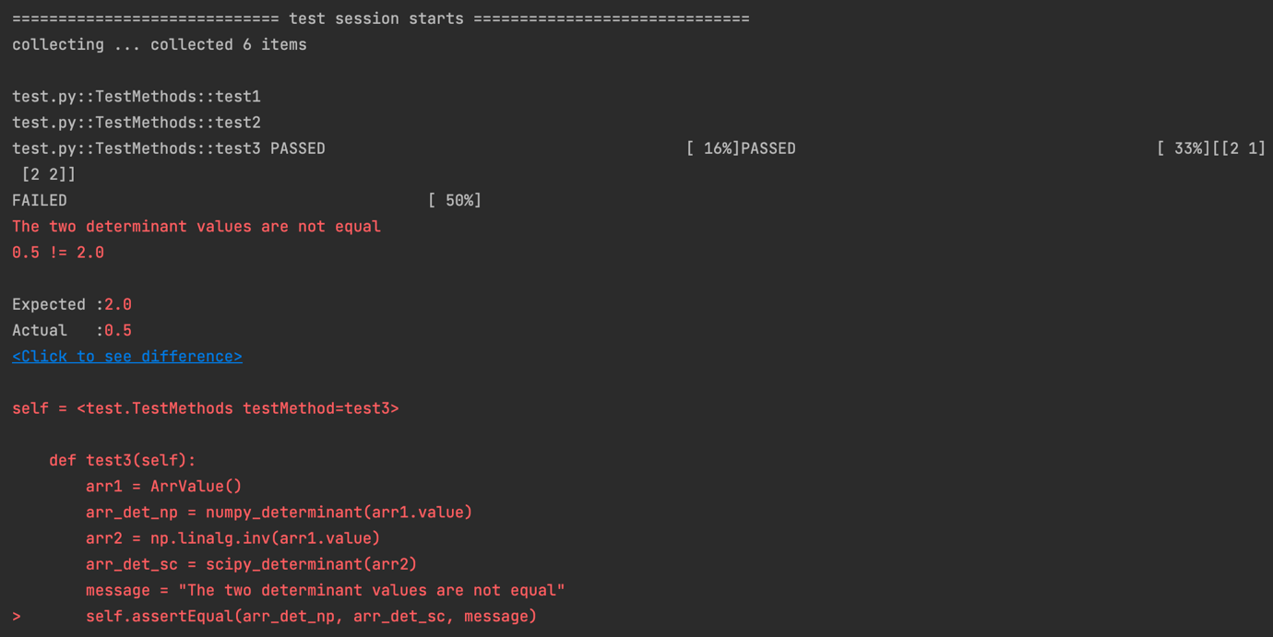

def test_positive(self): # this test is passing because both arr1 and arr2 are same (arr1=arr2= [[1,1],[1,1]] ) and both numpy determinant and scipy determinant give same answer.

def test1(self): # this test is passing because both arr1 and arr2 are same and both numpy determinant and scipy determinant give same answer

def test2(self): # arr1 is ArrValue and arr2 is getting by appending new column [[0], [0]], and then we get same output from both numpy and scipy determinant

def test3(self): # arr2 is inverse of arr1 so we get different determinant

def test4(self): # arr2 is transpose of arr1, so when we transpose the array we still get same determinant.

def test5(self): # an idempotent matrix is a matrix which, when multiplied by itself, yields itself. arr2 is idempotent and then square of idempotent is also idempotent and hence we get same idempotent.