1.

DDL

create database university;

create table students(name varchar, id varchar);

alter table students rename to firstyears;

drop table firstyears;

drop database university;

DML

insert into firstyears values('Amina', '21B031086');

update firstyears set id = '22B031086' where name = 'Amina';

delete from firstyears where name = 'Amina';

select * from firstyears;

select id from firstyears;

2.

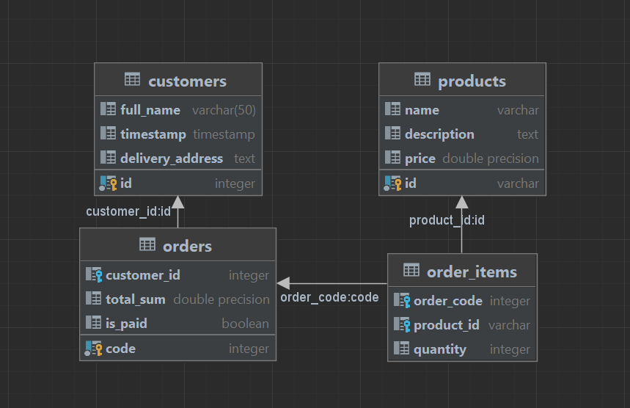

3.

create table students(

full_name text,

age integer,

birth_date varchar(10),

gender text,

average_grade float,

city varchar(21),

nationality varchar(21),

phone_number varchar(21),

social_category text,

primary key (full_name)

);

create table instructors(

full_name text,

speaking_languages varchar(255),

work_experience float,

remote_lessons float,

primary key (full_name)

);

create table lesson_participants(

lesson text,

teaching_instructor text,

studying_students text,

room_number text,

foreign key (teaching_instructor) references instructors,

foreign key (studying_students) references students

);

4.

insert into customers values(6, 'Amangeldi Amina',1664769731, 'Seifullina, 574');

insert into products values ('2840', 'milk', 'low in calories and light in taste', 450.00);

update customers set id = 1 where full_name = 'Amangeldi Amina';

delete from customers where id = 1;