**User Manual**

**For**

**A Novel Model Driven Framework**

**For Efficient Diet Plan Recommendation System**

**(MDDRS using Sirius)**

# **Introduction to a novel model driven framework for diet recommendation system (MDRS)**

MDRS is a novel model driven framework for diet recommendation system developed to generate diet plans by focusing on simplicity. This model driven framework concentrates on the creation of diet plan recommendation models that helps to cover the main concepts of weight loss domain. This proposed meta model sets as a baselined-requirements for transformation phase.

# **How to use?**

Some Installation requires for the execution of this proposed meta-model.

* This proposed meta-model has a central work on Obeo designer community platform-11.5
* Without the JDK-11, this proposed meta-model will not work on the obeo designer community platform.
* This proposed meta-model has implemented by the window os-64-bit architecture and it is tested on windows os-64-bit architecture.

# **Execution of Model driven diet recommendation system (Ecore Modeling)**

1. Download the project zip file from this link <https://github.com/AminaZafar-1998/Novel-Model-Driven-Framework-FOR-Diet_Recommendation>
2. Extract the zip files and import modelling project folder as a directory from file tab into the Obeo designer community workspace.
3. Choose Windows from tab🡪Open perspective🡪Modelling
4. After importing the folder into the workspace, analyse the ecore modelling project by selecting the model folder then it opens the modelling workbench of M2 - level.

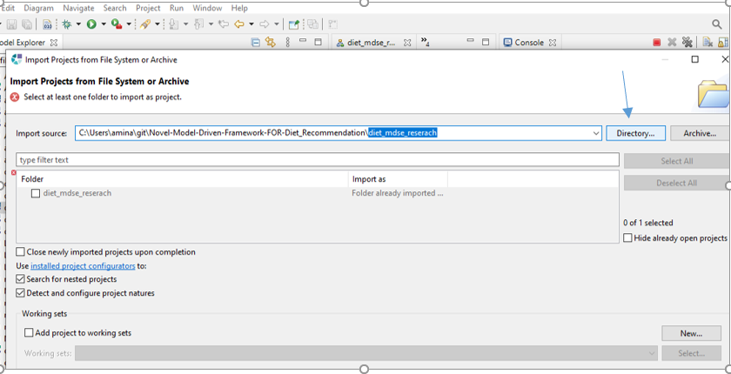

Figure 1. Import project from directory location

After that, it will add up to the workspace location.

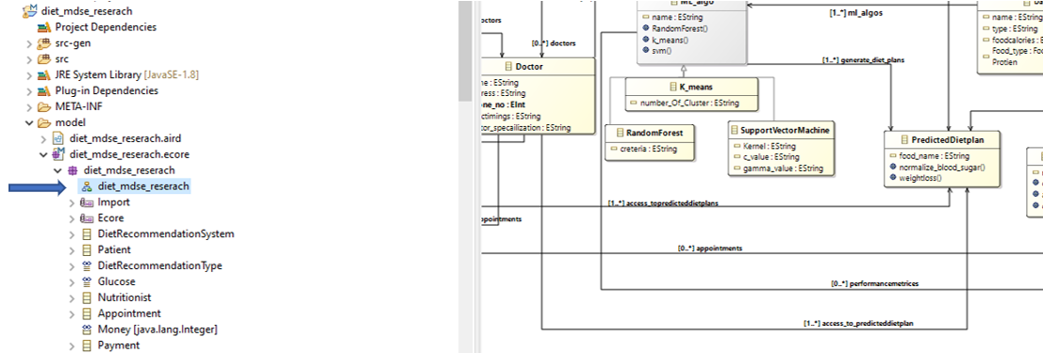

Figure 2. Open Ecore Modeling Project

Now it opens the ecore modelling project.

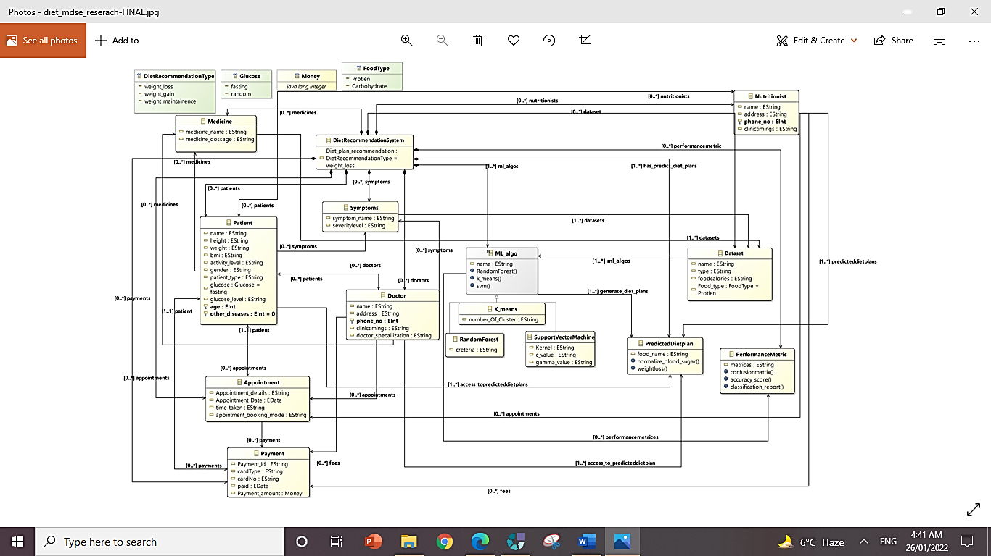

Figure 3. Platform Independent Meta model (Obeo Designer Community)

1. If want to change this ecore meta model, then simply drag and drop the classes, references or attributes from the palette view and then simply right click on the workbench area or genmodel file and select generate all.

# **Eclipse Modelling Project (Tree editor)**

1. Select file tab and Import the tree editor project by running an eclipse application.

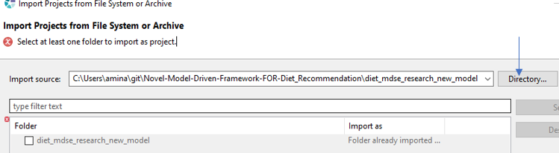

Figure 4. Import tree editor project (Eclipse modeling project)

1. Project will open in the workbench and then open the imported eclipse modelling project as a tree editor.

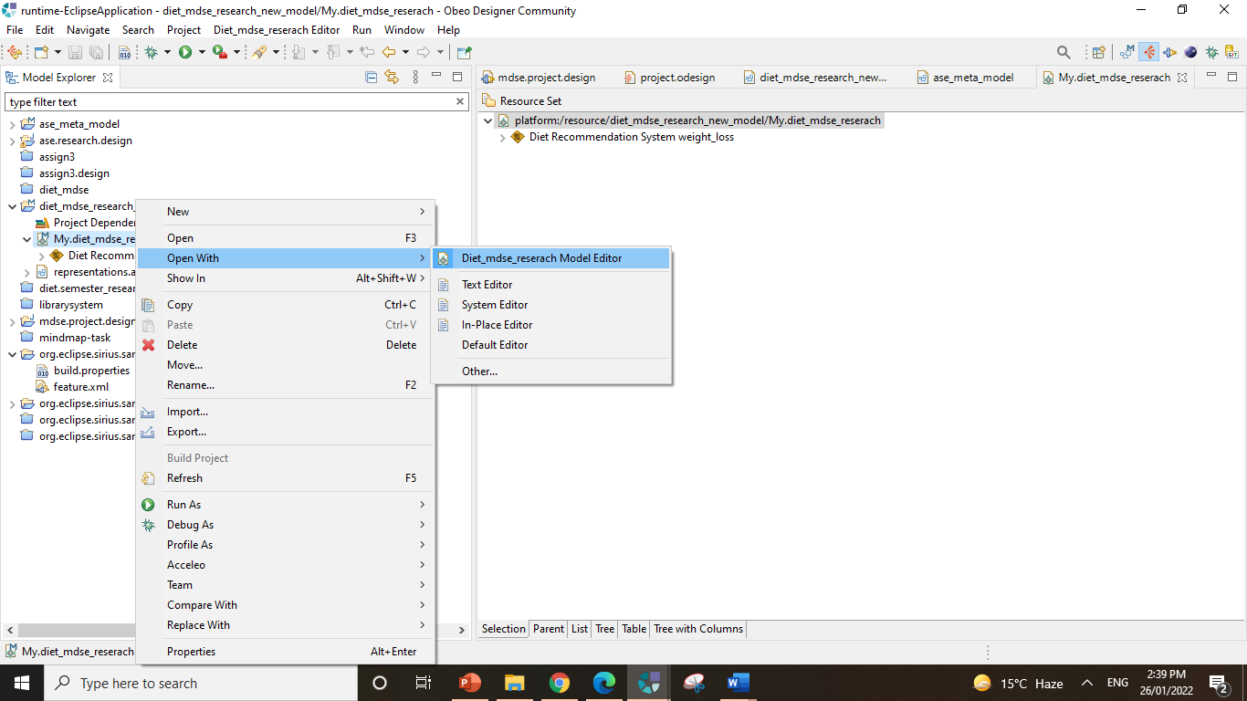

Figure 5. Open Tree editor (Eclipse modeling project)

1. Ecore meta model modifications will generate results in tree editor. Create further new child by your own choice.

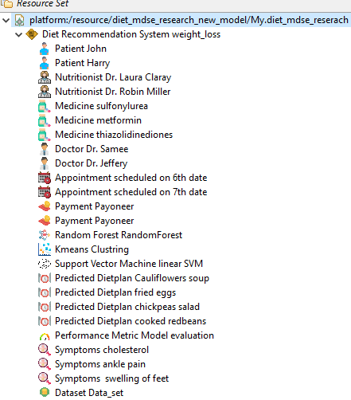

Figure 6. Eclipse Modelling Framework as Tree editor

# **Graphical Modelling Framework (Sirius Tool)**

1. Import the graphical modelling visualization project in the runtime-eclipse application.
2. Choose windows from tab🡪Open perspective🡪Sirius
3. Opens the project. odesign file.

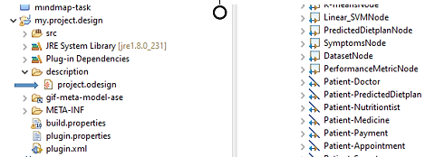

Figure 7. Open view specification project file (.odesign)

(Classes which have created in the ecore modelling project, made nodes in the view specification project (project.odesign file) and the edge creation should be create for bidirectional reference and uni-directional reference).

1. Opens the Graphical based visualization diagram.

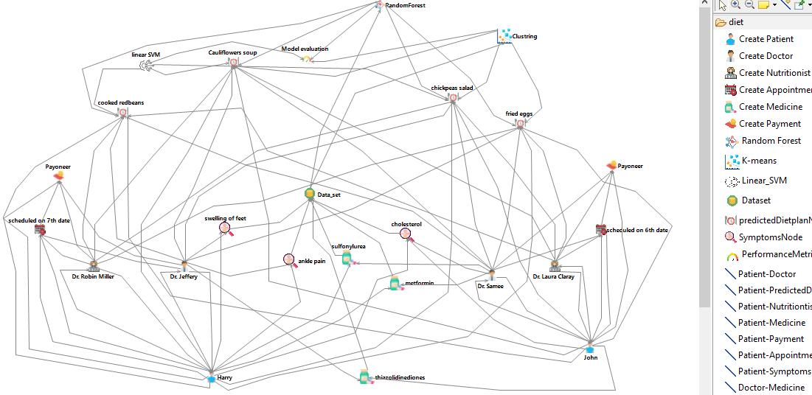

Figure 8. Instance model level of Case Study scenario using Graphical representation (Sirius Tool)

By your own choice, you can drag and drop the required concept and relation from created palette view by your own requirement that leads to changes in the eclipse modelling project (tree editor).

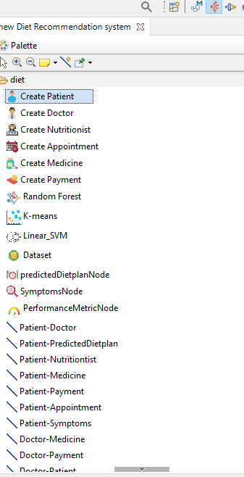

Figure 9. Palette View

# **Validity View**

Different constraints are imposed on the ecore modelling of M2 level using object constraint language. These constraints are validated through the eclipse modelling framework Sirius tool.

* + - 1. Object constraint language query has implemented on the root node that can viewable by opening the modelling project from the workspace as select on the ecore file🡪OCL inEcore editor.

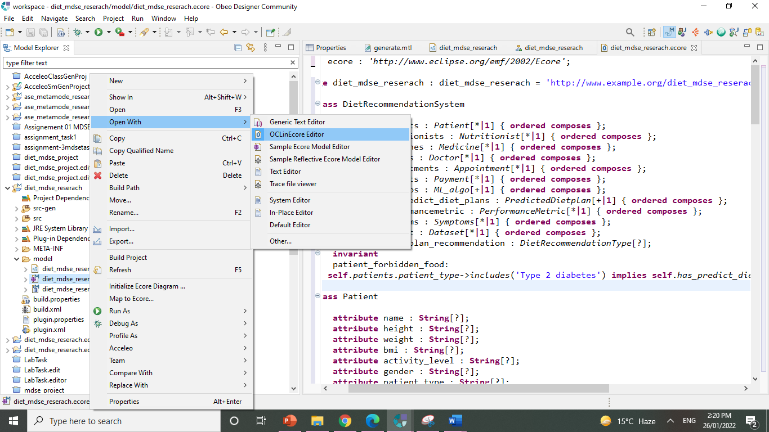

Figure 10. OCL constraint query

* + - 1. It will open the object constraint language editor, where the constraint has imposed on root class (Diet recommendation system).
      2. Then also check in the Sirius view for validation purpose. So, go to the tree editor view in the running eclipse application, then select the root node🡪ocl🡪validate.

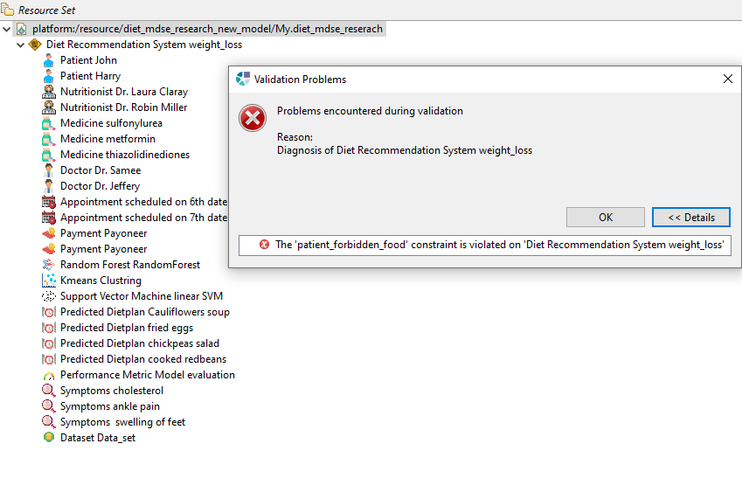

Figure 11. Constraint Validation

**Errors resolve procedure**

Sometimes, modifications encountered some problems. Like if ecore meta model has change with a little modification that leads to create problems in code generation. So one solution, is that go to the genmodel file, open it with EMF generator. Then right click on it🡪 generate All. Then run the modelling project as an eclipse application That’s simply resolved the problem.

Sometime such modifications take place in the ecore modelling project that cause errors in the tree editor such as feature not found. So simply open the tree editor with text editor and make changes there for fixation.